



Contents

Spring Cloud Stream Kafka 5

Kafka vs RabbitMQ Comparison 5

Kafka vs Solace Comparison 7

Microservices – Which Broker? 10

Overview 10

Download and Installation 13

Kafka Topics and Partitions 15

Topic and Messages 20

Consumer Offsets 24

Consumer Groups 25

Commit Log, Retention Policy 28

Processing Guarantees in Kafka 33

Exactly Once Semantics 44

Ordering of Messages in Kafka 48

Kafka Production Configuration 62

Kafka – A Distributed Streaming System 63

Kafka Cluster with 3 Brokers 64

Topics Distribution 66

Handle Data Loss 69

Fault Tolerance & Robustness in Kafka 72

Library Application 72

Source Code 73

Kafka Producer 74

Kafka Consumer 118

Retry in Kafka 151

Recovery in Kafka Consumer 156

Error Handling – Producer Level 160

Retain and Recover Failed Records 165

Kafka Security and SSL 168

2 way Authentication using SSL 186

Configuring Library Events Producer to access SSL secured Cluster 189

Configuring Library Events Consumer to access SSL secured Cluster 192

Kafka Streams 194

Introduction 194

Emergence of Big Data – Quick Recap 196

Conception of Event Streams 201

Stream Processing Use Cases 206

Real Time Streaming Challenges 214

Real Time Streaming Design Decisions 218

Kafka Architecture 225

Storage Architecture 226

Kafka Cluster Architecture 236

Work Distribution Architecture 239

Work Distribution Architecture – 2 242

Streaming into Kafka 251

Kafka Producers – Quick Start 254

Kafka Producer Internals 259

Scaling Kafka Producer 265

Advanced Kafka Producers ( Exactly Once ) 274

Advanced Kafka Producer ( Implementing Transactions ) 278

Kafka Producer – Micro Project ( Point of Sale Simulator ) 288

Kafka Producer – Final Note & References 305

Stream Processing in Apache Kafka 321

Kafka Consumer Practical Introduction 323

Kafka Consumer - Scalability, Fault tolerance and Missing Features 334

Kafka Streams API – QuickStart 341

Creating Streams Topology 347

Implementing Streams Topology 354

Kafka Streams Architecture 369

Summary and References 374

Foundations for Real Life Implementation 376

Introduction to Types and Serialization in Kafka 376

JSON Schema to POJO for JSON Serdes 378

Creating and Using JSON Serdes 385

AVRO Schema to POJO 390

Creating and using AVRO schema in Producers 394

Using AVRO in Kafka Streams 405

Summary and References 416

States and Stores 417

Understanding States and Stores 417

Creating your first State Store 420

Caution with States 433

State Store Fault Tolerance 442

Section Summary 447

KTable – An Update Stream 448

KTable 448

Creating your First Update Stream 453

Table Caching and Emit Rates 467

Introducing Global KTable 470

Real Time Aggregates 472

Computing Your First Aggregate - Real-time Streaming Word Count 472

Stream Aggregates – Core Concept 480

Kstreams – Aggregations using Reduce 483

KStream Aggregation using Aggregate() 491

Common Mistakes in Aggregation 500

Count on KTable 505

KTable Aggregation using Aggregate() 510

TimeStamp and Windows 515

Timestamps and Timestamp Extractors 515

Creating Tumbling Windows 521

Stream Time and Grace Period 532

Supressing Intermediate Results 543

Hopping Windows 556

Session Windows 562

Joining Streams and Tables 579

Streaming Joins 579

Joining a KStream to another Kstream 582

KTable – KTable Joins 597

Joining a KStream to a KTable and GlobalKTable 605

Joins and Aggregates 610

Mixing Joins with Aggregates - Advert CTR 625

Kafka Connect 627

Confluent Platform 627

Spring Reactive Kafka 628

Overview 628

Reactive Kafka Sender 628

Error handling 629

Send without result metadata 629

Threading model 630

Non-blocking back-pressure 630

Closing the KafkaSender 631

Access to the underlying KafkaProducer 631

Reactive Kafka Receiver 631

Subscribing to wildcard patterns 632

Manual assignment of topic partitions 632

Controlling commit frequency 632

Auto-acknowledgement of batches of records 633

Disabling automatic commits 633

At-most-once delivery 633

Partition assignment and revocation listeners 634

Controlling start offsets for consuming records 634

Consumer lifecycle 634

Sample Scenarios 635

Sending records to Kafka 635

Replaying records from Kafka topics 635

Reactive pipeline with Kafka sink 635

Reactive pipeline with Kafka source 636

Reactive pipeline with Kafka source and sink 636

At-most-once delivery 637

Fan-out with Multiple Streams 637

Concurrent Processing with Partition-Based Ordering 638

Transactional send 638

Exactly-once delivery 638

Spring Kafka 639

Using Spring for Apache Kafka 639

Changes between 2.4 and 2.5 639

Connecting to Kafka 640

Configuring Topics 641

Sending Messages 643

Receiving Messages 652

Listener Container Properties 671

Thread Safety 680

Monitoring 681

Transactions 682

Serialization, Deserialization, and Message Conversion 689

Message Headers 697

Null Payloads and Log Compaction of 'Tombstone' Records 700

Handling Exceptions 700

JAAS and Kerberos 710

Kafka Streams Support 711

Basics 711

Spring Management 711

KafkaStreams Micrometer Support 712

Streams JSON Serialization and Deserialization 712

Using KafkaStreamBrancher 713

Configuration 713

Header Enricher 713

MessagingTransformer 714

Recovery from Deserialization Exceptions 714

Kafka Streams Example 714

Testing Applications 715

Tips and Tricks 723

Spring Cloud Functions 725

Interview Questions – Kafka Streams 725

**Spring Cloud Stream Kafka**

## Kafka vs RabbitMQ Comparison

* RabbitMQ cannot be used as a store; Kafka can.
* In RabbitMQ, ordering is not guaranteed once we have multiple consumers. Kafka guarantees order for a partition in a topic.
* Messages can’t be replayed by RabbitMQ—they have to be resent those from the sending side. We do this with the Message Outbox pattern. Kafka stores data in the order it comes in and supports message replay with the help of offsets. However, it introduces other tradeoffs around data compaction, how long to keep the data on the streams, what to do if data required predates the stream, etc.
* RabbitMQ doesn’t support transactions natively, it uses acknowledgments. Kafka supports transactions.
* RabbitMQ has great .NET support—it completely outshines Kafka in this regard. Kafka treats .NET support as a secondary priority.
* RabbitMQ has good tooling for management on Windows. Kafka does not.
* RabbitMQ implements the Advanced Message Queuing Protocol. These guardrails help you stumble into a pit of success. With Kafka, you will have to implement a lot of these patterns and disciplines yourself.
* RabbitMQ doesn’t need an outside process running. Kafka requires Zookeeper’s running instance for its broker management. Zookeeper is responsible for assigning a broker for the topic.
* Out of the box, RabbitMQ is behind in multithreading support compared to Kafka—but not by much. Since NServiceBus works with RabbitMQ and has good support for multithreading, it is lesser of a problem for RabbitMQ. In both worlds, ordering is not guaranteed if the consumers are scaled out or have fetching records using multiple threads.
* RabbitMQ has a lot of plugins to support your needs. Kafka is not as mature and therefore doesn’t have as many plugin options.

|  |  |  |
| --- | --- | --- |
| **Consideration** | **RabbitMQ** | **Kafka** |
| Using a non-Java tech stack | **1** | **0** |
| Message is transient in nature: more command than event | **1** | **0** |
| Building an event store system | 0 | **1** |
| New consumers come up frequently | **0** | **1** |
| Using NServiceBus and related patterns and practices | **1** | 0 |
| Advanced Message Queueing Protocol-based routing | **1** | **0** |
| Tooling maturity | **1** | **0** |
| Raw throughput | **0** | **1** |
| Avoiding dependencies on external tools* | **1** | **0** |
| Producer side idempotency support | **0** | **1** |
| Potential data loss | **0** | **0** |
| Long term backward compatibility for events exposed outside organization | **0** | **1** |
| Building a reporting system | **1** | **1** |
| Community and vendor support | **1** | **1** |
| Pure data replication | **0** | **1** |
| **TOTAL** | **7** | **8** |

* There can only be trade-offs within different contexts. Building a scoring sheet can help you evaluate your options.

The considerations you choose will vary in different contexts, research, and comfort levels. Below is an example of an actual evaluation that we performed. You assign a “1” to the tool that is stronger in each scenario. If neither outranks the other, you assign “0”s to both. Tabulating the totals will give you an idea of how one suits your needs over the other.

**Have you answered these prerequisite questions?**

Any tool or framework may not necessarily address all underlying architectural problems. If database integration was the norm in the past, the chance of repeating mistakes is high. We need to think differently when we are dealing with tools like Kafka. For example, we don’t necessarily need new topics per message type, as Martin Kleppmann points out in his event types for Kafka topic post.

A change in mindset starts with the questions below—they need to be answered before you implement either tool. This is just a starting point, but if these considerations are not addressed early on, the odds of messaging success will be against you.

* Do you have observability/monitoring in place? Can you demonstrate a need for scale?
* Have you answered underlying architectural concerns in your system?
* Do you have proper business and data boundaries in place?
* Do you have a regular check of the business and data boundaries process?
* Do you have operational and standards concerned answered? Is your choice compliant with them?
* Have you documented your hardware constraints? Is your choice compliant with them?
* Have you documented your security constraints? Is your choice compliant with them?
* Have you evaluated other platform as a service (Event Hubs on Azure) options?
* Have you implemented the Outbox pattern correctly? Data loss is possible with RabbitMQ and Kafka both.

Cover from

<https://kafka.apache.org/documentation/#gettingStarted>

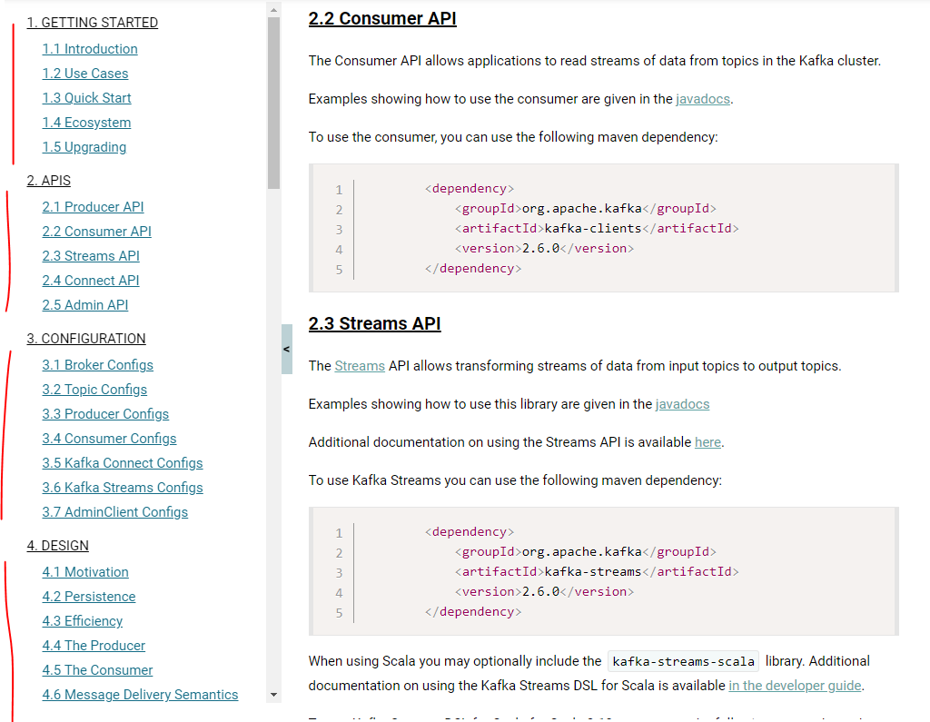

## Kafka vs Solace Comparison

< google this >

At least-once delivery

To achieve at least-once delivery the producer must make sure its messages has been persisted into Kafka. If not and if the node fails after receiving the message and before it is persisted then there is no way to guarantee at least-once delivery. Fortunately it’s possible for the producer to wait for its message to be acknowledge by kafka, making sure it has been persisted.

On the consumer side Kafka doesn’t push messages to consumers. Instead it’s the consumers who pulled messages from Kafka. In order to improve efficiency message are not pulled one by one but in (mini) batches. E.g. every few seconds the consumer polls for any messages published after a given offset. Kafka returns the batch of corresponding messages. Once all the messages have been processed, the consumer confirms the batch to Kafka and the offset for the batch is committed in Kafka and the next poll request will return the next messages. Now assumes that the consumer fails in the middle of the batch (i.e. some messages have been processed and some others haven’t). When the consumer recovers it will start from the beginning of the exact same batch, reprocessing some messages that were already processed. This is at-least once delivery.

Fan In and Fan Out

Fan In Ingress

How can data arriving from multiple instances of a data source be collected in an efficient manner?

**Problem**

Analysis of multiple streams of data originating from multiple instances of a data source may prove difficult if the streams are out-of-sync or if there are simply too many streams.

**Solution**

Multiple streams are reduced to fewer streams by implementing a system that intelligently consolidates data based on the system requirements.

**Application**

An event-based data ingress system is implemented, where streams collected from multiple sources are multiplexed into a single stream. This stream consists of events in the order in which they arrived or ordered according to criteria, or fine-grained events are combined to create coarse-grained events.

An event data transfer engine is used to collect multiple streams that originate from multiple instances of the same data source, such as a temperature sensor located across the perimeter of a factory floor. The collected streams are then joined together to create a single stream. The event data transfer engine provides automatic, inflight stream consolidation to eliminate the need of manual consolidation that first requires capturing each stream and then merging them together, which incurs processing latency.

This pattern is applicable under different scenarios. For example, the events emitted by multiple data source instances may not be in the order as required by the data analysis algorithm, or, due to network delay, the events may be out of order. In other scenarios, due to the sheer number of streams and limited available processing capacity, events originating from different instances of the same type of data source are simply added together to create a single event. This pattern can further be extended to create a single event from multiple events of the same data source that fall within a particular range, such as a time interval, and further consolidate with coarse-grained events from the rest of the data source instances. Furthermore, this pattern can be applied together with the Automated Processing Metadata Insertion pattern for adding traceability of the specific data source from where the stream originated.

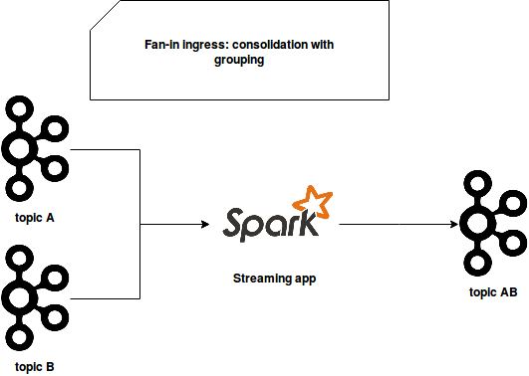

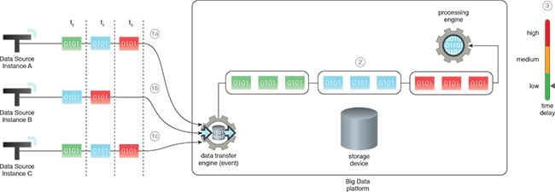

Date streams are consolidated into a single or manageable number of streams by applying analysis-specific consolidation logic. The process of consolidation generally takes place within the component that captures the different streams of data. The application of the Fan-in Ingress pattern helps to develop a simple data processing solution and keeps resource utilization to a minimum.

In the diagram, three different instances of a data source produce out-of-sync data streams that need processing in realtime. The streams are collected and processed as follows:

1. (a,b,c) Data from Instances A, B and C is collected by the event data transfer engine.
2. The event data transfer engine orders the events as required, which are then processed collectively by the processing engine.
3. This results in a low data processing latency.

Fan Out Ingress

How can streaming data arriving from a single source be simultaneously forwarded to multiple destinations without any delay?

**Problem**

Capturing and storing streaming data first and then creating multiple copies of data for multiple sinks in support of fulfilling different analysis requirements can significantly impact the speed of data analysis.

**Solution**

Multiple copies of input stream data are created the moment data is captured and are forwarded to the required sinks in realtime.

**Application**

An event-based data ingress system with demultiplexing functionality is used so that multiple copies of the incoming stream of data are generated inflight and then sent to the configured sinks.

**Mechanisms**

An event data transfer engine with fan-out capability is used to capture an incoming stream of data. The event data transfer engine is configured with multiple sinks. Once configured, the incoming stream of data is automatically replicated and then forwarded to the configured sinks.

Functionality is added to capture the incoming stream in realtime, create inflight copies of the data stream and forward each stream to the configured data sink. Some basic level of data cleansing is performed before the stream is replicated. The application of the Fan-out Ingress pattern not only removes data provisioning latency but also provides a scalable realtime ingestion functionality.

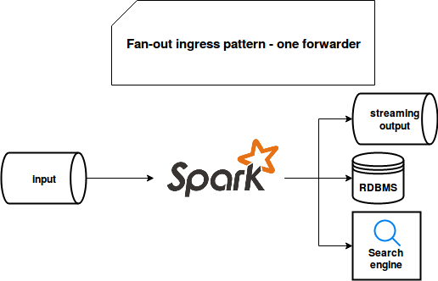

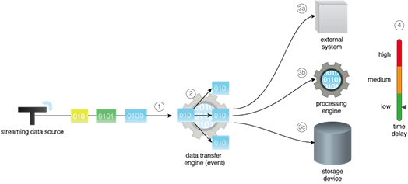

In the diagram, a data stream needs to be forwarded to an external system, a processing engine and a storage device. The stream is collected and forwarded as follows:

1. The stream is captured by an event data transfer engine.
2. The event data transfer engine creates three copies of the stream as it arrives.
3. (a,b,c) The copied stream is then forwarded to the external system, processing engine and storage device as a continuous stream.
4. This results in a low data provisioning latency in terms of the time it takes the data to reach the sink from the source.

## Microservices – Which Broker?

<https://otonomo.io/redis-kafka-or-rabbitmq-which-microservices-message-broker-to-choose/>

<https://blog.space-cloud.io/posts/building-event-driven-microservices-that-scale/>

<https://www.confluent.io/blog/exactly-once-semantics-are-possible-heres-how-apache-kafka-does-it/>

**Overview**

We will cover the following

* Introduction to Kafka and internals of Kafka
* Building Enterprise standard Kafka Clients using Spring-Kafka/ SpringBoot
* Resilient Kafka Client applications using Error-Handling/Retry/Recovery
* Writing Unit/Integration tests using JUnit

In the past all the applications that were built was a giant monolith applications using the monolith architecture. That means all the functionalities will reside in one single application. The example here is a retail application and some of the related services are order service payment service inventory service and notification service. All those services will reside in one single application and share the same database. This kind of architecture was proven to fail under heavy load. Things have changed and the current state of development uses a more modern architecture which is the micro services architecture. As you can see, in this slide the application in itself is decomposed into micro services and each micro service has its own database. But as a whole in order to deliver the business functionality or value multiple Microsoft users interact with each other using some communication protocol. The arrows represents the communication between them but I can definitely say it looks messy and it looks like a spaghetti.

**PAST CURRENT**

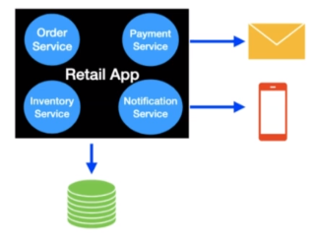 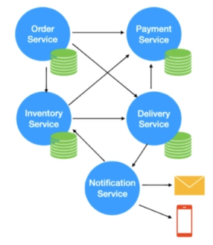

The expectation of the apps that are built today have a new requirement which is providing real time notifications and process the events as they occur in order to support that. We need to have a middleware in between a full blown architecture will look like this. This is a micro architecture the middleware that we are using here isn't even a streaming platform. I will explain about what isn't even streaming platform in a bit.

|  |  |
| --- | --- |
|  | Basically at its core each micro service will have an API which are going to generate a lot of events and other services. Read those events and take necessary action as the events occur. In a nutshell each micro service will have an API and it will have an event producer and event consumer. All other services communicate with each other through an event streaming platform. This fundamentally forms the basis for event driven system. You might be having this question right now in your mind. What does an event streaming platform fundamentally mean. An event streaming platform allows the application to produce and consume a stream of records as in Laker messaging system. You can think of this as a Pub Sub model. |

The producer and consumer here are independent of each other meaning the producer has no clue about which consumer is going to read this message and event streaming platform also stores the stream of events so that it can be replayed if it's necessary. Even so generally retained in multiple servers for providing fault tolerance and availability. I will explain more on those in the future. Part of the course and even streaming platform also allows the application to process the records as they occur. Basically these three principles form the foundation for the even streaming platform.

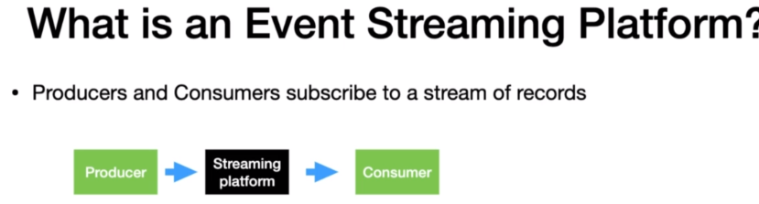

**Traditional Messaging System** **Kafka** **Streaming** **Platform**

• Transient Message Persistance • Stores events based on a retention time. Events are Immutable

• Brokers responsibility to keep track of consumed • Consumers Responsibility to keep track of consumed messages

messages

• Target a specific Consumer • Any Consumer can access a message from the broker

• Not a distributed system • It’s a distributed streaming system

Apache Kafka is built on top of these principles so here they are event streaming platform that we have can be replaced with Apache Kafka. Many of us might have this question in our mind is Kafka and enterprise messaging system. Then let me quickly show you the difference between the traditional messaging system and Kafka traditional messaging systems have the transient message persistence meaning once the records are read by the consumers then the messages will be removed from the message broker. In the case of Kafka it is going to save the event in the file system where Kafka has installed and the events are retained for a certain time all the Events in Kafka are immutable. Meaning once the records are sent to Kafka then it cannot be altered in traditional messaging system. It is the broker's RESPONSIBILITY TO KEEP TRACK OF MESSAGES consumed by the consumers and remove them from the broker when the messages are read. But in Kafka it's the responsibility of the consumer to keep track of consumed messages. Don't worry about it. For now we will learn about different techniques of doing it in the future.

The traditional messaging systems can target a specific consumer to read the message from the broker. That's not the case in Kafka any consumer who have access to the broker can read the message. Traditional messaging system does not follow the principles of distributed systems. But Kafka is built on top of the core principles of a distributed system a distributed system in general is proven to handle the load very well and has the intelligence to distribute the load. I believe the differences that we discussed here justifies that Kafka is a streaming system not just a messaging system.

Kafka Use Cases

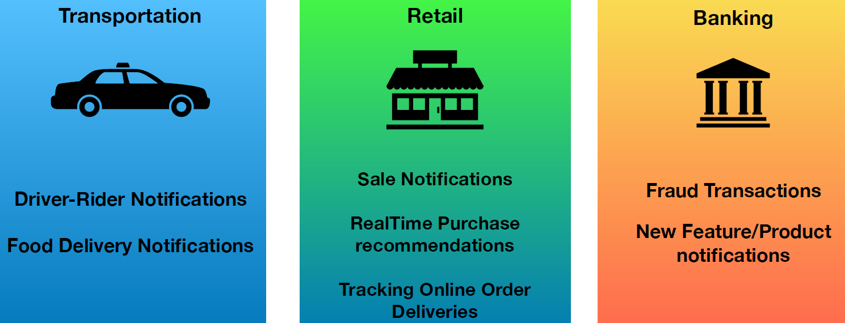

Kafka can be used for many different use cases in the transportation domain booking rides online through app is pretty common today. Kafka can be used for sending real time tracking of driver notification to the writer ordering food online is also a pretty common scenario today. And Kafka can be used to provide real time tracking of the driver delivering the food in retail. Kafka can be used to provide real time sale notifications and real time purchase recommendations based on the previous purchases and real time tracking of online orders and banking world Kafka can be used to unload on Real Time fraudulent transactions and provide new feature and product notifications and more. I hope this lecture gave you all a pretty good idea about Kafka and how Kafka can solve a lot of problems of today's software requirements.

At the heart of Kafka we have a Kafka cluster Kafka cluster generally consist of multiple brokers. I will introduce you to brokers and clusters in the future. In order to manage multiple brokers we need a zookeeper. Basically zookeeper keeps track of the health of the brokers and manage the cluster for you. Broker is what all the Kafka planes will interact with. Having just the clusters doesn't add any value. The very first client that I'm going to introduce you is the Kafka producer. A Kafka producer are the way to write and produce new data into Kafka blind users. The producer API to write the data and to look after the data is written into Kafka. What needs to be done. We need to consume the data from Kafka so Kafka consumers comes in handy to consume the messages they use the consumer API to consume the message from the Kafka cluster. Kafka Consumers and producers are basic plain APIs through which we can interact with Kafka. There are two advanced client s that comes with Kafka. No one is the Kafka connect. It has two different types of connectors named source connector and sync connector the source connector is used to pull the data from an external data source such as database our filesystem are an elastic search into the Kafka topic and the opposite of the same is done using the sync connector.

* With Kafka connect you can perform the data movement in and out of Kafka without writing a single line of code.

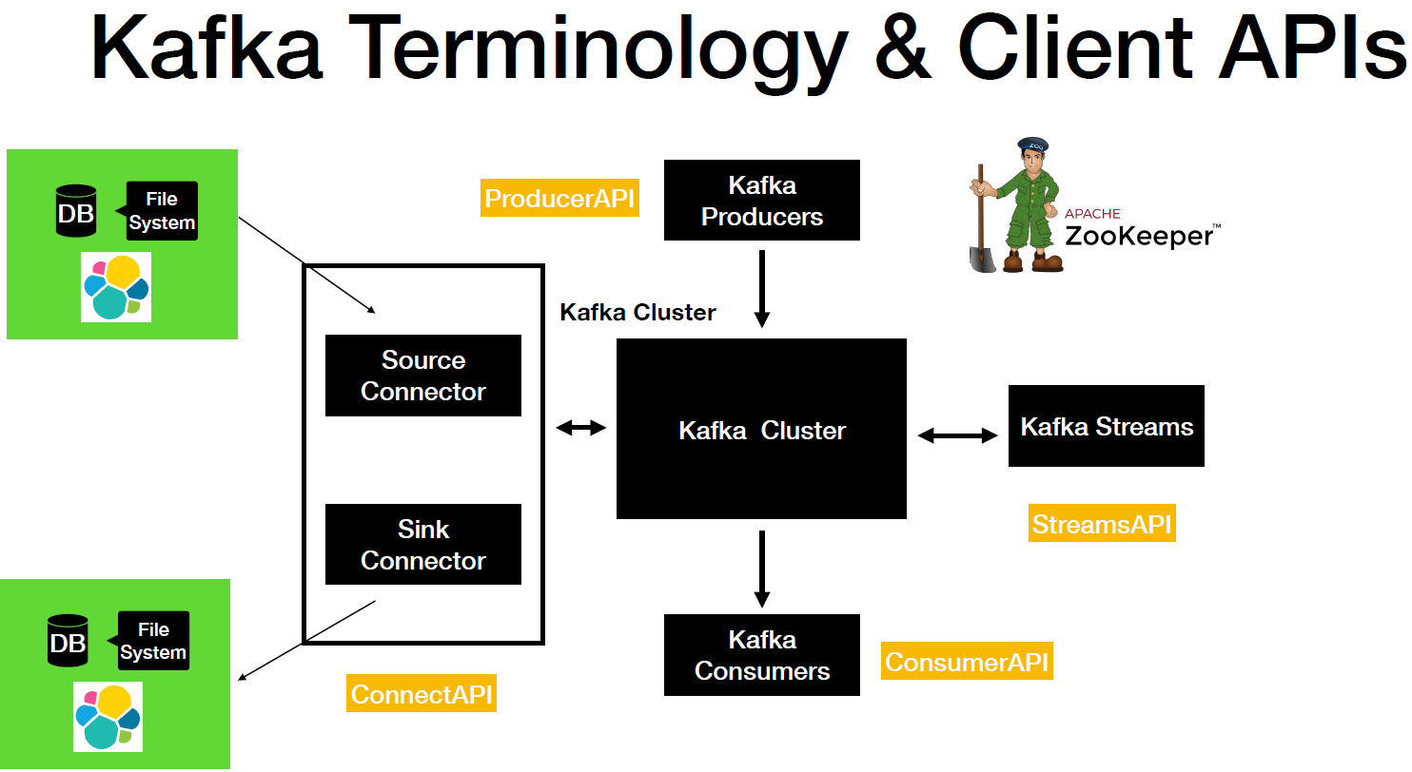

The next advanced API is the streams API which is basically used to take the data from Kafka and perform simple to complex transformations on it and put it back to Kafka.

If I have to summarize this lecture you have for client API such as the producer consumer API, the Connect API and Streams API using which you can interact with Apache Kafka. I'll be covering extensively about the producer and consumer API as part of this course.

**Download and Installation**

Let's go to the browser and then search for Kafka. Download it will give you a bunch of links. The link that we are going to select is a download Apache Kafka Apache Software opened up in a new tab and in here you have two binary downloads. Number one is two point one one.

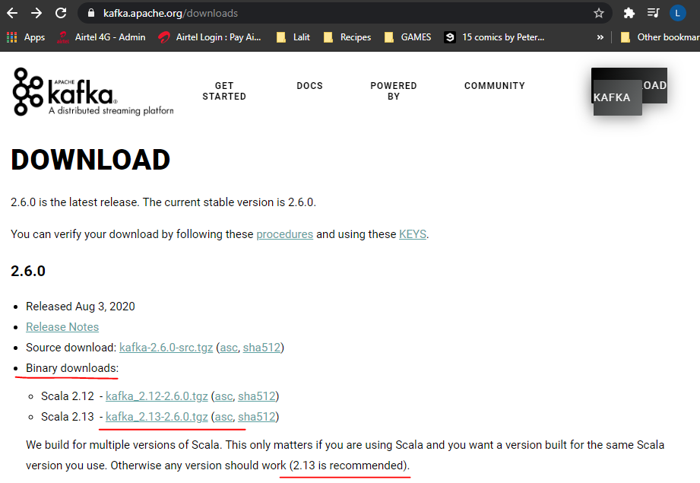

And number two is two point one to the Scala here matters only if you are using scout Scala. And the version two point one two is a recommended version. Let's click on this one. It will take you to another page in here. You have to select this particular link as soon as you click on that one it'll start the download in order to save something what I did was I have already downloaded the distribution. If you double click on it it will unzip the folder unzip the zip file and give you this folder. As you can see the folder name is Kafka. Pick the recommended one.

Let's go to the terminal. So in the terminal I have already navigated to the folder where I have downloaded this distribution. Let's do a list for a alerts.

Basically we have four different directories then config, libs, site and docs. And this course will pretty much need the bin and config directory.

Let's navigate inside the directories one by one and then look at the content inside the directory.

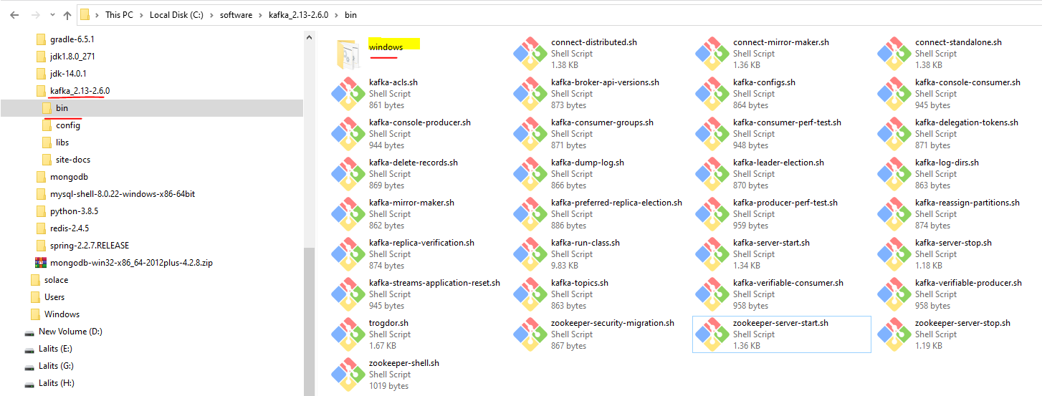

It has a bunch of shell scripts, out of these we need a couple of these scripts in order to stand up. Kafka broker. Number one is kafka-server-start.sh / windows/kafka-server-start.bat as such and in order to start up a zookeeper you need a zookeeper-server-start.sh or windows/zookeeper-server-start.bat and after that if you are using Windows then in that case you need to navigate inside the windows directory. And if you do unless you have all the bat files here basically you will use these ones in order to start up a Kafka broker and zookeeper in your machine. Let's go back and then do this.

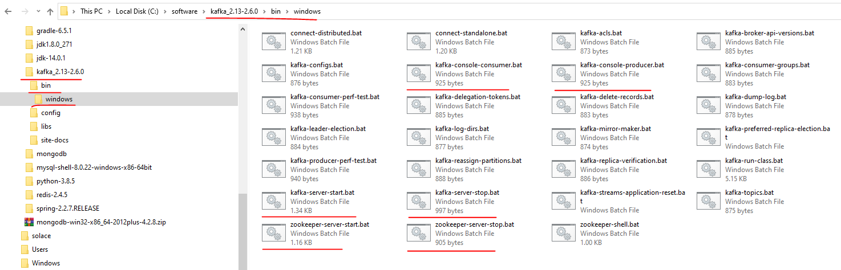

And here you see kafka-console-consumer.bat and kafka-console-producer.bat.

We will be using these scripts in order to produce and consume the messages. I'll show you a demonstration on this one in the future part of the course and I produce the next directly that we are going to navigate to is a let's do a ls. Let's go inside the conflig directory. You go into the config directly you will have lots and lots of property files.

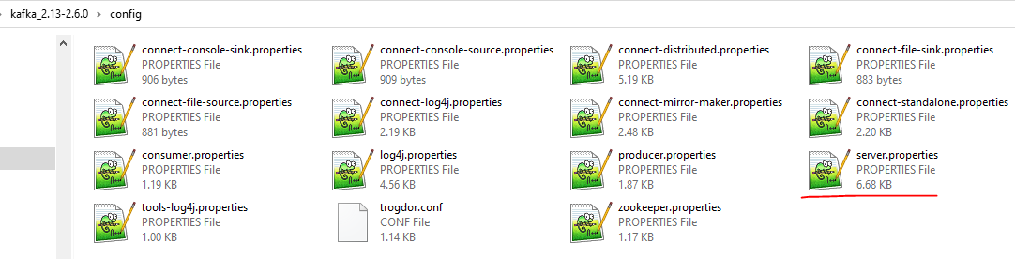

And this one the particular file that we are really focusing on is the server.properties. This particular file has the necessary information about the broker the Kafka broker. As you can see it has a broker id and it will have the connection details to connect to the zookeeper at the bottom if you take a look at it. The zookeeper connection timeout and which zookeeper instance it needs to connect.

**Kafka Architecture?**

Kafka topics

Kafkas fundamental unit for event organization is known as a Topic. Kafka is not a queue, it’s a log. Logs are a super easy data structure to understand with well known semantics. First of all they are append only whenever you write something to it, it always goes to the end. Consider Application Logging, Log4J or any of the 600 other logging APIs. Logs can only be read by seeking arbitary offsets in the log and then scanning sequential log entries. By default these are not indexed things. We seek a offset and then move from there. Events in a log are immutable ( they cannot be changed ). Once something has happened its exceedingly difficult to make it unhappen. These very simple semantics of a log make it easy for Kafka to deliver high levels of sustained through-put in and out of topics. When you look at that kind of single node performance, occassionally you would come across some crazy semantics like hundreds and thousands of messages being produced and consumed on a single server. Kafka is capable of clocking some very impressive single node performance numbers. Logs are also fundamentally durable, Queues are a little ephemeral, you put things into it and someone is a able to get things out of it and then they are gone. Traditional messaging systems have topics and queues which store messages temporarily to buffer them between a source and a destination but Kafka topics are logs, there is nothing there inherently temporary about the data in a log. Kafka topics can be configured for the messages in it to expire after they have reached a certain age. We can also configure that by size. Age is more typical though. Retention period is more typical – seconds, years or infinity. These really are durable things and they can live forever. Logs are files stored on disks – as durable as something you have written to a file system or any database that you ever trusted. The simplicity of log as a data structure and the immutability of the contents in it are the keys to success as a critical component in modern day infrastructure.

Because the world is filled with so many events, Kafka gives us a means to organize them and keep them in order: topics. A topic is an ordered log of events. When an external system writes an event to Kafka, it is appended to the end of a topic. By default, messages aren’t deleted from topics until a configurable amount of time has elapsed, even if they’ve been read. Topics are properly logs, not queues; they are durable, replicated, fault-tolerant records of the events stored in them. Logs are a very handy data structure that are efficient to store and maintain, but it’s worth noting that reading them is not too exciting. You can really only scan a log, not query it, so we’ll have to add functionality on a future day to make this more pleasant.

Partitioning

Topics are stored as log files on disk, and disks are notoriously finite in size. It would be no good if our ability to store events were limited to the disks on a single server, or if our ability to publish new events to a topic or subscribe to updates on that topic were limited to the I/O capabilities of a single server. To be able to scale out and not just up, Kafka gives us the option of breaking topics into partitions. Partitions are a systematic way of breaking the one topic log file into many logs, each of which can be hosted on a separate server. This gives us the ability in principle to scale topics out forever, although practical second-order effects and the finite amount of matter and energy available in the known universe to perform computation do place some upper bounds on scalability. Learn more about partitioning.

**Kafka Topics and Partitions**

Lets start with the Kafka Topic first. A Kafka topic is an entity in Kafka and it has a name. A quick analogy is to think of topic as a table in the database. Topics in general live inside the Kafka broker. In this example we have a topic inside the broker Kafka clients uses the topic name to produce and consume messages. Here in this example we have the producer on the left and consumer in the right.

The behavior of Kafka consumer is to poll continuously for new messages. So here the consumer is polling the broker using the topic name. Producer in general produces a message into the topic, if something outside invokes a producer. But even here the producer uses the topic name to produce a message. So often the message is sent from the producer. It reaches the Kafka topic first.

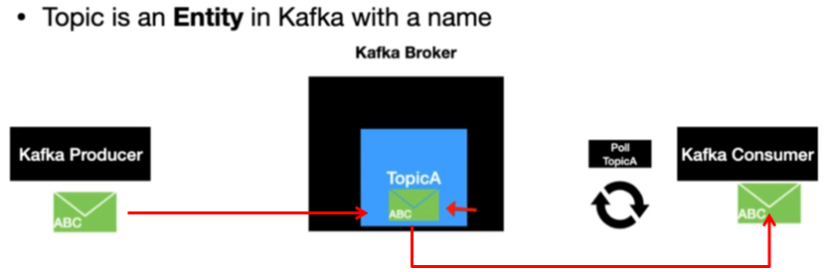

I have already mentioned about consumer is continuously polling new records. Once the poll notices this message, then it is consumed by the consumer and the consumer does some processing on that record that's retrieved.

One quick thing to call out here is that even though the record is read by the consumer the message still resides inside the Kafka as per the defined retention time. The defined retention time.

Now we learned about topics and it's time to introduce you to partitions. partitions is where actually the message is located inside the topic. Each topic in general can have one or more partitions**.** It is pretty common practice to have more than one partition. I have seen scenarios where topics had 100 partitions are more the partitions have a significant effect on scalable message conception. We will learn about those. Then we discuss about the consumers.

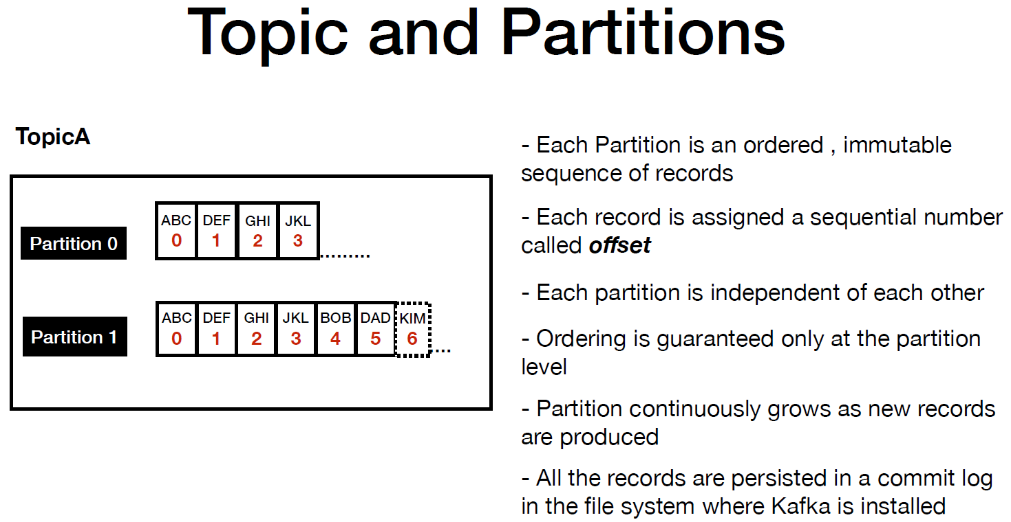

The example that I have here has two partitions each partition is an ordered immutable sequence of records. That means once a record is produced it cannot be changed at all. As you can see each record as a number associated to toward that number is called an offset. The offset is generated when a record is published to the Kafka topic. Offsets play an important role when it comes to consumers. I'll be talking more about it when we discuss about Kafka consumers.

Each partition is independent of each other and that's why you see the offset in both of those partitions starts with zero. And it continues to grow indefinitely. Ordering is guaranteed only at the partition level. So if you have a use case where you would like to publish and read the records in a certain order then you have to make sure to publish the records to the same partition.

Partitions continue to grow as new records are produced and offsets get incremented one by one. All records are persisted in a physical log file where the Kafka is installed. It is similar to a commit log file that you find that database transactions but this one is a distributed log file.

Now we have learnt about topics and partitions. Now let's put these concepts together and then see how it works. I just have the Kafka producer here because producer is what is fundamentally needed to produce a new record in Kafka. I just have the offsets displayed in this slide.

So let's say you are sending a new message and it goes to partition zero. Now as you can see the offset is incremented from three to four and it gets appended to the existing log. And then we are going to send another message to partition one as you can see the offset is increased from 5 to 6 and it is appended to the partition log and it continues to do the same as new records are produced into the Kafka topics.

Producer has a complete control of which partition the message is going to go.

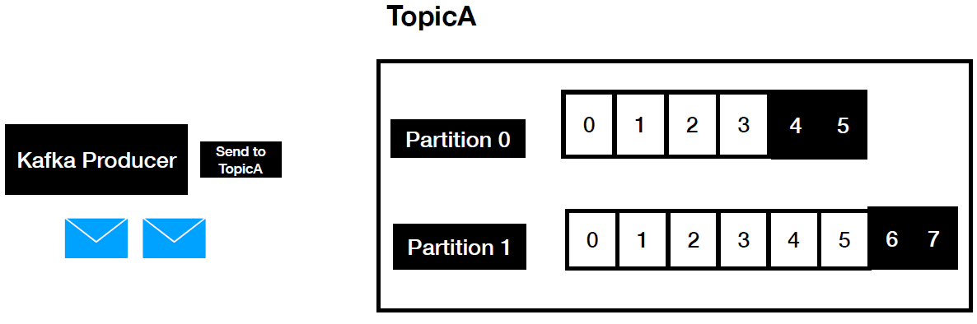

I'll cover the different strategies when we start coding the Kafka producer.

We will set up the Kafka broker in a local and start producing and consuming messages.

We will spin up a zookeeper instance. The zookeeper comes bundled with Kafka distribution that we downloaded. After that we are going to spin up a Kafka broker. Once a broker is up, it registers itself with the zookeeper after that zookeeper manages and monitors the health of the Kafka broker. Zookeeper plays a vital role. Then you have multiple brokers.

But at this point we are just going to open up a single broker, so I will save the discussion of multiple brokers for the upcoming lectures. Now let's get this started. I'm going to go to the terminal

On the root path where I have the Kafka distribution downloaded by to us. I see this bin, config, libs, logs and site-docs. So the first thing is I'm going to navigate inside the bin directory. We are going to open up is to spin the zookeeper instance right. So we are going to use this zookeeper-server-start.sh file.

In order to save some time what I did was I have I have necessary commands in order to start up Zookeeper instance in my github. Let's go to the github.

<https://github.com/dilipsundarraj1/kafka-for-developers-using-spring-boot>

C:\> zookeeper-server-start.bat C:\software\kafka_2.13-2.6.0\config\zookeeper.properties

[2020-12-18 15:04:54,647] INFO Reading configuration from: C:\software\kafka_2.13-2.6.0\config\zookeeper.properties (org.apache.zookeeper.server.quorum.QuorumPeerConfig)

[2020-12-18 15:04:54,650] WARN \tmp\zookeeper is relative. Prepend .\ to indicate that you're sure! (org.apache.zookeeper.server.quorum.QuorumPeerConfig)

...

[2020-12-18 15:04:54,774] INFO binding to port 0.0.0.0/0.0.0.0:2181 (org.apache.zookeeper.server.NIOServerCnxnFactory)

[2020-12-18 15:04:54,792] INFO zookeeper.snapshotSizeFactor = 0.33 (org.apache.zookeeper.server.ZKDatabase)

[2020-12-18 15:04:54,796] INFO Snapshotting: 0x0 to \tmp\zookeeper\version-2\snapshot.0 (org.apache.zookeeper.server.persistence.FileTxnSnapLog)

[2020-12-18 15:04:54,812] INFO Snapshotting: 0x0 to \tmp\zookeeper\version-2\snapshot.0 (org.apache.zookeeper.server.persistence.FileTxnSnapLog)

[2020-12-18 15:04:54,833] INFO Using checkIntervalMs=60000 maxPerMinute=10000 (org.apache.zookeeper.server.ContainerManager)

So now we have the zookeeper instance running. What is the next step. The next step is we have to bring up the Kafka broker.

Lets do this setup that needs to be completed before we start up the broker. At the root path where Kafka broker is installed, add the below properties in the server properties.

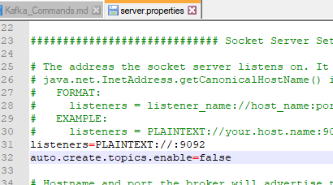

Number one is listener=PLAINTEXT://:9092. So this is the step where we are isolating the port number call Kafka broker and then I have this setup as auto.create.topics as false equal defaults. The reason I'm setting this as false is like I don't want to auto create any topics. So if we have the setup as true.

Basically what will happen is let's say you trying to produce a message to a off topic that doesn't exist. Then Kafka will automatically create for you. I would like to take the complete control of creating the topics so let's copy this one and then let's go back to the terminal in the terminal what I'm going to do. I'm going to navigate inside the config folder so the property file that we're going to edit this so not properties to have item installed in my machine.

$ kafka-server-start.bat C:\software\kafka_2.13-2.6.0\config\server.properties

[2020-12-18 15:23:59,852] INFO Registered kafka:type=kafka.Log4jController MBean (kafka.utils.Log4jControllerRegistration$)

[2020-12-18 15:24:00,185] INFO Setting -D jdk.tls.rejectClientInitiatedRenegotiation=true to disable client-initiated TLS renegotiation (org.apache.zookeeper.common.X509Util)

[2020-12-18 15:24:02,680] INFO [SocketServer brokerId=0] Started socket server acceptors and processors (kafka.network.SocketServer)

. . .

[2020-12-18 15:24:01,657] INFO [ThrottledChannelReaper-Fetch]: Starting (kafka.server.ClientQuotaManager$ThrottledChannelReaper)

[2020-12-18 15:24:01,657] INFO [ThrottledChannelReaper-Produce]: Starting (kafka.server.ClientQuotaManager$ThrottledChannelReaper)

[2020-12-18 15:24:01,660] INFO [ThrottledChannelReaper-Request]: Starting (kafka.server.ClientQuotaManager$ThrottledChannelReaper)

[2020-12-18 15:24:01,686] INFO Log directory C:\tmp\kafka-logs not found, creating it. (kafka.log.LogManager)

[2020-12-18 15:24:01,695] INFO Loading logs from log dirs ArraySeq(C:\tmp\kafka-logs) (kafka.log.LogManager)

[2020-12-18 15:24:01,697] INFO Attempting recovery for all logs in C:\tmp\kafka-logs since no clean shutdown file was found (kafka.log.LogManager)

[2020-12-18 15:24:01,703] INFO Loaded 0 logs in 8ms. (kafka.log.LogManager)

[2020-12-18 15:24:01,718] INFO Starting log cleanup with a period of 300000 ms. (kafka.log.LogManager)

[2020-12-18 15:24:01,720] INFO Starting log flusher with a default period of 9223372036854775807 ms. (kafka.log.LogManager)

[2020-12-18 15:24:02,146] INFO Awaiting socket connections on 0.0.0.0:9092. (kafka.network.Acceptor)

[2020-12-18 15:24:02,186] INFO [SocketServer brokerId=0] Created data-plane acceptor and processors for endpoint : ListenerName(PLAINTEXT) (kafka.network.SocketServer)

[2020-12-18 15:24:02,207] INFO [ExpirationReaper-0-Produce]: Starting (kafka.server.DelayedOperationPurgatory$ExpiredOperationReaper)

[2020-12-18 15:24:02,208] INFO [ExpirationReaper-0-DeleteRecords]: Starting (kafka.server.DelayedOperationPurgatory$ExpiredOperationReaper)

[2020-12-18 15:24:02,208] INFO [ExpirationReaper-0-Fetch]: Starting (kafka.server.DelayedOperationPurgatory$ExpiredOperationReaper)

[2020-12-18 15:24:02,209] INFO [ExpirationReaper-0-ElectLeader]: Starting (kafka.server.DelayedOperationPurgatory$ExpiredOperationReaper)

[2020-12-18 15:24:02,224] INFO [LogDirFailureHandler]: Starting (kafka.server.ReplicaManager$LogDirFailureHandler)

[2020-12-18 15:24:02,246] INFO Creating /brokers/ids/0 (is it secure? false) (kafka.zk.KafkaZkClient)

[2020-12-18 15:24:02,321] INFO Stat of the created znode at /brokers/ids/0 is: 24,24,1608285242265,1608285242265,1,0,0,72060703148146688,222,0,24

(kafka.zk.KafkaZkClient)

[2020-12-18 15:24:02,322] INFO Registered broker 0 at path /brokers/ids/0 with addresses: PLAINTEXT://DESKTOP-PEI24P3.mshome.net:9092, czxid (broker epoch): 24 (kafka.zk.KafkaZkClient)

[2020-12-18 15:24:02,456] INFO [ExpirationReaper-0-topic]: Starting (kafka.server.DelayedOperationPurgatory$ExpiredOperationReaper)

[2020-12-18 15:24:02,461] INFO [ExpirationReaper-0-Heartbeat]: Starting (kafka.server.DelayedOperationPurgatory$ExpiredOperationReaper)

[2020-12-18 15:24:02,462] INFO [ExpirationReaper-0-Rebalance]: Starting (kafka.server.DelayedOperationPurgatory$ExpiredOperationReaper)

[2020-12-18 15:24:02,482] INFO [GroupCoordinator 0]: Starting up. (kafka.coordinator.group.GroupCoordinator)

[2020-12-18 15:24:02,483] INFO [GroupCoordinator 0]: Startup complete. (kafka.coordinator.group.GroupCoordinator)

[2020-12-18 15:24:02,488] INFO [GroupMetadataManager brokerId=0] Removed 0 expired offsets in 5 milliseconds. (kafka.coordinator.group.GroupMetadataManager)

[2020-12-18 15:24:02,512] INFO Successfully created /controller_epoch with initial epoch 0 (kafka.zk.KafkaZkClient)

[2020-12-18 15:24:02,593] INFO [ProducerId Manager 0]: Acquired new producerId block (brokerId:0,blockStartProducerId:0,blockEndProducerId:999) by writing to Zk with path version 1 (kafka.coordinator.transaction.ProducerIdManager)

[2020-12-18 15:24:02,623] INFO [TransactionCoordinator id=0] Starting up. (kafka.coordinator.transaction.TransactionCoordinator)

[2020-12-18 15:24:02,624] INFO [TransactionCoordinator id=0] Startup complete. (kafka.coordinator.transaction.TransactionCoordinator)

[2020-12-18 15:24:02,624] INFO [Transaction Marker Channel Manager 0]: Starting (kafka.coordinator.transaction.TransactionMarkerChannelManager)

[2020-12-18 15:24:02,644] INFO [ExpirationReaper-0-AlterAcls]: Starting (kafka.server.DelayedOperationPurgatory$ExpiredOperationReaper)

[2020-12-18 15:24:02,665] INFO [/config/changes-event-process-thread]: Starting (kafka.common.ZkNodeChangeNotificationListener$ChangeEventProcessThread)

[2020-12-18 15:24:02,676] INFO [SocketServer brokerId=0] Starting socket server acceptors and processors (kafka.network.SocketServer)

[2020-12-18 15:24:02,680] INFO [SocketServer brokerId=0] Started data-plane acceptor and processor(s) for endpoint : ListenerName(PLAINTEXT) (kafka.network.SocketServer)

[2020-12-18 15:24:02,680] INFO [SocketServer brokerId=0] Started socket server acceptors and processors (kafka.network.SocketServer)

[2020-12-18 15:24:02,686] INFO Kafka version: 2.6.0 (org.apache.kafka.common.utils.AppInfoParser)

[2020-12-18 15:24:02,686] INFO Kafka commitId: 62abe01bee039651 (org.apache.kafka.common.utils.AppInfoParser)

[2020-12-18 15:24:02,688] INFO Kafka startTimeMs: 1608285242681 (org.apache.kafka.common.utils.AppInfoParser)

[2020-12-18 15:24:02,690] INFO [KafkaServer id=0] started (kafka.server.KafkaServer)

[2020-12-18 15:24:02,690] INFO [KafkaServer id=0] started (kafka.server.KafkaServer)

Open the file server.properties, I'm going to search for listeners. There you go. And in here I'm going to paste the value. I have provided a port for our broker so the broker id 0 and the port that this particular broker is going to run is 9092.

Now let's go back to the terminal. You have kafka-server-start.sh. And then we are providing the property file which is a file that we just modified. Copy this one now let's space the command that we copied. There we go. Basically this is going to start up the broker in your local as you can see Kafka id 0 started and you might have noticed some logs ran and the zookeeper instance still that's a signal there. The broker registered itself with the zookeeper.

|  |  |
| --- | --- |
| **server.properties**  broker.id=**0**  listeners=PLAINTEXT://:**9092**  auto.create.topics.enable=false  num.network.threads=3  num.io.threads=8  socket.send.buffer.bytes=102400  socket.receive.buffer.bytes=102400  socket.request.max.bytes=104857600  log.dirs=/tmp/kafka-logs-1  num.partitions=1  num.recovery.threads.per.data.dir=1  offsets.topic.replication.factor=1  transaction.state.log.replication.factor=1  transaction.state.log.min.isr=1  log.retention.hours=168  log.segment.bytes=1073741824  log.retention.check.interval.ms=300000  zookeeper.connect=localhost:2181  zookeeper.connection.timeout.ms=18000  group.initial.rebalance.delay.ms=0 | **server-01.properties**  broker.id=**1**  listeners=PLAINTEXT://:**9093**  auto.create.topics.enable=false  num.network.threads=3  num.io.threads=8  socket.send.buffer.bytes=102400  socket.receive.buffer.bytes=102400  socket.request.max.bytes=104857600  log.dirs=/tmp/kafka-logs-1  num.partitions=1  num.recovery.threads.per.data.dir=1  offsets.topic.replication.factor=1  transaction.state.log.replication.factor=1  transaction.state.log.min.isr=1  log.retention.hours=168  log.segment.bytes=1073741824  log.retention.check.interval.ms=300000  zookeeper.connect=localhost:2181  zookeeper.connection.timeout.ms=18000  group.initial.rebalance.delay.ms=0 |

There is also the server-02.properties for another Kafka broker to be run which is broker.id=2 ... and on port 9094

If you get this error

The Cluster ID 9fzS4JfcTIqnv03f-TmCHg doesn't match stored clusterId Some(PQxwF4vBTWaAAJw7IXktZw) in meta.properties. The broker is trying to join the wrong cluster. Configured zookeeper.connect may be wrong.

at kafka.server.KafkaServer.startup(KafkaServer.scala:218)

at kafka.Kafka$.main(Kafka.scala:109)

at kafka.Kafka.main(Kafka.scala)

Make sure the log.dir is correct, point it to the right location in the server-0, server-1, server-2 properties file

log.dirs=C://software/kafka-logs/server-0

**Topic and Messages**

Make sure that you have the zookeeper and the Kafka broker instance up and running in your local. The command that we are going to use kafka-topics.bat. So there is a handy shell script just for creating the topic. So we are going to use the Kafka topic shell script and after that we are going to provide the necessary parameters to that particular shell script. We provide the topic name and then it will provide the zookeeper instance. So normally when you provide a create topic command the command will be directed to the zookeeper instance. From the zookeeper it takes care of redirecting the request to broker and after that we have a new attribute called replication factor. For now we are going to provide the value was one because we just have only one broker running an machine. And after that I am passing the number of partitions as 4. So what we will do. Let's copy this and I'm going to go back to the terminal in the terminal. I'm in the bin dreictory.

$ **kafka-topics.bat**

--create

--topic test-topic

--zookeeper localhost:2181

--replication-factor 1

--partitions 4

Created topic test-topic.

The topic got created successfully. Now we are going to start producing and consuming the messages. Let's instantiate a console producer. So we have a handy script called kafka-console-producer.sh script and for that one we should provide the broker list as a parameter and followed by that we are going to provide the topic so we have two options here.

**How to create a topic ?**

./kafka-topics.sh

--create

--topic test-topic

--zookeeper localhost:2181

--replication-factor 1

--partitions 4

**## How to instantiate a Console Producer?**

**### Without Key**

./kafka-console-producer.sh

--broker-list localhost:9092

--topic test-topic

**### With Key**

./kafka-console-producer.sh

--broker-list localhost:9092

--topic test-topic

--property "key.separator=-" --property "parse.key=true"

C:\> kafka-console-producer.bat

--broker-list localhost:9092

--topic test-topic

>Hello, Message 1

>Hi, Message 2

>Hey, Message 3

>Howdy, Message 4

>

One is without key and one is with the key. For now copy this one without key. So I'm going to just collapse that one. Post this and that's a signal the Kafka console producers successfully instantiate it. Know what I'm going to do. I'm going to be some messages one. Hi. Hello. Hello. Kafka. So we have four messages successfully posted to the testtopic and it is waiting to be consumed. The next step is we are going to instantiate a console consumer.

**## How to instantiate a Console Consumer?**

**### Without Key**

./kafka-console-consumer.sh --bootstrap-server localhost:9092

--topic test-topic

--from-beginning

**### With Key**

./kafka-console-consumer.sh --bootstrap-server localhost:9092

--topic test-topic

--from-beginning

--property **"key.separator= - "**

--property **"print.key=true"**

c:\> kafka-console-consumer.bat --bootstrap-server localhost:9092

--topic test-topic

--from-beginning

Hello, Message 1

Hey, Message 3

Howdy, Message 4

Hi, Message 2

One is without key and one is with the key, lets use the one without key for now. We provide the bootstrap server. Basically this is the server in which our Kafka broker is up and running. And after that we provide the topic and I'm going to give it the option as from being beginning the meaning of this one is that I read all the messages from the beginning. As you can see it read all the messages. These are the messages that have posted the back. For some reason it is still sitting there. Now what I'm going to do I'm going to post some new messages like a real and probably the cause so far as you produce messages these are consumed by the consumer. So we have a producer and consumer successfully running an our machine as you produce messages. The consumer is able to pick it up and processed those messages. The processing here is just too. Printed in the console. No I'm going to show you a quick difference.

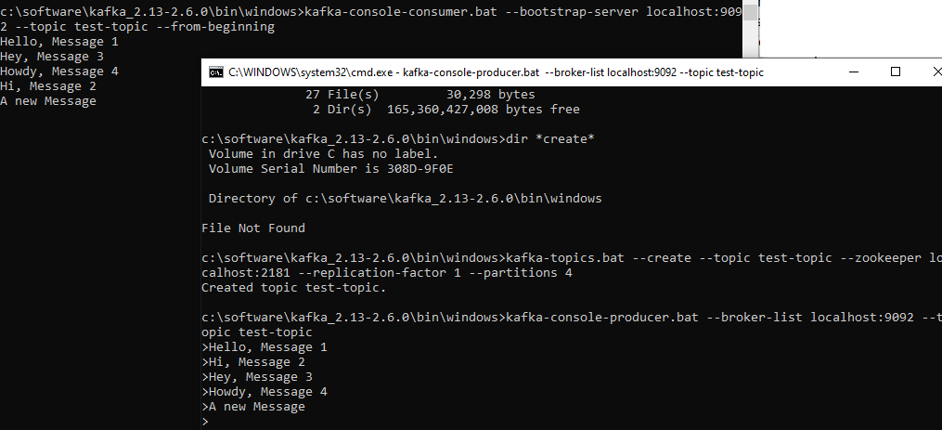

If I do not provide this from beginning what would happen basically it is not going to read the messages that are already posted earlier. But as you post new messages it's going to read this one as I posted 2 3 4. But if you look at it, it is coming in a different order here. So it is getting posted to different partitions. That's one of the reason you see messages are coming in different order.

So if you want ordering you have to make sure you're going to post to the same partition. So for ordering you need to pass the same key if you pass the same key then the messages will be retrieved in the same order. I will show that technique in the next lecture.

We will now see the properties that are part of the Kafka message. Any Kafka message that's sent from the producer has two properties key and value key. Key is an optional property and value is mandatory.

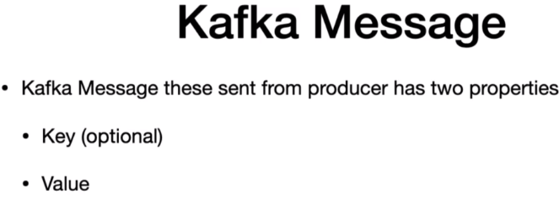

Until now we have seen examples of just sending the value. Let me quickly show you the behavior without the key. First let's say I have a use case where I would like to publish all the records. Start with the same character should go to the same partition so that the consumer can read the messages in the order they will publish to the topic. This is a pretty common requirement today for any application to read the messages in the order they were published to the message broker. If we can't recall from one of the previous lectures I had clearly mentioned that ordering is only guaranteed within the partition level.

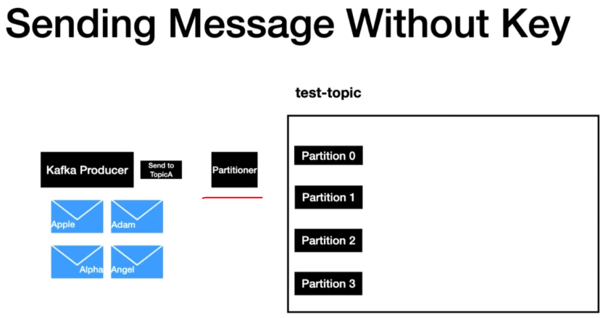

In this example we have four messages Apple, Adam, Alpha and Angel. I want all the messages to go to the same partition. When the producers invoke for sending the messages, it goes through a lot of layers behind the scenes before the messages are sent to Kafka. One of the layer is a partition. It will deep dive into the different layers beneath the Kafka producers when we start coding Kafka Producer.

The partitions first checks whether a key is present as part of the message or not. In this example we are not sending any key. So in this case the partitioner will use the round robin approach to send a message across all the partitions. So now Apple goes through partition zero item goes through partition 1, alpha goes through partition 2 and angel goes through partition 3. As you can see all the messages are distributed across all the partitions in this approach. There is no guarantee the consumer will be able to read the messages in the same order because consumer pulls the messages from all the partitions at the same time. This is what happened in our previous lecture. The console consumer did not read the message in the order they reproduce.

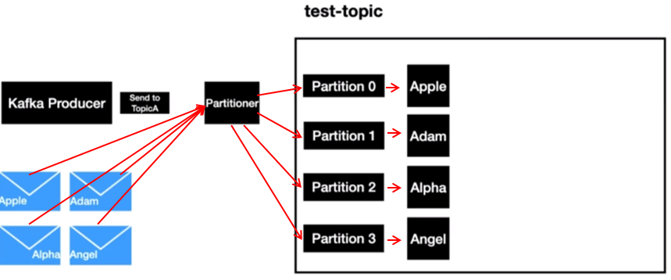

Now it's time to look at the behaviour that key as you can see in the slide. All the messages here has a key.

A key can be of any type. In this example we are using the string then a message is sent the Kafka partitioner which is part of the Kafka producer is going to apply some hashing technique to determine the partition value. So here we have the key A and its going to apply some kind of partitioning technique meaning the hashing technique and what it is going to do it is going to resolve to partition zero. If the same key is sent because the key is the same for both the messages right. So in that case it is going to result to the same partition. So in that case it's going to go to partition zero. The same is going to be applied for the following messages but the same key as you can see that all the messages went into partition zero.

Now in order to add some differences we have another set of messages and the key is B in that case the partition or is going to resolve that to go to partition one and the same is applicable for all other keys here in this slide. I just showed you. Key goes through partition 0 and B goes through partition 1 and so on. But in reality key a can go to one of the available partitions of the topic based on the hashing technique. But one thing to keep in our mind.

Same key always results to the same partition.

Let's quickly take this in our local machine. I'm in the bin directory of my Kafka distribution. There is a handy command that comes with Kafka console producer and consumer using which we can produce messages with the key and we can consume the message with the key.

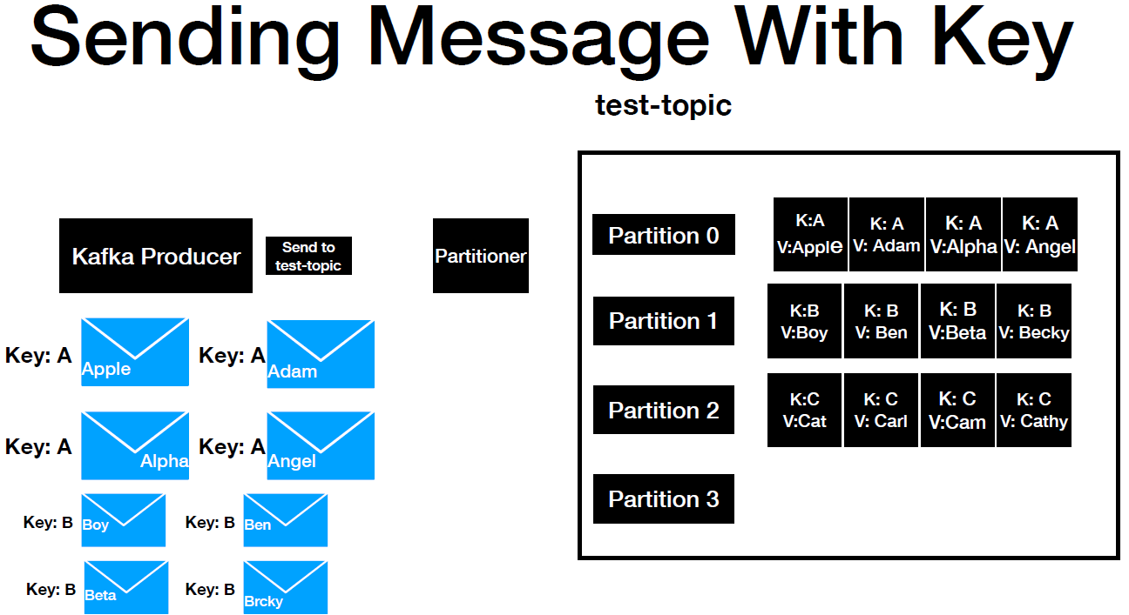

So the command if we look at it it is the same as the third key but there are two additional properties that we are passing as part of the console. Producer number one is a key separator which is equal to iPhone. That's what we are using here and number two is passkey equal neutral. When you parse these two parameters the console producer is going to read the key and then produce a message with the key. Let's copy this one and then put it here. There you go.

So now we have a console producer which is going to take the key and value. So what I'm going to do I'm going to use the same values that we have used in our slide actually. So Apple Adam Alpha Angel. So we have four messages published into the Kafka topic. Now what we're going to do. We are going to instantiate a console consumer which is going to read the messages with the key. We have the command, almost the same except that we have two additional properties. Number one is key separator. This should match that the key that's being produced with. And then we are printing the key also to the console. So if we do not provide this the key won't get printed.

Producer ( Message with Key )

kafka-console-producer.sh --broker-list localhost:9092

--topic test-topic

--property "key.separator=-"

--property "parse.key=true"

Consumer ( Message with Key )

kafka-console-consumer.sh --bootstrap-server localhost:9092

--topic test-topic

--from-beginning

--property "key.separator=-"

--property "print.key=true"

The expectation is that all the messages should be printed in the order that there should actually go. And if you look at it we have lots and lots of messages. But if you look at it these four messages these four missing messages matches the order in which they will produce. If you take a look at it for fruits are four items with same key and others are with same key. And the reason why it is coming in different order is because these are totally different partitions but if you look at these four messages they are in the order that they were produced. So this completes a demonstration of difference between sending a message with key and without key.

Consumer Producer

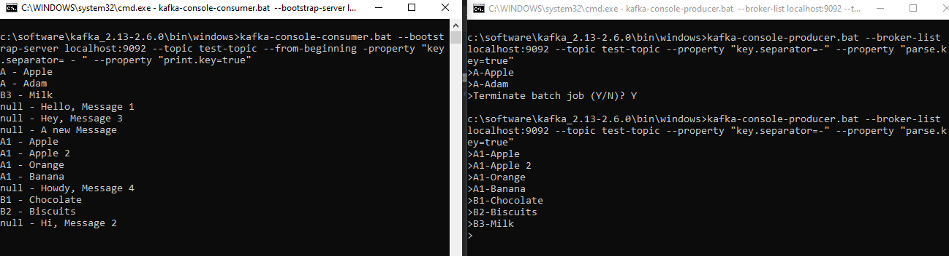

**Consumer Offsets**

Any message that's produced into the topic will have a **unique** **ID** **called** **offset**. Consumers have three options when it comes to reading the messages from the topic. They can read the messages from the beginning using the **--from-beginning** option, **latest** meaning read only the messages that's going to come after the consumers spun up, **specific offset** - meaning read the messages in the topic by passing a specific offset value from the consumer. This option can only be done programmatically so if you are building a consumer you have all these options when you start your consumer.

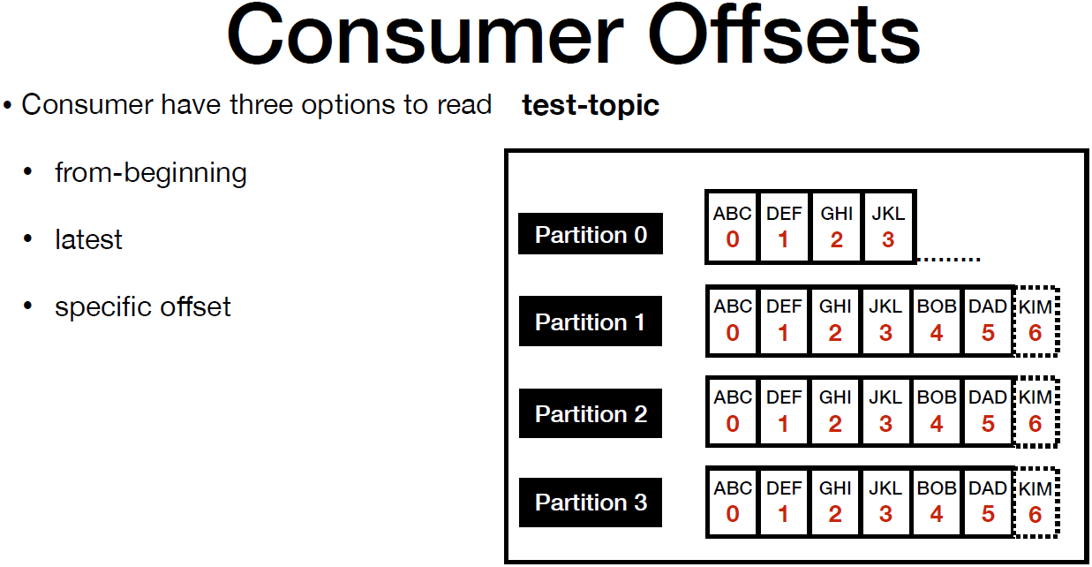

The first two options can be explored using the console consumer itself in this example just to keep it simple. I just have one partition and it has some records in it. Let's say you have a consumer which is going to read the message from the beginning. For any Kafka consumer it is required for the consumer to provide the group. I will explain about the significance of gr443

oup i.e. in the next lecture. Now the consumer in general pause and retrieves multiple records at the same time, as it process each message. It moves the consumer read offset one by one let's say for some reason the consumer is crashed. While the consumer was down. The producer of the topic produced some more messages. Now the consumer is brought up after some time. How does it know that it needs to read from offset for the consumer offset in general are stored in an internal topic called --consumer offset. Please bear with me as I'm going to repeat the same thing again. So in here we are going to read the messages from the beginning so it starts from offset zero and it proceeds one by one.

Once all the poll records are read the consumer commits the offset to the topic called --consumer-offsets topic with the group i.e. now the consumer goes down and new records are produced to the topic. In the meantime so it is brought up after some time now the consumer knows where to start reading the messages in the topic using the information that's available and the consumer offsets topic with a group. In a nutshell the consumer offsets behave like a bookmark for the consumers to go and check from which point in the topic it needs to read the messages from.

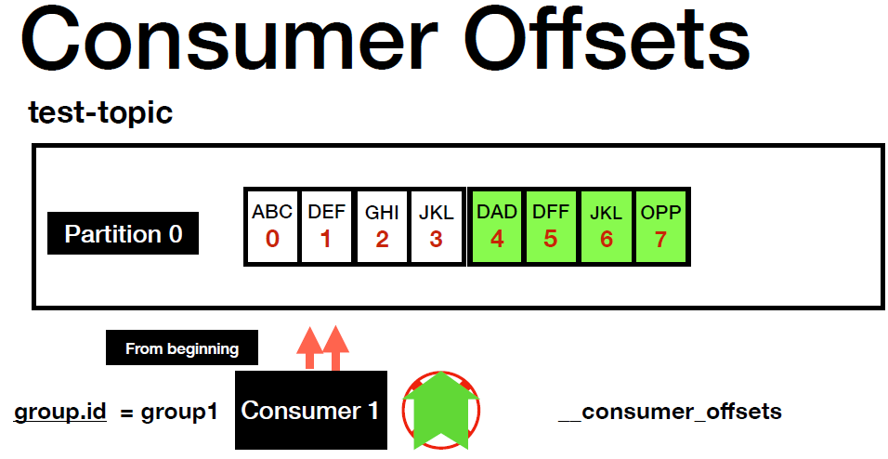

Now what I'll do is I'll go ahead and show you whether we have an internal topic which is --consumer offset in our local broker that is running in our machine for that purpose. I'm going to go to the terminal from the terminal. We are going to run a command. This is a handy command that you can run which is going to list all the topics that you have in your broker. So I have the command already. Now let's explore this.

**## List the topics in a cluster**

$ kafka-topics.bat --zookeeper localhost:2181 --list

$ kafka-topics.bat --zookeeper localhost:2181 --list

__consumer_offsets

test-topic

If we go here the first command which just lists the topics in the cluster. Number one is --consumer offset offsets. This is a topic which was auto created by the broker and this is a topic which takes care of maintaining the consumer offsets for you. Number two is this topic. This is a topic that we created.

**Consumer Groups**

In the previous lecture I have introduced you to group id, being a mandatory attribute to start up a consumer. But we did not talk about the significance offered. The group ID plays a major role when it comes to scalable message consumption. What do we exactly mean by that. Let me quickly explain that using an example. Let's say we have a topic here named test-topic and it has four partitions. Now we have a consumer ready with a group i.e. group one we have one single consumer polling all the four partitions in the topic and processing them the pull up is always single threaded. So in this case a single thread is going to pull from all the partitions.

* Let's say the producer of the topic is going to produce messages at a faster rate than the consumer processing rate. Then in that case it will introduce a lag in the consumer. And you might end up not processing the events real time. This is where consumer groups come in handy.

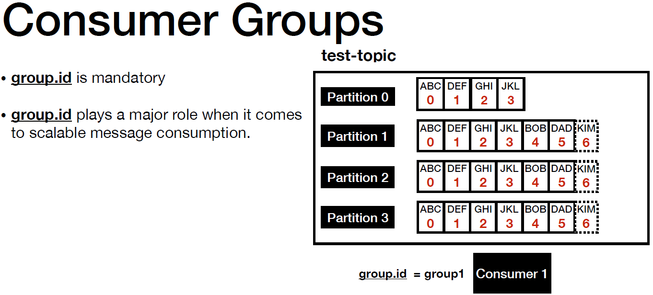

Now let's say we spun up another instance of consumer but make sure you are using the same group ID, now the partitions are split between the two instances of the consumer partition zero on partition one is taken care by the first instance and partition 2 and partition 3 is taken care by the second instance. Basically what this means is that we have a scale of message consumption. This will help process the records a little faster than it was before. Let's make it make it much better by spinning up two more instances.

* So we have four instances of consumer A application but the group IDs is same across all the different instances that we have. At any given point you are going to process four records parallely. So the consumer groups are fundamentally the basis for a scalable message consumption.

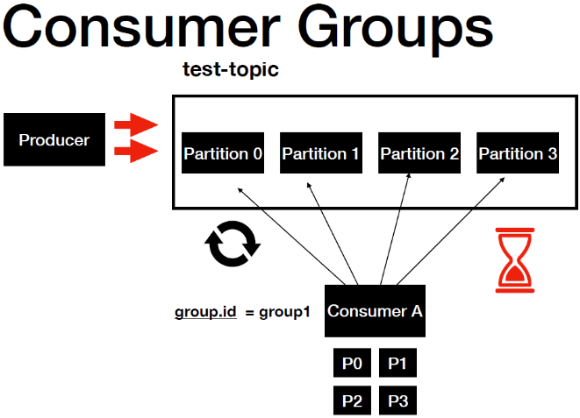 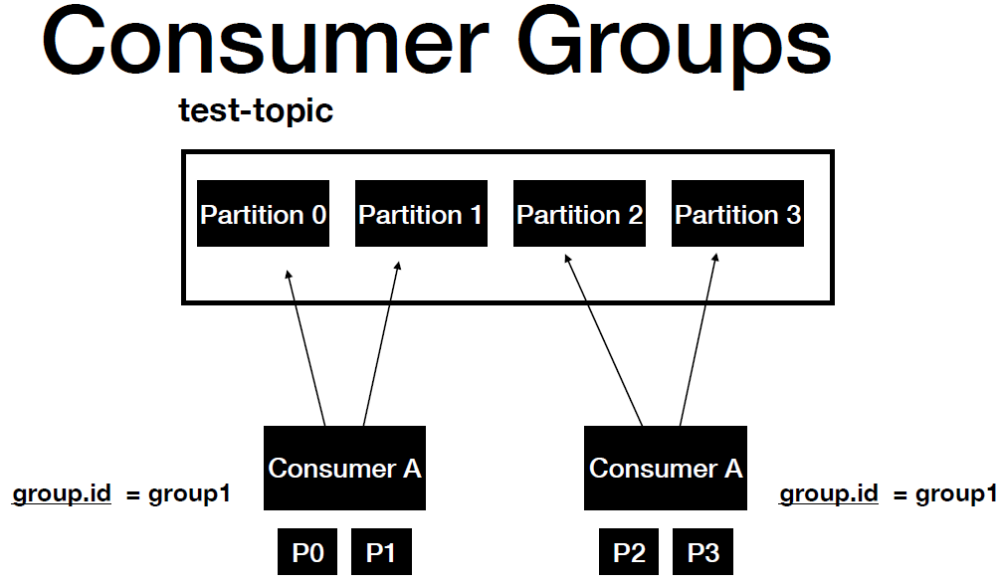

* Now let's say you have five consumer instances but only four partitions are available for a given topic. In that case one of the instance will be idle as I have mentioned before the consumer pool is single threaded. So in this case this will lead to inefficient use of resources.

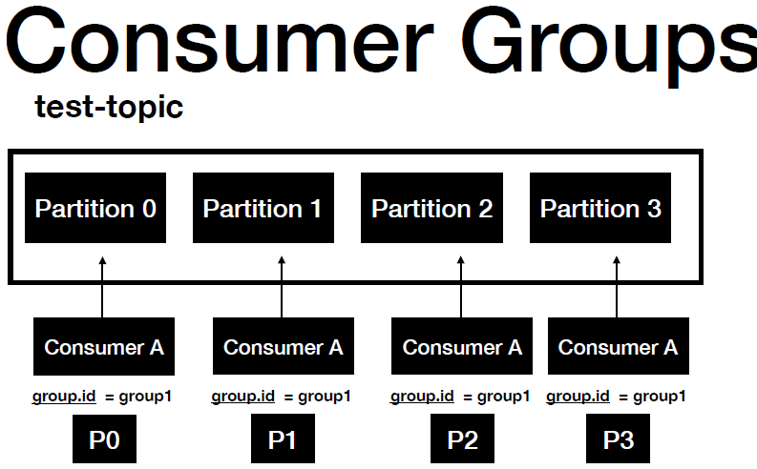 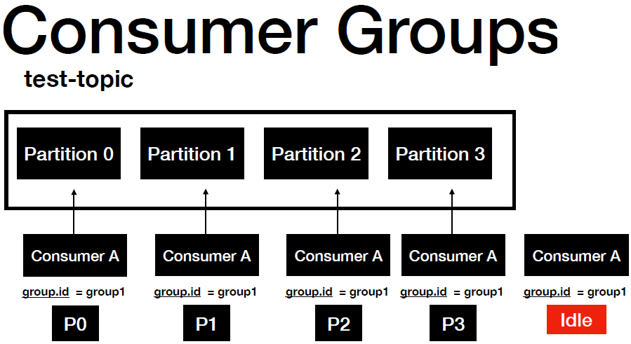

|  |  |
| --- | --- |
| Let me highlight the second common usage of consumer groups. Let's say you have two different applications for the same Kafka topic. This is a pretty common scenario in an enterprise. Each consumer app will have their own processing logic. Each app can have a different number of instances based on their equipment. In this example we have four instances of the consumer A application with a group ID one and two instances of the Consumer B app with a group ID two.  But the teams have to make sure they are not using the same group ID. That's the reason why you see the group IDs unique between the application. So the fact is that it is up to the team to decide on how many number of instances they want. Let me quickly summarize what we have learned so far. |  |

* Consumer groups are used far scalable message consumption. Different applications will need to have a unique group i.e. you might be having discussions running in your mind who manages the consumer group then.
* It is the Kafka broker which manages the consumer group. Basically the Kafka broker also acts as a group coordinator.

Let me quickly demonstrate the consumer groups in our local machine. I'm going to go to the terminal. I'm in the bin directory of the Kafka distribution. Now I'm going to run a handy command that's going to list the consumer groups that's in your local machine.

C:\> kafka-consumer-groups.bat --bootstrap-server localhost:9092 --list

console-consumer-57392

This is a command called how to view consumer groups. And it uses a script Kafka consumer groups or such and then you possibly bootstrap server and then I find a full list. It give me the group ideas console consumer 72239. This is a group ID that gets generated automatically for you whenever you run a console consumer instance in your machine. I will quickly show you that. Now I'm going to run the console consumer command. So now I have one more instance of the Kafka console consumer that is up and running in my machine. I'm going to shut it down now if I run this command. You will have one more entry in this one actually. There you go. So 72239 was the previous one. Now you see this right. 19595. So when you use a console consumer the group ID is automatically generated for you behind the scenes.

$ kafka-console-consumer.bat --bootstrap-server localhost:9092

--topic test-topic

--from-beginning

Apple

Adam

Milk

Hello, Message 1

Hey, Message 3

A new Message

Apple

Apple 2

Orange

Banana

Howdy, Message 4

Chocolate

Biscuits

Hi, Message 2

$ kafka-consumer-groups.bat --bootstrap-server localhost:9092 --list

console-consumer-14521

console-consumer-57392

* Let's say you're building a couple consumer through code. You want to interact with the Kafka topic. In that case it is mandatory for you to provide the group ID.

Now what I'm going to do as I'm going to instantiate a Kafka console consumer with the group. There is a handy command for that. The consumer group. So all the parameters are the same. But towards the end you have the --group. So now we have a Kafka console consumer instance which is up and running in our machine with a group of 80. I'm going to create one more window. Run the same thing. There you go. Let me zoom this a little bit. And then let's go inside the bin directory and give this.

$ kafka-console-consumer.bat --bootstrap-server localhost:9092

--topic test-topic

--group 80

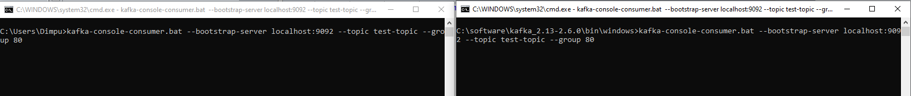

So now we have two instances of the Kafka console consumer with the same group getting up and running and the expectation is that this will have two partitions are saying do it. This will have two partitions are seeing to it because we are using the same topic when we created the this topic we gave four partitions.

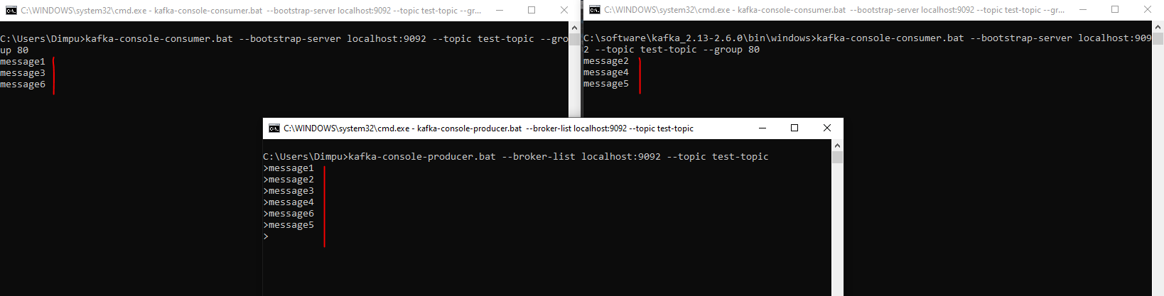

Now what I'm going to do I'm going to instantiate a console producer. Lets run this, so I'm going to start producing the messages one two three four. So I have produced four messages. As you can see 1 and 4 are present in this Kafka console consumer instance 2 and 3 is present in this one. And basically they are having the partitions split between these two instances of the console consumer I believe this lecture give you all a pretty good idea both console consumer.

Consumer Groups : Summary

* Consumer Groups are used for **scalable message consumption**
* Each different application will have a unique consumer group
* Kafka Broker manages the consumer-groups
* Kafka Broker acts as a Group Co-ordinator

**Commit Log, Retention Policy**

* One of the key qualities of Kafka is the concept of retaining the record for a certain period of time.

But how does it work. Let's quickly look at it using an example saying here we have the Kafka broker topic producer and consumer. When the producer sends a message it first reaches the topic and then the very next thing that happens is that the record gets returned to a file system in the machine. So the file system is where the Kafka broker is installed. In this example it is our local machine.

* The record is always written in the file system as bytes, the file system where that file needs to be written is configured using the log.days property the property is available in the server that properties file. I'll show you that in a bit it creates a file with the extension of .log as you can see we have numerous zeros followed by that .log.
* Each partition will have its own log actually, meaning if we have four partitions then you will have four log files in the file system. That's why these log files are otherwise called as partitioned comment log after the messages are written into the log file. That's when the records that got produced are committed.

So when the consumer who is continuously pulling for new records can we only see there records that are committed to the file system. As new records are published on the topic then the records get added to the log file. And the process continues. So this was all about at log.

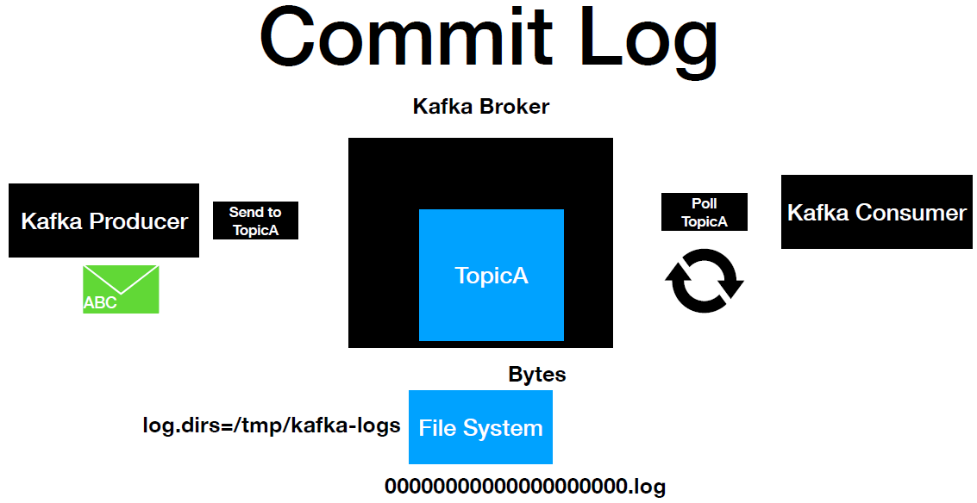

* Now it's time to introduce you to retention policy. Retention policy is one of the key properties that's going to determine how long the message is going to be retained. Retention policy is configured using the logged out retention.hours property which resides inside the server.properties file.
* The default retention period is 168 Hours which is nothing but seven days.

Retention Policy

* Determines how long the message is retained ?
* Configured using the property log.retention.hoursin server.propertiesfile
* Default retention period is 168hours( 7 days )

Now it's time to go ahead and verify these properties in the **server.properties** file. So I'm in the base part of the Kafka distribution. If you do a ls we have been config, libs, logs and site-docs. Let's navigate inside the config territory. You have a bunch of properties, the property that we are going to look at is in the server.properties We have several properties here. So this is a directory where all the Kafka logs are written into the local machine.

**server.properties**

# Licensed to the Apache Software Foundation (ASF) under one or more

# contributor license agreements. See the NOTICE file distributed with

# this work for additional information regarding copyright ownership.

# The ASF licenses this file to You under the Apache License, Version 2.0

# (the "License"); you may not use this file except in compliance with

# the License. You may obtain a copy of the License at

#

# http://www.apache.org/licenses/LICENSE-2.0

#

# Unless required by applicable law or agreed to in writing, software

# distributed under the License is distributed on an "AS IS" BASIS,

# WITHOUT WARRANTIES OR CONDITIONS OF ANY KIND, either express or implied.

# See the License for the specific language governing permissions and

# limitations under the License.

# see kafka.server.KafkaConfig for additional details and defaults

############################# Server Basics #############################

# The id of the broker. This must be set to a unique integer for each broker.

broker.id=0

############################# Socket Server Settings #############################

# The address the socket server listens on. It will get the value returned from

# java.net.InetAddress.getCanonicalHostName() if not configured.

# FORMAT:

# listeners = listener_name://host_name:port

# EXAMPLE:

# listeners = PLAINTEXT://your.host.name:9092

listeners=PLAINTEXT://:9092

auto.create.topics.enable=false

# Hostname and port the broker will advertise to producers and consumers. If not set,

# it uses the value for "listeners" if configured. Otherwise, it will use the value

# returned from java.net.InetAddress.getCanonicalHostName().

#advertised.listeners=PLAINTEXT://your.host.name:9092

# Maps listener names to security protocols, the default is for them to be the same. See the config documentation for more details

#listener.security.protocol.map=PLAINTEXT:PLAINTEXT,SSL:SSL,SASL_PLAINTEXT:SASL_PLAINTEXT,SASL_SSL:SASL_SSL

# The number of threads that server uses for receiving requests from network and sending responses to the network

num.network.threads=3

# The number of threads that the server uses for processing requests, which may include disk I/O

num.io.threads=8

# The send buffer (SO_SNDBUF) used by the socket server

socket.send.buffer.bytes=102400

# The receive buffer (SO_RCVBUF) used by the socket server

socket.receive.buffer.bytes=102400

# The maximum size of a request that the socket server will accept (protection against OOM)

socket.request.max.bytes=104857600

############################# Log Basics #############################

# A comma separated list of directories under which to store log files

log.dirs=/tmp/kafka-logs

# The default number of log partitions per topic. More partitions allow greater

# parallelism for consumption, but this will also result in more files across

# the brokers.

num.partitions=1

# The number of threads per data directory to be used for log recovery at startup and flushing at shutdown.

# This value is recommended to be increased for installations with data dirs located in RAID array.

**num.recovery.threads.per.data.dir=1**

############################# Internal Topic Settings #############################

# The replication factor for the group metadata internal topics "__consumer_offsets" and "__transaction_state"

# For anything other than development testing, a value greater than 1 is recommended to ensure availability such as 3.

offsets.topic.replication.factor=1

transaction.state.log.replication.factor=1

transaction.state.log.min.isr=1

############################# Log Flush Policy #############################

# Messages are immediately written to the filesystem but by default we only fsync() to sync

# the OS cache lazily. The following configurations control the flush of data to disk.

# There are a few important trade-offs here:

# 1. Durability: Unflushed data may be lost if you are not using replication.

# 2. Latency: Very large flush intervals may lead to latency spikes when the flush does occur as there will be a lot of data to flush.

# 3. Throughput: The flush is generally the most expensive operation, and a small flush interval may lead to excessive seeks.

# The settings below allow one to configure the flush policy to flush data after a period of time or

# every N messages (or both). This can be done globally and overridden on a per-topic basis.

# The number of messages to accept before forcing a flush of data to disk

#log.flush.interval.messages=10000

# The maximum amount of time a message can sit in a log before we force a flush

#log.flush.interval.ms=1000

############################# Log Retention Policy #############################

# The following configurations control the disposal of log segments. The policy can

# be set to delete segments after a period of time, or after a given size has accumulated.

# A segment will be deleted whenever *either* of these criteria are met. Deletion always happens

# from the end of the log.

# The minimum age of a log file to be eligible for deletion due to age

log.retention.hours=168

# A size-based retention policy for logs. Segments are pruned from the log unless the remaining

# segments drop below log.retention.bytes. Functions independently of log.retention.hours.

#log.retention.bytes=1073741824

# The maximum size of a log segment file. When this size is reached a new log segment will be created.

log.segment.bytes=1073741824

# The interval at which log segments are checked to see if they can be deleted according

# to the retention policies

log.retention.check.interval.ms=300000

############################# Zookeeper #############################

# Zookeeper connection string (see zookeeper docs for details).

# This is a comma separated host:port pairs, each corresponding to a zk

# server. e.g. "127.0.0.1:3000,127.0.0.1:3001,127.0.0.1:3002".

# You can also append an optional chroot string to the urls to specify the

# root directory for all kafka znodes.

zookeeper.connect=localhost:2181

# Timeout in ms for connecting to zookeeper

zookeeper.connection.timeout.ms=18000

############################# Group Coordinator Settings #############################

# The following configuration specifies the time, in milliseconds, that the GroupCoordinator will delay the initial consumer rebalance.

# The rebalance will be further delayed by the value of group.initial.rebalance.delay.ms as new members join the group, up to a maximum of max.poll.interval.ms.

# The default value for this is 3 seconds.

# We override this to 0 here as it makes for a better out-of-the-box experience for development and testing.

# However, in production environments the default value of 3 seconds is more suitable as this will help to avoid unnecessary, and potentially expensive, rebalances during application startup.

group.initial.rebalance.delay.ms=0

So this is the directory where all the partition logs are written. So each and every partition will have a folder created here. If you take a look at it, we have been using this topic right. So this topic when we created we have full folders we start with 0123, each folder represents a partition and you see this consumer offsets. This is a topic which got created for us automatically for maintaining the consumer offsets.

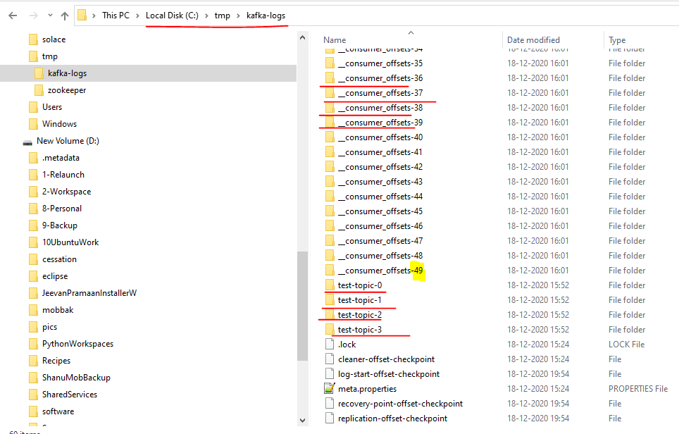

And it has the value until forty nine. That means this consumer offset topic has 50 partitions. Now what we will do is we will navigate into one of the directory and look at the content. Let's do this topic. I found zero and then if we do a loss you have a bunch of different files but the file that you're going to focus on is this log file. And if you take a look at it as I mentioned all the data that is written into this file will be converted into bytes and then it is written into this file. And if you take a look at it. Hello you see Hello right. Hello is a content that we have produced to this particular petition.

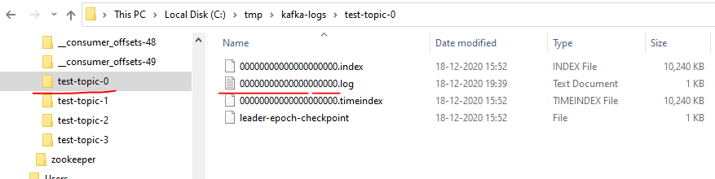

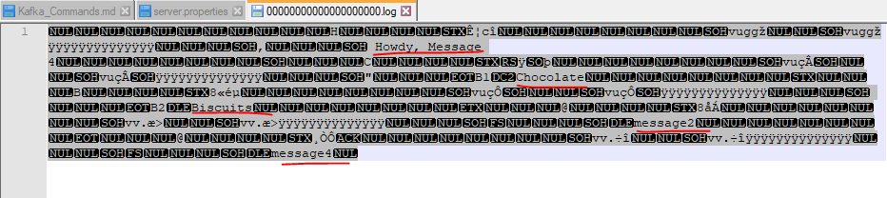

Now if you want to take a look at some other folders let's do that. Let's do lists and then see. Let's navigate into this one to clear it. So let's do a close and the log file at the same log file. Let's do that. As you can see we began view like hello Kafka. And do we have anything else that's really visible. I think one might be on the message that we produced into this Kafka topic. So this is the content which is present inside the Kafka partition log but there are many more information that is available as part of this log in order to view those.

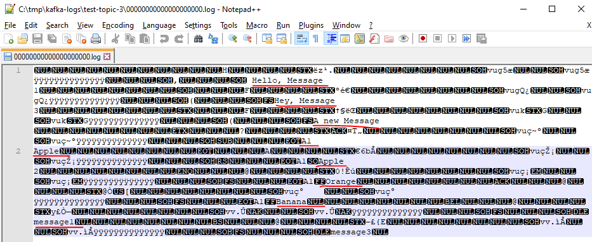

There is a command.

**## Viewing the Commit Log**

kafka-run-class.bat kafka.tools.DumpLogSegments

--deep-iteration

--files /tmp/kafka-logs/test-topic-0/00000000000000000000.log

C:\Users\Dimpu>kafka-run-class.bat kafka.tools.DumpLogSegments --deep-iteration --files /tmp/kafka-logs/test-topic-0/00000000000000000000.log

Dumping \tmp\kafka-logs\test-topic-0\00000000000000000000.log

Starting offset: 0

baseOffset: 0 lastOffset: 0 count: 1 baseSequence: -1 lastSequence: -1 producerId: -1 producerEpoch: -1 partitionLeaderEpoch: 0 isTransactional: false isControl: false position: 0 CreateTime: 1608287479710 size: 84 magic: 2 compresscodec: NONE crc: 3399902190 isvalid: true

| offset: 0 CreateTime: 1608287479710 keysize: -1 valuesize: 16 sequence: -1 headerKeys: []

baseOffset: 1 lastOffset: 1 count: 1 baseSequence: -1 lastSequence: -1 producerId: -1 producerEpoch: -1 partitionLeaderEpoch: 0 isTransactional: false isControl: false position: 84 CreateTime: 1608295891457 size: 79 magic: 2 compresscodec: NONE crc: 520031998 isvalid: true

| offset: 1 CreateTime: 1608295891457 keysize: 2 valuesize: 9 sequence: -1 headerKeys: []

baseOffset: 2 lastOffset: 2 count: 1 baseSequence: -1 lastSequence: -1 producerId: -1 producerEpoch: -1 partitionLeaderEpoch: 0 isTransactional: false isControl: false position: 163 CreateTime: 1608295896065 size: 78 magic: 2 compresscodec: NONE crc: 950790581 isvalid: true

| offset: 2 CreateTime: 1608295896065 keysize: 2 valuesize: 8 sequence: -1 headerKeys: []

baseOffset: 3 lastOffset: 3 count: 1 baseSequence: -1 lastSequence: -1 producerId: -1 producerEpoch: -1 partitionLeaderEpoch: 0 isTransactional: false isControl: false position: 241 CreateTime: 1608300553790 size: 76 magic: 2 compresscodec: NONE crc: 2402870721 isvalid: true

| offset: 3 CreateTime: 1608300553790 keysize: -1 valuesize: 8 sequence: -1 headerKeys: []

baseOffset: 4 lastOffset: 4 count: 1 baseSequence: -1 lastSequence: -1 producerId: -1 producerEpoch: -1 partitionLeaderEpoch: 0 isTransactional: false isControl: false position: 317 CreateTime: 1608300558318 size: 76 magic: 2 compresscodec: NONE crc: 3100824582 isvalid: true

| offset: 4 CreateTime: 1608300558318 keysize: -1 valuesize: 8 sequence: -1 headerKeys: []

So it gave you and gave you a bunch of different results. I'm going to search for as you can see the offset value started with a zero and then it is continuously incrementing you can zero one two three and four. This means this particular partition log has five records but it doesn't display the actual value that is present inside the partition log but it gives you a lot of different attributes. Number one is created time and the key sites where these records are produced with any key and the value says what is a value and a lot more information which as a developer we don't have to worry about. I believe you guys have a pretty good idea about how partition log looks like now it's time to go ahead and look at the retention policy properties.

In **server.properties**

############################# Log Retention Policy #############################

# The following configurations control the disposal of log segments. The policy can

# be set to delete segments after a period of time, or after a given size has accumulated.

# A segment will be deleted whenever *either* of these criteria are met. Deletion always happens

# from the end of the log.

# The minimum age of a log file to be eligible for deletion due to age

log.retention.hours**=168**

# The interval at which log segments are checked to see if they can be deleted according

# to the retention policies

log.retention.check.interval.ms**=300000**

# A size-based retention policy for logs. Segments are pruned from the log unless the remaining

# segments drop below log.retention.bytes. Functions independently of log.retention.hours.

#log.retention.bytes=1073741824

# The maximum size of a log segment file. When this size is reached a new log segment will be created.

log.segment.bytes**=1073741824**

Now it's time to go back to item in here. If you search for log dot it's going to give you a bunch of results. But in here we are going to focus on this one. So this is the retention period that gets that comes with Kafka by default. If you take a look at it it is 168. And the actual metric is ours. So 168 hours i.e. seven days and then you have different log segment, bytes log retention check interval. So this is going to check whether the log retention times exceeded if it is exceeded then it's going to delete the data from that log. I believe this lecture I'll give you all a pretty good idea both come at log and retention policy.

**Processing Guarantees in Kafka**

<https://medium.com/@andy.bryant/processing-guarantees-in-kafka-12dd2e30be0e>

Each of the projects I’ve worked on in the last few years has involved a distributed message system such as AWS SQS, AWS Kinesis and more often than not Apache Kafka. In designing these systems, we invariably need to consider questions such as:

How do we guarantee all messages are processed?

How do we avoid or handle duplicate messages?

These simple questions are surprisingly hard to answer. To do so, we need to delve into how producers and consumers interact with distributed messaging systems. In this post I’ll be looking at message processing guarantees and the implications these have when designing and building systems around distributed messages systems. I will be specifically concentrating on the Apache Kafka platform as it’s such a popular choice and the one I am most familiar with.

To start with, let’s look at the basic architecture of a distributed message system.

A producer process reads from some data source which may or may not be local, then writes to the messaging system over the network. The messaging system persists the message, typically in multiple locations for redundancy. One or more consumers poll the messaging system over the network, receive batches of new messages and perform some action on these messages, often transforming the data and writing to some other remote data store, possibly back to the messaging system. This basic design applies to Apache Kafka, Apache Pulsar, AWS Kinesis, AWS SQS, Google Cloud Pub/Sub and Azure Event Hubs among others.

If you read the documentation for any of these systems, you will fairly quickly come across the concept of message processing guarantees. These fall under the following categories:

**No guarantee** — No explicit guarantee is provided, so consumers may process messages once, multiple times or never at all.

**At most once** — This is “best effort” delivery semantics. Consumers will receive and process messages exactly once or not at all.

**At least once** — Consumers will receive and process every message, but they may process the same message more than once.

**Effectively once** — Also contentiously known as exactly once, this promises consumers will process every message once.

At this point, you may be asking why is this so complicated? Why isn’t it always effectively once? What’s causing messages to go missing or appear more than once? The short answer to this is system behaviour in the face of failure. The key word in describing these architectures is distributed. Here is a small subset of failure scenarios that you will need to consider:

* Producer failure
* Consumer publish remote call failure
* Messaging system failure
* Consumer processing failure

Your consumer process could run out of memory and crash while writing to a downstream database; your broker could run out of disk space; a network partition may form between ZooKeeper instances; a timeout could occur publishing messages to Kafka. These types of failures are not just hypothetical — they can and will happen with any non-trivial system in any and all environments including production. How these failures are handled determines the processing guarantee of the system as a whole.

Before looking at the different types of guarantees in detail, we’ll have a quick look at the Kafka consumer API as the implementation is relevant to many of the examples given below.

Kafka Consumer API

Processes will pull data from Kafka using the consumer API. When creating a Consumer, a client may specify a consumer group. This identifies a collection of consumers that coordinate to read data from a set of topic partitions.

The partitions of any topics subscribed to by consumers in a consumer group are guaranteed to be assigned to at most one individual consumer in that group at any time.

The messages from each topic partition are delivered to the assigned consumer strictly in the order they are stored in the log. To save progress in reading data from Kafka, a consumer needs to save the offset of the next message it will read in each topic partition it is assigned to.

Consumers are free to store their offsets wherever they want but by default and for all Kafka Streams applications, these are stored back in Kafka itself in an internal topic called _consumer_offsets.

To use this mechanism consumers either enable automatic periodic commitment of offsets back to Kafka by setting the configuration flag enable.auto.commit to true or by making an explicit call to commit the offsets. In the example below, the consumer would store offset 5 for topic-a partition-0 and offset 7 for topic-a partition-1.

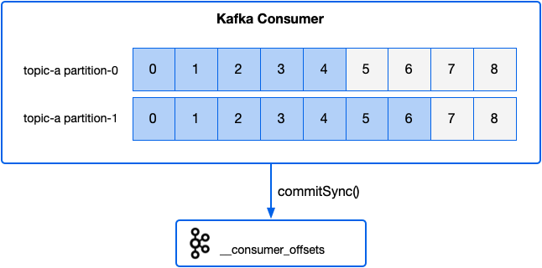

Let’s now look at each of these guarantees in detail and see some real-world examples of systems that provide each guarantee.

**No guarantee**

A system that provides no guarantee means any given message could be processed once, multiple times or not at all. With Kafka a simple scenario where you will end up with these semantics is if you have a consumer with enable.auto.commit **set to true** (this is the default) and for each batch of messages you asynchronously process and save the results to a database.

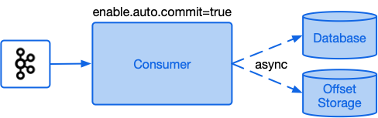

With auto commit enabled, the consumer will save offsets back to Kafka periodically at the start of subsequent poll calls.

The frequency of these commits is determined by the configuration parameter auto.commit.interval.ms.

If you save the messages to the database then the application crashes before the progress is saved, you will reprocess those messages again the next run and save them to the database twice. If progress is saved prior to the results being saved to the database, then the program crashes, these messages will not be reprocessed in the next run meaning you have data loss.

**At most once**

At most once guarantee means the message will be processed **exactly once, or not at all**. This guarantee is often known as “best effort” semantics.

1. A common example that results in at most once semantics is where a producer performs a **‘fire-and-forget’ approach** sending a message to Kafka with no retries and ignoring any response from the broker. This approach is useful where progress is a higher priority than completeness.

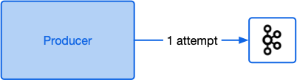

2. A producer saves its progress reading from a source system first, then writes data into Kafka. If the producer crashes before the second step, the data will never be delivered to Kafka.

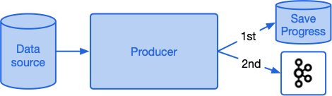

3. A consumer receives a batch of messages from Kafka, transforms these and writes the results to a database. The consumer application has enable.auto.commit **set to false** **and is programmed to commit their offsets back to Kafka prior to writing to the database.** If the consumer fails after saving the offsets back to Kafka but before writing the data to the database, it will skip these records next time it runs and data will be lost.

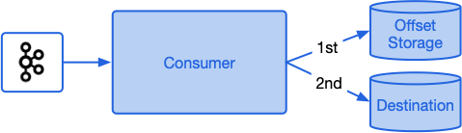

**At least once**

At least once guarantee means you will definitely receive and process every message, but you may process some messages additional times in the face of a failure. Here’s a few examples of some failure scenarios that can lead to at-least-once semantics:

1. An application sends a batch of messages to Kafka. The application never receives a response so sends the batch again. In this case it may have been the first batch was successfully saved, but the acknowledgement was lost, so the messages end up being added twice.

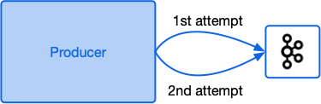

2. An application processes a large file containing events. It starts processing the file sending a message to Kafka for each event. Half way through processing the file the process dies and is restarted. It then starts processing the file again from the start and only marks it as processed when the whole file has been read. In this case the events from the first half of the file will be in Kafka twice.

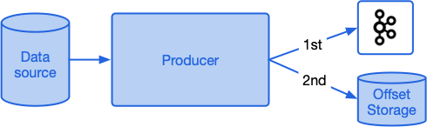

3. A consumer receives a batch of messages from Kafka, transforms these and writes the results to a database. The consumer application has enable.auto.commit set to **false** and is programmed to commit their offsets back to Kafka once the database write succeeds. If the consumer fails after writing the data to the database but before saving the offsets back to Kafka, it will reprocess the same records next time it runs and save them to the database once more.

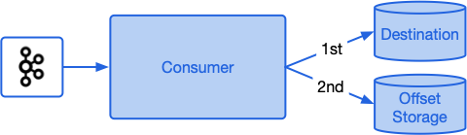

**Effectively once ( Exactly Once )**

Many distributed messaging systems such as Pulsar and Prevega as well as data processing systems such as Kafka Streams, Spark, Flink, Delta Lake and Cloud Dataflow claim exactly-onceoreffectively-oncesemantics in certain scenarios. In 2017 Confluent introduced Exactly Once semantics to Apache Kafka 0.11. Achieving exactly-once, or as many prefer to call it, effectively-once was a multi-year effort involving a detailed public specification, extensive real world testing, changes in the wire protocol and two new low level features to make it all work — idempotent writes and transactions. We’ll start by looking at these two features to see what they are and why they’re necessary for effectively-once support.

**Idempotent writes**

One of the at least once guarantee scenarios given above covered the case of a producer that is unable to determine if a previous publish call succeeded, so pushes the batch of messages again. In previous versions of Kafka, the broker had no means of determining if the second batch is a retry of the previous batch. From Kafka 0.11 onwards, producers can opt-in to idempotent writes (it’s disabled by default), by setting the configuration flag enable.idempotence to true. This causes the client to request a producer id (pid) from a broker. The pid helps the Kafka cluster identify the producer. With idempotence enabled, the producer sends the pid along with a sequence number with each batch of records. The sequence number logically increases by one for each record sent by the same producer. Given the sequence number of the first record in the batch along with the batch record count, the broker can figure out all the sequence numbers for a batch.

* With idempotence enabled, when the broker receives a new batch of records, if the sequence numbers provided are ones it has already committed, the batch is treated as a retry and ignored (a ‘duplicate’ acknowledgement is sent back to the client).

When idempotent writes first came out in v0.11 the brokers could only deal with one inflight batch at a time per producer in order to guarantee ordering of messages from the same producer. From Kafka 1.0.0, support for idempotent writes with up to 5 concurrent requests ( max.in.flight.requests.per.connection=5 ) from the same producer are now supported. This means you can have up to 5 inflight requests and still be sure they will be written to the log in the correct order. This works even in the face of batch retries or Kafka partition leader changes since in these cases the cluster will reorder them for you.

Transactions

Transactions give us the ability to atomically update data in multiple topic partitions. All the records included in a transaction will be successfully saved, or none of them will be.

Transactions are enabled through producer configuration. Clients need to first enable idempotent writes (enable.idempotence=true) and provide a transactional id (transactional.id=my-tx-id). The producer then needs to register itself with the Kafka cluster by calling initTransactions. The transactional id is used to identify the same producer across process restarts. When reconnecting with the same transactional id, a producer will be assigned the same pid and an epoch number associated with that pid will be incremented.

Kafka will then guarantee that any pending transactions from previous sessions for that pid will either be committed or aborted before the producer can send any new data. Any attempt by an old zombie instance of the producer with an older epoch number to perform operations will now fail.

Once registered, a producer can send data as normal (outside a transaction) or initiate a new transaction by calling beginTransaction. Only one transaction can be active at a time per producer. From within the transaction, the standard send method can be called to add data to the transaction.

Additionally, if a producer is sourcing data from Kafka itself, it can include the progress it is making reading from the source in the transaction by calling sendOffsetsToTransaction. In Kafka the default method for saving consumer progress is to save offsets back to an internal topic in Kafka and hence this action can be included in a transaction.

Once all required messages and offsets are added to the transaction, the client calls commitTransaction to attempt to commit the changes atomically to the Kafka cluster.

The client is also able to call abortTransaction if they no longer wish to go ahead with the transaction, likely due to some error.

The producer and brokers do not wait until the transaction is committed before writing the data to the data logs. Instead the brokers write records to the logs as they arrive. Transactional messages are also bracketed with special control messages that indicate where a transaction has started and either committed or aborted.

Consumers now have an additional configuration parameter called isolation.level that must be set to either read_uncommitted (the default) or read_committed.

When set to read_uncommitted, all messages are consumed as they become available in offset ordering.

When set to read_committed, only messages not in a transaction, or messages from committed transactions are read in offset ordering.

If a consumer with isolation.level=read_committed reaches a control message for a transaction that has not completed, it will not deliver any more messages from this partition until the producer commits or aborts the transaction or a transaction timeout occurs. The transaction timeout is determined by the producer using the configuration transaction.timeout.ms (default 1 minute).

That was a quick tour the key features of transactions. If you want to know more, this Confluent blog or the original design are both well worth a read. Now that we’ve established the basics on idempotent writes and transactions let’s see how they help us achieve effectively once guarantees.

Effectively once production of data to Kafka

When producing data to Kafka you need to save progress and publish the data to Kafka itself. Depending on the order you do these two operations you get different delivery semantics.

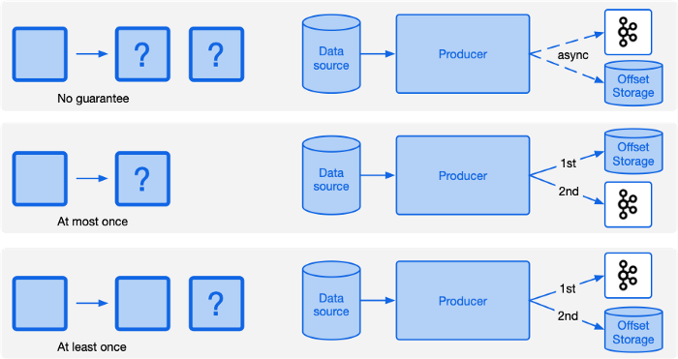

It seems that whatever order you perform these operations, you can’t get effectively once semantics. The issue with all these scenarios is in the face of failure we can be left with one of the two operations succeeding leaving us in an inconsistent state. We need to have a mechanism to either save the progress and the data or, in the face of failure, do neither. In other words we need to atomically save both the progress and data.

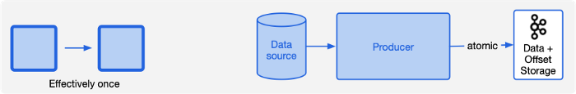

Kafka transactions can help us out here, but only if we’re willing and able to store the progress of reading the source in Kafka itself. Transactions only work on data stored in Kafka and cannot be extended to cover data stored elsewhere.

producer.initTransactions();

producer.beginTransaction();

sourceOffsetRecords.forEach(producer::send);

outputRecords.forEach(producer::send);

producer.commitTransaction();

This will guarantee your producer is always in a consistent state with your data being in sync with your source system. This is true even after a hard crash of your producer as after restarting your producer with the same transactional id, Kafka will guarantee all existing transactions will be resolved (aborted or committed) before it starts adding any new data.

Effectively once consuming of data from Kafka

The scenarios for consuming and processing data from Kafka should look familiar if you were paying attention in the previous section.

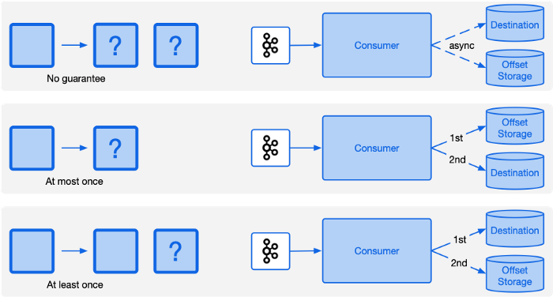

We have the same issues as with publishing data to Kafka where regardless of the order we do our data processing and storage of consumer offsets, we don’t get effectively once semantics. If our destination system is Kafka we can solve this just as we did in the previous section, by atomically updating the destination and storing the offsets as part of a transaction. Similarly if our destination is not Kafka but does have transactional support (such as PostgreSQL or MongoDB) we can use the same approach here by storing both the offsets and data in the destination system and updating both atomically.

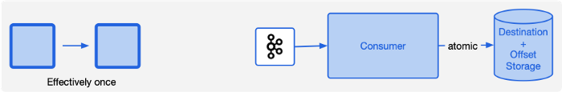

For Kafka clients reading from Kafka there is another option to achieve effectively-once semantics. If your stream processing or destination systems is able to behave idempotently, you can achieve the same effect by performing the idempotent operation then saving the progress.

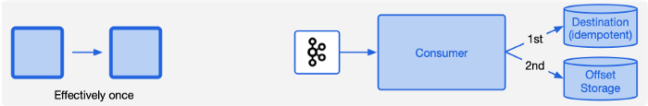

An idempotent operation is one where if you perform it multiple times it has the same effect as if it were performed once. If the application fails after performing the operation but before saving progress, it won’t matter that the next time the application is restarted the operation is run again.

An example of such a system is upserting a record into a database. If the record is already present in the database, any duplicates will simply update the record with the same values. Another example is the Kafka Connect S3 Sink Connector. In this case the connector saves the data to an S3 object, then commits the offsets to Kafka. Performing a multi-part upload to an S3 object multiple times with the same data is an idempotent atomic operation. So if the connector fails after writing a file, but prior to saving the offsets, it will simply repeat the process next time with the destination file being atomically replaced with a new file of exactly the same data.

Effectively once in Kafka Streams

Kafka Streams is a JVM based library for performing streaming transformations on data sourced from Kafka. It is a very good default choice for data processing backed by Kafka due to its simple deployment model, horizontal scalability, resilience to failures and straightforward well documented public API.

The API lets you read data from Kafka then perform a number of transformations on the data including filtering, mapping, aggregation and joining data from multiple topics. The API supports both stateless and stateful transformations. Stateful transformations back up their state into changelog topics in Kafka and cache values local to the processing nodes, typically using RocksDB.

Exactly once semantic support was added to Kafka Streams in the 0.11.0 Kafka release. Enabling exactly once is a simple configuration change setting the streaming configuration parameter processing.guarantee to exactly_once ( the default is at_least_once ).

A typical workload for a Kafka Streams application is to read data from one or more partitions, perform some transformations on the data, update a state store (such as a count), then write the result to an output topic. When exactly once semantics is enabled, Kafka Streams atomically updates consumer offsets, local state stores, state store changelog topics and production to output topics all together. If any one of these steps fail, all of the changes are rolled back.

Side effects

The Kafka Streams API lets you perform any action when processing input data, for instance you can write the data directly to a database, or fire off an email. These “side effect” operations are explicitly not covered by the exactly once guarantee. If a stream job fails after processing data, but just prior to writing it back to Kafka, it will be reprocessed the next time the Kafka Streams worker is restarted re-running any side-effect operations such as emailing a customer.

It is best to keep your Kafka Streams transform “pure” with no side effects beyond updating state stores and writing back to Kafka. This way your application will be more resilient (it won’t fail if it can’t contact the email server) and will shorten the length of transactions.

Side effects can then be performed via Kafka Connect Sink connectors or custom consumers.

Performance

The additional work required for transactions is independent of the number of messages included in the transaction, so throughput is improved by increasing the size of transactions. For Kafka Streams, transactions are cycled each time a stream worker commits their changes. This is tunable via the commit.interval.ms configuration. The higher the commit interval, the higher the throughput will be, but at the cost of increased latency for downstream “read_committed” consumers.

If your Kafka Streams application has multiple sub-topologies where intermediate data is written back to Kafka then read in a later step, each of these steps needs to wait for the transaction for the previous step to complete before it can read any data. The end to end latency of such a pipeline is worst case lower bounded by the number of intermediate steps multiplied by the commit interval. Expect this scenario to improve in future Kafka Streams releases as there’s talk of allowing internal consumers to reduce latency by reading “unstable data” triggering cascading rollbacks in failure scenarios.

Finally, in the case of an unclean shutdown of a stream job, local state stores could be left in an unknown state. In this case Kafka Streams rebuilds the state stores from changelog topics in Kafka. This process can take some time for large state stores. You can alleviate this situation by shutting down your topology cleanly whenever possible. In future Kafka releases there is talk of adding checkpoints to the local state stores, so that a full restore is not required each time.

Effectively once for the win?

Now that effectively once is possible with Kafka, why not use it all the time? As clearly stated in the Confluent articles, enabling exactly-once isn’t magical pixie dust. As should now be clear given the examples above, duplicates and lost messages are due not only to features of the messaging systems, but in the design of producer and consumer applications as well.

For any new applications, either using the lower level consumer/producer APIs or with Kafka Streams you now have the knowledge for how to set up effectively once. Very often you will wish to source or deliver data to other systems, many of which do not (yet) have effectively once support.

Probably the biggest gap right now is Kafka Connect Source connectors. The Connect Source API was designed well before transactions were available and there’s some work required to update it to support effectively once. You can track progress via the issue KAFKA-6080. Also, change data capture (CDC) systems such as Debezium only support at least once semantics in the event of system failure.

Another reason you may wish to choose to forgo effectively once guarantees is where you value progress over completeness. With at least once and effectively once guarantees, a producer will keep trying forever when attempting to push data into Kafka. For some setups such as real time monitoring, ML model scoring or an RFQ system, older messages may no longer useful, so dropping old data under failure conditions may be an acceptable trade-off.

Often data flows involve chains of services reading from the output topics of a previous service and writing to the input topics of the next service. As you can see from the table below, delivery guarantees don’t get better when you combine them. If you have anything other that effectively once anywhere in your pipeline, the whole pipeline will no longer be effectively once.

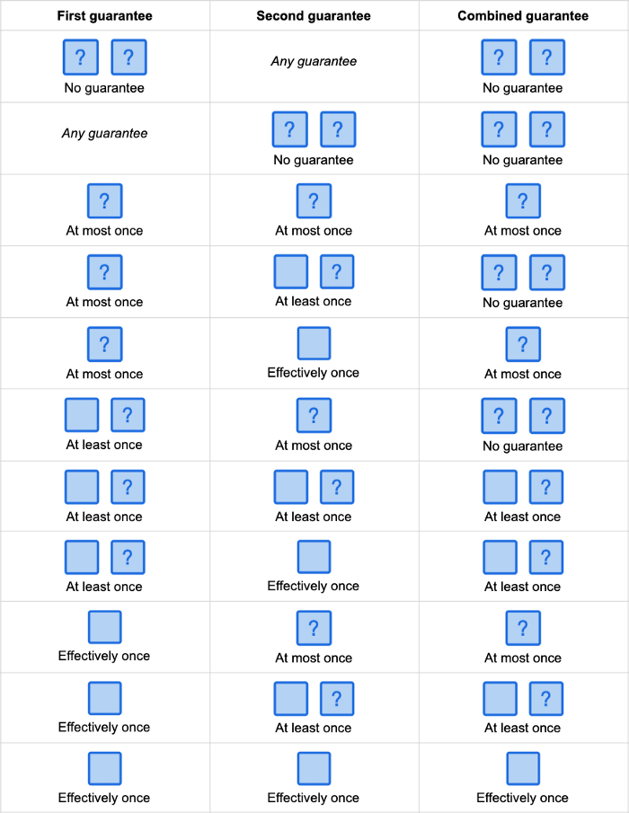

Using effectively once semantics everywhere can be a real challenge. You may be dealing with data sources that already have duplicates (be sure to check the semantics of all your source feeds), or it simply may be too much effort to always store your offsets atomically with your data. At least once guarantees are much easier to achieve. The offsets do not need to be stored together with the data. As long as you always store the offsets after saving the data, you can save offsets much less frequently than saving the data depending on how much duplicate data you can tolerate on a failure.

Given you have a stream of at least once data, is it possible to turn this into an effectively once stream? One way to do this is have all consumers of your data be idempotent, effectively ignoring the duplicate records. For this to work consumers need to be idempotent at the message level not the batch level. For instance, you can configure the JDBC and ElasticSearch Kafka Connect Sinks to be idempotent at the message level, but not the S3 Sink. Giving the S3 Sink a stream with duplicates, it will faithfully copy to S3 exactly what’s in the topic, duplicates and all.

For consumers that cannot act idempotently, you also have the option of adding a step to remove duplicates from your streaming pipeline converting your at least once guarantee into an effective once one.

Deduplication

Deduplicating a stream of records is an inherently stateful operation. For each record that arrives we need to determine if we’ve seen the record contents before. If so, discard the record, if not pass it on and update our state to remember the new record. What state should we store to identify duplicates?

Using a key to identify duplicates

If your data has an intrinsic business key that uniquely identifies a record, this can be a good candidate for deduplication. If no such key exists, a hash of the contents can also be used.

If using Kafka Streams as your deduplication mechanism, you can create a state store that adds an entry for each unique key it receives. When a new record is received, check the store to see if the key has been seen before.

Kafka Stream state stores are specific to source topic partitions, so make sure the source topic either has a single partition or that the Kafka messages are keyed by the same key you use for deduplication purposes. Kafka producers use the message key to determine what partition to push records into. Records with the same key will end up in the same partition.

This approach only works if you will never see update messages for the given key. In this case, you could store an update timestamp or version number in the state store value entry for each message and only pass through updates where the timestamp or version is greater than the previous value. If the number of unique keys is unbounded, strongly consider windowing your state store. This is reasonable since at least once failure scenarios where a failed batch is replayed, the duplicate messages are generally added within a few minutes or hours of the original messages, depending on the length of the outage.

Using a sequence number for deduplication

Using a key for deduplication does work well, but comes at the cost of additional latency and the ongoing cost of managing the state store. In some cases a lighter weight approach works if the source stream has some form of sequence number attached to each message whose value increases with each message. One such system is Change Data Capture (CDC) where the location in the database transaction log, often called the LSN, is included with each message along with a separate sequence number that identifies an individual CDC update within a transaction. Combining these two values you have a key that you expect to always go up. You can then have a state store with a single entry per partition storing the highest key seen to date (the high water mark for the partition). For any new message, if the key is less than or equal to the previously stored value, it is considered a duplicate and dropped. Otherwise the value is forwarded on and the state store is updated. The advantage to this approach is the lookups are fast (always in memory), the state stores are very small and never grow, and it can handle duplicates after any length of time since we don’t require windowing.

Using a datastore for deduplication

This example is a variation on the upsert based idempotent consumer example given above. In this case, we want to be sure we don’t have duplicates in the destination datastore, but don’t have a mechanism for updating. To identify duplicate messages we first query the destination system for each message and drop any that are already there, inserting the remaining messages. If doing this as a batch process using Spark you’d first remove the duplicates within a batch using the DataFrame method dropDuplicates, identify the field(s) to use as the key, then perform a left-anti join against the destination datastore. This removes all messages that are already in the destination. The resulting dataframe can then be safely inserted into the destination datastore.

For datastores where querying existing records is slow, you can add an optimisation using a probabilistic matching such as a bloom or cuckoo filter. These filters take up a predictable amount of space and can tell for each record in a stream whether you have definitely not seen it before, or you “may have”. By running records through this filter, we only have to query the actual source for those records that “may have” been seen before.

Summary

Effectively once message processing is possible today with Apache Kafka. This is a big achievement for the platform, and something its competitors such as Apache Pulsar, AWS Kinesis, Azure Event Hubs or Google Cloud Pub/Sub do not currently support so robustly. Nevertheless achieving an end-to-end effectively once data pipeline is a challenging prospect involving strict discipline. The basic tooling is available, but to achieve effectively once, every streaming process involved needs to be designed with effectively once support in mind. I expect the situation to gradually improve as components like Kafka Connect add effectively once support to sources, and other sources such as CDC systems start atomically storing their progress in Kafka.

At least once guarantees are far easier to implement and almost universally supported by existing tools. If your destination systems are tolerant of duplicates, an at least once pipeline is a good choice. Encourage your downstream consumers to be idempotent and you save the burden of implementing effectively once entirely.

Finally in cases where your consumers cannot be made idempotent and you have at least once semantics you can consider adding a deduplication step to convert your stream to effectively once semantics. Although deduplication is a useful tool to have available to you, be aware that it comes at a cost in pipeline complexity, additional state storage and increased latency.

**Exactly Once Semantics**

<https://dzone.com/articles/interpreting-kafkas-exactly-once-semantics>

Apache Kafka comes out-of-the-box packed with great data science features. We take a look at few of them in this post.

Until recently most organizations have been struggling to achieve the holy grail of message delivery, the exactly-once delivery semantic. Although this has been an out-of-the-box feature since Apache Kafkas 0.11, people are still slow in picking up this feature. Let's take a moment in understanding exactly-once semantics. What is the big deal about it and how does Kafka solve the problem?

Apache Kafka offers following delivery guarantees. Let's understand what this really means:

**At Most Once Delivery**: It guarantees that a particular message can either be delivered once or not at all. There can be a loss of messages but a message can never be delivered more than once.

**At Least Once Delivery**: It guarantees that a particular message will always be delivered. It can be delivered multiple times but there will never be any messages lost.

**Exactly Once Delivery**: It guarantees that all messages will always be delivered exactly once. Exactly once does not mean that there will be no failures or no retries. These are inevitable. The important thing is that the retries succeed. In other words, the result should be the same, whether it has been successfully processed exactly once or not.

Why Exactly-Once Is Important

There are certain use cases (like financial applications, IoT applications, and other streaming applications) which cannot afford anything less than exactly-once. You cannot afford to have duplicates or lose messages when depositing or withdrawing money from a bank account. It needs exactly-once as a final outcome.

Why it Is Difficult to Achieve

Assuming you have a small Kafka stream application with few inputs feeding partitions and few output partitions. The intent and expectation of the application is to receive data from input partitions, process the data, and write the same to output partitions. This is where one wants to achieve exactly-once as a guarantee. There are scenarios due to network glitches, system crashes, and other errors where duplicates get introduced during the process.

Problem 1: Duplicate or Multiple Writes

Refer to Figure 1a. Message m1 is being processed and being written to Topic B. Message m1 gets successfully written to Topic B (as m1') but the acknowledgment is not received. The reason could be, let's say, network delay and this eventually gets timed out.Image title

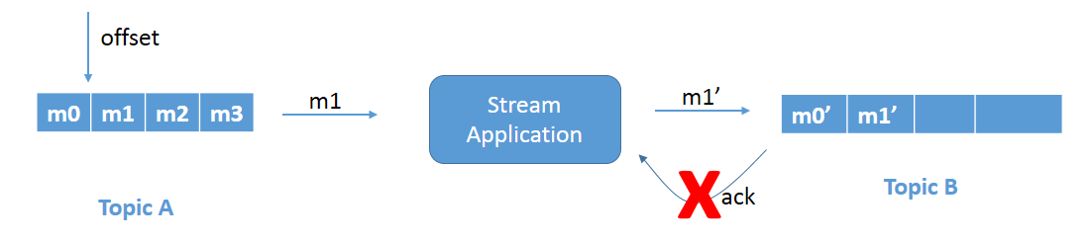

Figure 1a: Duplicate write problem.

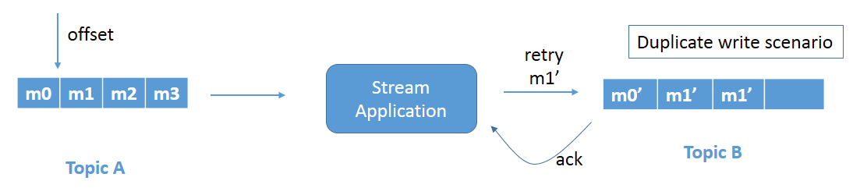

Figure 1b: Duplicate write problem due to retry.

Since the application does not know that the message is already successfully written, as it never received the acknowledgment, it retries and leads to a duplicate write. Refer to Figure 1b. Message m1' gets rewritten to Topic B. This is a duplicate write issue and needs to be fixed.

Problem 2: Reread Input Record

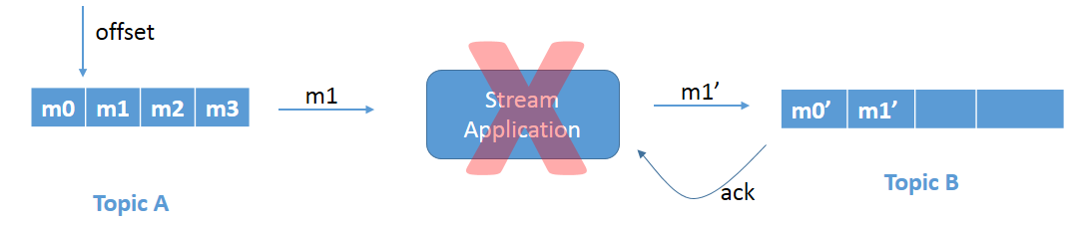

Figure 2a: Reread problem due to the application crashing.

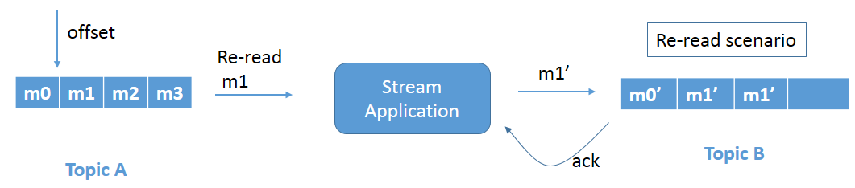

Figure 2b: Reread problem when the crashed application restarts.

Refer to Figure 2a. We have the same scenario as above, but, in this case, the stream application crashes just before committing the offset. Since the offset is not committed, when the stream application comes up again it rereads message m1 and processes the data again (Figure 2b). This again leads to duplicate writes of message m1 in Topic B.

How Apache Kafka Helps

Apache Kafka solves the above problems via exactly-once semantics using the following.

Idempotent Producer

Idempotency on the producer side can be achieved by preventing messages from being processed multiple times. This is achieved by persisting the message only once. With idempotency turned on, each Kafka message gets two things: a producer id (PID) and sequence number (seq). The PID assignment is completely transparent to users and is never exposed by clients.

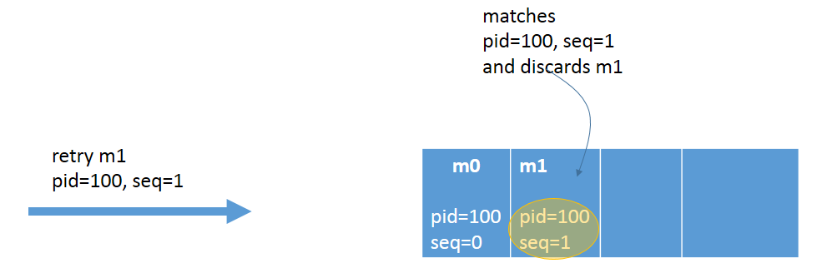

Figure 3: Idempotent Producer

producerProps.put("enable.idempotence", "true");

producerProps.put("transactional.id", "100");

In the case of broker failure or client failure, during retry of message send, the topic will only accept messages that have a new unique sequence number and producer id. The broker automatically deduplicates any message(s) sent by this producer, ensuring idempotency. No additional code changes are required.

Transactions Across Partitions

To ensure that each message gets processed exactly-once, transactions can be used. Transactions have an all-or-nothing approach. They ensure that after picking a message, that the message can be transformed and atomically written to multiple topics/partitions along with an offset of the consumed message.

Code Snippet for Atomic Transactions

producer.initTransactions();

try {

producer.beginTxn();

// ... read from input topic

// ... transform

producer.send(rec1); // topic A

producer.send(rec2); // topic B

producer.send(rec3); // topic C

producer.sendOffsetsToTxn(offsetsToCommit, “group-id”);

producer.commitTransaction();

} catch ( Exception e ) {

producer.abortTransaction();

}

Apache Kafka v0.11 introduced two components — the Transaction Coordinator and Transaction Log — which maintain the state of the atomic writes.

The below diagram details a high-level flow of events that enables atomic transactions across various partitions:

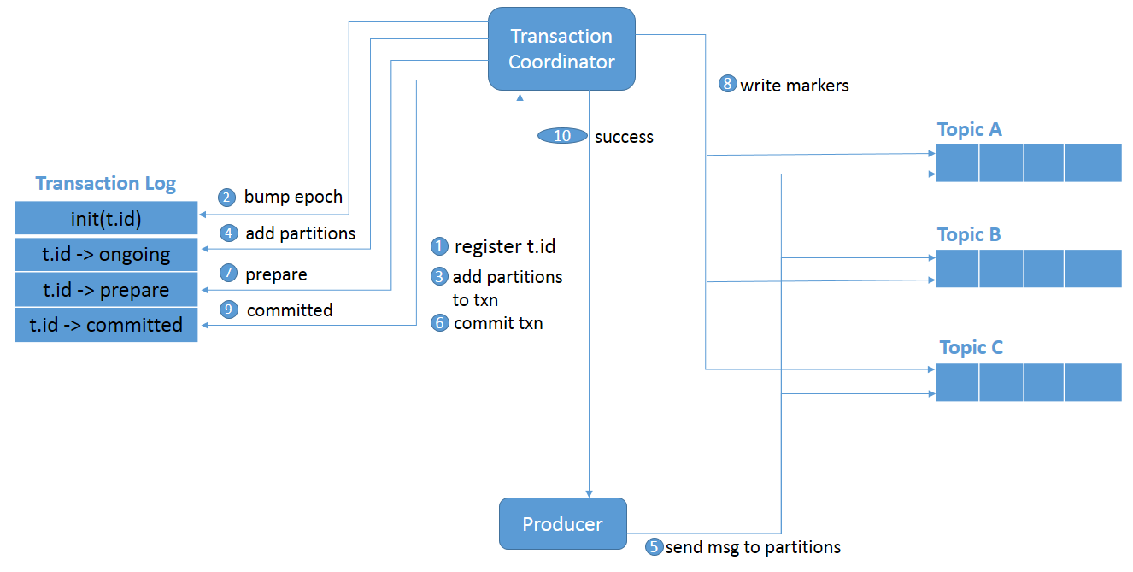

**Figure 4: Transactions across a partition.**

1. initTransactions() registers a transactional.id with the coordinator.
2. The coordinator bumps up the epoch of the PID so that previous instance of that PID is considered a zombie and fenced off. No writes in the future are accepted from these zombies.
3. The producer adds a partition with the coordinator when the producer is about to send data to a partition.
4. The transaction coordinator keeps the state of each transaction it owns in memory, and also writes that state to the transaction log (partition information, in this case).
5. The producer sends data to the actual partitions.
6. The producer initiates a commit transaction and, as a result, the coordinator begins the two-phase commit protocol.
7. This is where the first phase begins and the coordinator updates the transaction log to “prepare_commit”.
8. The coordinator then begins Phase 2, where it writes the transaction commit markers to the topic-partitions which are part of the transaction.
9. After writing the markers, the transaction coordinator marks the transaction as “committed.”

Transactional Consumer

* **If a consumer is transactional, we should use the isolation level, read_committed**. This ensures that it reads only committed data.

The default value of **isolation.level** is **read_uncommitted**.

This just a high-level view of how transactions work in Apache Kafka. I'd recommend exploring the docs if you're interested in taking a deeper dive.

Conclusion

In this post, we talked about various delivery guarantee semantics such as at-least-once, at-most-once, and exactly-once. We also talked about why exactly-once is important, the issues in the way of achieving exactly-once, and how Kafka supports it out-of-the-box with a simple configuration and minimal coding.

**Ordering of Messages in Kafka**

<https://medium.com/@felipedutratine/kafka-ordering-guarantees-99320db8f87f>

Kafka guarantee the order and it’s one of the reasons for choosing kafka. But to have your messages ordered they are somethings to know.

Partitions

**Unique Partition Ordering**

Physically topics are split into partitions. A partition lives on a physical node and persists the messages it receives.

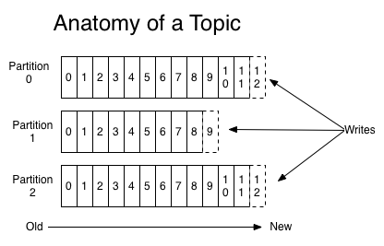

So on this case, with many partitions, the ordering cannot be guaranteed.

If you want to have a global ordering, you will need to have only 1 partition.

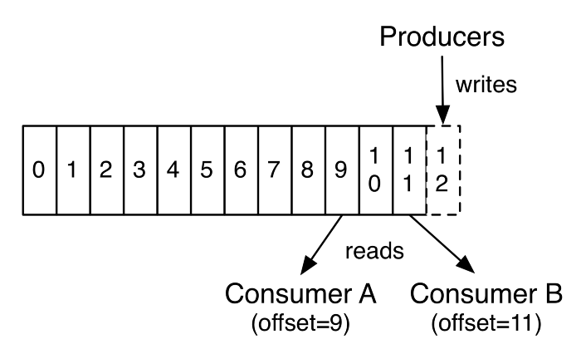

Now it’s better, Kafka preserves the order of messages within a partition. This means that if messages were sent from the producer in a specific order, the broker will write them to a partition in that order and all consumers will read them in that order.It’s better but not enough, you need also to set a special config.

Internal Retry Process

Kafka has an internal retry process :

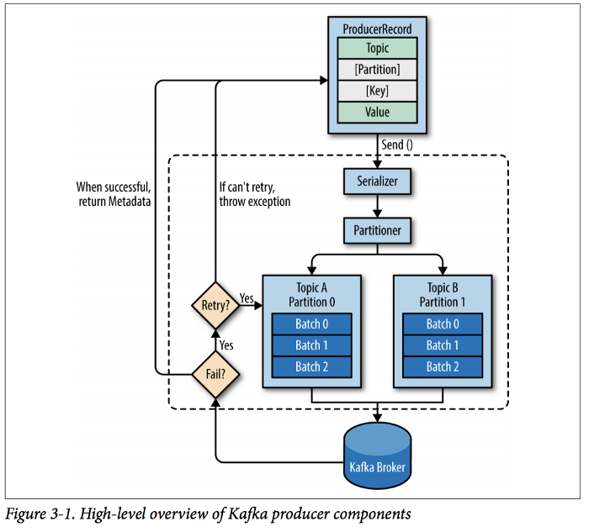

(Chapter 3 p 42 of the kafka guide : https://www.confluent.io/wp-content/uploads/confluent-kafka-definitive-guide-complete.pdf)

As you see on the schema, sometimes adding a message to the broker fails, so a Retry is performed.

So on this case what will happen if I send 2 messages, and the first one needs a retry, but not the second one. On this specific case, the second one working will be added on the commit log before the first one that was in retry.

It’s not possible to set the number of retries to zero is not an option in a reliable system, so if guaranteeing order is critical. You will need to set the config max.in.flight.requests.per.connection=1 to make sure that while a batch of messages is retrying, additional messages will not be sent. This will severely limit the throughput of the producer, so only use this when order is important. (you can have more information on the p52 of the kafka guide : <https://www.confluent.io/wp-content/uploads/confluent-kafka-definitive-guide-complete.pdf>)

Many Partitions ordering

Having one partition is cool (and sometimes depending of your business mandatory), but you will be obliged to have only one consumer, and the producer throughput will be limited. Thanks to the kafka system of key/ partitions, you can create a more intelligent structure, that will allow you to have many partitions and continue having ordered messages.

The keys used by kafka allows you to put all the messages with the same key on one partition. ( by a mathematical process Hash(key)%partitionNb to guarantee that one key will always be in the same partition ( as long as you don’t change the partition number ), so be careful because if you change the partition number during the life of your topic, a key will be put in a different partition than before the changing of partition number ).

The only question you should ask yourself is : Should my system be globally ordered or can I partition this order?

For example : In an marketplace system, you have to create a Cart and then Add your goods ( it should be ordered, you cannot add a good to a cart not yet created ) but as all your carts of your system isn’t related you can split them in different partition. For that you only need to add the same key, to the different steps ( logical process ) that should be ordered. On this case maybe the cart guid as key will be enough, but if you need to order all carts of a customer, the key should be the customer_id.

So don’t hesitate to play with the keys, to have the ordering that your business needs.

I hope my explanation is clear enough (comment if it’s not the case)

**How to Overcome Data Order Issues in Apache Kafka**

<https://www.dataversity.net/how-to-overcome-data-order-issues-in-apache-kafka/>

While Apache Kafka has earned its reputation as a highly capable distributed streaming platform, it also features a bit of complexity when it comes to ensuring that data is stored – and can be retrieved – in the order that you want it to be.

To capture streaming data, Kafka publishes records to a topic, a category or feed name that multiple Kafka consumers can subscribe to and retrieve data. The Kafka cluster maintains a partitioned log for each topic, with all messages from the same producer sent to the same partition and added in the order they arrive. In this way, partitions are structured commit logs, holding ordered and immutable sequences of records. Each record added to a partition is assigned an offset, a unique sequential ID.

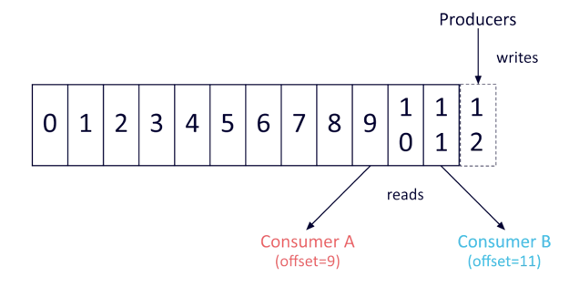

The challenge of receiving data in the order you prefer it in Kafka has a relatively simple solution: a partition maintains a strict order, and will always send data to consumers in the order it was added to the partition. However, Kafka does not maintain a total order of records across topics with multiple partitions.

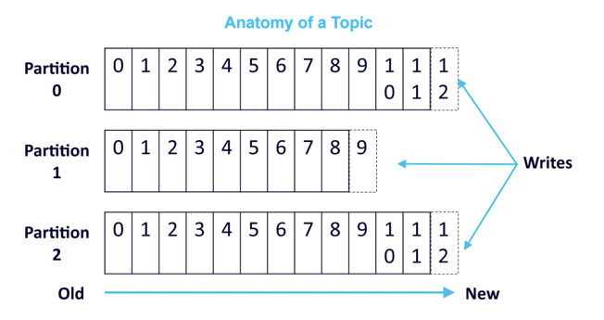

For applications requiring total control of records, the solution is using a topic with just a single partition (this will also limit utilization to a single consumer process per consumer group).

Keep in mind that most applications will not require this level of control, and are better served by the technique of using per-partition ordering alongside data partitioning by key.

Examples of How to Use Kafka Partitioning and Keying

Let’s look at an example of what happens when we send data to multiple partitions. First, we’ll create a topic with 10 partitions, named “my-topic”:



Next, we’ll make a producer and send records containing the numbers “1” through “10”.

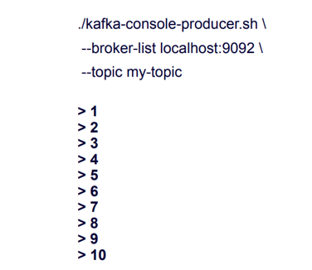

These records are sent to the topic in order, but to ten different partitions. When we use the consumer to read this data from the beginning of the topic, it arrives quite out of order:

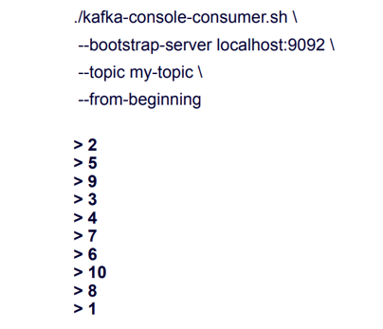

This demonstrates the fact that data order is not guaranteed at the topic level – data is retrieved from all partitions in a round robin fashion.

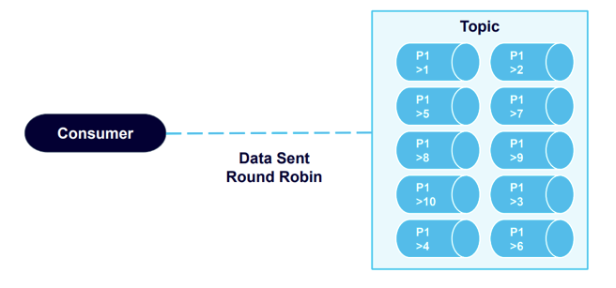

Now let’s create a new example, using a topic with just one partition:

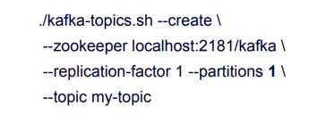

We’ll send the same “1” through “10” data:

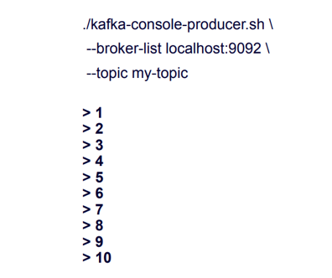

This time, we retrieve the data in the order we sent it.

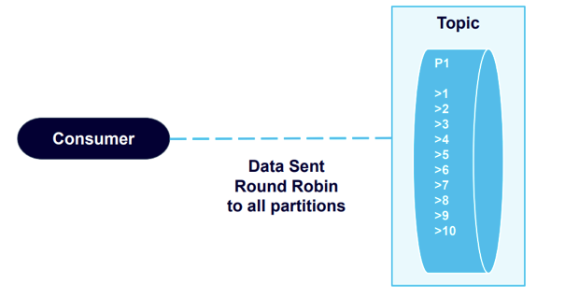

This validates Kafka’s guarantee of data order on the partition level. The producer sends messages in a specific order, the broker writes to the partition in that order, and consumers read the data in that order.

Next, let’s use an example that introduces keying, which allows you to add keys to producer records. We’ll send four messages that include keys to a Kafka topic with two partitions:

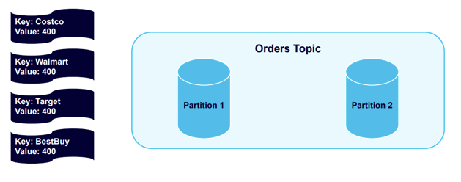

The four different keys – Costco, Walmart, Target, and Best Buy, and hashed and distributed across the cluster into the partitions:

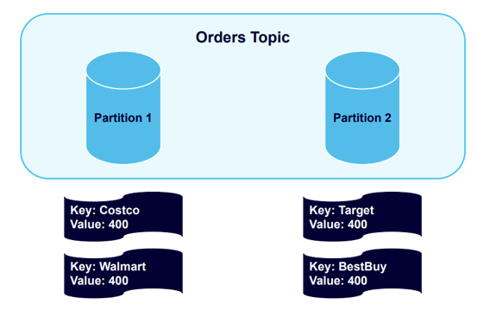

Now we’ll send another four messages:

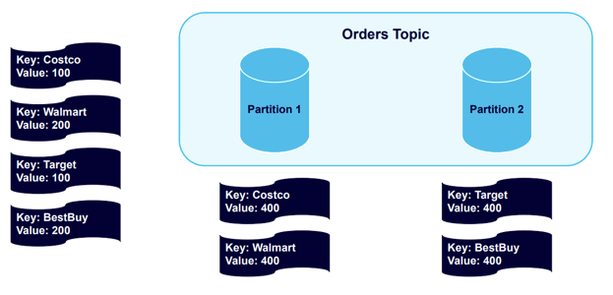

Kafka will send messages to the partitions that already use the existing key:

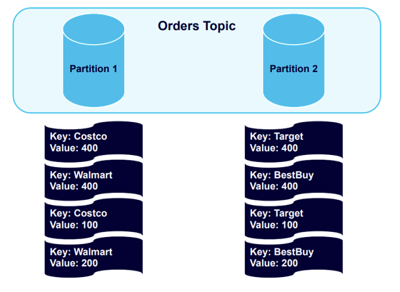

All Costco or Walmart records go in Partition 1, and all Target or Best Buy records go in Partition 2. The records are in the order that they were sent to those partitions.

Next, let’s see what happens if we add more partitions to the cluster, which we might want to do in order to balance the data in a healthier way.

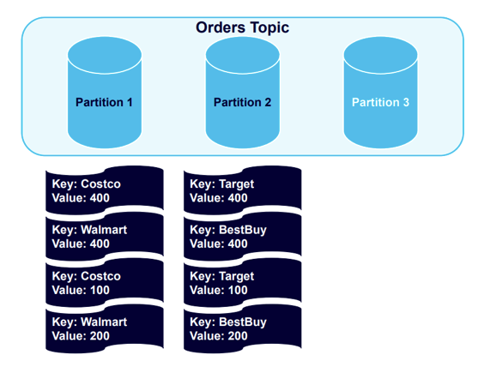

With the new partition added, we’ll trigger a rebalance event:

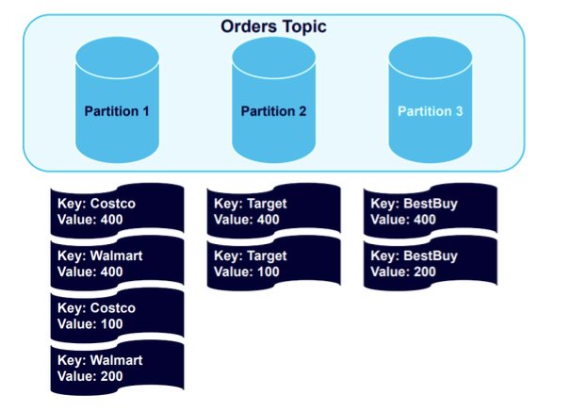

The data remains nicely structured by key, with all Best Buy data balanced to Partition 3. It will remain so if we add four more messages to the topic:

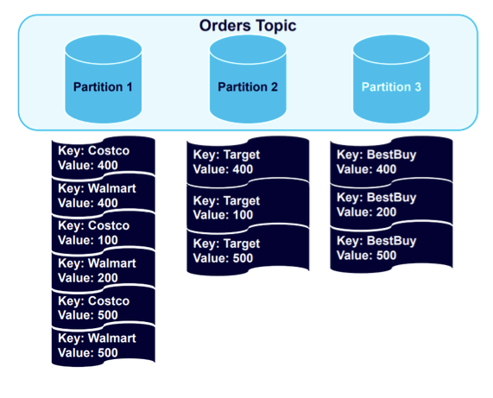

Data goes to the partitions holding the established keys. However, because one partition is holding twice as much data as the others, it makes logical sense to add a fourth partition and trigger another rebalance:

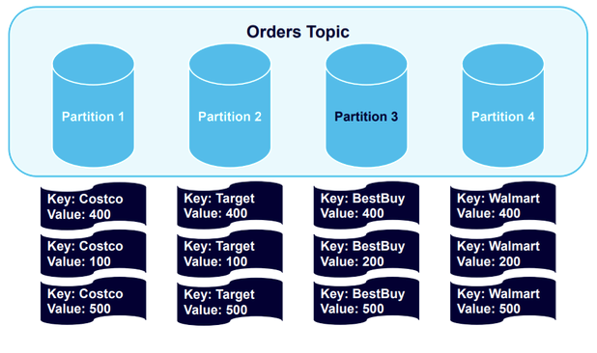

The result is a healthy balancing of the data sets.

Ensuring that Data is Always Sent in Order

There are a number of additional issues that can cause data to arrive out of order in Kafka, including broker or client failures and disorder produced by reattempts to send data. To address these , let’s first take a closer look at the Kafka producer.

Here is a high-level overview showing how a Kafka producer works:

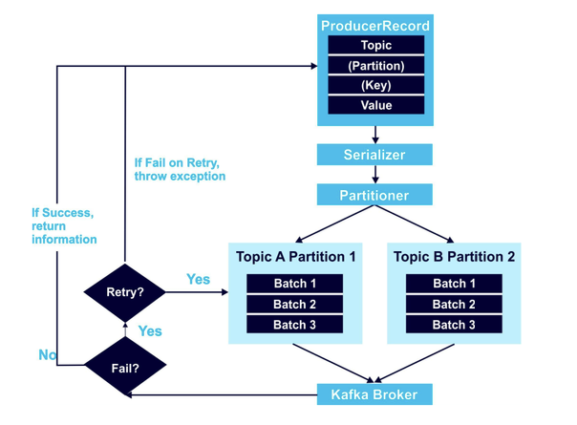

At minimum, a ProducerRecord object includes the topic to send the data to, and a value. It can also include a specified partition to use, and key. At stated in the examples above, I recommend that you always use keys. If you don’t, data will be distributed round robin to any partition with no organization in place. Data from the ProducerRecord is next encoded with the Serializer, and then the Partitioner algorithm decides where the data goes.

The retry mechanism, outlined on the left-hand side of the above diagram, is an area where data order issues can frequently occur. For example, say you attempt to send two records to Kafka, but one fails due to a network issue and the other goes through. When you try resending the data, there’s a risk that data will be out of order, because you’re now sending two requests to Kafka simultaneously.

You can resolve this issue by setting max.in.flight.requests.per.connection to 1. If this is set to more than one (and the retries parameter is nonzero), the broker could fail to write the first message batch, successfully write the second because it was allowed to also be in-flight, and then successfully retry the first batch, swapping their order to one you didn’t intend. In contrast, setting max.in.flight.requests.per.connection to 1 ensures that those requests occur and one after the other and in order.

In scenarios where order is crucial, I recommend setting in.flight.requests.per.session to 1; this ensures that additional messages won’t be sent while a message batch is retrying. However, this tactic severely limits producer throughput, and should only be used if order is essential. Setting allowed retries to zero may seem like a possible alternative, however, if the impact on system reliability makes it a non-option.

Achieving “Exactly-Once Message Delivery”

Kafka includes three different message delivery methods, each with its own guaranteed behaviors:

**At-Most-Once Message Delivery:** This method will either deliver a message batch once, or never. This eliminates the risk of resending the same messages, but allows them to be lost as well.

**At-Least-Once Message Delivery**: This method will not stop until messages are delivered. While delivery always succeeds and no messages are lost, they can be delivered multiple times.

**Exactly-Once Message Delivery**: This method guarantees delivery of all messages, and that each is delivered only one time. While failures and retries will occur, Exactly-Once Message Delivery takes extra steps to ensure a single successful delivery.

Obviously, Exactly-Once Message Delivery is ideal for preserving data order.

Putting Exactly-Once Message Delivery into practice requires utilizing three components: an idempotent producer, transactions across partitions, and a transactional consumer.

**1) Idempotent producer**

Producer idempotency can cause messages to persist through just a single process, preventing retry issues. Activating idempotency adds a producer ID (PID) and a sequence ID to each Kafka message. When a broker or client failure occurs and a retry is attempted, the topic only accepts messages with never-before-seen producer and sequence IDs. Idempotency is further assured by the broker, which deduplicates all messages the producer sends automatically.

**2) Transactions across partitions**

Transactions can make sure that each message is processed exactly once. This allows a selected message to be transformed and atomically written to multiple topics or partitions, along with an offset tracking consumed messages.

The state of atomic writes is maintained by the transaction coordinator and transaction log (introduced in Apache Kafka v0.11). The transaction coordinator is similar to the consumer group coordinator: each producer has an assigned transaction coordinator, which is responsible for assigning PIDs and managing transactions. The transaction log is a persistent record of all transactions acting as the state store for the transaction coordinator.

**3) Transactional Consumer**

To force a transactional consumer to read only committed data, set isolation.level to read_committed (by default, the isolation level is read uncommitted.)

Steps of a Kafka Transaction Workflow for Exactly-Once Message Delivery

The following diagram captures the Kafka transaction workflow steps needed to achieve Exactly-Once Message Delivery.

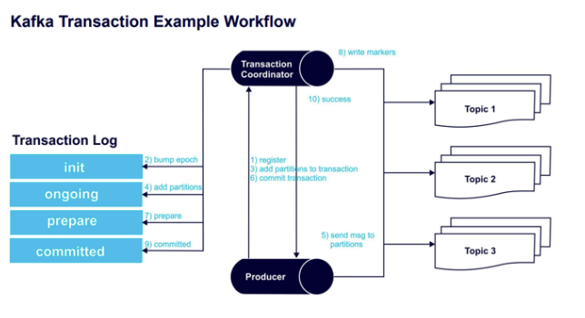

Step 1 – initTransactions() registers a transaction ID (a unique persistent producer ID) with the transaction coordinator.

Step 2 – The coordinator bumps up the epoch of the producer ID (ensuring there is just one legitimate active instance of the producer). Writes from previous instances of that PID are no longer accepted.

Step 3 – Before sending data to a partition, the producer adds a new partition with the coordinator.

Step 4 – The coordinator stores each transactions’ state in memory and writes it to the transaction log.

Step 5 – The producer sends the messages to the partitions.

Step 6 – The producer begins a commit transaction, causing the coordinator to initiate its two-phase commit protocol.

Step 7 – (Commit protocol phase 1) The coordinator prepares the commit by updating the transaction log.

Step 8 – (Commit protocol phase 2) The coordinator writes transaction commit markers to topic partitions involved in the transaction.

Step 9 – The coordinator marks the transaction as committed.

Step 10 – The “Exactly-Once Message Delivery” transaction is a success.

Below is a more technical architecture diagram of this process:

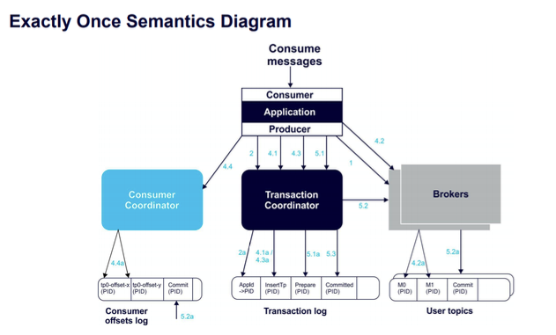

**How to maintain message ordering and no message duplication?**

<https://kafka-tutorials.confluent.io/message-ordering/kafka.html>

If your application needs to maintain ordering of messages with no duplication, you can enable your Apache Kafka producer for idempotency. An idempotent producer has a unique producer ID and uses sequence IDs for each message, which allows the broker to ensure it is committing ordered messages with no duplication, on a per partition basis.

Set the ProducerConfig configuration parameters relevant to the idempotent producer:

enable.idempotence=true

acks=all

How to Overcome Data Order Issues in Apache Kafka

<https://www.dataversity.net/how-to-overcome-data-order-issues-in-apache-kafka/>

Before you create your full application code, let’s highlight some of the most important ProducerConfig configuration parameters relevant to the idempotent producer:

enable.idempotence=true

acks=all

max.in.flight.requests.per.connection=5

retries=2147483647

The following parameter is required to be explicitly configured:

enable.idempotence: when set to true, it enables an idempotent producer which ensures that exactly one copy of each message is written to the brokers, and in order. The default value is enable.idempotence=false, so you must explicitly set this to enable.idempotence=true.

The other parameters may not be required to be explicitly set, but there are some noteworthy caveats:

acks: the KafkaProducer uses the acks configuration to tell the leader broker how many acknowledgments to wait for to consider a produce request complete. This value must be acks=all for the idempotent producer to work, otherwise the producer cannot guarantee idempotence. The default value is acks=1, so you have two choices: (a) do not explicitly set it in the configuration and allow the producer automatically override it, or (b) explicitly set this to acks=all. The producer will fail to start if enable.idempotence=true and your application configures this to anything but acks=all.

max.in.flight.requests.per.connection: the maximum number of unacknowledged requests the producer sends on a single connection before blocking. The idempotent producer still maintains message order even with pipelining (i.e., max.in.flight.requests.per.connection can be greater than 1), and the maximum value supported with idempotency is 5. The default value is already max.in.flight.requests.per.connection=5, so no change is required for the idempotent producer.

retries: setting a value greater than zero will cause the producer to resend any record whose send fails with a potentially transient error. The only requirement for idempotency is that this is greater than zero. The default value is already retries=2147483647, so no change is required for the idempotent producer.

This is only a small subset of producer configuration parameters focused on idempotent producer semantics. For further reading, please see KIP-98. This KIP also discusses other elements of exactly once semantics (EOS), including transactional guarantees which enable applications to produce to multiple partitions atomically, ie. all writes across multiple partitions can succeed or fail as a unit.

**Kafka Production Configuration**

<https://strimzi.io/blog/2020/10/15/producer-tuning/>

<https://docs.confluent.io/cloud/current/client-apps/optimizing/throughput.html>

<https://strimzi.io/blog/2021/06/08/broker-tuning/>

<https://www.instaclustr.com/the-power-of-kafka-partitions-how-to-get-the-most-out-of-your-kafka-cluster/>

**Kafka – A Distributed Streaming System**

Apache Kafka is a distributed streaming platform. But what does it actually mean.

|  |  |
| --- | --- |
|  | Let's take a step back and understand what is a distributed system and its characteristics are distributed system in general are a collection of systems work and interact together in order to deliver the functionality. In this example we have three systems, they all interact with each other. We have clients who interact with these systems and the systems receive the request from the client and respond to them. I would like to highlight some of the key characteristics of the distributed system. |

|  |  |
| --- | --- |
| Number one is availability and fault tolerance. Let's say one of the system is down. Still this won't impact the overall availability of the systems. Even in this case the client request will be handled gracefully. Number two is reliable work distribution. The requests that received from the clients in general are equally distributed between the available systems. It is easily scalable meaning adding new systems to the existing setup is really easy. Concurrency is another quality which can be handled fairly easy with distributed systems.  Let's apply these concepts to Apache Kafka and then understand how it works. What do we have in our local until now we have a zookeeper and a Kafka broker running in our machine. In any enterprise, it is pretty common to have a bunch of producers and consumers but one broker in place.  Let's talk through some of the key behaviors all the producer and consumer requests will go to the same broker. There is a very big possibility the current setup will get overwhelmed with a bunch of requests pretty faster and it might crash the system or it might make the broker to perform for, the next big thing is that if the broker goes down for some reason then there is no way to serve the client request. This leads to single point of failure. How to make this better. Let me introduce you to Kafka cluster. |  |

A cluster normally has one broker or more. It is pretty common to have more than one broker. In this example we have three brokers on the cluster will be managed by zookeeper all the brokers send heartbeats to the zookeeper at regular intervals to ensure that the state of the [REMOVED] a broker is healthy and active too so blind. Request but three brokers in place. The client requests are evenly distributed between them and it handles the load pretty well.

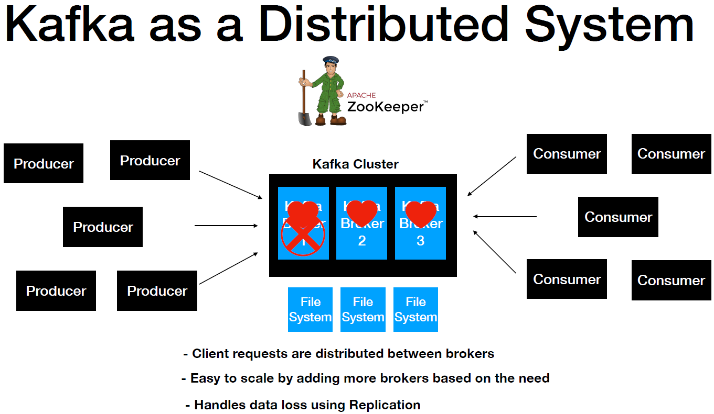

If one of the broker goes down then the cluster manager which is the zookeeper here gets notified then all the client requests will be routed to the other available brokers. Clients won't have any clue that an issue is going on. It is easy to scale the number of brokers in the cluster without affecting the clients. I mentioned about Kafka retains the record and a file system and each broker will have its own file system in the even in failure.

* How were Kafka handle data loss. Kafka handles it using replication.

**Kafka Cluster with 3 Brokers**

We will set up the Kafka cluster with three brokers in our machine. So far we have one broker running in our machine. We have launched the Kafka broker using this command and the several properties file is passed as a parameter. This starts up the Kafka broker in our machine.

kafka-server-start.bat ..\..\config\server.properties

So in order to start up multiple Kafka brokers what needs to be done. We need to have a new server.properties file in our machine and the properties should have a unique value compared to the other. So server.properties file example configuration would look like this. We already have a broker with the ID zero. So we are using one here, the broker port that's been used in our machine is in 1992. So here we have a different port 9093, the log directory is Kafka logs-1 and the order to create topic property is set as false here but that's an optional value.

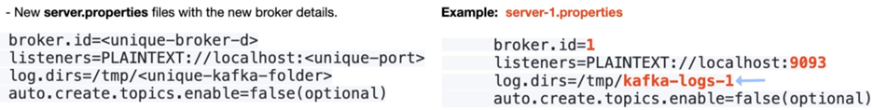

Now it's time to set up the multiple Kafka brokered set up in our local machine. I'm going to go to the bin directory of Kafka distribution. So here I have a zookeeper and a Kafka broker up and running and my machine. What I'm going to do I'm going to create a new window and then I'm going to go to the Kafka distribution and then into config directory.

**server-1.properties**

############################# Server Basics #############################

# The id of the broker. This must be set to a unique integer for each broker.

broker.id=1

############################# Socket Server Settings #############################

# The address the socket server listens on. It will get the value returned from

# java.net.InetAddress.getCanonicalHostName() if not configured.

# FORMAT:

# listeners = listener_name://host_name:port

# EXAMPLE:

# listeners = PLAINTEXT://your.host.name:9092

listeners=PLAINTEXT://:9093

auto.create.topics.enable=false

. . .

############################# Log Basics #############################

# A comma separated list of directories under which to store log files

log.dirs=/tmp/kafka-logs-1

# The default number of log partitions per topic. More partitions allow greater

# parallelism for consumption, but this will also result in more files across

# the brokers.

num.partitions=1

So these are the properties that needs to be modified in order to start up a new broker. So now let's go back to the terminal so in the terminal we have that ready. The second property file that I'm going to name this one as server2.properties. Let's do the same thing.

**server-2.properties**

############################# Server Basics #############################

# The id of the broker. This must be set to a unique integer for each broker.

broker.id=2

############################# Socket Server Settings #############################

# The address the socket server listens on. It will get the value returned from

# java.net.InetAddress.getCanonicalHostName() if not configured.

# FORMAT:

# listeners = listener_name://host_name:port

# EXAMPLE:

# listeners = PLAINTEXT://your.host.name:9092

listeners=PLAINTEXT://:9094

auto.create.topics.enable=false

############################# Log Basics #############################

# A comma separated list of directories under which to store log files

log.dirs=/tmp/kafka-logs-2

Now what we will do will go ahead and start this Kafka brokers.

So now we have a Kafka cluster which is up and running in our machine that has three brokers. Now it's time to create a new topic and then they will try to produce and consume the message. The nuclear sub set up. The first thing is we are going to create a new topic. So I'm in the bin directory of the Kafka distribution. I'm going to bump up the replication factor to three. Normally this is recommended if you're using a cluster setup and this value should be a equal to or less than the number of brokers that you have in the Kafka cluster. In here we have three brokers right. So I'm going to give the replication factor value was three and we already have the this-topic right. So I'm going to name this one second-topic and I'm going to change the partition values from four to three. I'm just trying to keep it in sync with the number of brokers that we have. It doesn't matter you can have any number of values you want. I'm just giving the values three here.

**Create a Topic**

$ kafka-topics.bat --create --topic second-topic

--zookeeper localhost:2181

**--replication-factor** 3

**--partitions** 3

Created topic second-topic.

So now we have the create topic that's topic replicated created in your machine. Now what we will do we will try to produce and consume to this topic.

**To produce to this topic**

C:\>kafka-console-producer.bat

--broker-list localhost:9092

--topic second-topic

>

So now the producer is ready. It's time to instantiate the consumer.

**To Consume from this Topic**

C:\>kafka-console-consumer.bat

--bootstrap-server localhost:9092

--topic second-topic

--from-beginning

So now we have the producer and consumer up and running.

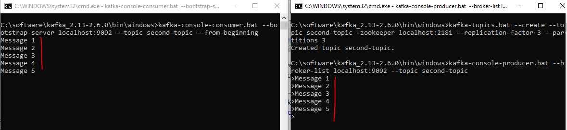

Now the most interesting part is that we have created three new folders right. Let's go ahead and check what do we have in that one actually. So I'm going to shut down the producer and then let me do a clear. So if you take a look at the configuration we have created Kafka logs to Kafka logs one right. So we have created all those new log directories for the new broker.

|  |  |
| --- | --- |
|  | So all these are a representation of each broker. Now each broker got a new folder. That's where it is actually replicating not replicating. That is where it is basically persisting all the messages that are produced to a particular broker. So we have three different directories for each and every broker. So as part of this lecture we have successfully created a Kafka cluster with three brokers and created a topic in the cluster and successfully produced and consumed new messages into the Kafka cluster. |

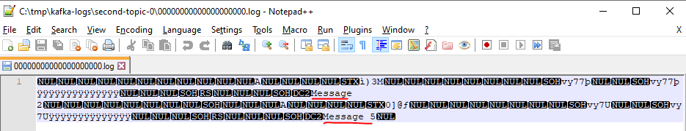

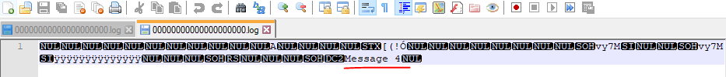

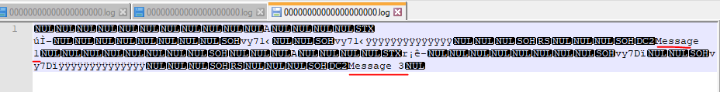

**Topics Distribution**

We now will learn about how Kafka distributes the client request between the brokers before we get to the details of how Kafka distributes a client request. I would like to take a step back and explain about how Kafka topics are distributed across the available brokers.

* At first we have a zookeeper and a Kafka cluster. In this e.g. we have a cluster but 3 brokers.
* One of the available broker will behave as a controller. Normally this is the first broker to join the cluster. Think of this as one additional role for the broker.

Now we have the environment completely set.

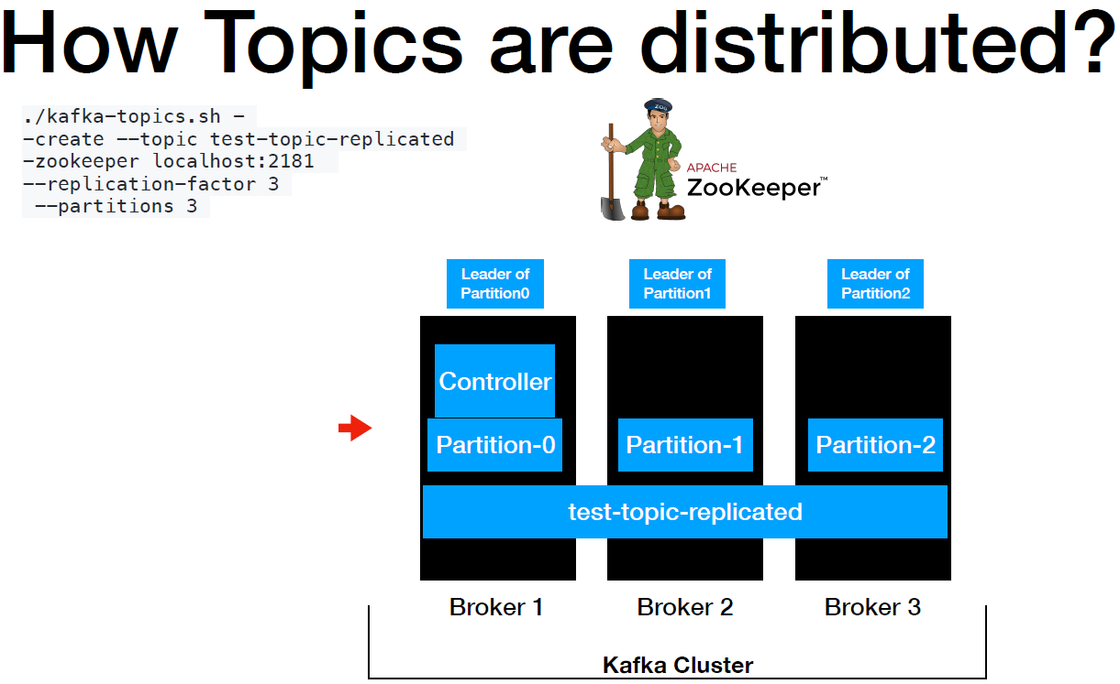

* Now it's time to create the topic. The zookeeper takes care of redirecting this request to the controller. The role of this controller is to distribute the ownership of the partitions to the available broker. So in this example we have partition-0 sitting in Broker 1, partition-1 sitting in Broker 2 and partition-2 sitting in Broker 3.
* In distributed systems this concept of distributing partitions to the brokers is called a **Leader Assignment**. So in a nutshell the topic is distributed across the Kafka cluster. Now the topic is distributed right. It's time to learn about how does the cluster handle the connection from the client's.

Let's look at the producer first, if you can recall from one of the previous lectures, producer has a layer called partitioner which takes care of determining which partition the message is going to go, so the producer sends the first message ABC. It goes to the partitioner before the messages is sent to the Kafka topic. The partitioner determines that this message should go to partition-0. In this case the leader of partition-0 is Broker 1. So the message will be sent to Broker 1.

* The client will always invoke the leader of the partition.

After that the message is persisted into the file system of Broker 1. The process is repeated for the following messages. Now we have another message DEF, It goes to the partitioner, the partitioner resolves to partition one and the leader of the partition one is Broker 2. So the request is directed to the Broker 2 and it gets persisted into the file system of broker 2. Next the message is UHI, it follows the same step, the message resolves it to partition 2 and the leader of the partition 2 is broker 3. So the message is directed to broker 3. So as you can see the client request from the producer are distributed between the brokers based on the partition, which indirectly means that the load is distributed between the brokers.

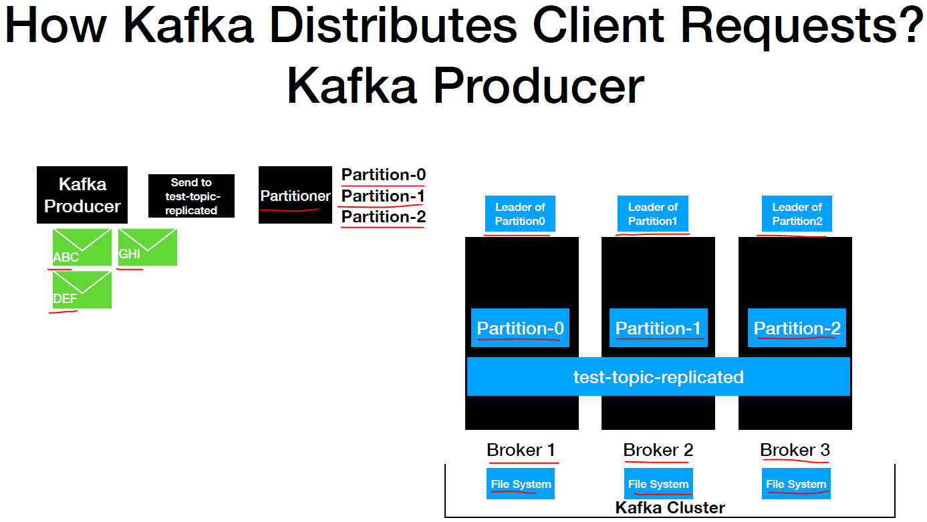

* Now it's time to look at how the client requests are distributed from the Kafka consumer and we have the consumer ready to pull from the replicated topic when the poll loop is executed. The request goes to all the partitions and retrieve the records from them. Each broker owns a partition. In this case the poll loop request goes to all the brokers and retrieves the record from them and retrieved records are handed over to the consumer and. The consumer processes the records successfully and the same flow repeats. So in a nutshell even from the consumer end the request to retrieve the data are distributed between the brokers. Basically the client call then only goes to the partition leader of the topic and retrieves the data.

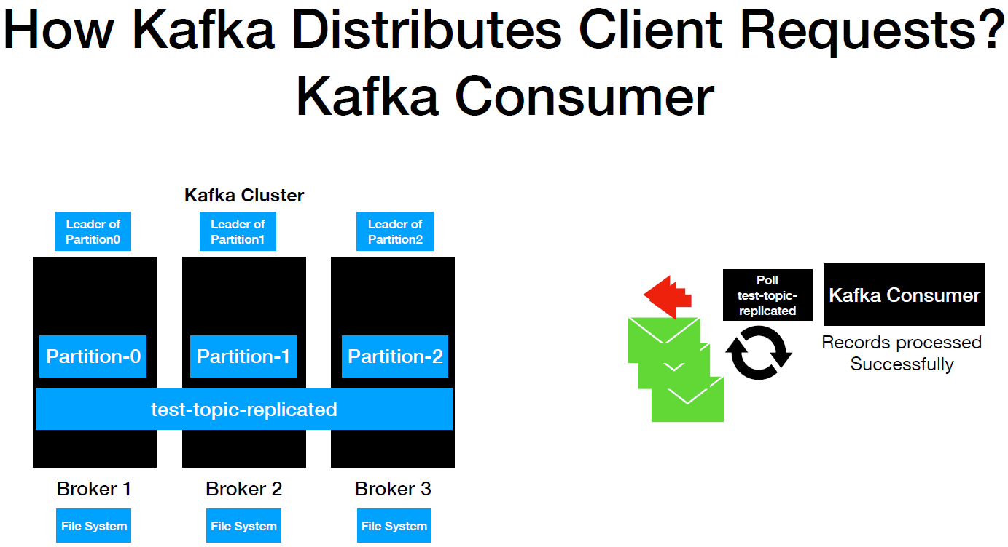

Now let's take a look at the Kafka consumer flow through consumer groups because it is a common practice to run multiple instances of the consumer and process the records from the Kafka topic. So in here we have three instances of the consumer with the same group ID. If you cant recall from the concepts of consumer groups, if there are one or more instances of the consumer with the same group ID then the partitions are distributed for scalable message consumption. So in here each consumer instance has one partition assigned then the poll gets executed. Each instance is going to poll the data from the partition that they are interested in and the poll call goes to the leader of the partition of the topic and retrieves the data. So in here partition 0 call goes to Broker 1 and partition one call goes to Broker 2 and so on and the process repeats. Let's quickly summarize what we had learned so far partition leaders are assigned during topic creation. Any clients irrespective of the producer or consumer will invoke the leader of the partition to produce or consume data but thus the load is evenly distributed by invoking the partition leaders.

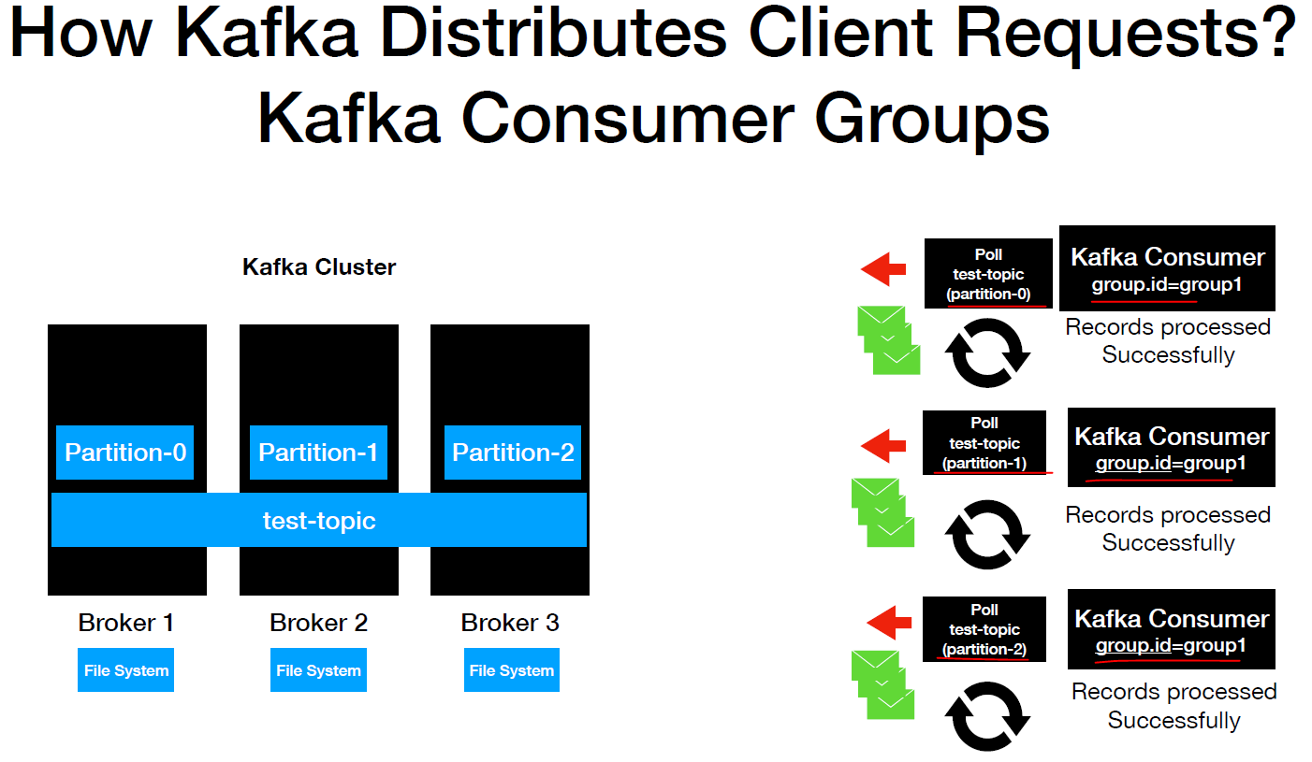

**Summary : How Kafka Distributes the Client Requests?**

* Partition leaders are assigned during topic Creation
* Clients will only invoke leader of the partition to produce and consume data
* Load is evenly distributed between the brokers

**Handle Data Loss**

In this lecture we will learn about how Kafka handles data loss in the event of a broker failure in here. We have a a cluster and a representation of how the topic is distributed across the cluster and we have some records present in the file system. As we all know by now the clients which are the producers and consumers always talk to the leader to retrieve the data from a partition. Let's say the broker one goes down for some reason right now.

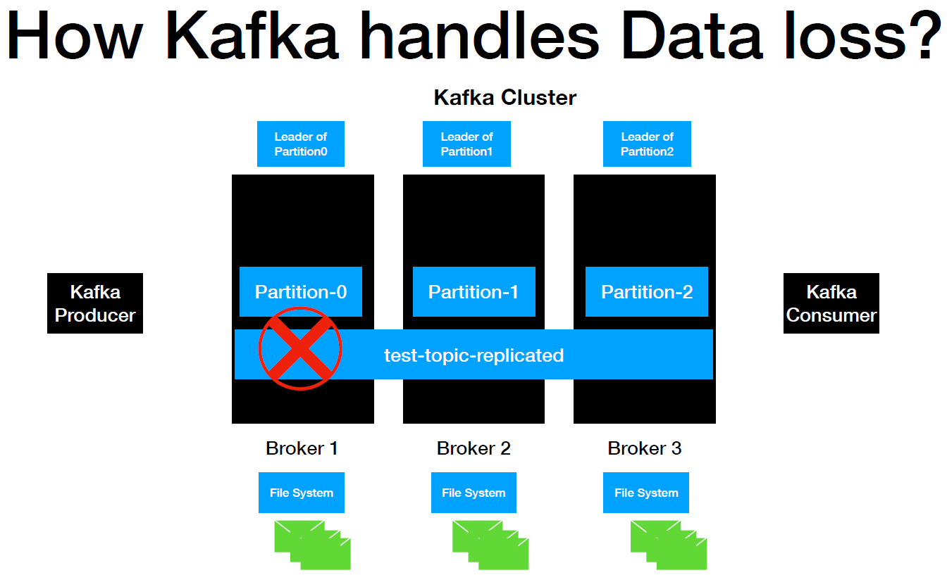

This is the broker which is the leader of partition-0, all the data which is returned to partition-0 is residing in the filesystem of this Broker-1. Once it goes down there is no way for the clients to access this data. This is a data loss actually and it's a big problem. Now it's time to learn about how does Kafka handle this issue. Kafka handles this issue using replication. If we all can recall this command when we created the topic. I did mention that I will explain about the significance of replication factor and we did provide the value as three.

$ ./kafka-topics.sh - -create --topic test-topic-replicated

-zookeeper localhost:2181 **--replication-factor 3** --partitions 3

Let me quickly demonstrate how it works in here we have a Kafka producer on the left which produces the message to partition zero.

|  |  |
| --- | --- |
|  | And it goes to the leader which is the broker one and after the message is received with a broker one the message is persisted into the filesystem. Now the broker one is the leader replica. If we can look at that application factories three right now we have one copy of the actual message. Since that application factory's three we need two more copies of the same message. So replication factors equal to number of copies of the same message.  So the next step is the same messages copied to broker 2 and it gets written into the filesystem. So Broker 2 is the follower of partition-0 which is also known as the **follower** **replica**. And the same step is repeated for Broker 3. |

Now we have three copies of the same data up available in all the brokers in Kafka terminology. This concept is called an application and the replica of the leader is called the **leader replica**. And the other two replicas are called follower replicas and the same technique is applicable far Broker 2 in here. Any message that's sent to the broker too is copied into the broker 1 and broker 2 which behaves as a follower replicas and the same thing for broker 3 to. So now it's time to revisit the flow with the failure of one broker. Now we have the leader to pick us for each and every partition and the follower replicas right. Let's say the broker one is down but still the data of the partition is available in Broker 2 and Broker 3 right zookeeper gets notified about the failure and it assigns the new leader to the controller. Now the broker 2 is the leader of partition zero and partition one this leader assignment is taken care by the **control node** which is a part of the customer actually. So now the client's request for producing and consuming the data for partition-0 will go to Broker 2 hereafter. So this is how Kafka handles the loss and that's all about replication and Kafka.

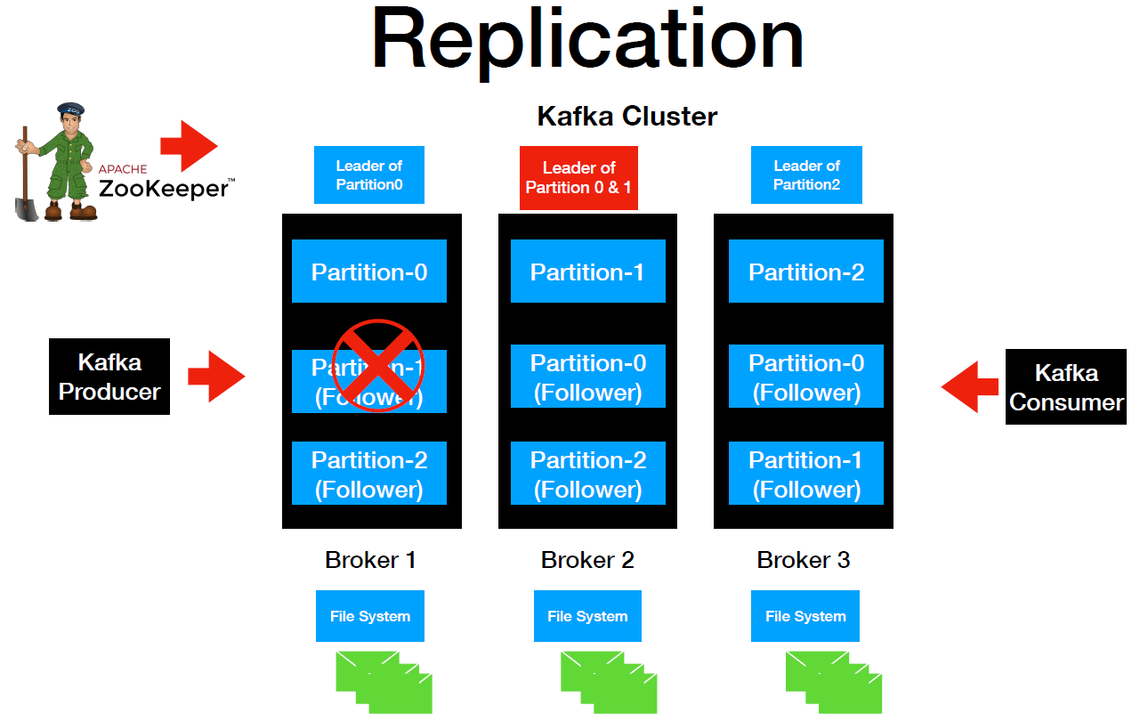

**In-Sync Replica**

Now it's time to introduce you all to the new concept in Kafka which is **In-Sync Replica**. This represents the number of replica in sync with each other and the Kafka cluster. This includes both the leader and follower replica. The in-sync replica is always recommended to be greater than one. The ideal state of replication is ISR == Replication factor. ISR is also called N Sync. I'll pick up. The N Sync replica can be controlled by the min.insync.replicas property, this can be set at the Broker level or at the topic level.

**In-Sync Replica(ISR)**

* Represents the number of replica in sync with each other in the cluster
* Includes both leader and follower replica
* Recommended value is always greater than 1
* Ideal value is ISR == Replication Factor
* This can be controlled by min.insync.replicas property
* It can be set at the broker or topic level

Let's quickly look at the application and ISR value in our local machine, so here is where is the representation of the Broker cluster. I have a zookeeper and all the three brokers up and running in my machine and what we will do was, we will look at what is the replication values and who is the leader and in-sync replica and more so I'm going to go to the terminal. So I go to the bin directory of the terminal there you go. There is a command in order to check who's the leader who is it because of the partition and you sort of value.

## Describe topic

$ kafka-topics.bat --zookeeper localhost:2181 --describe

C:\Users\Dimpu>kafka-topics.bat --zookeeper localhost:2181 --describe

Topic: __consumer_offsets PartitionCount: 50 ReplicationFactor: 1 Configs: compression.type=producer,cleanup.policy=compact,segment.bytes=104857600

Topic: __consumer_offsets Partition: 0 Leader: 2 Replicas: 2 Isr: 2

Topic: __consumer_offsets Partition: 1 Leader: 0 Replicas: 0 Isr: 0

Topic: __consumer_offsets Partition: 2 Leader: 1 Replicas: 1 Isr: 1

Topic: __consumer_offsets Partition: 3 Leader: 2 Replicas: 2 Isr: 2

Topic: __consumer_offsets Partition: 4 Leader: 0 Replicas: 0 Isr: 0

Topic: __consumer_offsets Partition: 5 Leader: 1 Replicas: 1 Isr: 1

Topic: __consumer_offsets Partition: 6 Leader: 2 Replicas: 2 Isr: 2

Topic: __consumer_offsets Partition: 7 Leader: 0 Replicas: 0 Isr: 0

Topic: __consumer_offsets Partition: 8 Leader: 1 Replicas: 1 Isr: 1

Topic: __consumer_offsets Partition: 9 Leader: 2 Replicas: 2 Isr: 2

Topic: __consumer_offsets Partition: 10 Leader: 0 Replicas: 0 Isr: 0

Topic: __consumer_offsets Partition: 11 Leader: 1 Replicas: 1 Isr: 1

Topic: __consumer_offsets Partition: 12 Leader: 2 Replicas: 2 Isr: 2

Topic: __consumer_offsets Partition: 13 Leader: 0 Replicas: 0 Isr: 0

Topic: __consumer_offsets Partition: 14 Leader: 1 Replicas: 1 Isr: 1

Topic: __consumer_offsets Partition: 15 Leader: 2 Replicas: 2 Isr: 2

Topic: __consumer_offsets Partition: 16 Leader: 0 Replicas: 0 Isr: 0

Topic: __consumer_offsets Partition: 17 Leader: 1 Replicas: 1 Isr: 1

Topic: __consumer_offsets Partition: 18 Leader: 2 Replicas: 2 Isr: 2

Topic: __consumer_offsets Partition: 19 Leader: 0 Replicas: 0 Isr: 0

Topic: __consumer_offsets Partition: 20 Leader: 1 Replicas: 1 Isr: 1

Topic: __consumer_offsets Partition: 21 Leader: 2 Replicas: 2 Isr: 2

Topic: __consumer_offsets Partition: 22 Leader: 0 Replicas: 0 Isr: 0

. . .

Topic: __consumer_offsets Partition: 46 Leader: 0 Replicas: 0 Isr: 0

Topic: __consumer_offsets Partition: 47 Leader: 1 Replicas: 1 Isr: 1

Topic: __consumer_offsets Partition: 48 Leader: 2 Replicas: 2 Isr: 2

Topic: __consumer_offsets Partition: 49 Leader: 0 Replicas: 0 Isr: 0

Topic: second-topic PartitionCount: 3 ReplicationFactor: 3 Configs:

Topic: second-topic Partition: 0 Leader: 1 Replicas: 1,2,0 Isr: 1,2,0

Topic: second-topic Partition: 1 Leader: 2 Replicas: 2,0,1 Isr: 2,0,1

Topic: second-topic Partition: 2 Leader: 0 Replicas: 0,1,2 Isr: 0,1,2

We got a bunch of results actually if you look at it. Number one is the __consumer offsets. This particular offset topic is created by Kafka. And after that we have two additional topics that we created for this course. Number one the is second-topic. This topic is replicated so we can override this command. For this command, we can pass a specific topic. So if we do this and pass the topic name, this is going to just give me the result of does not want actually let me do a clear. So now we have the second-topic topic. And then after that we have a partition-0, partition-1 and partition-2.

C:\Users\Dimpu>kafka-topics.bat --zookeeper localhost:2181 --describe --topic second-topic

Topic: second-topic PartitionCount: 3 ReplicationFactor: 3 Configs:

Topic: second-topic Partition: 0 Leader: **1** Replicas: **1,2,0** Isr: **1,2,0**

Topic: second-topic Partition: 1 Leader: **2** Replicas: **2,0,1** Isr: **2,0,1**

Topic: second-topic Partition: 2 Leader: **0** Replicas: **0,1,2** Isr: **0,1,2**

So **those numbers later 0 2 1**. This is the broker ID. So for partition 2 the leaders is broker 0 and for partition 1 the leader is broker 2 and for partition 0 the leader is broker 1 actually, and then the replicas **this one is a leader replica** **and the others are follower replicas.** As you can see the leader is 1 right in the replicas values 1, 2, 0. So number 1 is a leader replica, number two and zero are the follower replicas. Because the same is applicable for the other two partitions and the In Sync Replicas (ISR).

**So In Sync Replicas, guys basically equal to the replicas here.** This means that In Sync Replica is 100 percent. Basically the data is replicated in all the available brokers for just equal to that application factor.

Now in order to make this more interesting what I'm going to do is I'm going to bring one of the broker down and then I'll show you the In Sync Replica value. So I'm going to bring one broker down it's shutting down as you can see. And the broker is done. Now let's go ahead and check. What do we have for the In Sync Replica. So the broker goes down.

C:\Users\Dimpu>kafka-topics.bat --zookeeper localhost:2181 --describe --topic second-topic

Topic: second-topic PartitionCount: 3 ReplicationFactor: 3 Configs:

Topic: second-topic Partition: 0 Leader: 1 Replicas: 1,2,0 Isr: **1,0**

Topic: second-topic Partition: 1 Leader: 0 Replicas: 2,0,1 Isr: **0,1**

Topic: second-topic Partition: 2 Leader: 0 Replicas: 0,1,2 Isr: **0,1**

Now the zookeeper received the actual signal. Hey there is a broker which is down and what it will do was it will reassign the leader and in the ISR group like a value will go down actually. Let's do this. Now if we look at it dilutes our value was just 1 and 0 the broker 2 is down. That's one reason why you don't see this value here. And if you look at it for partition 1 the previous leader was later 2. Now though for the partition 1 the leader is 0. **So broker 0 is a leader for partition 1 and 2** there are advanced setup that you can do in order to have two brokers always available. If you provide the **min.insync.replicas** values as 2 then in that case it will always make sure the data can only be produced with the topic if there are 2 brokers available.

Fault Tolerance & Robustness in Kafka

Please make sure you have the zookeeper and the Kafka cluster instances up and running in your machine. So I have a three broker cluster which is running in my machine. I'm going to go to the other terminal. So in this terminal I have a console producer and a console consumer instance up and running and the topic that we are going to use as second-topic. I'm going to send a message called Message 1. As soon as I produce a message consumers able to read the message. So now we have our active producer and consumer instance which is able to read the messages from the topic which is created in our Kafka cluster. Now what I'm going to do is just for the fun of it I'm going to bring one of the broker down as soon as I brought one of the broker down. We see a warning here. This is just a warning right. So here it says like broker may not be available.

C:\> kafka-console-consumer.bat --bootstrap-server localhost:9092 --topic second-topic

My Message

[2020-12-19 12:10:22,985] WARN [Consumer clientId=consumer-console-consumer-17864-1, groupId=console-consumer-17864] Connection to node 2147483645 (DESKTOP-PEI24P3/172.30.0.1:9094) could not be established. Broker may not be available. (org.apache.kafka.clients.NetworkClient)

What I'm going to do is I'm going to check for the is my consumer completely crashed are actively pulling the records from the Kafka cluster. Now what I'm going to do I'm going to send a message called Are you still there. As soon as I produce a message here I'm able to still receive the message. So we did see a warning here just to call us out. All these are warnings basically. Now Let's type in on my message a low and I'm still able to produce and consume the message from the coffee cluster. So from a client perspective even though the server which is a coffee cluster has some issues going on it does not impact the clients. Clients are still going to work as expected. This is one of the far tolerance behavior which I wanted to showcase to you guys. This is where Kafka shines basically. So it takes care of error handling for you. And from a client perspective you don't have to worry much about it.

< Need more material, if we kill the Kafka broker that was using the port 9092, then the producer and consumer are not linked up and new messages don’t arrive > - Needs more work here.

**Library Application**

The application that we're going to build is for the library. To be more precise we are going to build a library inventory application. So we have a librarian and the library inventory as new books are in the library. The librarian needs to scan those books before it's moved to the shelf. Let's quickly start with a simplistic view of the application architecture, librarian scans and this can be categorized as events for that purpose. We are going to have a Kafka topic named library events. Now the floor would look like this, as the librarian scans the new books which are treated as events, in here gets published into the library events topic.

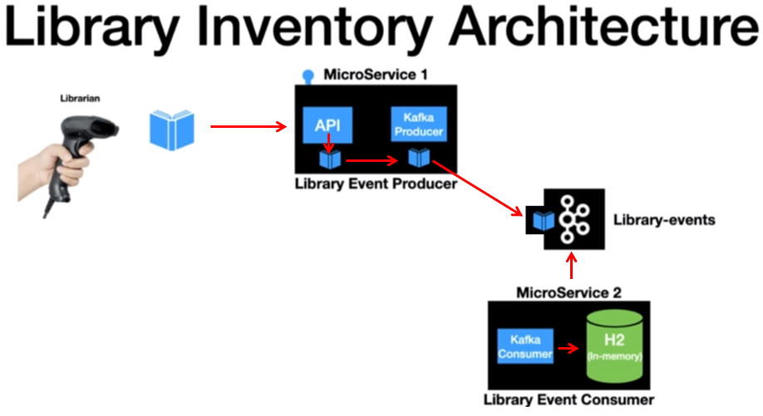

What we have here is a simplistic view of the library scans and its related flow of evens. A full blown architecture would look like this. You have two Microservices here. One is a library event producer and the other one is a library event consumer. Microservices are in place. So the librarian scans the book and the library event producer has an API exposed which gets invoked as soon as the books scanned from the API. It goes to the next layer which is the Kafka producer. And after that there Record gets published into the Kafka topic. The second application which is the library event consumer which is continuously pulling for new records in the library events topics. As soon as a new record is published on the topic, the consumer is going to read those events and start processing them here. The processing logic is to read the message and persist the library scan event into the in-memory database. I have using the in-memory H2 database here. This will be the end of the library scan. Even so this is the library inventory application that we are going to build as part of this course.

curl -i -d "{\"libraryEventId\":null,\"book\":{\"bookId\":456,\"bookName\":\"Kafka Using Spring Boot\",\"bookAuthor\":\"Lalit\"}}"

-H "Content-Type: application/json"

-X POST http://localhost:9000/v1/libraryevent

HTTP/1.1 201

Content-Type: application/json

Transfer-Encoding: chunked

Date: Sat, 19 Dec 2020 09:45:58 GMT

{"libraryEventId":null,"libraryEventType":"NEW","book":{"bookId":456,"bookName":"Kafka Using Spring Boot","bookAuthor":"Lalit"}}

**Consumer Application Log**

2020-12-19 14:38:10.379 INFO 8904 --- [ main] c.l.k.LibraryEventsConsumerApplication : Started LibraryEventsConsumerApplication in 10.27 seconds (JVM running for 11.839)

2020-12-19 15:15:59.907 INFO 8904 --- [ntainer#0-2-C-1] c.l.k.c.LibraryEventsConsumer : **ConsumerRecord** : **ConsumerRecord**(topic = library-events, partition = 2, leaderEpoch = 0, offset = 0, CreateTime = 1608371158971, serialized key size = -1, serialized value size = 128, headers = RecordHeaders(headers = [RecordHeader(key = event-source, value = [115, 99, 97, 110, 110, 101, 114])], isReadOnly = false), key = null, value = {"libraryEventId":null,"libraryEventType":"NEW","book":{"bookId":456,"bookName":"Kafka Using Spring Boot","bookAuthor":"Lalit"}})

2020-12-19 15:15:59.945 INFO 8904 --- [ntainer#0-2-C-1] c.l.k.s.LibraryEventsService : libraryEvent : LibraryEvent(libraryEventId=null, libraryEventType=NEW)

2020-12-19 15:15:59.988 INFO 8904 --- [ntainer#0-2-C-1] c.l.k.s.LibraryEventsService : Successfully Persisted the libary Event LibraryEvent(libraryEventId=1, libraryEventType=NEW)

**Source Code**

Generated a project from Spring Initializr with following dependencies

* Kafka
* Web
* Lombok

Using Java 11 for this project

**Kafka Producer**

**Post API**

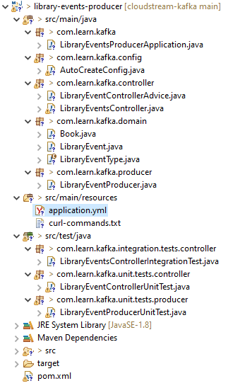

**pom.xml**

<?xml version=*"1.0"* encoding=*"UTF-8"*?>

<project xmlns=*"http://maven.apache.org/POM/4.0.0"* xmlns:xsi=*"http://www.w3.org/2001/XMLSchema-instance"*

xsi:schemaLocation=*"http://maven.apache.org/POM/4.0.0 https://maven.apache.org/xsd/maven-4.0.0.xsd"*>

<modelVersion>4.0.0</modelVersion>

<parent>

<groupId>org.springframework.boot</groupId>

<artifactId>spring-boot-starter-parent</artifactId>

<version>2.3.1.RELEASE</version>

<relativePath/> <!-- lookup parent from repository -->

</parent>

<groupId>com.learn.kafka</groupId>

<artifactId>01-library-events-producer</artifactId>

<version>0.0.1-SNAPSHOT</version>

<name>01-library-events-producer</name>

<description>Kafka Spring Cloud Streaming</description>

<properties>

<java.version>1.11</java.version>

</properties>

<dependencies>

<dependency>

<groupId>org.springframework.boot</groupId>

<artifactId>spring-boot-starter-data-jpa</artifactId>

</dependency>

<dependency>

<groupId>org.springframework.boot</groupId>

<artifactId>spring-boot-starter-web</artifactId>

<exclusions>

<exclusion>

<groupId>org.springframework.boot</groupId>

<artifactId>spring-boot-starter-logging</artifactId>

</exclusion>

</exclusions>

</dependency>

<dependency>

<groupId>org.springframework.boot</groupId>

<artifactId>spring-boot-starter-log4j2</artifactId>

</dependency>

<dependency>

<groupId>org.springframework.kafka</groupId>

<artifactId>spring-kafka</artifactId>

</dependency>

<dependency>

<groupId>org.springframework.boot</groupId>

<artifactId>spring-boot-starter-validation</artifactId>

</dependency>

<dependency>

<groupId>com.h2database</groupId>

<artifactId>h2</artifactId>

</dependency>

<dependency>

<groupId>com.h2database</groupId>

<artifactId>h2</artifactId>

<scope>runtime</scope>

</dependency>

<dependency>

<groupId>org.projectlombok</groupId>

<artifactId>lombok</artifactId>

<version>1.18.4</version>

<scope>provided</scope>

</dependency>

<dependency>

<groupId>org.springframework.kafka</groupId>

<artifactId>spring-kafka-test</artifactId>

<scope>test</scope>

</dependency>

<dependency>

<groupId>org.springframework.boot</groupId>

<artifactId>spring-boot-starter-test</artifactId>

<scope>test</scope>

<exclusions>

<exclusion>

<groupId>org.junit.vintage</groupId>

<artifactId>junit-vintage-engine</artifactId>

</exclusion>

</exclusions>

</dependency>

</dependencies>

<build>

<plugins>

<plugin>

<groupId>org.springframework.boot</groupId>

<artifactId>spring-boot-maven-plugin</artifactId>

</plugin>

</plugins>

</build>

</project>

We will set up the LibraryEvent domain that's going to be received from the scanner to the API. Let's add some Lombok related annotations here. @AllArgsConstructor @NoArgsConstructor @Data. So our data is going to generate the actual getters and setters to string and all those methods. And after that I'm going to have a @Build annotation. If you have not worked on Lombok that's OK. All you need to know is this annotation

@AllArgsConstructor is going to generate the all args constructor for this particular domain object.

@NoArgsConstructor that's going to generate no args constructor.

@Data annotation is going to generate the getter setter and two string methods

@Builder is going to give you the fluent API style of building this LibraryEvent domain.

In addition to this it's going to have the information about the book. So for that purpose what I'm going to do is I'm going to create a book class so book is again another domain object.

|  |  |
| --- | --- |
| **LibraryEvent.java**  import lombok.AllArgsConstructor;  import lombok.Builder;  import lombok.Data;  import lombok.NoArgsConstructor;  import javax.validation.Valid;  import javax.validation.constraints.NotNull;  @AllArgsConstructor  @NoArgsConstructor  @Data  @Builder  public class LibraryEvent {  private Integer libraryEventId;  private LibraryEventType libraryEventType;  @NotNull  @Valid  private Book book;  } | **Book.java**  import lombok.AllArgsConstructor;  import lombok.Builder;  import lombok.Data;  import lombok.NoArgsConstructor;  import javax.validation.constraints.NotBlank;  import javax.validation.constraints.NotNull;  @AllArgsConstructor  @NoArgsConstructor  @Data  @Builder  public class **Book** {    @NotNull  private Integer bookId;  @NotBlank  private String bookName;  @NotBlank  private String bookAuthor;  } |

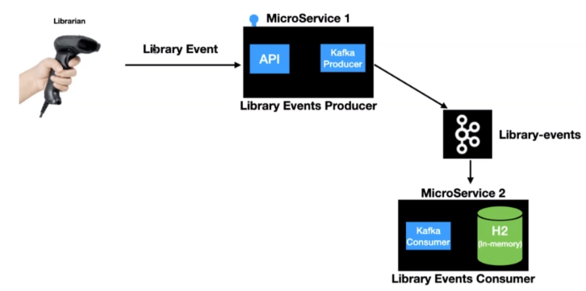

So the next step is let's build and expose the REST API which will allow the clients to post the library scans into the library Event Producer Microservice. Before we get to the coding part let me give you an overview of the two different flows that our API is going to support the first flow is scanning a new book meaning adding a new book to the library inventory for this purpose. We are going to build up posts endpoint the second flow is upgrading a book which is already there and the inventory for this purpose. We are going to build the endpoint in the LibraryEventsProducer Microservice that will build the post endpoint first.

The first thing that we are going to do first we are going to add the REST controller annotation. I hope you all already have experience building RESTful API is using Springboard because the scope of this course is to teach you on how to build Kafka clients using Spring Boot not necessarily using Spring Boot. So by adding that as controller we are going to make this class behave like an endpoint. The next thing is we are going to add a post mapping. So we are going to create a post mapping and then let's give you all so that you all is going to be /v1/libraryevent. Even so that's a domain that we are going to receive as part of this endpoint right. This is going to return a ResponseEntity of type LibraryEvent and let's give it a name, it's going to postLibraryEvent. This one is going to receive RequestBody. The RequestBody is going to be LibraryEvent. We're going to invoke the Kafka producer, so that's the code that we will be writing in the following lectures. So the next thing is we are going to return the ResponseEntity of type status. I'm going to have the status returned as HttpStatus.CREATED. So it's a post endpoint. Even though we're not going to be persisting anything in this Microservice, I'm still going to send the response as HttpStatus.CREATED created and the body is going to be the same LibraryEvent that we received as part of the request. So now we have the end point which is bold and it is ready to serve the incoming client request. Let me quickly show you whether this end point is returning the status off 201, 201 is nothing but creator status. What we will do is it will start this application. So when we created this project from Spring initially there this is the class which gets created for you automatically. And it has annotation off at @SpringBootApplication. So let's run this one, very good application started successfully.

**LibraryEventsController.java**

import com.fasterxml.jackson.core.JsonProcessingException;

import com.learn.kafka.domain.LibraryEvent;

import com.learn.kafka.domain.LibraryEventType;

import com.learn.kafka.producer.LibraryEventProducer;

import lombok.extern.slf4j.Slf4j;

import org.springframework.beans.factory.annotation.Autowired;

import org.springframework.http.HttpStatus;

import org.springframework.http.ResponseEntity;

import org.springframework.kafka.support.SendResult;

import org.springframework.web.bind.annotation.PostMapping;

import org.springframework.web.bind.annotation.PutMapping;

import org.springframework.web.bind.annotation.RequestBody;

import org.springframework.web.bind.annotation.RestController;

import javax.validation.Valid;

import java.util.concurrent.ExecutionException;

@RestController

@Slf4j

public class LibraryEventsController {

@Autowired

LibraryEventProducer libraryEventProducer;

@PostMapping("/v1/libraryevent")

public ResponseEntity<LibraryEvent> postLibraryEvent(@RequestBody @Valid LibraryEvent **libraryEvent**)

throws JsonProcessingException, ExecutionException, InterruptedException {

//invoke kafka producer

**libraryEvent**.setLibraryEventType( LibraryEventType.NEW );

libraryEventProducer.sendLibraryEvent_Approach2( **libraryEvent** );

return ResponseEntity.status( HttpStatus.CREATED ).body( libraryEvent );

}

//PUT

@PutMapping("/v1/libraryevent")

public ResponseEntity<?> putLibraryEvent(@RequestBody @Valid LibraryEvent **libraryEvent**) throws

JsonProcessingException, ExecutionException, InterruptedException {

if( libraryEvent.getLibraryEventId() == null ) {

return ResponseEntity.status( HttpStatus.BAD_REQUEST )

.body("Please pass the LibraryEventId");

}

**libraryEvent**.setLibraryEventType(LibraryEventType.UPDATE);

libraryEventProducer.sendLibraryEvent_Approach2( **libraryEvent** );

return ResponseEntity.status( HttpStatus.OK ).body( **libraryEvent** );

}

}

Now it's time to post the event to the endpoint and then validate that we are receiving the status as 201 or not. So let's go to the terminal and in the terminal I'm going to use the curl Command to post the library event to this end point. So the endpoint is /v1/libraryevent so here is a code command.

**curl-command-to-test**

curl -i -d '{"libraryEventId":null,"book":{"bookId":456,"bookName":"Kafka Using Spring Boot", "bookAuthor":"Lalit"}}'

-H "Content-Type: application/json"

-X POST http://localhost:8080/v1/libraryevent

–i which is going to give us more information as part of the response.

-d stands for data. So the data that we are passing as part of this particular endpoint is a library event. So we have a JSON representation of the LibraryEvent.

–H which stands for header. We are passing the content type as application/json

–X and then the actual method type is PUSH and followed by that we are passing the endpoint. If I press enter.

There you go, I got the response. If we take a look at the response which gives to a one that's the response that we are sending as part of this endpoint. And after that we are just sending the actual LibraryEvent, as part of this particular endpoint but we are manually testing this at this point. We will be writing the integration and unit test cases in the following sections.

We will now learn about the Kafka Producer and Spring provides us with the KafkaTemplate class that's part of Spring to produce messages into the Kafka topic. Here quick analogy is to think of this as a JDBCTemplate for DB interactions. Let me quickly show you the documentation for Spring Kafka Template.

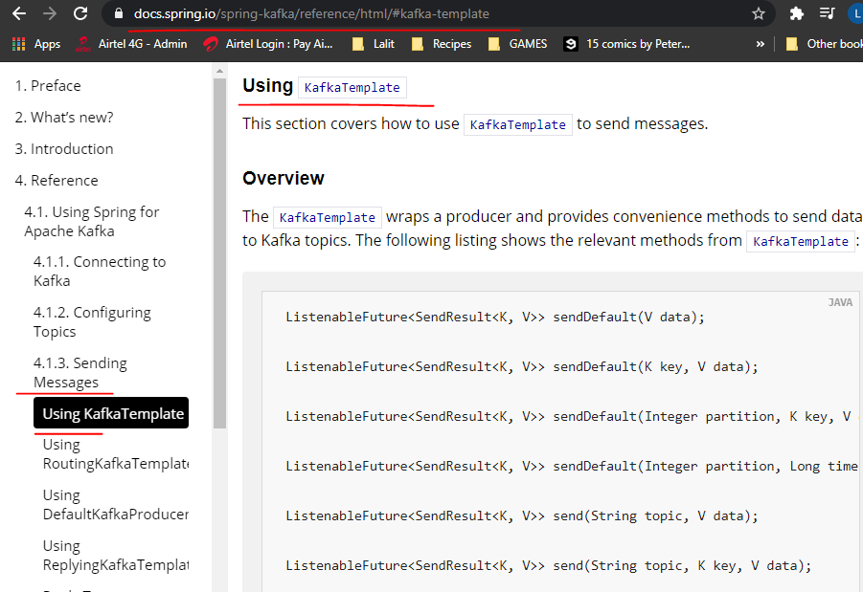

And if you look at it you have many different overloaded versions of Kafka template that are supported. So here we have seen default. It has four different variations. And then you have sendDefault method actually and it has one two three six overloaded types. And we will be exploring some of these as part of this course. So now we have some idea about what is Kafka template. Now the next step is to explore how it works behind the scenes. In a nutshell KafkaTemplate.send is going to send the message to Kafka, but in reality it goes through different layers before the messages sent to Kafka. The very first layer is the serialized or a new record that's sent to the Kafka needs to be serialized to bytes. There are two different types of serialization techniques that's applied to a new record. Number one is the key serializer. And the second one is the value serializer. This configuration is mandatory for any producer. The client needs to provide the key serialize and value.serialize value. The Kafka Client Java libraries comes with some predefined serializers. The second layer is the partitioner, this layer is going to determine which partition the message is going to go into the topic. The Kafka producer API comes up with the default partition logic and in most cases that's enough to handle the partitioning logic and there are options to override this default partition of logic too but for our use case we'll be using the default partition or I'll cover more about partitioning

logic as part of the separate lecture.

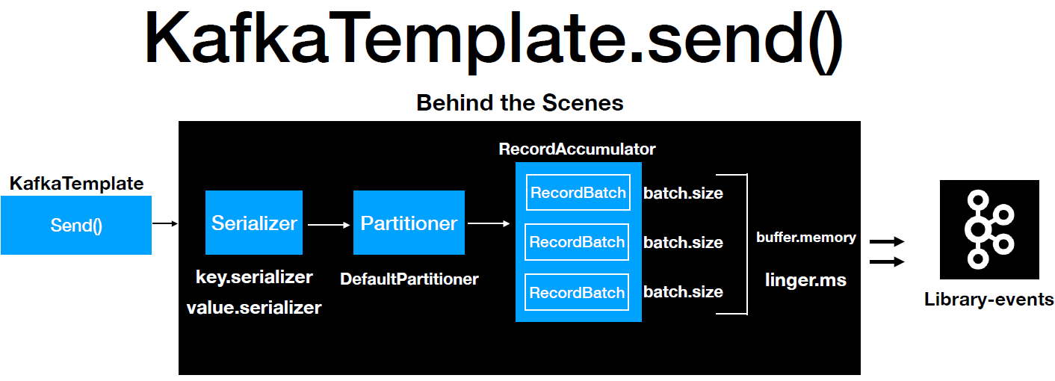

The next layer is the RecordAccumulator. Any record that's sent from the Kafka template won't get sent to the topic immediately. There are RecordAccumulator that buffer the records and the records are sent to the Kafka topic once the buffers for the records are full. This approach is to limit the number of trips from the application to the Kafka cluster and this eventually avoids the overhead of bombarding the Kafka cluster with numerous requests. This also helps in improving the overall performance of the system. The record batch that you see here is a representation of the topic partition combination.

We have a topic with three partitions then you will have three RecordBatch as it's shown here. Every record batch as a batch size which is represented by the batch.size property and the value is represented as number of bytes. It also has a overall buffer memory which is represented by the property buffer.memory and this value is also represented as a number of bytes.

So under what scenarios the messages are sent to look after topic, once the batch is full then the message will be sent to the topic. There may be many scenarios where the RecordBatch won't fill up. The producer API is not going to wait for so long to send the message to the Kafka topic. There is also another handy property called linger.ms which will be used in this case to publish the records into the Kafka topic. As the name suggests this value is represented in millisecond. If the batch is not full and the Records accumulated meets the linger.ms value then the records will be sent to Kafka. So these are the different layers. All the records goes through before it's published to the Kafka topic.

Now the next step is to learn what's needed to configure a Kafka template. To configure the Kafka template we need to provide these mandatory values to configure a simple version of Kafka template. Number one is bootstrap servers which represents the broker address. You can see the value as a localhost:1992,localhost:1993 and localhost:1994. You need to provide a key serializer and value serializer if you remember from our console producer examples. By default it used the String Serializer. So here in this example I have provided the Integer Serializer and this is a very simplistic version. You can write your own key serializer and value serializer for complicated examples. Now we know these are the values to configure the template complete the next step. How do we configure the KafkaTemplate. We can use the Spring Boot auto configuration technique, and this example is what I have used in the application.

**Kafka Template Auto Configuration using Spring Boot Auto Configuration**

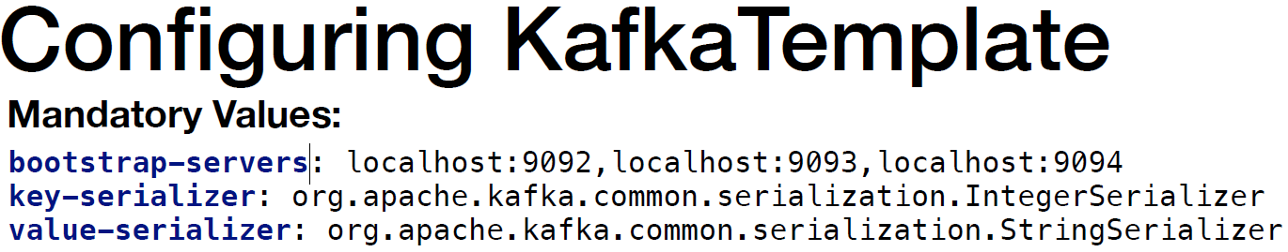

**application.yml**

spring:

profiles:

active: local

server:

port: 9000

---

spring:

profiles: local

kafka:

template:

default-topic: library-events

producer:

bootstrap-servers: localhost:9092,localhost:9093,localhost:9094

key-serializer: org.apache.kafka.common.serialization.IntegerSerializer

value-serializer: org.apache.kafka.common.serialization.StringSerializer

properties:

acks: all

retries: 10

retry.backoff.ms: 1000

admin:

properties:

bootstrap.servers: localhost:9092,localhost:9093,localhost:9094

If we look at the file we have the spring section followed by profiles and after that we have the Kafka section followed by that we have the producer and we are providing all these properties which are the bootstrap servers key serializer and value serializer as part of the application.yml file. This is where a springboot comes in handy and does the magic of reading these properties and configuring the KafkaTemplate for us.

The reason to use the integer serializer is because in the LibraryEvent we have an integer libraryEventId and we are thinking of using that as a key when we publish the message into the topic. The actual value of the payload we are going to use would be string format. So when we are publishing the message into the Kafka topic the key is going to be of type Integer and the payload the actual body is going to be of type String as you proceed further.

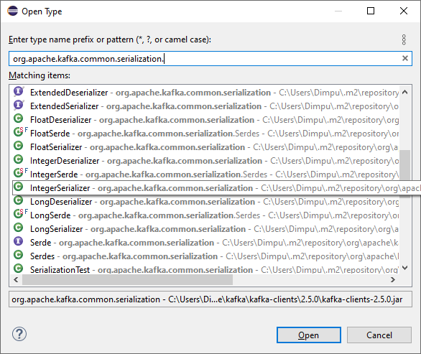

Spring profiles is one of the handy features of SpringBoot which helps developers to maintain the environment specific configuration as part of the application itself. This configuration setup is going to instruct SpringBoot to configure the Kafka template for us. Observe how we have set it up for local, dev and prod environments

Complete configuration with different profiles for different environments could be like this

spring:

profiles:

active: local

---

spring:

profiles: local

kafka:

template:

default-topic: library-events

producer:

bootstrap-servers: localhost:9092,localhost:9093,localhost:9094

key-serializer: org.apache.kafka.common.serialization.IntegerSerializer

value-serializer: org.apache.kafka.common.serialization.StringSerializer

properties:

acks: all

retries: 10

retry.backoff.ms: 1000

admin:

properties:

bootstrap.servers: localhost:9092,localhost:9093,localhost:9094

---

spring:

profiles: nonprod

kafka:

template:

default-topic: library-events

producer:

bootstrap-servers: localhost:9095,localhost:9096,localhost:9097

key-serializer: org.apache.kafka.common.serialization.IntegerSerializer

value-serializer: org.apache.kafka.common.serialization.StringSerializer

ssl:

trust-store-location: file:/Dilip/udemy/kafka-for-developers/ssl/client.truststore.jks

trust-store-password: password

key-store-location: file:/Dilip/udemy/kafka-for-developers/ssl/client.keystore.jks

key-store-password: password

properties:

acks: all

retries: 10

retry.backoff.ms: 1000

security:

protocol: SSL

ssl.endpoint.identification.algorithm:

---

spring:

profiles: prod

kafka:

producer:

bootstrap-servers: prod:9092

key-serializer: org.apache.kafka.common.serialization.IntegerSerializer

value-serializer: org.apache.kafka.common.serialization.StringSerializer

We'll look at how SpringBoot auto configures the Kafka Topic by reading the configurations provided in the application.yml file. We have provided three properties the SpringBoot auto configuration that create the Kafka template for us. How does it work. So the first thing is, let's expand the maven libraries, search for auto. You get this are .springframework.boot.autoconfigure 2.3.1 release. Let's expand this one and in here expand the META-INF directory and it has a file called spring.factories and in here if you search for Kafka you get this KafkaAutoConfiguration. This is the class which reads the application or the yaml file and it looks for those properties and creates the Kafka template for us.

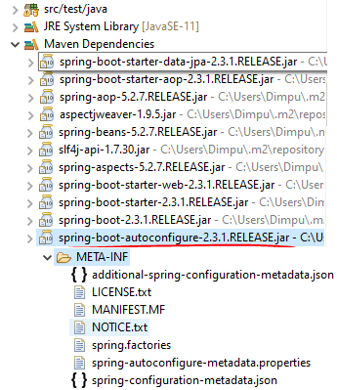 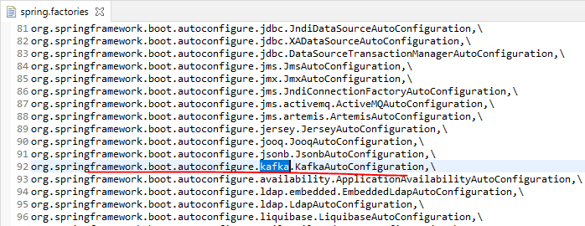

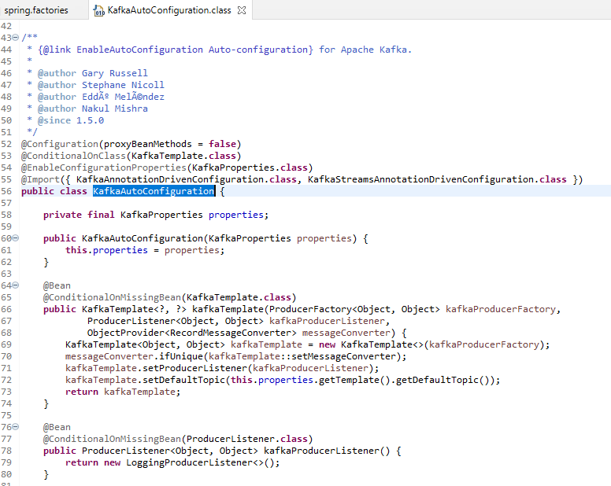

If you look at this class the first thing is @ConditionalOnClass KafkaTemplate.class. What does it mean, it checks for this class in your class and if the KafkaTemplate.class is there then this configuration is going to be enabled. So we have added the spring Kafka dependencies right, in the pom.xml file. So that is going to evaluate this condition to true. The next thing is it's going to enable the KafkaProperties.class. The next thing is as you can see @ConditionalOnMissing KafkaTemplate.class. If you can recall we have not configured anything in our class specifically for Kafka Template. Basically we didn't create any bean explicitly right in our application until now. So what this is going to check is its going to check do we have a bean in the application context. This is going to evaluate to false because we don't have any bean right, so in that case this block is going to get executed and this block takes two properties. Number one is a ProducerFactory and number two is a KafkaProducerListener and number three is the MessageConverter. So let's go out and check what we have in the ProducerFactory. If you scroll a little bit down this is where the ProducerFactory gets created.

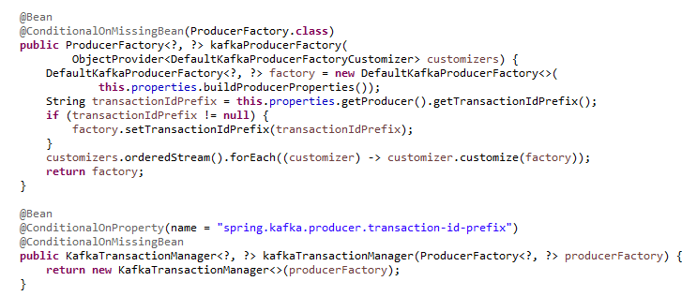

So the ProducerFactory has this call buildProducerProperties. Let's go to that one. And if you look at the file which we are in

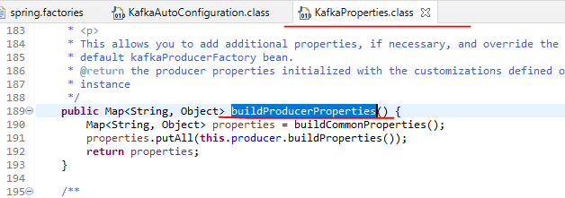

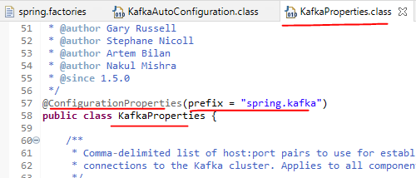 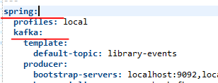

It uses that configuration properties prefix of spring.kafka. This matches with what we have here which is spring.kafka. And in here what are we setting we are setting the producer right. The next thing is we are going to check. Do we have a producer in the Kafka properties that loss is down at line number 80.

|  |  |
| --- | --- |
|  | What are the properties that we are setting, we are setting the producer right. Number one is bootstrap-servers. And if you check line number 454 it has this value which is bootstrap servers have we scroll a little bit down. We have the key serializer. And the value serializer as you can see key serializer and value serializer. |

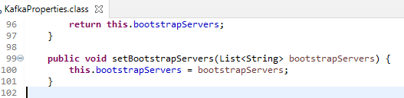 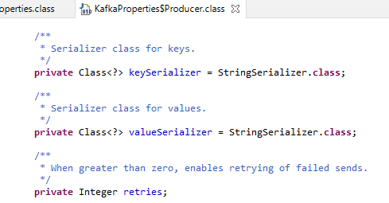

|  |  |
| --- | --- |
|  | We would like a look at the current state of the application and what are the components that we have completed. Until now we have the domain object created successfully and the API is also completed. So what spending we have to build the Kafka producer and we have to create the topic LibraryEvent. I'm going to show you a technique to create a topic from our code. This is just to let you know that there is an another option available to create a topic into our cluster. I would like to call this out. This option is not recommended for production. |

|  |  |
| --- | --- |
| Spring Kafka has a handy class named Kafka admin which we can use to create the Kafka topics programmatically. Kafka admin class is part of the spring Kafka dependency and that we added in our pom.xml. Now we have the class right. The next step is how do we use Kafka admin to create the topic. In a nutshell we have to create the bean. The first thing is we need to create a bean of type KafkaAdmin in Spring configuration. The next step is we have to create another Bean of type NewTopic in our spring configuration. The first thing that I'm going to do is I'm going to create a package called config. |  |

I have the config package created in here. I'm going to create a file called AutoCreateConfig, so I have the class created and the class name this AutoCreateConfig. So we are going to add this on @configuration because the beans which is a KafkaAdmin and NewTopic both needs to be present inside the spring application context. So the next thing is we are going to configure the admin client first, so in order to configure the admin client we can follow the same approach that we have used for the Kafka producer. After the value serialize and then give admin, we we're going to provide bootstrap.servers. So in here we'll provide bootstrap.servers, just to quickly call out, it shouldn't be bootstrap.service it should be bootstrap.servers and you provide the same address of the cluster that we have in our local.

spring:

profiles:

active: local

---

spring:

profiles: local

kafka:

template:

default-topic: library-events

producer:

bootstrap-servers: localhost:9092,localhost:9093,localhost:9094

key-serializer: org.apache.kafka.common.serialization.IntegerSerializer

value-serializer: org.apache.kafka.common.serialization.StringSerializer

properties:

acks: all

retries: 10

retry.backoff.ms: 1000

admin:

properties:

bootstrap.servers: localhost:9092,localhost:9093,localhost:9094

So the next thing is we are going to create the NewTopic bean, so let's create a bean. And this is going to be of type NewTopic right. We're going to provide the partitions so the partition is going to be free. And how many replicas there are because it's going to be equal to our actual cluster. So three and then. So this is going to give you the new topic been meaning the instance of new topic that's written I spun on this one.

**AutoCreateConfig.java**

import org.apache.kafka.clients.admin.AdminClientConfig;

import org.apache.kafka.clients.admin.NewTopic;

import org.springframework.context.annotation.Bean;

import org.springframework.context.annotation.Configuration;

import org.springframework.context.annotation.Profile;

import org.springframework.kafka.config.TopicBuilder;

import org.springframework.kafka.core.KafkaAdmin;

import java.util.HashMap;

import java.util.Map;

@Configuration

@Profile("local")

public class AutoCreateConfig {

@Bean

public NewTopic libraryEvents(){

return TopicBuilder.name("library-events")

.partitions(3)

.replicas(3)

.build();

}

}

So we have the new topic configuration ready and the admin client properties are also ready. The next step is we are going to start up this application before we start up this application. We have to make sure the broker and the zookeeper is up and running in your machine. I'm going to go to the right as you can see the zookeeper and all the three brokers are up and running in a machine. So they will start the application. Let's go to the LibraryEventProducerApplication and start this one.

**LibraryEventsProducerApplication.java**

import org.springframework.boot.SpringApplication;

import org.springframework.boot.autoconfigure.SpringBootApplication;

@SpringBootApplication

public class LibraryEventsProducerApplication {

public static void main(String[] args) {

SpringApplication.run(LibraryEventsProducerApplication.class, args);

}

}

So the first thing to call out is the spring profile is active is local. And after that we have a bunch of admin client config values. The one property that I'm going to focus on, is the bootstrap.servers properties. And it did take the values whatever we have provided in the application document file. Now what do we have to check. The expectation is that as soon as the application is started up it would have created the topic LibraryEvent. So how do we validate. Let's go to the terminal. So in the terminal I'm going to go to the Kafka distribution. So I'm in the bin directory of the Kafka distribution. It has a handy command called Kafka topics which takes in a zookeeper. And then you pass the address of zookeeper and then if you call the list this is going to list all the topics that are present in your local press enter.

C:\software\kafka_2.13-2.6.0\bin\windows>kafka-topics.bat --zookeeper localhost:2181 --list

__consumer_offsets

library-events

second-topic

As you can see the library evens is available. This was created by our configuration that we have in the file AutoCreateConfig. This kind of configuration is not recommended for production environment. So how do we make sure this code is not going to run in the production environment. Spring has a handy method, a handy annotation @Profile. We will provide the profiles local. If you do this, this particular configuration, it is going to be invoked only for the local profile. And if you look at the application.yml file we just have this AdminClient in our local profile. It is not available for the dev and prod profile.

@Configuration

@Profile("local")

public class AutoCreateConfig {

. . .

}

We will call our Kafka producer LibraryEventKafkaProducer. We will annotate this class with @Component and then we will give it a annotation of @Slf4j. This is going to give an access to the logger instance automatically for us. Lets then leverage the Kafka Template that is automatically created for us by the Spring Boot Application. So we have seen how Springboot configures the Kafka template instance for us. Now we are going to start using that. So let's do a @Autowire for KafkaTemplate in here. We are going to explicitly provide the types Integer and String. Why did they choose to use integer and string. Let's quickly go to the application.yaml file and then check it out. So in the application.yml file for the key serializer, we have the value as Integer. For the value serializer we have the value as string. That's the reason why I'm using integer for the key and a string for the value.

Now the next step is let's create a method public void and let's name this method as sendLibraryEvent. What will be the input that's going to come to this method. Let's go to the controller, because controller is the one which is going to invoke this LibraryEventProducer class, so in the LibraryEventsController if you look at the input that we're receiving from the scanner library. So the input to this method is a LibraryEvent right.

@Component

@Slf4j

public class LibraryEventProducer {

@Autowired

KafkaTemplate<Integer,String> kafkaTemplate;

public void sendLibraryEvent(LibraryEvent libraryEvent) throws JsonProcessingException {

Integer key = libraryEvent.getLibraryEventId();

String value = objectMapper.writeValueAsString(libraryEvent);

kafkaTemplate.sendDefault(key,value);

. . .

So the next thing is lets use the KafkaTemplate. So in KafkaTemplate there are many options to send the record. Right now we will use the sendDefault. And I'll explain about the significance and difference between sendDefault and send. So if you're using sendDefault, you don't have to explicitly provide the topic value as you can see the topic is not even present. What you have is a key and value.

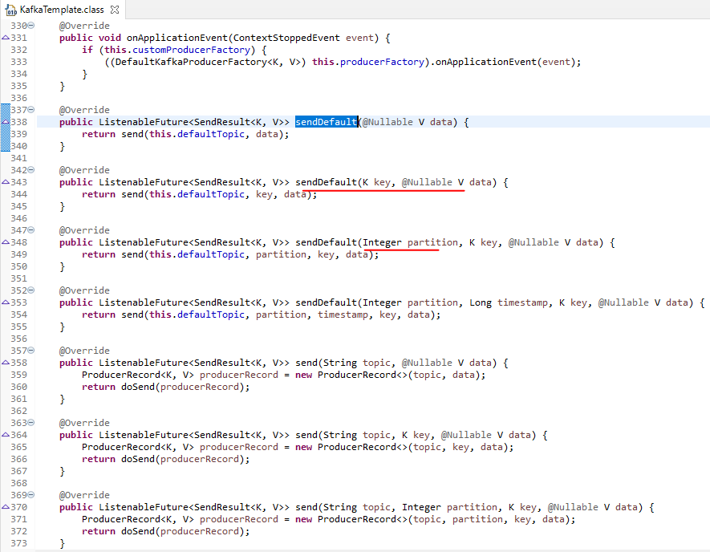

The integer here in the sendDefault method stands for the actual partition that you want to send the message to. Let's go to this method and then check. So here you have the partition you can explicitly call out which partition you are going to send the message. And the next variation is send default integer timestamp key in value. But we are not going to use any of these things we are going to use the very simplest version for now, which is the key and value (data) because for our use case this is enough in most of the use cases key and value us enough actually. So where are we going to get the key, the key is the libraryEventID and the value is the whole payload. So let's go ahead and build the key first and here it's going to be Integer key equal to LibraryEvent.getLibraryEventId, followed by that we have the value, which would be of type String. So we need to extract the string out of this library. Basically we need to convert the library from object to a string actually. So for this purpose I'm going to use object mapper which is part of the Jackson library. So ObjectMapper is very handy if we want to convert a JSON object to a representation of string. So I'm going to have a JSON representation of the library event into the library event Kafka topic.

You need to add this throws JsonProcessingException to the signature. So we have the Kafka template which is using the same default method to send the message but we have not configured which topic this message is going to go right. Let's go ahead and configure that. So in here for this use case we are just going to publish this message to the one single topic which is LibraryEvent. Now let's configure the default topic so you have this option template.defaultTopic. It is going to automatically configure the Kafka template to use this topic to publish the records too.

**application.yml**

---

spring:

profiles: local

kafka:

template:

default-topic: library-events

@Component

@Slf4j

public class LibraryEventProducer {

@Autowired

KafkaTemplate<Integer,String> kafkaTemplate;

String topic = "library-events";

@Autowired

ObjectMapper objectMapper;

public void sendLibraryEvent(LibraryEvent libraryEvent) throws JsonProcessingException {

Integer key = libraryEvent.getLibraryEventId();

String value = objectMapper.writeValueAsString(libraryEvent);

ListenableFuture<SendResult<Integer,String>> listenableFuture =

kafkaTemplate.sendDefault(key,value);

listenableFuture.addCallback(new ListenableFutureCallback<SendResult<Integer, String>>() {

@Override

public void onFailure(Throwable ex) {

handleFailure(key, value, ex);

}

@Override

public void onSuccess(SendResult<Integer, String> result) {

handleSuccess(key, value, result);

}

});

}

. . .

}

The next step is what is the written value of this sendDefault. The sendDefault is returning something called a ListenableFuture. If we all can recall from the introduction to Kafka template lecture, I mentioned about a message matching where the Kafka producer batches the Records and send it to the Kafka topic. Once the batch is full or the linger.ms in the setting values. That's one of the reason why we are getting a future if we have not. If you have not worked with future, think of this as a reference to something that's going to happen in the future. Now what we will do we will go ahead and add that here actually. So the return type is going to be of type ListenableFuture. And the ListenableFuture is going to be of type Integer,String. So now listenable future has the option to add a callback. Let's go ahead and add that .addCallback and the callback is going to be of type new ListenableFutureCallback. So you have this onFailureCallback and onSuccessCallback. The onSuccessCallback gets invoked if the publish is successful and the onFailureCallback gets invoked if the message that's published is ended up with failure. Now lets add a handler for this one, so I'm going to use handler success method and then I'm going to pass the key, message and results. It's basically key value. So this method is going to just log the response. The reason why I'm extracting this handler is a separate method is because we can reuse it for the future part of the course, log.info to log the message, just message sent successfully for the key and the value. The Record gives you more information on which partition that the message has gone to, which offset and all those things. I'm just going to print on the partition here and let's give.

private void handleFailure(Integer key, String value, Throwable ex) {

log.error("Error Sending the Message and the exception is {}", ex.getMessage());

try {

throw ex;

} catch (Throwable throwable) {

log.error("Error in OnFailure: {}", throwable.getMessage());

}

}

private void handleSuccess(Integer key, String value, SendResult<Integer, String> result) {

log.info("Message Sent SuccessFully for the key : {} and the value is {} , partition is {}",

key, value, result.getRecordMetadata().partition());

}

This is a Record which gets built for us as soon as you pass the key and value. We will see how to build the Producer Record but for now we are going to use the getRecordMetadata, followed by that we are going to print the partition. So to handle failure, the input of this method is going to be the same thing key and value. But in place of the result we are going to have exception. What we are going to do is we are going to throw the exception. Right. That's the right way of handling the exception so we are going to let the caller know hey there are some exceptions happen. Add the log.error in the logger. We will have the message as “error sending the message” and the exception as, it's going to be the exception.getMessage.

So we have provided the handler for success and handler for failure call. Let me quickly summarize what we did here in here. We have used a Kafka template and then we are using the sendDefault method. So sendDefault is going to automatically read the topic and then it's going to pass the key and value. And after that this default is going to return you ListenableFuture which is a reference for something that's going to happen in the future. And it has the option of providing a Callback. From the Callback we have provided the success handler and error handler.

We will now integrate the Controller layer with the Kafka Producer. The first thing is we are going to inject the using the @Autowire annotation we are going to inject the LibraryEventProducer. We're going to call LibraryEventProducer.sendLibraryEvent and pass the LibraryEvent. And this is going to ask you to handle the exception. Now we have the integration between the controller and the actual producer. We're going to test this in our local. In order to test this, we have to make sure you have the zookeeper and the Kafka Cluster up and running because we are testing it in our local machine.

It is launching the application on the profile that it uses is local profile. Basically if you did not have the topic it's going to automatically created for you. Now we will go ahead and invoke the library

@RestController

@Slf4j

public class LibraryEventsController {

@Autowired

LibraryEventProducer libraryEventProducer;

@PostMapping("/v1/libraryevent")

public ResponseEntity<LibraryEvent> postLibraryEvent(@RequestBody @Valid LibraryEvent libraryEvent)

throws JsonProcessingException, ExecutionException, InterruptedException {

//invoke kafka producer

libraryEvent.setLibraryEventType(LibraryEventType.NEW);

libraryEventProducer.sendLibraryEvent_Approach2(libraryEvent);

return ResponseEntity.status(HttpStatus.CREATED).body(libraryEvent);

}

. . .

}

**POST WITH-NULL-LIBRARY-EVENT-ID**

**-------------------------------**

curl -i -d "{\"libraryEventId\":null,\"book\":{\"bookId\":456,\"bookName\":\"Kafka Using Spring Boot\",\"bookAuthor\":\"Lalit\"}}” -H "Content-Type: application/json" -X POST http://localhost:8080/v1/libraryevent

I'm going to make sure I have a console consumer up and running in my machine. We will run the curl command and we see this message now. This means the message was successfully posted into the Kafka topic and lets see the logs. We have the producer config values when the Kafka template makes the first call that's when it's going to read all the configuration and then it's going to give you this config values printed on console. And if take a look at this, the address that we have provided in our application and for the key serializer, it uses a integer serializer as I have mentioned in the introduction to Kafka template. It uses a default paritioner and if you scroll a little bit down you should be see String Serializer in the logs. There is an interesting thing, it's an asynchronous call as I mentioned. In here this is the log that we see in the console

@Component

@Slf4j

public class LibraryEventProducer {

. . .

private void handleSuccess(Integer key, String value, SendResult<Integer, String> result) {

*log*.info("Message Sent SuccessFully for the key : {} and the value is {} , partition is {}",

key, value, result.getRecordMetadata().partition());

}

Message sent successfully, the key as null. If the key is null then the default partitioner is going to use a round robin approach to publish the message into the partitions for that particular topic and the value is. This is a payload that's been sent from the curl command and the partition that this message had gone to this one.



We are going to pause for a bit and check about the behavior of the post endpoint, that we have. The reason why I would like to explicitly call this out is because this endpoint has an asynchronous behavior involved in it in here, when the curl command is invoked the call comes to the scanner. The call is going to go to the LibraryEventProducer and if you look at the sendLibraryEvent as soon as a call reaches this kafkaTemplate.sendDefault. This is when it's going to return a ListenableFuture. Basically it's an asynchronous call which is going to return immediately as soon as this call is returned immediately. The call will go back to the controller layer from there.

It's up to the application to recover if there is an error or retry if there is an error. When we talk about the recovery, retry and error scenarios in the future part of the lecture I will explain the about some of the techniques to automatically recover or retry if there is an error. Publishing the message into the Kafka topic. I'm going to quickly demonstrate the asynchronous behavior that we have in our LibraryEventsProducer. We will add @Slf4j and add a couple of logs here just to show you the asynchronous behavior of this particular method called, let's add log.info. So we added these logs. The expectation is that the afterSendLibraryEvent will be logged in the console before the message sent successfully for the key and value partitions. So that's the expectation let's go ahead and restart applications. I'm going to click this run library even producer application. This is going to rerun the application at my local and after this I'm going to post a new one from our terminal. So I'm going to use this same code command.

@RestController

@Slf4j

public class LibraryEventsController {

@Autowired

LibraryEventProducer libraryEventProducer;

@PostMapping("/v1/libraryevent")

public ResponseEntity<LibraryEvent> postLibraryEvent(@RequestBody @Valid LibraryEvent libraryEvent)

throws JsonProcessingException, ExecutionException, InterruptedException {

//invoke kafka producer

log.info("before send library event");

libraryEvent.setLibraryEventType(LibraryEventType.NEW);

libraryEventProducer.sendLibraryEvent(libraryEvent);

log.info("after send library event");

//libraryEventProducer.sendLibraryEvent_Approach2(libraryEvent);

return ResponseEntity.status( HttpStatus.CREATED ).body( libraryEvent );

}

. . .

You can see I have a new message that got posted into the library. As you can see the after scene library event is logged before the message sent successfully. So this is the asynchronous behavior I was talking about irrespective of whether the message is successfully published into the Kafka topic or not.

2020-12-20 09:36:33.856 INFO 12992 --- [ad | producer-1] o.a.k.c.Metadata : [Producer clientId=producer-1] Cluster ID: ji7jjpYERV6A-cQ4TXkWSw

2020-12-20 09:36:33.895 INFO 12992 --- [nio-9000-exec-1] c.l.k.c.LibraryEventsController : after send library event

2020-12-20 09:36:33.895 INFO 12992 --- [ad | producer-1] c.l.k.p.LibraryEventProducer : Message Sent SuccessFully for the key : null and the value is {"libraryEventId":null,"libraryEventType":"NEW","book":{"bookId":1,"bookName":"Kafka Using Spring Boot","bookAuthor":"Lalit"}} , partition is 2

* Message sent is being published after the after send library event info log

Message Sent Successfully is being logged from LibraryEventProducer.java method onSuccess() -> handleSuccess() method. We can see different threads being used, producer-1 and the nio-9000-exec threads being used.

Kafka Template - Approach 2

We will try to see how to make the Kafka Template behave in a synchronous fashion in this method named sendLibraryEventSynchronous. The code is the same for getting the key and the value & it also accepts the LibraryEvent from the Controller.

@Component

@Slf4j

public class LibraryEventProducer {

. . .

public SendResult<Integer, String> sendLibraryEventSynchronous(LibraryEvent libraryEvent)

throws JsonProcessingException, ExecutionException, InterruptedException, TimeoutException {

Integer key = libraryEvent.getLibraryEventId();

String value = objectMapper.writeValueAsString(libraryEvent);

log.info("before send library event");

SendResult<Integer,String> sendResult = kafkaTemplate.sendDefault(key, value)

.get(1, TimeUnit.*SECONDS*);

log.info("SendResult is {}", sendResult.toString());

log.info("after sendLibraryEvent");

return sendResult;

}

. . .

}

We have done the .get(1, TimeUnit.SECONDS) call after the sendDefault method call, so basically it is going to wait for the ListenableFuture to resolve either via onSuccess or onFailure. We have a catch for the ExecutionException & InterruptedException and then one for any other Exception apart from these two. We will throw the exception in case of a exception. We are accepting the response as SendResult<Integer, String> and returning that back in case there is no exception. This will make the KafkaTemplate behave as synchronous now. From the controller give a call to this method instead of the sendLibraryEvent(..) method now. Lets run the application and check the logs now.

2020-12-20 09:50:25.112 INFO 14900 --- [nio-9000-exec-1] c.l.k.c.LibraryEventsController : before send library event

2020-12-20 09:50:25.143 INFO 14900 --- [nio-9000-exec-1] o.a.k.c.p.ProducerConfig : ProducerConfig values:

acks = -1

batch.size = 16384

bootstrap.servers = [localhost:9092, localhost:9093, localhost:9094]

buffer.memory = 33554432

client.dns.lookup = default

client.id = producer-1

compression.type = none

connections.max.idle.ms = 540000

delivery.timeout.ms = 120000

enable.idempotence = false

interceptor.classes = []

key.serializer = class org.apache.kafka.common.serialization.IntegerSerializer

linger.ms = 0

max.block.ms = 60000

max.in.flight.requests.per.connection = 5

. . .

transaction.timeout.ms = 60000

transactional.id = null

value.serializer = class org.apache.kafka.common.serialization.StringSerializer

2020-12-20 09:50:25.187 INFO 14900 --- [nio-9000-exec-1] o.a.k.c.u.AppInfoParser : Kafka version: 2.5.0

2020-12-20 09:50:25.187 INFO 14900 --- [nio-9000-exec-1] o.a.k.c.u.AppInfoParser : Kafka commitId: 66563e712b0b9f84

2020-12-20 09:50:25.187 INFO 14900 --- [nio-9000-exec-1] o.a.k.c.u.AppInfoParser : Kafka startTimeMs: 1608438025187

2020-12-20 09:50:25.206 INFO 14900 --- [ad | producer-1] o.a.k.c.Metadata : [Producer clientId=producer-1] Cluster ID: ji7jjpYERV6A-cQ4TXkWSw

2020-12-20 09:50:25.258 INFO 14900 --- [nio-9000-exec-1] c.l.k.p.LibraryEventProducer : SendResult is SendResult [producerRecord=ProducerRecord(topic=library-events, partition=null, headers=RecordHeaders(headers = [], isReadOnly = true), key=null, value={"libraryEventId":null,"libraryEventType":"NEW","book":{"bookId":8,"bookName":"Kafka Using Spring Boot","bookAuthor":"Lalit"}}, timestamp=null), recordMetadata=library-events-1@4]

2020-12-20 09:50:25.258 INFO 14900 --- [nio-9000-exec-1] c.l.k.p.LibraryEventProducer : after sendLibraryEvent

2020-12-20 09:50:25.258 INFO 14900 --- [nio-9000-exec-1] c.l.k.c.LibraryEventsController : after send library event

There is a synchronous behavior now as we are calling a get after the sendDefault method – it prints the before and then the message and then the after send log. We can provide a timeout as well in the get call as we can see .get(1, TimeUnit.*SECONDS*); If the response is not returned then it is going to timeout in that case. This also requires us to then handle the TimeoutException in this method call.

Approach 3 – Producer Record

We will create another method for this and this will use the aynchronous approach. So here instead of calling the sendDefault method, we have called the send method instead that takes the ProducerRecord and we have created the ProducerRecord just before that. The send method takes a topic and followed by that a key and value.

public ListenableFuture< SendResult<Integer,String> > sendLibraryEvent_Approach2(

LibraryEvent libraryEvent) throws JsonProcessingException {

Integer key = libraryEvent.getLibraryEventId();

String value = objectMapper.writeValueAsString(libraryEvent);

ListenableFuture< SendResult< Integer,String > > listenableFuture =

kafkaTemplate.send("library-events", key, value);

listenableFuture.addCallback( new ListenableFutureCallback< SendResult<Integer, String> >() {

@Override

public void onFailure(Throwable ex) {

handleFailure(key, value, ex);

}

@Override

public void onSuccess(SendResult<Integer, String> result) {

handleSuccess(key, value, result);

}

});

return listenableFuture;

}

Instead of providing the key and value along-with the topic, we could use another approach for this that uses a ProducerRecord as below

The ProducerRecord class of org.apache.kafka.clients.producer in the kafka-clients-2.5.0.jar

public class ProducerRecord<K, V> {

private final String topic;

private final Integer partition;

private final Headers headers;

private final K key;

private final V value;

private final Long timestamp;

. . .

public ProducerRecord(String topic, Integer partition, Long timestamp, K key, V value,

Iterable<Header> headers) {

. . .

}

public ProducerRecord(String topic, Integer partition, Long timestamp, K key, V value) {

. . .

}

. . .

}

So lets use this one in our Producer.

public ListenableFuture<SendResult<Integer,String>> sendLibraryEvent_Approach2(

LibraryEvent libraryEvent) throws JsonProcessingException {

Integer key = libraryEvent.getLibraryEventId();

String value = objectMapper.writeValueAsString(libraryEvent);

ProducerRecord<Integer,String> producerRecord = buildProducerRecord(key, value, topic);

ListenableFuture<SendResult<Integer,String>> listenableFuture = kafkaTemplate.send( producerRecord );

listenableFuture.addCallback(new ListenableFutureCallback<SendResult<Integer, String>>() {

@Override

public void onFailure(Throwable ex) {

handleFailure(key, value, ex);

}

@Override

public void onSuccess(SendResult<Integer, String> result) {

handleSuccess(key, value, result);

}

});

return listenableFuture;

}

private ProducerRecord<Integer, String> buildProducerRecord( Integer key, String value, String topic ) {

List<Header> recordHeaders = List.*of*( new RecordHeader("event-source", "scanner".getBytes()) );

return new ProducerRecord<>(topic, null, key, value, recordHeaders);

}

The ProducerRecord has all the information that is needed to publish it. The key, value and the topic and the headers as well. From the controller make the change to give to this call instead of sendLibraryEvent i.e. use this sendLibraryEvent_Approach2 method. Kafka headers are kind of handy if you want to add some additional information to the record that you are publishing. Headers are a type of Iterable Iterable<Headers>.

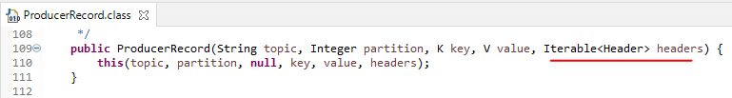

So we can create a List<Header> and create that using the List.of method passing in a new class called as the RecordHeader that takes in the following

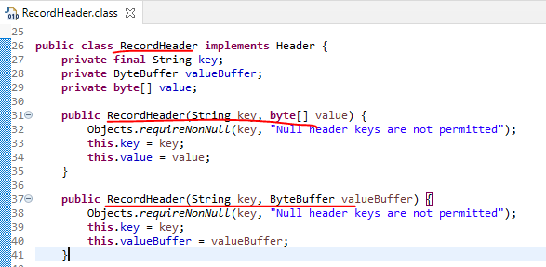

We will implement this and pass it the event source, i.e. where the event generated from.

List<Header> recordHeaders = List.*of*(new RecordHeader("event-source", "scanner".getBytes()));

So this is how we add recordHeaders to a ProducerRecord. To add multiple just add a comma after the new RecordHeader and provide more new RecordHeader(…).

When we build a consumer for the LibraryEvents topic we will see the technique of how to read the RecordHeader and then how to pass them and process them after you consume the record.

Add the Library Event Type – NEW / UPDATE

So for this purpose what we are going to create a LibraryEventType which would be of type enum.

package com.learn.kafka.domain;

public enum LibraryEventType {

NEW,

UPDATE

}

Lets go to the Controller now, this is the POST endpoint, further we would also built the PUT endpoint to enable updates that we want to make to the book already added to the inventory. This event type is going to help us differentiante between those two.

@RestController

@Slf4j

public class LibraryEventsController {

@Autowired

LibraryEventProducer libraryEventProducer;

@PostMapping("/v1/libraryevent")

public ResponseEntity<LibraryEvent> postLibraryEvent(@RequestBody @Valid LibraryEvent libraryEvent)

throws JsonProcessingException, ExecutionException, InterruptedException {

libraryEvent.setLibraryEventType( LibraryEventType.*NEW* );

try {

libraryEventProducer.sendLibraryEvent_Approach2(libraryEvent);

} catch (JsonProcessingException | ExecutionException | InterruptedException

| TimeoutException e) {

e.printStackTrace();

}

return ResponseEntity.*status*(HttpStatus.*CREATED*).body(libraryEvent);

}

. . .

}

The full Producer application code

**LibraryEventProducer.java**

import com.fasterxml.jackson.core.JsonProcessingException;

import com.fasterxml.jackson.databind.ObjectMapper;

import com.learn.kafka.domain.LibraryEvent;

import lombok.extern.slf4j.Slf4j;

import org.apache.kafka.clients.producer.ProducerRecord;

import org.apache.kafka.common.header.Header;

import org.apache.kafka.common.header.internals.RecordHeader;

import org.springframework.beans.factory.annotation.Autowired;

import org.springframework.kafka.core.KafkaTemplate;

import org.springframework.kafka.support.SendResult;

import org.springframework.stereotype.Component;

import org.springframework.util.concurrent.ListenableFuture;

import org.springframework.util.concurrent.ListenableFutureCallback;

import java.util.List;

import java.util.concurrent.ExecutionException;

import java.util.concurrent.TimeUnit;

import java.util.concurrent.TimeoutException;

@Component

@Slf4j

public class LibraryEventProducer {

@Autowired

KafkaTemplate<Integer,String> kafkaTemplate;

String topic = "library-events";

@Autowired

ObjectMapper objectMapper;

public void sendLibraryEvent(LibraryEvent libraryEvent) throws JsonProcessingException {

Integer key = libraryEvent.getLibraryEventId();

String value = objectMapper.writeValueAsString(libraryEvent);

ListenableFuture< SendResult<Integer,String> > listenableFuture =

kafkaTemplate.sendDefault(key,value);

listenableFuture.addCallback( new ListenableFutureCallback< SendResult<Integer, String> >() {

@Override

public void onFailure(Throwable ex) {

handleFailure(key, value, ex);

}

@Override

public void onSuccess(SendResult<Integer, String> result) {

handleSuccess(key, value, result);

}

});

}

public ListenableFuture< SendResult<Integer,String>> sendLibraryEvent_Approach2(

LibraryEvent libraryEvent) throws JsonProcessingException {

Integer key = libraryEvent.getLibraryEventId();

String value = objectMapper.writeValueAsString(libraryEvent);

ProducerRecord<Integer,String> producerRecord = buildProducerRecord(key, value, topic);

ListenableFuture< SendResult<Integer,String> > listenableFuture =

kafkaTemplate.send( producerRecord );

listenableFuture.addCallback(new ListenableFutureCallback<SendResult<Integer, String>>() {

@Override

public void onFailure(Throwable ex) {

handleFailure(key, value, ex);

}

@Override

public void onSuccess(SendResult<Integer, String> result) {

handleSuccess(key, value, result);

}

});

return listenableFuture;

}

private ProducerRecord<Integer, String> buildProducerRecord(Integer key, String value,

String topic) {

List<Header> recordHeaders = List.of(new RecordHeader("event-source", "scanner".getBytes()));

return new ProducerRecord<>(topic, null, key, value, recordHeaders);

}

public SendResult<Integer, String> sendLibraryEventSynchronous(LibraryEvent libraryEvent)

throws JsonProcessingException, ExecutionException, InterruptedException, TimeoutException {

Integer key = libraryEvent.getLibraryEventId();

String value = objectMapper.writeValueAsString(libraryEvent);

SendResult<Integer,String> sendResult=null;

try {

sendResult = kafkaTemplate.sendDefault(key,value).get(1, TimeUnit.SECONDS);

} catch (ExecutionException | InterruptedException e) {

log.error("Exception … sending the Message & exception is {}", e.getMessage());

throw e;

} catch (Exception e) {

log.error("Exception Sending the Message and the exception is {}", e.getMessage());

throw e;

}

return sendResult;

}

private void handleFailure(Integer key, String value, Throwable ex) {

log.error("Error Sending the Message and the exception is {}", ex.getMessage());

try {

throw ex;

} catch (Throwable throwable) {

log.error("Error in OnFailure: {}", throwable.getMessage());

}

}

private void handleSuccess(Integer key, String value, SendResult<Integer, String> result) {

log.info("Message Sent SuccessFully for the key : {} and the value is {} , partition is {}",

key, value, result.getRecordMetadata().partition());

}

}

**LibraryEventsControllerAdvice.java**

import lombok.extern.slf4j.Slf4j;

import org.springframework.http.HttpStatus;

import org.springframework.http.ResponseEntity;

import org.springframework.validation.FieldError;

import org.springframework.web.bind.MethodArgumentNotValidException;

import org.springframework.web.bind.annotation.ControllerAdvice;

import org.springframework.web.bind.annotation.ExceptionHandler;

import java.util.List;

import java.util.stream.Collectors;

@ControllerAdvice

@Slf4j

public class LibraryEventControllerAdvice {

@ExceptionHandler( MethodArgumentNotValidException.class )

public ResponseEntity<?> handleRequestBody( MethodArgumentNotValidException ex ) {

List<FieldError> errorList = ex.getBindingResult().getFieldErrors();

String errorMessage = errorList.stream()

.map(fieldError -> fieldError.getField()

+ " - " + fieldError.getDefaultMessage())

.sorted()

.collect( Collectors.joining(", ") );

log.info("errorMessage : {} ", errorMessage);

return new ResponseEntity<>( errorMessage, HttpStatus.BAD_REQUEST );

}

}

Types of Automated Tests:

• UnitTest

• Integration Tests

• End to End Tests

Tools for Automated Tests

• JUnit

• Spock

**Integration Tests using JUnit 5**

**What is Integration Test?**

A Test that combines the different layers of the code and verify the behavior is working as expected.

Let's check the integration points for our LibraryEventsProducer application. Number one is the control layer which has the endpoint through the client post LibraryEvent. Number two is the Kafka producer integration and Number three is the library EventsTopic from an integration test perspective. We need to make sure when the client invokes the push in point with the request body whether the request body is received as expected and then it is sent to the Gulf Cooperation layer and from there it reached the Kafka topic.

As expected this is the flow that we are going to test as part of our integration test.

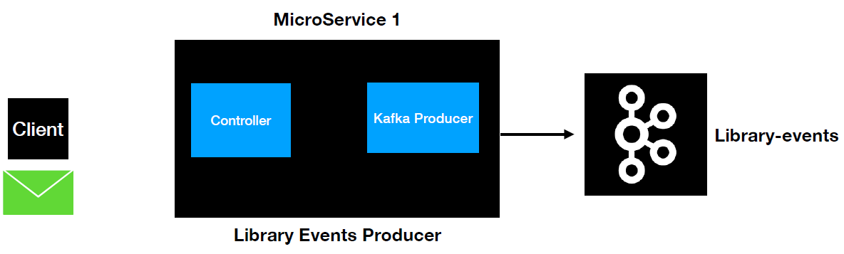

The EmbeddedKafka is going to spin up alongside our test and our code will interact with the embedded Kafka instead of the

actual Kafka. EmbeddedKafka will shut down once the tests are completed. This is going to be handy as our test doesn't require a real Kafka broker in our machine. The same concept will be applied if we are running the integration test case in our CI/CD pipeline. It's going to be easy to write integration test.

|  |  |
| --- | --- |
| **What is EmbeddedKafka?**  • In-Memory Kafka  • Integration Tests can interact with EmbeddedKafka | **Why do we need Embedded Kafka ?**  • Easy to write Integration Tests  • Test all the code as like you interact with Kafka |

**In the pom.xml we would add the following dependencies**

|  |  |
| --- | --- |
| <dependency>  <groupId>org.springframework.kafka</groupId>  <artifactId>spring-kafka-test</artifactId>  <scope>test</scope>  </dependency>  <dependency>  <groupId>org.springframework.boot</groupId>  <artifactId>spring-boot-starter-test</artifactId>  <scope>test</scope>  <exclusions>  <exclusion>  <groupId>org.junit.vintage</groupId>  <artifactId>junit-vintage-engine</artifactId>  </exclusion>  </exclusions>  </dependency> | **Package structure** |

The first thing is to add the @SpringBootTest annotation and then provide the web environment that uses a random port.

@SpringBootTest( webEnvironment = SpringBootTest.WebEnvironment.RANDOM_PORT )

This will help us avoid conflict with port 8080 as it works using a random port then. Add a test method now to postLibraryEvent for the endpoint /v1/libraryevent. We can use the TestRestTemplate for this so @Autowire that one, so this TestTemplate is automatically going to wire to the test port and help us invoke the endpoints. The URL is /v1/libraryevent, follow that up with the HttpMethod.POST and then pass the request both and the LibraryEvent.class

**Configuring Embedded Kafka**

So in order to configure Embedded Kafka the number one thing that we need to do is use a handy annotation that is

@EmbeddedKafka( topics = {"library-events"}, partitions = 3 )

We need to provide the topic so the topic is going to be topics and it takes an array of topics. So in here we are going to provide LibraryEvent. The next thing is that we can provide some additional properties. Now provide the number of partitions as three. So this is similar to the number of partitions that we have for our library-events Kafka topic. Now we have this configuration set.

The next thing is to override the bootstrap-servers value. In the application.yml file we have provided the bootstrap-servers value.

**application.yml**

spring:

profiles:

active: local

server:

port: 9000

---

spring:

profiles: local

kafka:

template:

default-topic: library-events

producer:

bootstrap-servers: localhost:9092,localhost:9093,localhost:9094

key-serializer: org.apache.kafka.common.serialization.IntegerSerializer

value-serializer: org.apache.kafka.common.serialization.StringSerializer

properties:

acks: all

retries: 10

retry.backoff.ms: 1000

admin:

properties:

bootstrap.servers: localhost:9092,localhost:9093,localhost:9094

These are the addresses where it is referring to ( configured on our local machine ). But from the embedded kafka perspective we need to override these values with the embedded kafka values. Where do we find those?

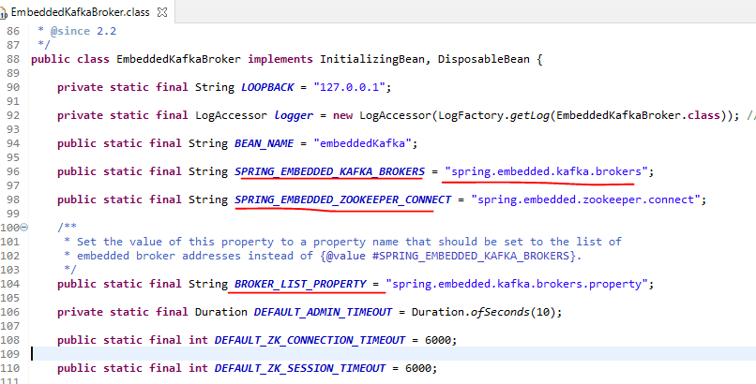

This can be used to override the value we have in the application.yml file.

@TestPropertySource(

properties = {"spring.kafka.producer.bootstrap-servers=${spring.embedded.kafka.brokers}",

"spring.kafka.admin.properties.bootstrap.servers=${spring.embedded.kafka.brokers}" } )

Use the dollar symbol to dynamically pull that value to here. A lot of logs related to EmbeddedKafka will start appearing now when we run the test case.

To invoke now use following method, the controller returns a ResponseEntity<LibraryEvent> so the same is accepted here.

ResponseEntity<LibraryEvent> responseEntity =

restTemplate.exchange("/v1/libraryevent", HttpMethod.POST, request, LibraryEvent.class);

What are we going to assert on, and what status do we expect?

assertEquals( HttpStatus.CREATED, responseEntity.getStatusCode() );

ConsumerRecord<Integer, String> consumerRecord =

KafkaTestUtils.getSingleRecord( consumer, "library-events" );

String expectedRecord =

"{\"libraryEventId\":null,\"libraryEventType\":\"NEW\",\"book\":{\"bookId\":123,

\"bookName\":\"Kafka using Spring Boot\",\"bookAuthor\":\"Dilip\"}}";

String value = consumerRecord.value();

assertEquals( expectedRecord, value );

To pass the request and the headers use as below – request is the HttpEntity class with type as LibraryEvent ( the controller expects a LibraryEvent as we know ) and that takes in a LibraryEvent and the Headers ( of HttpHeaders class )

HttpHeaders headers = new HttpHeaders();

headers.set( "content-type", MediaType.APPLICATION_JSON.toString() );

HttpEntity<LibraryEvent> request = new HttpEntity<>( libraryEvent, headers );

To build the LibraryEvent use the builder method – LibraryEvent in turn needs the Book

Book book = Book.*builder*()

.bookId(123)

.bookAuthor("Lalit")

.bookName("Kafka using Spring Boot")

.build();

LibraryEvent libraryEvent = LibraryEvent.*builder*()

.libraryEventId(**null**)

.book(book)

.build();

Lets configure a Kafka consumer in our JUnit using which we can read the messages from the KafkaTopic and validate them. The first thing is we need to create an instance of a consumer let's give private consumer the consumer.

private Consumer<Integer, String> consumer;

In spring there is a class to configure the KafkaConsumer called the DefaultKafkaConsumerFactory using which we can configure the Kafka Consumer. This will take arguments – it will take a HashMap for configuration and then a Key Serializer and Value Serializer and then we can call the createConsumer() method on it. We will create a Map<String, Object> for the configs. We can use the KafkaTestUtils class consumerProps method for populating these. It will automatically build the config based on these. It takes the groupId, if we recall its something important when we are creating the Brokers, followed by the auto commit set as true and then passing in the embeddedKafkaBroker. The auto-commit is a concept where the Kafka consumer commits the offset after it reads a Record and processes their Record.

@BeforeEach

void setUp() {

Map<String, Object> **configs** =

new HashMap<>(

KafkaTestUtils.consumerProps("group1", "true", embeddedKafkaBroker)

);

**consumer** = new DefaultKafkaConsumerFactory<>( **configs**,

new IntegerDeserializer(),

new StringDeserializer()

).createConsumer();

embeddedKafkaBroker.consumeFromAllEmbeddedTopics( **consumer** );

}

We don’t have the bean ready yet so lets go ahead and @Autowire that one

@Autowired

EmbeddedKafkaBroker embeddedKafkaBroker;

We can now consume from all embedded kafka topics, this ensures that this consumer would consume from all embedded kafka topics.

embeddedKafkaBroker.consumeFromAllEmbeddedTopics( consumer );

Setup a tearDown method now, this is to shutdown the consumer, otherwise it will create complications when we have different test cases running using the embedded kafka

@AfterEach

void tearDown() {

consumer.close();

}

We can make the following call for consuming a single record from the Kafka Broker. This returns a ConsumerRecord.

ConsumerRecord<Integer, String> consumerRecord =

KafkaTestUtils.getSingleRecord( consumer, "library-events" );

Thread.sleep(3000);

String expectedRecord = "{\"libraryEventId\":null,\"libraryEventType\":\"NEW\",\"book\":

{\"bookId\":123,\"bookName\":\"Kafka using Spring Boot\",\"bookAuthor\":\"Lalit\"}}";

String value = consumerRecord.value();

assertEquals(expectedRecord, value);

We have made a asynchronous call here, so your test case and this call are going to run in different threads. This is one of the problems when we are dealing with asynchronous code. This is one of the not recommeded options for writing the test case. We provided a Thread.sleep(3000) for 3 seconds basically.

Now let's go ahead and remove this Thead.sleep() method. What other options do we have we can use a CountDown latch. But for dealing with code like this, we can use a @Annotation called a @Timeout and then we can provide 5 seconds for it. The test case can be annotated with @Test and then a @Timeout(5). If the record is not retrieved in 5 seconds, the test case execution will complete.

The full class is below

**LibraryEventsControllerIntegrationTest.java**

package com.learn.kafka.integration.tests.controller;

import org.apache.kafka.clients.consumer.Consumer;

import org.apache.kafka.clients.consumer.ConsumerRecord;

import org.apache.kafka.common.serialization.IntegerDeserializer;

import org.apache.kafka.common.serialization.StringDeserializer;

import org.junit.jupiter.api.AfterEach;

import org.junit.jupiter.api.BeforeEach;

import org.junit.jupiter.api.Test;

import org.junit.jupiter.api.Timeout;

import org.springframework.beans.factory.annotation.Autowired;

import org.springframework.boot.test.context.SpringBootTest;

import org.springframework.boot.test.web.client.TestRestTemplate;

import org.springframework.http.*;

import org.springframework.kafka.core.DefaultKafkaConsumerFactory;

import org.springframework.kafka.test.EmbeddedKafkaBroker;

import org.springframework.kafka.test.context.EmbeddedKafka;

import org.springframework.kafka.test.utils.KafkaTestUtils;

import org.springframework.test.context.TestPropertySource;

import com.learn.kafka.domain.Book;

import com.learn.kafka.domain.LibraryEvent;

import java.util.HashMap;

import java.util.Map;

import static org.junit.jupiter.api.Assertions.assertEquals;

@SpringBootTest( webEnvironment = SpringBootTest.WebEnvironment.RANDOM_PORT )

@EmbeddedKafka( topics = {"library-events"}, partitions = 3 )

@TestPropertySource(

properties = {

"spring.kafka.producer.bootstrap-servers=${spring.embedded.kafka.brokers}",

"spring.kafka.admin.properties.bootstrap.servers=${spring.embedded.kafka.brokers}"

})

public class LibraryEventsControllerIntegrationTest {

@Autowired

TestRestTemplate restTemplate;

@Autowired

EmbeddedKafkaBroker embeddedKafkaBroker;

private Consumer<Integer, String> consumer;

@BeforeEach

void setUp() {

Map<String, Object> configs =

new HashMap<>( KafkaTestUtils.consumerProps( "group1", "true", embeddedKafkaBroker ) );

consumer = new DefaultKafkaConsumerFactory<>( configs, new IntegerDeserializer(),

new StringDeserializer() )

.createConsumer();

embeddedKafkaBroker.consumeFromAllEmbeddedTopics(consumer);

}

@AfterEach

void tearDown() {

consumer.close();

}

@Test

@Timeout(5)

void **postLibraryEvent**() throws InterruptedException {

//given

Book book = Book.builder()

.bookId(123).bookAuthor("Dilip").bookName("Kafka using Spring Boot")

.build();

LibraryEvent libraryEvent = LibraryEvent.builder()

.libraryEventId(null).book(book)

.build();

HttpHeaders headers = new HttpHeaders();

headers.set( "content-type", MediaType.APPLICATION_JSON.toString() );

HttpEntity<LibraryEvent> request = new HttpEntity<>( libraryEvent, headers );

//when

ResponseEntity<LibraryEvent> responseEntity =

restTemplate.exchange( "/v1/libraryevent", HttpMethod.POST,

request, LibraryEvent.class );

//then

assertEquals( HttpStatus.CREATED, responseEntity.getStatusCode() );

ConsumerRecord<Integer, String> consumerRecord =

KafkaTestUtils.getSingleRecord(consumer, "library-events");

String **expectedRecord** =

"{\"libraryEventId\":null,\"libraryEventType\":\"NEW\",\"book\":{\"bookId\":123,

\"bookName\":\"Kafka using Spring Boot\",\"bookAuthor\":\"Dilip\"}}";

String value = consumerRecord.value();

assertEquals( **expectedRecord**, value );

}

...

}

**Unit Test**

|  |  |
| --- | --- |
|  | **Unit testing is a type of test that**   * Test just focuses on a single unit (method) * Mocks the external dependecies   **Why Unit Test?**  • Unit Tests are handy to mock external dependencies  • Unit Tests are faster compared to Integration tests  • Unit Tests cover scenarios that’s not possible with Integration tests |

We will use Mockito for this to mock out external dependencies. Unit tests are faster as compared to the Integration Tests. Unit tests can cover scenarios that are not possible with the integration test.

We will go ahead and write the unit test for our controller layer. Let's go ahead and check what do we have in the control here. So in the controller layer we have one endpoint. As you can see this integration test validates whether the client would be able to post the request body of type library event and then it validates whether the message reached the topic or not. Now it's time to write the unit test for this purpose.

We are going to leverage some of the spring unit test annotations. Spring has a handy annotation called

* @WebMvc so this can be used if we are writing unit tests for controller layers. We need to provide the name of the Controller for which we are writing this Unit Test.
* After that we will use another annotation called as @AutoConfigureMockMvc annotation.

@WebMvcTest( LibraryEventsController.class )

@AutoConfigureMockMvc

We will use MockMvc in order to write the unit test cases for the endpoints that are both in the LibraryEventController.

@Autowired

MockMvc mockMvc;

So now this MockMvc will have access to all the endpoints that are part of this LibraryEventsController. Lets write the Unit Test now. Calling the endpoint using the MockMvc

mockMvc.perform( post("/v1/libraryevent")

.content( json )

.contentType( MediaType.APPLICATION_JSON ))

.andExpect( status().isCreated() );

@Test

void postLibraryEvent() throws Exception {

// given

Book book = Book.builder()

.bookId(123)

.bookAuthor("Dilip")

.bookName("Kafka using Spring Boot")

.build();

LibraryEvent libraryEvent = LibraryEvent.builder()

.libraryEventId(null)

.book(book)

.build();

// when

String json = objectMapper.writeValueAsString(libraryEvent);

when( libraryEventProducer.sendLibraryEvent_Approach2( isA( LibraryEvent.class ) ) )

.thenReturn( null );

// then

mockMvc.perform( post( "/v1/libraryevent" )

.content( json )

.contentType( MediaType.APPLICATION_JSON ))

.andExpect( status().isCreated() );

}

So as you can see this is how you make a post call using the MockMvc, we see the advantage with Mock and what we see is that when this is run it is not going to scan the whole project. Basically in our project we have Controller and the Producer. When you run a unit test case with the MockMvc test, it's not going to scan the layer and just going to run the test case against that one. It is not even going to scan the library producer at all. So the bean won't even be visible to this particular case.

So we got an error and I expected that because I wanted to fail this test case and then show you the behavior on what needs to be done. So it says no qualifying being of type LibraryEventProducer. This particular test case is just going to scan this particular class and then load that into context. So it's not even going to consider scanning the LibraryEventProducer. But this is a dependency for this particular class. So in that case how do we get that. MockMvc has a handy annotation card @MockBean and then what will do is just create LibraryEventProducer.

@MockBean

LibraryEventProducer libraryEventProducer;

Now this is going to inject this Bean into this Test context and after this what is the behavior that we have when this dark this is in book there's an asynchronous call right. And then we are just going return null, because this status doesn't care about how this is going to behave.

*when*(libraryEventProducer.sendLibraryEvent_Approach2(*isA*(LibraryEvent.class))).*thenReturn*(*null*);

Let's quickly recap what we did here. So we have created a Unit Test case using the MVC test and then we are using the MockMvc to simulate the behavior of these endpoints and then we have used a Mock Bean to inject the external dependencies to this controller class and then we have used Mockito to mock the behavior of send library even underscore approach to. And then we are asserting whether the status that has returned from this end point is is created and that this case is working as expected

import static org.mockito.ArgumentMatchers.isA;

import static org.mockito.Mockito.when;

import static org.springframework.test.web.servlet.request.MockMvcRequestBuilders.post;

import static org.springframework.test.web.servlet.request.MockMvcRequestBuilders.put;

import static org.springframework.test.web.servlet.result.MockMvcResultMatchers.content;

import static org.springframework.test.web.servlet.result.MockMvcResultMatchers.status;

import org.junit.jupiter.api.Test;

import org.springframework.beans.factory.annotation.Autowired;

import org.springframework.boot.test.autoconfigure.web.servlet.AutoConfigureMockMvc;

import org.springframework.boot.test.autoconfigure.web.servlet.WebMvcTest;

import org.springframework.boot.test.mock.mockito.MockBean;

import org.springframework.http.MediaType;

import org.springframework.test.web.servlet.MockMvc;

import com.fasterxml.jackson.databind.ObjectMapper;

import com.learn.kafka.controller.LibraryEventsController;

import com.learn.kafka.domain.Book;

import com.learn.kafka.domain.LibraryEvent;

import com.learn.kafka.producer.LibraryEventProducer;

@WebMvcTest( LibraryEventsController.class )

@AutoConfigureMockMvc

public class LibraryEventControllerUnitTest {

@Autowired

MockMvc mockMvc;

ObjectMapper objectMapper = new ObjectMapper();

@MockBean

LibraryEventProducer libraryEventProducer;

@Test

void postLibraryEvent() throws Exception {

//given

Book book = Book.builder()

.bookId(123)

.bookAuthor("Dilip")

.bookName("Kafka using Spring Boot")

.build();

LibraryEvent libraryEvent = LibraryEvent.builder()

.libraryEventId(null)

.book(book)

.build();

String json = objectMapper.writeValueAsString( libraryEvent );

when( libraryEventProducer.sendLibraryEvent_Approach2( isA( LibraryEvent.class ) ) )

.thenReturn( null );

//expect

mockMvc.perform( post("/v1/libraryevent")

.content( json )

.contentType( MediaType.APPLICATION_JSON )

).andExpect( status().isCreated() );

}

@Test

void postLibraryEvent_4xx() throws Exception {

//given

Book book = Book.builder()

.bookId(null)

.bookAuthor(null)

.bookName("Kafka using Spring Boot")

.build();

LibraryEvent libraryEvent = LibraryEvent.builder()

.libraryEventId(null)

.book(book)

.build();

String json = objectMapper.writeValueAsString( libraryEvent );

when( libraryEventProducer.sendLibraryEvent_Approach2( isA( LibraryEvent.class ) ) )

.thenReturn( null );

//expect

String expectedErrorMessage = "book.bookAuthor - must not be blank, book.bookId - must not be null";

mockMvc.perform( post( "/v1/libraryevent")

.content( json )

.contentType( MediaType.APPLICATION_JSON ))

.andExpect( status().is4xxClientError() )

.andExpect( content().string( expectedErrorMessage ) );

}

@Test

void updateLibraryEvent() throws Exception {

// given

Book book = new Book().builder()

.bookId(123)

.bookAuthor("Dilip")

.bookName("Kafka Using Spring Boot")

.build();

LibraryEvent libraryEvent = LibraryEvent.builder().libraryEventId(123).book(book)

.build();

String json = objectMapper.writeValueAsString( libraryEvent );

// when

when( libraryEventProducer.sendLibraryEvent_Approach2( isA( LibraryEvent.class ) ) )

.thenReturn( null );

// expect

mockMvc.perform( put( "/v1/libraryevent")

.content( json )

.contentType( MediaType.APPLICATION_JSON )

)

.andExpect( status().isOk() );

}

@Test

void updateLibraryEvent_withNullLibraryEventId() throws Exception {

// given

Book book = new Book().builder()

.bookId(123).bookAuthor("Dilip").bookName("Kafka Using Spring Boot")

.build();

LibraryEvent libraryEvent = LibraryEvent.builder().libraryEventId(null).book(book)

.build();

String json = objectMapper.writeValueAsString( libraryEvent );

// when

when( libraryEventProducer.sendLibraryEvent_Approach2( isA( LibraryEvent.class ) ) )

.thenReturn(null);

// expect

mockMvc.perform( put("/v1/libraryevent" )

.content( json )

.contentType( MediaType.APPLICATION_JSON ) )

.andExpect( status().is4xxClientError() )

.andExpect( content().string("Please pass the LibraryEventId") );

}

}

Validations to the Payload

We are passing the LibraryEvent class as the payload. If we pass a value of null for this, what would happen, if we run the test case we still get the status as created, so we need to bring in some validation for this. We will add the @Valid annotation for this ( it is a part of the javax.validation ) in the controller class. This will apply the validations to our payload based on the constraints we are going to add to the LibraryEvent object.

@RestController

@Slf4j

public class LibraryEventsController {

@Autowired

LibraryEventProducer libraryEventProducer;

@PostMapping("/v1/libraryevent")

public ResponseEntity<LibraryEvent> postLibraryEvent(

@RequestBody @Valid LibraryEvent libraryEvent)

throws JsonProcessingException, ExecutionException, InterruptedException {

*log*.info("before send library event");

libraryEvent.setLibraryEventType( LibraryEventType.*NEW* );

libraryEventProducer.sendLibraryEvent_Approach2(libraryEvent);

*log*.info("after send library event");

return ResponseEntity.*status*( HttpStatus.*CREATED* ).body( libraryEvent );

}

. . .

We will introduce a @NotNull annotation for the Book member field of the LibraryEvent class, this is again a part of the javax.validation.constraints. This will now make sure that there is a Book object that is going to be posted to the endpoint. If we run the test case now we would get a response of error as Book object was not passed to the endpoint.

|  |  |
| --- | --- |
| **LibraryEvent.java**  import lombok.AllArgsConstructor;  import lombok.Builder;  import lombok.Data;  import lombok.NoArgsConstructor;  import javax.validation.Valid;  import javax.validation.constraints.NotNull;  @AllArgsConstructor  @NoArgsConstructor  @Data  @Builder  public class LibraryEvent {  private Integer libraryEventId;  private LibraryEventType libraryEventType;  @NotNull  @Valid  private Book book;  } | **Book.java**  import lombok.AllArgsConstructor;  import lombok.Builder;  import lombok.Data;  import lombok.NoArgsConstructor;  import javax.validation.constraints.NotBlank;  import javax.validation.constraints.NotNull;  @AllArgsConstructor  @NoArgsConstructor  @Data  @Builder  public class Book {  @NotNull  private Integer bookId;  @NotBlank  private String bookName;  @NotBlank  private String bookAuthor;  } |

These 4 are Lombok annotations

@AllArgsConstructor - an all argument constructor

@NoArgsConstructor - a no argument constructor

@Data - setters/ getters/ to methods

@Builder - Builder methods

The problem now is if someone passes a empty i.e. a new Book() for example without any data, this would still pass. We haven’t passed any value inside the Book object. So lets add constraints at the Book object level too. We add a @NotNull for the bookId which is a Integer and as @NotBlank for the 2 string fields of bookName and bookAuthor. We cannot pass null data in a empty Book object now to the endpoint. The @Valid annotation added to the Book field inside the LibraryEvent class will enforce validation of the constraints in the Book class that we added. We haven’t put a validation for the libraryEventId as we expect that to be generated as we progress further on this use case.

Controller Advice – Custom Error Messages

Copy the Unit test case and introduce a new method prefixed as 4xx

@WebMvcTest( LibraryEventsController.class )

@AutoConfigureMockMvc

public class LibraryEventControllerUnitTest {

@Autowired

MockMvc mockMvc;

ObjectMapper objectMapper = new ObjectMapper();

@MockBean

LibraryEventProducer libraryEventProducer;

// Passing the book as null and expecting a 4xxClientError

@Test

void postLibraryEventBookAsNull_4xx() throws Exception {

LibraryEvent libraryEvent = LibraryEvent.*builder*()

.libraryEventId( null )

.book( null )

.build();

String json = objectMapper.writeValueAsString(libraryEvent);

when( libraryEventProducer.sendLibraryEvent_Approach2( isA( LibraryEvent.class ) ) )

.thenReturn( null );

// then

mockMvc.perform( post("/v1/libraryevent")

.content( json )

.contentType( MediaType.APPLICATION_JSON ))

.andExpect( status().is4xxClientError() );

}

How about also validating that the book id and author are not passed as null and then expecting a appropriate error message. For this purpose we would need to use something called a spring Controller Advice

This will return the error messages for us. This is going to capture any kind of error message that's thrown from the endpoint.

And then we will implement a custom error handling here. The method here should return a object of type ResponseEntity which can take a error message and a HttpStatus where we can pass the HttpStatus.BAD_REQUEST as there is a validation error in this case. The kind of exception this throws is MethodArgumentNotValidException. The exception.getBindingResult().getFieldErrors() would return all the field errors to us and we stream through those fields and collect the field and defaultMessage for the field.

import lombok.extern.slf4j.Slf4j;

import org.springframework.http.HttpStatus;

import org.springframework.http.ResponseEntity;

import org.springframework.validation.FieldError;

import org.springframework.web.bind.MethodArgumentNotValidException;

import org.springframework.web.bind.annotation.ControllerAdvice;

import org.springframework.web.bind.annotation.ExceptionHandler;

import java.util.List;

import java.util.stream.Collectors;

@ControllerAdvice

@Slf4j

public class LibraryEventControllerAdvice {

@ExceptionHandler(MethodArgumentNotValidException.class)

public ResponseEntity<?> handleRequestBody(MethodArgumentNotValidException ex) {

List<FieldError> errorList = ex.getBindingResult().getFieldErrors();

String errorMessage = errorList.stream()

.map(fieldError -> fieldError.getField() + " - " + fieldError.getDefaultMessage())

.sorted()

.collect(Collectors.joining(", "));

log.info("errorMessage : {} ", errorMessage);

return new ResponseEntity<>(errorMessage, HttpStatus.BAD_REQUEST);

}

}

Test Methods

Writing another test case method now for this to also check the validation and error message expected for book id and author. We have populated the book id and author as null when using the builder method of Book. We are expecting a status of is4xxClientError and errorMessage as book.bookAuthor - must not be blank, book.bookId - must not be null. Note that we used .sorted() method here as well, if we do not give that then the messages would come in any order and our test cases would fail.

To read the response body we use the handy method called content() and do a string() call on it and then pass the expectedErrorMessage to it for comparing

@WebMvcTest(LibraryEventsController.class)

@AutoConfigureMockMvc

public class LibraryEventControllerUnitTest {

@Autowired

MockMvc mockMvc;

ObjectMapper objectMapper = new ObjectMapper();

@MockBean

LibraryEventProducer libraryEventProducer;

// Passing the book id and author as null and expecting a 4xxClientError & message

@Test

void postLibraryEvent_4xx() throws Exception {

//given

Book book = Book.*builder*()

.bookId(null)

.bookAuthor(null)

.bookName("Kafka using Spring Boot")

.build();

LibraryEvent libraryEvent = LibraryEvent.*builder*()

.libraryEventId(null)

.book(book)

.build();

String json = objectMapper.writeValueAsString(libraryEvent);

when(libraryEventProducer.sendLibraryEvent_Approach2(isA(LibraryEvent.class)))

.thenReturn(null);

// then

String expectedErrorMessage = "book.bookAuthor - must not be blank,

book.bookId - must not be null";

mockMvc.perform(post("/v1/libraryevent")

.content(json)

.contentType( MediaType.APPLICATION_JSON ))

.andExpect(status().is4xxClientError())

.andExpect(content().string(expectedErrorMessage));

}

. . .

We will now write a test case for LibraryEvent Producer. The Producer method is

We are calling the send method and after this send method is called It has two different callbacks. Number one is on success callback. And number two is on failure callback as part of the integration test case. We were able to cover the on success callback because when we ran the test case we validated whether we saw this log in the console or not. But we were never able to test the on failure block for that purpose.

We have to write a unit test case in order to make sure this on failure block is also covered as part of our automated test in order to cover this what we are going to do is we are going to change the routine type of this method to listenable feature. So what we are going to do is we're going to send the listenable future as part of the response and we're going to return this listenable feature because we thought thus it is so difficult to write a unit test case for this one and we might have to go and change the marks that we have created for the control layer.

@Component

@Slf4j

public class LibraryEventProducer {

. . .

public ListenableFuture<SendResult<Integer,String>> sendLibraryEvent_Approach2(

LibraryEvent libraryEvent) throws JsonProcessingException {

Integer key = libraryEvent.getLibraryEventId();

String value = objectMapper.writeValueAsString(libraryEvent);

ProducerRecord<Integer,String> producerRecord = buildProducerRecord(key, value, topic);

ListenableFuture<SendResult<Integer,String>> listenableFuture =

kafkaTemplate.send(producerRecord);

listenableFuture.addCallback(new ListenableFutureCallback<SendResult<Integer, String>>() {

@Override

public void onFailure(Throwable ex) {

handleFailure(key, value, ex);

}

@Override

public void onSuccess(SendResult<Integer, String> result) {

handleSuccess(key, value, result);

}

});

return listenableFuture;

}

Writing a test case for this now for the Producer.

We are going to add a @ExtendWith(MockitoExtension.class)

We're going to give a mosquito extension class because we are going to use Mockito for making the send call the KafkaTemplate.send call.

So we're going to mock the send call so that it is going to give you ListenableFuture and response. So for that purpose, we need to provide this Mockito instace class. This way of writing unit test cases is different from the control or test cases that we wrote in the previous lectures.

So number one is we need to create an instance of the KafkaEventProducer.

@InjectMocks

LibraryEventProducer eventProducer;

And what are the dependencies that are needed in this LibraryEventProducer. Number one is the KafkaTemplate. Kafka template is going to make a call to the send method which is going to publish this message into the KafkaTopic. For that we are going to mock that actually. So what we're going to do is we are going to use our mock annotation to inject the dependency.

@Mock

KafkaTemplate<Integer,String> kafkaTemplate;

Number two is we are going to use @Spy to create an instance of Object mapper because object mapper I still want to perform this conversion actually so I want this conversion to happen. That's one of the reason why I am using @Spy instead of Mock, because I'm not going to mark the behavior of right value string and thus give object mapper.

@Spy

ObjectMapper objectMapper = new ObjectMapper();

We will give it the payload using the builder methods

Book book = Book.*builder*()

.bookId(123)

.bookAuthor("Dilip")

.bookName("Kafka using Spring Boot")

.build();

LibraryEvent libraryEvent = LibraryEvent.*builder*()

.libraryEventId(**null**)

.book(book)

.build();

That's now the next step is we are going to use the even producer and then let's invoke the sendLibraryEvent_Approach2. That's the one which is being used by our controller and the input for that one is a LibraryEvent. Pass the payload created using the build methods above to this method now.

ListenableFuture<SendResult<Integer,String>> listenableFuture =

eventProducer.sendLibraryEvent_Approach2(libraryEvent);

Now to create the Mock for the Kafka template so it's going to be then and then we will use KafkaTemplate.send method and for the send method is of type ProducerRecord.class. The send method is going to return done, it's going to return of Future. So we have to create a mock for this response actually.

when( kafkaTemplate.send( isA( ProducerRecord.class ) ) ).thenReturn( future );

So in order to create a listenable future object that is a handy class called suitable listenable feature. So let's create an instance or document future equal to new SuitableListenableFuture. So we have that ready. In this one we're going to set the response so in here we are going to set future.setException. So we are trying to simulate the error block.

SettableListenableFuture future = new SettableListenableFuture();

If we set an exception in that case it's going to invoke the handle failure BLOCK. Let's go ahead and do the set exception and hear what I'm going to give. I'm going to give an exception called New runtime exception exception calling Kafka. There you go. So we have the feature set. With the exception.

future.setException(new RuntimeException("Exception Calling Kafka"));

Now we have a Mock created, whenever a Kafka template.send call is invoked its going to return of future.

Now what we are going to do we are going to call the .get method because this is an ListenableFuture object and then we are trying to get the response out of it. So we need to provide a handle for the exception. In JUnit 5 the way we handle the exception is by using a handy method called assertThrows. If you're using JUnit 4 you might not find this one. So it's going to be all assertThrows. And after that the first argument or this one is the Exception. So we are expecting a Exception.class followed by that you need to provide this particular call in a lambda as you can see we have a lambda that's basically making the call and then doing the get call of this one.

assertThrows(Exception.class, ()->eventProducer.sendLibraryEvent_Approach2(libraryEvent).get());

import static org.junit.jupiter.api.Assertions.assertThrows;

import static org.mockito.ArgumentMatchers.isA;

import static org.mockito.Mockito.when;

import java.util.concurrent.ExecutionException;

import org.apache.kafka.clients.producer.ProducerRecord;

import org.apache.kafka.clients.producer.RecordMetadata;

import org.apache.kafka.common.TopicPartition;

import org.junit.jupiter.api.Test;

import org.junit.jupiter.api.extension.ExtendWith;

import org.mockito.InjectMocks;

import org.mockito.Mock;

import org.mockito.Spy;

import org.mockito.junit.jupiter.MockitoExtension;

import org.springframework.kafka.core.KafkaTemplate;

import org.springframework.kafka.support.SendResult;

import org.springframework.util.concurrent.ListenableFuture;

import org.springframework.util.concurrent.SettableListenableFuture;

import com.fasterxml.jackson.core.JsonProcessingException;

import com.fasterxml.jackson.databind.ObjectMapper;

import com.learn.kafka.domain.Book;

import com.learn.kafka.domain.LibraryEvent;

import com.learn.kafka.producer.LibraryEventProducer;

@ExtendWith(MockitoExtension.class)

public class LibraryEventProducerUnitTest {

@Mock

KafkaTemplate<Integer,String> kafkaTemplate;

@Spy

ObjectMapper objectMapper = new ObjectMapper();

@InjectMocks

LibraryEventProducer eventProducer;

@Test

void sendLibraryEvent_Approach2_failure()

throws JsonProcessingException, ExecutionException, InterruptedException {

// given

Book book = Book.builder()

.bookId(123)

.bookAuthor("Dilip")

.bookName("Kafka using Spring Boot")

.build();

LibraryEvent libraryEvent = LibraryEvent.builder()

.libraryEventId(null)

.book(book)

.build();

SettableListenableFuture future = new SettableListenableFuture();

future.setException(new RuntimeException("Exception Calling Kafka"));

// when

when(kafkaTemplate.send(isA(ProducerRecord.class))).thenReturn(future);

// then

assertThrows(Exception.class, ()->eventProducer.sendLibraryEvent_Approach2(libraryEvent).get());

}

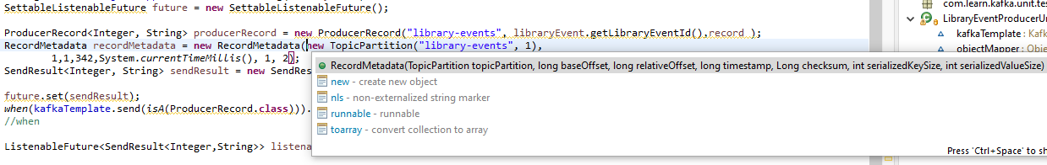

From the logs we can make out that there are messages saying

Error sending the message and the exception is ….

Message send successfully for the key ….

So we have successfully through our test case tried to cover the handle failure block. And there is one more thing that we need to do before we wind up this one. We have our do nothing here. This won't work with this method. Now we're return a ListenableFuture. So we need to go ahead and change this one. It's going to be .send and it's going to be as a LibraryEvent and in here we are going return null, because the controller is not going to use any of these things right. So in this case we can return null. So do the same thing for the below case too. Now let's quickly run this test case and then validate we are not breaking any off or automated test. Now we have successfully return a unit test for the Kafka corporatism layer which is handling the failure block.

@Test

**void** postLibraryEvent() **throws** Exception {

when( libraryEventProducer.sendLibraryEvent_Approach2( isA( LibraryEvent.**class** ) ) )

.thenReturn( null );

}

@Test

**void** postLibraryEvent_4xx() **throws** Exception {

. . .

when( libraryEventProducer.sendLibraryEvent_Approach2( isA( LibraryEvent.**class** ) ) )

.thenReturn( null );

}

So we have successfully through our test case tried to cover the handle failure block. And there is one more thing that we need to do before we wind up this one. We have our do nothing here. This won't work with this method. Now we're return a ListenableFuture. So we need to go ahead and change this one. It's going to be .send and it's going to be as a LibraryEvent and in here we are going return null, because the controller is not going to use any of these things right. So in this case we can return null. So do the same thing for the below case too. Now let's quickly run this test case and then validate we are not breaking any off or automated test. Now we have successfully return a unit test for the Kafka corporatism layer which is handling the failure block.

**Test case for success**

The producer is returning us a ListenableResult<SendResult<K,V>> from the Producer.send method below

**public** ListenableFuture<SendResult<Integer,String>> sendLibraryEvent_Approach2(

LibraryEvent libraryEvent) **throws** JsonProcessingException {

Integer key = libraryEvent.getLibraryEventId();

String value = objectMapper.writeValueAsString(libraryEvent);

. . .

Difference here is we are not setting the Exception and instead we are setting the

SettableListenableFuture future = new SettableListenableFuture();

ProducerRecord<Integer, String> producerRecord =

new ProducerRecord("library-events", libraryEvent.getLibraryEventId(),record );

So we would have to create a SendResult and that is a type <Integer, String> and takes in a ProducerRecord and RecordMetaData.

So it takes a lot of arguments. Number one us as you can see it is a topic partition. So we need to create an instance of that one and it's going to take a the topic name first which is a library events and followed by that what is a partition. The partition is one OK. We have to pass a lot of other arguments to this metadata. Number one as a base offset to offset, timestamp, checksumand serialized key size and serialized value size. You can use some random values for those things. So what does the first one the first one is a base offset I'm going to give the values one followed by that delay to offset the values one and the timestamp. Let's give a number. 342 and followed by that current time in milliseconds and followed by Serialized key size and Serialized value size. You can just give 1 and 2.

RecordMetadata recordMetadata = new RecordMetadata(

new TopicPartition("library-events", 1),1,1,342,System.*currentTimeMillis*(), 1, 2);

SendResult<Integer, String> sendResult =

new SendResult<Integer, String>(producerRecord, recordMetadata);

So we have both the ProducerRecord and RecordMetaData ready and now we will set it to the SettableListenableFuture

future.set(sendResult);

It returns you the ListenableFuture

*when*( kafkaTemplate.send( *isA*(ProducerRecord.class) ) ).thenReturn( future );

//when

ListenableFuture<SendResult<Integer,String>> listenableFuture =

eventProducer.sendLibraryEvent_Approach2(libraryEvent);

We will do a get call after this to the ListenableFuture you get the end result

SendResult<Integer,String> sendResult1 = listenableFuture.get();

We will assert on the partition number from response to be 1 since we have set that to 1 while creating the RecordMetaData.

assert sendResult1.getRecordMetadata().partition()==1;

The test case is below.

@Test

void sendLibraryEvent_Approach2_success()

throws JsonProcessingException, ExecutionException, InterruptedException {

//given

Book book = Book.*builder*()

.bookId(123)

.bookAuthor("Dilip")

.bookName("Kafka using Spring Boot")

.build();

LibraryEvent libraryEvent = LibraryEvent.*builder*()

.libraryEventId(null)

.book(book)

.build();

String record = objectMapper.writeValueAsString(libraryEvent);

SettableListenableFuture future = new SettableListenableFuture();

ProducerRecord<Integer, String> producerRecord =

new ProducerRecord("library-events", libraryEvent.getLibraryEventId(),record );

RecordMetadata recordMetadata = new RecordMetadata(

new TopicPartition("library-events", 1),1,1,342,System.*currentTimeMillis*(), 1, 2);

SendResult<Integer, String> sendResult =

new SendResult<Integer, String>(producerRecord, recordMetadata);

future.set(sendResult);

*when*( kafkaTemplate.send( *isA*(ProducerRecord.class) ) ).thenReturn( future );

//when

ListenableFuture<SendResult<Integer,String>> listenableFuture =

eventProducer.sendLibraryEvent_Approach2(libraryEvent);

//then

SendResult<Integer,String> sendResult1 = listenableFuture.get();

assert sendResult1.getRecordMetadata().partition()==1;

}

**PUT Api**

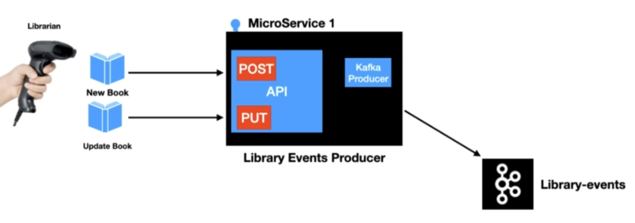

The payload will look the same as the post endpoint.

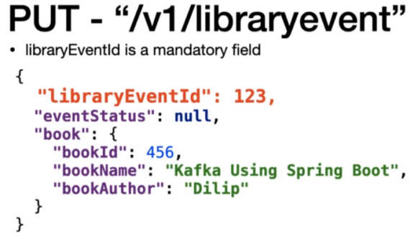

The catch here is that the LibraryEventId is a mandatory value. When the librarian scans it, they will know the libraryEventId is already present and there should be a validation in the end point to make sure that LibraryEvent is always present when the put endPoint is invoked.

In the Controller the code is the same as the POST method except for the red highlighted differences below. This will need a PUT mapping instead of a POST mapping. We have checked here for a LibraryEventId being null and if yes then returned that as a HttpStatus.BAD_REQUEST. The event type is set to UPDATE and on successful completion we are returning a HttpStatus.OK

@RestController

@Slf4j

**public** **class** LibraryEventsController {

@Autowired

LibraryEventProducer libraryEventProducer;

//PUT

@PutMapping("/v1/libraryevent")

public ResponseEntity<?> putLibraryEvent(@RequestBody @Valid LibraryEvent libraryEvent)

throws JsonProcessingException, ExecutionException, InterruptedException {

if(libraryEvent.getLibraryEventId()==null){

return ResponseEntity.status(HttpStatus.BAD*_*REQUEST).body("Please pass LibraryEventId");

}

libraryEvent.setLibraryEventType(LibraryEventType.UPDATE);

libraryEventProducer.sendLibraryEvent_Approach2(libraryEvent);

return ResponseEntity.*status*(HttpStatus.*OK*).body(libraryEvent);

}

. . .

Curl command to test this

C:\>curl -i -d "{\"libraryEventId\":1,\"book\":{\"bookId\":456,\"bookName\":\"Kafka Using Spring Boot 2.X\",\"bookAuthor\":\"Dilip\"}}" -H "Content-Type: application/json" -X PUT http://localhost:9000/v1/libraryevent

HTTP/1.1 **200**

Content-Type: application/json

Transfer-Encoding: chunked

Date: Mon, 21 Dec 2020 08:27:40 GMT

{"libraryEventId":1,"libraryEventType":"UPDATE","book":{"bookId":456,"bookName":"Kafka Using Spring Boot 2.X","bookAuthor":"Dilip"}}

Producer Logs

2020-12-21 13:57:40.312 INFO 12108 --- [ad | producer-1] o.a.k.c.Metadata : [Producer clientId=producer-1] Cluster ID: ji7jjpYERV6A-cQ4TXkWSw

2020-12-21 13:57:40.547 INFO 12108 --- [ad | producer-1] c.l.k.p.LibraryEventProducer : Message Sent SuccessFully for the key : 1 and the value is {"libraryEventId":1,"libraryEventType":"UPDATE","book":{"bookId":456,"bookName":"Kafka Using Spring Boot 2.X","bookAuthor":"Dilip"}} , partition is 0

Curl command to put a request without a id, we should get a 4xx Bad Request in that case

C:\>curl -i -d "{\"libraryEventId\":1,\"book\":{\"bookId\":null,\"bookName\":\"Kafka Using Spring Boot 2.X\",\"bookAuthor\":\"Dilip\"}}" -H "Content-Type: application/json" -X PUT http://localhost:9000/v1/libraryevent

HTTP/1.1 400

Content-Type: text/plain;charset=UTF-8

Content-Length: 30

Date: Mon, 21 Dec 2020 08:29:57 GMT

Connection: close

book.bookId - must not be null

Producer Logs

2020-12-21 13:59:57.613 INFO 12108 --- [nio-9000-exec-2] c.l.k.c.LibraryEventControllerAdvice : errorMessage : book.bookId - must not be null

Now the one thing that we need to validate is that the did it reach the same partition or not as you can see it went to the same partition. This is really important. The ordering of the Events. This is important to you because Kafka guarantees ordering only the partition level. So the partition or behind the scenes apply the hashing technique to figure out the partition from the available partitions for the given key. So if you want to send a message to the same partition make sure you pass the same key. Now just to show you the difference I would like to post another even with a totally different libraryEventId.

C:\Users\Dimpu>curl -i -d "{\"libraryEventId\":999,\"book\":{\"bookId\":12,\"bookName\":\"Kafka Using Spring Boot 2.X\",\"bookAuthor\":\"Dilip\"}}" -H "Content-Type: application/json" -X PUT http://localhost:9000/v1/libraryevent

HTTP/1.1 200

Content-Type: application/json

Transfer-Encoding: chunked

Date: Mon, 21 Dec 2020 08:38:24 GMT

{"libraryEventId":999,"libraryEventType":"UPDATE","book":{"bookId":12,"bookName":"Kafka Using Spring Boot 2.X","bookAuthor":"Dilip"}}

C:\Users\Dimpu>curl -i -d "{\"libraryEventId\":2,\"book\":{\"bookId\":12,\"bookName\":\"Kafka Using Spring Boot 2.X\",\"bookAuthor\":\"Dilip\"}}" -H "Content-Type: application/json" -X PUT http://localhost:9000/v1/libraryevent

HTTP/1.1 200

Content-Type: application/json

Transfer-Encoding: chunked

Date: Mon, 21 Dec 2020 08:38:24 GMT

{"libraryEventId":2,"libraryEventType":"UPDATE","book":{"bookId":12,"bookName":"Kafka Using Spring Boot 2.X","bookAuthor":"Dilip"}}

C:\Users\Dimpu>curl -i -d "{\"libraryEventId\":999,\"book\":{\"bookId\":12,\"bookName\":\"Kafka Using Spring Boot 2.X\",\"bookAuthor\":\"Dilip\"}}" -H "Content-Type: application/json" -X PUT http://localhost:9000/v1/libraryevent

HTTP/1.1 200

Content-Type: application/json

Transfer-Encoding: chunked

Date: Mon, 21 Dec 2020 08:38:18 GMT

Checking from the logs the 1st and the 3rd curl call having the same libraryEventId of 2 went to the same partition and the middle one having the libraryEventId of 999 went to a different partition. We are also setting the type as UPDATE.

2020-12-21 14:08:12.195 INFO 12108 --- [ad | producer-1] c.l.k.p.LibraryEventProducer : Message Sent SuccessFully for the key : 999 and the value is {"libraryEventId":999,"libraryEventType":"UPDATE","book":{"bookId":12,"bookName":"Kafka Using Spring Boot 2.X","bookAuthor":"Dilip"}} , partition is 0

2020-12-21 14:08:18.550 INFO 12108 --- [ad | producer-1] c.l.k.p.LibraryEventProducer : Message Sent SuccessFully for the key : 2 and the value is {"libraryEventId":2,"libraryEventType":"UPDATE","book":{"bookId":12,"bookName":"Kafka Using Spring Boot 2.X","bookAuthor":"Dilip"}} , partition is 2

2020-12-21 14:08:24.718 INFO 12108 --- [ad | producer-1] c.l.k.p.LibraryEventProducer : Message Sent SuccessFully for the key : 999 and the value is {"libraryEventId":999,"libraryEventType":"UPDATE","book":{"bookId":12,"bookName":"Kafka Using Spring Boot 2.X","bookAuthor":"Dilip"}} , partition is 0

Integration Test – PUT Endpoint

Put Integration Test for LibraryEventsControllerIntegrationTest

@SpringBootTest(webEnvironment = SpringBootTest.WebEnvironment.***RANDOM_PORT***)

@EmbeddedKafka(topics = {"library-events"}, partitions = 3)

@TestPropertySource(properties = {"spring.kafka.producer.bootstrap-servers=${spring.embedded.kafka.brokers}",

"spring.kafka.admin.properties.bootstrap.servers=${spring.embedded.kafka.brokers}"})

**public** **class** LibraryEventsControllerIntegrationTest {

@Autowired

TestRestTemplate restTemplate;

@Autowired

EmbeddedKafkaBroker embeddedKafkaBroker;

. . .

@Test

@Timeout(5)

**void** putLibraryEvent() **throws** InterruptedException {

//given

Book book = Book.*builder*()

.bookId(456)

.bookAuthor("Dilip")

.bookName("Kafka using Spring Boot")

.build();

LibraryEvent libraryEvent = LibraryEvent.*builder*()

.libraryEventId(123)

.book(book)

.build();

HttpHeaders headers = **new** HttpHeaders();

headers.set("content-type", MediaType.APPLICATION_JSON.toString());

HttpEntity<LibraryEvent> request = new HttpEntity<>(libraryEvent, headers);

//when

ResponseEntity<LibraryEvent> responseEntity =

restTemplate.exchange("/v1/libraryevent", HttpMethod.PUT, request, LibraryEvent.class);

//then

assertEquals(HttpStatus.OK, responseEntity.getStatusCode());

ConsumerRecord<Integer, String> consumerRecord =

KafkaTestUtils.getSingleRecord(consumer, "library-events");

String expectedRecord = "{\"libraryEventId\":123,\"libraryEventType\":\"UPDATE\",\"book\":

{\"bookId\":456,\"bookName\":\"Kafka using Spring Boot\",\"bookAuthor\":\"Lalit\"}}";

String value = consumerRecord.value();

assertEquals(expectedRecord, value);

}

. . .

}

Unit Test – PUT Endpoint

@Test

void updateLibraryEvent() throws Exception {

//given

Book book = new Book().*builder*()

.bookId(123)

.bookAuthor("Lalit")

.bookName("Kafka Using Spring Boot")

.build();

LibraryEvent libraryEvent = LibraryEvent.*builder*()

.libraryEventId(123)

.book(book)

.build();

String json = objectMapper.writeValueAsString(libraryEvent);

*when*(libraryEventProducer.sendLibraryEvent_Approach2(*isA*(LibraryEvent.class)))

.*thenReturn*(*null*);

//expect

mockMvc.perform(

put("/v1/libraryevent")

.content(json)

.contentType( MediaType.APPLICATION_JSON ))

.andExpect(status().isOk()

);

}

**Producer Configuration**

Some of the important configurations to consider while building the Kafka Producer. The first value is acks which is the key configuration for reliable data delivery. The possible values are 0 1 and all. If the value is 1 then that means the producer Record is considered to be successful if the data is persistent to the leader replica and this is the default setting for the Kafka producer.

* acks
  + acks = 0, 1 and all
  + acks = 1 -> guarantees message is written to a leader ( Default) 
  + acks = all -> guarantees message is written to a leader and to all the replicas 
  + acks=0 -> no guarantee (Not Recommended) 

So the Kafka producer that we have created until now has this setting. If the value is all then that means a producer and call is considered to be successful only if the ProducerRecord is persistent in the leader replica and the follower replica too. So when do you use this option. If the data that's generated from your app is very critical and the data loss leads to a big problem then this is the recommended setting.

If the value is zero then the producers send call doesn't care about whether the messages successfully persisted into the reader replica or follow or pick up. It is just considered successful as soon as the send call is invoked. So the recommended setting is use this value as 1 are all. The zero value is not recommended.

Now the next config is retries, retries config takes care of retrying the record in case of any failure producing the messages the Kafka. The value of retries is an integer, the value can range from zero to the number displayed in the slide.

* retries
* Integer value = [0 - 2147483647]
* In Spring Kafka, the default value is **-> 2147483647**

In spring Kafka the default values the max value for the retries.

The next config is a retry.backoff.ms. This configuration represent the value in milliseconds. The default value of this one is hundred milliseconds.

* retry.backoff.ms
* Integer value represented in milliseconds
* Default value is 100ms

There are lots of other configurations that are part of the producer config. Let me quickly show you where to find them. Now let's go to the browser and then search far Kafka producer config.

<https://kafka.apache.org/documentation/#producerconfigs>

There are lots and lots of different configurations.

Lets see where to find the configurations and how to override the default producer configurations. The first thing is I'm going to run the integration test case just for that purpose. So let's select the postLibraryEvent test method. All the configuration would be displayed in the console. So we're going to go and check one of the confog and then we are going to override the default value. So we have the integration test case.

**ProducerConfig values:**

acks = 1

batch.size = 16384

bootstrap.servers = [127.0.0.1:13614]

buffer.memory = 33554432

client.dns.lookup = default

client.id = producer-1

compression.type = none

connections.max.idle.ms = 540000

delivery.timeout.ms = 120000

enable.idempotence = false

interceptor.classes = []

key.serializer = class org.apache.kafka.common.serialization.IntegerSerializer

linger.ms = 0

max.block.ms = 60000

max.in.flight.requests.per.connection = 5

max.request.size = 1048576

metadata.max.age.ms = 300000

metadata.max.idle.ms = 300000

metric.reporters = []

metrics.num.samples = 2

metrics.recording.level = INFO

metrics.sample.window.ms = 30000

partitioner.class = class org.apache.kafka.clients.producer.internals.DefaultPartitioner

receive.buffer.bytes = 32768

reconnect.backoff.max.ms = 1000

reconnect.backoff.ms = 50

request.timeout.ms = 30000

retries = 2147483647

retry.backoff.ms = 100

sasl.client.callback.handler.class = null

sasl.jaas.config = null

sasl.kerberos.kinit.cmd = /usr/bin/kinit

sasl.kerberos.min.time.before.relogin = 60000

sasl.kerberos.service.name = null

sasl.kerberos.ticket.renew.jitter = 0.05

sasl.kerberos.ticket.renew.window.factor = 0.8

sasl.login.callback.handler.class = null

sasl.login.class = null

sasl.login.refresh.buffer.seconds = 300

sasl.login.refresh.min.period.seconds = 60

sasl.login.refresh.window.factor = 0.8

sasl.login.refresh.window.jitter = 0.05

sasl.mechanism = GSSAPI

security.protocol = PLAINTEXT

security.providers = null

send.buffer.bytes = 131072

ssl.cipher.suites = null

ssl.enabled.protocols = [TLSv1.2]

ssl.endpoint.identification.algorithm = https

ssl.key.password = null

ssl.keymanager.algorithm = SunX509

ssl.keystore.location = null

ssl.keystore.password = null

ssl.keystore.type = JKS

ssl.protocol = TLSv1.2

ssl.provider = null

ssl.secure.random.implementation = null

ssl.trustmanager.algorithm = PKIX

ssl.truststore.location = null

ssl.truststore.password = null

ssl.truststore.type = JKS

transaction.timeout.ms = 60000

transactional.id = null

value.serializer = class org.apache.kafka.common.serialization.StringSerializer

**ConsumerConfig values:**

2020-12-21 15:57:15.045 INFO 2532 --- [ main] o.a.k.c.u.AppInfoParser: Kafka version: 2.5.0

2020-12-21 15:57:15.046 INFO 2532 --- [ main] o.a.k.c.u.AppInfoParser: Kafka commitId: 66563e712b0b9f84

2020-12-21 15:57:15.046 INFO 2532 --- [ main] o.a.k.c.u.AppInfoParser: Kafka startTimeMs: 1608546435045

2020-12-21 15:57:16.765 INFO 2532 --- [ main] o.a.k.c.c.ConsumerConfig: ConsumerConfig values:

allow.auto.create.topics = true

auto.commit.interval.ms = 10

auto.offset.reset = earliest

bootstrap.servers = [127.0.0.1:13614]

check.crcs = true

client.dns.lookup = default

client.id =

client.rack =

connections.max.idle.ms = 540000

default.api.timeout.ms = 60000

enable.auto.commit = true

exclude.internal.topics = true

fetch.max.bytes = 52428800

fetch.max.wait.ms = 500

fetch.min.bytes = 1

group.id = group1

group.instance.id = null

heartbeat.interval.ms = 3000

interceptor.classes = []

internal.leave.group.on.close = true

isolation.level = read_uncommitted

key.deserializer = class org.apache.kafka.common.serialization.IntegerDeserializer

max.partition.fetch.bytes = 1048576

max.poll.interval.ms = 300000

max.poll.records = 500

metadata.max.age.ms = 300000

metric.reporters = []

metrics.num.samples = 2

metrics.recording.level = INFO

metrics.sample.window.ms = 30000

partition.assignment.strategy = [class org.apache.kafka.clients.consumer.RangeAssignor]

receive.buffer.bytes = 65536

reconnect.backoff.max.ms = 1000

reconnect.backoff.ms = 50

request.timeout.ms = 30000

retry.backoff.ms = 100

sasl.client.callback.handler.class = null

sasl.jaas.config = null

sasl.kerberos.kinit.cmd = /usr/bin/kinit

sasl.kerberos.min.time.before.relogin = 60000

sasl.kerberos.service.name = null

sasl.kerberos.ticket.renew.jitter = 0.05

sasl.kerberos.ticket.renew.window.factor = 0.8

sasl.login.callback.handler.class = null

sasl.login.class = null

sasl.login.refresh.buffer.seconds = 300

sasl.login.refresh.min.period.seconds = 60

sasl.login.refresh.window.factor = 0.8

sasl.login.refresh.window.jitter = 0.05

sasl.mechanism = GSSAPI

security.protocol = PLAINTEXT

security.providers = null

send.buffer.bytes = 131072

session.timeout.ms = 60000

ssl.cipher.suites = null

ssl.enabled.protocols = [TLSv1.2]

ssl.endpoint.identification.algorithm = https

ssl.key.password = null

ssl.keymanager.algorithm = SunX509

ssl.keystore.location = null

ssl.keystore.password = null

ssl.keystore.type = JKS

ssl.protocol = TLSv1.2

ssl.provider = null

ssl.secure.random.implementation = null

ssl.trustmanager.algorithm = PKIX

ssl.truststore.location = null

ssl.truststore.password = null

ssl.truststore.type = JKS

value.deserializer = class org.apache.kafka.common.serialization.StringDeserializer

Lets override the acks value from the Producer Config now in the application.yml file in producer microservice

spring:

profiles:

active: local

server:

port: 9000

---

spring:

profiles: local

kafka:

template:

default-topic: library-events

producer:

bootstrap-servers: localhost:9092,localhost:9093,localhost:9094

key-serializer: org.apache.kafka.common.serialization.IntegerSerializer

value-serializer: org.apache.kafka.common.serialization.StringSerializer

properties:

acks: all

retries: 10

retry.backoff.ms: 1000

admin:

properties:

bootstrap.servers: localhost:9092,localhost:9093,localhost:9094

We can see the new values in the log now when we re-run the test case.

**Kafka Consumer**

Lets setup the base project for LibraryEventConsumer

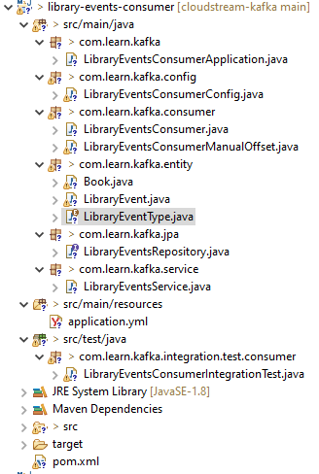

Before we get into the Consumer we will look at how the Consumer works

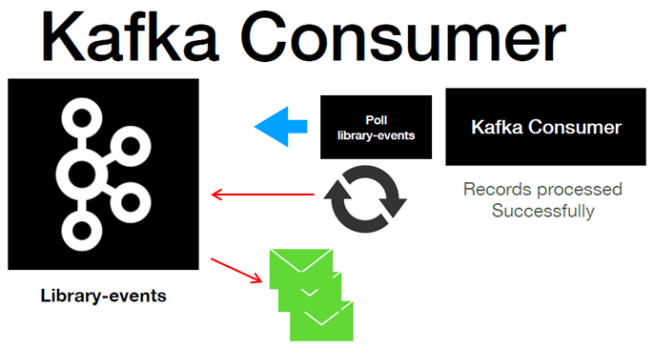

Lets discuss the flow of how Kafka Consumer is going to read the records from the Kafka topic in here. We have the coffee topic and then we have the Kafka consumer. Then the poll loop is executed. What it is going to do is it is going to pull four new records from the Kafka topic and then it is going to retrieve those records. Once the records are retrieved, It's going to be processed by the proper consumer and then it's going to continue the same process. A quick callout here is that copy consumer also have the option to consume records from multiple topics at the same time but it is not applicable for the application that we are going to poll because we are just going to consume the records from one topic which is library-events-topic. Now let's discuss about what are the options that we have for configuring Kafka consumer.

Option number one is Kafka MessageListenerContainer which is an interface actually. And it has two implementations. Number one is KafkaMessageListenerContainer and number two is ConcurrentMessageListenerContainer. Option number two is using the article as an annotation which uses the ConcurrentMessageListenerContainer behind the scenes. I would like to quickly cover what is the behavior of all the implementations that's shown in this slide. Let's start with Kafka MessageListenerContainer.

Spring Kafka Consumer

* MessageListenerContainer
  + KafkaMessageListenerContainer
  + ConcurrentMessageListenerContainer
* **@KafkaLisener** Annotation
  + Uses ConcurrentMessageListenerContainer behind the scenes

**KafkaMessageListenerContainer**

* Implementation of MessageListenerContainer
* Polls the records
* Commits the Offsets
* Single Threaded

This is the class which is the implementation of the MessageListenerContainer, it takes care polling the records from the Kafka topic and it also takes care of committing the offsets after that the records are processed. This class is a single threaded which means the poll call is handled by a single thread.

**ConcurrentMessageListenerContainer**

* Represents multiple **KafkaMessageListenerContainer**

This represents multiple Kafka MessageListenerContainer. Think of this as multiple instance of Kafka message Listener containers. The implementation is going to work in the similar approach to the Kafka MessageListenerContainer. One advantage with it is that you can spin up a multiple instance of Kafka message Listener container so that you can poll from the Kafka topic simultaneously using multiple threads.

**@KafkaListener**

This is the easiest way to build Kafka Consumer

**KafkaListener Sample Code**

@KafkaListener(topics = {"${spring.kafka.topic}"})

public void onMessage(ConsumerRecord<Integer, String> consumerRecord) {

log.info("OnMessage Record : {} “, consumerRecord);

}

Configuration Sample Code

@Configuration

@EnableKafka

@Slf4j

public class LibraryEventsConsumerConfig {

. . .

The third option is a Kafka listener annotation. This is one of the simplest way to build a Kafka Consumer. In spring we will be using this option for building the Kafka consumer. All you got to do is to add the @KafkaListener annotation to a method in a class annotated with @Component ( as a bean basically ) and add the @EnableKafka on a configuration class which will be set up. Configuration is simple too, all we need to do is

**KafkaConsumer Config**

key-deserializer: org.apache.kafka.common.serialization.IntegerDeserializer

value-deserializer: org.apache.kafka.common.serialization.StringDeserializer

group-id: library-events-listener-group

Now I'm going to show you where to find more information about Kafka consumers. Search for Spring for Kafka and go to the link called Receiving Messages

<https://docs.spring.io/spring-kafka/reference/html/#receiving-messages>

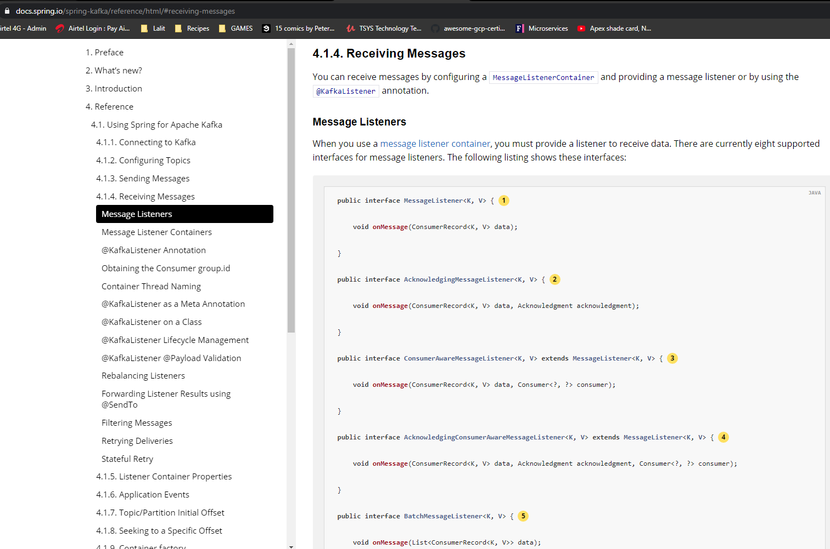

Use this interface for processing individual ConsumerRecord instances received from the Kafka consumer poll() operation when using auto-commit or one of the container-managed [commit methods](https://docs.spring.io/spring-kafka/reference/html/#committing-offsets).

public interface MessageListener<K, V> {

void onMessage(ConsumerRecord<K, V> data);

}

Use this interface for processing individual ConsumerRecord instances received from the Kafka consumer poll() operation when using one of the manual [commit methods](https://docs.spring.io/spring-kafka/reference/html/#committing-offsets).

public interface AcknowledgingMessageListener<K, V> {

void onMessage(ConsumerRecord<K, V> data, Acknowledgment acknowledgment);

}

Use this interface for processing individual ConsumerRecord instances received from the Kafka consumer poll() operation when using auto-commit or one of the container-managed [commit methods](https://docs.spring.io/spring-kafka/reference/html/#committing-offsets). Access to the Consumer object is provided.

public interface ConsumerAwareMessageListener<K, V> extends MessageListener<K, V> {

void onMessage(ConsumerRecord<K, V> data, Consumer<?, ?> consumer);

}

Use this interface for processing individual ConsumerRecord instances received from the Kafka consumer poll() operation when using one of the manual commit methods. Access to the Consumer object is provided.

public interface AcknowledgingConsumerAwareMessageListener<K, V> extends MessageListener<K, V> {

void onMessage(ConsumerRecord<K, V> data, Acknowledgment acknowledgment, Consumer<?, ?> consumer);

}

Use this interface for processing all ConsumerRecord instances received from the Kafka consumer poll() operation when using auto-commit or one of the container-managed [commit methods](https://docs.spring.io/spring-kafka/reference/html/#committing-offsets). AckMode.RECORD is not supported when you use this interface, since the listener is given the complete batch.

public interface BatchMessageListener<K, V> {

void onMessage(List<ConsumerRecord<K, V>> data);

}

Use this interface for processing all ConsumerRecord instances received from the Kafka consumer poll() operation when using one of the manual commit methods.

public interface BatchAcknowledgingMessageListener<K, V> {

void onMessage(List<ConsumerRecord<K, V>> data, Acknowledgment acknowledgment);

}

Use this interface for processing all ConsumerRecord instances received from the Kafka consumer poll() operation when using auto-commit or one of the container-managed [commit methods](https://docs.spring.io/spring-kafka/reference/html/#committing-offsets). AckMode.RECORD is not supported when you use this interface, since the listener is given the complete batch. Access to the Consumer object is provided.

public interface BatchConsumerAwareMessageListener<K, V> extends BatchMessageListener<K, V> {

void onMessage(List<ConsumerRecord<K, V>> data, Consumer<?, ?> consumer);

}

Use this interface for processing all ConsumerRecord instances received from the Kafka consumer poll() operation when using one of the manual [commit methods](https://docs.spring.io/spring-kafka/reference/html/#committing-offsets). Access to the Consumer object is provided.

public interface BatchAcknowledgingConsumerAwareMessageListener<K, V> extends BatchMessageListener<K, V> {

void onMessage(List<ConsumerRecord<K, V>> data, Acknowledgment acknowledgment, Consumer<?, ?> consumer);

}

Below we have the @KafkaListener as well

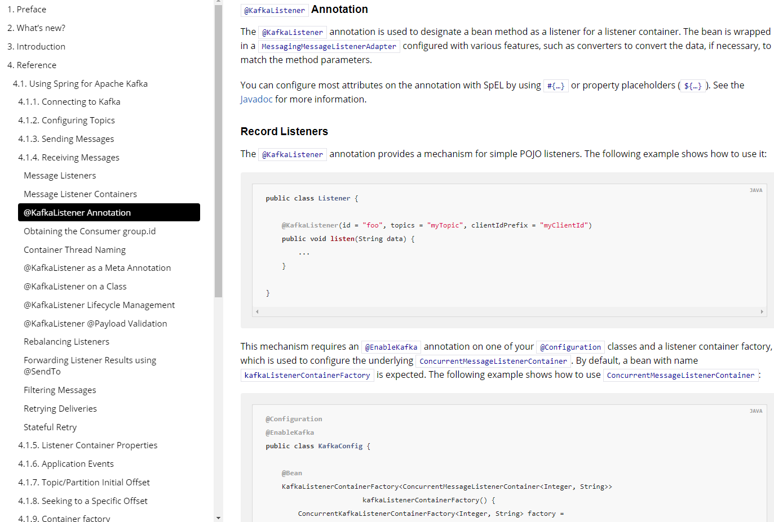

This mechanism requires an @EnableKafka annotation on one of your @Configuration classes and a listener container factory, which is used to configure the underlying ConcurrentMessageListenerContainer. By default, a bean with name kafkaListenerContainerFactory is expected. The following example shows how to use ConcurrentMessageListenerContainer:

@Configuration

@EnableKafka

public class KafkaConfig {

@Bean

KafkaListenerContainerFactory< ConcurrentMessageListenerContainer<Integer, String>>

kafkaListenerContainerFactory() {

ConcurrentKafkaListenerContainerFactory<Integer, String> factory =

new ConcurrentKafkaListenerContainerFactory<>();

factory.setConsumerFactory(consumerFactory());

factory.setConcurrency(3);

factory.getContainerProperties().setPollTimeout(3000);

return factory;

}

@Bean

public ConsumerFactory<Integer, String> consumerFactory() {

return new DefaultKafkaConsumerFactory<>( consumerConfigs() );

}

@Bean

public Map<String, Object> consumerConfigs() {

Map<String, Object> props = new HashMap<>();

props.put( ProducerConfig.BOOTSTRAP_SERVERS_CONFIG, embeddedKafka.getBrokersAsString() );

...

return props;

}

}

**pom.xml**

Dependencies we will use are

* Spring Data JPA
* H2 Database
* Lombok
* Kafka

<?xml version=*"1.0"* encoding=*"UTF-8"*?>

<project xmlns=*"http://maven.apache.org/POM/4.0.0"* xmlns:xsi=*"http://www.w3.org/2001/XMLSchema-instance"*

xsi:schemaLocation=*"http://maven.apache.org/POM/4.0.0 https://maven.apache.org/xsd/maven-4.0.0.xsd"*>

<modelVersion>4.0.0</modelVersion>

<parent>

<groupId>org.springframework.boot</groupId>

<artifactId>spring-boot-starter-parent</artifactId>

<version>2.3.1.RELEASE</version>

<relativePath/> <!-- lookup parent from repository -->

</parent>

<groupId>com.learn.kafka</groupId>

<artifactId>01-library-events-consumer</artifactId>

<version>0.0.1-SNAPSHOT</version>

<name>01-library-events-consumer</name>

<description>Kafka Spring Cloud Streaming</description>

<properties>

<java.version>1.11</java.version>

</properties>

<dependencies>

<dependency>

<groupId>org.springframework.boot</groupId>

<artifactId>spring-boot-starter-data-jpa</artifactId>

</dependency>

<dependency>

<groupId>org.springframework.boot</groupId>

<artifactId>spring-boot-starter-web</artifactId>

<exclusions>

<exclusion>

<groupId>org.springframework.boot</groupId>

<artifactId>spring-boot-starter-logging</artifactId>

</exclusion>

</exclusions>

</dependency>

<dependency>

<groupId>org.springframework.boot</groupId>

<artifactId>spring-boot-starter-log4j2</artifactId>

</dependency>

<dependency>

<groupId>org.springframework.kafka</groupId>

<artifactId>spring-kafka</artifactId>

</dependency>

<dependency>

<groupId>org.springframework.boot</groupId>

<artifactId>spring-boot-starter-validation</artifactId>

</dependency>

<dependency>

<groupId>com.h2database</groupId>

<artifactId>h2</artifactId>

</dependency>

<dependency>

<groupId>com.h2database</groupId>

<artifactId>h2</artifactId>

<scope>runtime</scope>

</dependency>

<dependency>

<groupId>org.projectlombok</groupId>

<artifactId>lombok</artifactId>

<version>1.18.4</version>

<scope>provided</scope>

</dependency>

<dependency>

<groupId>org.springframework.kafka</groupId>

<artifactId>spring-kafka-test</artifactId>

<scope>test</scope>

</dependency>

<dependency>

<groupId>org.springframework.boot</groupId>

<artifactId>spring-boot-starter-test</artifactId>

<scope>test</scope>

<exclusions>

<exclusion>

<groupId>org.junit.vintage</groupId>

<artifactId>junit-vintage-engine</artifactId>

</exclusion>

</exclusions>

</dependency>

<dependency>

<groupId>de.flapdoodle.embed</groupId>

<artifactId>de.flapdoodle.embed.mongo</artifactId>

<scope>test</scope>

</dependency>

<dependency>

<groupId>io.projectreactor</groupId>

<artifactId>reactor-test</artifactId>

<scope>test</scope>

</dependency>

</dependencies>

<build>

<plugins>

<plugin>

<groupId>org.springframework.boot</groupId>

<artifactId>spring-boot-maven-plugin</artifactId>

</plugin>

</plugins>

</build>

</project>

Spring Profiles – Application YAML

We will configure the properties that are necessary to configure a Kafka consumer and then we are going to use SpringBoot profiles to set this up. This is similar to the activity that we had done for the LibraryEventProducer.

So we would configure the bootstrap-servers, key-serializer, value-serializer and group-id ( which is mandatory )

Note that in case of consumer we would provide the key-deserializer here instead of the key-serializer as in the case of a producer. Same for value – it would be value-deserializer instead of the value-deserializer

If you are building this for an enterprise you would have multiple profiles like this, this one is local so there would also be something like dev, uat, prod and so on. We have also mentioned which one is going to be active at the top. Also specify the server: port so that there won’t be a conflict with the Producer application.

**application.yaml**

spring:

profiles:

active: local

server:

port: 8081

---

spring:

profiles: local

kafka:

template:

default-topic: library-events

**consumer**:

bootstrap-servers: localhost:9092,localhost:9093,localhost:9094

key-deserializer: org.apache.kafka.common.serialization.IntegerDeserializer

value-deserializer: org.apache.kafka.common.serialization.StringDeserializer

group-id: library-events-listener-group

**producer**:

bootstrap-servers:

- localhost:9092,localhost:9093,localhost:9094

key-serializer: org.apache.kafka.common.serialization.IntegerSerializer

value-serializer: org.apache.kafka.common.serialization.StringSerializer

**datasource**:

url: jdbc:h2:mem:testdb

driver-class-name: org.h2.Driver

**jpa**:

database: h2

database-platform: org.hibernate.dialect.H2Dialect

generate-ddl: true

**h2**:

console:

enabled: true

**Main Application**

import org.springframework.boot.SpringApplication;

import org.springframework.boot.autoconfigure.SpringBootApplication;

@SpringBootApplication

public class LibraryEventsConsumerApplication {

public static void main(String[] args) {

SpringApplication.run(LibraryEventsConsumerApplication.class, args);

}

}

Lets code the actual Kafka Consumer now. This will need a @Component ( to make it a bean ) and a @Slf4j annotation. This needs to have a method that can react to the events on the topic so we would annotate that one with the @KafkaListener and provide the topic name to it as library-events. We will inject the LibraryEventsService to this that will help us process the event. There are lots of properties in the @KafkaListener annotation like

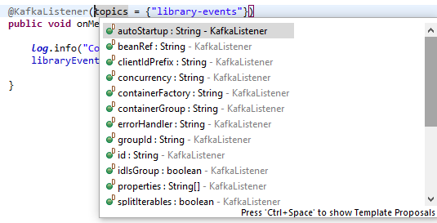 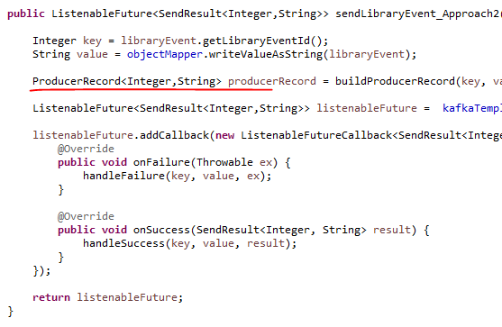

The listener method receives a ConsumerRecord<Integer, String>. The Producer uses a ProducerRecord, likewise for a Consumer we would have a ConsumerRecord ( right side screenshot above ).

Even though this call is going to retrieve multiple records here we have the handle of records one by one. So the Kafka listener container which is going to pull the records it is going to get multiple records at the same time. But it is going to pass the records one by one to this on message.

**LibraryEventsConsumer.java**

package com.learn.kafka.consumer;

import com.fasterxml.jackson.core.JsonProcessingException;

import com.learn.kafka.service.LibraryEventsService;

import lombok.extern.slf4j.Slf4j;

import org.apache.kafka.clients.consumer.ConsumerRecord;

import org.springframework.beans.factory.annotation.Autowired;

import org.springframework.kafka.annotation.KafkaListener;

import org.springframework.stereotype.Component;

@Component

@Slf4j

public class LibraryEventsConsumer {

@Autowired

private LibraryEventsService libraryEventsService;

@KafkaListener(topics = {"library-events"})

public void onMessage(ConsumerRecord<Integer,String> consumerRecord)

throws JsonProcessingException {

log.info("ConsumerRecord : {} ", consumerRecord );

libraryEventsService.processLibraryEvent(consumerRecord);

}

}

The consumer instance got created by reading all the configurations that we provided in the application.yml file.

kafka:

template:

default-topic: library-events

producer:

bootstrap-servers: localhost:9092,localhost:9093,localhost:9094

key-serializer: org.apache.kafka.common.serialization.IntegerSerializer

value-serializer: org.apache.kafka.common.serialization.StringSerializer

properties:

acks: all

retries: 10

retry.backoff.ms: 1000

admin:

properties:

bootstrap.servers: localhost:9092,localhost:9093,localhost:9094

Once you see the message partitions are assigned that’s the signal that the consumer was able to successfully connect to the topic and it has all the partitions. You can see library-events-1, library-events-2 and library-events-0 were assigned. We created 3 partitions.

2020-12-22 06:55:17.815 INFO 2648 --- [ main] c.l.k.LibraryEventsConsumerApplication : Started LibraryEventsConsumerApplication in 5.162 seconds (JVM running for 6.067)

2020-12-22 06:55:17.825 INFO 2648 --- [ntainer#0-0-C-1] o.a.k.c.c.i.AbstractCoordinator : [Consumer clientId=consumer-library-events-listener-group-1, groupId=library-events-listener-group] Successfully joined group with generation 17

2020-12-22 06:55:17.826 INFO 2648 --- [ntainer#0-1-C-1] o.a.k.c.c.i.AbstractCoordinator : [Consumer clientId=consumer-library-events-listener-group-2, groupId=library-events-listener-group] Successfully joined group with generation 17

2020-12-22 06:55:17.826 INFO 2648 --- [ntainer#0-2-C-1] o.a.k.c.c.i.AbstractCoordinator : [Consumer clientId=consumer-library-events-listener-group-3, groupId=library-events-listener-group] Successfully joined group with generation 17

2020-12-22 06:55:17.839 INFO 2648 --- [ntainer#0-0-C-1] o.a.k.c.c.i.ConsumerCoordinator : [Consumer clientId=consumer-library-events-listener-group-1, groupId=library-events-listener-group] Adding newly assigned partitions: library-events-0

2020-12-22 06:55:17.839 INFO 2648 --- [ntainer#0-1-C-1] o.a.k.c.c.i.ConsumerCoordinator : [Consumer clientId=consumer-library-events-listener-group-2, groupId=library-events-listener-group] Adding newly assigned partitions: library-events-1

2020-12-22 06:55:17.839 INFO 2648 --- [ntainer#0-2-C-1] o.a.k.c.c.i.ConsumerCoordinator : [Consumer clientId=consumer-library-events-listener-group-3, groupId=library-events-listener-group] Adding newly assigned partitions: library-events-2

2020-12-22 06:55:17.866 INFO 2648 --- [ntainer#0-0-C-1] o.a.k.c.c.i.ConsumerCoordinator : [Consumer clientId=consumer-library-events-listener-group-1, groupId=library-events-listener-group] Setting offset for partition library-events-0 to the committed offset FetchPosition{offset=2, offsetEpoch=Optional.empty, currentLeader=LeaderAndEpoch{leader=Optional[DESKTOP-PEI24P3.mshome.net:9092 (id: 0 rack: null)], epoch=12}}

2020-12-22 06:55:17.866 INFO 2648 --- [ntainer#0-1-C-1] o.a.k.c.c.i.ConsumerCoordinator : [Consumer clientId=consumer-library-events-listener-group-2, groupId=library-events-listener-group] Setting offset for partition library-events-1 to the committed offset FetchPosition{offset=5, offsetEpoch=Optional.empty, currentLeader=LeaderAndEpoch{leader=Optional[DESKTOP-PEI24P3.mshome.net:9094 (id: 2 rack: null)], epoch=13}}

2020-12-22 06:55:17.867 INFO 2648 --- [ntainer#0-1-C-1] o.s.k.l.KafkaMessageListenerContainer : library-events-listener-group: partitions assigned: [library-events-1]

2020-12-22 06:55:17.867 INFO 2648 --- [ntainer#0-0-C-1] o.s.k.l.KafkaMessageListenerContainer : library-events-listener-group: partitions assigned: [library-events-0]

2020-12-22 06:55:17.870 INFO 2648 --- [ntainer#0-2-C-1] o.s.k.l.KafkaMessageListenerContainer : library-events-listener-group: partitions assigned: [library-events-2]

Lets test this one, use the curl command

C:\> curl -i -d "{\"libraryEventId\":null,\"book\":{\"bookId\":456,\"bookName\":\"Kafka Using Spring Boot\",\"bookAuthor\":\"Lalit\"}}" -H "Content-Type: application/json" -X POST

http://localhost:9000/v1/libraryevent

HTTP/1.1 201

Content-Type: application/json

Transfer-Encoding: chunked

Date: Tue, 22 Dec 2020 01:34:20 GMT

{"libraryEventId":null,"libraryEventType":"NEW","book":{"bookId":456,"bookName":"Kafka Using Spring Boot","bookAuthor":"Lalit"}}

The key is now because it's a post call as you can see we are passing the key as null. In the Kafka Header we see the value as encrypted so we see that as [115, 99, 97, 110, 110, 101, 114]). We are passing that as bytes from the producer.

Logs of Consumer

2020-12-22 07:04:20.386 INFO 2648 --- [ntainer#0-2-C-1] c.l.k.c.LibraryEventsConsumer : ConsumerRecord : ConsumerRecord(topic = library-events, partition = 2, leaderEpoch = 13, offset = 8, CreateTime = 1608600860147, serialized key size = -1, serialized value size = 128, headers = RecordHeaders(headers = [RecordHeader(key = event-source, value = [115, 99, 97, 110, 110, 101, 114])], isReadOnly = false), key = null, value = {"libraryEventId":null,"libraryEventType":"NEW","book":{"bookId":456,"bookName":"Kafka Using Spring Boot","bookAuthor":"Lalit"}})

2020-12-22 07:04:20.387 INFO 2648 --- [ntainer#0-2-C-1] c.l.k.s.LibraryEventsService : libraryEvent : LibraryEvent(libraryEventId=null, libraryEventType=NEW)

2020-12-22 07:04:20.419 INFO 2648 --- [ntainer#0-2-C-1] c.l.k.s.LibraryEventsService : Successfully Persisted the libary Event LibraryEvent(libraryEventId=1, libraryEventType=NEW)

**AutoConfiguration of Consumer**

Lets see how Spring Boot configures the Kafka consumer under the hood

This information is necessary and you need to have a knowledgeable because if you run into some consumer related issues or if you're going to override some consumer configuration then this knowledge will be really handy. Open the class KafkaAutoConfiguration

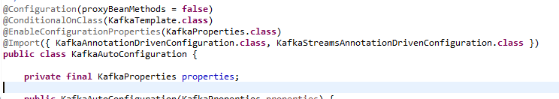

The KafkaProperties class here has information about the producer configuration properties and consumer configuration properties. The properties we configured in the application.yml file for bootstrap-servers, key serializer and value serializer etc would be available in this KafkaProperties

The class @KafkaAnnotationDrivenConfiguration is the class responsible for driving this Kafka configuration. Lets open that one.

|  |  |
| --- | --- |
|  | The first annotation there to notice is the @ConditionalOnClass(EnableKafka.class), So it basically looks for this annotation called @EnableKafka and if that is done then its going to do this auto configuration. This class has the 3 beans down below i.e. the KafkaAnnotationDrivenConfiguration, ConcurrentKafkaListenerContainerFactoryConfigurer and ConcurrentKafkaListenerContainerFactory |

The @KafkaListener that we annotated on the listner method in the Consumer brings in this method to play. The @Kafka listener takes a factory as a argument, but we haven’t provided that so this method will be triggered into play.

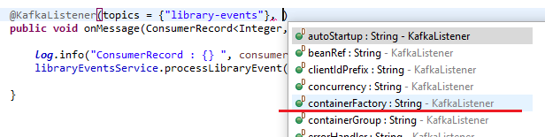

@Bean

@ConditionalOnMissingBean(name = "kafkaListenerContainerFactory")

ConcurrentKafkaListenerContainerFactory<?, ?> kafkaListenerContainerFactory(

ConcurrentKafkaListenerContainerFactoryConfigurer configurer,

ObjectProvider<ConsumerFactory<Object, Object>> kafkaConsumerFactory) {

ConcurrentKafkaListenerContainerFactory<Object, Object> factory =

**new** ConcurrentKafkaListenerContainerFactory<>();

configurer.configure(factory, kafkaConsumerFactory.getIfAvailable(() ->

**new** DefaultKafkaConsumerFactory<>(**this**.properties.buildConsumerProperties())));

**return** factory;

}

So what are the configurations the Kafka listener container factory is just defined or here. It has information about the error handler and it has information about what is a kind of interceptor and more so that's what the Kafka factory configured it has. Number two is Kafka consumer factory. This being is defined in the Kafka auto configuration.

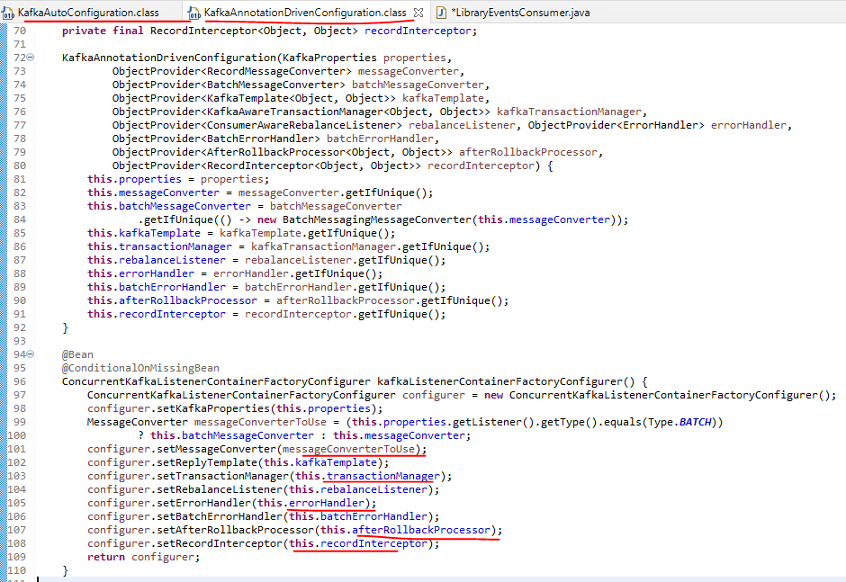

You have the Kafka consumer factory bean here so this bean is a default Kafka consumer factory. And then this is going to read all the consumer properties from here. So whatever properties are to do fine in here is read by this particular bean and then it's going to build the Kafka consumer based on that property. So here we have this call to buildCommonProperties. So this is where you see this bootstrap server config right. So this is going to read the bootstrap server conflict that we do find out here which is this one. And after that it is going to build some additional properties. Let's go to that one.

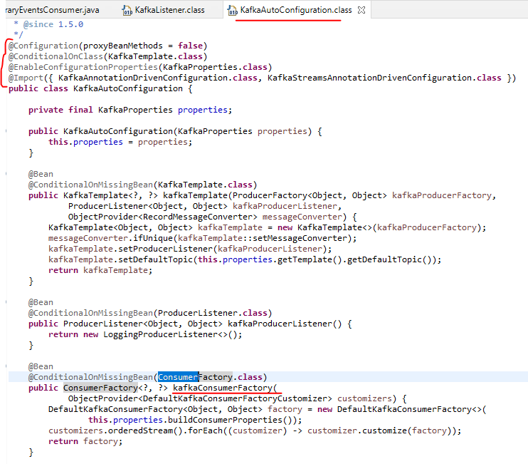

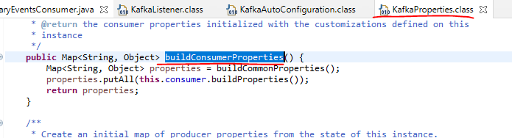

Lets see both the buildCommonProperties and the buildProperties method in screenshots below

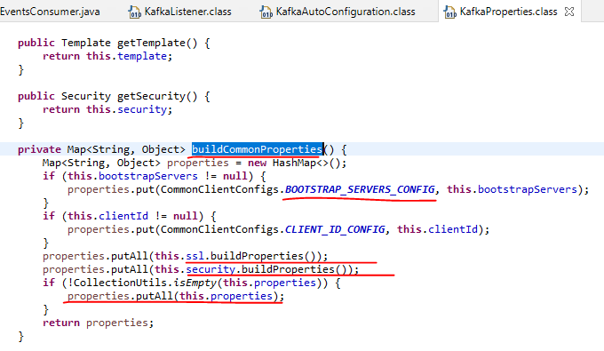

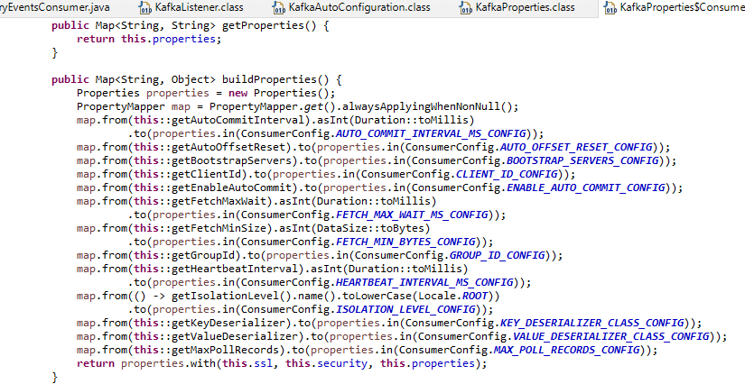

What it provides is that it provides it concurrent Kafka listener container factory. If you can recall from one of the lecture I did mention the KafkaListener annotation uses the concurrentMessageListenerContainer behind the scenes. So that's one of the reason why we have concurrent Kafka listener container factory. It is a factory of concurrent KafkaListener container. Ultimately this particular bean gets those references like configuring and KafkaConsumer factory. And this is a one which is used by @KafkaListener annotation.

Lets create the Kafka Configuration file now.

If you can recall we need to provide the @EnableKafka configuration. Also add the @Configuration annotation – these two are really important if we want to use the Spring Auto Config.

**LibraryEventsConsumerConfig.java**

import lombok.extern.slf4j.Slf4j;

import org.apache.kafka.clients.consumer.ConsumerRecord;

import org.springframework.beans.factory.ObjectProvider;

import org.springframework.beans.factory.annotation.Autowired;

import org.springframework.boot.autoconfigure.condition.ConditionalOnMissingBean;

import org.springframework.boot.autoconfigure.kafka.ConcurrentKafkaListenerContainerFactoryConfigurer;

import org.springframework.boot.autoconfigure.kafka.KafkaProperties;

import org.springframework.context.annotation.Bean;

import org.springframework.context.annotation.Configuration;

import org.springframework.dao.RecoverableDataAccessException;

import org.springframework.kafka.annotation.EnableKafka;

import org.springframework.kafka.config.ConcurrentKafkaListenerContainerFactory;

import org.springframework.kafka.core.ConsumerFactory;

import org.springframework.kafka.core.DefaultKafkaConsumerFactory;

import org.springframework.kafka.listener.ContainerProperties;

import org.springframework.retry.RetryPolicy;

import org.springframework.retry.backoff.FixedBackOffPolicy;

import org.springframework.retry.policy.SimpleRetryPolicy;

import org.springframework.retry.support.RetryTemplate;

import com.learn.kafka.service.LibraryEventsService;

import java.util.Arrays;

import java.util.HashMap;

import java.util.Map;

@Configuration

@EnableKafka

@Slf4j

public class LibraryEventsConsumerConfig {

@Autowired

LibraryEventsService libraryEventsService;

@Autowired

KafkaProperties kafkaProperties;

@Bean

@ConditionalOnMissingBean(name = "kafkaListenerContainerFactory")

ConcurrentKafkaListenerContainerFactory<?, ?> kafkaListenerContainerFactory(

ConcurrentKafkaListenerContainerFactoryConfigurer configurer,

ObjectProvider<ConsumerFactory<Object, Object>> kafkaConsumerFactory) {

ConcurrentKafkaListenerContainerFactory<Object, Object> factory =

new ConcurrentKafkaListenerContainerFactory<>();

configurer.configure(factory, kafkaConsumerFactory

.getIfAvailable(() -> new DefaultKafkaConsumerFactory<>(

this.kafkaProperties.buildConsumerProperties())));

factory.setConcurrency(3);

// factory.getContainerProperties().setAckMode(ContainerProperties.AckMode.MANUAL);

factory.setErrorHandler(((thrownException, data) -> {

log.info("Exception in consumerConfig is {} and the record is {}",

thrownException.getMessage(), data);

//persist

}));

factory.setRetryTemplate(retryTemplate());

factory.setRecoveryCallback( (context -> {

if(context.getLastThrowable().getCause() instanceof RecoverableDataAccessException){

//invoke recovery logic

log.info("Inside the recoverable logic");

Arrays.asList(context.attributeNames())

.forEach(attributeName -> {

log.info("Attribute name is : {} ", attributeName);

log.info("Attribute Value is : {} ", context.getAttribute(attributeName));

});

ConsumerRecord<Integer, String> consumerRecord =

(ConsumerRecord<Integer, String>) context.getAttribute("record");

libraryEventsService.handleRecovery(consumerRecord);

}else{

log.info("Inside the non recoverable logic");

throw new RuntimeException(context.getLastThrowable().getMessage());

}

return null;

}));

return factory;

}

private RetryTemplate retryTemplate() {

FixedBackOffPolicy fixedBackOffPolicy = new FixedBackOffPolicy();

fixedBackOffPolicy.setBackOffPeriod(1000);

RetryTemplate retryTemplate = new RetryTemplate();

retryTemplate.setRetryPolicy(simpleRetryPolicy());

retryTemplate.setBackOffPolicy(fixedBackOffPolicy);

return retryTemplate;

}

private RetryPolicy simpleRetryPolicy() {

/*SimpleRetryPolicy simpleRetryPolicy = new SimpleRetryPolicy();

simpleRetryPolicy.setMaxAttempts(3);*/

Map<Class<? extends Throwable>, Boolean> exceptionsMap = new HashMap<>();

exceptionsMap.put(IllegalArgumentException.class, false);

exceptionsMap.put(RecoverableDataAccessException.class, true);

SimpleRetryPolicy simpleRetryPolicy = new SimpleRetryPolicy(3,exceptionsMap,true);

return simpleRetryPolicy;

}

}

**Consumer Groups and Rebalance**

Lets see the impact of consumer groups and rebalance that can happen in Kafka consumers. Number one is what are consumer groups. Consumer groups are formed when we have multiple instance of the same application. Consumer groups are the foundation for a scalable message consumption.

Consumer Groups

• Multiple instances of the same application with the same group id.

Rebalance is a Kafka consumer concept and it means changing the partition ownership from one to another. Let us quickly look at it using an example. Here we have the LibraryEventConsumer. And then we have the library EventKafkaTopic.

Rebalance

• Changing the partition ownership from one consumer to another

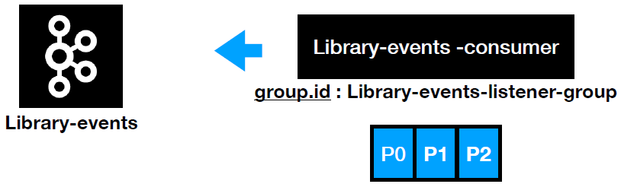

The group.id of the library-events consumer is the library-events-listener-group, which means here we have just one instance of the application, which means as soon as the consumer makes a connection to the library-events kafka topic it's going to determine how many partitions that particular topic is going to have. In our example we have three partitions and after that all those three partitions will be assigned to this one single instance.

Rebalance 🡪 Changing the partition ownership from one consumer to another

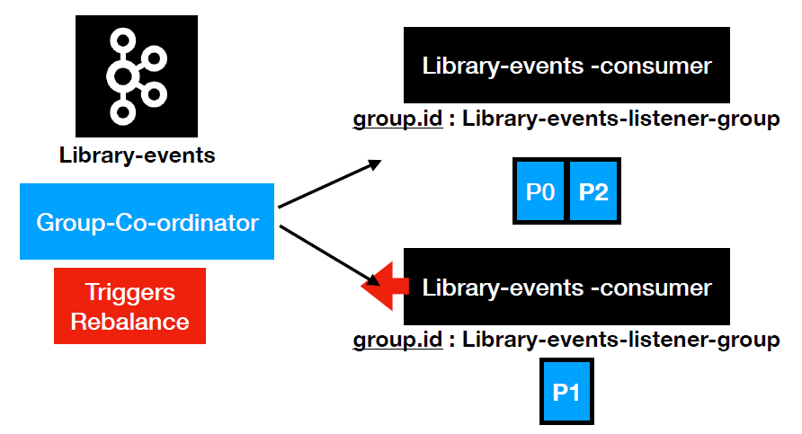

Let's say we spin up another instance of the same application with the same group. In that case what happens is that there is a group co-ordinator which is one other Kafka broker, is going to receive the signal from the library-events consumer application and it's going to check whether it is in the same group i.e. in our use case it's the same group id and then what it is going to do is it is going to trigger a rebalance. Basically it's going to find out, oh I have one more instance of the same application, in that case I'm going to redistribute the partitions. So in that case the partitions are redistributed here. The library evens consumer first instance has p0 and p2 and library-events consumer, the second instance has only one partition. That's because we have odd number of partitions. If we have even number of partitions then P1,P3 will be assigned to the library evens consumer. And the process continues as you add new instance of the application. Now let's quickly go ahead and check this behavior in the application that we had built so far.

As soon as you run this command it's going to launch the application in your local as you can see the application is launched and all the three partitions are assigned to this particular instance. And if you take a look at it the port that this particular application is running on it is 9000. Now the next step would be let's go ahead and try to launch one more instance of the same application. Let's do Java --jar but we need to provide a different port here. So the port is going to be -d server.port equal to 8082. And then it's the same.

$ java –jar –Dserver.port=8082 target\library-events-consumer-0.0.1-SNAPSHOT.jar

As you launch this. It's going to start the application on the port 8082. And now if you go and check the logs of the first instance you would have seen something called the rebalance. As you can see it started like reworking previously unseen partitions and then it reworked a partition. And after that it started to reassign the partitions. Now this particular instance has only one partition which is a library-events two. And the new instance has a library-events 1 and library-events 0.

This is the 2nd instance of Kafka Consumer that we are running and on a different port 8082 now

2020-12-22 08:49:11.795 INFO 11928 --- [ main] c.l.k.LibraryEventsConsumerApplication : Started LibraryEventsConsumerApplication in 4.759 seconds (JVM running for 5.883)

2020-12-22 08:49:14.352 INFO 11928 --- [ntainer#0-1-C-1] o.a.k.c.c.i.AbstractCoordinator : [Consumer clientId=consumer-library-events-listener-group-2, groupId=library-events-listener-group] Successfully joined group with generation 18

2020-12-22 08:49:14.355 INFO 11928 --- [ntainer#0-2-C-1] o.a.k.c.c.i.AbstractCoordinator : [Consumer clientId=consumer-library-events-listener-group-3, groupId=library-events-listener-group] Successfully joined group with generation 18

2020-12-22 08:49:14.356 INFO 11928 --- [ntainer#0-1-C-1] o.a.k.c.c.i.ConsumerCoordinator : [Consumer clientId=consumer-library-events-listener-group-2, groupId=library-events-listener-group] Adding newly assigned partitions:

2020-12-22 08:49:14.360 INFO 11928 --- [ntainer#0-0-C-1] o.a.k.c.c.i.AbstractCoordinator : [Consumer clientId=consumer-library-events-listener-group-1, groupId=library-events-listener-group] Successfully joined group with generation 18

2020-12-22 08:49:14.360 INFO 11928 --- [ntainer#0-2-C-1] o.a.k.c.c.i.ConsumerCoordinator : [Consumer clientId=consumer-library-events-listener-group-3, groupId=library-events-listener-group] Adding newly assigned partitions:

2020-12-22 08:49:14.362 INFO 11928 --- [ntainer#0-1-C-1] o.s.k.l.KafkaMessageListenerContainer : library-events-listener-group: partitions assigned: []

2020-12-22 08:49:14.366 INFO 11928 --- [ntainer#0-2-C-1] o.s.k.l.KafkaMessageListenerContainer : library-events-listener-group: partitions assigned: []

2020-12-22 08:49:14.372 INFO 11928 --- [ntainer#0-0-C-1] o.a.k.c.c.i.ConsumerCoordinator : [Consumer clientId=consumer-library-events-listener-group-1, groupId=library-events-listener-group] Adding newly assigned partitions: library-events-0

2020-12-22 08:49:14.380 INFO 11928 --- [ntainer#0-0-C-1] o.a.k.c.c.i.ConsumerCoordinator : [Consumer clientId=consumer-library-events-listener-group-1, groupId=library-events-listener-group] Setting offset for partition library-events-0 to the committed offset FetchPosition{offset=5, offsetEpoch=Optional.empty, currentLeader=LeaderAndEpoch{leader=Optional[DESKTOP-PEI24P3.mshome.net:9092 (id: 0 rack: null)], epoch=12}}

2020-12-22 08:49:14.381 INFO 11928 --- [ntainer#0-0-C-1] o.s.k.l.KafkaMessageListenerContainer : library-events-listener-group: partitions assigned: [library-events-0]

Previous consumer shows the log like this

2020-12-22 08:53:27.075 INFO 2648 --- [ntainer#0-0-C-1] o.a.k.c.c.i.ConsumerCoordinator : [Consumer clientId=consumer-library-events-listener-group-1, groupId=library-events-listener-group] Setting offset for partition library-events-2 to the committed offset FetchPosition{offset=9, offsetEpoch=Optional.empty, currentLeader=LeaderAndEpoch{leader=Optional[DESKTOP-PEI24P3.mshome.net:9093 (id: 1 rack: null)], epoch=13}}

2020-12-22 08:53:27.075 INFO 2648 --- [ntainer#0-0-C-1] o.s.k.l.KafkaMessageListenerContainer : library-events-listener-group: partitions assigned: [library-events-2]

The partition distribution is totally up to the actual group co-ordinator. If you go and search for that configuration so search for partition assigner, there will be a class which is called partition assigner, as you can see the partition assignment strategy right. So in here we have the RangeAssigner ( in the properties printed out in the logs ) this is a strategy it uses by default and then it is going to distribute the partitions accordingly and it distributed the library events 1 and 0 for this instance. We have the partitions distributed between the two instances. And it's going to consume the records in parallel. So this is the behavior of consumer groups and its impact. And whatever that happens when a new instance is spun up that's called rebalance.

metrics.recording.level = INFO

metrics.sample.window.ms = 30000

partition.assignment.strategy = [class org.apache.kafka.clients.consumer.RangeAssignor]

receive.buffer.bytes = 65536

reconnect.backoff.max.ms = 1000

reconnect.backoff.ms = 50

request.timeout.ms = 30000

**Default Consumer Offset Management**

We posted 3 records using the curl command and we then look at the logs here

2020-12-22 11:34:38.929 INFO 5480 --- [ad | producer-1] c.l.k.p.LibraryEventProducer : Message Sent SuccessFully for the key : null and the value is {"libraryEventId":null,"libraryEventType":"NEW","book":{"bookId":456,"bookName":"Kafka Using Spring Boot","bookAuthor":"Dilip"}} , partition is 1

2020-12-22 11:34:39.610 INFO 5480 --- [ad | producer-1] c.l.k.p.LibraryEventProducer : Message Sent SuccessFully for the key : null and the value is {"libraryEventId":null,"libraryEventType":"NEW","book":{"bookId":456,"bookName":"Kafka Using Spring Boot","bookAuthor":"Dilip"}} , partition is 2

2020-12-22 11:34:40.476 INFO 5480 --- [ad | producer-1] c.l.k.p.LibraryEventProducer : Message Sent SuccessFully for the key : null and the value is {"libraryEventId":null,"libraryEventType":"NEW","book":{"bookId":456,"bookName":"Kafka Using Spring Boot","bookAuthor":"Dilip"}} , partition is 1

Now we will shutdown the consumer and start it again.

When we brought this up again, it did not read the ConsumerRecord again. What is the change that happened behind the scenes, that is actually helping us to experience this behavior for this purpose.

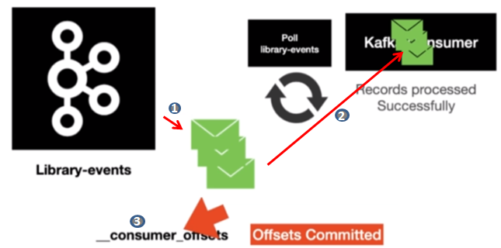

As you can see our Consumer is pulling the Consumer Records from the poll loop that is executing. It's going to go ahead and retrieve the Records for the consumer. And then our Consumer is going to read the messages. Once the Records are processed successfully then there is a activity that happens behind the scenes, which we did not see it at all. So what happens behind the scenes is that, after that the Records are processed, it's going to commit the offsets. This happens behind the scenes and once the offsets are committed, now when the poll look executes again, it knows from where it needs to read the records from, from the Kafka topic. That's one of the reason why it's not reading the same message again. This is how the consumer offsets are managed by default in Spring Kafka. We can change his behavior too.

Lets see the different options that are present when we want to commit the offsets

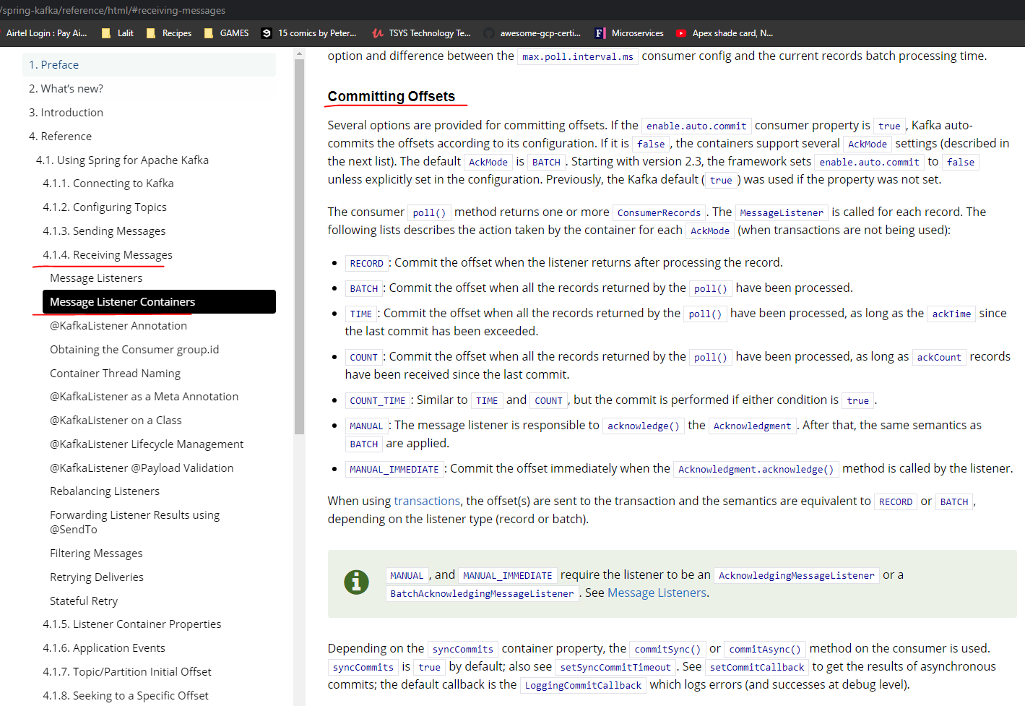

**Committing Offsets**

Several options are provided for committing offsets. If the enable.auto.commit consumer property is true, Kafka auto-commits the offsets according to its configuration. If it is false, the containers support several AckMode settings (described in the next list). The defaultAckMode is BATCH. Starting with version 2.3, the framework sets enable.auto.commit to false unless explicitly set in the configuration. Previously, the Kafka default (true) was used if the property was not set.

The consumer poll() method returns one or more ConsumerRecords. The MessageListener is called for each record. The following lists describes the action taken by the container for each AckMode (when transactions are not being used):

* RECORD: Commit the offset when the listener returns after processing the record.
* BATCH: Commit the offset when all the records returned by the poll() have been processed.
* TIME: Commit the offset when all the records returned by the poll() have been processed, as long as the ackTime since the last commit has been exceeded.
* COUNT: Commit the offset when all the records returned by the poll() have been processed, as long as ackCount records have been received since the last commit.
* COUNT_TIME: Similar to TIME and COUNT, but the commit is performed if either condition is true.
* MANUAL: The message listener is responsible to acknowledge() the Acknowledgment. After that, the same semantics as BATCH are applied.
* MANUAL_IMMEDIATE: Commit the offset immediately when the Acknowledgment.acknowledge() method is called by the listener.

Most common options that are used are BATCH and MANUAL. Application can control when it wants to commit in case of MANUAL.

When using [transactions](https://docs.spring.io/spring-kafka/reference/html/#transactions), the offset(s) are sent to the transaction and the semantics are equivalent to RECORD or BATCH, depending on the listener type (record or batch).

We will override the default behavior of the consumer offset management. We will learn about how to manage the offsets manually from the application itself. Here we have the Kafka consumer and Kafka topic and then the poll loop is going to get execute, when the poll loop executes it is going to go to acknowledge the topic and retrieves the new records. Nothing new until this point. Now the application is going to process the records one by one. The interesting behavior after processing each Record is that the application will need to acknowledge after processing each record, the meaning for this one is to keep track of the number of records and the offsets that had been processed. Once all the records are processed then only the offset will be committed. Until then the offset tracking will happen behind the scenes for you. From an application perspective we would need to acknowledge after processing each and every record.

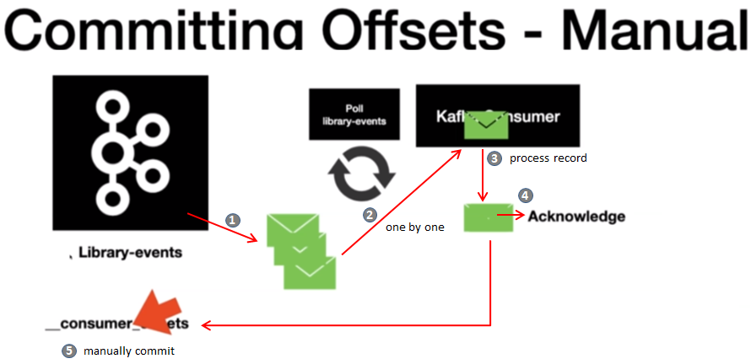

We have the LibraryEventConsumer application open, the very first thing that we are going to do is we are going to overwrite the default config for the LibraryEventConsumer. We are going to override the KafkaFactory actually, so if you can recall from we looked at the class which is Kafka AnnotationDriven configuration. So in here there is a bean which is one of the key bean for the Kafka listener to work.

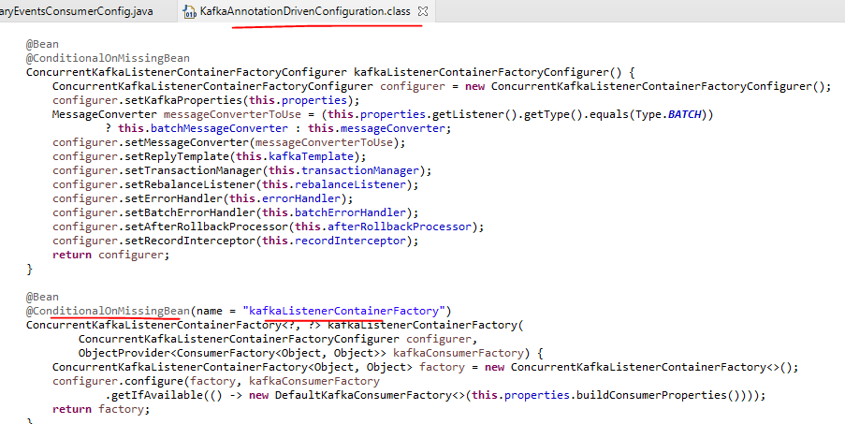

Let's copy this one.

Now what we're going to do is in here, we are going to override the ackMode from default which is BATCH to AckMode.MANUAL. That's the acknowledgment mode. So what it will do is we will do factory.getContent for properties, so this is the KafkaMessageListener container properties – by doing this you get access to the content of properties.

@Configuration

@EnableKafka

@Slf4j

public class LibraryEventsConsumerConfig {

. . .

@Autowired

KafkaProperties kafkaProperties;

@Bean

@ConditionalOnMissingBean(name = "kafkaListenerContainerFactory")

ConcurrentKafkaListenerContainerFactory<?, ?> kafkaListenerContainerFactory(

ConcurrentKafkaListenerContainerFactoryConfigurer configurer,

ObjectProvider<ConsumerFactory<Object, Object>> kafkaConsumerFactory) {

ConcurrentKafkaListenerContainerFactory<Object, Object> factory =

**new** ConcurrentKafkaListenerContainerFactory<>();

configurer.configure(factory, kafkaConsumerFactory

.getIfAvailable(

() -> **new** DefaultKafkaConsumerFactory<>(**this**.properties.buildConsumerProperties())

)

);

factory.getContainerProperties().setAckMode(ContainerProperties.AckMode.MANUAL);

**return** factory;

}

. . .

}

And then what we are going to do is we are going to set that act mode so you can see this method right. Act more saying here's what we're going to do. We're going to do AckMode.MANUAL because we are going to manually manage the offset. For this to work, you need to have a listener of a certain type. What I'm going to do is I'm going to copy this and then create a copy of this one because for our project that we're going to build we are going to use a default offset management.

We are trying to see what are the different options when it comes to managing the offset. In here what we are going to do is the first thing we have to implement is a message listener. So in here as you can see the acknowledgment.acknowledge call.  By doing this you're letting the message listener know that you have successfully processed the message. We are going to disable the @Component annotation and the way to do it is by commenting it out. And let's start the application. Let's go to the LibraryEvenConsumerApplication and then start to spin out of your having this running in your machine already.

import lombok.extern.slf4j.Slf4j;

import org.apache.kafka.clients.consumer.ConsumerRecord;

import org.springframework.kafka.annotation.KafkaListener;

import org.springframework.kafka.listener.AcknowledgingMessageListener;

import org.springframework.kafka.support.Acknowledgment;

import org.springframework.stereotype.Component;

//@Component

@Slf4j

public class LibraryEventsConsumerManualOffset implements AcknowledgingMessageListener<Integer,String> {

@Override

@KafkaListener(topics = {"library-events"})

public void onMessage(ConsumerRecord<Integer, String> consumerRecord,

Acknowledgment acknowledgment) {

log.info("ConsumerRecord : {} ", consumerRecord );

acknowledgment.acknowledge();

}

}

Publish some messages and then restart the application, after we restart the application the messages are not fetched again as they have already been acknowledged as received by the methods we have overridden above.

For now we will comment the acknowledgement as manual in the LibraryEventsConsumerConfig > kafkaListenerContainerFactory method

// factory.getContainerProperties().setAckMode(ContainerProperties.AckMode.MANUAL);

**Concurrent Consumers**

We will see how to spin up multiple instances of the MessageListener in the same application because the @KafkaListener uses the ConcurrentMessageListenerContainer. You can spin up multiple instances of the same KafkaMessageListenerContainer. If your application is not running in a cloud like environment, in those kind of scenarios this option is really handy. If you're already running in a cloud like environment or if you're using Kubernetes then this option is not necessary. So for this purpose what we're going to do is we are going to leverage the LibraryEventsConsumerConfig in here.

@Configuration

@EnableKafka

@Slf4j

public class LibraryEventsConsumerConfig {

@Autowired

LibraryEventsService libraryEventsService;

@Autowired

KafkaProperties kafkaProperties;

@Bean

@ConditionalOnMissingBean(name = "kafkaListenerContainerFactory")

ConcurrentKafkaListenerContainerFactory<?, ?> kafkaListenerContainerFactory(

ConcurrentKafkaListenerContainerFactoryConfigurer configurer,

ObjectProvider<ConsumerFactory<Object, Object>> kafkaConsumerFactory) {

ConcurrentKafkaListenerContainerFactory<Object, Object> factory =

new ConcurrentKafkaListenerContainerFactory<>();

configurer.configure(factory, kafkaConsumerFactory

.getIfAvailable(() -> new DefaultKafkaConsumerFactory<>(

this.kafkaProperties.buildConsumerProperties())));

factory.setConcurrency(3);

So setConcurrency is a method which we can use in order to configure multiple Kafka listeners from the same application itself. So we have three partitions right, I'm going to provide the value as 3. So basically what will happen is that it is going to spawn three threads for the same instance of the KafkaListener. This is one interesting behavior which we have not paid attention to it. Let me quickly highlight that if you click on the run I believe you have the application up and running in your local. If the answer is yes, in the logs if you can look at it the consumer is running in a totally different third which is the container 0- 0 – C - 1.

2020-12-22 15:18:24.124 INFO 13088 --- [ntainer#0-0-C-1] o.a.k.c.Metadata : [Consumer clientId=consumer-library-events-listener-group-1, groupId=library-events-listener-group] Cluster ID: ji7jjpYERV6A-cQ4TXkWSw

This is not the main thread, the main thread is where the application started up here

2020-12-22 15:18:23.798 INFO 13088 --- [ main] o.a.k.c.u.AppInfoParser : Kafka version: 2.5.0

2020-12-22 15:18:23.798 INFO 13088 --- [ main] o.a.k.c.u.AppInfoParser : Kafka commitId: 66563e712b0b9f84

2020-12-22 15:18:23.798 INFO 13088 --- [ main] o.a.k.c.u.AppInfoParser : Kafka startTimeMs: 1608630503798

Now with this configuration let's go ahead and check how this behavior is going to change actually. Let's restart this application so we have restarted the application. Now if we look at the behavior we have three threads now

2020-12-22 15:18:24.124 INFO 13088 --- [ntainer#0-**2**-C-1] o.a.k.c.Metadata : [Consumer clientId=consumer-library-events-listener-group-3, groupId=library-events-listener-group] Cluster ID: ji7jjpYERV6A-cQ4TXkWSw

2020-12-22 15:18:24.124 INFO 13088 --- [ntainer#0-**0**-C-1] o.a.k.c.Metadata : [Consumer clientId=consumer-library-events-listener-group-1, groupId=library-events-listener-group] Cluster ID: ji7jjpYERV6A-cQ4TXkWSw

2020-12-22 15:18:24.124 INFO 13088 --- [ntainer#0-**1**-C-1] o.a.k.c.Metadata : [Consumer clientId=consumer-library-events-listener-group-2, groupId=library-events-listener-group] Cluster ID: ji7jjpYERV6A-cQ4TXkWSw

You have three instances of the container and each instance is listening to one partition. So this thread is going to poll the Records from the library-events partition-0. This thread is going to poll the records from the partition-1 and this thread is going to poll from the partition-2. So this is one of the other approach to scale your application. Basically scale your consumer to parallely process the records. This option is recommended if you are not running your application in a cloud like environment.

**Persisting Events to H2 Database**

We are going to persist the LibraryEvent into the database. For this cause we are going to use H2 which is the in memory database.

|  |  |
| --- | --- |
|  | So we will use the H2 Database and the data-jpa library  <dependency>  <groupId>com.h2database</groupId>  <artifactId>h2</artifactId>  </dependency>  <dependency>  <groupId>org.springframework.boot</groupId>  <artifactId>spring-boot-starter-data-jpa</artifactId>  </dependency>  We would also need a dependency to the starter-web to be able to see the H2 console  <dependency>  <groupId>org.springframework.boot</groupId>  <artifactId>spring-boot-starter-web</artifactId>  </dependency> |

We are going to set up all those things in the local profile

**application.yml**

spring:

profiles:

active: local

server:

port: 8081

---

spring:

profiles: local

kafka:

template:

default-topic: library-events

consumer:

bootstrap-servers: localhost:9092,localhost:9093,localhost:9094

key-deserializer: org.apache.kafka.common.serialization.IntegerDeserializer

value-deserializer: org.apache.kafka.common.serialization.StringDeserializer

group-id: library-events-listener-group

producer:

bootstrap-servers:

- localhost:9092,localhost:9093,localhost:9094

key-serializer: org.apache.kafka.common.serialization.IntegerSerializer

value-serializer: org.apache.kafka.common.serialization.StringSerializer

datasource:

url: jdbc:h2:mem:testdb

driver-class-name: org.h2.Driver

jpa:

database: h2

database-platform: org.hibernate.dialect.H2Dialect

generate-ddl: true

h2:

console:

enabled: true

We are going to generate the tables and everything based on the entities that we will be configuring so we have generate-ddl set to true. And after that we have the h2 console enabled as true, so that we can go ahead and view the console. Now the next step is that you are is going to be localhost:8081 and followed by h2-console. Change the JDBC Url to the url we had provided i.e. jdbc:h2:mem:testdb and

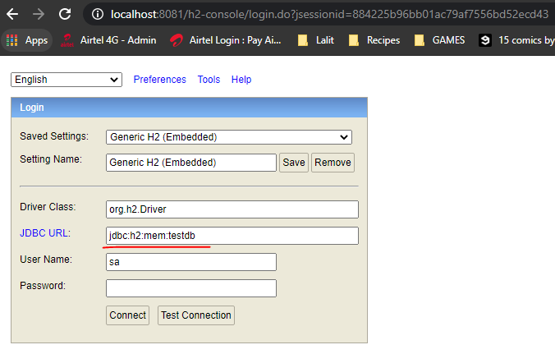

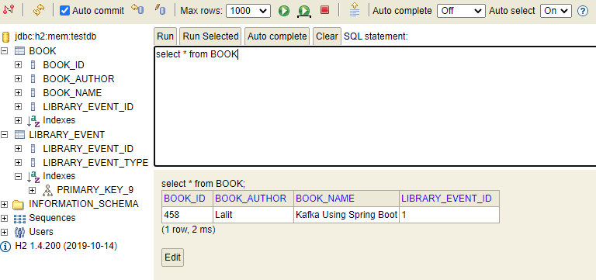

We will configure the following Entity in the package com.learn.kafka.entity of our project. This will create the tables for them.

|  |  |
| --- | --- |
| **Book.java**  import lombok.AllArgsConstructor;  import lombok.Builder;  import lombok.Data;  import lombok.NoArgsConstructor;  import javax.persistence.Entity;  import javax.persistence.Id;  import javax.persistence.JoinColumn;  import javax.persistence.OneToOne;  import javax.validation.constraints.NotBlank;  import javax.validation.constraints.NotNull;  @AllArgsConstructor  @NoArgsConstructor  @Data  @Builder  @Entity  public class Book {  @Id  private Integer bookId;  private String bookName;  private String bookAuthor;  @OneToOne  @JoinColumn(name = "**libraryEventId**")  private LibraryEvent libraryEvent;  } | **LibraryEvent.java**  import lombok.*;  import javax.persistence.*;  import javax.validation.Valid;  import javax.validation.constraints.NotNull;  @AllArgsConstructor  @NoArgsConstructor  @Data  @Builder  @Entity  public class LibraryEvent {  @Id  @GeneratedValue  private Integer libraryEventId;  @Enumerated(EnumType.STRING)  private LibraryEventType libraryEventType;  @OneToOne(**mappedBy** **=** "**libraryEvent**",  cascade = {CascadeType.ALL})  @ToString.Exclude  private Book book;  } |

**LibraryEventType.java**

package com.learn.kafka.entity;

public enum LibraryEventType {

NEW,

UPDATE

}

There is a one to one mapping between Book and LibraryEvent here. We need to provide the JoinColumn which is the libraryEventId.

Cascading - This is mainly used whenever you want to cascade any kind of update that's made to the pattern table. Let's say you were inserting into this LibraryEvent table which is library work. And if it has a reference of Book then it's going to automatically perform the insert in the Book table.

There is one more activity that we need to do we need to exclude this from the two string of this LibraryEvent. The reason why we are excluding this is because if we go to the book, the book also has a reference to this one right. So in that case it will have a circular dependency, and then it will give you the stack overflow error. In order to avoid that we need to exclude this value from the string.

@ToString.Exclude

private Book book;

Restart the Application. Now the next step that we are going to do is we are going to go to the extra to console and then we're going to check whether these tables are created in the in-memory database or not.

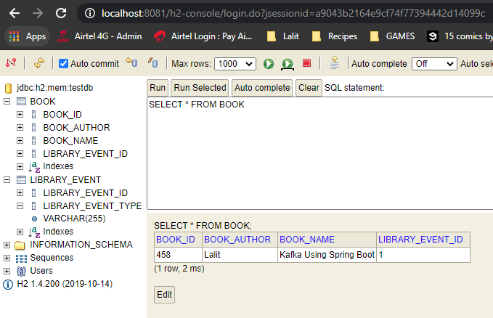

Repository Class for Persistence of Events

import org.springframework.data.repository.CrudRepository;

import com.learn.kafka.entity.LibraryEvent;

public interface LibraryEventsRepository extends CrudRepository<LibraryEvent,Integer> {

}

The CrudRepository is of type of Object being passed and the type of the Primary Key

Lets create the Service Class now

Let's go ahead and knock the service annotation @Service. We have a processLibraryEvent method that takes the input of ConsumerRecord. We will then use the ObjectMapper to retrieve the LibraryEvent from the ConsumerRecord. The next thing is we are going to persist this into the database. We would handle both the new operation and the update operation based on the LibraryEventType in the LibraryEvent. Autowire the LibraryEventRepository to this service class. In save method perform the save using the repository class injected. Call this service class from the LibraryEventsConsumer. This service class would be autowired into the LibraryEventsConsumer and would be called from the onMessage KafkaListener annotated method.

We have also written the validate method in this class. So what we're going to do is we are going to perform some object level validation. So in this method the very first thing that we are going to validate us the LibraryEventID should be coming from the upstream system. So if the LibraryEventData is null then you cannot perform an update on a record that doesn't exist in the database.

So let's say you're publishing an update to a library even we have to make sure that library work is present in the database. Otherwise we need to throw an exception.

So in the LibraryEventConsumer we have this message actually the messages is a IllegalArgumentException it's not a library not a valid LibraryEvent. And if you take a look at it we have a default error handler that comes that Kafka consumer without us logging in our handler. What does it do, if an exception is thrown from here by default this logging error handler is going to receive that exception and then it is going to give you the Consumer Record that actually caused this exception. And then it's going to print the log in the console, so that it can be used for debugging purposes. In the future part of the course we will go ahead and explore different strategies for error handling in a consumer and how to override and write your own.

**LibraryEventsService.java**

import com.fasterxml.jackson.core.JsonProcessingException;

import com.fasterxml.jackson.databind.ObjectMapper;

import com.learn.kafka.entity.LibraryEvent;

import com.learn.kafka.jpa.LibraryEventsRepository;

import lombok.extern.slf4j.Slf4j;

import org.apache.kafka.clients.consumer.ConsumerRecord;

import org.springframework.beans.factory.annotation.Autowired;

import org.springframework.dao.RecoverableDataAccessException;

import org.springframework.kafka.core.KafkaTemplate;

import org.springframework.kafka.support.SendResult;

import org.springframework.stereotype.Service;

import org.springframework.util.concurrent.ListenableFuture;

import org.springframework.util.concurrent.ListenableFutureCallback;

import java.util.Optional;

@Service

@Slf4j

public class LibraryEventsService {

@Autowired

ObjectMapper objectMapper;

@Autowired

KafkaTemplate<Integer,String> kafkaTemplate;

@Autowired

private LibraryEventsRepository libraryEventsRepository;

public void processLibraryEvent(ConsumerRecord<Integer,String> consumerRecord)

throws JsonProcessingException {

LibraryEvent libraryEvent = objectMapper.readValue(consumerRecord.value(), LibraryEvent.class);

log.info("libraryEvent : {} ", libraryEvent);

if ( libraryEvent.getLibraryEventId() != null && libraryEvent.getLibraryEventId() == 000 ){

throw new RecoverableDataAccessException("Temporary Network Issue");

}

switch( libraryEvent.getLibraryEventType() ){

case NEW:

save(libraryEvent);

break;

case UPDATE:

//validate the libraryevent

validate(libraryEvent);

save(libraryEvent);

break;

default:

log.info("Invalid Library Event Type");

}

}

private void validate(LibraryEvent libraryEvent) {

if(libraryEvent.getLibraryEventId()==null){

throw new IllegalArgumentException("Library Event Id is missing");

}

Optional<LibraryEvent> libraryEventOptional =

libraryEventsRepository.findById(libraryEvent.getLibraryEventId());

if( !libraryEventOptional.isPresent() ){

throw new IllegalArgumentException("Not a valid library Event");

}

log.info("Validation is successful for the library Event : {} ", libraryEventOptional.get());

}

private void save(LibraryEvent libraryEvent) {

libraryEvent.getBook().setLibraryEvent(libraryEvent);

libraryEventsRepository.save(libraryEvent);

log.info("Successfully Persisted the libary Event {} ", libraryEvent);

}

public void handleRecovery(ConsumerRecord<Integer,String> record){

Integer key = record.key();

String message = record.value();

ListenableFuture<SendResult<Integer,String>> listenableFuture =

kafkaTemplate.sendDefault(key, message);

listenableFuture.addCallback(new ListenableFutureCallback<SendResult<Integer, String>>() {

@Override

public void onFailure(Throwable ex) {

handleFailure(key, message, ex);

}

@Override

public void onSuccess(SendResult<Integer, String> result) {

handleSuccess(key, message, result);

}

});

}

private void handleFailure(Integer key, String value, Throwable ex) {

log.error("Error Sending the Message and the exception is {}", ex.getMessage());

try {

throw ex;

} catch (Throwable throwable) {

log.error("Error in OnFailure: {}", throwable.getMessage());

}

}

private void handleSuccess(Integer key, String value, SendResult<Integer, String> result) {

log.info("Message Sent SuccessFully for the key : {} and the value is {} , partition is {}",

key, value, result.getRecordMetadata().partition());

}

}

**Integration Testing**

We will go ahead and write the integration test case for our library evens consumer so here is our library evens consumer. Our LibraryEventsConsumer here, doesn't do much because the whole business logic is in the LibraryEventService. So it will just be writing integration test for the LibraryEventConsumer and we won't be writing the unit test for this one because our libraryEventConsumer is pretty much dumb, it's just going to pass the keyboard to the library even service.

And the next thing we are going to set up the Embedded Kafka related annotations. The very first thing is we are going to add the @SpringBootTest annotation which takes care of spinning up the application context for us. What is the next thing. The next thing is we need to add the Embedded Kafka related annotation because we are going to leverage embedded Kafka for integration test. So what I'm going to do is I'm going to use the same configuration that we have used in the LibraryEventsProducer.

@SpringBootTest

@EmbeddedKafka(topics = {"library-events"}, partitions = 3)

@TestPropertySource(properties = {

"spring.kafka.producer.bootstrap-servers=${spring.embedded.kafka.brokers}",

"spring.kafka.consumer.bootstrap-servers=${spring.embedded.kafka.brokers}"

}

)

Copied that from the Producer. We have this ready but we don't have any of these admin configurations in the library even consumer. So I'm going to remove that one take off.

The next thing is we are going to create the instance of embedded Kafka broker so here let's do on a Autowire and it's going to be embedded broker.

@Autowired

EmbeddedKafkaBroker embeddedKafkaBroker;

If you can recall from the integration test case for the LibraryEventsProducer. Let's go to library events producer in here what we did was we instantiated the consumer and then this consumer is something which we used in order to validate whether the message reached the Kafka topic or not. Likewise we are writing integration test case for the consumer right.

So in here we are going to instantiate the producer which is a KafkaTemplate so that we can publish the message into the KafkaTopic. Basically the embedded KafkaTopic so that our consumer can read the message.

So now what we will do is, we will go ahead and set up the Kafka producer in our application.yml file. This Kafka producer is just to be used in the application integration test. So in here what we will do to configure the Kafka producer is, it's going to

be bootstrap servers the servers values are going to be let's give the same value. And after that it's going to be key serialize and value serialize ( as it’s a producer ). We also provided the default-topic here as library-events

spring:

profiles:

active: local

server:

port: 8081

---

spring:

profiles: local

kafka:

template:

default-topic: library-events

consumer:

bootstrap-servers: localhost:9092,localhost:9093,localhost:9094

key-deserializer: org.apache.kafka.common.serialization.IntegerDeserializer

value-deserializer: org.apache.kafka.common.serialization.StringDeserializer

group-id: library-events-listener-group

producer:

bootstrap-servers:

- localhost:9092,localhost:9093,localhost:9094

key-serializer: org.apache.kafka.common.serialization.IntegerSerializer

value-serializer: org.apache.kafka.common.serialization.StringSerializer

Now we have the producer instance ready. Using the producer instance we can publish the message into the Kafka topic so that our consumer can pick it up and then process it. Now what is the next thing. Let's autowire the KafkaTemplate because KafkaTemplate is going to be automatically created for us. And here it's going to be Integer, String.

So in here we are all writing the producer properties right. Likewise we need to override the consumer properties too. So let's do that now so it's going to be to come a and then that's the same value here. But in the place of producer we will provide consumer actually. So what we are doing here as we are all writing this to values to connect to the embedded Kafka because as part of our integration test the actual code is going to talk to the embedded Kafka. And it should talk to the address and port value of the embedded Kafka. So what is the next thing the next thing is we're going to make sure the Kafka consumer is completely up and running.

@SpringBootTest

@EmbeddedKafka(topics = {"library-events"}, partitions = 3)

@TestPropertySource(properties = {

"spring.kafka.producer.bootstrap-servers=${spring.embedded.kafka.brokers}",

"spring.kafka.consumer.bootstrap-servers=${spring.embedded.kafka.brokers}"

}

)

public class LibraryEventsConsumerIntegrationTest {

Write the setup method and the tearDown method now

So in the setup method I'm going to introduce you to the new class called Kafka endpoint registry so that gets created actually when you start up the application that's also a Bean. So it's going to be KafkaListenerEndpointRegistry.

@Autowired

KafkaListenerEndpointRegistry endpointRegistry;

So this endpoint registry have a hold of all the listener containers. So what is the ListenerContainer that we have the LibraryEvenConsumerListenerContainer right.

So for this purpose what we are going to do is we are going to get all the containers. In our case its just going to be one.

for (MessageListenerContainer messageListenerContainer :

endpointRegistry.getListenerContainers()) {

ContainerTestUtils.waitForAssignment(messageListenerContainer,

embeddedKafkaBroker.getPartitionsPerTopic());

}

We are going to make a call so that the consumer is completely up and running before we go ahead and launch this case. So it's going to be container testing tools. There is a containerTestingUtils class. This is part of the spring kafka actually. In the containerTestingUtils class what we are going to do is we are going to call wait for assignment, so waitForAssignment and then you pass a container, so it's going to be MessageListenerContainer followed by that we are going to provide EmbeddedKafkaBroker.getPartitionsPerTopic.

ContainerTestUtils.waitForAssignment(messageListenerContainer,

embeddedKafkaBroker.getPartitionsPerTopic());

So let's go ahead and create the test case so that this case is going to be publish new library even. The next thing is we are going to publish the JSON string into the Kafka topic. So for that purpose we need the JSON string. So just to save some time I just created this in a separate file and this is the actual JSON string that we are going to publish. As you can see the libraryEventType is new and the libraryEventId is going in as well. So what is the next thing, the next thing is we are going to leverage the Kafka template to publish this into the Embedded Kafka. So let's do KafkaTemplate.sendDefault. The send call is going to automatically send a message to the default topic. We specified the default-topic in the application.yml file.

As we all know by now the same default call is an asynchronous call. But in here I'm going to make this call synchronous because I want to go and perform other steps. Now what I'm going to do I'm going to add the exception to the message signature, and in here the event call is going to be interesting, because as we all know by now the consumer is going to run in a totally different thread from the actual application. So after this call, it might take a while for the consumer to read that record and then process the record, basically the processing here involves processing the record into the in memory database.

So for this purpose what I'm going to do is I'm going to introduce you to Countdown Latch, it is something handy which is going to help us block the current execution of the thread. It's really handy when you are writing test cases which involves asynchronous code execution. So I'm going to do a countdown latch.

CountDownLatch latch = new CountDownLatch(1);

latch.await(3, TimeUnit.SECONDS);

We will perform some verification on the beans that we have, let's go through the code flow again, the very first thing is after the message is published from the KafkaTemplate it's going to reach the KafkaTopic from the Kafka topic it's going to go to the LibraryEventConsumer and from the LibraryEventConsumer it's going to go to the processLibraryEvent method which is part of the libraryEventService. So what I'm going to do I'm going to create @Spy beans in the integration test. So let's do a @Spy bean annotation. Spy Bean is a annotation that will give you the access to the real bean actually. So it's going to be LibraryEventsConsumer let's name it a spy. Also the Service

@SpyBean

LibraryEventsConsumer libraryEventsConsumerSpy;

@SpyBean

LibraryEventsService libraryEventsServiceSpy;

I believe we have to do a static import of this, so input static method which is part of the Mockito actually. So in here you have to pass the being first. The bean is going to be libraryEventsConsumers first and we can pass the times i.e. how many times you are expecting this call to happen to this particular method. So it's going to be onMessage and then you can give the type as ConsumerRecord.class. So we are verifying that the. So what's going on here. It's going to be our exception to the method signature. This condition validates whether the onMessage method in the libraryEventsConsumer class is invoked or not. If it's not invoked once then this test case is going to fail.

verify(libraryEventsConsumerSpy, times(1)).onMessage(isA(ConsumerRecord.class));

We will do the same thing for the libraryEventService spy and it's going to be a different method. It's going to be processLibraryEvent method, so we're evaluating whether the libraryEventConsumer and libraryEventService and these appropriate methods are invoked once or not. Let's go ahead and run this risks. This might take a little while when you were running this test case for the very first time. As you can see it is launching the test case actually to the test case came us and green.

verify(libraryEventsServiceSpy, times(1)).processLibraryEvent(isA(ConsumerRecord.class));

Since we're using embedded H2 database, so it persisted the events in the embedded database. Now we can enhance the integration test case to query the embedded database and then validate the data on it. So what we'll do is we will do Autowire.

@Autowired

LibraryEventsRepository libraryEventsRepository;

It's going to be LibraryEventRepository to findAll.

List<LibraryEvent> libraryEventList = (List<LibraryEvent>) libraryEventsRepository.findAll();

assert libraryEventList.size() ==1;

libraryEventList.forEach(libraryEvent -> {

assert libraryEvent.getLibraryEventId() != null;

assertEquals(456, libraryEvent.getBook().getBookId());

});

Now what we will do we will go ahead and delete the data after this just gives us one because if you have multiple test cases and if they are sharing in memory database then there is a possibility you might run into some data issues. So what I'm going to do is I'm going to do our teardown which is going to be invoked after each and every test case.

@AfterEach

void tearDown() {

libraryEventsRepository.deleteAll();

}

So we have a very mature test case which is validating the invocations and it is also validating the data that is data up in memory database.

**Update Event Integration Test Case**

For the update integration test the only changes as compared to the publishNewLibraryEvent test case are

First step is to persist a record ( since we need a ConsumerRecord already, so that we can update it )

String json =

"{\"libraryEventId\":null,\"libraryEventType\":\"NEW\",\"book\":{\"bookId\":456,\"bookName\":

\"Kafka Using Spring Boot\",\"bookAuthor\":\"Dilip\"}}";

LibraryEvent libraryEvent = objectMapper.readValue(json, LibraryEvent.class);

libraryEvent.getBook().setLibraryEvent(libraryEvent);

libraryEventsRepository.save(libraryEvent);

Set now for updation, the type of the event to update

libraryEvent.setLibraryEventType(LibraryEventType.UPDATE);

Make the updates to the book Name

Book updatedBook = Book.builder().

bookId(456).bookName("Kafka Using Spring Boot 2.x").bookAuthor("Lalit").build();

libraryEvent.setLibraryEventType(LibraryEventType.UPDATE);

libraryEvent.setBook(updatedBook);

Pass the key in the call we are making

kafkaTemplate.sendDefault(libraryEvent.getLibraryEventId(), updatedJson).get();

Comment out these two verifications

//verify(libraryEventsConsumerSpy, times(1)).onMessage(isA(ConsumerRecord.class));

//verify(libraryEventsServiceSpy, times(1)).processLibraryEvent(isA(ConsumerRecord.class));

Validate based on book name by doing a findById on repository and checking the name of the book name that we updated

LibraryEvent persistedLibraryEvent =

libraryEventsRepository.findById(libraryEvent.getLibraryEventId()).get();

assertEquals("Kafka Using Spring Boot 2.x", persistedLibraryEvent.getBook().getBookName());

**IntegrationTest.java**

package com.learn.kafka.integration.test.consumer;

import static org.junit.jupiter.api.Assertions.assertEquals;

import static org.junit.jupiter.api.Assertions.assertFalse;

import static org.mockito.ArgumentMatchers.isA;

import static org.mockito.Mockito.atLeast;

import static org.mockito.Mockito.times;

import static org.mockito.Mockito.verify;

import java.util.List;

import java.util.Optional;

import java.util.concurrent.CountDownLatch;

import java.util.concurrent.ExecutionException;

import java.util.concurrent.TimeUnit;

import org.apache.kafka.clients.consumer.ConsumerRecord;

import org.junit.jupiter.api.AfterEach;

import org.junit.jupiter.api.BeforeEach;

import org.junit.jupiter.api.Test;

import org.springframework.beans.factory.annotation.Autowired;

import org.springframework.boot.test.context.SpringBootTest;

import org.springframework.boot.test.mock.mockito.SpyBean;

import org.springframework.kafka.config.KafkaListenerEndpointRegistry;

import org.springframework.kafka.core.KafkaTemplate;

import org.springframework.kafka.listener.MessageListenerContainer;

import org.springframework.kafka.test.EmbeddedKafkaBroker;

import org.springframework.kafka.test.context.EmbeddedKafka;

import org.springframework.kafka.test.utils.ContainerTestUtils;

import org.springframework.test.context.TestPropertySource;

import com.fasterxml.jackson.core.JsonProcessingException;

import com.fasterxml.jackson.databind.ObjectMapper;

import com.learn.kafka.consumer.LibraryEventsConsumer;

import com.learn.kafka.entity.Book;

import com.learn.kafka.entity.LibraryEvent;

import com.learn.kafka.entity.LibraryEventType;

import com.learn.kafka.jpa.LibraryEventsRepository;

import com.learn.kafka.service.LibraryEventsService;

@SpringBootTest

@EmbeddedKafka(topics = {"library-events"}, partitions = 3)

@TestPropertySource(properties = {

"spring.kafka.producer.bootstrap-servers=${spring.embedded.kafka.brokers}",

"spring.kafka.consumer.bootstrap-servers=${spring.embedded.kafka.brokers}"

}

)

public class LibraryEventsConsumerIntegrationTest {

@Autowired

EmbeddedKafkaBroker embeddedKafkaBroker;

@Autowired

KafkaTemplate<Integer, String> kafkaTemplate;

@Autowired

KafkaListenerEndpointRegistry endpointRegistry;

@SpyBean

LibraryEventsConsumer libraryEventsConsumerSpy;

@SpyBean

LibraryEventsService libraryEventsServiceSpy;

@Autowired

LibraryEventsRepository libraryEventsRepository;

@Autowired

ObjectMapper objectMapper;

@BeforeEach

void setUp() {

for (MessageListenerContainer messageListenerContainer :

endpointRegistry.getListenerContainers()) {

ContainerTestUtils.waitForAssignment(messageListenerContainer,

embeddedKafkaBroker.getPartitionsPerTopic());

}

}

@AfterEach

void tearDown() {

libraryEventsRepository.deleteAll();

}

@Test

void publishNewLibraryEvent()

throws ExecutionException, InterruptedException, JsonProcessingException {

//given

String json = " {\"libraryEventId\":null,\"libraryEventType\":\"NEW\",\"book\":{\"bookId\":456,

\"bookName\":\"Kafka Using Spring Boot\",\"bookAuthor\":\"Dilip\"}}";

kafkaTemplate.sendDefault(json).get();

//when

CountDownLatch latch = new CountDownLatch(1);

latch.await(3, TimeUnit.SECONDS);

//then

verify(libraryEventsConsumerSpy, times(1)).onMessage(isA(ConsumerRecord.class));

verify(libraryEventsServiceSpy, times(1)).processLibraryEvent(isA(ConsumerRecord.class));

List<LibraryEvent> libraryEventList = (List<LibraryEvent>) libraryEventsRepository.findAll();

assert libraryEventList.size() ==1;

libraryEventList.forEach(libraryEvent -> {

assert libraryEvent.getLibraryEventId()!=null;

assertEquals(456, libraryEvent.getBook().getBookId());

});

}

@Test

void publishUpdateLibraryEvent()

throws JsonProcessingException, ExecutionException, InterruptedException {

//given

String json =

"{\"libraryEventId\":null,\"libraryEventType\":\"NEW\",\"book\":{\"bookId\":456,\"bookName\":

\"Kafka Using Spring Boot\",\"bookAuthor\":\"Dilip\"}}";

LibraryEvent libraryEvent = objectMapper.readValue(json, LibraryEvent.class);

libraryEvent.getBook().setLibraryEvent(libraryEvent);

libraryEventsRepository.save(libraryEvent);

//publish the update LibraryEvent

Book updatedBook = Book.builder().

bookId(456).bookName("Kafka Using Spring Boot 2.x").bookAuthor("Lalit").build();

libraryEvent.setLibraryEventType(LibraryEventType.UPDATE);

libraryEvent.setBook(updatedBook);

String updatedJson = objectMapper.writeValueAsString(libraryEvent);

kafkaTemplate.sendDefault(libraryEvent.getLibraryEventId(), updatedJson).get();

//when

CountDownLatch latch = new CountDownLatch(1);

latch.await(3, TimeUnit.SECONDS);

//then

//verify(libraryEventsConsumerSpy, times(1)).onMessage(isA(ConsumerRecord.class));

//verify(libraryEventsServiceSpy, times(1)).processLibraryEvent(isA(ConsumerRecord.class));

LibraryEvent persistedLibraryEvent =

libraryEventsRepository.findById(libraryEvent.getLibraryEventId()).get();

assertEquals("Kafka Using Spring Boot 2.x", persistedLibraryEvent.getBook().getBookName());

}

@Test

void publishModifyLibraryEvent_Not_A_Valid_LibraryEventId()

throws JsonProcessingException, InterruptedException, ExecutionException {

//given

Integer libraryEventId = 123;

String json = "{\"libraryEventId\":" + libraryEventId +

",\"libraryEventType\":\"UPDATE\",\"book\":{\"bookId\":456,

\"bookName\":\"Kafka Using Spring Boot\",\"bookAuthor\":\"Dilip\"}}";

System.out.println(json);

kafkaTemplate.sendDefault(libraryEventId, json).get();

//when

CountDownLatch latch = new CountDownLatch(1);

latch.await(3, TimeUnit.SECONDS);

verify(libraryEventsConsumerSpy, atLeast(1)).onMessage(isA(ConsumerRecord.class));

verify(libraryEventsServiceSpy, atLeast(1)).processLibraryEvent(isA(ConsumerRecord.class));

Optional<LibraryEvent> libraryEventOptional = libraryEventsRepository.findById(libraryEventId);

assertFalse(libraryEventOptional.isPresent());

}

@Test

void publishModifyLibraryEvent_Null_LibraryEventId()

throws JsonProcessingException, InterruptedException, ExecutionException {

//given

Integer libraryEventId = null;

String json = "{\"libraryEventId\":" + libraryEventId +

",\"libraryEventType\":\"UPDATE\",\"book\":{\"bookId\":456,\"bookName\":\"Kafka Using Spring Boot\",\"bookAuthor\":\"Dilip\"}}";

kafkaTemplate.sendDefault(libraryEventId, json).get();

//when

CountDownLatch latch = new CountDownLatch(1);

latch.await(3, TimeUnit.SECONDS);

verify(libraryEventsConsumerSpy, atLeast(1)).onMessage(isA(ConsumerRecord.class));

verify(libraryEventsServiceSpy, atLeast(1)).processLibraryEvent(isA(ConsumerRecord.class));

}

}

We will shed some light on how to write integration tests for real databases because we won't be using an in-memory database for enterprise standard applications. We will see some useful resources so that you all can take it forward and play the number one resource is the YouTube video that talks about testing SpringBoot applications. And this is the latest one.

This video has information about how to write integration test cases for real databases using test containers with code examples. This is an hour long video but it's worth watching.

<https://youtu.be/Wpz6b8ZEgcU>

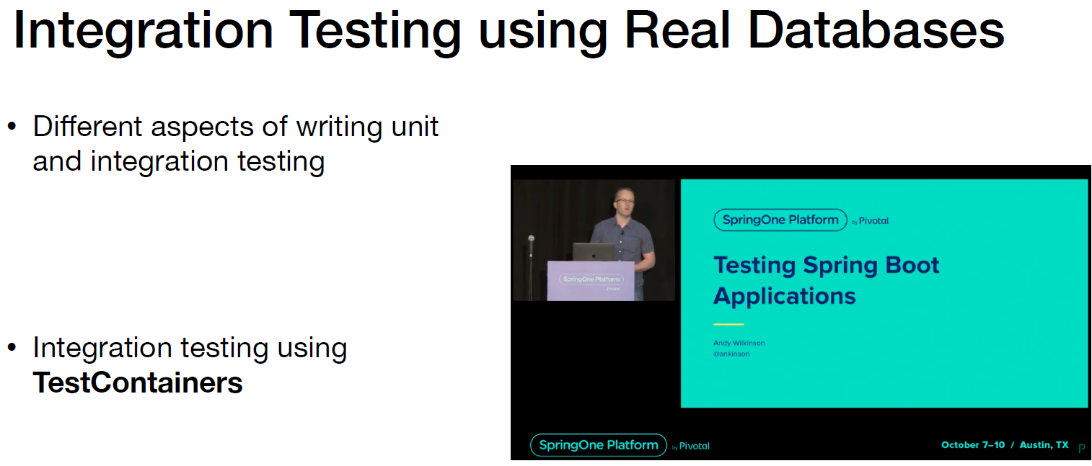

TestContainers

• What are TestContainers?

• Testcontainers is a Java library that supports JUnit tests, providing lightweight, throwaway instances of common databases, Selenium web browsers, or anything else that can run in a Docker container.

• More Info about TestContainers - <https://www.testcontainers.org/>

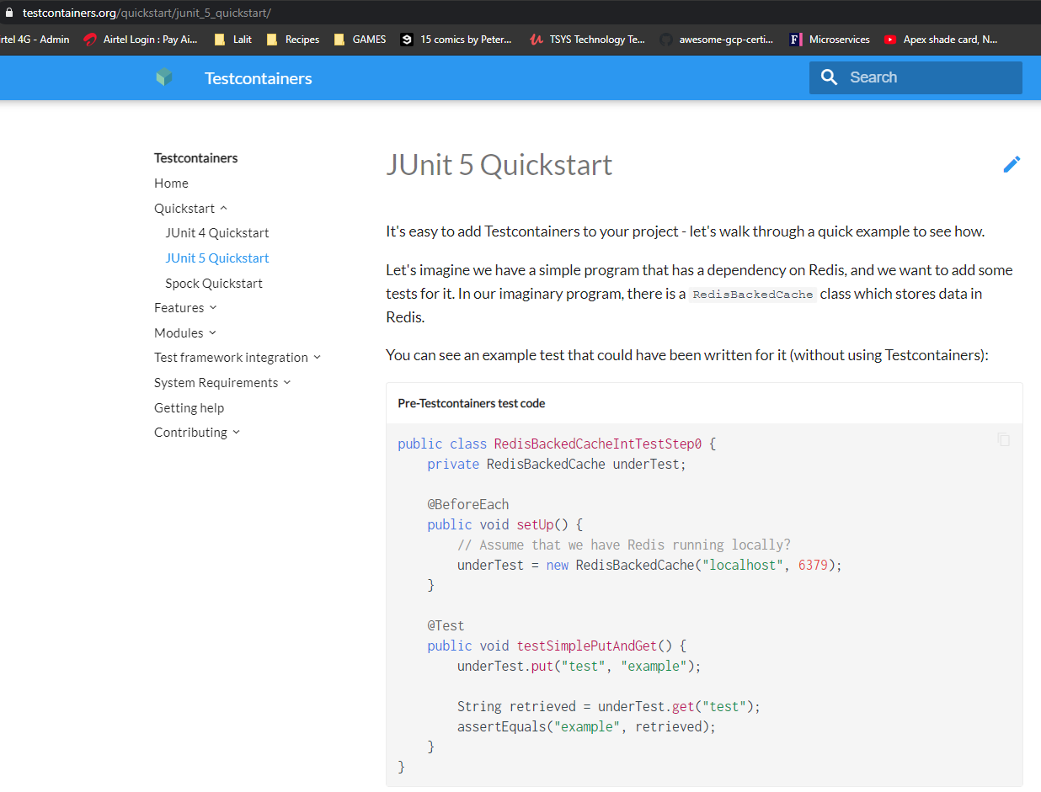

**Custom Error Handlers - Kafka Consumer**

So in this code as you can see I am just trying to perform an update. But the libraryEvenId that I'm parsing here is null. If this is passed as null then, in our service code, basically in our service layer we have a validation which is going to check as you can see in the update flow. We have this validated method. Now then we're going to through a IllegalArgumentException.

Let's go and run this test case and then see what do we have in the logs. That's a default error handler that comes with spring Kafka consumer and in the actual logger we do see the exception the exception here is java.lang.IllegalArgumentException - libraryEvenId is missing.

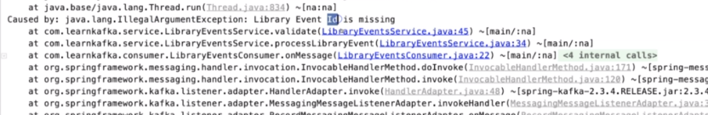

That's what we have here.

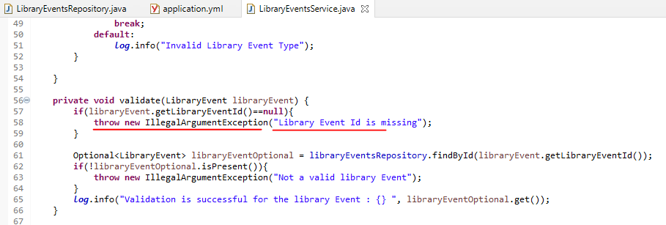

We didn't do any kind of of logging. This is the logging that comes with you by default. As you can scroll a little bit down, this is coming from the class which is a logging error handler and we have the message error while processing and then it is going to give you the actual record which caused the issue also. Let's go to the logging error handler. So logging it at handler.

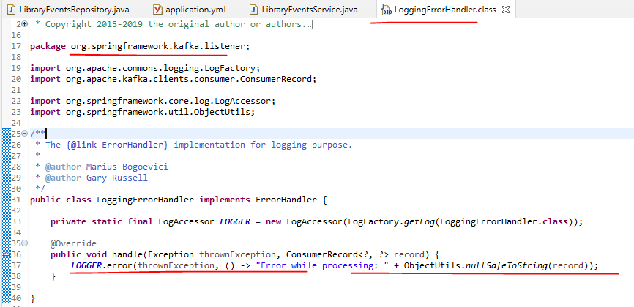

If you want to write as you can see a simple example would be you can create your own Bean that's going to implement this error handler interface and there is one more option and that's option which I'm going to show you know so let's go to the config file. So in the config file in here what we're going to do is the factory has a handy way of handling the head of sexually.

So let's do a factory dog set and a handler. So you have this handler and for this one you can pass the error handling function.

So you're going to pass the lambda function to this error handler as you can see the set error handler takes an instance of error handler.

In the Consumer we have the LibraryEventsConsumerConfig so call the errorHandler and pass in a Lamda here to do the logging for us.

@Configuration

@EnableKafka

@Slf4j

public class LibraryEventsConsumerConfig {

@Autowired

LibraryEventsService libraryEventsService;

@Autowired

KafkaProperties kafkaProperties;

@Bean

@ConditionalOnMissingBean(name = "kafkaListenerContainerFactory")

ConcurrentKafkaListenerContainerFactory<?, ?> kafkaListenerContainerFactory(

ConcurrentKafkaListenerContainerFactoryConfigurer configurer,

ObjectProvider<ConsumerFactory<Object, Object>> kafkaConsumerFactory) {

ConcurrentKafkaListenerContainerFactory<Object, Object> factory =

new ConcurrentKafkaListenerContainerFactory<>();

configurer.configure(factory, kafkaConsumerFactory

.getIfAvailable(() ->

new DefaultKafkaConsumerFactory<>(this.kafkaProperties.buildConsumerProperties())));

factory.setConcurrency(3);

// factory.getContainerProperties().setAckMode(ContainerProperties.AckMode.MANUAL);

factory.setErrorHandler(((thrownException, data) -> {

*log*.info("Exception in consumerConfig is {} and the record is {}",

thrownException.getMessage(), data);

//persist

}));

. . .

When we run the test case, we can see the custom error message appearing now from the error handler that we have passed.

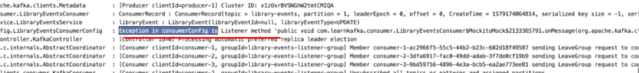

**Why would we do this?**

Because we already have our default error handler right which is actually logging it and here we are doing the same thing. So why are we doing it. Let's say you want to do something additional on top of just logging it. So in those kind of scenarios you can actually leverage that handler. So in this case you can actually persist that record just to keep track of all the records that got failed in a certain interval. Are you can do some kind of additional logic based on your use case. There is a custom error handling if you have a use case where you want to provide custom error handling then this is the way to do it.

**Retry in Kafka**

We will learn about the techniques to enable retry for a failed record. It's time for me to introduce you to some error scenarios which might succeed after all retry. In this example here the consumer reads a message and for some reason the app ran into some temporary network issues with the database which might result in a runtime exception in the service layer here. In these kind of scenarios retrying the failed record would result in successful processing of the record. The software that we build today is pretty much Microservices and the network calls are pretty much everywhere. It's really handy to have retry enabled in the processing logic so that we can avoid a lot of errors.

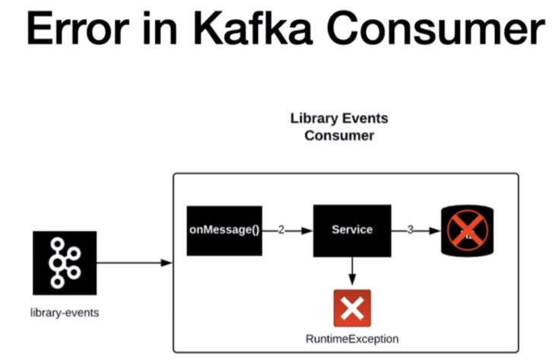

So in this example if the service call fails then we will have a retry enabled for the failed record so that it can succeed in the following retry items. Now let's go ahead and set up the retry in our consumer processing logic. In the LibraryEventsConsumerConfig class we are going to do after the errorhandler is factory.retry. So there is a method called retryTemplate that's the one which we're going to use actually. So the retryTemplate logic is something which I'm going to put in a separate method.

factory.setRetryTemplate( retryTemplate() );

This method is going to return a RetryTemplate

Lets add the customizations, the retryTemplate has a handy method called retryPolicy. Even if we have not worked on retryTemplate that's also okay because the retryTemplate implementation that we are going to do is pretty simple and straightforward. So now we are going to do a setRetryPolicy. So I'm going to create a method called retryPolicy and in here let's go ahead and you can see this is going to return retryPolicy. We will use a retryPolicy called simpleRetryPolicy.

I know I'm going to add one more customization that is Let's type and rewrite template not set a backOffPolicy. Basically every time it attempts to retry I want to have a back off first before it attempts to retry again. So there is a fixedBackoffPolicy. We are going to leverage that. We are going to set up a back off period. So it's going to be set back off period to the back of period in milliseconds. Now we have a retryTemplate in place which is going to do two things. Number one it is going to retry three times for any failure of Records. And number two is it is going to back off one second before it attempts to retry. How do we validate this. Let's go ahead and run the integration test.

Now you will see there is a increasing the time interval for the test case to complete because we have the retrained place right now. The test case failed.

private RetryTemplate retryTemplate() {

FixedBackOffPolicy fixedBackOffPolicy = new FixedBackOffPolicy();

fixedBackOffPolicy.setBackOffPeriod(1000);

RetryTemplate retryTemplate = new RetryTemplate();

retryTemplate.setRetryPolicy( simpleRetryPolicy() );

retryTemplate.setBackOffPolicy( fixedBackOffPolicy );

return retryTemplate;

}

private RetryPolicy simpleRetryPolicy() {

SimpleRetryPolicy simpleRetryPolicy = new SimpleRetryPolicy();

simpleRetryPolicy.setMaxAttempts(3);

return simpleRetryPolicy;

}

This is going to retry three times for any failure of Records. And number two is it is going to back off one second before it attempts to retry. How do we validate this. Let's go ahead and run the integration test. This is where integration test cases comes in handy

Now you will see there is a increasing the time interval for the test case to complete because we have the retrained place right now. The test case failed. Let's go and check what is the actual error of this one actually wanting one time.

So now for the test case we are expecting this LibraryEventConsumer spy to invoke the onMessage one time, but it got invoked three times. What is the reason. It is because of the retry configuration that we have here. So what we will do we will go ahead and check the logger. Let's open the libraryEventConsumer, so I'm expecting this to be present in the logger three times actually. Search for this and we see we have the matches as three. It means the retry came into the picture and then it attempted to retry three times. That's one of the reason why you see this consumer record printed three times.

The test method

@Test

void publishModifyLibraryEvent_Null_LibraryEventId() throws JsonProcessingException,

InterruptedException, ExecutionException {

//given

Integer libraryEventId = null;

String json = "{\"libraryEventId\":" + libraryEventId +

",\"libraryEventType\":\"UPDATE\",\"book\":{\"bookId\":456,

\"bookName\":\"Kafka Using Spring Boot\",\"bookAuthor\":\"Dilip\"}}";

kafkaTemplate.sendDefault(libraryEventId, json).get();

//when

CountDownLatch latch = new CountDownLatch(1);

latch.await(3, TimeUnit.*SECONDS*);

*verify*( libraryEventsConsumerSpy, *times*(1) ).onMessage( *isA*( ConsumerRecord.class ) );

*verify*( libraryEventsServiceSpy, *times(1)* ).processLibraryEvent( *isA*( ConsumerRecord.class ) );

}

logs

2020-12-23 08:41:36.825 INFO 2404 --- [ntainer#0-0-C-1] c.l.k.c.LibraryEventsConsumer : ConsumerRecord : ConsumerRecord(topic = library-events, partition = 0, leaderEpoch = 0, offset = 0, CreateTime = 1608693096756, serialized key size = -1, serialized value size = 131, headers = RecordHeaders(headers = [], isReadOnly = false), key = null, value = {"libraryEventId":null,"libraryEventType":"UPDATE","book":{"bookId":456,"bookName":"Kafka Using Spring Boot","bookAuthor":"Lalit"}})

2020-12-23 08:41:36.866 INFO 2404 --- [ntainer#0-0-C-1] c.l.k.s.LibraryEventsService : libraryEvent : LibraryEvent(libraryEventId=null, libraryEventType=UPDATE)

2020-12-23 08:41:37.870 INFO 2404 --- [ntainer#0-0-C-1] c.l.k.c.LibraryEventsConsumer : ConsumerRecord : ConsumerRecord(topic = library-events, partition = 0, leaderEpoch = 0, offset = 0, CreateTime = 1608693096756, serialized key size = -1, serialized value size = 131, headers = RecordHeaders(headers = [], isReadOnly = false), key = null, value = {"libraryEventId":null,"libraryEventType":"UPDATE","book":{"bookId":456,"bookName":"Kafka Using Spring Boot","bookAuthor":"Lalit"}})

2020-12-23 08:41:37.870 INFO 2404 --- [ntainer#0-0-C-1] c.l.k.s.LibraryEventsService : libraryEvent : LibraryEvent(libraryEventId=null, libraryEventType=UPDATE)

2020-12-23 08:41:38.872 INFO 2404 --- [ntainer#0-0-C-1] c.l.k.c.LibraryEventsConsumer : ConsumerRecord : ConsumerRecord(topic = library-events, partition = 0, leaderEpoch = 0, offset = 0, CreateTime = 1608693096756, serialized key size = -1, serialized value size = 131, headers = RecordHeaders(headers = [], isReadOnly = false), key = null, value = {"libraryEventId":null,"libraryEventType":"UPDATE","book":{"bookId":456,"bookName":"Kafka Using Spring Boot","bookAuthor":"Lalit"}})

2020-12-23 08:41:38.872 INFO 2404 --- [ntainer#0-0-C-1] c.l.k.s.LibraryEventsService : libraryEvent : LibraryEvent(libraryEventId=null, libraryEventType=UPDATE)

2020-12-23 08:41:38.873 INFO 2404 --- [ntainer#0-0-C-1] c.l.k.c.LibraryEventsConsumerConfig : Inside the non recoverable logic

2020-12-23 08:41:38.874 INFO 2404 --- [ntainer#0-0-C-1] c.l.k.c.LibraryEventsConsumerConfig : Exception in consumerConfig is Listener failed; nested exception is java.lang.RuntimeException: Listener method 'public void com.learn.kafka.consumer.LibraryEventsConsumer$MockitoMock$1790862644.onMessage(org.apache.kafka.clients.consumer.ConsumerRecord<java.lang.Integer, java.lang.String>) throws com.fasterxml.jackson.core.JsonProcessingException' threw exception; nested exception is java.lang.IllegalArgumentException: Library Event Id is missing and the record is ConsumerRecord(topic = library-events, partition = 0, leaderEpoch = 0, offset = 0, CreateTime = 1608693096756, serialized key size = -1, serialized value size = 131, headers = RecordHeaders(headers = [], isReadOnly = false), key = null, value = {"libraryEventId":null,"libraryEventType":"UPDATE","book":{"bookId":456,"bookName":"Kafka Using Spring Boot","bookAuthor":"Dilip"}})

Now how do we go and fix that integration test. We are going to change his value from one to three. There you go. Now let's go ahead and run our integration test. Yes Your call is out our integration test here uses embedded Kafka. It doesn't require you to have the whole Kafka clustered up and running in your machine. There you go. We got the green bar because our retry is publishing the message again going to the onMessage method. And that's one of the reason why we have this wanted number of locations as three.

*verify*(libraryEventsConsumerSpy, *times*(3)).onMessage(*isA*(ConsumerRecord.**class**));

*verify*(libraryEventsServiceSpy, *times(3)*).processLibraryEvent(*isA*(ConsumerRecord.**class**));

But we have a problem here. What is a problem. Let's go to the library even consumer and then process library even in here. We are attempting to retry the Illegal argument exception right. You can see this in the logs above. So we are seeing this in the logs because we are trying to retry this record even though it is a hundred times it's going to still get you to the same problem because it's an illegal argument. This is not a temporary network issue that caused this right. So we will go ahead and implement some more customization, to the retry policy so that it will not retry for specific exceptions.

It is very difficult to simulate a network issue or something like that for this purpose. What I'm going to do is I'm going to explicitly hard code a certain payload, if the payload value is this then we are going to consider that as a recoverable exception. If the id is null or if the id comes in as 0 that means I'm going to treat this record as a recoverable exception. I'm just going to throw new RecoverableDataAccessException.

Inside the LibraryEventsConsumerConfig.java

@Bean

@ConditionalOnMissingBean(name = "kafkaListenerContainerFactory")

ConcurrentKafkaListenerContainerFactory<?, ?> kafkaListenerContainerFactory(

ConcurrentKafkaListenerContainerFactoryConfigurer configurer,

ObjectProvider<ConsumerFactory<Object, Object>> kafkaConsumerFactory) {

ConcurrentKafkaListenerContainerFactory<Object, Object> factory =

new ConcurrentKafkaListenerContainerFactory<>();

configurer.configure(factory, kafkaConsumerFactory

.getIfAvailable(() -> new DefaultKafkaConsumerFactory<>(this.kafkaProperties

.buildConsumerProperties())));

factory.setConcurrency(3);

// factory.getContainerProperties().setAckMode(ContainerProperties.AckMode.MANUAL);

factory.setErrorHandler(((thrownException, data) -> {

*log*.info("Exception in consumerConfig is {} and the record is {}",

thrownException.getMessage(), data);

//persist

}));

factory.setRetryTemplate(retryTemplate());

factory.setRecoveryCallback((context -> {

if(context.getLastThrowable().getCause() instanceof RecoverableDataAccessException){

//invoke recovery logic

*log*.info("Inside the recoverable logic");

Arrays.*asList*(context.attributeNames())

.forEach(attributeName -> {

*log*.info("Attribute name is : {} ", attributeName);

*log*.info("Attribute Value is : {} ", context.getAttribute(attributeName));

});

ConsumerRecord<Integer, String> consumerRecord =

(ConsumerRecord<Integer, String>) context.getAttribute("record");

**libraryEventsService**.**handleRecovery**(consumerRecord);

} else {

*log*.info("Inside the non recoverable logic");

throw new RuntimeException(context.getLastThrowable().getMessage());

}

return null;

}));

Inside the LibraryEventsService.java

@Service

@Slf4j

public class LibraryEventsService {

@Autowired

ObjectMapper objectMapper;

@Autowired

KafkaTemplate<Integer,String> kafkaTemplate;

@Autowired

private LibraryEventsRepository libraryEventsRepository;

. . .

public void **handleRecovery**( ConsumerRecord<Integer,String> record ) {

Integer key = record.key();

String message = record.value();

ListenableFuture<SendResult<Integer,String>> listenableFuture =

kafkaTemplate.sendDefault(key, message);

listenableFuture.addCallback(new ListenableFutureCallback< SendResult<Integer, String> >() {

@Override

public void onFailure(Throwable ex) {

**handleFailure**(key, message, ex);

}

@Override

public void onSuccess(SendResult<Integer, String> result) {

**handleSuccess**(key, message, result);

}

});

}

private void **handleFailure**( Integer key, String value, Throwable ex ) {

*log*.error("Error Sending the Message and the exception is {}", ex.getMessage());

try {

throw ex;

} catch (Throwable throwable) {

*log*.error("Error in OnFailure: {}", throwable.getMessage());

}

}

private void **handleSuccess**(Integer key, String value, SendResult<Integer, String> result) {

*log*.info("Message Sent SuccessFully for the key : {} and the value is {} , partition is {}",

key, value, result.getRecordMetadata().partition());

}

. . .

Lets modify the retryPolicy. This constructor takes in how many number times you want to retry. And you're going to provide a map of exception, basically this is going to traverse the flow and determine whether this exception needs to be retried or not. Lets provide the exceptions for which we do not want to retry. IllegalArgumentExceptions we do not want to retry.

private RetryPolicy simpleRetryPolicy() {

// SimpleRetryPolicy simpleRetryPolicy = new SimpleRetryPolicy();

// simpleRetryPolicy.setMaxAttempts(3);

Map<Class<? extends Throwable>, Boolean> exceptionsMap = new HashMap<>();

exceptionsMap.put(IllegalArgumentException.class, false);

exceptionsMap.put(RecoverableDataAccessException.class, true);

SimpleRetryPolicy simpleRetryPolicy = new SimpleRetryPolicy( 3, exceptionsMap, true );

return simpleRetryPolicy;

}

Run the test case, the test case would fail because it will try now only 1 time, so lets change this back to 1

*verify*( libraryEventsConsumerSpy, *times*(1)).onMessage( *isA*( ConsumerRecord.**class** ) );

*verify*( libraryEventsServiceSpy, *times(1)*).processLibraryEvent( *isA*( ConsumerRecord.**class** ) );

Now let's go ahead and check if we throw this exception as a recoverableDataException in that case whether it will trigger the retry or not. So I'm going to copy the same thing and then put it here.

@Test

void publishModifyLibraryEvent_Null_LibraryEventId()

throws JsonProcessingException, InterruptedException, ExecutionException {

//given

Integer libraryEventId = null;

String json = "{\"libraryEventId\":" + libraryEventId + ",\"libraryEventType\":\"UPDATE\",

\"book\":{\"bookId\":456,\"bookName\":\"Kafka Using Spring Boot\",

\"bookAuthor\":\"Dilip\"}}";

kafkaTemplate.sendDefault(libraryEventId, json).get();

//when

CountDownLatch latch = new CountDownLatch(1);

latch.await(3, TimeUnit.*SECONDS*);

verify(libraryEventsConsumerSpy, times(1)).onMessage(isA(ConsumerRecord.class));

verify(libraryEventsServiceSpy, times(1)).processLibraryEvent(isA(ConsumerRecord.class));

}

This is where having integration test cases handy so that you can run all these different types of scenarios and have your code tested without having to run the whole application in your local and then publish the data into the topic and then verifying it manually. The Consumer Record, being printed twice and we go to the green bar.

This means if the exception type RecoverableDataException and then in that case we are retrying our flow actually basically reaching the failed record. Let's go out and check what we have in the exception so exception and consumer configure something which you can check the console you will see the actual recoverable error exception as you can see. The exception is recoverable delay exception and the actual messages temporary networking issue.

So if you go to the actual SimpleRetryPolicy class it is part of the SpringRetry itself as a separate module. You can provide lots of different configurations to retry a particular field record but the project I showed you is one of the popular approaches of performing retry in a consumer failed record.

**Recovery in Kafka Consumer**

|  |  |
| --- | --- |
| Lets talk of a new concept in Spring Kafka consumer which is Recovery. Recovery, what does it actually mean in the scope of consumer. We have a Kafka consumer here and it has a retry in place. Let's say that the retrials are attempted for a record and all the retrials are finished. The record ran into a one time exception and the number of retries are exhausted. Then what is a next option that we have to the record that got failed. That's where the recovery comes into picture. |  |

|  |  |
| --- | --- |
|  | If the record succeeds in the retry items then we are good. Otherwise the record will be forwarded to the recovery block. If the record is recoverable then it will be handled in the recovery block otherwise the record will be forwarded to the handler and it will be handled over there.  We will see two different types of recovery patterns that can be implemented and Kafka consumer. Let's discuss about the type 1 recovery here. |

|  |  |
| --- | --- |
| Let's assume the retries are exhausted. The next check here is that if there are Records recoverable then produce in the message back to the original topic, so that the record will go through the regular processing.  If the record fails again then the same process continues until it is successfully processed. If the record is not recoverable then you can either produce a message to the dead letter topic which is optional in here or you can just log it and move on.  It's up to you to take the decision on what needs to be done.  For a record that's cannot be recoverable you cannot do much with that record. Right. That's all about the type one. |  |

|  |  |
| --- | --- |
|  | It's the same scenario in here in which the retrials are exhausted basically and then the flow is almost the same except the fact that instead of producing the message back to the original topic which is library events you will have a topic specifically for the records that are eligible for recovery and the consumer will be reading from this topic too.  In addition to the actual topic I hope these two patterns are very clear for you, in this cause we will implement the type one. |

**Handling recovery in Kafka Consumer**

In this lecture we will go ahead and implement the Recovery callback for our library and consumer. So let's open the library even consumer config file in this file we have the right template here right and then we will go ahead and write the recovery callback. So let's do a factory which has a handy method called assetRecovery. There you go. You have this set recovery callback.

You have this setRecoveryCallback and the input to this method is going to be a recovery callback. So if you go to the recovery callback What do you have. You have a method called recover and it accepts the parameter as RetryContext. So RetryContext is nothing but the value that we get from the retry attempts. So in a nutshell retry and a recovery go together basically. So the input parameter to this recover amateurism retry context. So what I'm going to do is I'm going to implement the Recovery callback using lambda.

The very first thing is we're going to check if the exception is of type RecoverableDataAccessException if that's the case then we will have a recovery logic or else we will have the error handler which is over here, to take all that exception and handler.

So do we will do here, context has a handy method called if contact does not getLastThrowable(). So what is the last thrown exception. And then if you do the getCause().

Inside the LibraryEventsConsumerConfig.java

@Bean

@ConditionalOnMissingBean(name = "kafkaListenerContainerFactory")

ConcurrentKafkaListenerContainerFactory<?, ?> kafkaListenerContainerFactory(

ConcurrentKafkaListenerContainerFactoryConfigurer configurer,

ObjectProvider<ConsumerFactory<Object, Object>> kafkaConsumerFactory) {

ConcurrentKafkaListenerContainerFactory<Object, Object> factory =

new ConcurrentKafkaListenerContainerFactory<>();

configurer.configure(factory, kafkaConsumerFactory

.getIfAvailable(() -> new DefaultKafkaConsumerFactory<>(this.kafkaProperties

.buildConsumerProperties())));

factory.setConcurrency(3);

// factory.getContainerProperties().setAckMode(ContainerProperties.AckMode.MANUAL);

factory.setErrorHandler(((thrownException, data) -> {

*log*.info("Exception in consumerConfig is {} and the record is {}",

thrownException.getMessage(), data);

//persist

}));

factory.setRetryTemplate(retryTemplate());

factory.setRecoveryCallback((context -> {

if(context.getLastThrowable().getCause() instanceof RecoverableDataAccessException){

//invoke recovery logic

*log*.info("Inside the recoverable logic");

Arrays.*asList*(context.attributeNames())

.forEach(attributeName -> {

*log*.info("Attribute name is : {} ", attributeName);

*log*.info("Attribute Value is : {} ", context.getAttribute(attributeName));

});

ConsumerRecord<Integer, String> consumerRecord =

(ConsumerRecord<Integer, String>) context.getAttribute("record");

libraryEventsService.handleRecovery(consumerRecord);

} else {

*log*.info("Inside the non recoverable logic");

throw new RuntimeException(context.getLastThrowable().getMessage());

}

return null;

}));

We can see this in the logs as below

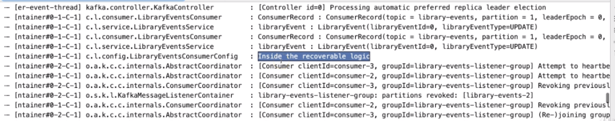

Now we have a recovery called back and the handle to differentiate the recoverable exception and non recoverable exception.

We will go ahead and implement the Recovery logic for the failed record. I hope you all remember the. If the issue is a recoverable one then we're going to produce the message back to the LibraryEventsKafkaTopic right. What do we need in order for that to happen. We need to know the actual Record that got failed. And number two is we need to have a Kafka producer so that we can produce a message back to the KafkaTopic.

The attributes that come with the RetryContext ( see above in green ) are as below.

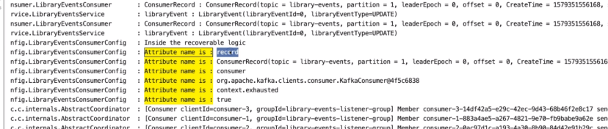

@Configuration

@EnableKafka

@Slf4j

public class LibraryEventsConsumerConfig {

@Autowired

LibraryEventsService libraryEventsService;

@Autowired

KafkaProperties kafkaProperties;

@Bean

@ConditionalOnMissingBean(name = "kafkaListenerContainerFactory")

ConcurrentKafkaListenerContainerFactory<?, ?> kafkaListenerContainerFactory(

ConcurrentKafkaListenerContainerFactoryConfigurer configurer,

ObjectProvider<ConsumerFactory<Object, Object>> kafkaConsumerFactory) {

ConcurrentKafkaListenerContainerFactory<Object, Object> factory =

new ConcurrentKafkaListenerContainerFactory<>();

configurer.configure(factory, kafkaConsumerFactory

.getIfAvailable(() ->

new DefaultKafkaConsumerFactory<>(this.kafkaProperties.buildConsumerProperties())));

factory.setConcurrency(3);

// factory.getContainerProperties().setAckMode(ContainerProperties.AckMode.MANUAL);

factory.setErrorHandler(((thrownException, data) -> {

log.info("Exception in consumerConfig is {} and the record is {}",

thrownException.getMessage(), data);

//persist

}));

factory.setRetryTemplate(retryTemplate());

factory.setRecoveryCallback((context -> {

if(context.getLastThrowable().getCause() instanceof RecoverableDataAccessException){

//invoke recovery logic

log.info("Inside the recoverable logic");

Arrays.asList(context.attributeNames())

.forEach(attributeName -> {

log.info("Attribute name is : {} ", attributeName);

log.info("Attribute Value is : {} ", context.getAttribute(attributeName));

});

ConsumerRecord<Integer, String> consumerRecord =

(ConsumerRecord<Integer, String>) context.getAttribute("record");

libraryEventsService.handleRecovery(consumerRecord);

} else {

log.info("Inside the non recoverable logic");

throw new RuntimeException(context.getLastThrowable().getMessage());

}

return null;

}));

return factory;

}

Basically we need to write the producer to publish the message into the topic for this purpose. What I'm going to do is I'm going to write a recovery method and the consumer service class. Autowire the LibraryEventsService into the config class above. So let's open the service glass so in here we will go ahead and write the recovery call.

@Service

@Slf4j

public class LibraryEventsService {

. . .

public void handleRecovery(ConsumerRecord<Integer,String> record){

Integer key = record.key();

String message = record.value();

ListenableFuture<SendResult<Integer,String>> listenableFuture =

kafkaTemplate.sendDefault(key, message);

listenableFuture.addCallback(new ListenableFutureCallback<SendResult<Integer, String>>() {

@Override

public void onFailure(Throwable ex) {

handleFailure(key, message, ex);

}

@Override

public void onSuccess(SendResult<Integer, String> result) {

handleSuccess(key, message, result);

}

});

}

**Error Handling – Producer Level**

All the request validations in here are done at the API layer itself. The Kafka producer just takes the requisite data and produces the message to the Kafka topic. So what are the possible exceptions that can happen in here. Let me quickly show you some of the examples in this slide.

Number one is the unavailability of the Kafka cluster itself. This will definitely throw some errors back to the libraryEventProducer of an application. The next one is the acks value is set as all and some of the brokers are not available in the cluster. Then the producer will throw some errors back to the application. The next one is the min.insync.replicas configuration. I have not talked about this configuration. This is one of the important configuration when it comes to reliable data delivery. This can be set at the broker level or the topic level. Let me quickly explain this using an example. This config takes in an integer value. If the min.insync.replicas values is 2, this means that you need to have two replicas of the data that's produced into the topic. In our local we have three brokers in the cluster right. Let's say for some reason two brokers are down and the cluster has only one broker. If the producer tried to produce a message then you will get an error message stating not enough replicas - these are some of the error scenarios that can happen from the Kafka producer and let's go ahead and explore some of these scenarios in the following lectures.

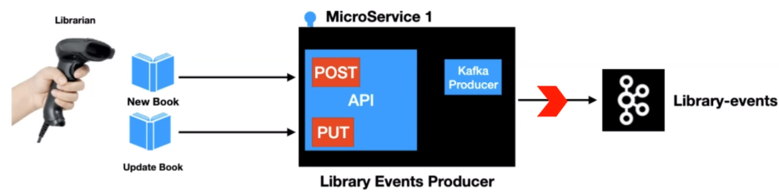

Lets explore what happens when the broker is not available. How the application is going to behave. I have the Kafka cluster with three brokers up and running. I expect you to have the same set up in your local machine. Now the very next thing which we are going to do is I'm going to start up this application.

And what we will do is we will go ahead and try to bring the broker down and the configuration that you see in the logger. These are argument client conflicts. These are related to the auto create conflict that we have in here. Now what it will do will go ahead and bring the cluster down. Basically we are introducing chaos into our environment. So one broker is going down I'm bringing the other one down. Bringing all the 3 down.

We will go ahead and try to publish a message into the Kafka topic. Basically we are going to use one of the curl commands that we have and then we are going to publish a message. What this is going to do. The call is going to go to the controller. Its going to hit the post end point and it's going to go ahead and invoke this sendLibraryEvent_approach2, this is where it's going to send the message. Now let's go ahead and post this message. Now let's go to the run window, in the run window after the post messages and book as it can see it pulled in the Producer config and then if you scroll a little bit down what we have here is that we have an error that's coming from the network link.

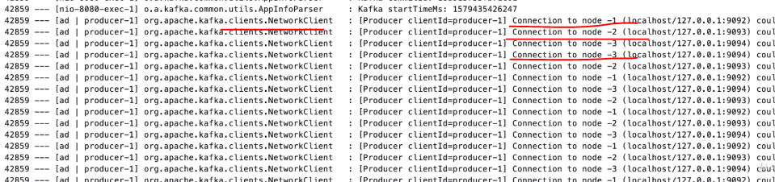

And it is continuously doing this until 60 seconds. If you scroll a little bit down after the 60 seconds window you will see a error message here actually. And it's continuously trying to tried to connect to the actual broker and then we got an error message here which states or exception topic a library even is not present in metadata. What does this mean is that there is a metadata that's available for each and every conflict linked API. This metadata is mandatory.

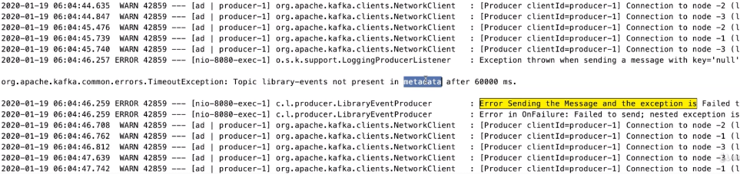

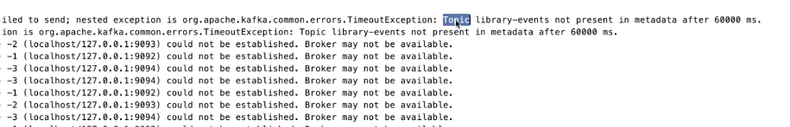

The clients use this in order to find out the leader and publish the message into the Kafka topic. This metadata in general gets updated continuously actually. And if you look at it this is our application later error actually, if you go to the handle failure this is where we have this message if you search for error sending the message and the exception go. We have this exception and the exception is failed to send and the actual letter exception is timeout exception. And the message is topic A library event is not present in metadata after 60000 milliseconds.

The reason why you are getting the metadata information is that whenever you produce a message the very first call that happens basic behind the scenes is that it's going to go ahead and invoke Kafka Cluster and get the metadata so that it has the latest data aboard the Kafka cluster. And then it produces the message as you can see after this exception it is continuously getting that error message it is continuously trying to connect to the Kafka Cluster behind the scenes. Now the application has no clue because after this error, the requisite data that came in as part of the API call is error out and then it's continuous to trying to connect to the Kafka cluster.

What I'm going to do is I'm going to try to bring one of the broker up actually. Let's go ahead and try to bring one of the broken up. I'm bringing the broker number one with the id zero and then we'll go ahead and check what's going on in here as you can see we see a different message. Error while fetching the metadata with correlation 1 and it's right now it is trying to connect to the actual cluster. That's one of the reason why the message changed from could not established to error while fitting the metadata but correlation id 1.



Now let's go ahead and try to publish a message and then see what's going on. So I'm going to publish the same message as you can see the a message immediately. Let's go out and check. As you can see the message sent successfully for the key and the value. Basically with our local Kafka cluster even though if we have the whole cluster down the application did not go down, it was continuously trying to connect to it. As soon as one of the brokers up it was able to connect and your application is back to normal processing to the Kafka producer has the behavior of auto healing and this is where the Kafka planes are really handy and its durability is much better than any other even streaming systems.

min.insync.replicas

We will explore the min.insync.replicas configuration and its impact to the Kafka Cluster. In this slide, we have the Kafka cluster with three brokers and a zookeeper and that's a setup that we have in our local machine. Let's say the min.insync.replicas value is set to 2 for our libraryEventsTopic. This configuration will allow the producer to send the message to the Kafka topic, only if there are at least two of the brokers always up and running all the time. Let's see if we have only one broker up and running and then you are trying to produce the message from your app. Then you will get an error message stating not enough replicas, let's go ahead and explore the same.

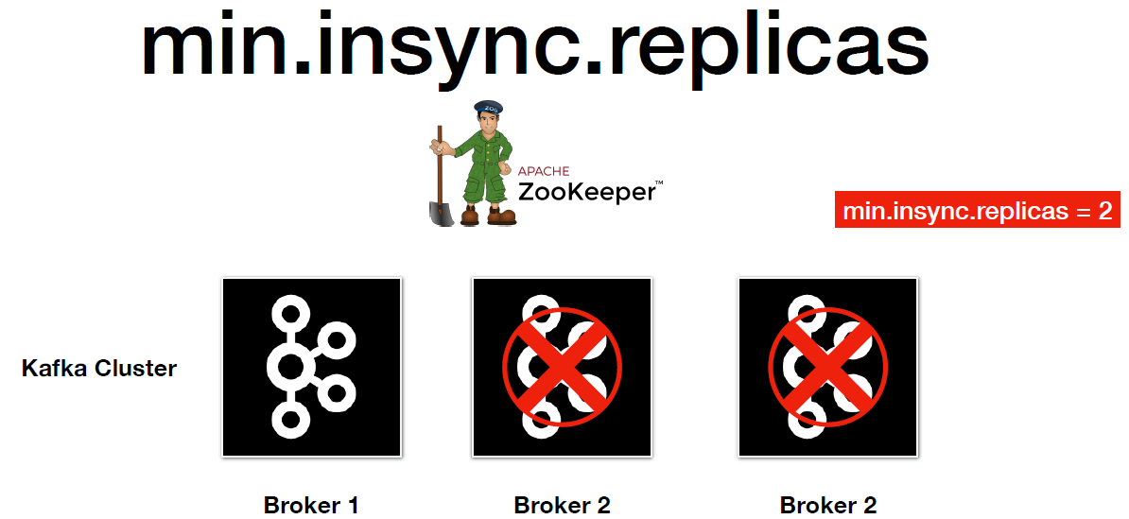

The very first thing we would do is set up the min.insync.replicas as 2 for the library-events-topic. Run the following command

## Alter the min insync replica

./kafka-topics.sh --alter --zookeeper localhost:2181 --topic library-events

--config min.insync.replicas=2

In here we have a command which is specifically used to set up the min.insync.replicas as two. If we take a look at it we have kafka-topics.sh command and then we are using the alter key word and then we are passing to the zookeeper address and after that we are passing the actual topic to which we are going to set this configuration value too and then we are setting up the configuration using the --config and the min.insync.replicas as equal to 2. Run this command.

Now I'm in the libraryEventsProducer application and its up and running in the local. Publish a message. We will bring down two of the brokers and then publish a message.

If you scroll a little bit up in this application.yaml file we have this retrace value set as 10. What is the significance of this value is that if you receive any error other than the macro data related issues that we saw in the previous lecture then go ahead and retry that failure card 10 times before we mark that record as failure.

spring:

profiles:

active: local

server:

port: 9000

---

spring:

profiles: local

kafka:

template:

default-topic: library-events

producer:

bootstrap-servers: localhost:9092,localhost:9093,localhost:9094

key-serializer: org.apache.kafka.common.serialization.IntegerSerializer

value-serializer: org.apache.kafka.common.serialization.StringSerializer

properties:

acks: all

retries: 10

retry.backoff.ms: 1000

admin:

properties:

bootstrap.servers: localhost:9092,localhost:9093,localhost:9094

We will go ahead and publish the same message. But if you take a look at that error that we have in the logger here we have this message which is not enough replicas. And as you can see the number of attempts that's taken us from three to twelve basically, it attempted 10 times before it considered this record to be a failure record. And all these is happening instantaneously right.

2020-12-30 16:41:13.892 INFO 10004 --- [nio-9000-exec-2] o.a.k.c.u.AppInfoParser : Kafka startTimeMs: 1609326673890

2020-12-30 16:41:15.927 WARN 10004 --- [ad | producer-1] o.a.k.c.NetworkClient : [Producer clientId=producer-1] Connection to node -2 (localhost/127.0.0.1:9093) could not be established. Broker may not be available.

2020-12-30 16:41:15.928 WARN 10004 --- [ad | producer-1] o.a.k.c.NetworkClient : [Producer clientId=producer-1] Bootstrap broker localhost:9093 (id: -2 rack: null) disconnected

2020-12-30 16:41:18.968 WARN 10004 --- [ad | producer-1] o.a.k.c.NetworkClient : [Producer clientId=producer-1] Connection to node -2 (localhost/127.0.0.1:9093) could not be established. Broker may not be available.

2020-12-30 16:41:18.968 WARN 10004 --- [ad | producer-1] o.a.k.c.NetworkClient : [Producer clientId=producer-1] Bootstrap broker localhost:9093 (id: -2 rack: null) disconnected

2020-12-30 16:41:22.008 WARN 10004 --- [ad | producer-1] o.a.k.c.NetworkClient : [Producer clientId=producer-1] Connection to node -3 (localhost/127.0.0.1:9094) could not be established. Broker may not be available.

2020-12-30 16:41:22.009 WARN 10004 --- [ad | producer-1] o.a.k.c.NetworkClient : [Producer clientId=producer-1] Bootstrap broker localhost:9094 (id: -3 rack: null) disconnected

2020-12-30 16:41:25.041 WARN 10004 --- [ad | producer-1] o.a.k.c.NetworkClient : [Producer clientId=producer-1] Connection to node -2 (localhost/127.0.0.1:9093) could not be established. Broker may not be available.

2020-12-30 16:41:25.041 WARN 10004 --- [ad | producer-1] o.a.k.c.NetworkClient : [Producer clientId=producer-1] Bootstrap broker localhost:9093 (id: -2 rack: null) disconnected

2020-12-30 16:41:28.058 WARN 10004 --- [ad | producer-1] o.a.k.c.NetworkClient : [Producer clientId=producer-1] Connection to node -2 (localhost/127.0.0.1:9093) could not be established. Broker may not be available.

2020-12-30 16:41:28.058 WARN 10004 --- [ad | producer-1] o.a.k.c.NetworkClient : [Producer clientId=producer-1] Bootstrap broker localhost:9093 (id: -2 rack: null) disconnected

2020-12-30 16:41:29.068 INFO 10004 --- [ad | producer-1] o.a.k.c.Metadata : [Producer clientId=producer-1] Cluster ID: rgLFm_G7QSOPibwT5wj-Dg

2020-12-30 16:41:29.123 WARN 10004 --- [ad | producer-1] o.a.k.c.p.i.Sender : [Producer clientId=producer-1] Got error produce response with correlation id **3** on topic-partition library-events-0, retrying (9 attempts left). Error: NOT_ENOUGH_REPLICAS

2020-12-30 16:41:30.128 WARN 10004 --- [ad | producer-1] o.a.k.c.p.i.Sender : [Producer clientId=producer-1] Got error produce response with correlation id **4** on topic-partition library-events-0, retrying (8 attempts left). Error: NOT_ENOUGH_REPLICAS

2020-12-30 16:41:31.142 WARN 10004 --- [ad | producer-1] o.a.k.c.p.i.Sender : [Producer clientId=producer-1] Got error produce response with correlation id **5** on topic-partition library-events-0, retrying (7 attempts left). Error: NOT_ENOUGH_REPLICAS

2020-12-30 16:41:32.152 WARN 10004 --- [ad | producer-1] o.a.k.c.p.i.Sender : [Producer clientId=producer-1] Got error produce response with correlation id **6** on topic-partition library-events-0, retrying (**6** **attempts** **left**). Error: NOT_ENOUGH_REPLICAS

2020-12-30 16:41:33.168 WARN 10004 --- [ad | producer-1] o.a.k.c.p.i.Sender : [Producer clientId=producer-1] Got error produce response with correlation id **7** on topic-partition library-events-0, retrying (5 attempts left). Error: NOT_ENOUGH_REPLICAS

2020-12-30 16:41:34.180 WARN 10004 --- [ad | producer-1] o.a.k.c.p.i.Sender : [Producer clientId=producer-1] Got error produce response with correlation id **8** on topic-partition library-events-0, retrying (4 attempts left). Error: NOT_ENOUGH_REPLICAS

2020-12-30 16:41:35.196 WARN 10004 --- [ad | producer-1] o.a.k.c.p.i.Sender : [Producer clientId=producer-1] Got error produce response with correlation id **9** on topic-partition library-events-0, retrying (3 attempts left). Error: NOT_ENOUGH_REPLICAS

2020-12-30 16:41:36.200 WARN 10004 --- [ad | producer-1] o.a.k.c.p.i.Sender : [Producer clientId=producer-1] Got error produce response with correlation id **10** on topic-partition library-events-0, retrying (2 attempts left). Error: NOT_ENOUGH_REPLICAS

2020-12-30 16:41:37.203 WARN 10004 --- [ad | producer-1] o.a.k.c.p.i.Sender : [Producer clientId=producer-1] Got error produce response with correlation id **11** on topic-partition library-events-0, retrying (1 attempts left). Error: NOT_ENOUGH_REPLICAS

2020-12-30 16:41:38.207 WARN 10004 --- [ad | producer-1] o.a.k.c.p.i.Sender : [Producer clientId=producer-1] Got error produce response with correlation id **12** on topic-partition library-events-0, retrying (0 attempts left). Error: NOT_ENOUGH_REPLICAS

2020-12-30 16:41:39.222 ERROR 10004 --- [ad | producer-1] c.l.k.p.LibraryEventProducer : Error Sending the Message and the exception is Failed to send; nested exception is org.apache.kafka.common.errors.NotEnoughReplicasException: Messages are rejected since there are fewer in-sync replicas than required.

2020-12-30 16:41:39.222 ERROR 10004 --- [ad | producer-1] c.l.k.p.LibraryEventProducer : Error in OnFailure: Failed to send; nested exception is org.apache.kafka.common.errors.NotEnoughReplicasException: Messages are rejected since there are fewer in-sync replicas than required.

2020-12-30 16:41:39.223 ERROR 10004 --- [ad | producer-1] o.s.k.s.LoggingProducerListener : Exception thrown when sending a message with key='1' and payload='{"libraryEventId":1,"libraryEventType":"UPDATE","book":{"bookId":456,"bookName":"Kafka Using Spring ...' to topic library-events:

org.apache.kafka.common.errors.NotEnoughReplicasException: Messages are rejected since there are fewer in-sync replicas than required.

We can actually very well increase that replay back off interval to see if you scroll a little bit up. So here we have the retrace back off.

acks = -1

batch.size = 16384

bootstrap.servers = [localhost:9092, localhost:9093, localhost:9094]

buffer.memory = 33554432

client.dns.lookup = default

client.id = producer-1

compression.type = none

connections.max.idle.ms = 540000

delivery.timeout.ms = 120000

enable.idempotence = false

interceptor.classes = []

key.serializer = class org.apache.kafka.common.serialization.IntegerSerializer

linger.ms = 0

max.block.ms = 60000

max.in.flight.requests.per.connection = 5

max.request.size = 1048576

metadata.max.age.ms = 300000

metadata.max.idle.ms = 300000

metric.reporters = []

metrics.num.samples = 2

metrics.recording.level = INFO

metrics.sample.window.ms = 30000

partitioner.class = class org.apache.kafka.clients.producer.internals.DefaultPartitioner

receive.buffer.bytes = 32768

reconnect.backoff.max.ms = 1000

reconnect.backoff.ms = 50

request.timeout.ms = 30000

retries = 10

**retry.backoff.ms = 1000**

sasl.client.callback.handler.class = null

sasl.jaas.config = null

sasl.kerberos.kinit.cmd = /usr/bin/kinit

sasl.kerberos.min.time.before.relogin = 60000

sasl.kerberos.service.name = null

sasl.kerberos.ticket.renew.jitter = 0.05

sasl.kerberos.ticket.renew.window.factor = 0.8

sasl.login.callback.handler.class = null

sasl.login.class = null

sasl.login.refresh.buffer.seconds = 300

sasl.login.refresh.min.period.seconds = 60

sasl.login.refresh.window.factor = 0.8

sasl.login.refresh.window.jitter = 0.05

sasl.mechanism = GSSAPI

security.protocol = PLAINTEXT

security.providers = null

send.buffer.bytes = 131072

ssl.cipher.suites = null

ssl.enabled.protocols = [TLSv1.2]

ssl.endpoint.identification.algorithm = https

ssl.key.password = null

ssl.keymanager.algorithm = SunX509

ssl.keystore.location = null

ssl.keystore.password = null

ssl.keystore.type = JKS

ssl.protocol = TLSv1.2

ssl.provider = null

ssl.secure.random.implementation = null

ssl.trustmanager.algorithm = PKIX

ssl.truststore.location = null

ssl.truststore.password = null

ssl.truststore.type = JKS

transaction.timeout.ms = 60000

transactional.id = null

value.serializer = class org.apache.kafka.common.serialization.StringSerializer

We can go ahead and change the value of retry.backoff to say 1000, i.e. 1 second. Restart the application and repeat the process and now it will take a second before it retries again in its 10 attempts.

Now bring the second broker up and send the message again, as you can see message sent successfully. So we see the importance of min.insync.replicas and retry.backoff time interval before reattempts.

**Retain and Recover Failed Records**

Lets see how do we retrain and recover the failed record in Kafka producer, because of an error returned from the conflict in last attempt. Until now we have seen different scenarios that a Kafka producer can feel and how do we try to make sure of the following items succeeds or not. Let me quickly show you what do we have in our error callback. So here is our Kafka producer we have this on failure callback and on success callback and on failure callback basically the handle failure method. What do we do here. We just log them and move on right.

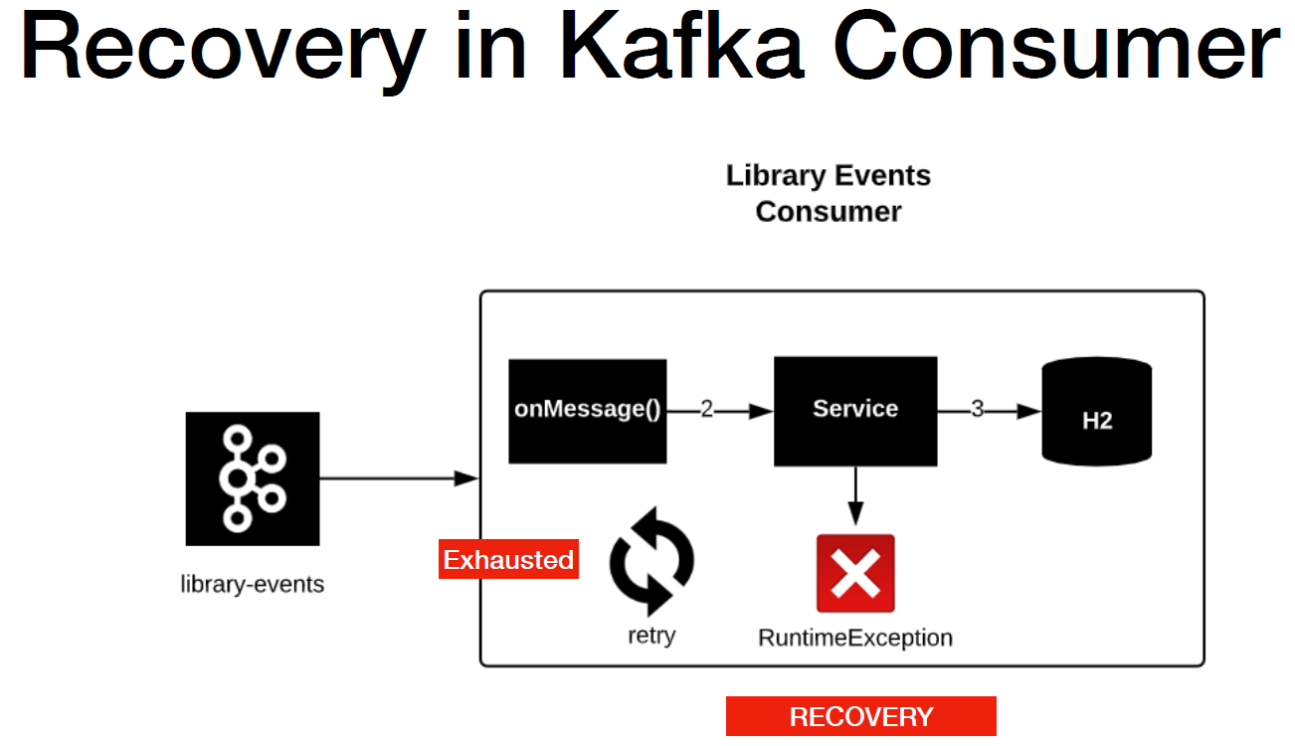

@Component

@Slf4j

public class LibraryEventProducer {

@Autowired

KafkaTemplate<Integer,String> kafkaTemplate;

String topic = "library-events";

@Autowired

ObjectMapper objectMapper;

public void sendLibraryEvent(LibraryEvent libraryEvent) throws JsonProcessingException {

Integer key = libraryEvent.getLibraryEventId();

String value = objectMapper.writeValueAsString(libraryEvent);

ListenableFuture<SendResult<Integer,String>> listenableFuture = kafkaTemplate.sendDefault(key,value);

listenableFuture.addCallback(new ListenableFutureCallback<SendResult<Integer, String>>() {

@Override

public void onFailure(Throwable ex) {

handleFailure(key, value, ex);

}

@Override

public void onSuccess(SendResult<Integer, String> result) {

handleSuccess(key, value, result);

}

});

}

public ListenableFuture<SendResult<Integer,String>> sendLibraryEvent_Approach2(LibraryEvent libraryEvent)

throws JsonProcessingException {

Integer key = libraryEvent.getLibraryEventId();

String value = objectMapper.writeValueAsString(libraryEvent);

ProducerRecord<Integer,String> producerRecord = buildProducerRecord(key, value, topic);

ListenableFuture<SendResult<Integer,String>> listenableFuture = kafkaTemplate.send(producerRecord);

listenableFuture.addCallback(new ListenableFutureCallback<SendResult<Integer, String>>() {

@Override

public void onFailure(Throwable ex) {

handleFailure(key, value, ex);

}

@Override

public void onSuccess(SendResult<Integer, String> result) {

handleSuccess(key, value, result);

}

});

return listenableFuture;

}

private ProducerRecord<Integer, String> buildProducerRecord(Integer key, String value, String topic) {

List<Header> recordHeaders = List.*of*(new RecordHeader("event-source", "scanner".getBytes()));

return new ProducerRecord<>(topic, null, key, value, recordHeaders);

}

public SendResult<Integer, String> sendLibraryEventSynchronous(LibraryEvent libraryEvent)

throws JsonProcessingException, ExecutionException, InterruptedException, TimeoutException {

Integer key = libraryEvent.getLibraryEventId();

String value = objectMapper.writeValueAsString(libraryEvent);

*log*.info("before send call");

SendResult<Integer,String> sendResult = kafkaTemplate.sendDefault(key,value).get(1, TimeUnit.*SECONDS*);

*log*.info("SendResult is {}", sendResult.toString());

*log*.info("after sendLibraryEvent");

return sendResult;

}

private void handleFailure(Integer key, String value, Throwable ex) {

*log*.error("Error Sending the Message and the exception is {}", ex.getMessage());

try {

throw ex;

} catch (Throwable throwable) {

*log*.error("Error in OnFailure: {}", throwable.getMessage());

}

}

private void handleSuccess(Integer key, String value, SendResult<Integer, String> result) {

*log*.info("Message Sent SuccessFully for the key : {} and the value is {} , partition is {}",

key, value, result.getRecordMetadata().partition());

}

}

As a result of this we are losing the record right. How can we avoid this and how can we try to save this record and have it automatically recover. I have a producer retain and recover flow in this slide

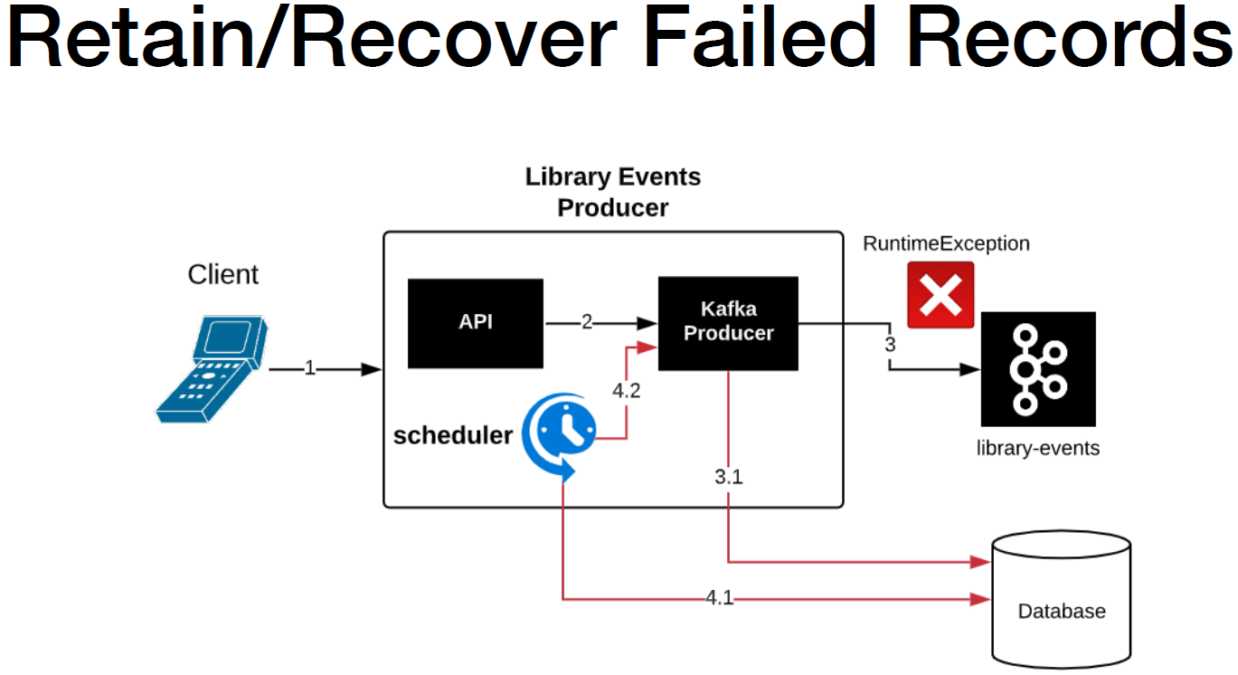

So the very first thing is when this call fails basically the Kafka cluster is having some issues in those kind of scenarios. What we have to do is we have two persist that record in a database that will be the first step. So now we have successfully retained that failure record. So what is the next step. The next step is we need to automatically retry that failed record which has already persisted in the database. Right. So the very next thing is you need to have a scheduler in place so that it can actually pull the data from the database and then try to produce that message again to the after topic. If the record fails again then it will be saved in the database with the same state as it was before.

I have another approach which is option 2 to recover a failed record. Basically have a recovery topic and publish the failed record to the recovery topic and you will need to have a copy of consumer recovery topic in the same producer application so that you can process this immediately.

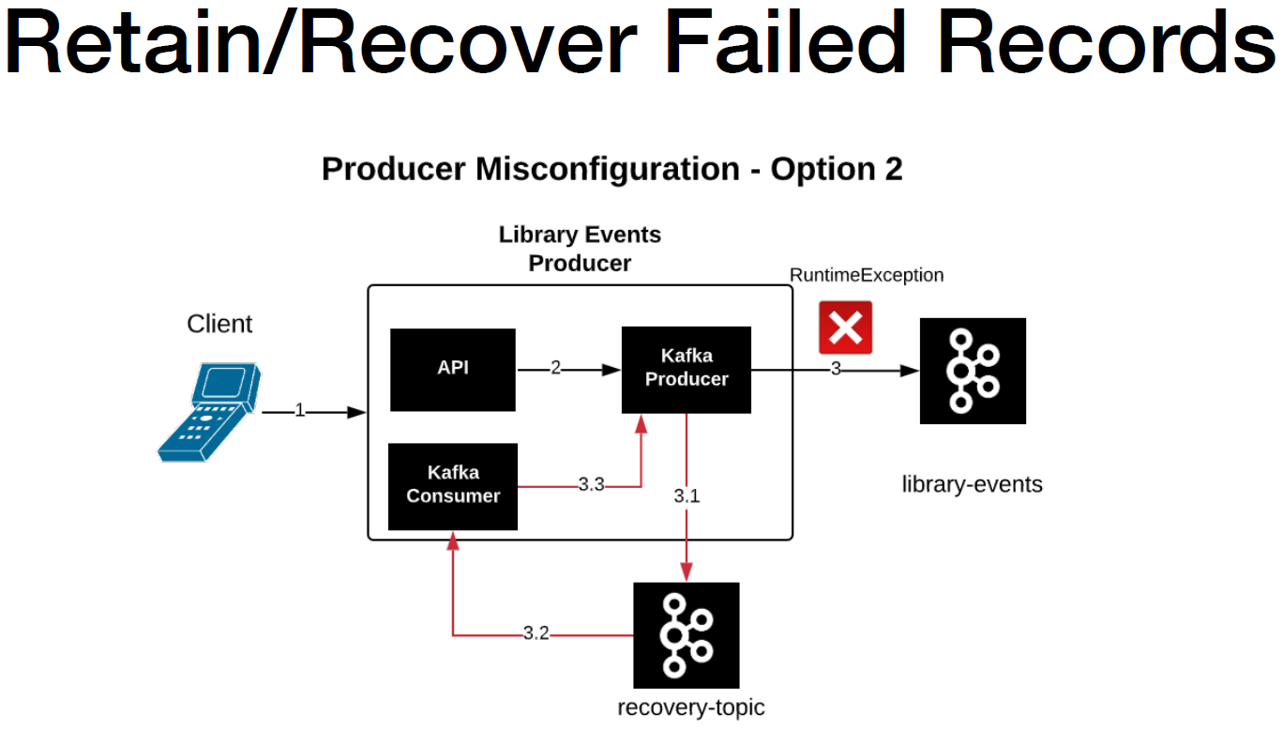

Personally I'm not a big fan of this approach because if the Kafka cluster itself has some issues and there is no way to publish the record and to look off topic and it will end up losing the record. Primarily these are the two different options to retain and recover the failed record and Kafka producer.

Issues with Recovery ? Recovery can alter the order of events

**Kafka Security and SSL**

Let's talk about why do we need Kafka security. Kafka is used in variety of businesses today. Banking, Retail, Insurance and more. Security is definitely one of the important aspects for all the businesses, when it comes to using Kafka as part of their environment, because all these businesses involve confidential information which has information about credit card details and customer information and more so. What does Kafka offer when it comes to security. Kafka supports two popular protocols one is SSL which stands for Secure Socket Layer which is actually tailors now which stands for transport layer security as SSL was deprecated in June 2015. But for some reason the industry still refer to it as SSL.

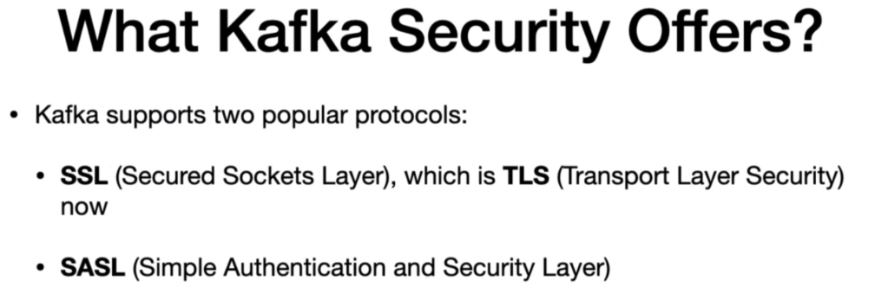

The next one is SASL which stands for Simple Authentication and Security Layer. In this course will learn about the techniques to interact with one protocol. We will explore about the SSL setup as SSL setup is a simple compared to SASL. The Kafka documentation page is really good as you can see if you go to the Kafka documentation home page and then click on the security. It will take you to the security section and it does pretty good information about what is Kafka security and what are the different types of protocols that Kafka security supports.

<https://kafka.apache.org/documentation/#security>

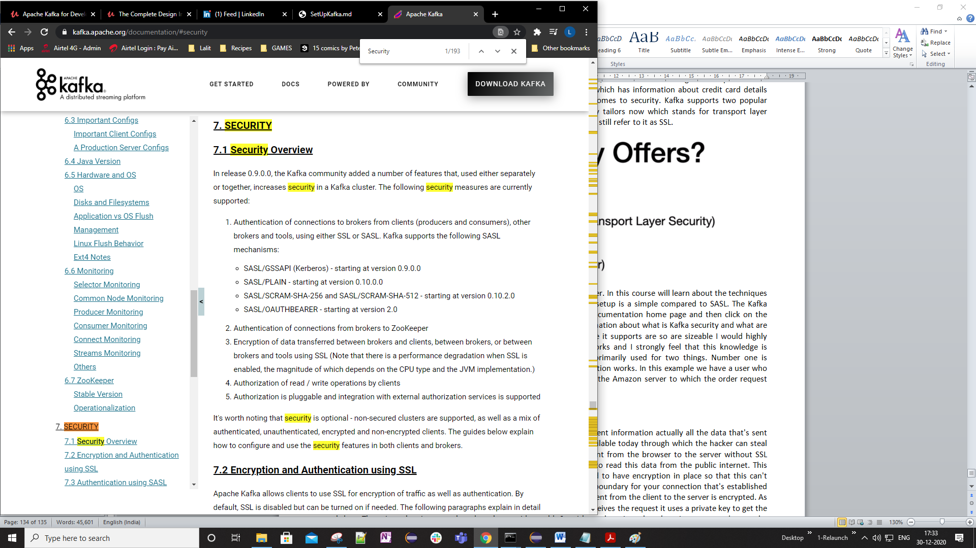

As you can see it supports SSL and SASL. I would highly recommend you all to go through this. We will focus mainly on how it works and I strongly feel that this knowledge is mandatory if you're going to setup the SSL in your local cluster. SSL is primarily used for two things. Number one is encryption and number two is authentication. Let's start with how SSL encryption works. In this example we have a user who uses Google Chrome to place an order in amazon.com. In the right we have the Amazon server to which the order request will be sent to, once the order is placed, the request will be sent to the server.

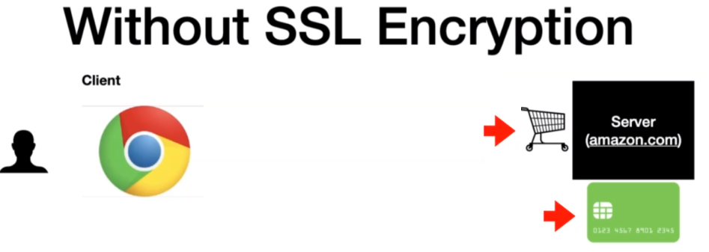

An order in general will have information about the line items and the payment information actually. All the data that's sent to the server is in the public Internet and there are a lot of modern tools available today using which the hacker can steal this data. Let's replay this again actually, we have the credit card details sent from the browser to the server without SSL encryption. The data is sent as plain text basically. So it's easy for a hacker to read this data from the public internet. This technique is popularly called as man in the middle attack. We need to have encryption in place so that this can't happen.

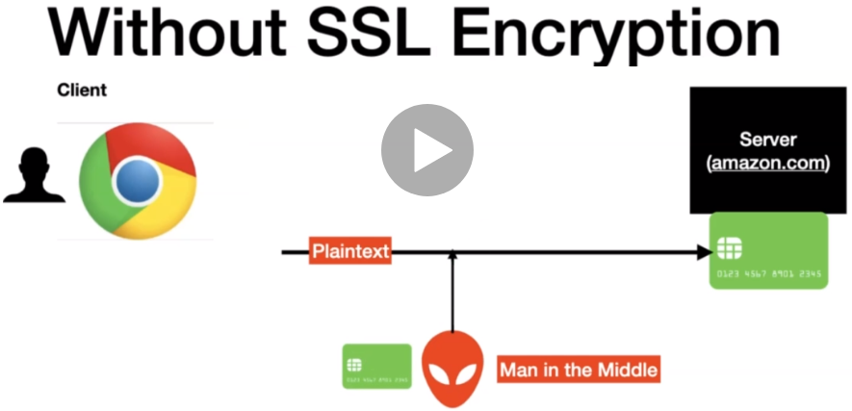

Let's look at the same flaw that SSL encryption in place. You have a boundary for your connection that's established between the client and the server which is the SSL layer and the data that's sent from the client to the server is encrypted. As you can see the data looks garbage for the naked eye but when the server receives the request, it uses a private key to get the actual data. The private key is never shared to the outside world. So without the private key there is no way to decrypt the data.

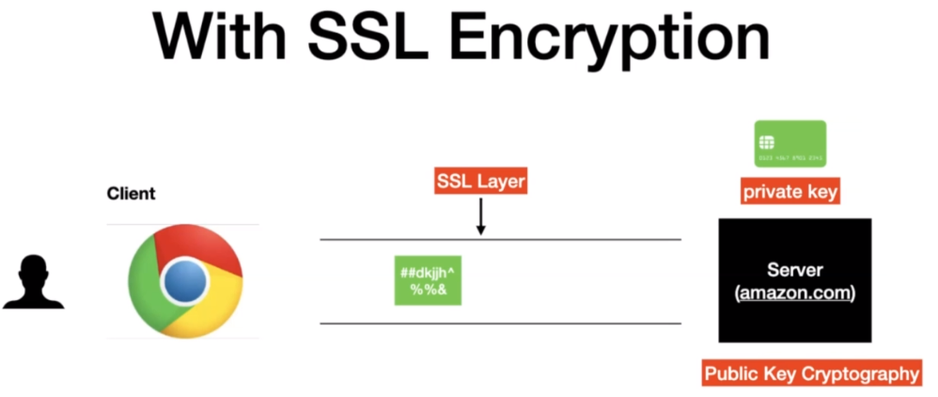

The technique that's used to decrypt the data is called a public key cryptography. If you'd like to understand more about public key cryptography then wikipedia has pretty good information about it. Let's replay the same flaw that man in the middle attacker. So now we have the man in the middle attacker and attacker is trying to retrieve the data. What the attacker will see is just some garbage straight up and there is no way for the attacker to decrypt the data without the private key. In a nutshell this is how SSL encryption works.

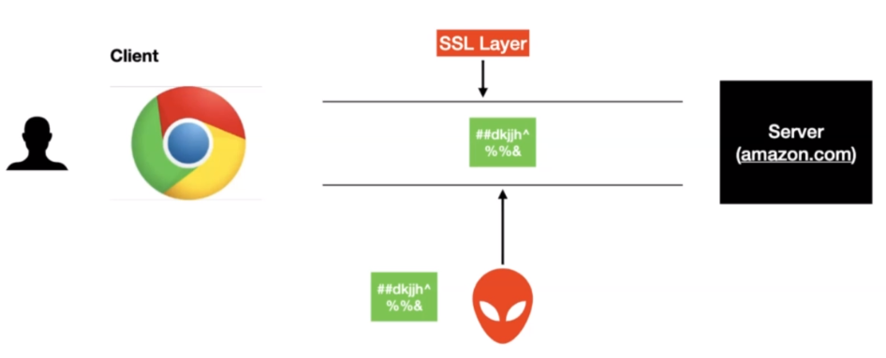

Now it's time to talk about Authentication. Authentication is to make sure that you're talking to the correct server.

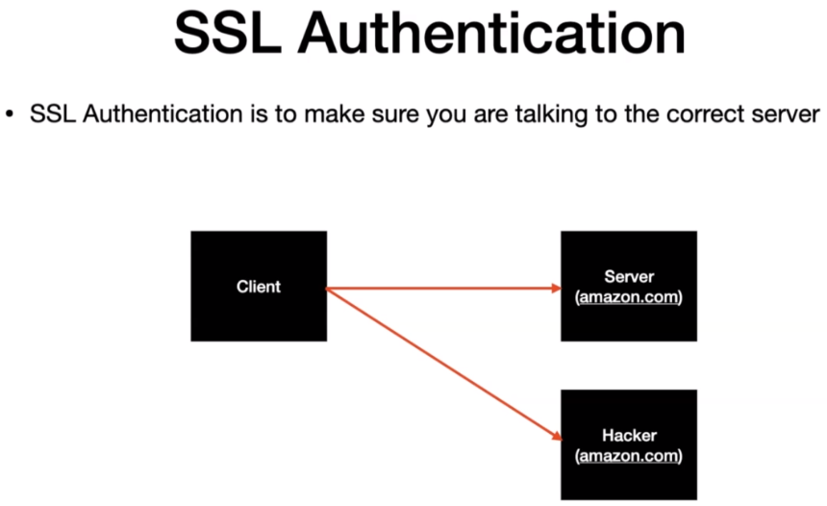

Basically the idea is to make sure that no one else intercepted the request and trying to impersonate the actual servers. What are the tools that we have today to make sure that you're talking to the correct server and your connection is secure. I would like to go to the Google Chrome browser and in here I'm in the home page of amazon.com. I'm not sure how many of you have noticed this padlock, if you click on this one you see this message right. Connection is secure. This means this connection whatever that's established between this browser to the actual server is secure.

|  |  |  |
| --- | --- | --- |
|  |  |  |

So who was giving you this message actually. This message is given to you by the browser, all the modern browsers today have this capability to check whether they are talking to the right server or not. But how does a browser handles that for click on the certificate. You will have this whole SSL certificate. This is a certificate that is installed in the actual Amazon server as you can see the first message that you see here is it is issued by the desert global root G2. Basically this is a certificate authority. If you click on the retail section you will have information about what the certificate has. It does information about the actual company itself so it does information about the website which is www.amazon.com and then the organization country Washington state and Seattle. This is the subject name and after that you have the issue or name. So who issued the certificate. This certificate is issued by a certificate authority which is DG Cert Inc. Think of certificate authority as a government who issues actually the passports. Basically they take it of validating the address and the portal and all those things to make sure that they are legit or not.

Now lets talk about how this padlock symbol gets enabled actually let's close this and go back to the slide. So now we're going to learn about how SSL authentication works behind the scenes declined. Which is the browser here makes a call to the server. The very first thing that happens behind the scenes is the server handing over the SSL to the client.

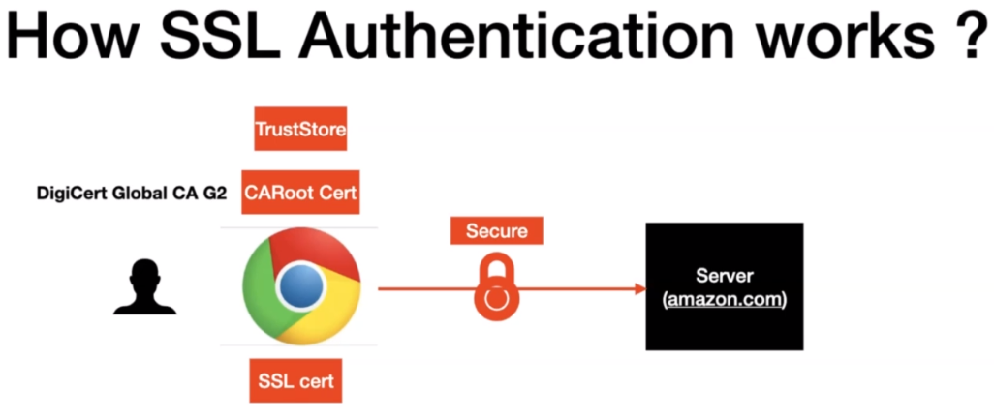

The cert here just has information about the organization and the issuer. I would like to quickly call this out the cert does not have the private key in it. What does the browser here use to validate the sort by using the Trust for any client that you install in your machine comes with a bunch of trust stores. Your trust store will have the root cert of the Certificate Authority. In our example for Amazon.com it is DigiCert Global CA G2, so the browser validates whether the cert has one of the trusted cert in it. Then it means the server is valid and a secure connection is established. A quick analogy would be when you travel to different countries, the immigration of the country that you are entering into trusts the country that issued the passport to you. This is how the point in this case the browser validates that you are talking to the right server. This marks the end of the SSL authentication part. This lecture might be exhaustive for someone who had never worked with SSL. Please go through those couple of times so that you get a pretty good idea of board SSL encryption and authentication.

Lets see the technical details of how does any enterprise get the SSL certificate from the certificate authority and install it. Lets understand different parties involved in setting up the SSL. Let's say you have a website abc.com and you want to enable bill as a sell for your website. The very first thing that we have to do is to generate a keystore file. The keystore file will have information about your website address and other relevant data about your enterprise. We will have hands on exercise on this one. Once the case your file is ready then the enterprise will create a CSR which stands for a certificate signing request and send it to the Certificate Authority. The certificate authority validates the data provided by the enterprise by checking the address, domain and more. Once the validation is completed and then the Certificate Authority would issue a signed SSL certificate to the enterprise. Now the server which is the abc.com will install the certificate into the software. Now we have the server part completed and abc.com have SSL enabled right now.

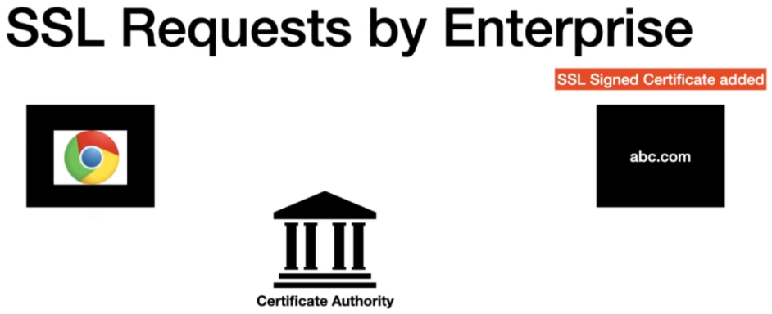

Clients in general are bowsers like Chrome, Firefox and so on. When a new browser is installed in a machine it comes with the trust store with the root CA Cert, when the connection is initiated from the browser to abc.com.

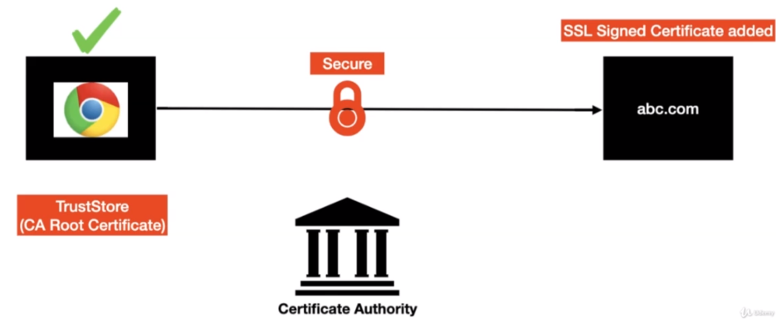

Then the cert is presented to the browser and it's validated by the browser using the trust store which is a part of the root CA cert. Once the handshake is successful then the secure connection will be established. In a nutshell this is how enterprises enable SSL for their domain.

Lets set up the SSL for our local Kafka cluster.

Let's look at what do we have in our local environment. We have the Kafka cluster and the clients interacting with the Kafka cluster. Clients interacting with the Kafka cluster are not browsers. It's our producer and consumer applications which is different from what we saw in the previous lectures. The end goal is to install the SSL signed certificate in the Kafka cluster in order to get the SSL signed certificate we need the local certificate authority from the client. And if you can recall from the previous lecture we need the trust store file to trust the software actually in order to set up those are so Kafka cluster.

All we need to do is we need to complete these seven steps.

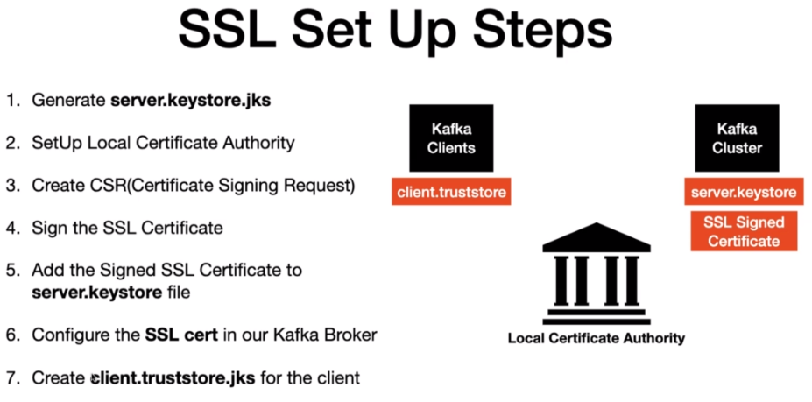

These steps are self explanatory. Let's go ahead and execute these steps one by one. I'm in the terminal here and I have a directory created called SSL. As you can see the directory name is a ssl. Now if you can recall from the steps the very first steps we are going to generate the server keystore file. Lets first generate the keystore, the keys your commands are basically available in my github repo.

<https://github.com/dilipsundarraj1/kafka-for-developers-using-spring-boot/blob/master/Kafka_Security.md>

And in here you will find a section called Kafka SSL setup that's open that and I have all the list of steps that needs to be followed in order to install the SSL certificate. All these steps are pretty much available in the Apache Kafka security. I'll show you that. So if you search for Kafka security in this page if you click on the security section it will take you to another page. And if you go a little bit down here the section 7.2 covers about encryption and authentication using SSL. As you can see all these steps are clearly defined. What I did was I just created a Read Me which has a consolidated list of all the commands that needs to be run in order to set up this SSL in our local machine. So the very first thing is we are going to set up the keystroke file. Right.

<https://kafka.apache.org/documentation/#security_ssl>

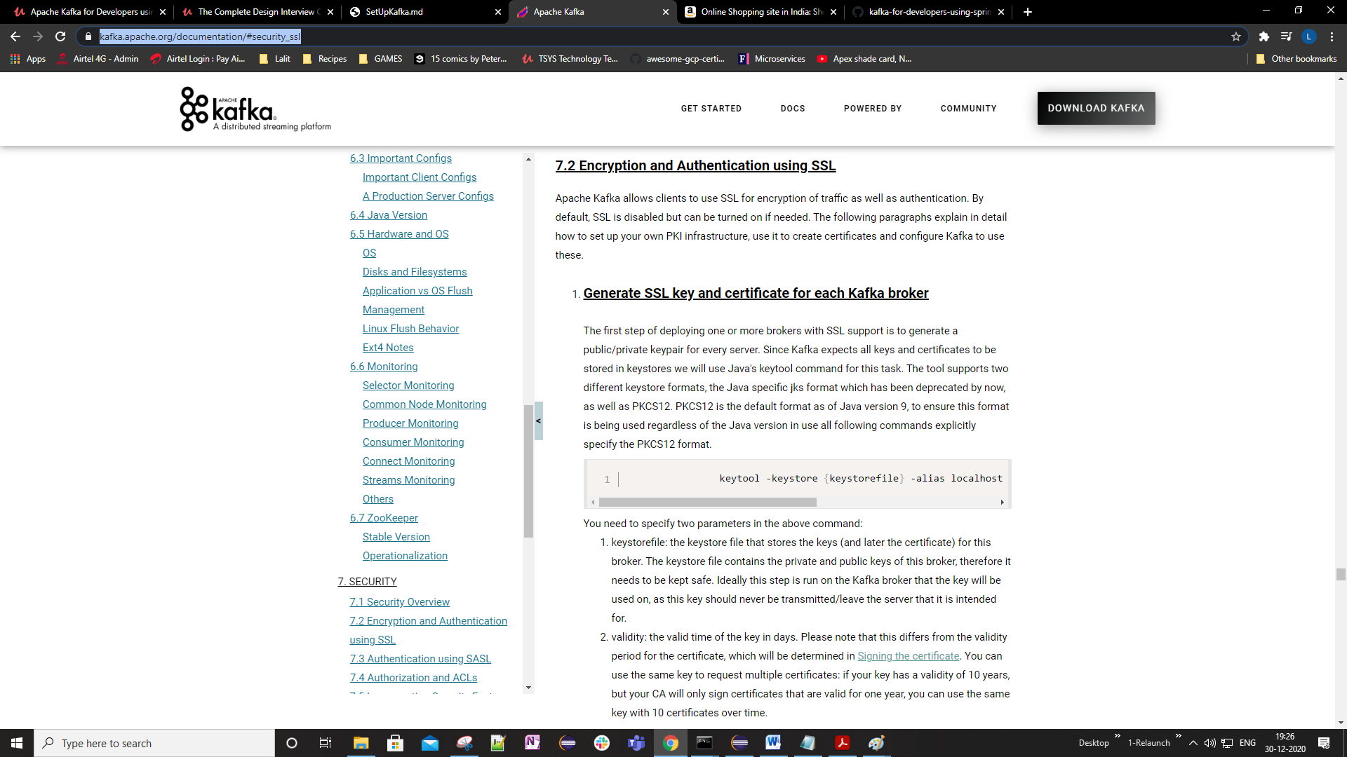

**Enabling SSL in Kafka**

* Follow the below steps for enabling SSL in your local environment

**Generating the KeyStore**

* The below command is to generate the **keyStore**.
* KeyStore in general has information about the server and the organization

keytool -keystore server.keystore.jks -alias localhost -validity 365 -genkey -keyalg RSA

**Example**

* After entering all the details the final value will look like below.

CN=localhost, OU=localhost, O=localhost, L=Chennai, ST=TN, C=IN

**Generating CA**

* The below command will generate the ca cert(SSL cert) and private key. This is normally needed if we are self signing the request.

openssl req -new -x509 -keyout ca-key -out ca-cert -days 365 -subj "/CN=local-security-CA"

**Certificate Signing Request(CSR)**

* The below command will create a **cert-file** as a result of executing the command.

keytool -keystore server.keystore.jks -alias localhost -certreq -file cert-file

**Signing the certificate**

* The below command takes care of signing the CSR and then it spits out a file **cert-signed**

openssl x509 -req -CA ca-cert -CAkey ca-key -in cert-file -out cert-signed -days 365 -CAcreateserial -passin pass:password

* To view the content inside the file **cert-signed**, run the below command.

keytool -printcert -v -file cert-signed

**Adding the Signed Cert in to the KeyStore file**

keytool -keystore server.keystore.jks -alias CARoot -import -file ca-cert

keytool -keystore server.keystore.jks -alias localhost -import -file cert-signed

**Generate the TrustStore**

* The below command takes care of generating the truststore for us and adds the **CA-Cert** in to it.
* This is to make sure the client is going to trust all the certs issued by CA.

keytool -keystore client.truststore.jks -alias CARoot -import -file ca-cert

**Broker SSL Settings**

ssl.keystore.location=<location>/server.keystore.jks

ssl.keystore.password=password

ssl.key.password=password

ssl.endpoint.identification.algorithm=

**Accessing SSL Enabled Topics using Console Producers/Consumers**

* Create a topic

./kafka-topics.sh --create --topic test-topic -zookeeper localhost:2181 --replication-factor 1 --partitions 3

* Create a file named **client-ssl.properties** and have the below properties configured in there.

security.protocol=SSL

ssl.truststore.location=<location>/client.truststore.jks

ssl.truststore.password=password

ssl.truststore.type=JKS

**Producing Messages to Secured Topic**

* Command to Produce Messages to the secured topic

./kafka-console-producer.sh --broker-list localhost:9095,localhost:9096,localhost:9097 --topic test-topic --producer.config client-ssl.properties

**Consuming Messages from a Secured Topic**

* Command to Produce Messages to the secured topic

./kafka-console-consumer.sh --bootstrap-server localhost:9095,localhost:9096,localhost:9097 --topic test-topic --consumer.config client-ssl.properties

**Producing Messages to Non-Secured Topic**

./kafka-console-producer.sh --broker-list localhost:9092,localhost:9093,localhost:9094 --topic test-topic

**Consuming Messages from a Non-Secured Topic**

./kafka-console-consumer.sh --bootstrap-server localhost:9092,localhost:9093,localhost:9094 --topic test-topic

**2 Way Authentication**

* This config is to enable the client authentication at the cluster end.

keytool -keystore server.truststore.jks -alias CARoot -import -file ca-cert

* Add the **ssl.client.auth** property in the **server.properties**.

ssl.truststore.location=<location>/server.truststore.jks

ssl.truststore.password=password

ssl.client.auth=required

* Kafka Client should have the following the config in the **client-ssl.properties** file

ssl.keystore.type=JKS

ssl.keystore.location=<location>/client.keystore.jks

ssl.keystore.password=password

ssl.key.password=password

All the above steps are here <https://github.com/dilipsundarraj1/TeachApacheKafka/blob/master/Kafka_Commands.md>

Let's copy this command and then go to the terminal. As you can see we are creating a file called server.keystore.file and then I'm going to give the alias as localhost and the validity of this keystroke file is 365. And then I'm using the RSA as a key algorithm. If you press Enter it's going to ask you for keys to your password. I'm going to give a password. Make sure you remember this password because we will need. We'll be needing this when we try to interact with the actual secured cluster from the client and and what is your first name and last name. This is equal to the actual domain name. If I think about amazon.com, so you will give amazon.com in place of first name and last name. So I'm going to give a localhost because we are going to install this certificate in our local machine. And what is the name of your organization unit. I'm still going to give a localhost. What is name of your city and locality. Basically this is the city variant organization is located.

$ keytool -keystore server.keystore.jks -alias localhost -validity 365 -genkey -keyalg RSA

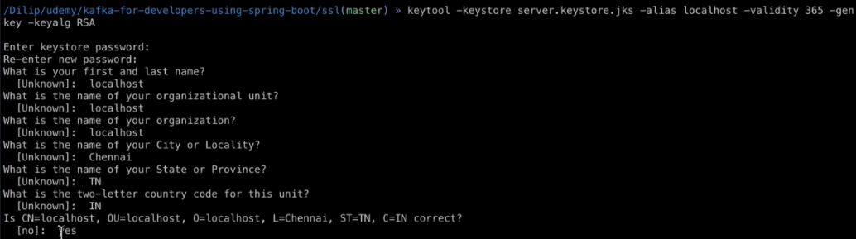

That's good. So I'm going to get the value as Yes. That means, it's going to generate a server.keystore.file. The file that got generated is server.keystore.jks. What else. Now it's time to go ahead and take a look at the content inside this server.keystore file. There is a handy command called keytool -list -v stands for verbose and then you have to provide the key store. It's going to be - and then you're going to provide the server keystore file. You need to enter the password that you provided while we generated this keystroke file. So it's going to be password.

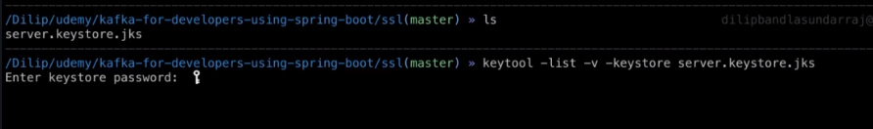

As you can see it has basically one entry and the certificate or note on the issuer or both are the same. Right. So this is what we did and it is actually displaying the content whatever we did in the previous step. So let's go to the presentation and then check which step we are on. So now we have the server keys to a file generated.

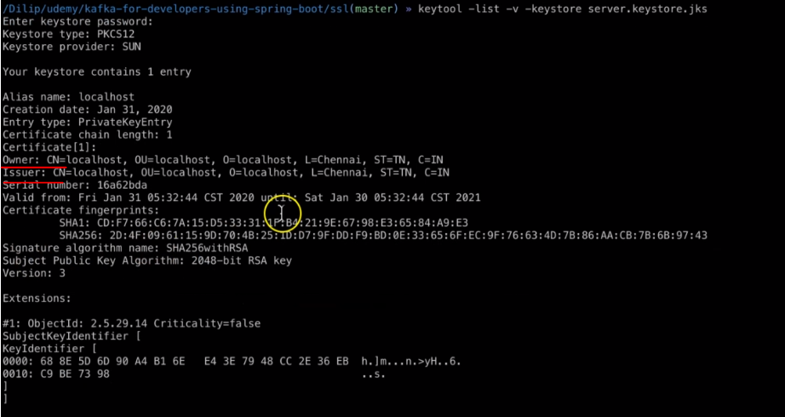

What is the next step, the next step is we need to set up the local Certificate Authority. Let's go ahead and do that. I have the generating command in the steps.

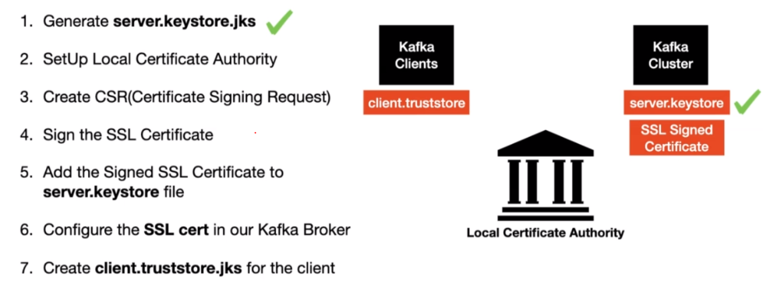

The below command will generate the ca cert(SSL cert) and private key. This is normally needed if we are self signing the request.

openssl req -new -x509 -keyout ca-key -out ca-cert -days 365 -subj "/CN=local-security-CA"

Basically the reason why we are doing this is because we are generating the SSL certificate by ourselves because we are just running this up in our local right. If you're are doing this step for your enterprise you don't have to do the step at all. Because there are some approved certificate authorities outside the verge. We will request the SSL sign certificate. So we are going to generate. If you look at this command we are using the openssl also. And then what we are doing is we are requesting for a new key and a cert and a number of days the cert is going to be active is 365. And then we are providing a CA name. This is your local security CA. This is a name which you are providing for your certificate authority and then press enter as you can see it is generating up private key.

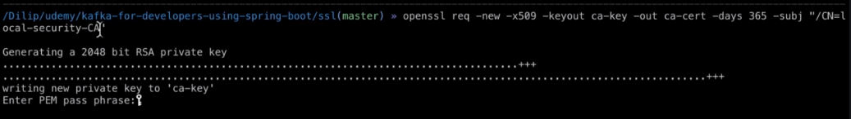

So normally private key is something which will be trivial keep it to ourselves. We will never share it to the outside world. So even here we have to provide the pen passphrase. So what I'm going to do I'm going to provide the password. There you go. So if we do ls you will see two additional files here.

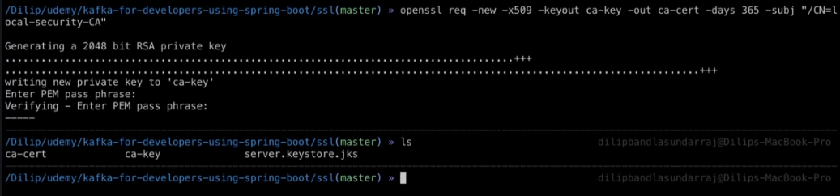

Number one is the ca-cert and number two is the ca-key which is a private key. You will never share this to the outside world. So now we have the ca-cert ready. What is the next step. Let's go back to the slide and then check. What step are we on in here.

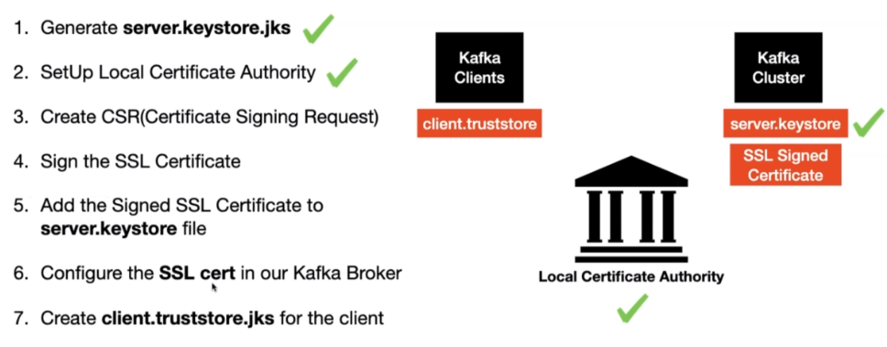

We have the certificate authority done as I mentioned before the next step is creating the certificate signed a request to go back to the terminal and then we are going to copy the command from the github repo. There you go. And then we are going to use the keytool command as you can see.

The below command will create a **cert-file** as a result of executing the command.

keytool -keystore server.keystore.jks -alias localhost -certreq -file cert-file

And then I'm providing the keystore file that we generated in the previous step. And then we are creating a cert request -file and then it's going to create a file called cert-file. So it's going to take in the civil case to file and then it's going to create a file called cert-file. Let's put it here and then you have to provide the password. Also here. There you go. So now we have the cert-file creator. As you can see we have a new file called cert-file. This is the certificate signing request file.

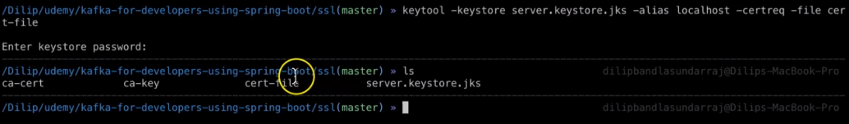

Let's go back to the slide and then check which what is the next step. There you go. That is done. The next step is sign the SSL certificate.

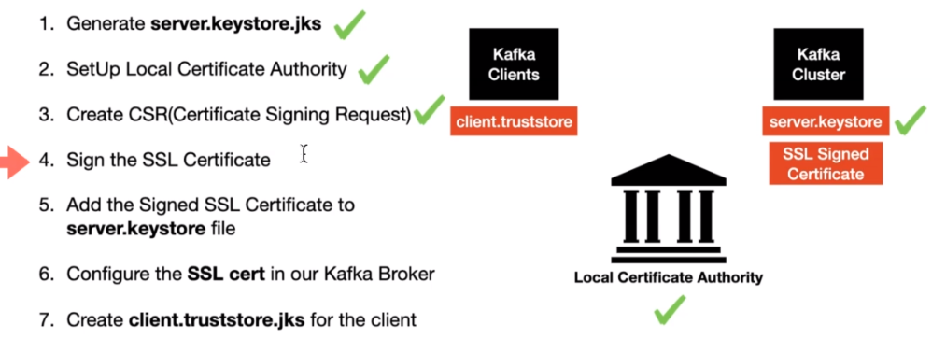

There is a handy command as you can see Open SSL. We are using open SSL to sign the certificate and the input file is a cert-file and the generated output file is the cert-signed.

The below command takes care of signing the CSR and then it spits out a file **cert-signed**

openssl x509 -req -CA ca-cert -CAkey ca-key -in cert-file -out cert-signed -days 365 -CAcreateserial -passin pass:password

To view the content inside the file **cert-signed**, run the below command.

keytool -printcert -v -file cert-signed

As you can see I'm going to pass in the password as password because this is a password which I have provided and I generated the file. So this should be the value whatever you give as part of the password field or center. There you go. Now if we do a list there will be one more file which is the sort assigned file as you can see. We have that file created.

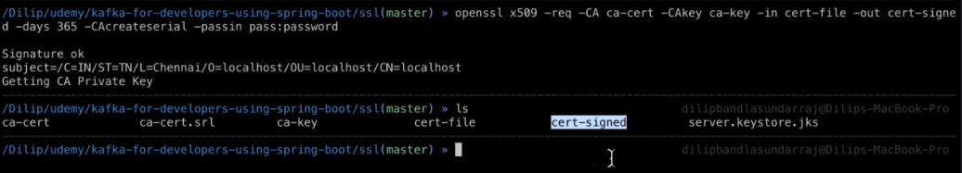

What is the next step. The next step is I the signed SSL certificate into the server keys to your file.

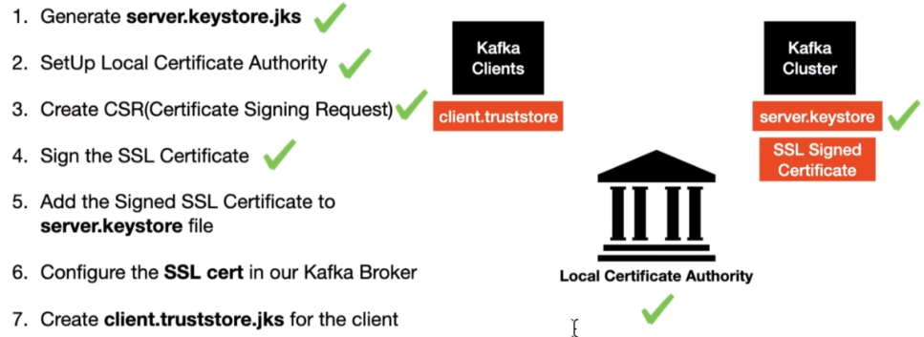

Now what we will do it will go ahead and copy those comments from the github, adding the signed certificate into the keystone file.

keytool -keystore server.keystore.jks -alias CARoot -import -file ca-cert

keytool -keystore server.keystore.jks -alias localhost -import -file cert-signed

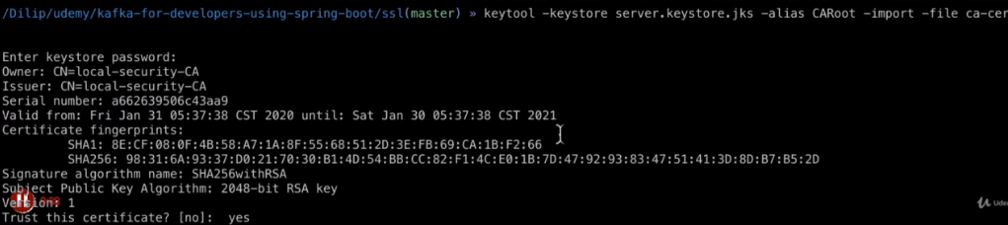

You have to provide the password. So if we do a clear, so if we do a list we didn't create any new file, it's the same file but we have added those. There is a file which we just added.

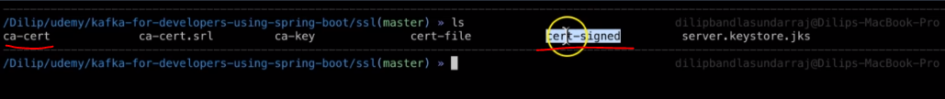

The next thing is we are going to add a cert-sign file into the server key-store file. What it will do was we will go ahead and look at the content inside the server keys to a file.

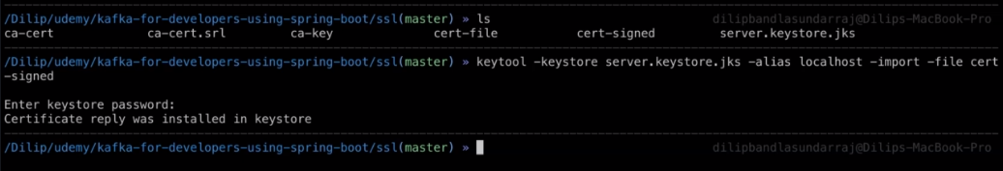



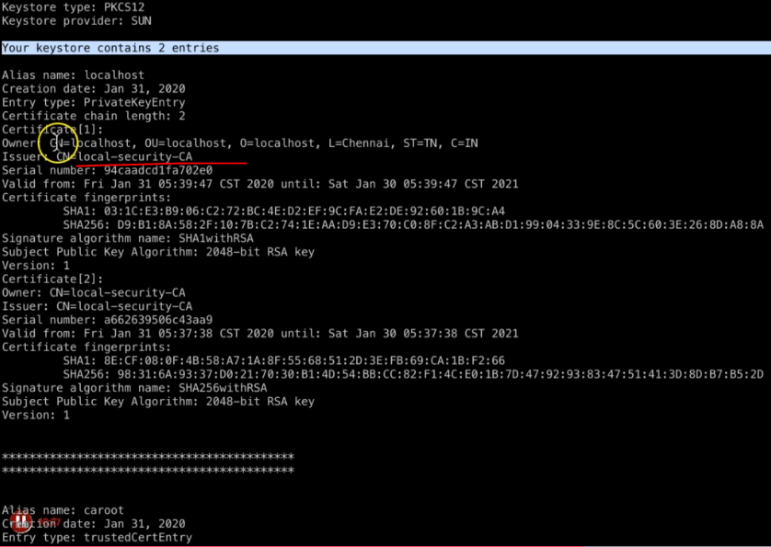

You will have two entries, your keystore contains two entries. As you can see the issuer right now is a local security agency if you remember from the first step that we did it was localhost. Now it got over and done with the local security. See this means the SSL certificate- the SSL signed certificate, is basically added to the keystore file. The very next thing that we are going to do is we are going to add the SSL cert into our Kafka cluster.

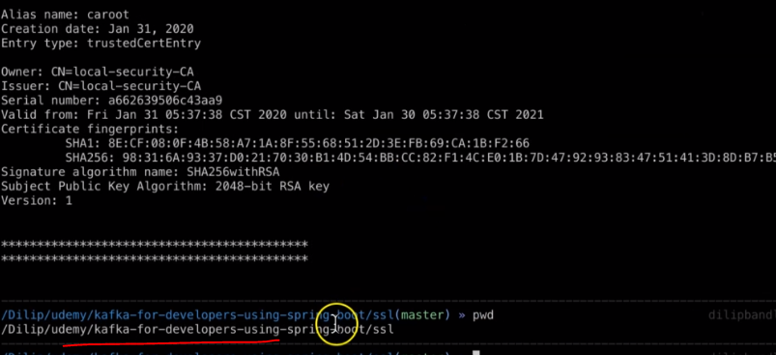

So in the terminal make sure you are copying the path because we are going to need the path while providing the latest file to our Kafka cluster. So in the github you can see we have this broker SSL Settings.

So we are going to copy those and then put it inside the server properties file which is inside the config directory of the Kafka distribution that we downloaded. As you can see I'm in the config directory of the Kafka distribution. As you can see we have the server-1.properties server-2.properties file and the server.properties.

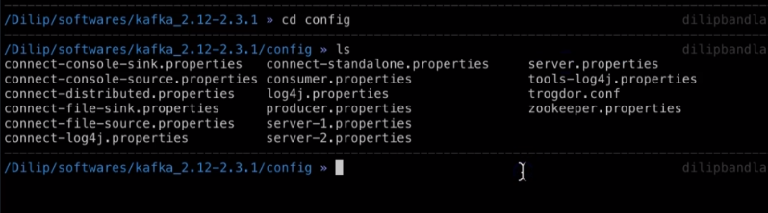

Let's fast make the change in the server properties.

**Broker SSL Settings**

ssl.keystore.location=<location>/server.keystore.jks

ssl.keystore.password=password

ssl.key.password=password

ssl.endpoint.identification.algorithm=

After that the changes are pretty much the same. So let's do the item sever.properties there you go. I need to add the content, as you can see just copy this one and then brought here and the location is basically the location where you have the actual jks file. So if you do a ls. So this is where I have my several keys to logic is file copy this one and then put it here.

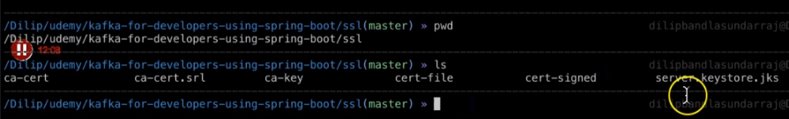

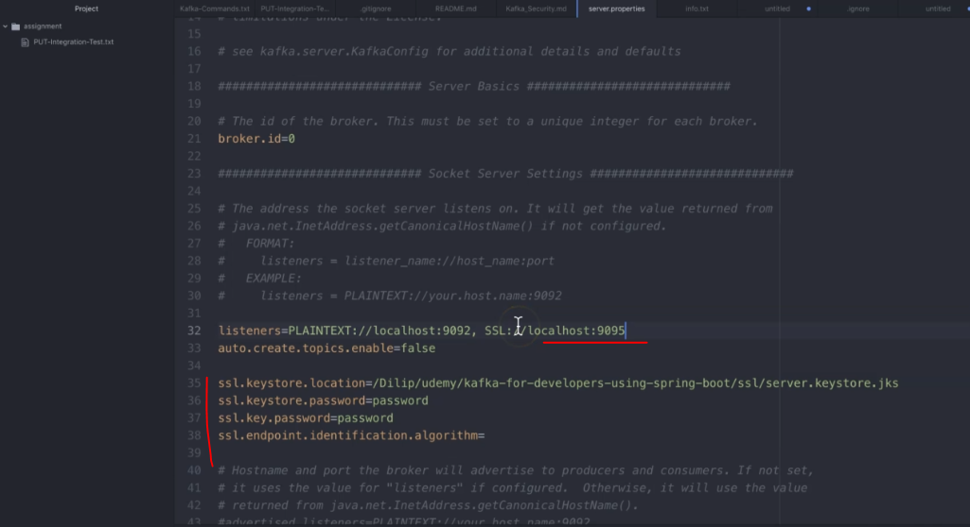

There you go. And after that as you can see the listener's or just plain text right now. Right. This needs to be changed. We need to provide the SSL but the new port, please make sure you're providing a port that doesn't exist or that is not used. So it's going to be 1995. So basically 1990 to 1993 and 1994 already occupied in 1994 is the one we put that that is not used by any of the process in my local machine. So let's go ahead and do the same change for the other three clusters. Now we will open server-1.properties and it's the same change. Basically what it will do was revoke just copy this and make sure you provide the port that doesn't exist. Right. That's going to be 1996 and we have to provide the same configuration because we are just running it not a local machine we can share the same custom file across all the brokers.

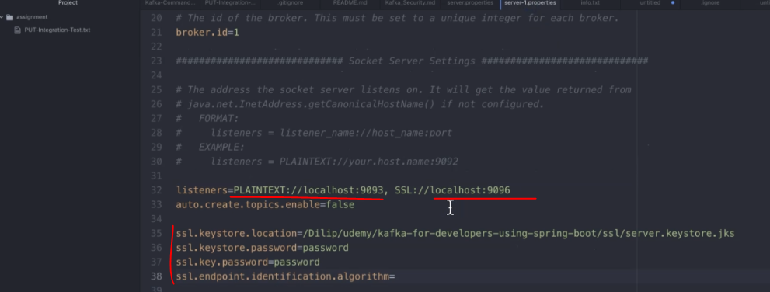

And one thing which I would like to quickly call out. Here I am providing the ssl.endpoint.identification.algorithm as empty value because by default it is enabled with a https yes. So since I'm running it and local we don't have to need we don't need that actually. So thats why I'm providing this value as empty string. Let's do the same change for the server-2.properties. 9097, that support we're going to provide.

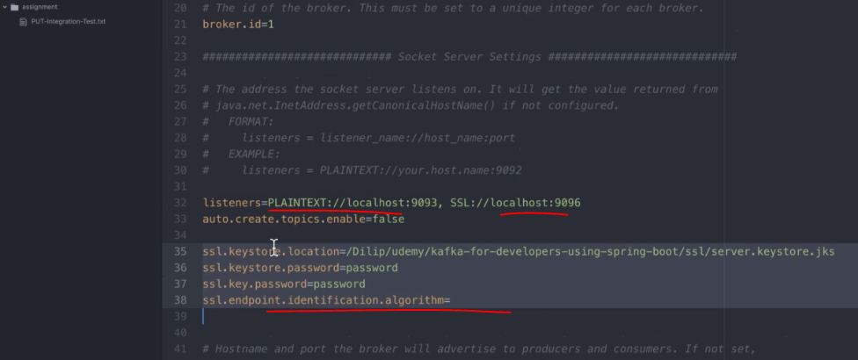

Now we have all the broker configurations ready. Let's go ahead and restart the cluster not local machine. So I'm going to go to the terminal to here I am in the terminal and then let's launch the broker's one by one I'm starting up those server.properties followed by that I'm going to start the server-1.properties followed by that I'm going to start the server-2.properties. Now we have the cluster successfully up and running. It looks like we have some issues going on with them. So what would our properties. Let's go out and check that all in here we still have the port as 9096. This needs to be changed to 9097. There you go and let's go ahead and restart this.

Now we have the Kafka cluster up and running. Now we have both the secured cluster and the plaintext which is the unsecured cluster running in our machine but unsecured cluster is running in a totally different port which is 1994. But the secure cluster is running in the port 9097. Basically we have three different ports. So in 9097, 9096m 9095 those are all far the second cluster. 9092, 9093, 9094, those are for the unsecured cluster. So what is the next step that we need to do in our SSL setup steps. We have the step number six completed the next step us greed the blind trust or logic.

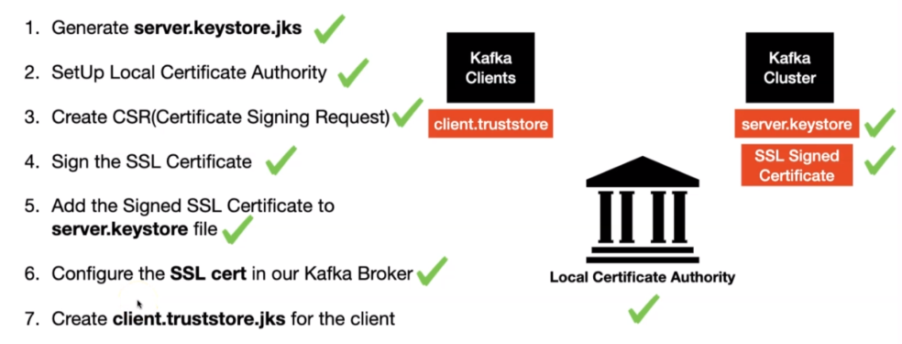

Yes this is needed for the client validation, when the connection is made from the client to the Kafka cluster, it's going to present the SSL certificate right. So during that time but they do trust the certificate or not. Right. So we need to explicitly create this file. In browsers it automatically comes with that when you install the browser part. That's not the case with our clients. Now we will go ahead and generate the client trust-store file.

The below command takes care of generating the truststore for us and adds the **CA-Cert** in to it.

This is to make sure the client is going to trust all the certs issued by CA.

$ keytool -keystore client.truststore.jks -alias CARoot -import -file ca-cert

So the key tool command and then we are creating a keystore. And then after that we are providing the client.truststore.jks file that's a file we want to create and then we are going to import the ca-cert. Let's go out and run this one. There you go. We need to provide the password here too.

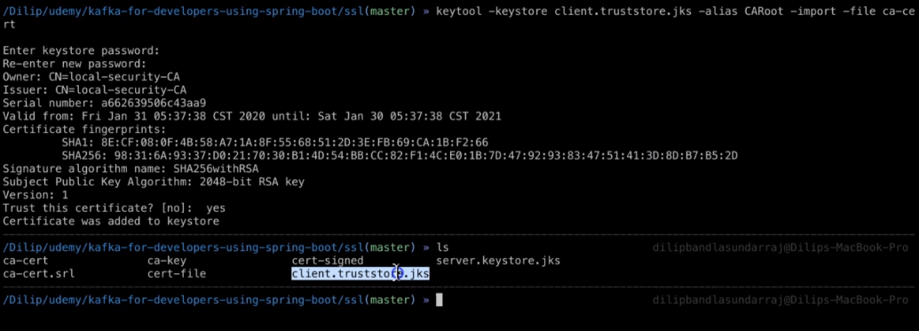

You can see the client.truststore.jks file generated. Now we have completed the seventh step also. So we have completed all the steps and we have successfully installed the SSL certificate the work off a cluster in the next lecture we will learn about how to interact with the Kafka cluster from clients. We are going to use the command line interface first to talk to the secured a cluster in the next section we will learn about how to interact with the secured a cluster from our code.

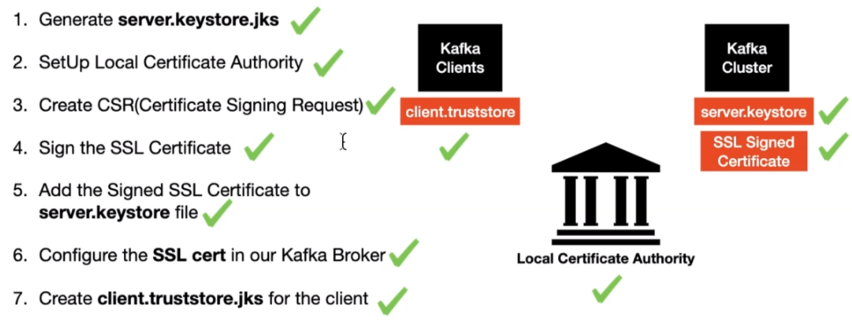

Accessing Secured Kafka Cluster using CLI - Producer/Consumer Messages

This is our current state of our local environment.

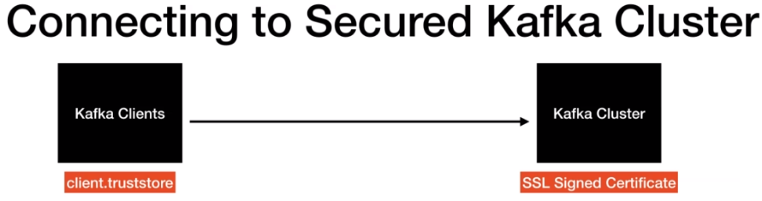

We have the Kafka cluster which is SSL secured and we have the client trust store file ready but we have not used yet. So the next step is we are going to use a client trust store file and then interact with the secured Kafka cluster. Now let's go back to the terminal. So I'm in the bin directory of the Kafka distribution as you can see. In order to check the connectivity from our plane to the secured kafka cluster. I'm going to specifically create a topic. I have the Kafka comments in the GitHub repo.

From here: <https://github.com/dilipsundarraj1/kafka-for-developers-using-spring-boot/blob/master/Kafka_Security.md>

**Accessing SSL Enabled Topics using Console Producers/Consumers**

Create a topic

./kafka-topics.sh --create --topic test-topic -zookeeper localhost:2181 --replication-factor 1 --partitions 3

The very first thing this created topic so we are going to focus on this section which is accessing a enabled topic using the console producer and consumer. The very first thing that I'm going to do is I'm going to create this topic using this kafka-topic command. These are the commands which we saw in the initial part of the course. I'm just going to reuse the same command. And if you look at the topic name this test-topic. There you go. And then this is going to create the test-topic in my local. I have the Kafka cluster up and running as you can see. You should have the Kafka cluster up and running in your machine in order to follow this lecture. There you go. We have created the topic.

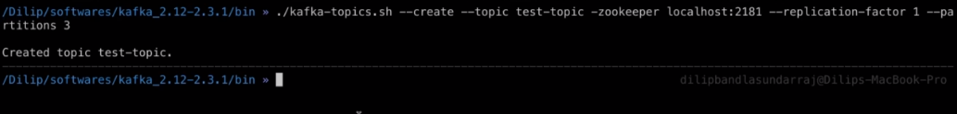

What is the next step. Let's go to the get the people in here. We are going to create a file called client-ssl.properties and have the below properties configured. So this is the next step. So what we are going to do is we are going to create this file first.

Create a file named **client-ssl.properties** and have the below properties configured in there.

security.protocol=SSL

ssl.truststore.location=<location>/client.truststore.jks

ssl.truststore.password=password

ssl.truststore.type=JKS

It is a brand new file. It has no content in it. What we are going to do is we're going to go to the GitHub repo and then we are going to add all the trust store related information as you can see we are adding the trusted location and then we are adding the truststore password and then we are going to add the truststore type as JKS. So this is what browser when you install from the Internet will have actually, all these come into that automatically. But since we are not using any browser we have to explicitly provide this configuration copy this and then put it here. So the next thing is we need to provide the truststore location as you can remember we created the trust store location in the SSL folder. I have the server.properties file open here. I'm just going to copy the part actually so if we take a look at it the path under SSL far both the server.keystore file and the client-trust store file. Go ahead and give that value.

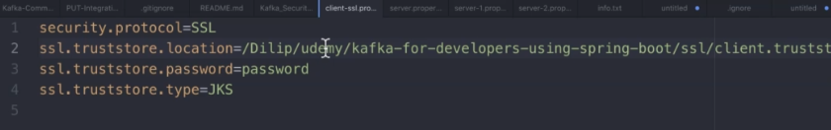

What is the next thing. Let's follow the steps.

**Producing Messages to Secured Topic**

Command to Produce Messages to the secured topic

./kafka-console-producer.sh --broker-list localhost:9095,localhost:9096,localhost:9097 --topic test-topic --producer.config client-ssl.properties

We are going to produce a message to the secure topic so we are going to connect to the port which is 9095 9096 and 9097. These ports are SSL secured ports, right. And after that we are providing the topic as test-topic and there is a new property that we are providing as part of that console producer config which is --producer.config. And then we are going to provide the file which is client-ssl.properties file. Let's copy this command.

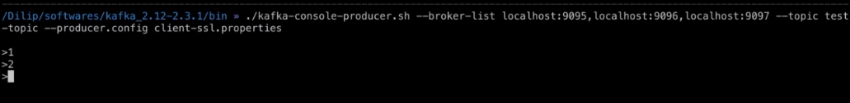

Now this Kafka console producer is connected as you can see I got the arrow mark here. What I'm going to do is I'm going to try to publish some messages. So the call returned after I publish these messages. That means it is able to talk to the Kafka cluster successfully. In order to validate this what I'm going to do is I'm going to instantiate a Kafka console consumer by passing the client-ssl.properties.

**Consuming Messages from a Secured Topic**

Command to Produce Messages to the secured topic

./kafka-console-consumer.sh --bootstrap-server localhost:9095,localhost:9096,localhost:9097 --topic test-topic --consumer.config client-ssl.properties

As you can see it uses the same port which is in 9095 9096 and 9097 and then we are providing the topic as test-topic and for this one we are providing the consumer-config and the file that we are passing as client-ssl. properties. Copy this and then put it here.

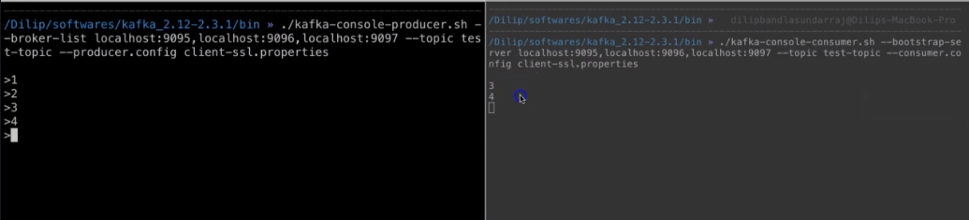

So we have this console consumer which is waiting for new messages. What I'm going to do I'm going to publish some messages three and four as they publish the messages. It is basically consuming these messages. This means both of these consumer and producer is able to talk to the actual secured Kafka cluster using the properties that's provided using the client –ssl.properties. What we will do is we will try to break it. So I'm going to stop this and then what I'm going to do is I'm going to stop the console on this too. So in here let's not provide this and then see what is the response that we get. Right. Enter and we did get the response as if like it was able to connect to the Kafka cluster.

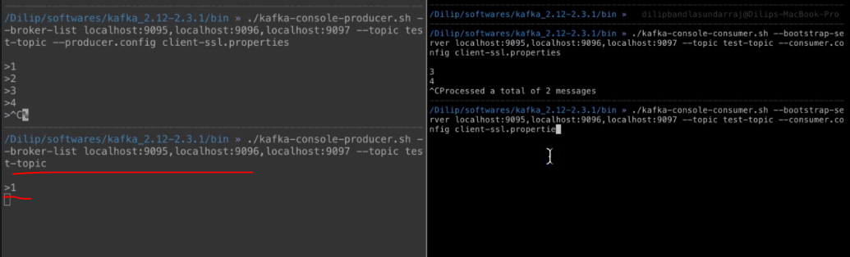

If it was one, as you can see it did not return at all it is still waiting actually. Right. So this means it has some issues going on when it's tried to post the new message into the Kafka cluster which is one. Let's try to do the same thing with the consumer. Let's remove this and then press enter.

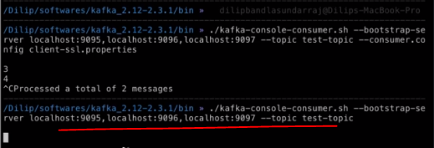

We got the wrong message. Basically it has a timeout of 60000 milliseconds. That means it is one minute. So it took us some time to receive this error message. As you can see it is not able to make the connection at all. Basically without those properties the connectivity cannot be established at all. As you can see we see the error messages and the consumer end do.

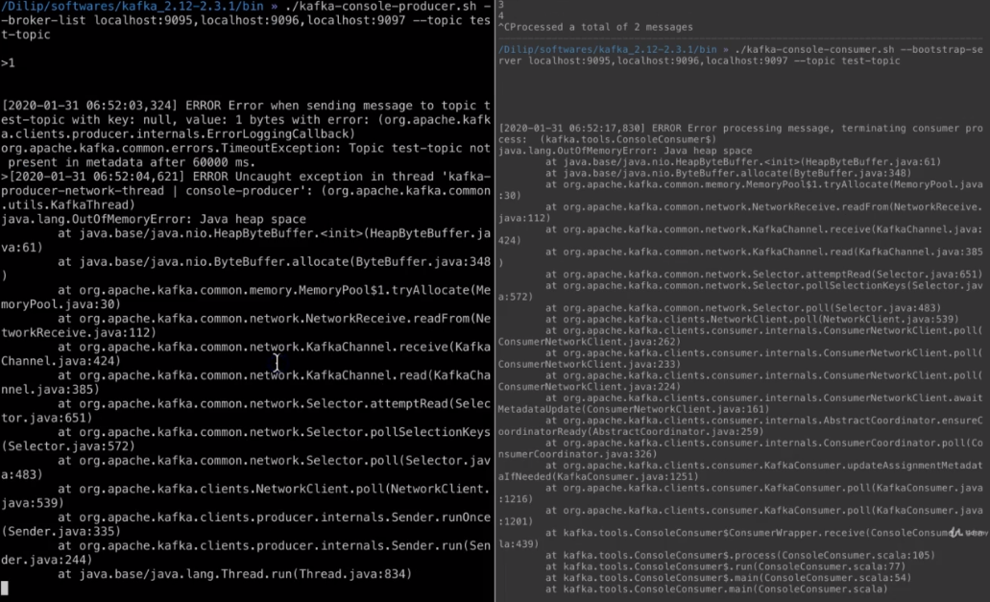

So it is having some issues because the secured Kafka cluster information is not provided as part of the console consumer. I'm gonna shut it down to let's bring it back to its old state okay.

Now we have an approach and we also know how to connect to the secured Kafka cluster from console consumer and console producer. Now what is the next step the next step us if we go to the GitHub repo. You will still be able to produce messages to the port 9092 to 9093 and 9094 without the ssl properties. Basically you have two different types of Kafka clusters. One which is SSL secured one which is not SSL secured. Right. Let's go out and does this one do. I'm going to copy this and go to the console command. Let's close both of these console producer and console consumer. Now what I'm going to do is I'm going to produce a message to the port 9092 to 9093 and 9094 which is not secured with us. As you can see I'm not providing any SSL related properties as part of this command. There you go. Let's go ahead and do the same thing for this one to. There you go. Now what I'm going to do I'm going to post messages One two three as I post the messages the messages are received by the console consumer. So this is what I was saying earlier. You have two different sets of clusters one is secured and one is unsecured. We have learnt about how to produce and consume messages to a secure cluster using the console producer and consumer.

**2 way Authentication using SSL**

Lets learn about the two way authentication and it's a cell and setup the two way authentication and are Kafka cluster. Until now the SSL authentication mechanism that we explored with Kafka is one way authentication meaning when the client initiates the connection the server presents the SSL cert and then the client validates the search using the trust or file. So this is just one way authentication. Basically the client only validates the software credentials the server here is not performing any validation about the client credential.

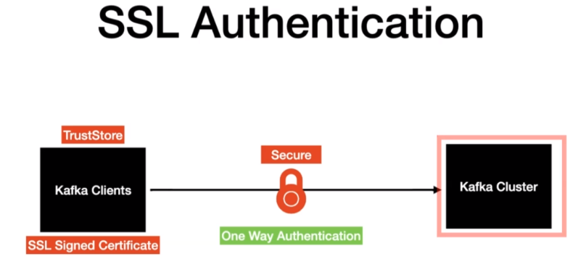

For a server to validate the client connection we will need to have a trust store file in the server end and the keystore file in the client end. So that when the client initiates the connection the client will send the ssl cert and the server will validate the ssl cert using the trust store that's present in the Kafka cluster using the trust store that's present in the kafka cluster. So what's needed to set up the two way ssl authentication.

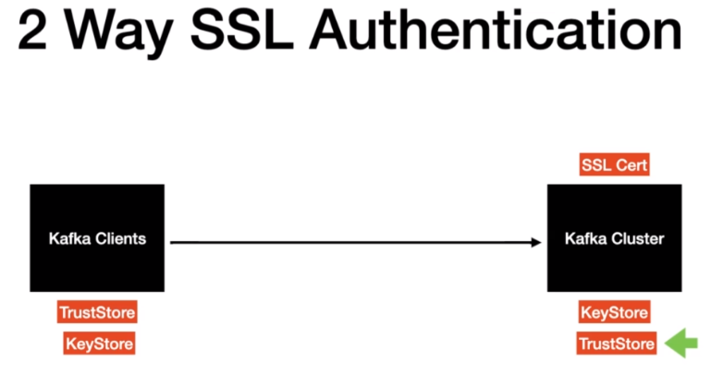

We need to make changes in the cluster and also in the client and let's talk about what changes are needed in the Kafka cluster first. What we need is a server trust store file and then we need the following configuration in the server properties file.

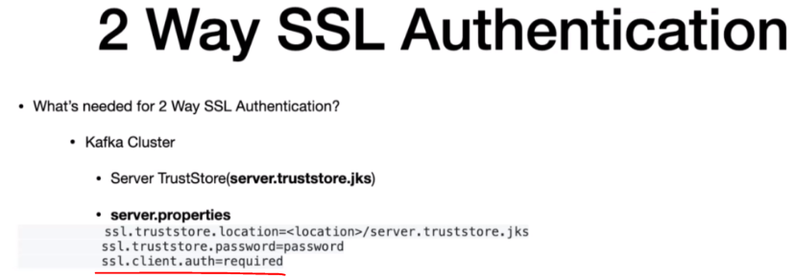

One of the key property to call out is the ssl.client.auth as required. That's all you need in the kafka cluster. Now let's talk about what do we need in the client and in the client what we need to have is the client. Keystore.jks file and then we need to provide the SSL key store values in the client-ssl.properties file that we created in the previous lecture.

**2 Way Authentication**

* This config is to enable the client authentication at the cluster end.

keytool -keystore server.truststore.jks -alias CARoot -import -file ca-cert

* Add the **ssl.client.auth** property in the **server.properties**.

ssl.truststore.location=<location>/server.truststore.jks

ssl.truststore.password=password

ssl.client.auth=required

* Kafka Client should have the following the config in the **client-ssl.properties** file

ssl.keystore.type=JKS

ssl.keystore.location=<location>/client.keystore.jks

ssl.keystore.password=password

ssl.key.password=password

Now let's go ahead and set up this in our local machine. Go to the github repo. There is a section called 2 way authentication and it has all the information that we need in order to set up the two way authentication. The very first thing is we are going to generate the trust store file. So in here we are going to generate the server trust store file. We are going use the command

This config is to enable the client authentication at the cluster end.

$ keytool -keystore server.truststore.jks -alias CARoot -import -file ca-cert

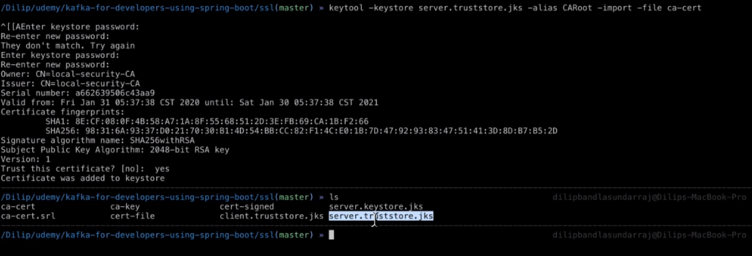

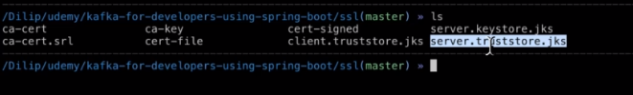

Provide the password. So type in yes. And then we have a server trust or file created.

What is the next step. The next step is we are going to add some configuration in the so called our properties file. Let's go to the server.properties file. So what does a configuration that's needed. Please go back to the GitHub repo. And then this is a configuration that needs to be added.

Add the **ssl.client.auth** property in the **server.properties**.

ssl.truststore.location=<location>/server.truststore.jks

ssl.truststore.password=password

ssl.client.auth=required

Here we are going to provide the SSL location. Let's put this here in the same configuration needs to be copied for all the other several properties fine.

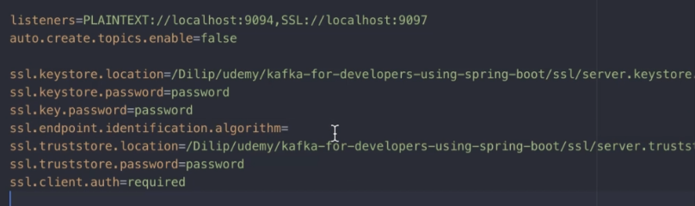

I have added the configuration and all the three server properties file. Now let's go ahead and restart the Kafka Cluster. So I have successfully restarted the Kafka cluster. Now it has claimed two way authentication enabled. Which means it is going to expect the client to send the SSL certificate from there. So what is the next step the next step is we are going to add these configurations in the client-ssl.properties file so very first thing that we need is a client.keystore.jks file. So what we are going to do. Let's go to the SSL directory. Since we are having both the client and the server running in the same machine we don't have to generate a brand new customer file. What I'm going to do is I'm going to copy the server keystore jks file and then I'm going to rename this one to client keystore jks file because we have both the client and server running in our local host.



We have our client keystore jks file. The next thing is we are going to add this into our client–ssl.properties file. So let's go ahead and copy this config.

Kafka Client should have the following the config in the client-ssl.properties file

ssl.keystore.type=JKS

ssl.keystore.location=<location>/client.keystore.jks

ssl.keystore.password=password

ssl.key.password=password

And let's point out the client-ssl.properties. There you go. And the location is going to be the same.

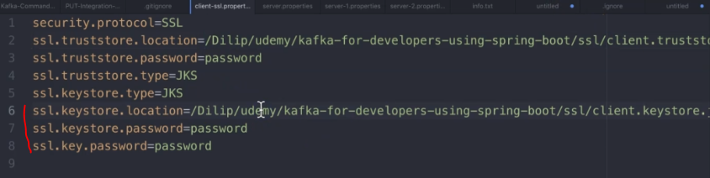

Now we have the setup between the server and the client ready. Basically the two way authentication is enabled from the client end and the server and the next step is to test this actually. Let's go to the GitHub repo. Let's go ahead and copy this command

Command to Produce Messages to the secured topic

./kafka-console-producer.sh --broker-list localhost:9095,localhost:9096,localhost:9097 --topic test-topic --producer.config client-ssl.properties

So in the producer config we are passing the line defined as a client-ssl.properties, let's put it here and then as you can see we got the arrow mark and then we will be able to produce this message.

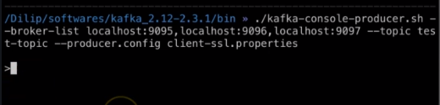

So what is the next thing that we're going to do. We're going to basically instantiate the console consumer to let's copy this one. Basically I'm just copying this command from the consumer message consuming messages from a secure topic let's throw in that one too.

**Consuming Messages from a Secured Topic**

Command to Produce Messages to the secured topic

./kafka-console-consumer.sh --bootstrap-server localhost:9095,localhost:9096,localhost:9097 --topic test-topic --consumer.config client-ssl.properties

Now as we produce messages we are going to see the messages in the Kafka console consumer window. Let's go out and produce the messages one two three as we produce the messages. You're seeing this message here.

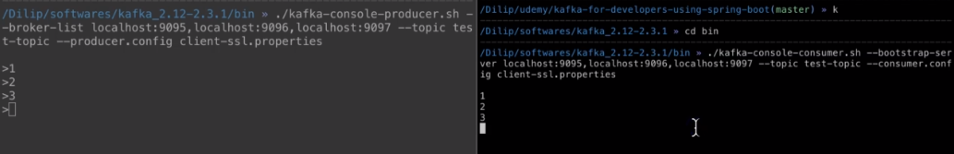

That means we have the two way authentication enabled. And the producer and consumer applications are able to talk to the cluster which is secured and have those two way authentication enabled.

We saw how to enable twp way authentication and how to configure the client to interact with the two way SSL authenticated Kafka cluster.

**Configuring Library Events Producer to access SSL secured Cluster**

We will see how to access the SSL Secure cluster using Spring Boot. Before we get into the coding part let me quickly show you what do we have in our local cluster at this point. We have two different types of cluster in our local, the type is a plaintext which is the non secured cluster and it's running again support 9092 9093 and 9094 and the second type is the secure cluster which is running again support 9095 9096 and 9097.

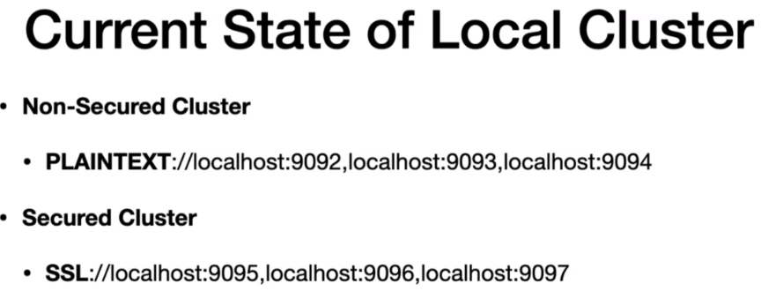

We have learned about accessing the non secured cluster from our Springboot application. Now it's time to access the secure cluster from our Springboot application. We are in the library even producer application. We're going to start changing the application.yaml file first and then we will go ahead and launch this application in our local machine. Let's open the application.yml file. In the application.yml file as you can see we have three different profiles right. Number one is local. Number two is Dev. I'm going to change this one to non-prod and number three is prod. So until now we have been using the local profile. What I'm going to do is I'm going to switch our default profile to non-prod. Think of this as you are going to connect to the staging environment, which is almost similar to your prod environment. Normally staging environments are always secured so that you can test your actual application in the non prod environment before we move to the prod environment.

spring:

profiles:

active: non-prod

server:

port: 9000

---

spring:

profiles: local

kafka:

template:

default-topic: library-events

producer:

bootstrap-servers: localhost:9092,localhost:9093,localhost:9094

key-serializer: org.apache.kafka.common.serialization.IntegerSerializer

value-serializer: org.apache.kafka.common.serialization.StringSerializer

properties:

acks: all

retries: 10

retry.backoff.ms: 1000

admin:

properties:

bootstrap.servers: localhost:9092,localhost:9093,localhost:9094

---

spring:

profiles: nonprod

kafka:

template:

default-topic: library-events

producer:

bootstrap-servers: localhost:9095,localhost:9096,localhost:9097

key-serializer: org.apache.kafka.common.serialization.IntegerSerializer

value-serializer: org.apache.kafka.common.serialization.StringSerializer

ssl:

trust-store-location: file:/Dilip/udemy/kafka-for-developers-using-spring-boot/ssl/client.truststore.jks

trust-store-password: password

key-store-location: file:/Dilip/udemy/kafka-for-developers-using-spring-boot/ssl/client.keystore.jks

key-store-password: password

properties:

acks: all

retries: 10

retry.backoff.ms: 1000

security:

protocol: SSL

ssl.endpoint.identification.algorithm:

---

spring:

profiles: prod

kafka:

producer:

bootstrap-servers: prod:9092

key-serializer: org.apache.kafka.common.serialization.IntegerSerializer

value-serializer: org.apache.kafka.common.serialization.StringSerializer

Now it's time to add the SSL configurations into our configuration. So the first thing that we're going to do is we are going to type in SSL. There you go. And after that we are going to provide the trust store location, trust store password and all those information. Where can we find the trust or location. We can take this value from the client-ssl.properties. We can take this value and put it over here. And what is the next thing the next thing is we need to provide the trust store password. So the actual password is password. What is the next thing. The next thing is we need to provide the key store location because our local cluster at this point is having two way authentication enabled. So let's give this value from here there you go.

Normally if you provide the location values without the file:/ it might take it in a different location. So it is recommended to give file:/ before the actual path so that it goes and picks this file directly from the actual location. So the next thing is it's going to be key store password.

Now we have the SSL configuration set. There are few other properties we need to provide. Before we move on and start this application those properties are we need to provide the security protocol. So it's going to be security:protocol it needs to be. We need to provide that value as SSL. And after that there is one more additional property we need to provide. That's ssl.endpoint.identification.algorithm:. And then we will give the value as empty string because by default this value us has HTTPS. So we don't want a HTTPS for our local cluster communication. The very next thing that we are going to do is we are going to check whether we have that to profile us non-prod. We have the profile set up a non-prod. So in here what are the new properties that we added.

Number one is we added this ssl section and after that we added this security protocol here and then we have added the SSL endpoint identification algorithm to empty value. Now let's go ahead and start this application library event producer application and then start this application. So let's stop and rerun as you can see the profiles that are active is non-prod. So by default we have the non-prod profile enabled. That's what we did in the application.yml file and that configuration is picked up by our application. You have to make sure that you have the kafka cluster up and running as you can see in my machine. I have the Kafka cluster up and running in my machine. The very next thing that we are going to do is we are going to post a message and then see whether it reached the Kafka cluster successfully or not because we are going to test the SSL configuration that we have provided here right. So we have to test that and then we will test whether the message logger is printed successfully in the console or not. So open the curl commands. So what we're going to do is we are going to post this actually. So I have the terminal open copy this and paste it here.

POST WITH-NULL-LIBRARY-EVENT-ID

---------------------

curl -i \

-d '{"libraryEventId":null,"book":{"bookId":456,"bookName":"Kafka Using Spring Boot","bookAuthor":"Dilip"}}' \

-H "Content-Type: application/json" \

-X POST http://localhost:8080/v1/libraryevent

We got this actual response. Let's go ahead and check the logger because we have asynchronous posting enabled right. So let's go ahead and check it out in the run tab in the run tab as you can see we see this message which is message sent successfully for the key value note and the value is this. This means we were able to successfully post the message into the kafka cluster. That's next.

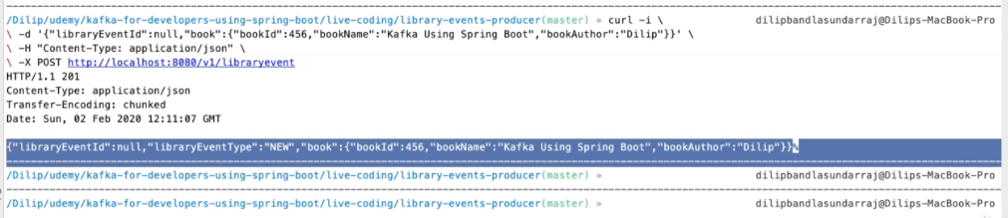

Make sure that it is posting to the second cluster or not. You will be able to see this bootstrap server value which is 9095 9096 and 9097 which is a secured cluster.

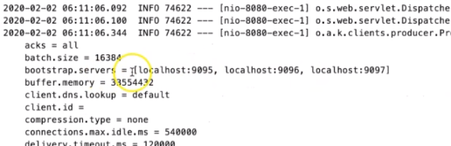

And as you can look here here we have the user file location and all those configurations are also pulled in by R. Springboard application.

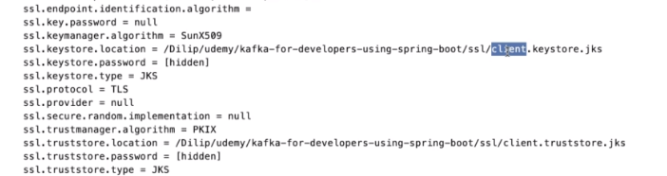

Now what we will do is we will try to break this. What I'm going to do I'm going to provide the password value as password1. Basically when we have a configuration like this it shouldn't even post a message into the secured kafka cluster and it shouldn't even connect to the kafka cluster. Right. Let's restart this application. There you go. The application got restarted. The next step that we are going to do is we are going to try to post this message again. I posted this message. It looks like we are in error. As you can see internal server error failed to construct the Kafka producer.

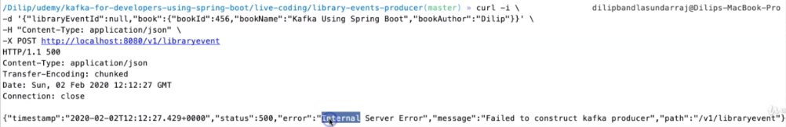

This is good. Let's go and check what is the issue that's going on in the console in the console. We have a bunch of log errors as you can see just complaining about unrecoverable key exception.

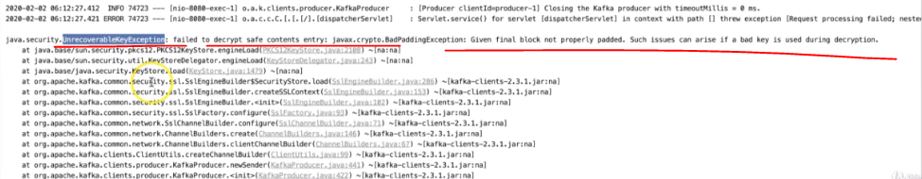

This means it is not able to recover the blind trust or file actually. Let's go out and change it back to its old way and restart the application and we will try to post the same message again and then it will go ahead and verify the locks so open the terminal and then post this. As you can see there are no errors in the actual response and in the run method if you look at it we have the message as the message sent successfully that's a signal we are able to successfully interact with the powerful cluster.

**Configuring Library Events Consumer to access SSL secured Cluster**

We are going to start with the changes in the application.yml file of the Library Events Consumer project. We have the local profile. In addition to that we have the non-prod profile as in the previous lecture. We are going to start making changes in our non-prod profile. So what we are going to do is, we will copy whatever we have here and this one actually in the non-prod.

spring:

profiles:

active: nonprod

server:

port: 8081

---

spring:

profiles: local

kafka:

template:

default-topic: library-events

consumer:

bootstrap-servers: localhost:9092,localhost:9093,localhost:9094

key-deserializer: org.apache.kafka.common.serialization.IntegerDeserializer

value-deserializer: org.apache.kafka.common.serialization.StringDeserializer

group-id: library-events-listener-group

producer:

bootstrap-servers:

- localhost:9092,localhost:9093,localhost:9094

key-serializer: org.apache.kafka.common.serialization.IntegerSerializer

value-serializer: org.apache.kafka.common.serialization.StringSerializer

datasource:

url: jdbc:h2:mem:testdb

driver-class-name: org.h2.Driver

jpa:

database: h2

database-platform: org.hibernate.dialect.H2Dialect

generate-ddl: true

h2:

console:

enabled: true

---

spring:

profiles: nonprod

kafka:

template:

default-topic: library-events

consumer:

bootstrap-servers: localhost:9095,localhost:9096,localhost:9097

key-deserializer: org.apache.kafka.common.serialization.IntegerDeserializer

value-deserializer: org.apache.kafka.common.serialization.StringDeserializer

group-id: library-events-listener-group

ssl:

trust-store-location: file:/Dilip/udemy/kafka-for-developers-using-spring-boot/ssl/client.truststore.jks

trust-store-password: password

key-store-location: file:/Dilip/udemy/kafka-for-developers-using-spring-boot/ssl/client.keystore.jks

key-store-password: password

producer:

bootstrap-servers:

- localhost:9095,localhost:9096,localhost:9097

key-serializer: org.apache.kafka.common.serialization.IntegerSerializer

value-serializer: org.apache.kafka.common.serialization.StringSerializer

properties:

security:

protocol: SSL

ssl.endpoint.identification.algorithm:

datasource:

url: jdbc:h2:mem:testdb

driver-class-name: org.h2.Driver

jpa:

database: h2

database-platform: org.hibernate.dialect.H2Dialect

generate-ddl: true

h2:

console:

enabled: true

---

spring:

profiles: prod

kafka:

consumer:

bootstrap-servers: localhost:9092,localhost:9093,localhost:9094

key-deserializer: org.apache.kafka.common.serialization.IntegerDeserializer

value-deserializer: org.apache.kafka.common.serialization.StringDeserializer

group-id: library-events-listener-group

So this is one change that we need in order to enable SSL configuration for our consumer application. And what is the next step and the next step is we are going to change as value to nonprod. So because I want to launch this application with the nonprod profile as a default profile, so that it picks up all the ssl related configuration here, what we will do we will try to start this application as you can see the application is getting started and and we see this message which is started the actual consumer. And we have the partitions assigned. Then you see this message. That means a disabled to successfully connect to the secured Kafka cluster. Now what we will do we will try to post a message from our library event producer an application. Let's go back to the library events producer application and then from here we'll post this message as you can see that event just posted. And our consumer at that event. And then it successfully persisted that even in the in-memory database. Now we have both the producer and consumer successfully interacting with the secured cluster using the as a sole configurations as you can see. We have this sort of configurations enabled or not. Applications are amplified.

# Kafka Streams

## Introduction

Data processing started with the idea of capturing and storing data first and then processing it later. When Bigdata processing started to emerge, it followed the same pattern capture the data first, save it, and then, processes it later. Data Lake is the result of the same idea. Data Lake is a place where data goes to sit, and after that, you process it in smaller batches. While many of us are building upon the data lake at the same time, a whole new fleet of technology companies are architecting their systems in a non-traditional method. They take everything happening in the business and make it available as a stream of events. Then they create applications to tap into the stream, consume data packets in real-time and put them to use for taking critical actions and decision making. I am talking about the change in perspective, we are not looking at the data as a table in a database or a file in the data lake.

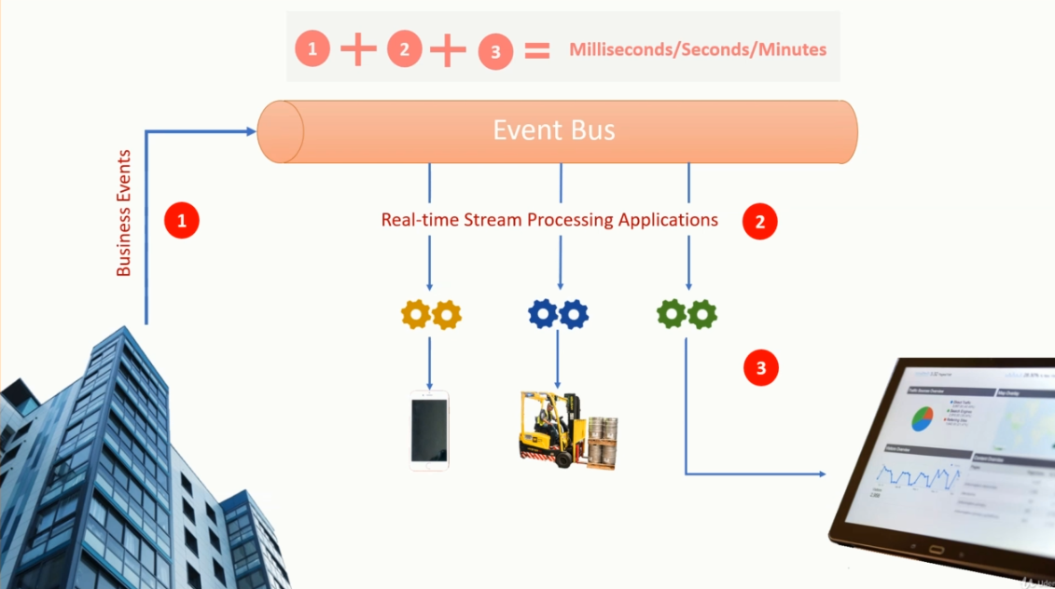

Data lake is stationary, but the stream is data in motion. When you process a dataset that is already sitting in a database, or it is stored in a data lake, we call it as data processing. But when you are processing a data stream or a dataset which is in motion, we call it "stream processing." And when you want to do it in seconds or in milliseconds, the idea is termed as real-time stream processing. You already learned and a kind of mastered data processing techniques. It is straightforward. Read data from the database, process it using SQL or using a procedural language, and then, store the outcome back to a database.

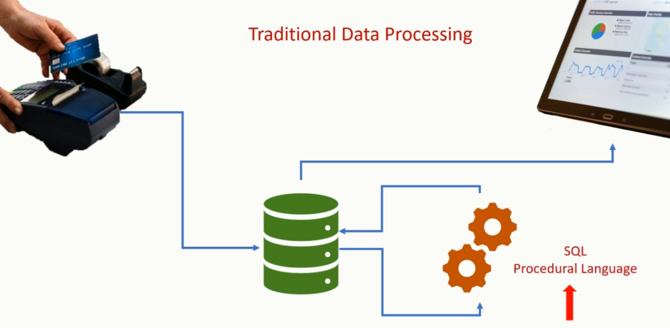

If you are dealing with big data, the idea is still the same. Read it from the data lake, process it using SQL or using a procedural language, and then, store the outcome back to the data lake.

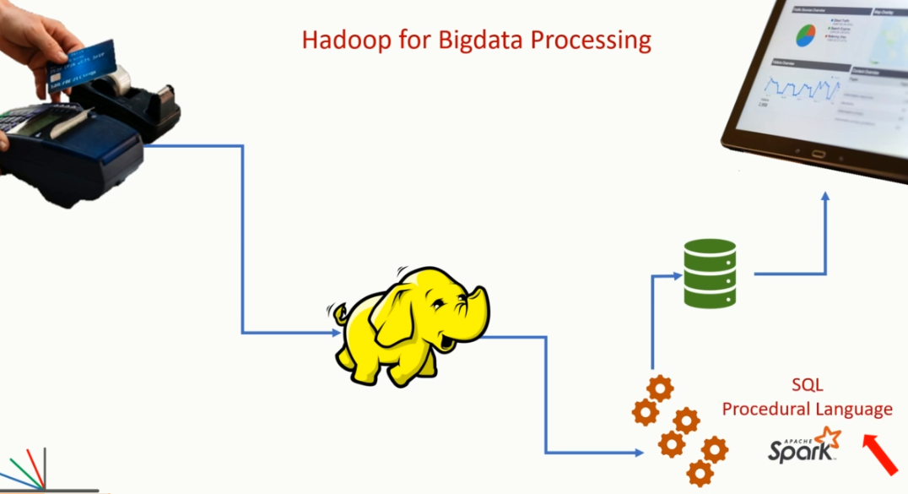

But processing a stream of data is not that straightforward. A stream is a continuous flow of data, it is unbounded. It’s an endless flow that keeps bringing more and more data to your system every second.

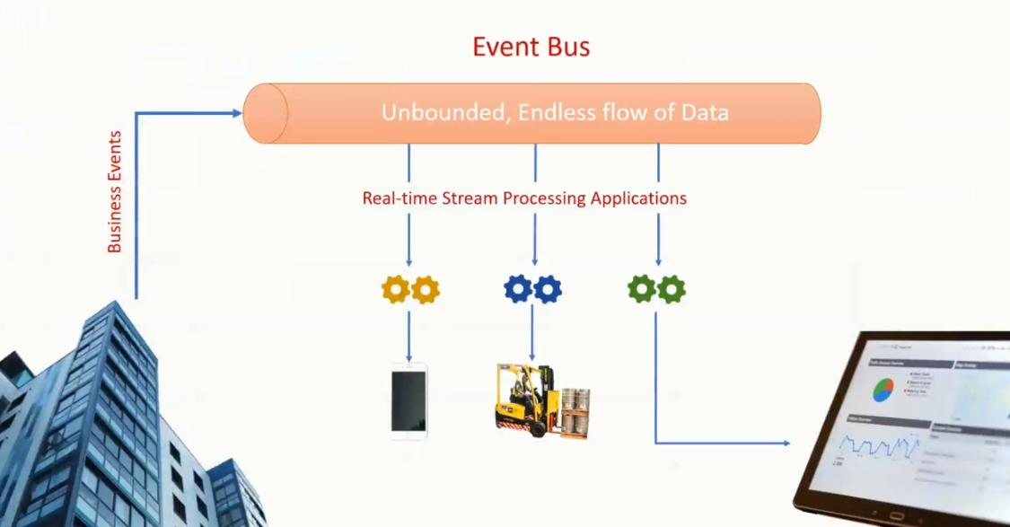

How do you deal with that? How do you process that stream? Your data is not stored in a database table or in a file. The moment you start thinking about real-time stream processing, a whole bunch of new problems starts popping in your mind. And that’s what this course is all about. Solving those problems. Answering those questions. In this course, I am going to teach you two things.

How do you create and manage a stream of data? I mean, to process data from a data lake, you must bring some data into a lake. Similarly, to process a stream of data, you must create a stream. Right? No stream means no stream processing. So, the first half of the course is all about creating streams.

Once you start creating streams, we go ahead and learn how to process it in real-time. This course will help you to understand the real-time stream processing in general and apply that knowledge to create real-time stream processing applications using Apache Kafka and Kafka Streams library. My approach to building this course is example driven and applying the progressive common-sense technique for developing new skills. What does that mean? That means, every concept that I explain in this course is supported by and demonstrated by an appropriate example. That’s what I mean by an example-driven approach. We will be creating simple, straightforward examples and relate them to a real-life scenario.

**Example Driven:**

* Point of Sale Simulator
* Customer Reward Computation
* Retail Store Performance
* Clickstream for News/ Article Performance
* Top 3 Analysis
* OTP Validation for Online Payment
* Last Login Time for WebSites
* Rest Interface for Microservices
* Delayed Store Tick Simulator
* Custom Window Aggregation
* Custom Sink to Hbase
* Data Enrichment

I have structured this course to follow a progressive approach. That means, you learn one technique first, and then progressively add new ideas one by one to grow your knowledge and enhance your skills. I will never introduce you to more than one new concept at a time to avoid confusion. I will first talk about what, then why and finally talk about how. And that’s a common sense approach.

**Step By Step**

* Understanding Real Time Streams
* Strengthen your Kafka Foundation
* Start Creating Streams
* Get Familiar with Kafka Streams DSL
* Strengthen your Foundation for Serdes
* Creating and Working with State Store
* Start working with Update Stream

This course is designed to help you to apply your general ability to perceive, understand and reason the concepts by asking the right questions. This course is designed for software engineers willing to develop a stream processing application using Kafka Streams library. I am also creating this course for data architects and data engineers who are responsible for designing and building the organization’s data-centric infrastructure. Another group of people is the managers and architects who do not directly work with Kafka implementation, but they work with the people who implement Kafka Streams at the ground level.

**Step By Step**

* Compute Real time Aggregation
* Blend it with Windowing Operations
* Join Streams and Tables
* Understanding Architecture and Scalability
* Testing your Applications
* Microservices and Interactive Query
* Taking full control using Processor API

Link: <https://github.com/LearningJournal/Kafka-Streams-Master-Class>

<https://github.com/LearningJournal/Kafka-Streams-Real-time-Stream-Processing>

**Kafka 2.2 and Java 8**

## Emergence of Big Data – Quick Recap

In this first lecture, I will give you a quick introduction of from where we started on big data and where are we going. Right? Let's begin. The search engine has become a necessity in our daily life. However, until the year 1993, the World Wide Web was indexed by hand. Can you believe it? Sir Tim Berners-Lee used to edit that list by hand and host it on the CERN web server. There was no search engine. Later, Yahoo emerged as the first popular method for people to find web pages on the internet. However, that was based on a web-directory rather than a full-text index and a search engine algorithm. In between the years, many developments happened, but around the year 2000, Google rose to the prominence with an innovative idea of PageRank algorithm.

The initial PageRank algorithm was based on two critical ideas. The number of websites that link to a given web page or you can say the number of external links that are pointing to a webpage. The second idea was the keywords found on the webpage. We will not go into the details of the PageRank algorithm. But Google implemented this page rank algorithm at a large scale. One of the critical requirements for implementing the PageRank algorithm was to crawl and collect a massive amount of data from the World Wide Web. This was the time and the need that I would attribute to the birth of Bigdata. That's how it all started.

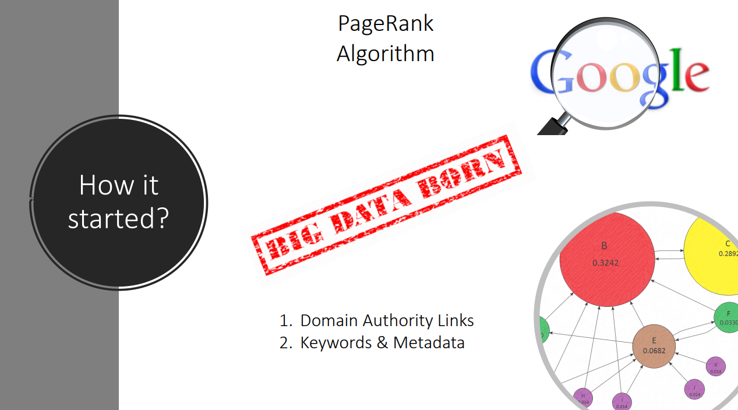

Google was not only the first to realize the Bigdata problem, but also the first to develop a viable solution and establish a commercially successful business around the use of Bigdata processing techniques. At a high level, Google Search Engine had four main problems to solve. Discover and crawl the web pages over the internet and capture content and metadata. This first problem was easy to solve. All they needed was a simple program that can retrieve the content of a webpage and stores it in the storage system. Such programs are now popularly known as a web crawler. But this requirement gave birth to the second problem. Where to Store the massive amount of data collected by the Web Crawler. Storage was not the end of the problem. They also wanted to process that data and apply the PageRank algorithm. And that was the third problem. Finally, they also wanted to organize the result of PageRank in a random-access database that can support high-speed queries by the Google Search Engine application. These problems were not new, and in general, they existed even before the year 2000 when Google was trying to solve them using a new and innovative approach. The industry was already generating, collecting, processing and accessing data.

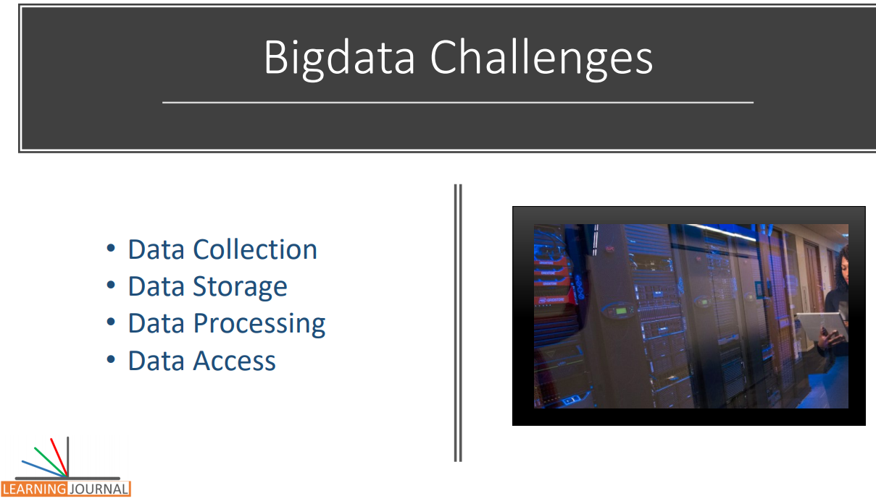

The database management systems like Oracle and MS SQL Server were in the middle of such applications. At the time, some organizations were already managing terabytes of data volume using systems like Teradata. However, the problem that Google was trying to solve had a combination of three unique attributes that made it much more challenging to be addressed using DBMS of the time. Volume, Variety, and Velocity.

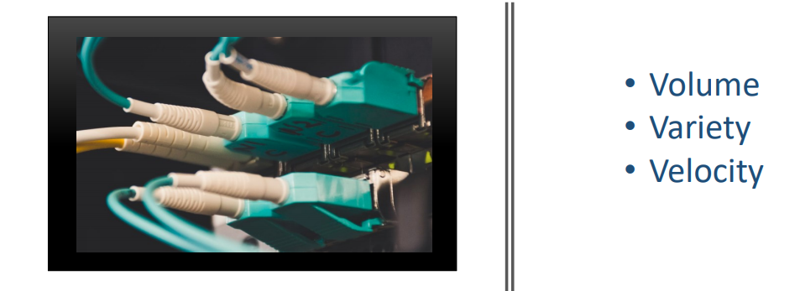

Creating a Web Crawler was not a big deal for Google. It was a simple program that takes a page URL, retrieves the content of the page and stores it in the storage system. But in this process, the main problem was the amount of data that the crawler collects. The Web Crawler was supposed to read all the web pages over the internet and store a copy of those pages in the storage system.

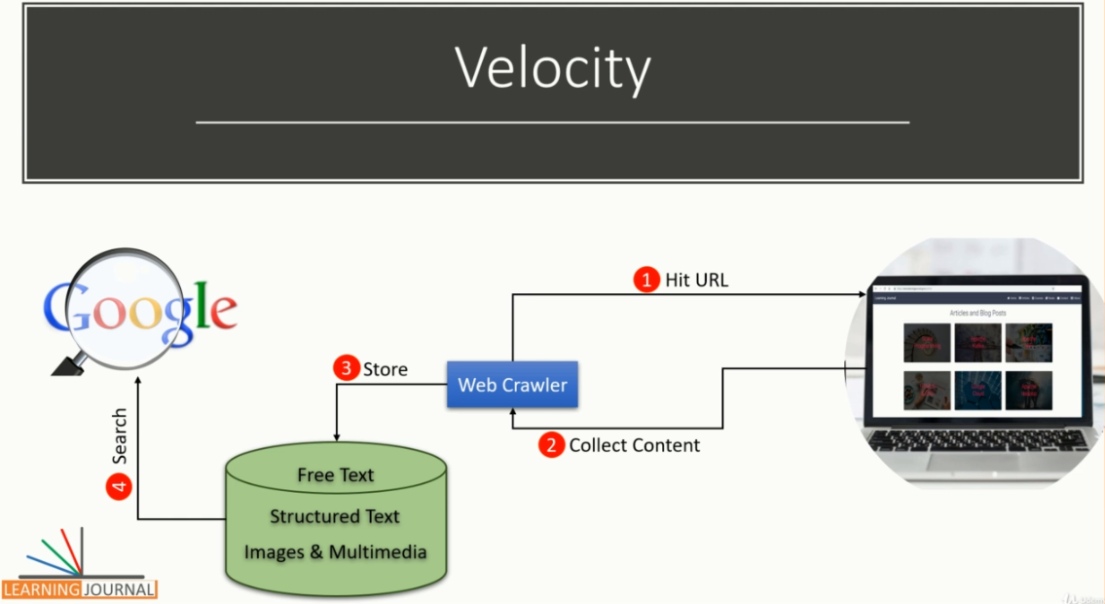

Google knew that they will be dealing with the massive volume of data and no DBMS at the time was scalable to store and manage that quantity. The content of the web pages had no structure. It was not possible to convert them into a row-column format without storing and processing them.

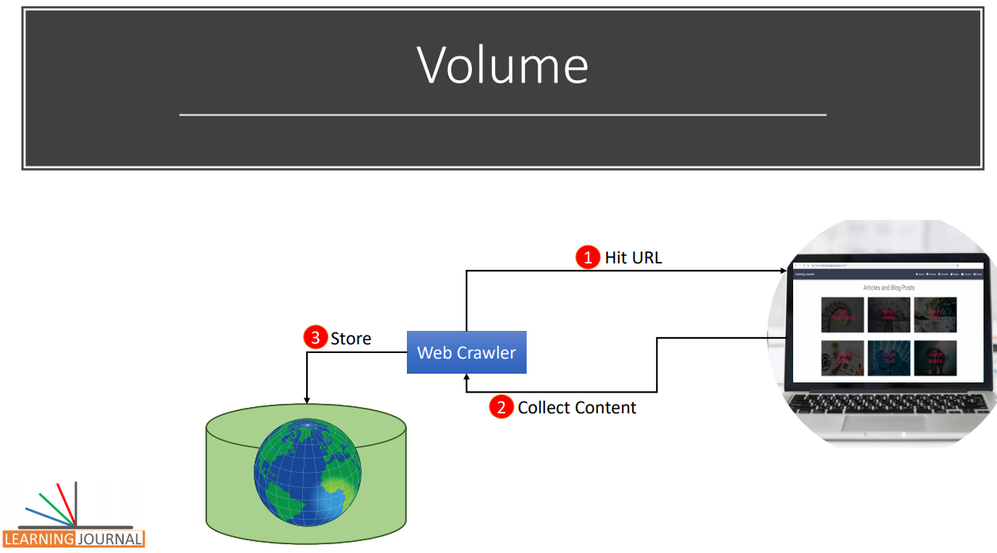

Google knew that they need a system to deal with the raw data files that may come in a variety of formats. The DBMS of the time had no significant support to deal with the raw data. Velocity is one of the most critical and essential characteristics of any sound system.

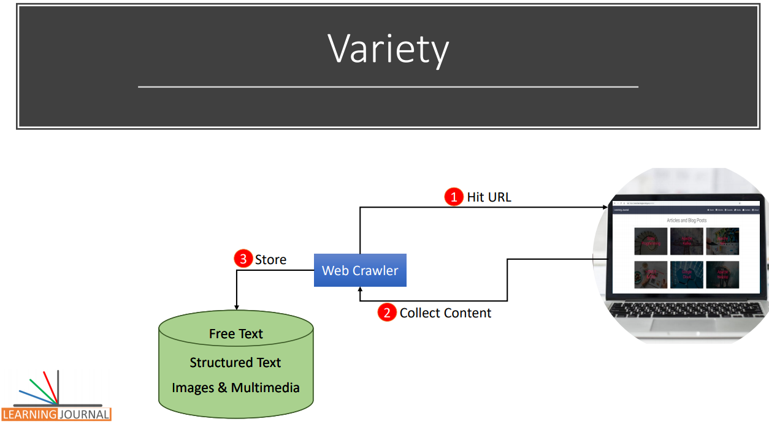

Google needed to acquire data quickly, process it, and use it at a faster rate. The speed of the Google Search Engine has been its USP since they came into the search engine business. It is the speed that is driving the new age of Bigdata applications that need to deal with the data in real-time. In some cases, the data points are highly time sensitive like a patient’s vitals. Such data elements have a limited shelf-life where their value can be useless with time, and in some cases, very quickly.

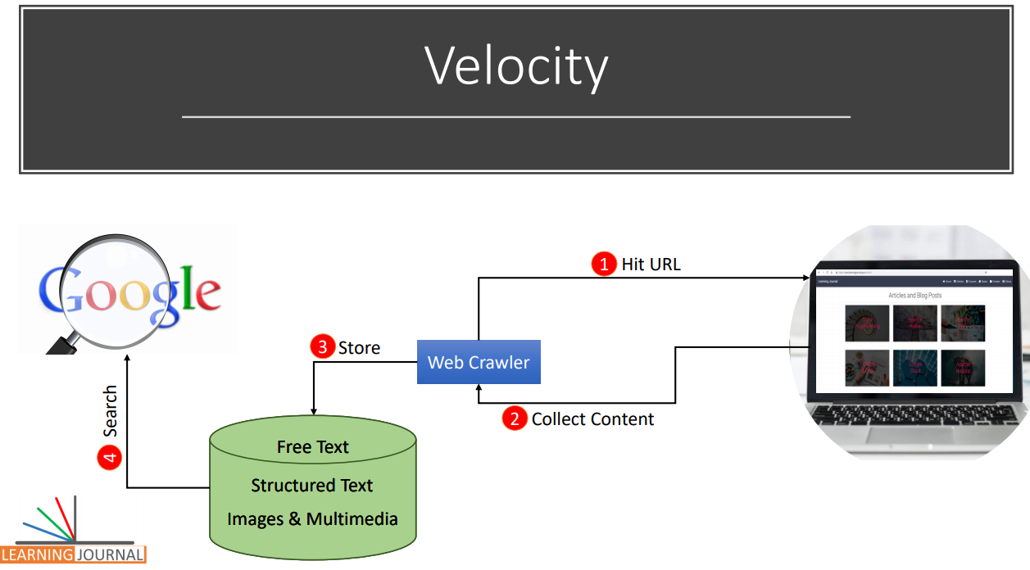

We will come back to the velocity once again in the next lecture because the speed is the driving force of a real-time system – the main subject of this course. Google successfully solved all the above problems, and they were generous enough to reveal their solution to the rest of the world in a series of three white papers.

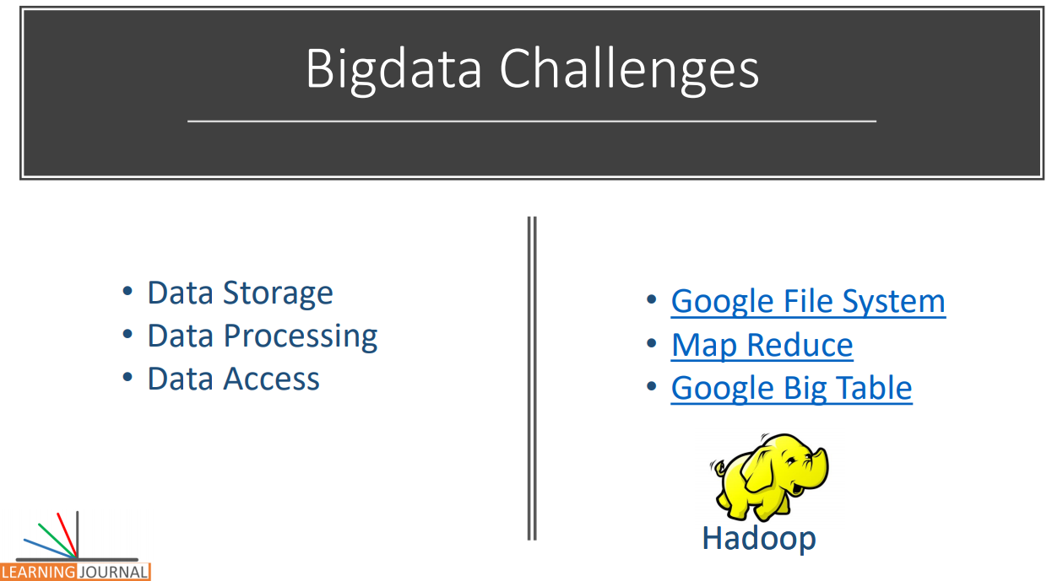

These three whitepapers talked about Google’s approach to solving data storage, data processing, and data retrieval. All these three whitepapers were well appreciated by the open source community, and they formed the basis for the design and the development of a similar open-source implementation called Hadoop. Hadoop and all the other similar solutions tried to solve a common problem of processing large volumes of data that was previously stored in the distributed storage. This approach is popularly termed as Batch Processing. In the batch processing approach, the data is collected and stored in the distributed system. Then a batch job is used to read the data and process the same by utilizing the distributed cluster. While you are processing the previously stored data, the new data keeps arriving at the storage. Then you must do the next batch and take care of combining the results with the outcome of the previous batch. This process goes on in a series of batches. In the batch processing approach, the outcome is available after a specific time that depends upon the frequency of your batches and the time taken by the batch to complete the processing.

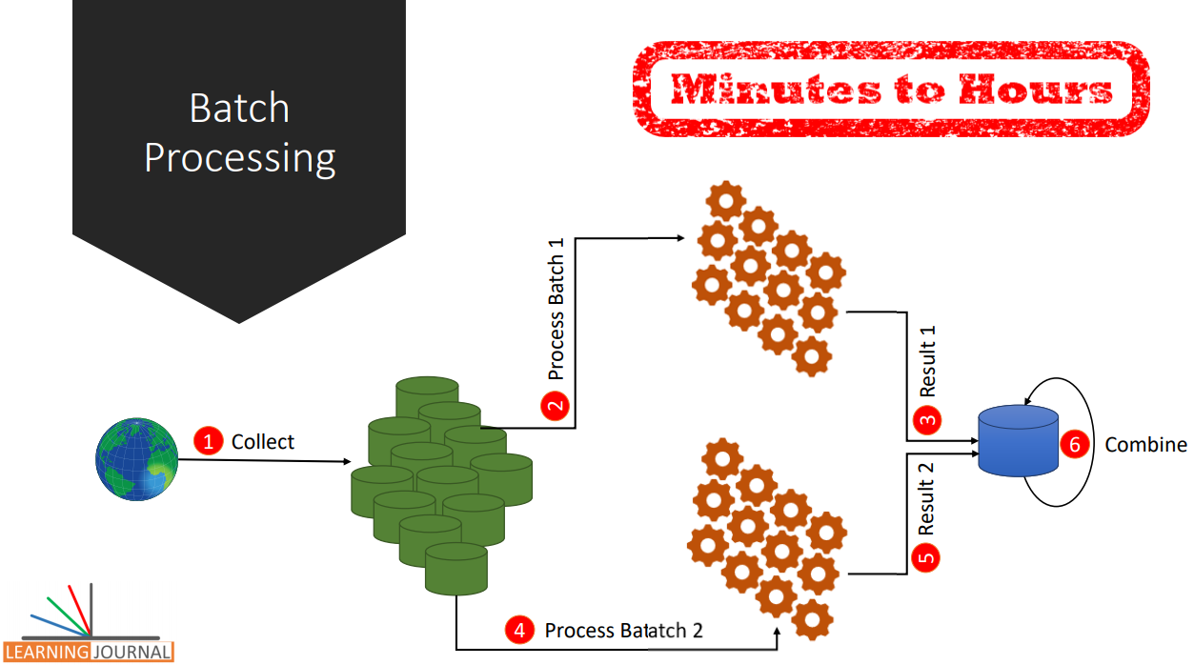

The insights derived from these data processing batches are valuable. However, all such insights are not equal. Some insights may have a much higher value shortly after the data was initially generated, and that value diminishes very fast with the time. In many cases, the data points are highly time-sensitive, and they need to be actioned in minutes, seconds or even in milliseconds. For example, a fraud detection system is much more valuable if it can identify a fraudulent transaction even before the transaction completes. Similarly, in a healthcare ICU or in the surgical operation setup, the data from various monitors can be used in real time to generate alerts for nurses and doctors, so they know instantly about changes in a patient’s condition. We will discuss some of the common use cases and data sources for such requirements in the upcoming lectures.

However, it is essential to comprehend that the demand for the speed in processing the time-sensitive data is continuously pushing the limits of Bigdata processing solutions. These requirements are the source of many innovative and new frameworks such as Kafka Streams, Spark streaming, Apache Storm, Apache Flink, Apache Samza and cloud services like Google Cloud Dataflow and Amazon Kinesis. These new solutions are evolving to meet the real-time data processing requirements. Great! So, In this lecture, I talked about the Bigdata problem and how it started. We also talked about the three whitepapers that Google published which started the big data movement and led to the development of Hadoop. Hadoop grabbed immense attention and popularity among the organizations and professionals. But the Hadoop adopted a batch processing approach, and we briefly talked about it. But the expectation is growing, and there is a need to handle time-sensitive data at speed. In the next lecture, I will discuss more on how can you start thinking about building solutions that can meet the real-time data processing expectations.

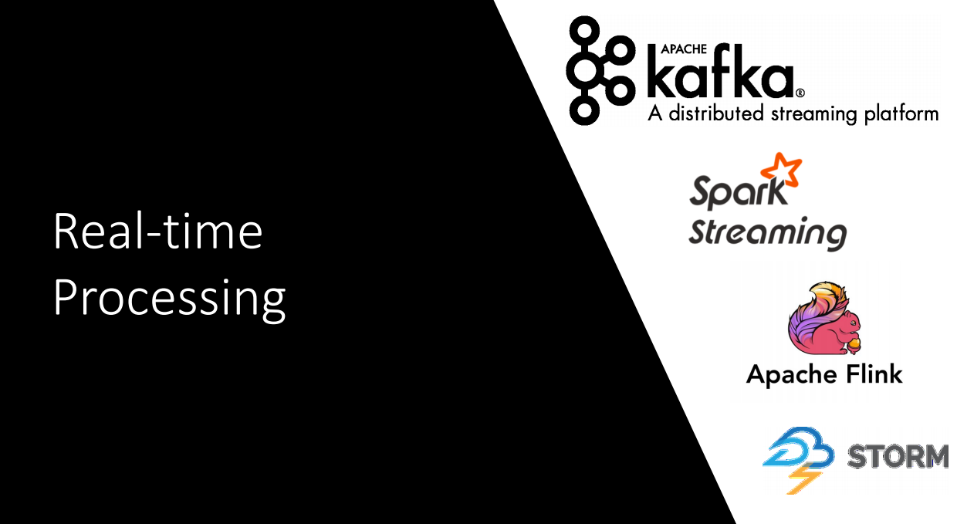

## Conception of Event Streams

I talked about the genesis of Bigdata, and we learned that things are now expanding into the real-time data processing requirements. In this video, we will try to help you develop a broader sense of real-time stream processing. The idea of real-time stream processing starts with looking at the day to day business activities as a sequence of events. The notion of business activities as events is in the foundation of real-time stream processing. For example, a retailer has a series of events for orders, returns, shipments and so on. If you have ordered something on Amazon, that means, you created an order event. When you are tracking your delivery, you are monitoring a shipment event. Similarly, a bank may have events of customer service requests, stock ticks, market indicators, trade transactions, and financial time series transactions. A popular website might want to track the occurrence of clicks and ad impressions. Displaying an advertisement on your website is also an event. Google AdSense is all about matching an advertiser's bid event to the website's ad-request event in real-time and then monitoring the ad-click events. So, the first step of heading towards stream processing is the idea of looking at your business activities as events.

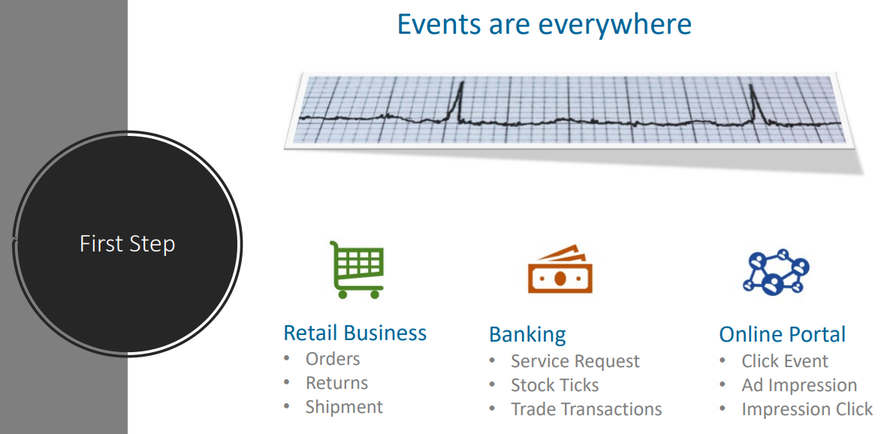

Applying this idea in practice is not too difficult, but it often starts with four main questions. How to identify and model events? How to create a stream of events? How to transport events? And Finally, how to process events? Let me elaborate on these fundamental problems with some examples. The first thing that we want to understand is: How to identify and model an event from your business activity? Assume that you have a retail business. The business performs many activities. However, every business activity is played by an actor. An actor is a real-life person or a machine, or it could be an automated process. The action performed by an actor generates an event. For example, invoicing is a business activity performed by a point-of-sale operator that generates an invoice. The POS operator is the Actor. The verb 'Create' is an action. The Invoice is the event that is generated by the Create action. We identified an event. It is that simple. So, the event is an outcome of the action performed by an actor. That’s what we mean by an event in this course.

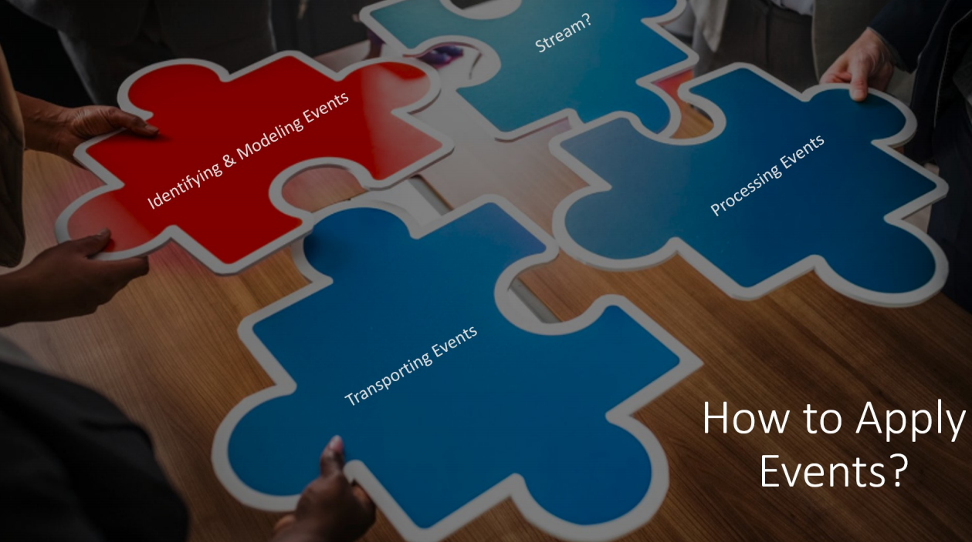

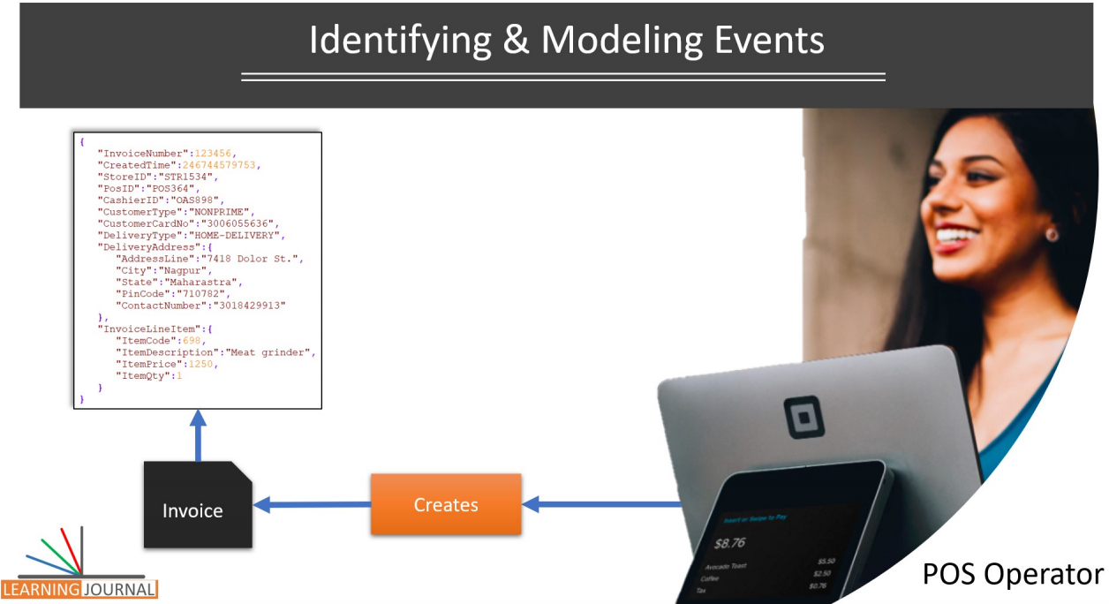

Once you know the event, the next step is to capture the event as a data object that can be streamed and transported from one place to another place and also can be processed by an event processor application. Capturing the invoice event as a data object is as simple as creating a JSON object for the invoice. Here is an example. This JSON object is an invoice event. So, we identified an event, modeled it using a JSON object. Simple, isn't it? The next problem is to make a stream of events. How do you make a stream from your events? Whatever events you identify, they are likely to be generated continuously over time as a series of events. These events are produced one after other. For our POS example, the invoicing is not a one-time activity. The operator keeps generating invoices one after other and this series of invoices is what we term as a stream of events. You might see a time gap between two consecutive events and this time gap may or may not be equal. However, the events keep occurring in a continuous stream.

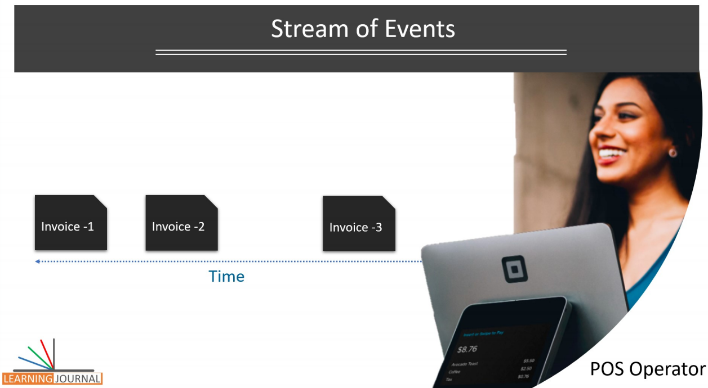

The point is straightforward. The stream of events is a natural phenomenon of the business. All we need to do is to transport these events from the point of origin to the location of processing. But here is a question? Why do we need to transport an event? Transporting events from one place to another place is a common requirement. You can’t avoid the need for moving events from one place to another location for simple reasons such as you cannot process everything on a single machine in a single monolithic application. The industry has adopted a microservices architecture, and we create a bunch of simple autonomous applications, each taking care of specific responsibility. For our retail sector example, invoice event that is generated at the POS is also needed by the various other services. The shipment service would be interested in scheduling the shipment of the items. within the invoice. Similarly, the analytics service would also need to know about the invoice event and take it into account for analyzing sales pattern. The point is straightforward.

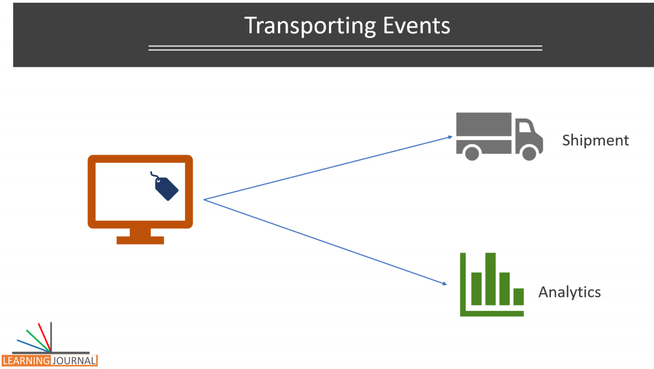

You cannot avoid the need for transporting events, because you cannot process everything in one place. However, transporting events from one application to another application is a big problem. Look at this diagram. It shows an indicative requirement for a retail system. If you have a multi-store business, your POS terminals are spread across the stores. If you are accepting online orders, your invoice events are also coming from your online web store.

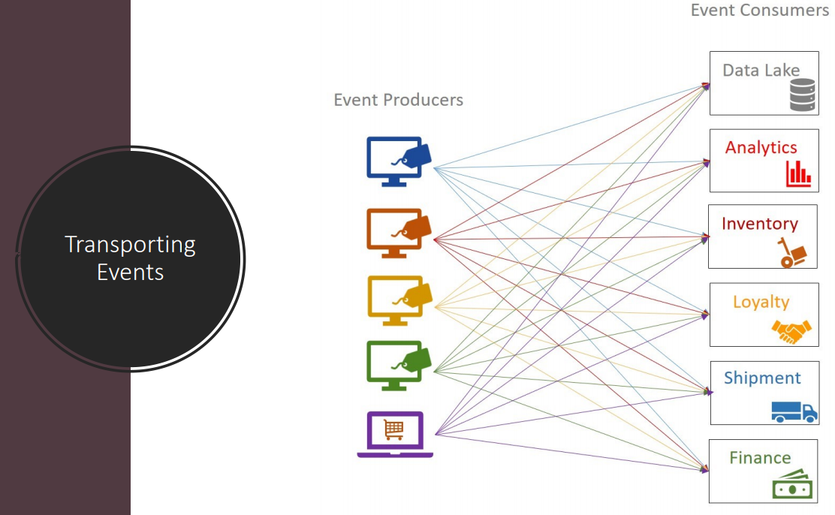

The point is straightforward. There are multiple sources for the same type of event. Similarly, there is no single destination for the invoice. The invoice is required by the finance, shipment, inventory planning, loyalty services, analytics, long-term storage and many more. So how do we solve that many-to-many streaming requirement? Do you want to build all those streaming data pipelines? Creating all those crossing lines that are shown in the diagram? I leave you there to think about it and at least identify a possible solution for this requirement. You may be right or wrong but just do it, think about it. We will come back to this problem in the next lecture and discuss what makes a good or bad solution. Before I close this lecture, let's talk a little about the last question. Assuming we can easily transport the events using some magical solution, but once carried, How to process events in real-time. Let's try to understand this question with an example. Extending to our invoicing example, let us assume a simple requirement. As soon as an invoice is generated for a customer who has enrolled in a loyalty scheme, we want to compute the total reward points for the customer and send him an SMS with the details. The most critical point, we want to send the SMS within a few seconds of invoicing.

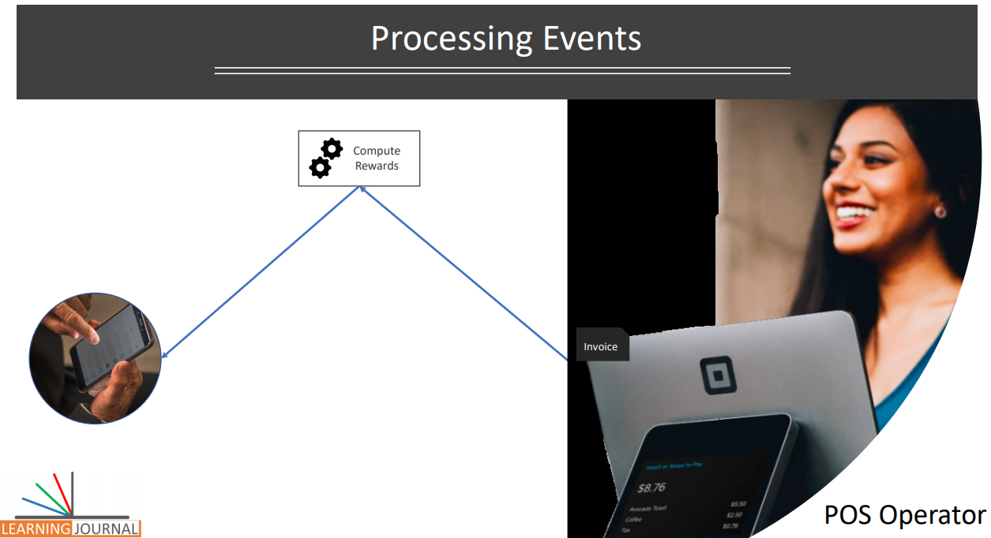

Let's take another example from the payment industry. You want to pay bills for your Internet. You internet provider (iNet) offers you an option to pay your bills using your mobile wallet . Have you done this yourself? Do you remember the steps? You would log-in to the iNet application and select the mWallet option to initiate the bill payment. In a typical case, the iNet would ask for your linked mobile number.

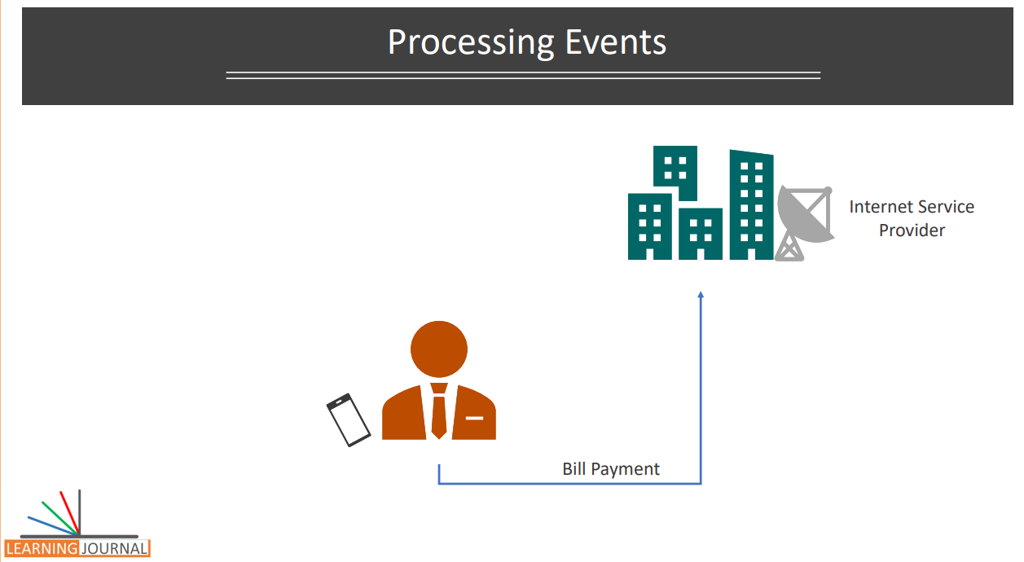

Once you supply your cell number, the iNet would call the mWallet payment API. The mWallet payment API would generate an OTP and securely send you the OTP for transaction verification. This OTP could be valid for five minutes. When you supply the valid OTP, the mWallet should approve the transaction or reject it if you delayed it by 5 minutes or provided a wrong OTP. All this happens in real-time.

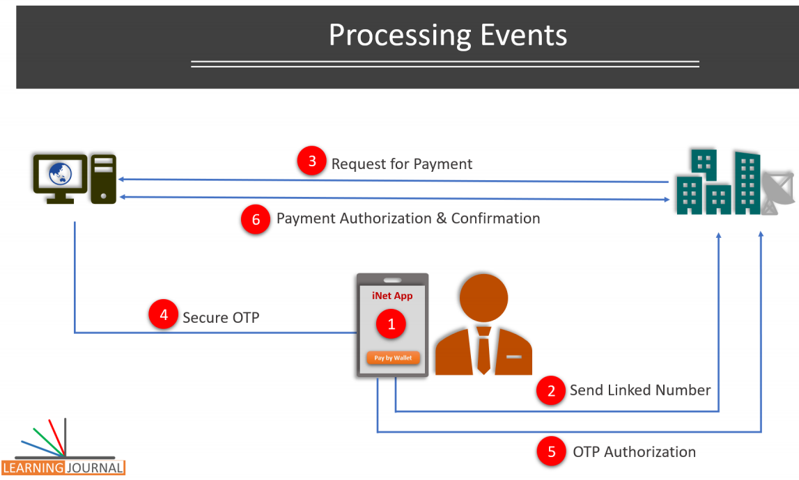

These are the examples of the event processing that I am talking about, and in this course, you will be creating both of these examples and solving many other similar real-time streaming problems. The main objective of this lecture was to give you the first sense of real-time stream processing. I tried to give you an idea of what do we mean by the event. An event is nothing but a business activity that we captured as a data object, right? I also tried to give you a clear understanding of what do we mean by a stream of events. Again, the stream of events is nothing but a continuous flow of event objects one after other. That's all. The third thing was the need to flow or transport the stream from one location to another location, and I hope I clarified that as well. Finally, I wanted you to understand, what do we mean by real-time stream processing. I tried to give you a couple of examples to have a pre-sense of what do we mean when we say real-time stream processing. And you can find examples all over around you.

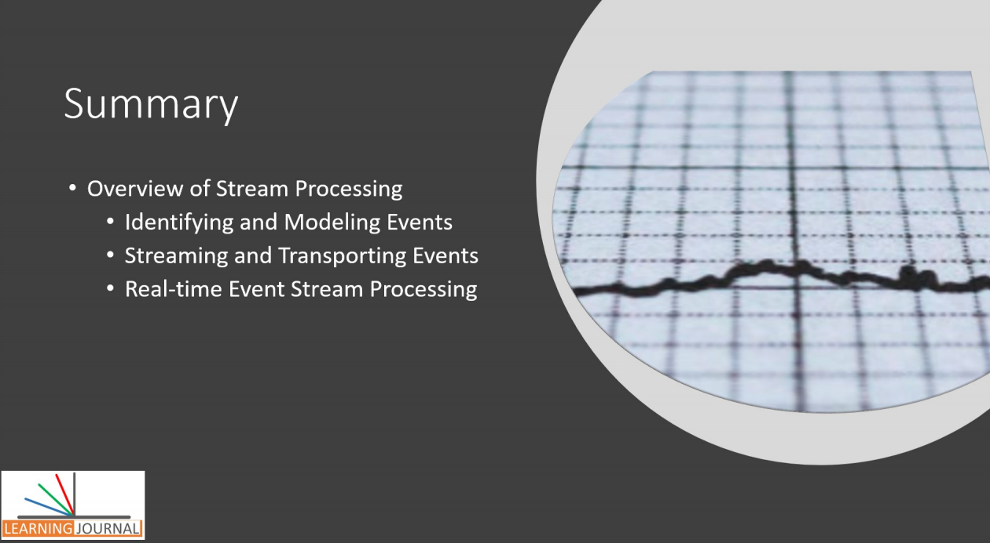

You are ordering food on your mobile app, booking a cab, looking at the traffic status on your way, performing a financial transaction, or a patient is going through a surgery, real-time stream processing has found its application in every business. In the next lecture, I will talk about a wide range of real-time stream processing use cases and some examples. Before you start processing streams, I intend to cement the notion of stream processing in your mind talking about the depth and breadth of real-time stream processing use cases. See you in the next lecture. Keep learning and keep growing.

## Stream Processing Use Cases

Everything that I talked in the previous video should have been good enough to help you develop a general perception of what the stream processing means, and what we do in a real-time stream processing system. However, to cement the idea and concrete your understanding, I am going to talk about the five different technical categories where stream processing is applied. I will also give you some specific business examples, but the main idea is to broadly classify the technical categories where stream processing is being used. While the categories that I am going to talk about are not exhaustive, but I have tried to arrange them in the increasing order of complexity.

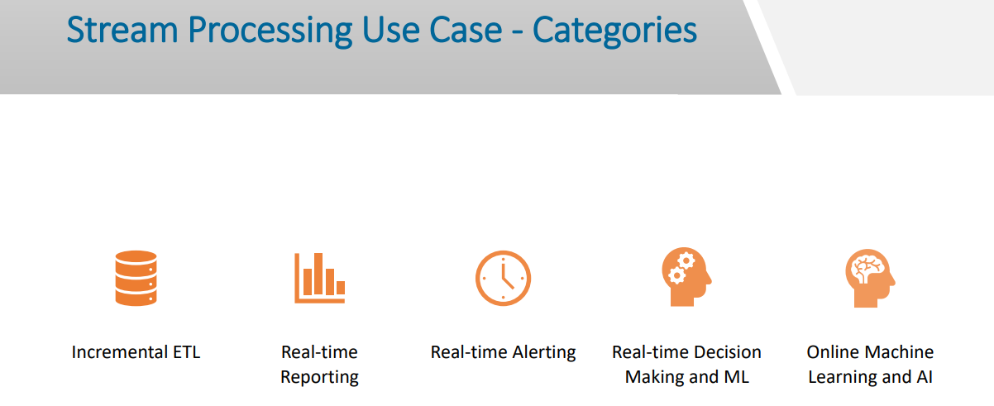

A typical business may want to start with the first category of the use case and progress towards the more complex use case. Let's talk about these categories in a little more detail.

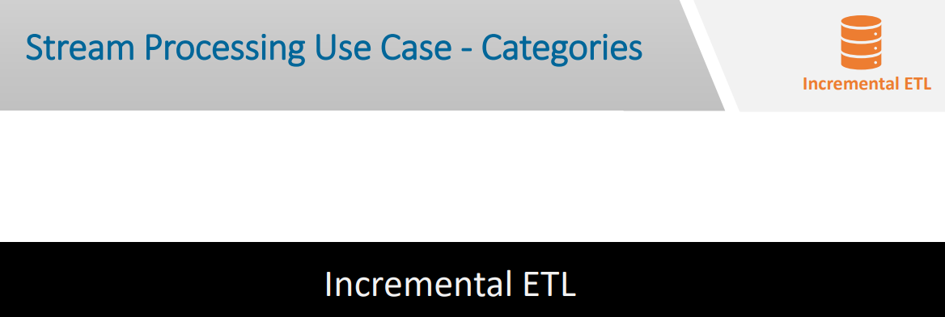

Incremental ETL is one of the most common requirements for enterprises. I will quickly skim through one very basic and one advance example to help you understand the concept. At the most basic level, it is similar to turning your OLTP databases into a stream of events, applying transformation in real-time, and finally, pushing it to the target data store where it is actually used. These implementations could be as simple as a combination of Change Data Capture and a real-time transformation pipeline.

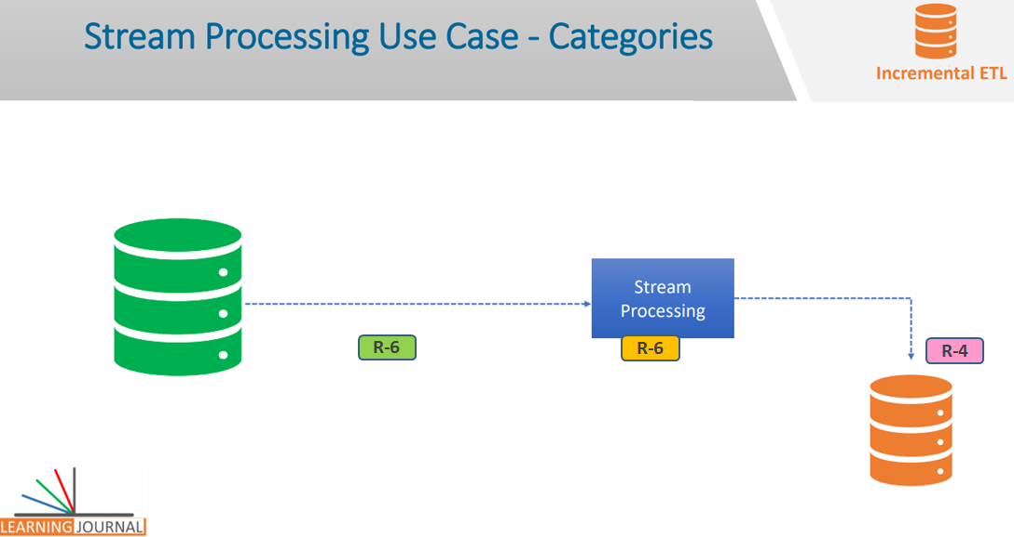

We have been using it in data warehouses. This figure shows a typical implementation of the CDC in a data warehouse or a data lake setup.

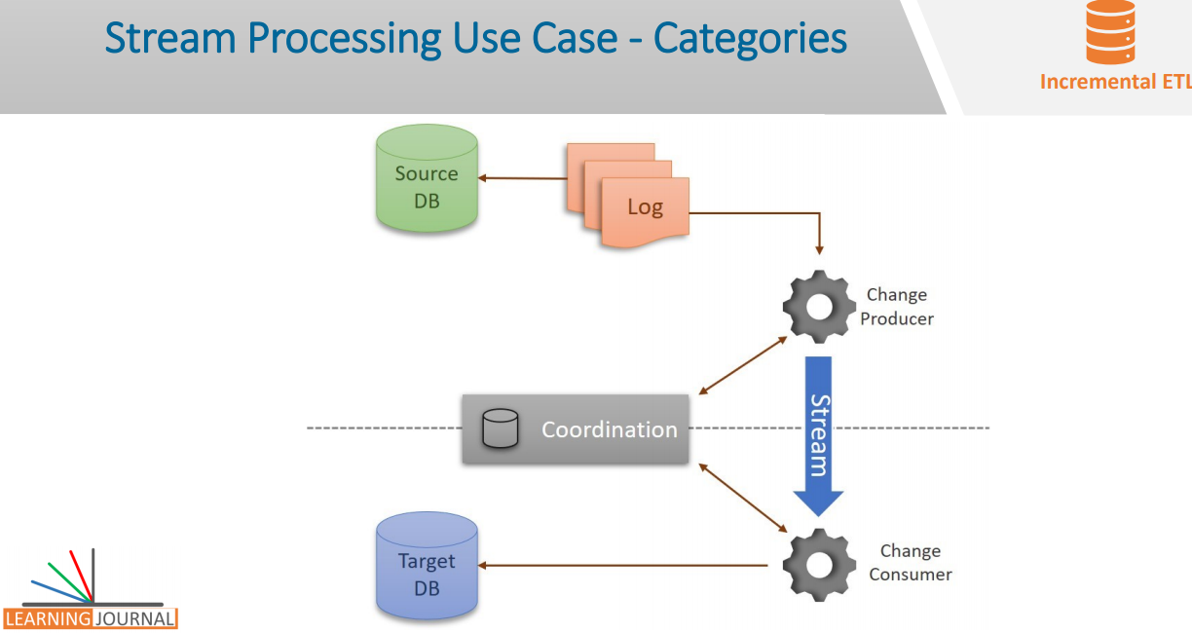

In this configuration, a Change Producer continuously monitors the redo logs and produces a stream of events for the Change Consumer on the other side. The consumer materializes the stream back to the target database. This figure also shows a Coordinator. CDC tools often need a Coordinator to configure, coordinate and monitor the whole process. The CDC process may be as simple as continuously bringing data to the data warehouse, but in many cases, we can also implement a sequence of transformations on the fly. Such data transformations may include data quality checks, data enrichment, and other data enhancements. Incremental ETL is the most basic streaming application, and it is quite popular because it allows you to incorporate new data within seconds, enabling users to query it faster at the downstream system.

However, the same idea of incremental ETL is taken up by teams to create a much more sophisticated stream processing pipelines. We see a typical example of the extension of this idea in most of the social media platforms.





Let’s take a simple problem from social media applications such as LinkedIn, Facebook and Twitter. As a user of a social media platform, we perform two types of operations. We Create some Content which is basically a Write Operation for the social media platform. We also Consume some Content, and that would be a Read Operation for the social media platform. The big question is, how do they support these read/write operations for such a massive population at a reasonable speed?

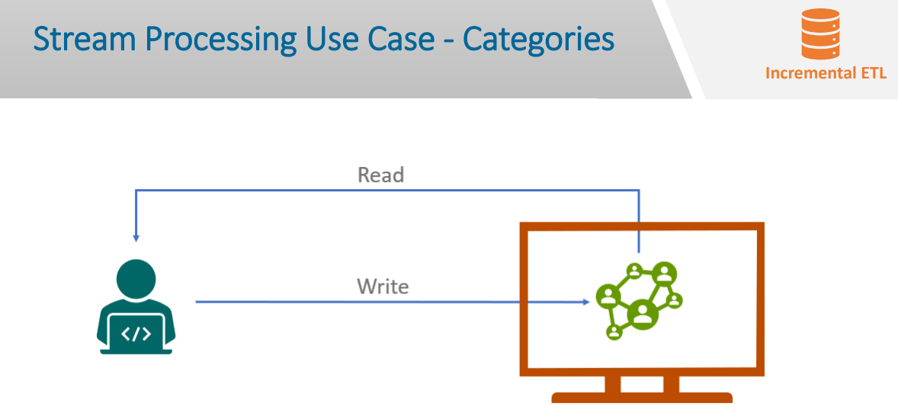

At a very high level, the solution is simple. What is it? Any guesses? Well, the idea as simple as to partition the overall system and serve a finite number of users from each partition at a deterministic speed. What does that mean? That simply means, all my read/write operations are served by a specific partition of the system and hence a particular database. Whatever I write, goes to that partition and when I read something, it comes from the same partition. And this specific partition might be serving 100K users of which 1K might be active at any given point in time. Similarly, other partitions are serving a different group of users. I am oversimplifying things, and such systems require the careful design in terms of routing, load balancing, caching, and you may have to solve many other complex problems. But the idea is to distribute the workload among partitions and improve the read/write operation.

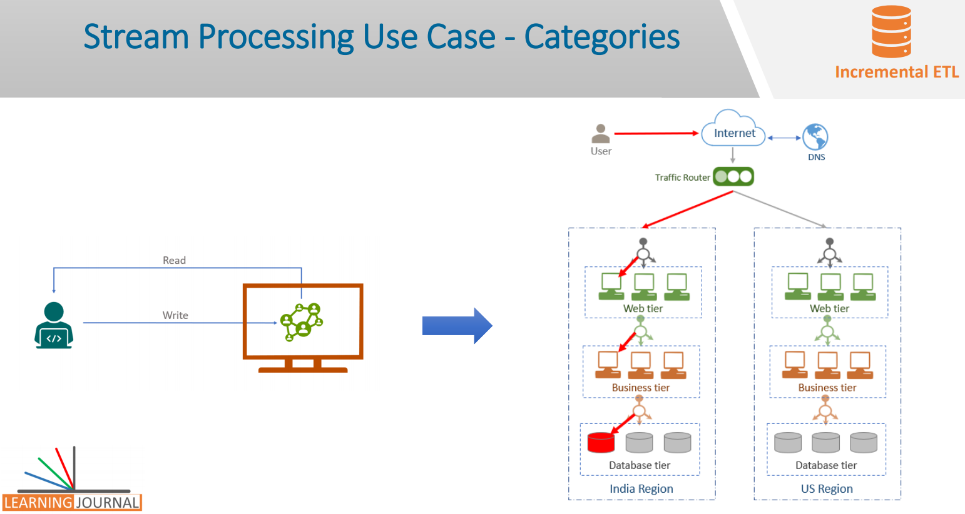

You might be wondering, in all this, where is the real-time stream processing? Let me come to that part. Let’s assume I am using a popular social media platform and they have a dedicated database partition based on my user-id where all my contents are stored. I can create a post, I can write some comment, I can like a comment and do many other things. All these activities are generating some content that goes and sits into my database partition. The write operation is efficient and scalable because the load balancer redirects my request to the service that stores my content in my database partition.

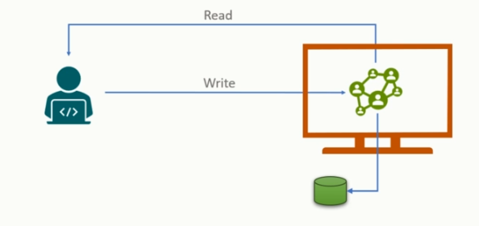

Now let us look at the read operation. The read operation also appears to be quick. I open the social media App or the website, based on my user-id, the page load is redirected to the service that serves me. The service reads the page content from my database partition and servers it very quickly. All looks good. However, there is a catch. Some of the key ingredients of my social media page are my feeds, my messages, and my notifications. Where are they coming from? These are not the content that I created, and hence they were not supposed to be in my storage partition. My social feed is the content that is produced by the people I follow. My notifications are based on the activities of other people on my content such as they commented or liked one of my posts. What does all that mean? Well, these are the events that are being generated by some other sources such as the people whom I follow, the people who comment on my post, the advertisement that is identified relevant for me. Those events are flowing to my database partition in real-time so that they can be served to me quickly. And this is where the real-time incremental ETL or real-time data preparation is being implemented. The solution to this problem could be an excellent implementation of real-time stream processing.

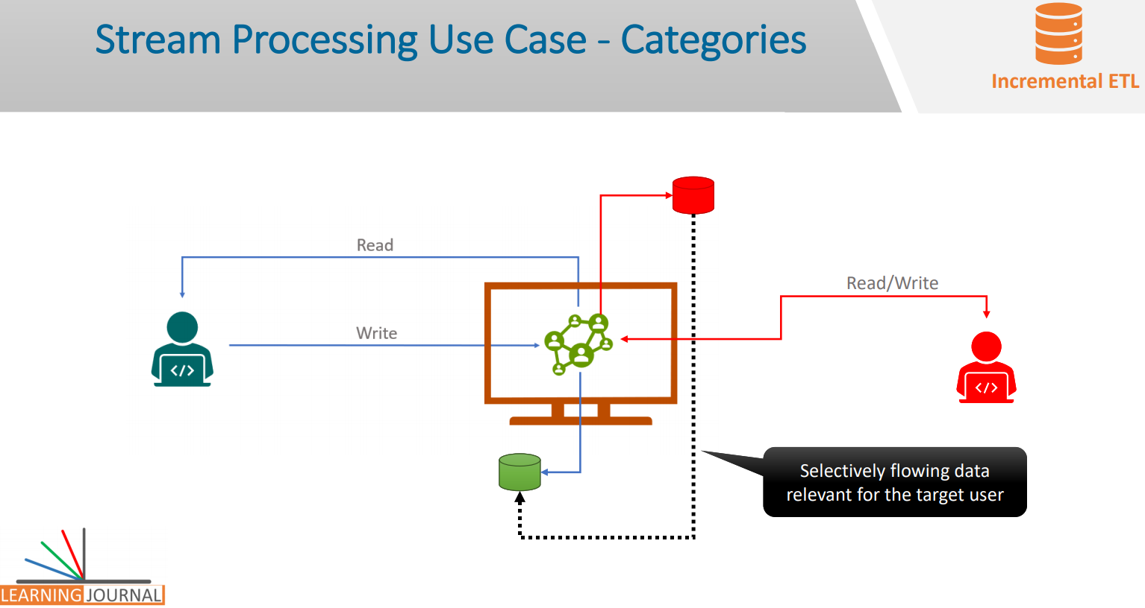

This may fall under the incremental ETL category; however, it may not be a straightforward CDC extract, on the fly transformations, and final load into the target database that you might have seen in the data warehouses.





The next category is the Real-time Reporting If you have worked in business intelligence applications, you are already familiar with this category. Yes, I am talking about dashboards and reports. But these reports are real-time reports that refresh in seconds or in milliseconds, and you can find them all over. Organizations use stream processing applications to run real-time dashboards, and this one is the second most popular category where we see amazing implantations of real-time stream processing. Let me give you examples of some specific use cases.





Infrastructure Monitoring is one common area Every platform team would use a dashboard to monitor the platform KPIs such as storage, CPU, network usage, overall system load, uptime, etc. Another excellent example of monitoring is to watch the adoption of new features as they are rolled out among applications. What does it mean? That means, you introduced a new feature in your app and started collecting data about how many users are adapting to the new functionality. Is it working fine, how quickly is it getting popular among your users and many other similar things? Campaign Management is another similar use case Most of the e-commerce applications continuously monitor the effects that new campaigns and site changes may have on their traffic such as to see whether a one-day promotion is driving traffic to their site? Business Dashboards are a common requirement Businesses use real-time dashboards to monitor KPIs such as a delivery backlog, on-time shipment, loading-time indicators, etc. These KPIs when generated in real-time are critical for planning, organizing and taking in-time decisions for day to day operations.

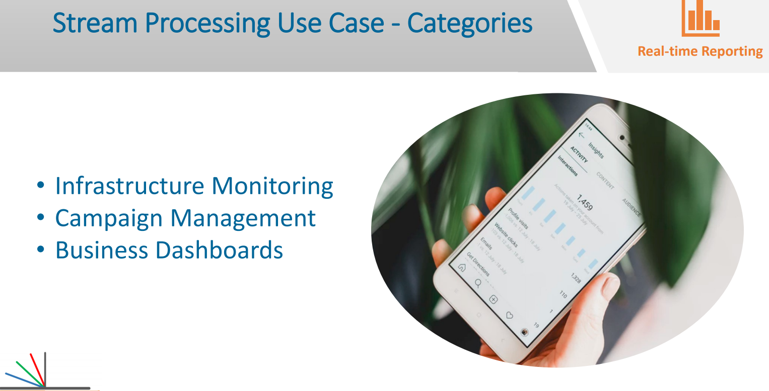

The next category is the Real-time Alerting Notification and alerts are probably the most apparent streaming use cases, and they are the next stage of real-time reporting. In a typical example, these applications identify a pattern of events or continuously compute a threshold to trigger an alert. Let me give you some specific use cases. Supply Chain Alerts is a typical example In this case, a real-time notification is pushed to the mobile devices of the warehouse employees for the fulfillment of critical orders. Healthcare Monitoring another critical area In these cases, patient’s essential readings are continuously monitored remotely against a threshold by using sensors, and alerts are generated to provide in-time efficient medical services. Traffic Monitoring is another use case. These systems use traffic data streams to immediately detect incidents and reduce the impact by notifying to the right people for timely actions. Other two categories are the intricate areas. First one is the Real-time Decision Making and Machine Learning. Real-time decision making involves analyzing new inputs and responding to them automatically using some business logic.





This business logic may include a set of simple business decisions or rules. However, it could also be an application of a medium to a sophisticated machine learning model. But in all cases, these systems make clear, concrete and automated decisions. Some specific examples are listed below. Fraud detection A bank that wants to automatically verify whether a new transaction on a customer’s credit card represents fraud by applying a decision tree and deny the operation if the charge is determined fraudulent.

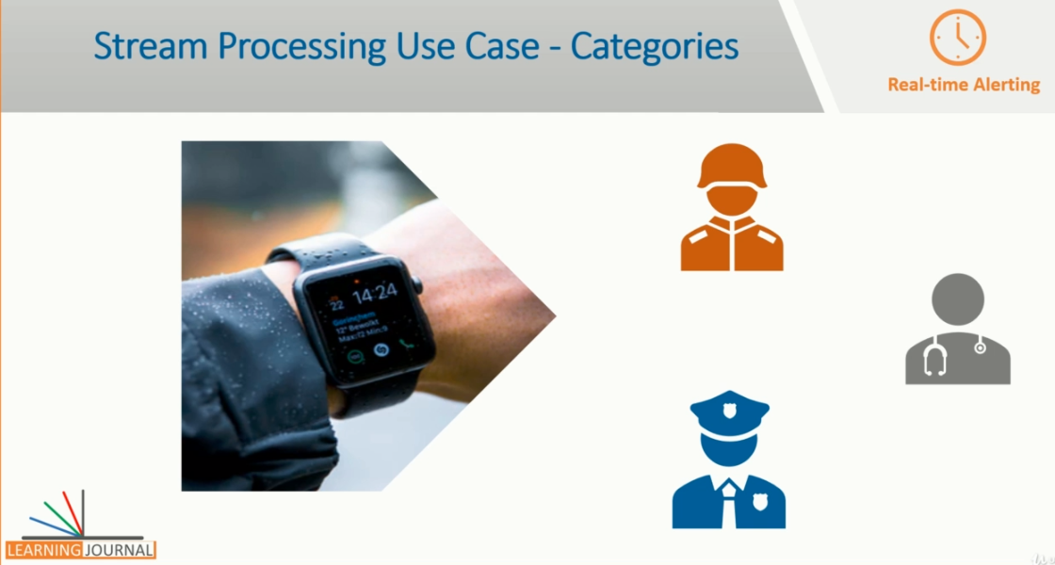

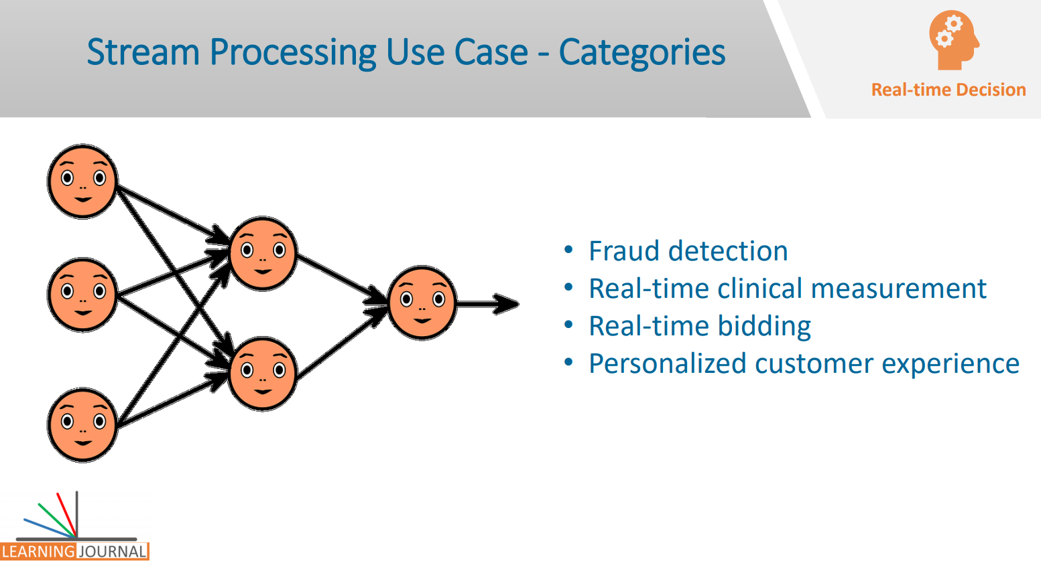

And that's what we call fraud detection that must happen in real-time. Real-time clinical measurement I am not sure if you heard about the Visensia Safety Index. VSI is a real-time data-driven clinical measurement. It can make accurate predictions about the patient’s deterioration up to 24 hours earlier. Such predictions should permit medical interventions to save both lives and money. Real-time bidding is another excellent example When a user visits a webpage, a request for an advertisement goes to the exchange where multiple advertisers bid for the ad-space in real-time. However, the decision goes in favor of the highest bidder. This also happens in milliseconds. Personalized customer experience is the key focus area for any modern business Customer experience is critical for every industry , but for our purpose, let’s take an example from an online gaming system. Gaming platforms implement adaptive gameplay to fine tune the difficulty level ensuring that the session is sufficiently challenging without being boring or frustrating And these things are done in real-time. Finally, the last category is Online Machine Learning and AI You should not confuse this category with the real-time decision making that also may apply a machine learning model in the real-time to take decisions.

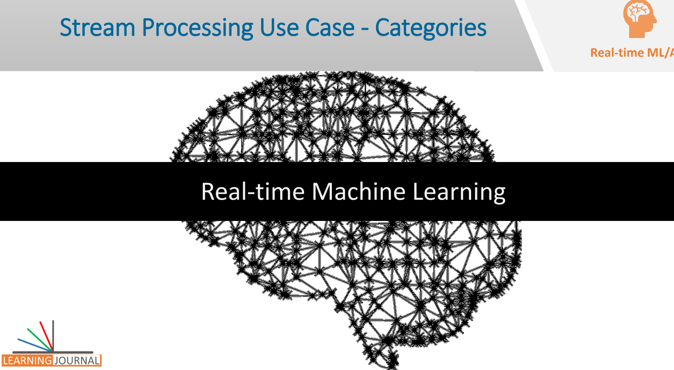

This category is specific to the Online machine learning and AI where the model is trained in real-time on live data. Online machine learning is the real artificial intelligence and the most challenging area of stream processing and machine learning. In this technique, the real-time data is used to update the best prediction at each step. In many cases, online learning dynamically adapts the new patterns in the data and optimize the learning model in real-time. There is not much work done in this area, and still, various researches are under the way. Great! That's all I wanted to cover in this video. The tool and the technology that we are going to learn in this course, may or may not be able to solve the problems of all these five categories alone.

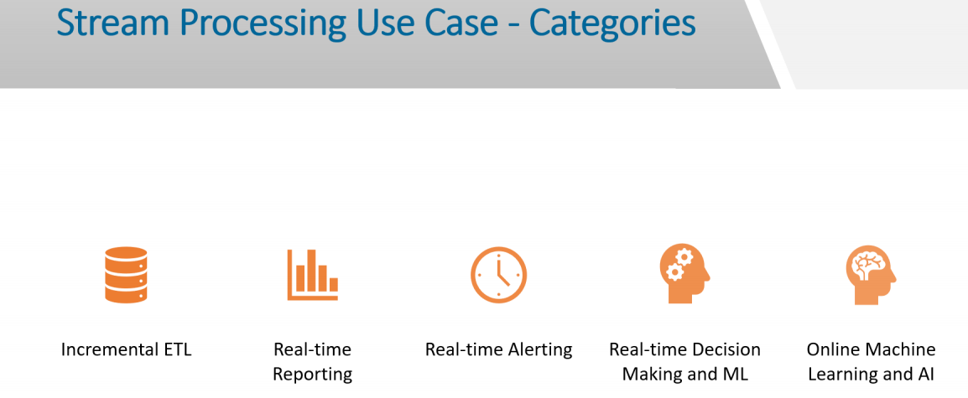

The end to end solution for any of these problems would require a combination of many tools and technologies. However, the objective of this course is to develop a solid foundation and understanding of real-time stream processing paradigm and learn the role of Apache Kafka and Kafka Streams API in developing these types of solution. See you in the next lecture.

## Real Time Streaming Challenges

I talked about three main problem areas when we are dealing with real-time stream processing. How to model events? How to transport or stream events? And Finally, How to process them in real-time? We also learned that event modeling is more of a data modeling and a process modeling problem.

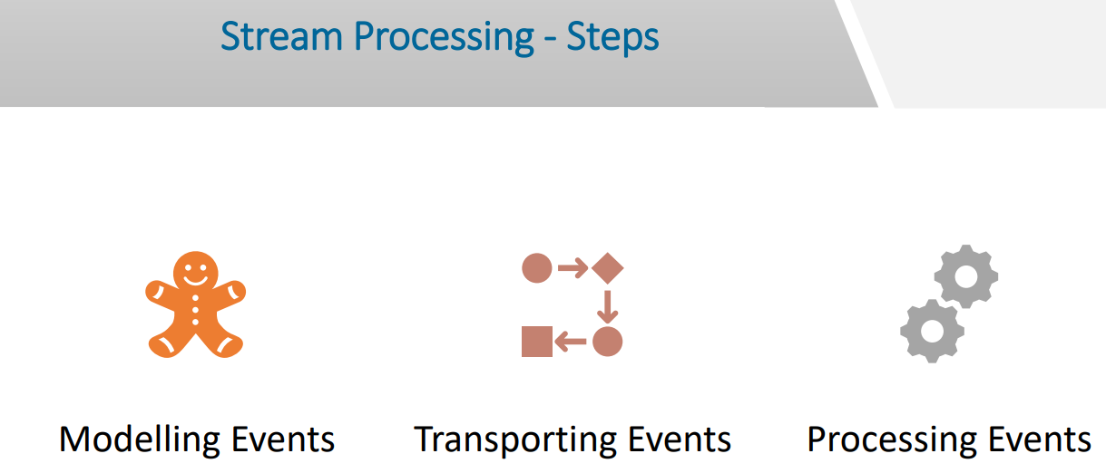

It is not a technical problem. I gave you an example of how can you model an invoice event for a retail organization. All we need to do is to identify an event and represent it using a data object. It could be a JSON object or an AVRO object or could be an XML object. You are free to choose an appropriate representation of the event. Let me give you a couple more examples to make you feel comfortable with the idea. Here is an example of a stock trade event represented as a JSON data object. Here is another event and this one represents a payment request using your mobile wallet. The point is straightforward. Representing an event is the easiest part of the game. We have been doing it for a long time when we created a record to store it in a database table.

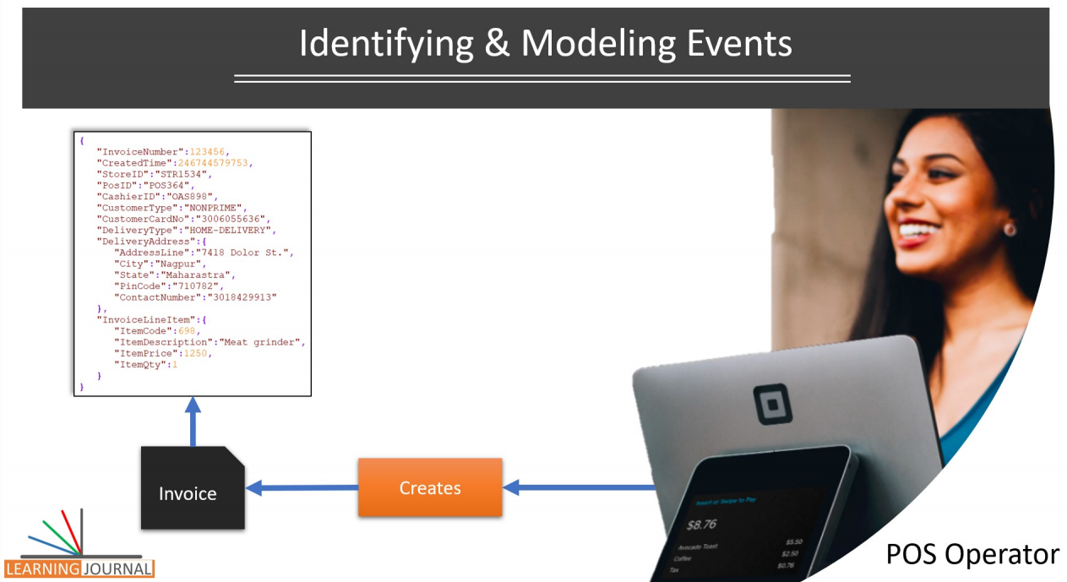

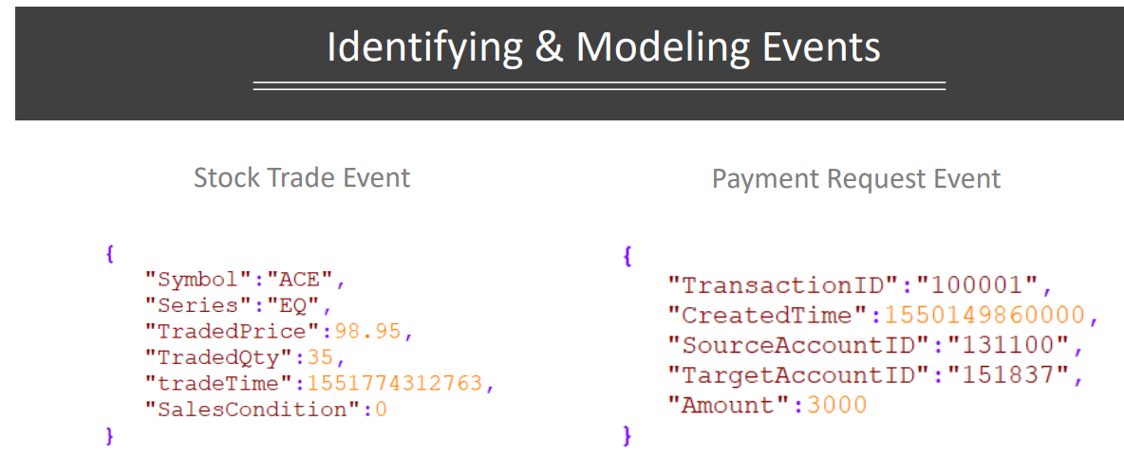

But now, since we want to transmit that record, we are representing them using JSON notation. So, the next part of the problem is to continuously transmit or transport these events and turn them into a stream. And that's where the real challenge starts. I will come back to the stream processing because that's what this course is all about. But before we begin processing events, let's try to explore the challenges for streaming events. If we can start streaming events, we would be able to process them as well. Right? Let's come back to the retail segment example that I introduced earlier. I have already talked about this example in an earlier lecture. This figure represents a typical retail system. There are many POS systems in your store. If you have a multistore business, they are spread across the stores. If you are accepting online orders, your invoice events are also coming from your online web store. The point is straightforward. There are multiple sources for the same type of event. Similarly, there is no single destination for the invoice. The invoice is required by the finance, shipment, inventory planning, loyalty services, analytics, long-term storage and many more.

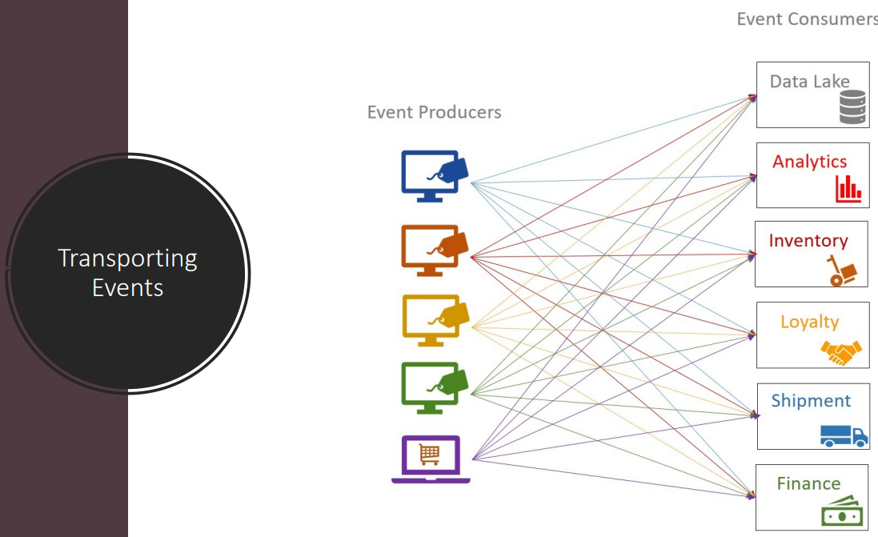

The point that I am trying to make is straightforward. In a typical case, the event transportation requirement is a many-to-many relation. The same type of events are produced at many sources, and all of them are often required at many destinations.

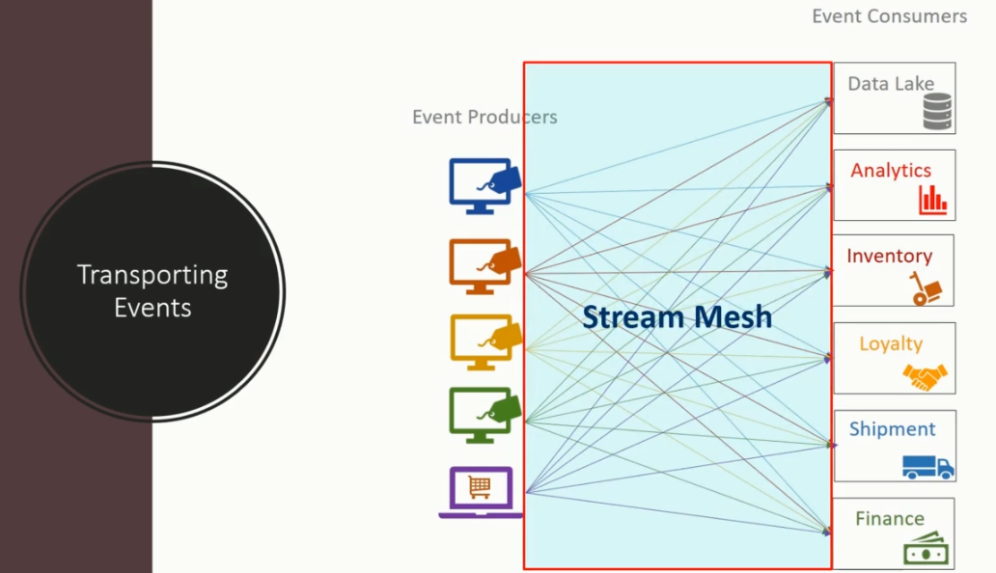

In the given figure, each connection between a source and a destination becomes a stream. It is practically impossible for the POS to send the invoice to twenty different services. That's simply too much of work for the POS system. Similarly, none of those target systems can handle the connections coming from hundreds of POS terminals. Then how do we solve that kind of problem? We need a solution that is simple and straightforward. Can we use databases to solve this problem? Let’s try to evaluate the database as an alternative.

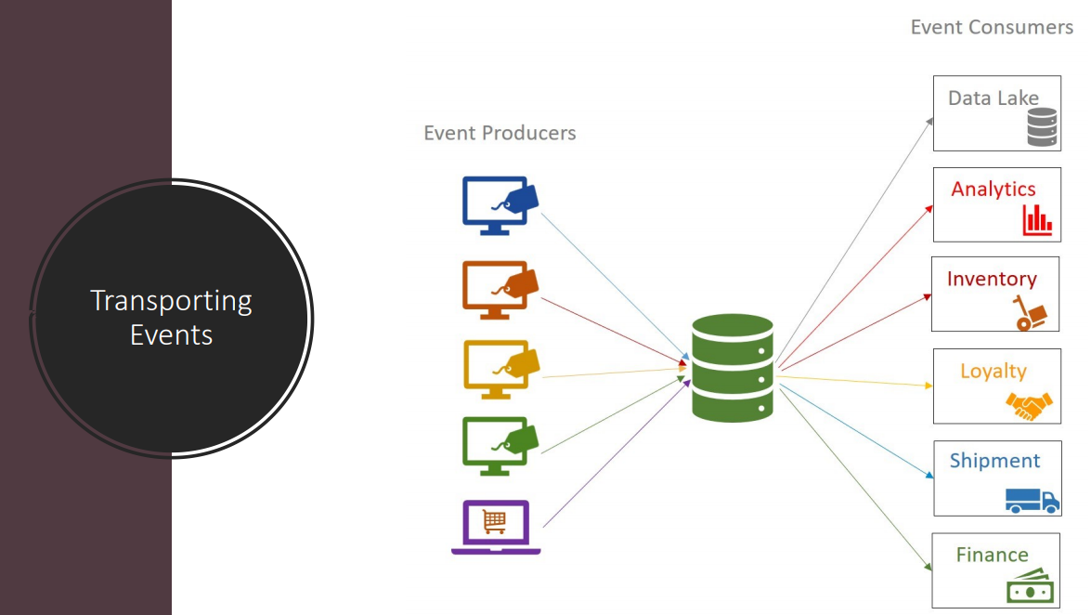

This new diagram shows a possible solution using a database. We can place a database in between and simplify the many-to-many relationship. Putting a database in between simplifies the problem to a many-to-one from the perspective of the event producers. If you just look at a single producer, it is merely a one-to-one relation for each producer. Similarly, when you look at an individual consumer, the read operation is a one-to-one relation. The event producers such as POS terminals and your online web store, they all persist the JSON object into a database.

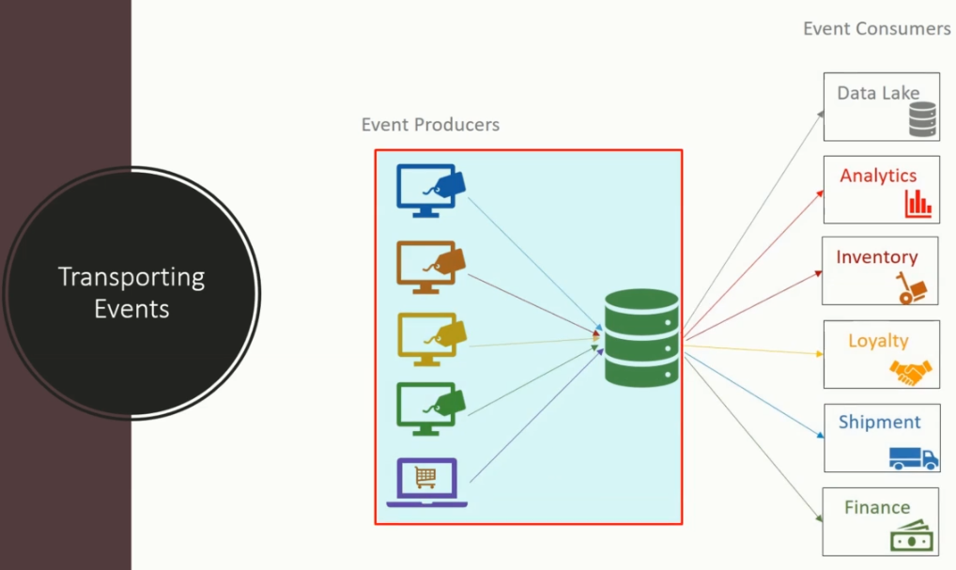

The event consumers such as finance, shipment, inventory planning, loyalty services, analytics, etc. are sitting on the other side of the database. They merely consume those events from the database.

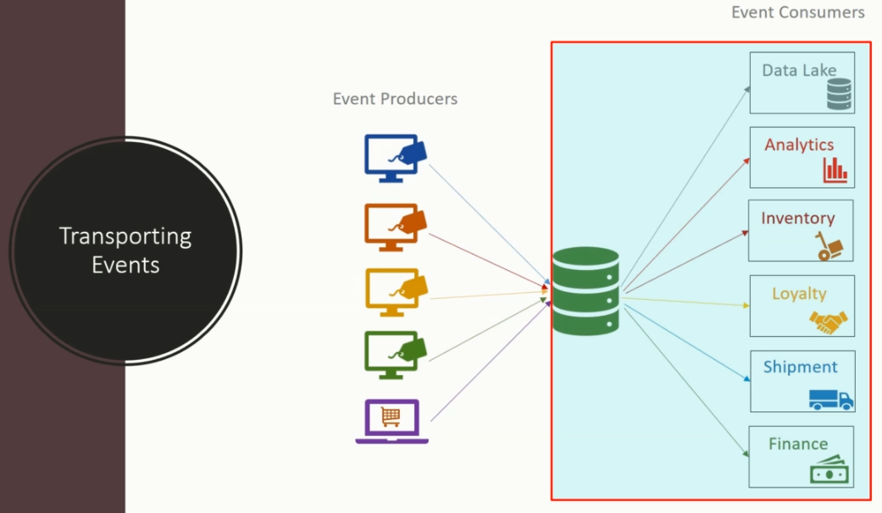

The producers and the consumers are decoupled, and we do not need to have a direct connection between producers and consumers. This solution appears to be a good alternative, and you might have seen this approach being implemented in many organizations in the past. However, there is a question that immediately follows. Is this the best possible option for streaming data or events? We cannot answer a straight Yes or No. What we want to do is to challenge this option on some critical decision-making criteria. And at the same time, we want to identify and evaluate some other alternatives and pick up the best option.

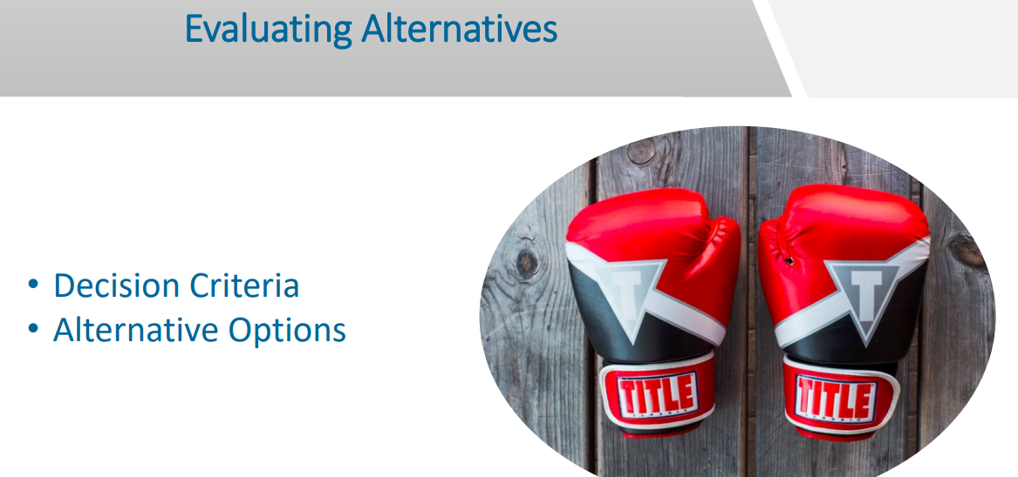

That is what is the topic for the next lecture. In the following lecture, we will identify and list out some other alternatives. Then we will identify some decision criteria and evaluate those alternatives on the same standards and finally, try to settle down on a best possible solution for streaming events.

## Real Time Streaming Design Decisions

We stressed upon the point that we cannot develop a single standalone application that does everything in an enterprise. Applications can be custom designed, or they can be purchased from the third-party vendors. Some of the applications may be running outside of the organization and maintained by the partners or the service providers. These applications may be running on multiple computers, on different platforms, using various technologies and could be geographically dispersed. We need to integrate these applications together to achieve a unified set of functionalities. The point is straightforward. Data integration among the systems is not a new requirement. However, when you are transforming your organization to respond to event streams, the data integration becomes more critical. Like any technological decision, real-time data integration requires a range of considerations. So, as promised in the earlier lecture, let’s formulate some critical decision criteria that we can use to evaluate the right solution for streaming data. I am going to talk about the following five essential requirements, and then we will evaluate some streaming solutions against these requirements.

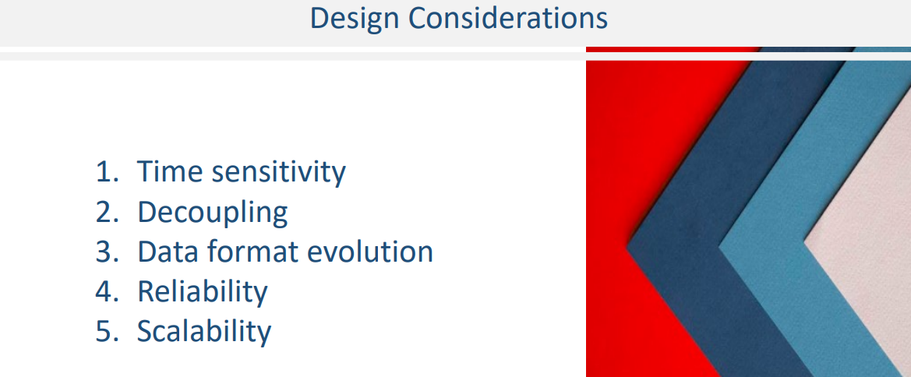

Let me explain these.

1. **Time sensitivity** is an obvious requirement, and it is one of the critical elements of real-time data integration. An acceptable solution must be able to make data available to other applications in a time-critical manner. What does that mean? That means the source system must be able to push events to the target system consumed in seconds and milliseconds.
2. The next requirement is to achieve **decoupling of applications**. Therefore, the integration should be flexible enough to allow both the applications to change as needed. The integration goal should be to minimize the dependency among data producers and data consumers and yet achieve the integration needs.
3. The **data format** is another critical problem. We can’t change existing applications to use a unified data format. The data producers and consumers may evolve over time, and we need the flexibility to support the evolution and extensibility of the data formats as the applications, and the business needs evolve.
4. **Reliability** is all about failure-free operations. In a typical system, different applications may be scattered on discrete computers across locations. These systems may not be available all the time, or the network may be temporarily unavailable. Data integration solution must be free from such failures and avoid loss of data and operations.
5. **Scalability** is obvious. We are living in the Bigdata era, and we want our systems to be horizontally scalable. You may start with a couple hundred events a day, but as the business grows, the solution should be scalable to support millions and trillions of events. A functional data integration solution should at least meet these five decision criteria.

Once you have the evaluation criteria, the next question is obvious. What options do we have? There are many ways of integrating applications for data exchange. However, all those approaches can be broadly grouped into four main patterns. Shared Database Remote Procedure Invocation File Transfer and Messaging Let's quickly evaluate them on our requirement. Databases are great. I already talked about this pattern in the earlier lecture. In this approach, all the data producers write to a shared database, and all the data consumers read from the same database. If you select a modern database, your solution will meet the time sensitivity, and decoupling requirement to some extent. However, databases are often restrictive in supporting a variety of data formats and allowing them to evolve over time.

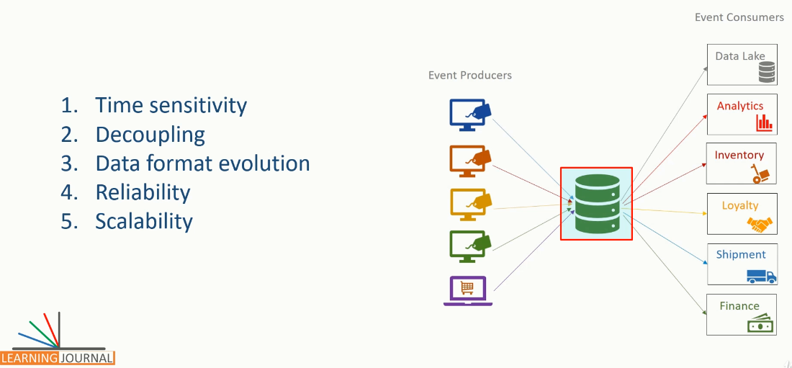

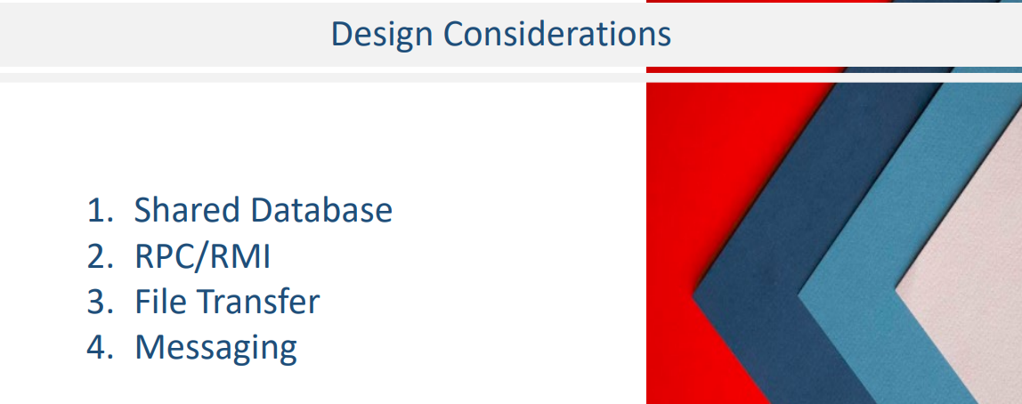

Designing a unified schema that meets the need for all the participating applications is a practically impossible task. This problem becomes more prominent if you need to integrate with packaged applications or the external applications that are not flexible enough to adapt to the shared schema design. Reliability and scalability is also a concern with many database systems. Many applications simultaneously querying and modifying the same data will also bottleneck the database performance at scale. When systems are distributed across various locations, accessing a single, shared database is often not practical.

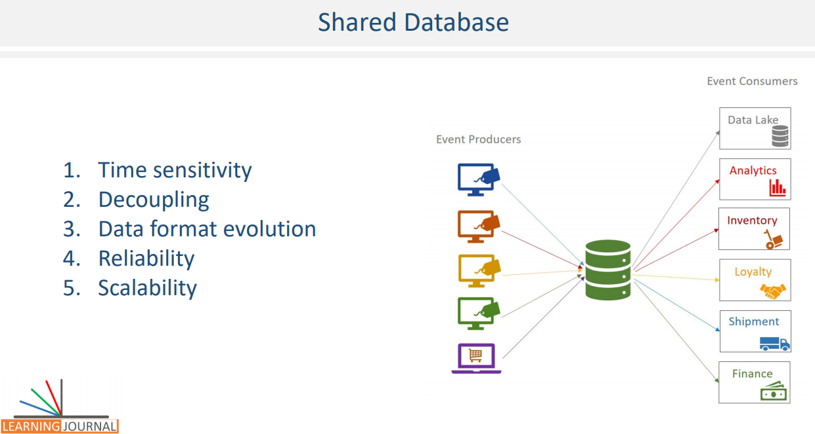

More importantly, databases were designed with data-at-rest approach rather than data-in-motion approach.

They are suitable for persisting data and querying it at a later stage. However, when you start using then for real-time millisecond integration, your solution starts becoming tricky on all these fronts. The next pattern is using remote procedures. RMI or RPC is mainly used to trigger some action using APIs at the other application and provide the necessary data for the operation. The API is typically offered by the receiver application, and it needs to be implemented by the sender application. This approach creates a tight coupling among the applications. We already evaluated this option in the earlier chapter and realized that it fails on the decoupling and scalability parameters for implementing real-time streams.

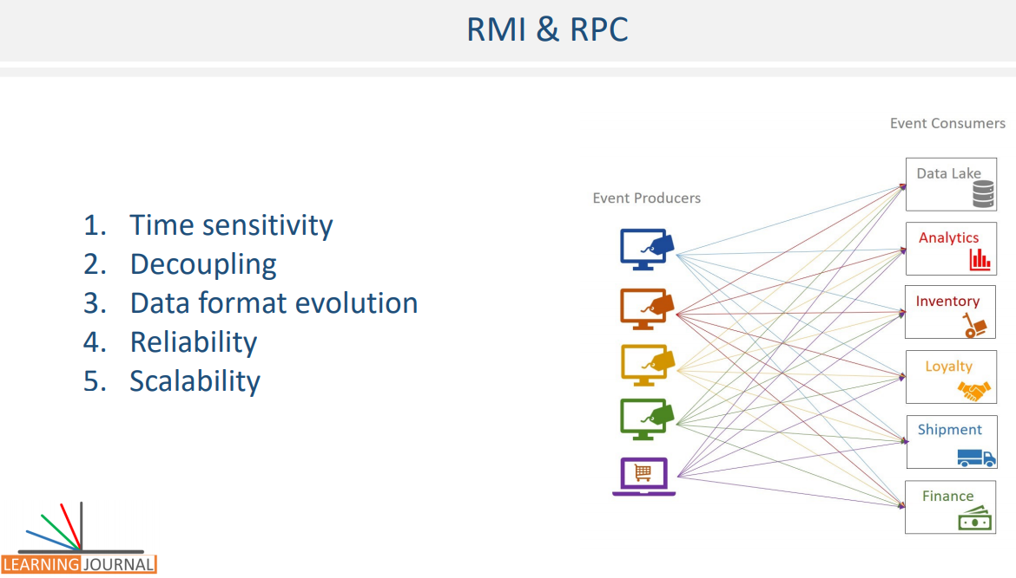

The third pattern of integrating data among applications is to use file transfer. File transfer is the most straightforward pattern for implementing data integration. The data producer application produces a file, and all the data consumer applications are supposed to consume the data files. The most obvious example is the export-import operations. These files could be XML, JSON or maybe a simple delimited file formats such as CSV. However, this approach is obviously not going to work for real-time requirements, and they fail on the time-sensitivity parameter. Generating files and handling them on-time may get you into many other trade-offs.

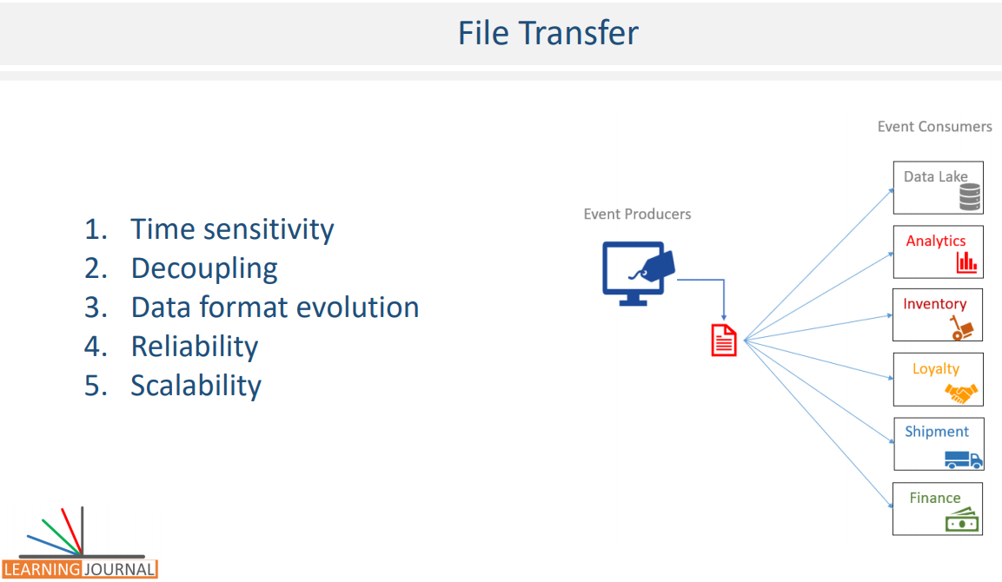

The final data integration pattern is the messaging system. As the name suggests, a messaging system is all about sending small chunks of data from one system to other systems. There are two approaches to messaging. Point to Point and Publish/Subscribe or pub/sub In a point-to-point messaging, each message is targeted for one consumer application. This option definitely doesn't meet our requirement. We have a one-to-many, so we simply reject PTP messaging. A publish/subscribe or pub/sub messaging system is built on the concept of publishers, broker, topic, and subscribers. Before we evaluate this option, let’s try to understand the components of a pub/sub messaging system and then we will determine if this approach fits our requirement on those five criterions.

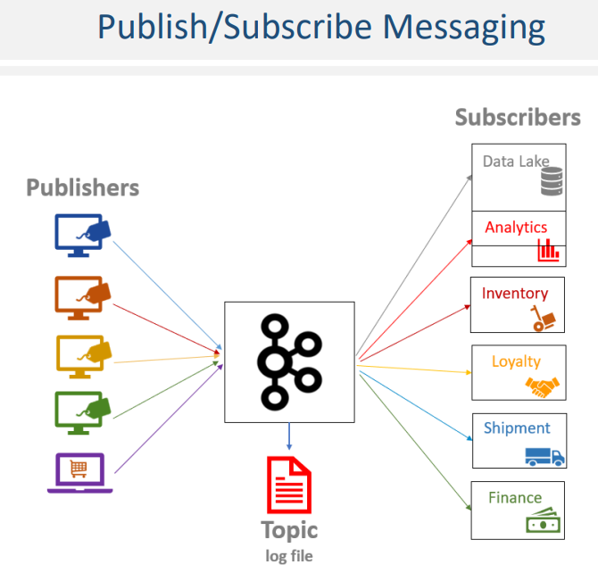

The first componenet of pub/sub messaging system is the publisher. Any application that sends data should act as a publisher. For our retail-chain example, the POS application works as a publisher, and it sends the invoices for other apps. People use different names such as data publisher, data producer, and sender, however, it means the same thing – a Publisher.

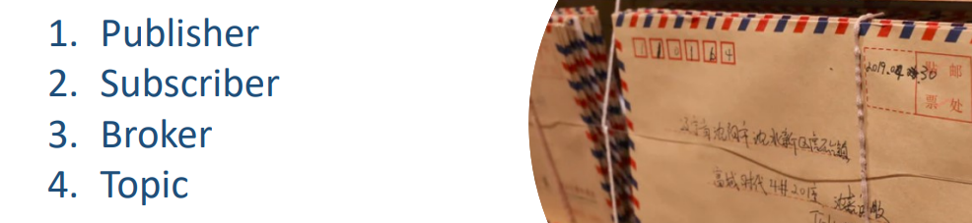

The second component of the pub/sub messaging system is subscribe. An application that reads data sent by the publisher is a subscriber. For our retail-chain example, services such as shipment and loyalty are subscribers. They read invoices that are sent by the POS systems. You might notice people referring to them as data consumers or receivers; however, all that means the same thing – a Subscriber. The next and main core component of pub/sub messaging sytem is the broker. The Broker is at the heart of the pub/sub messaging system. The broker sits in the middle of the publisher and subscriber. And acts as a middleman between them.

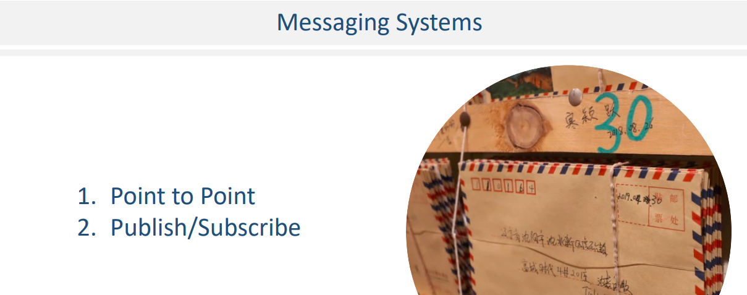

In other words, The Broker is responsible for receiving messages from the publishers, storing them into a log file, and sending the message to the subscibers. Any application that wants to send a message should send it to the Broker. The broker receives the message, sends an acknowledgment and persists the data into a log file. When a consumer application wants to read the message, they consume it from the broker. Finally, The Topic is another logical component in a pub/sub system. The Topic is nothing but a message namespace which offers a mechanism to categorize the messages. If you are coming from the database world, you can think of the topic as a table name. The producer always writes the message to a Topic, and the consumer reads it from the Topic. The broker creates a log file for each topic, and at the same time, the broker maintains multiple topics like a database that maintains numerous tables. When a producer sends a message, it specifies the topic name for the message and accordingly the broker persists the message in the corresponding log file. When a consumer wants to read the message, they ask the broker for the messages from the specified topic.

I hope you got some fundamental understanding of how a pub/sub messaging works. This course is about Kafka, and Apache Kafka adopted pub/sub messaging architecture to offer a streaming infrastructure. Why? Because pub/sub messaging wins on all five criterions over all other alternatives. Let's try to understand it. By adopting pub/sub schematics, Apache Kafka can become a circulatory system of your data ecosystem that carries messages to various members of the infrastructure. It occupies a central place in your real-time data integration infrastructure. The data producers can send data like messages, and they can send it to Kafka broker as quickly as the business event occurs. Data consumers can consume the messages from the broker as soon as they arrive at the broker.

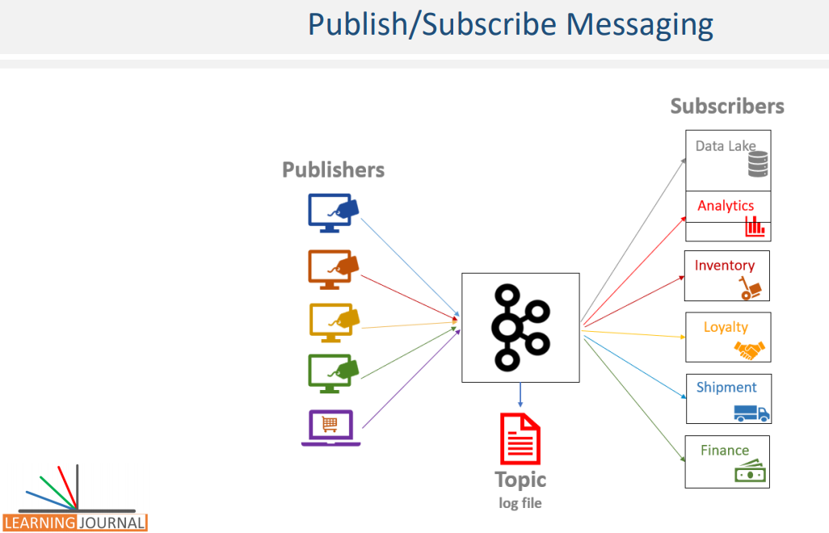

With careful design, the messages can reach from producers to consumers in milliseconds. The producers and consumers are completely decoupled, and they do not need tight coupling or direct connections. They always interact with the Kafka Broker using a consistent interface. The producers do not need to be concerned about who is using the data and they just send the data once without worrying about how many consumers would be reading the data. Producers and consumers can be added, removed, and modified as the business case evolves. When coupled with a system to provide message schema service and a connector service, the producer and consumers would have the flexibility to handle schema evolution. So, we understand that the pub/sub messaging systems qualifies for the first three decision criteria of time sensitivity, decoupling, and data format. However, we still need to ensure reliability and scalability. These two features are offered by Kafka architecture and design. Apache Kafka is not a traditional pub/sub messaging system. It is a distributed, fault tolerant and highly scalable system that is designed to provide the backbone infrastructure for real-time streaming requirements. Understanding the reliability and scalability features of Apache Kafka reqiures a deeper discussion.

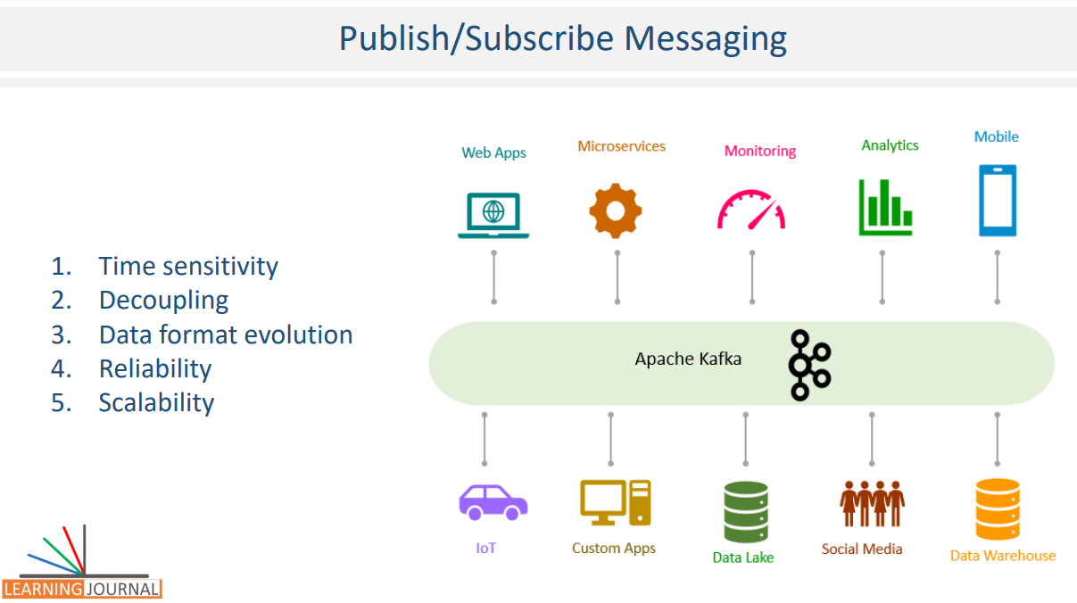

Let's quickly recap some of the main things that I talked in this section. How Big data started to emerge and Google's contribution to the Big data solution space, which resulted in Hadoop and other open source tools. How the expectations are growing for the need to handle time-sensitive data at speed and why it is fostering new innovations in real-time stream processing. How to start looking at your data as events and envisage it as a continuous stream of events. I also talked about a bunch of use cases to help you understand what the stream processing means and how it is being used in the industry. Finally, I explained the challenges associated with implementing streaming pipelines, we evaluated several patterns and concluded onto Apache Kafka to offer a streaming infrastructure backbone for your data ecosystem. Your technical know-how starts from the next section. I will fully dedicate the upcoming 4-5 lectures to talk about Kafka Architecture and some essential internals to understand how Kafka works in a scalable and reliable manner.

## Kafka Architecture

We learned that the messaging system is the most appropriate solution for creating real-time streams. I also mentioned that Apache Kafka implements the pub/sub messaging system and offers you a solution to create your real-time streaming ecosystem. In this section, we start exploring Kafka internals and some architectural concepts.

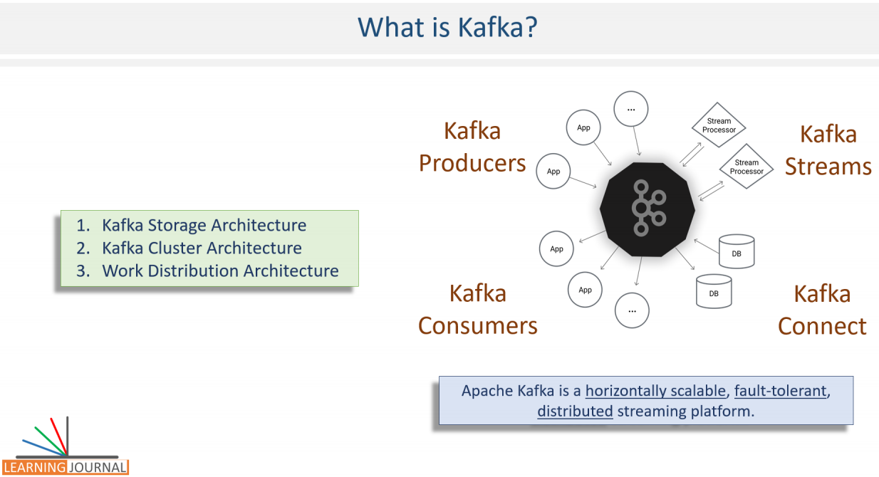

These fundamental concepts are critical for the rest of the course. So, even if you are already familier with Kafka, it is worth spending time to fill some potential gaps. Great, let's start. What is Apache Kafka? Think about it. You must be categorically sure about the answer. Apache Kafka is a Message Broker. That is all, everything else is an API, library, or a framework to either interact with the Kafka Broker or work with the data in real-time.

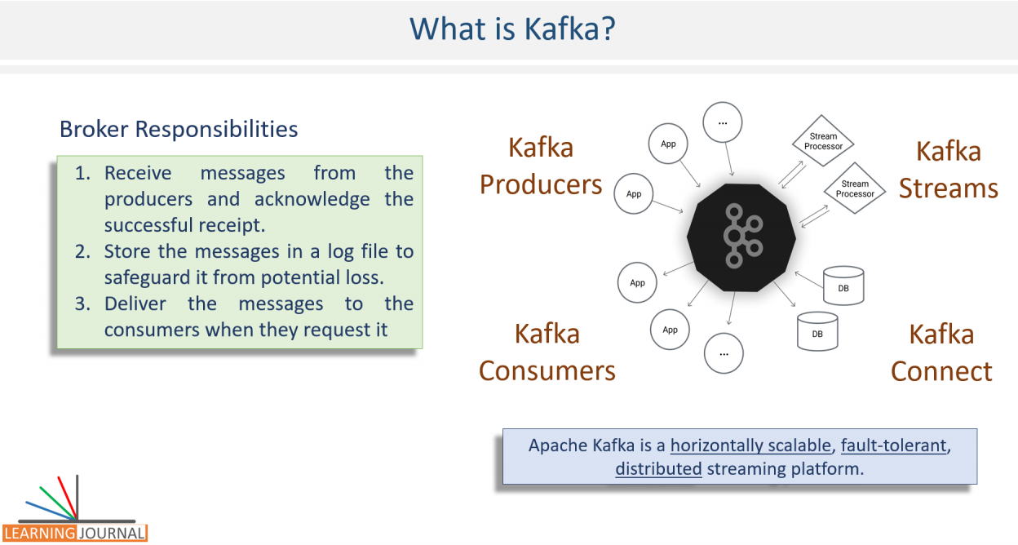

Kafka broker is a middleman between producers and the consumers, and it plays three primary responsibilities. Receive messages from the producers and acknowledge the successful receipt. Store the messages in a log file to safeguard it from potential loss. Storage is also critical to ensure that the consumers can consume it later and they do not necessarily need to read it in real-time. However, this is a real-time stream processing course, so you will be reading them in real-time. Finally, deliver the messages to the consumers when they request it. That's all at a high level. That's what Kafka Broker does. However, that's an oversimplified answer to the question about Kafka. A more elaborated answer could be something like this.

Apache Kafka is a horizontally scalable, fault-tolerant, distributed streaming platform, and it is consciously designed for building real-time streaming data architecture.

This new definition is a lot to understand. So, I break things into three parts to make it easy to understand. In the first part, I will talk about Kafka message storage architecture. This discussion will help you understand some core concepts such as Kafka topics, logs, partitions, replication factor, segments, offsets, and offset-index. Then we will move into Kafka Cluster Architecture. This discussion will help you understand some concepts associated with Cluster formation, Zookeeper, and the controller. Finally, we will tie-up these two architectures and try to understand how the work is distributed in the Kafka cluster. In this part, you will learn some concepts such as Leaders, Followers, In Sync Replicas, committed, and un-committed messages.

### Storage Architecture

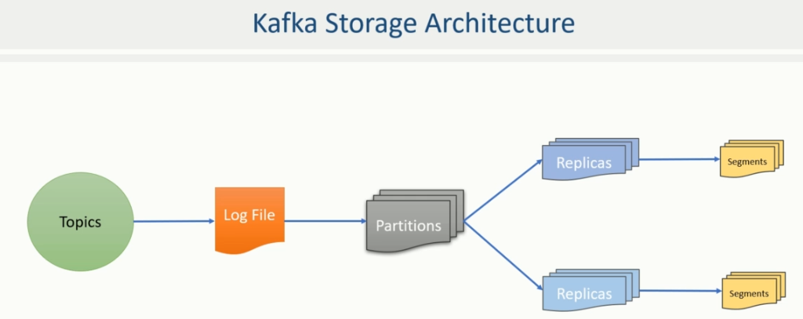

You already learned that Apache Kafka organizes the messages in Topics, and the broker creates a log file for each Topic to store these messages. However, these log files are partitioned, replicated, and segmented. In this lecture, I will not only explain but also show you the Kafka log file organization. So, this lecture is going to be a working session. Great! Let's start with a high-level concept of the Topic. What is a Kafka Topic? A Topic a logical name to group your messages. Like in a database, you must create a table to store your data records, In Kafka, you must create a topic to store messages. So, Let's create a Topic and see a few things in action. I have a three node Kafka Cluster running on my machine.

D:\2-Workspace\kafka-streaming>tree

Folder PATH listing for volume WORK

Volume serial number is 4844-CC41

D:.

└───01-storage-demo

├───.idea

├───scripts

└───src

├───main

│ ├───java

│ │ └───guru

│ │ └───learningjournal

│ │ └───kafka

│ │ └───examples

│ └───resources

└───test

└───java

Scripts folder contains the following files ( contents shown below their names )

**zookeeper-start.cmd**

zookeeper-server-start.bat %KAFKA_HOME%\config\zookeeper.properties

**0-kafka-server-start.cmd**

kafka-server-start.bat %KAFKA_HOME%\config\server-0.properties

**1-kafka-server-start.cmd**

kafka-server-start.bat %KAFKA_HOME%\config\server-1.properties

**2-kafka-server-start.cmd**

kafka-server-start.bat %KAFKA_HOME%\config\server-2.properties

**topic-create.cmd**

kafka-topics.bat --create

--zookeeper localhost:2181

--topic invoice

--partitions 5

--replication-factor 3

--config segment.bytes=1000000

**describe-topic.cmd**

kafka-topics.bat --describe --zookeeper localhost:2181 --topic invoice

I have configured things in a way that I can efficiently work from the IntelliJ IDEA, and I do not have to switch screens. I have also set all three brokers to use this tmp directory as a home directory. What does that mean? That means, everything that my Kafka brokers are going to create, will reside in this tmp directory. This arrangement makes things easy to watch and understand what is happening under the hood. My three node Kafka Cluster is up, and all three brokers are running. Let me show what we do we have inside the tmp directory. I have this zookeeper directory. Kafka needs Zookeeper, and I will explain it in a different video. However, for now, you can think of this directory as a Zookeeper data directory where the Zookeeper will store its data. Other three directories are the data directories of my three Kafka Brokers. Let me take you inside one of these. So these are some initial files. When a broker starts, it creates some initial files. Most of these files would be empty at this point. I haven't created any topic yet, so we do not have any file for a Topic. This is an initial state of the Kafka Broker.

We do not want to get into further details of these files. Our focus is to understand how Topic is organized at the broker level. So, we will create one topic and investigate these directories to know how a Topic is physically held at the broker. So, let's create a topic. Here is the command that I would use to create a Kafka Topic. kafka-topics is a shell script on Linux machine and a batch script on a windows machine. Rest all are arguments to the command. The first argument is to tell Kafka that we want to create a topic. The second argument is the zookeeper coordinates. The third argument is the name of the Topic. These three arguments are mandatory and fundamental arguments for the command to work. When you create a topic in Apache Kafka, you must specify two more configurations. Number of Partitions Replication Factor

**topic-create.cmd**

kafka-topics.bat --create

--zookeeper localhost:2181

--topic invoice

--partitions 5

--replication-factor 3

--config segment.bytes=1000000

If you do not provide these parameters, Kafka assumes a default value, but every Topic must have some value for these two parameters. Let's execute this command, and then I will talk about the partitions and replication factor. Great! Topic creation is complete.

Now, Let me talk about the Topic Partition. What are they? In Kafka, a single topic may store millions of messages, and hence, it is not practical to keep all those messages in a single file. The topic partitions are a mechanism to break the Topic further into smaller parts. Right?

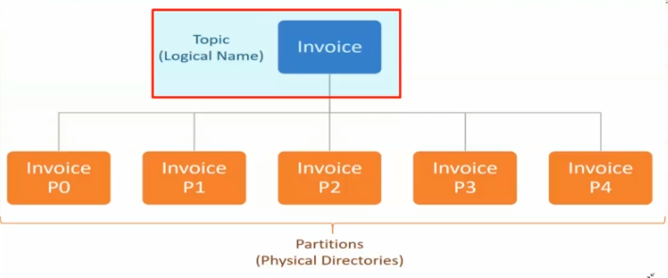

But what does it mean for Apache Kafka? For Apache Kafka, a partition is nothing but a physical directory. What does it mean? It means a simple thing. Apache Kafka creates a separate directory for each topic partition. I created a topic for invoices and specified five partitions, that means, Kafka will create five directories for the invoice topic. You can see it here. We got five new directories because we created five partitions for the invoice topic. So, Kafka topic partitions are nothing but directories. You create a Topic with 3 partitions, Kafka broker will create three directories. You ask for 10 partitions, the broker will create ten directories. Simple. Isn't it. I hope you got some sense about Kafka Topic Partitions.

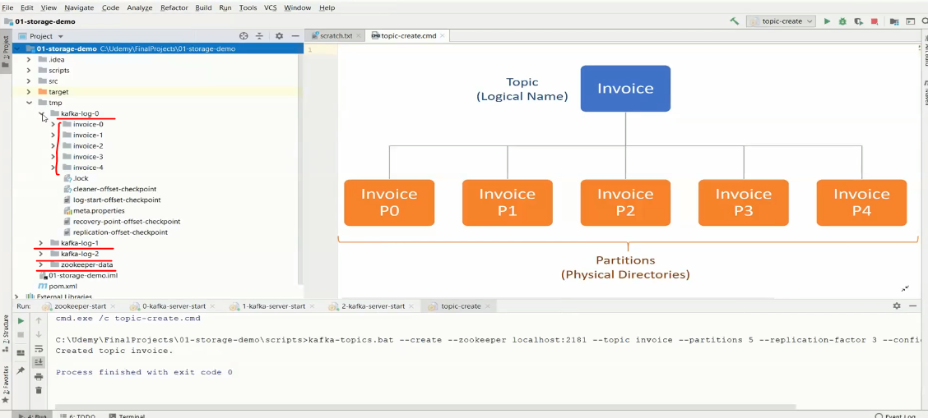

Now the next thing that I want to talk about is the Replication factor. What is the replication factor? The replication factor specifies how many copies do you want to maintain for each partition.

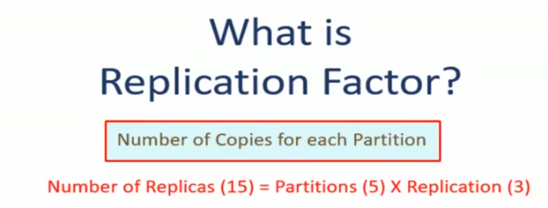

That simply means the replication factor multiplies to the number of partitions. For example, we created one topic for Invoices. While creating the Topic, we specified the number of partitions as five and a replication factor as three. In this case, Kafka should create fifteen directories. The calculation is simple. We wanted to produce five partitions and maintain three copies of each partition, and that makes fifteen directories. But where are they? But where are they? I showed you only five directories. Where are the other ten directories? They are created on the other brokers.

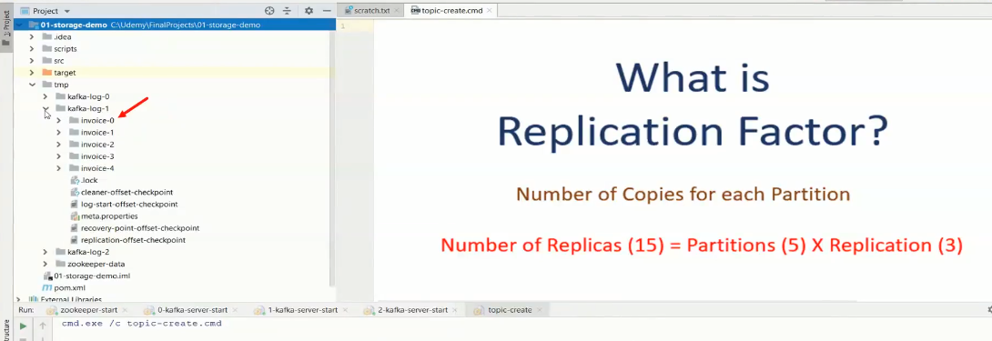

So if you look at the other two broker homes, they also have those five directories. Altogether, we have five partitions on each broker, and in total, we have fifteen directories. We term these directories as a partition replica. How do I name them? Well, I can call it as - the First replica of partition zero. Second replica of partition zero, third replica of partition zero. Similarly, we have three replicas of partition 1 and so on. Great! So we understand that the number of partitions and replication factor multiplies and results into directories. And we call them as partition replicas. In our example, we have fifteen partition replicas. All these fifteen directories are the part of the same Topic, but they are distributed among the available brokers. I will talk about the distribution logic in a separate video. For now, I want to talk about the classification of the partition replicas. So, We can classify Topic partition replicas into two categories. Leader Partitions and Follower Partitions

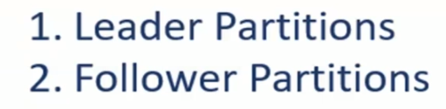

While creating the Topic, we specified the number of partitions as five, and Kafka creates five directories. These five directories are called the Leader Partitions. So, the leaders are created first. Then we also specified the replication factor as three. That means Kafka should ensure three copies for each of these five partitions. One is already there, the leader, hence Kafka creates two more directories for each leader, and we call these copies as Followers. Remember, the follower is a duplicate copy of the leader.

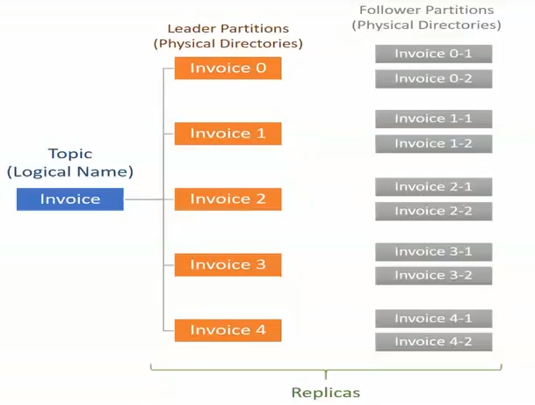

And all of them are nothing but directories. If you want to know, which one is the leader and which ones are followers, you can use Kafka topics command once again to describe the Topic. The output clearly tells, where does the leader reside for the given partition.

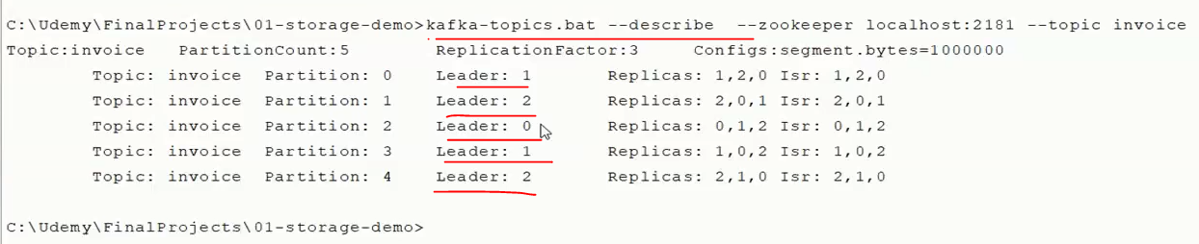

This number is the broker id that holds the leader partition for partition id 0. We will learn more about leaders and followers in further lectures. However, at this stage, it is essential to understand that there are leader partitions that are followed by several followers. The number of follower partition depends on the replication factor. Great! So we are done with the directories. These directories are there to hold log files where messages are stored. So the next thing I want to talk about is the log file. The messages are stored within the directories in the log files. However, instead of creating one large file in the partition directory, Kafka creates several smaller files. That means the Kafka log file is split into smaller files known as segments. Let me show you the first segment file. Here is the first log segment file. Every topic partition would create the first log segment file, and you can see them in each partition.

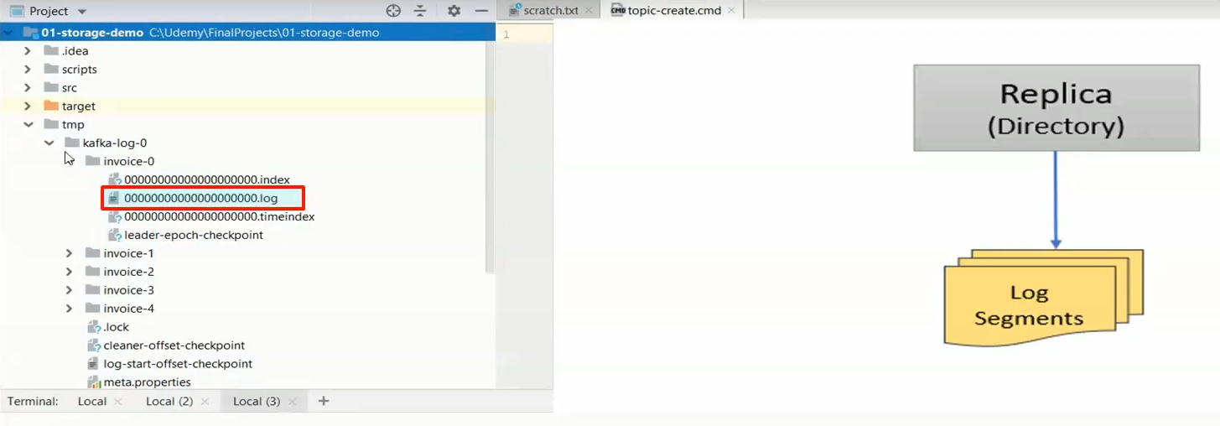

Source code

**AppConfigs.java**

package guru.learningjournal.kafka.examples;

class AppConfigs {

final static String applicationID = "StorageDemo";

final static String bootstrapServers = "localhost:9092,localhost:9093";

final static String topicName = "invoice";

final static int numEvents = 500000;

}

**StorageDemo.java**

package guru.learningjournal.kafka.examples;

import org.apache.kafka.clients.producer.KafkaProducer;

import org.apache.kafka.clients.producer.ProducerConfig;

import org.apache.kafka.clients.producer.ProducerRecord;

import org.apache.kafka.common.serialization.IntegerSerializer;

import org.apache.kafka.common.serialization.StringSerializer;

import org.apache.logging.log4j.LogManager;

import org.apache.logging.log4j.Logger;

import java.util.Properties;

public class StorageDemo {

private static final Logger logger = LogManager.getLogger();

public static void main(String[] args) {

logger.info("Creating Kafka Producer...");

Properties props = new Properties();

props.put( ProducerConfig.CLIENT_ID_CONFIG, AppConfigs.applicationID );

props.put( ProducerConfig.BOOTSTRAP_SERVERS_CONFIG, AppConfigs.bootstrapServers );

props.put( ProducerConfig.KEY_SERIALIZER_CLASS_CONFIG,

IntegerSerializer.class.getName());

props.put( ProducerConfig.VALUE_SERIALIZER_CLASS_CONFIG,

StringSerializer.class.getName());

KafkaProducer<Integer, String> producer = new KafkaProducer<>(props);

logger.info("Start sending messages...");

for (int i = 1; i <= AppConfigs.numEvents; i++) {

producer.send( new ProducerRecord<>( AppConfigs.topicName, i,

"Simple Message-" + i));

}

logger.info("Finished - Closing Kafka Producer.");

producer.close();

}

}

**pom.xml**

<?xml version="1.0" encoding="UTF-8"?>

<project xmlns="http://maven.apache.org/POM/4.0.0"

xmlns:xsi="http://www.w3.org/2001/XMLSchema-instance"

xsi:schemaLocation="http://maven.apache.org/POM/4.0.0 http://maven.apache.org/xsd/maven-4.0.0.xsd">

<modelVersion>4.0.0</modelVersion>

<groupId>guru.learningjournal.kafka.examples</groupId>

<artifactId>storage-demo</artifactId>

<version>2.3.0</version>

<properties>

<java.version>1.8</java.version>

<kafka.version>2.3.0</kafka.version>

</properties>

<build>

<plugins>

<!-- Maven Compiler Plugin-->

<plugin>

<groupId>org.apache.maven.plugins</groupId>

<artifactId>maven-compiler-plugin</artifactId>

<version>3.8.0</version>

<configuration>

<source>${java.version}</source>

<target>${java.version}</target>

</configuration>

</plugin>

</plugins>

</build>

<dependencies>

<!-- Apache Kafka Clients-->

<dependency>

<groupId>org.apache.kafka</groupId>

<artifactId>kafka-clients</artifactId>

<version>${kafka.version}</version>

</dependency>

<!-- Apache Log4J2 binding for SLF4J -->

<dependency>

<groupId>org.apache.logging.log4j</groupId>

<artifactId>log4j-slf4j-impl</artifactId>

<version>2.11.0</version>

</dependency>

</dependencies>

</project>

Now we start sending messages and see what happens next. Let me execute my producer program. I am configuring my producer to send half a million short messages. Average message size is roughly twenty bytes. Let's run it. Finished. Quick isn't it.

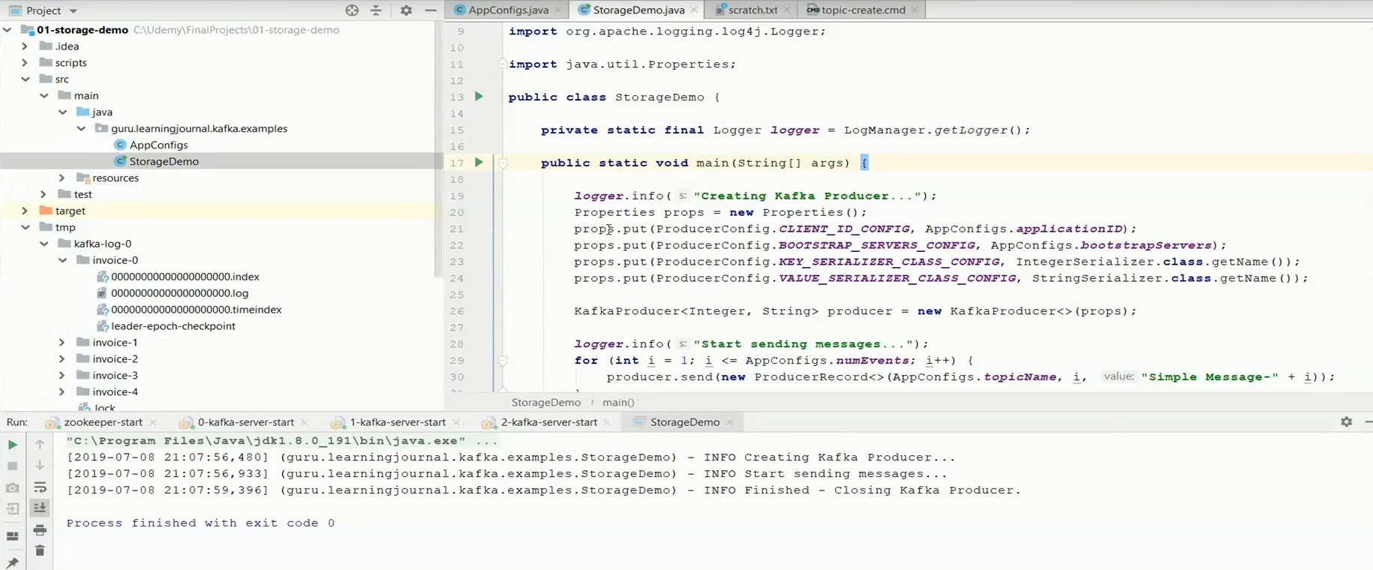

Now you can see a bunch of log segment files. But how it happens? The next important thing to understand is the logic behind the splitting of segment files. Let's try to understand how this split happens. When the partition receives its first message, it stores the message in the first segment. The next message also goes in the same segment, and the segment file continues to grow until the maximum segment limit is reached.

|  |  |
| --- | --- |
|  | As the Kafka broker is writing to a partition, if the segment limit is reached, they close the file and start a new one. That's how we get multiple segment files in each partition directory. The default maximum segment size is either 1 GB of data or a week of data, whichever is smaller. I configured the maximum segment size as 1 MB, and hence, I got multiple segments. Otherwise, this split happens only after one GB limit is reached. Great! So you now understand the log segment. Let's move to the next item. There is one critical thing to understand about the Kafka messages. Each Kafka message in the partition is uniquely identified by a 64-bit integer offset. Every Kafka message within a single partition is uniquely identified by the offset. |

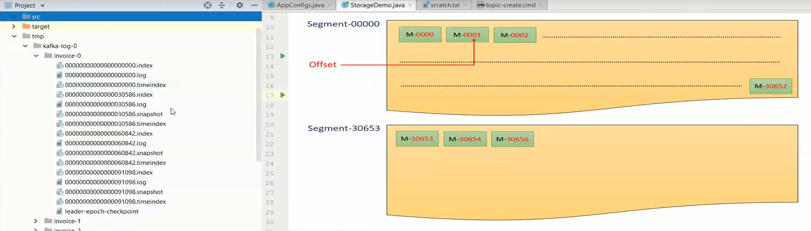

For example, the offset for the first message in the partition would be 0000, the offset for the second message would be 0001 and so on. This numbering also continues across the segments to keep the offset unique within the partition. Let’s consider that the offset of the last message in the first segment is 30652. Assume that the maximum segment limit is reached. so the Kafka should close this segment and create a new segment file for the next message. The offset of the first message in the new segment continues from the earlier segment and hence, the offset of the first message in the second segment would be 30653. For easy identification, the segment file name is also suffixed by the first offset in that segment. And you can see that here. You should remember that the offset is unique within the partition. If you look across the partitions, the offset starts from zero in each partition. Hence the offset is a 64-bit integer giving a unique ID to the message in a given partition. Since the offsets are not unique across the topic, if you want to locate a specific message, you must know at least three things. Topic name, Partition number, and then the Offset number.

|  |  |
| --- | --- |
|  | At first sight, this arrangement of uniqueness looks strange. Let me explain. If you think in database terms, this unique identification does not make a good sense for locating the messages. Topic name is like a table name in the database. But partition and offset are just numbers. In database applications, we may want to access data on some critical columns such as invoice_number, customer_name, or customer_id. However, you cannot do that in Kafka because messages are not structured into column names. And that's why this arrangement of uniqueness looks strange. However, this numbering may not be a problem for a real-time stream processing application. How? |

Let's take an example to understand it. In a stream processing application, the requirement is different. A stream processing application wants to read all messages in a sequence. Let's assume that you have a stream processing application that computes loyalty points for the customer in real-time. The application should read each invoice and calculate loyalty points. While computing loyalty points, you need customer_id and the amount, but you must read all the events. Let's look at the sequence of activities. The application connects to the broker and asks for the messages starting from the offset 0000. Let's assume the broker sends ten messages to the application. The application takes a few milliseconds to compute loyalty points on those ten invoices.

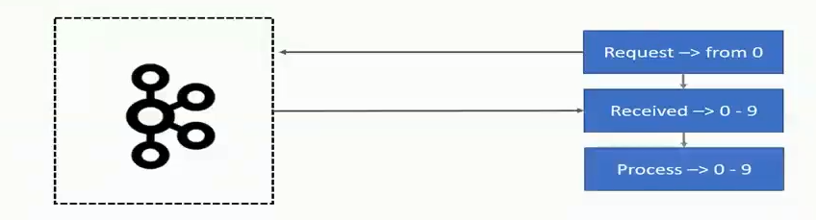

Now it is again ready to process a few more messages. So, it goes back to the broker and requests for more messages starting from offset 0010. The broker provides another batch of fifteen messages

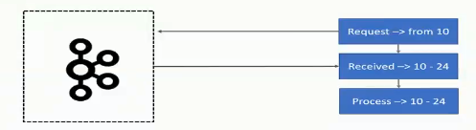

Next time, the application requests for another set of messages starting from the offset 0026. This process continues for the life of the application. The process explained in this example is the typical pattern of how a stream processing application would work. In this process, you must have noticed that the consumer application is requesting messages based on the offset. The point is straightforward. Kafka allows consumers to start fetching messages from a given offset number. This means, if consumer demands for messages beginning at offset 100, the broker must be able to locate the message for offset 100. To help brokers rapidly find the message for a given offset, Kafka maintains an index of offsets. The index files are also segmented for easy management, and they are also stored in the partition directory along with the log file segments. You can see them here. Finally, the last thing in this lecture.

**The time index.** Kafka allows consumers to start fetching messages based on the offset number. However, in many use cases, you might want to seek messages based on timestamp. These requirements are as straightforward as you want to read, all the events that are created after a specific timestamp. To support such needs, Kafka also maintains a timestamp for each message builds a time index to quickly seek the first message that arrived after the given timestamp. The time index is like the offset index, and it is also segmented and stored in the partition directory along with the offset index and log file segment.

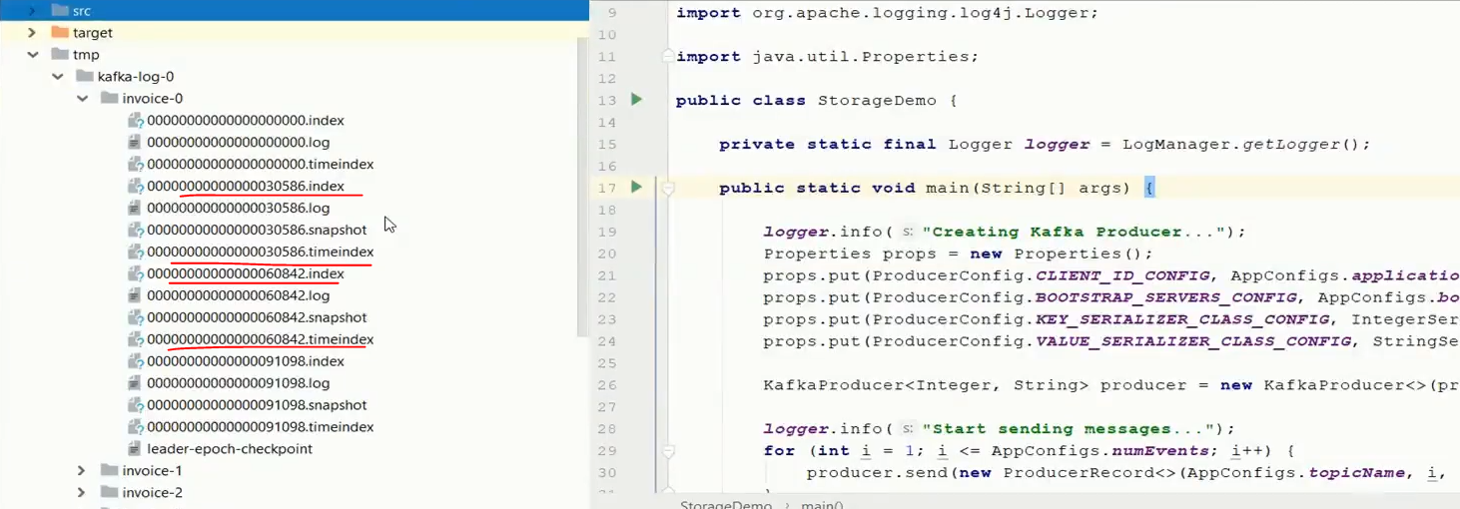

You might see a few other types of files in the partition directory. But those files have nothing to do with the data. Kafka creates those files to keep some control information and clean them from time to time. We do not care much about those files.

### Kafka Cluster Architecture

In the previous lecture, we learned about the Kafka broker as an individual entity and how the Kafka topics are logically organized. The next logical step is to look at the scalability side of Apache Kafka and how Kafka Cluster is formed. Let's start. Kafka brokers are often configured to form a Cluster. A Cluster is nothing but a group of brokers that work together to share the workload, and that's how Apache Kafka becomes a distributed and scalable system.

|  |  |
| --- | --- |
|  | You can start with a single broker in your development environment and deploy a cluster of three or five brokers in your production environment. Later, as the workload grows, you can increase the number of brokers in the cluster. It can grow up to hundreds of brokers in a single cluster. However, the notion of clustering brings out two critical questions. Who manages cluster membership? Who performs the routine administrative tasks in the cluster? Let's try to understand the questions and then we will get into the answer. In a typical distributed system, there is a master node that maintains a list of active cluster members. The master always knows the state of the other members. The first question is about the master node? Who manages the list of active brokers, and how does it know that a broker has possibly crashed, or a new broker has recently joined the cluster? The second question is also related to the administrative activities that are typically performed by the master in a clustered environment. Let's try to understand this question with an example. Suppose a broker is active and it is taking care of some responsibilities in the cluster. |

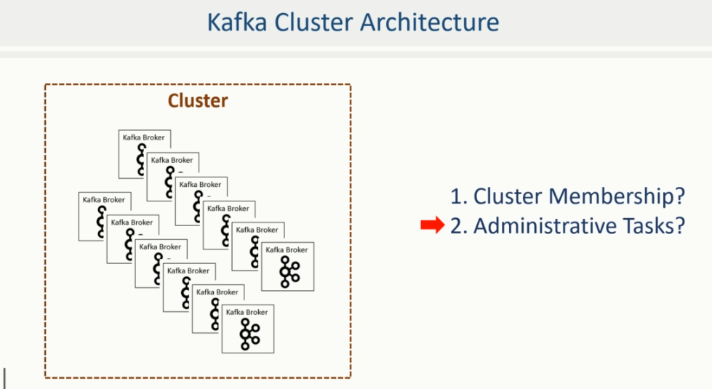

|  |  |
| --- | --- |
|  | Suddenly the broker leaves the cluster or dies for some reason. Now at this stage, who will perform those responsibilities? We need someone to reassign that work to an active broker to ensure that the cluster continues to function. I hope you understand the meaning of these two questions. Let's try to explain the answers. Kafka broker is a master-less cluster.  It does not follow a master-slave architecture. However, it uses Apache Zookeeper to maintain the list of active brokers. Every Kafka Broker has a unique_id that you define in the broker configuration file. We also specify the Zookeeper connection details in the broker configuration file. When the broker starts, it connects to the Zookeeper and creates an ephemeral node using broker_id to represent an active broker session. |

The ephemeral node remains intact as long as the broker session with the Zookeeper is active. When a broker loses connectivity to the Zookeeper for some reason, the Zookeeper automatically removes that ephemeral node. So, the list of active brokers in the cluster is maintained as the list of ephemeral nodes under the /brokers/ids path in the Zookeeper. I can show you that list. You can start a Zookeeper shell using this command.

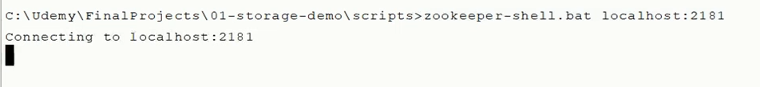

Great, I am connected to the Zookeeper of my Kafka cluster. I can easily look at what we have in the zookeeper database. Let me issue the ls command. Great! We have these many hierarchies.



But I am interested in brokers. So, let's check brokers. Ok, so let's look into the ids. Great!

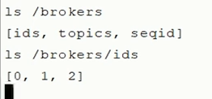

So I have 0, 1, and 2. Three brokers in this cluster. What if I bring one broker down. Let me stop broker id 1. Broker id one is gone from the Zookeeper.

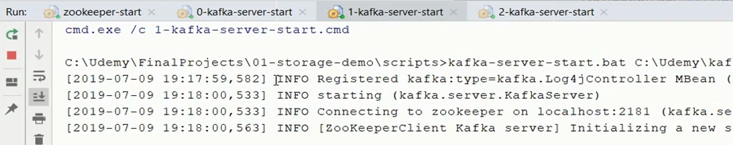

Let me start the broker one again. Great! So this is how Kafka maintains the list of brokers in a cluster.

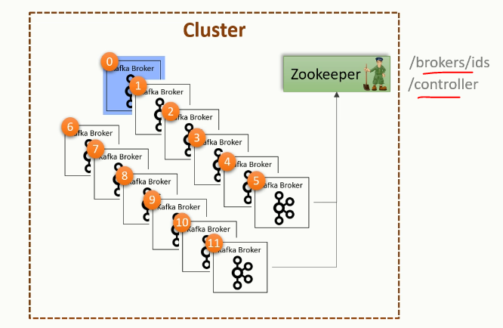 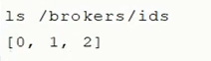

The list of active brokers in the cluster is maintained as the list of ephemeral nodes under the /brokers/ids path in the Zookeeper. Let's move on to the next question. Kafka is a master-less cluster, and the list of active brokers is maintained in the Zookeeper. However, we still need someone to perform the routine administrative activities such as monitoring the list of active brokers and reassigning the work when an active broker leaves the cluster. All those activities are performed by a Controller in the Kafka cluster. The controller is not a master. It is simply a broker that is elected as a controller to take up some extra responsibilities. That means, the controller also acts as a regular broker. So, if you have a single node cluster, it serves as a controller as well as a broker. However, there is only one controller in a Kafka cluster at any point in time. The controller is responsible for monitoring the list of active brokers in the Zookeeper. When the controller notices that a broker left the cluster, it knows that it is time to reassign some work to the other brokers.

The controller election is straightforward. The first broker that starts in the cluster becomes the controller by creating an ephemeral (/controller) node in Zookeeper. When other brokers start, they also try to create this node, but they receive an exception as "node already exists," which means that the controller is already elected. In that case, they start watching the /controller node in the Zookeeper to disappear. When the current controller dies, the ephemeral node disappears. Now, every broker again tries to create the /controller node in the Zookeeper, but only one succeeds, and others get an exception once again. This process ensures that there is always a controller in the cluster, and there exists only one controller. Let me show you this thing in real.

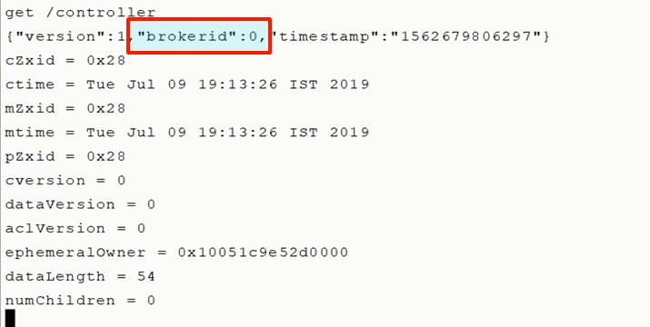

I have a three node cluster. If I ls the root directory of Zookeeper, I can see that there is a controller node already created. So we have a controller elected for this cluster. And that's obvious. But who is the controller? Let's query the controller note. Great! So broker id 0 is the controller. What if I bring that broker down? Let me query it again. Now we have a new controller. Let me bring that poor broker back up. Good. But now, his controllership is already gone so even if the broker comes back, then it doesn't become a controller.

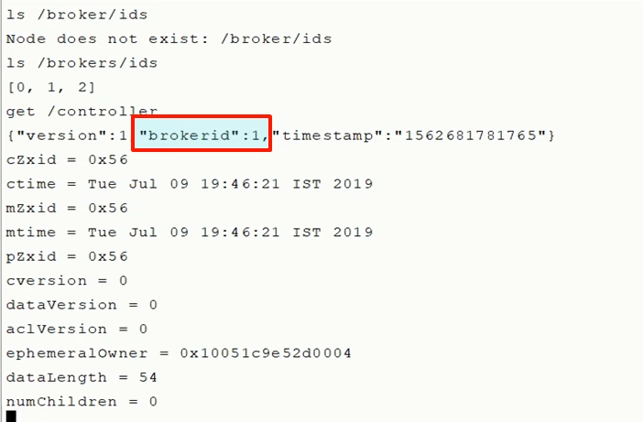

Someone else is already elected as a controller. Great! So that's how the Kafka cluster is managed. Just to summarize, Zookeeper is the database of the Kafka cluster control information. And one of the broker in the cluster is elected to take up the responsibilities of the controller and take care of the cluster level activities.

### Work Distribution Architecture

The next logical step is to tie up the relationship between these two dimensions and understand how the work is distributed among the brokers in a Kafka cluster. Primarily, we want to understand what makes Kafka a scalable and fault tolerant system. If you look at the Kafka topic organization, it is broken into independent partitions. Each partition is self-contained. What I mean is simple. All the information about the partition, such as segment files and indexes are stored inside the same directory.

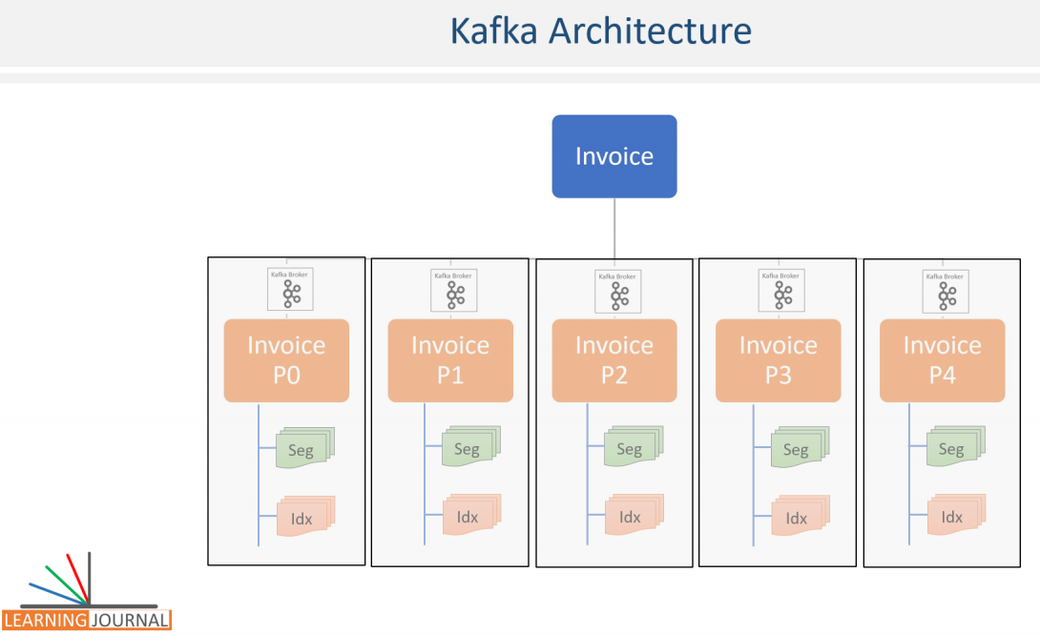

This structure is excellent because it allows us to distribute the work among Kafka brokers in a cluster efficiently. All we need to do is to spread the responsibility of partitions in the Kafka cluster. The point is straightforward. When you create a topic, the responsibility to create, store, and manage partitions is distributed among the available brokers in the cluster. That means every broker in the cluster is responsible for managing one or more partitions that are assigned to that broker. And that is how the work is shared by the brokers. Having said that, let's try to understand it with the help of an example. Kafka cluster is a group of brokers. These brokers may be running on individual machines. In a large production cluster, you might have organized those machines in multiple racks.

This diagram shows a six-node cluster that is designed using two racks. Now, I have a simple question. How are the partitions allocated to brokers? I mean, how we decide, which broker should be maintaining which partition?

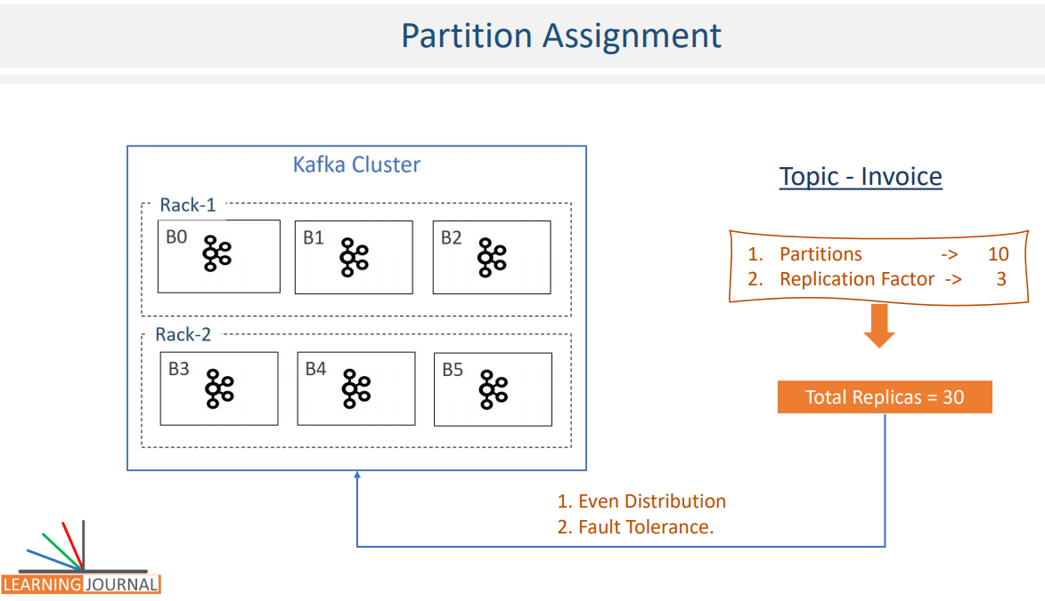

Are there any rules for assigning work among the brokers? Let me explain this. Suppose you have 6 brokers and you placed them into two different racks as shown in the Figure. You decide to create a topic with 10 partitions and a replication factor of 3. That means, Kafka now have 30 replicas to allocate to 6 brokers. Are there any rules for the assignment? Well, Kafka tries to achieve two goals for this partition allocation. Partitions are distributed evenly as much as possible, to achieve workload balance. Follower partitions, I mean duplicate copies must be placed on different machines to achieve fault tolerance. That's it. Just two goals. These are not rules, but you can take them as a goal that Kafka would want to achieve. Now let's see how it gets distributed. The rule part of it, right? To distribute our 30 partitions, Kafka applies the following steps.

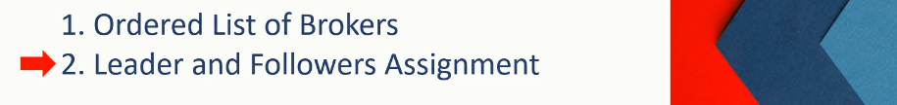

Make an ordered list of available brokers. and then Assign Leaders and Followers to the list in order. Let's apply the first rule. Kafka begins with a randomly chosen broker in a rack and places it into a list. Let's assume we start with B0. Now we have one item on the list. The next broker in the list must be from a different rack. So, let's assume Kafka picks B3. Now we have two brokers in the ordered list. The next one again comes from the first rack. Let`s say, this time it is B1. This goes on as an alternating process for selecting another broker in a different rack. So, we take B4, then B2 and finally B5. That's all. You have an ordered list of brokers. Now we come to the second step. Assigning partitions to this list. We have 30 partitions to allocate to these six brokers. Ideally, Kafka should place five partitions on each broker to achieve the first goal of evenly distributing the partitions.

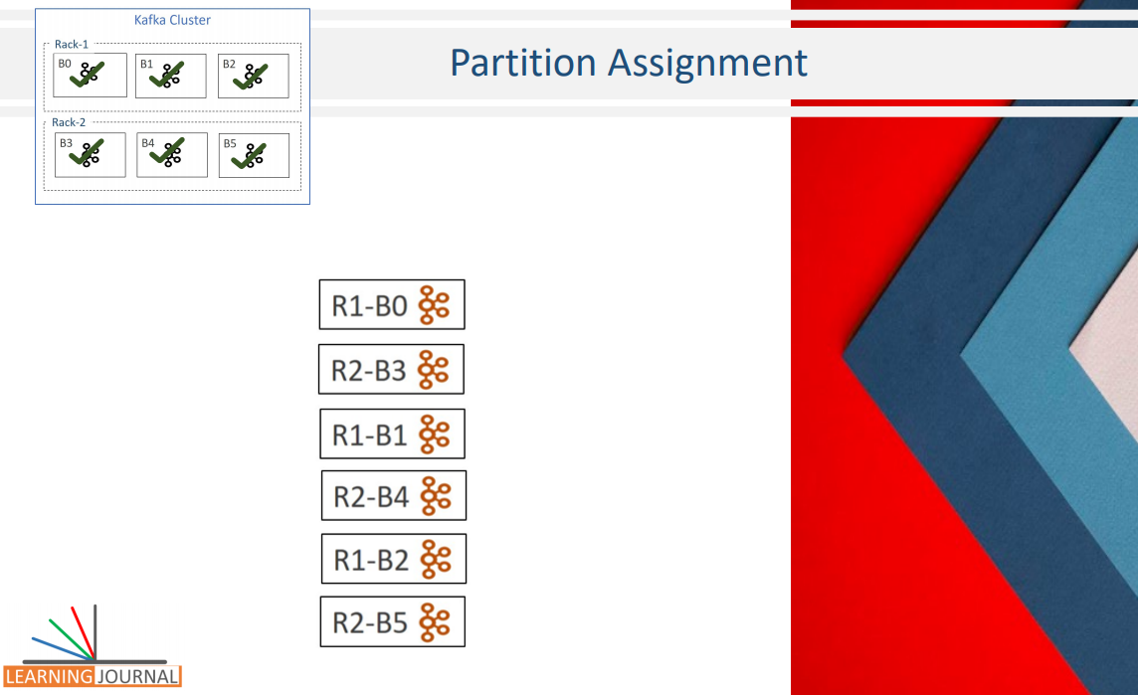

However, we have another goal to achieve fault tolerance. What is fault tolerance? It is as simple as making sure that if one broker fails for some reason, we still have a copy on some other broker. Further, making sure that if the entire rack fails, we still have a copy on a different rack. We can achieve fault tolerance by merely placing duplicate copies on different machines. For example, the first partition has three copies. All we need to do is to make sure that those three copies are not allocated to the same broker in the above list. How Kafka does that? Let's see the step by step process. Once we have the ordered list of available brokers, assigning partitions is as simple as assign one to each broker using a round robin method. Kafka starts with the leader partitions and finishes creating all leaders first. So, we take the leader of the P0 and assign it to B0, the leader of P1 goes to B3, the leader of P2 lands on B1 and so on.

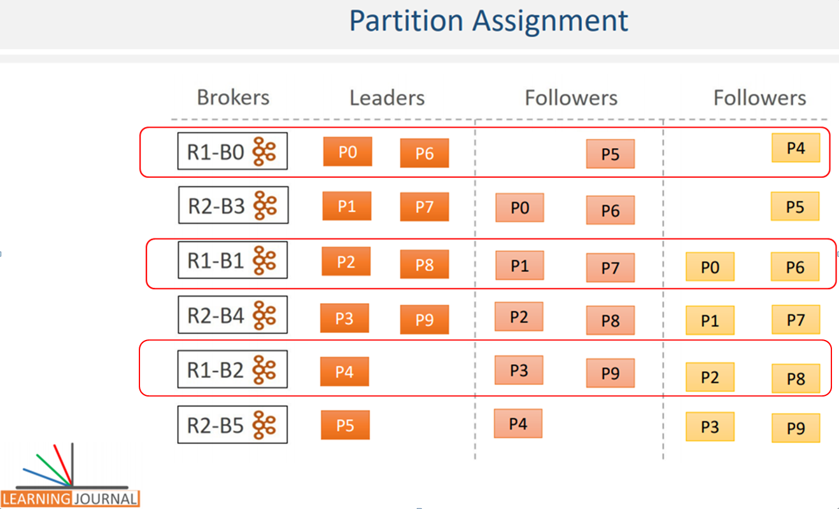

Once the leader partitions are created, it starts creating the first follower. Fist follower allocation simply starts from the second broker in the list and follows a round robin approach. So, we skip the first broker in the list and place the first follower of P0 to B3, the first follower of P1 goes to B1. Similarly, the first follower of P2 goes to B4, and so on others are also created. Finally, it begins with the list of the second follower and maps them to the same broker list by jumping one more broker from the previous start. So, the second follower of P0 goes to B1, and similarly, others are also created. Great! We are done.

This is what happens when you create a topic. Leaders and followers of the topic are created across the cluster. If you look at the outcome of this allocation, we couldn't achieve a perfectly even distribution. The broker B0 has got four, and the B4 has got six partitions. However, we made an ideal fault tolerance at the price of little disparity. Let's quickly check the fault tolerance level. The leader of the fourth partition is placed at the B2 that sits in the first rack. However, the first follower P4 goes to a different rack at broker B5. So, even if one of the racks is entirely down, we still have at least one copy of the P4 available on the other rack. Similarly, the second follower is placed at a different broker B0. So, even if two brokers are down, we will still have at least one broker available to serve the P4. You can validate it for other partitions as well. They all are well arranged in a way that at least two copies are placed on two different racks. This arrangement is ideal for fault tolerance. Great! So we learned how the replicas are distributed among the brokers in the cluster, making the system fault tolerant. However, Distributing the replicas among the brokers is the first half of the work distribution. The second half of the problem is to define the responsibility of an individual broker.

### Work Distribution Architecture – 2

In the previous session, we learned how the replicas are distributed among the brokers in the cluster. In this lecture, I will talk about the responsibilities of the leader and the followers. So, let's start. We learned that the broker manages two types of partitions. Leader partition and Follower partition Depending upon the partition type, a typical broker performs two kinds of activities. Leader Activity and Follower Activity



Let's try to understand it. In the example, we allocated 30 replicas among six brokers. Now each broker owns multiple replicas. For example, the broker 4 holds six replicas. Two of these replicas are the leader partitions, and the remaining four are the follower partitions. So, the broker acts as a leader for the two leader partitions, and it also works as a follower for the remaining four follower partitions. What does that mean? Let's try to understand, what does it mean by a broker to act as a leader. Regarding Kafka broker, being a leader means one thing.

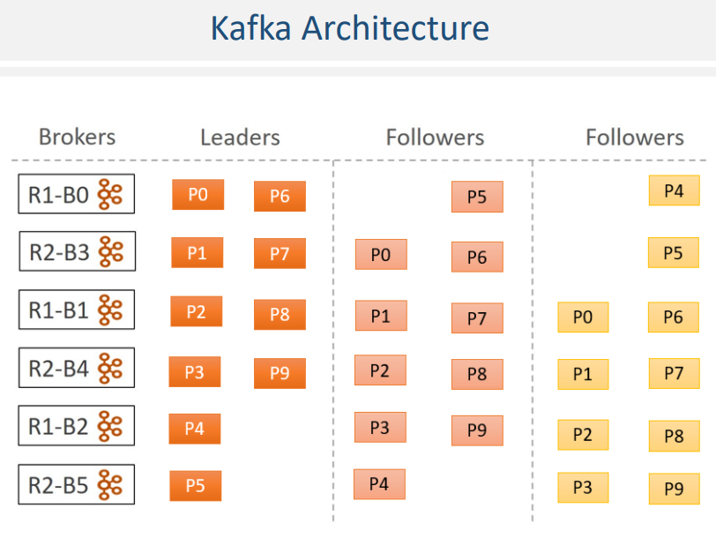

The leader is responsible for all the requests from the producers and consumers. For example, Let's assume that a producer wants to send some messages to a Kafka topic. So, the producer will connect to one of the brokers in the cluster and query for the topic metadata. All Kafka brokers can answer a metadata request, and hence the producer can connect to any of the broker and query for the metadata. The metadata contains a list of all the leader partitions and their respective host and port information.

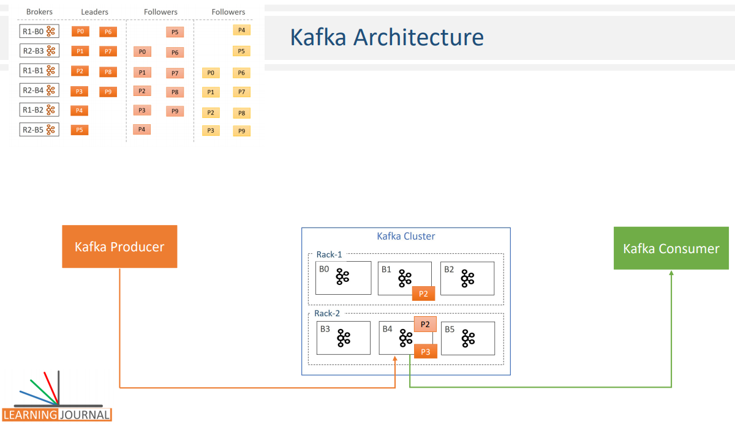

Now the producer has a list of all leaders. It is the producer that decides on which partition does it want to send the data, and accordingly send the message to the respective broker. That means, the producer directly transmits the message to a leader. On receiving the message, the leader broker persists the message in the leader partition and sends back an acknowledgment. Similarly, when a consumer wants to read messages, it always reads from the leader of the partition. We will learn more details about the producer and consumer interaction in the next section. However, at this stage, you should be clear that the producer and the consumer always interact with the leader. And that's what is the responsibility of the leader broker. Interact with the producer and the consumer. Now, let's come back to the follower. Kafka broker also acts as a follower for all the follower partitions that are allocated to the broker. In the figure, the broker B4 owns four follower partitions and hence the B4 acts as a follower for these replicas.

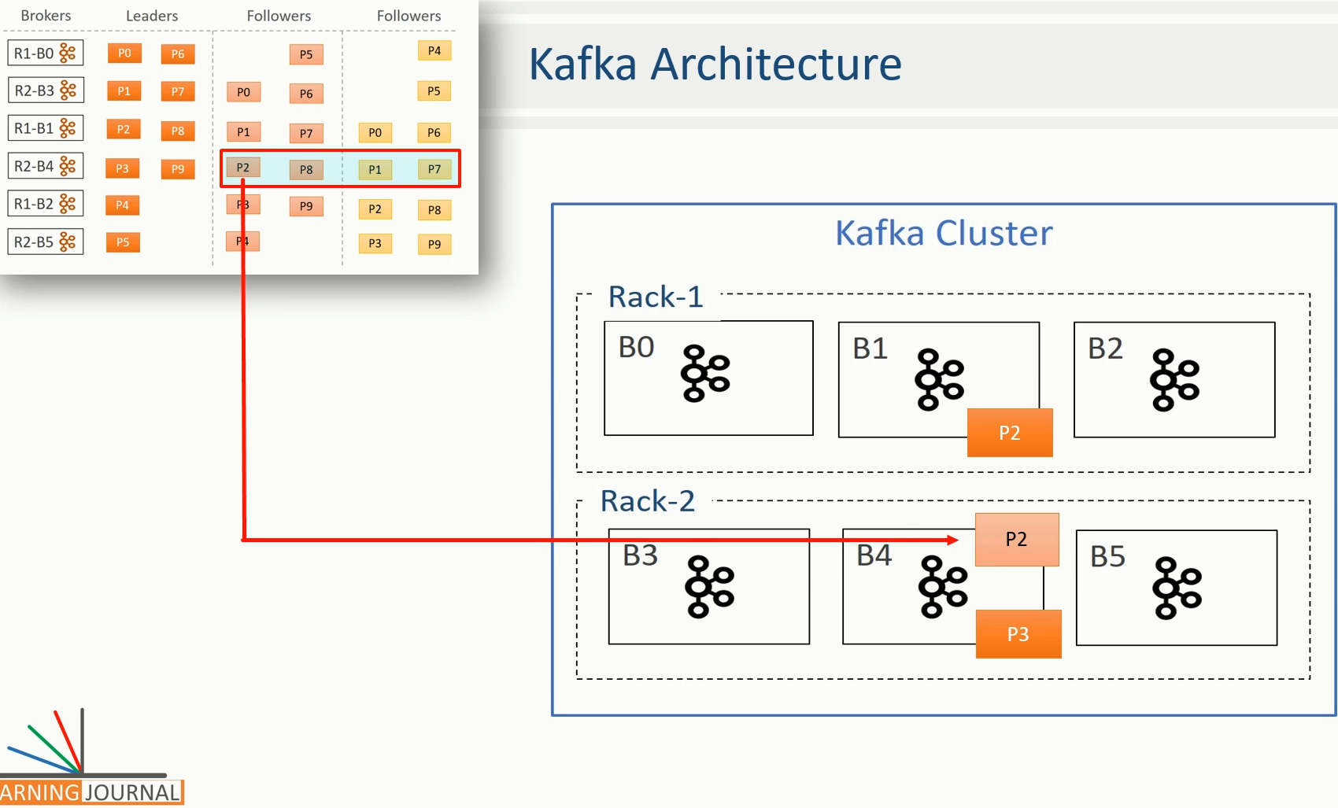

Followers do not serve producer and consumer requests. Their only job is to copy messages from leader and stay up-to-date with all the messages.

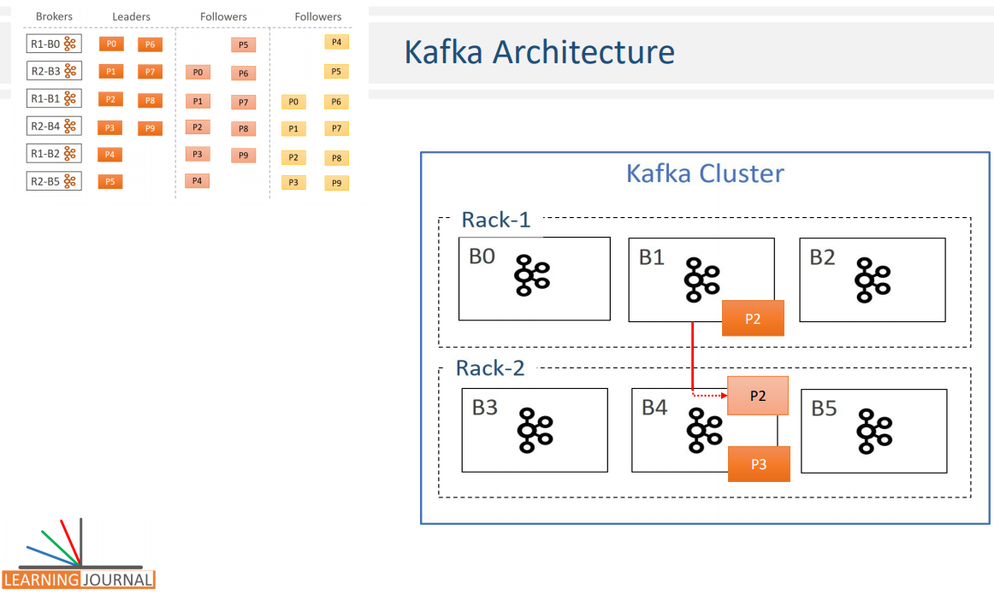

The aim of the follower is to get elected as a leader when the current leader fails or dies. So, they have a single point agenda. Stay in sync with the leader. Why? Because they can't get elected as a leader if they are falling behind the leader and fail to be in sync with the leader by copying all the messages. The next question is this? How does the follower stay in sync with the leader? To stay in sync with the leader, the follower connects to the leader and requests for the data. The leader sends some messages, and the follower persists them in the replica and requests for more. This goes on forever as an infinite loop to ensure that the followers are in sync with the leader.

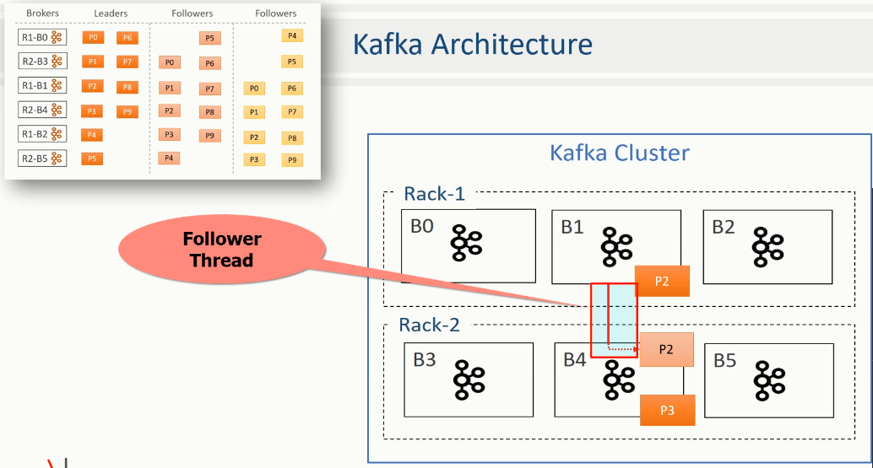

The method of copying messages at the follower appears full proof. However, some followers can still fail to stay in sync for various reasons. Two common causes are network congestion and broker failure. Network congestion can slow down replication, and the followers may start falling behind. When a follower broker crashes, all replicas on that broker will begin falling behind until we restart the follower broker and they can start replicating again, right? Since the replicas may be falling behind, the leader has one more important job to maintain a list of In-Sync-Replicas (ISR).

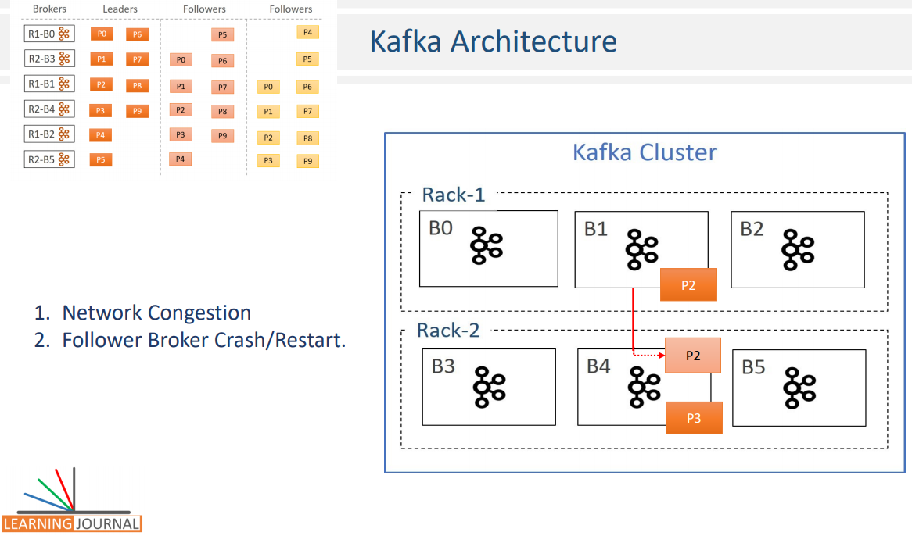

This list is known as the ISR list of the partition and persisted in the Zookeeper. And this list is maintained by the leader broker. The ISR list is very critical. Why? Because, all the followers in that list are known to be in sync with the leader, and they are an excellent candidate to be elected as a new leader when something wrong happens to the current leader. And that makes the ISR list a critical thing.

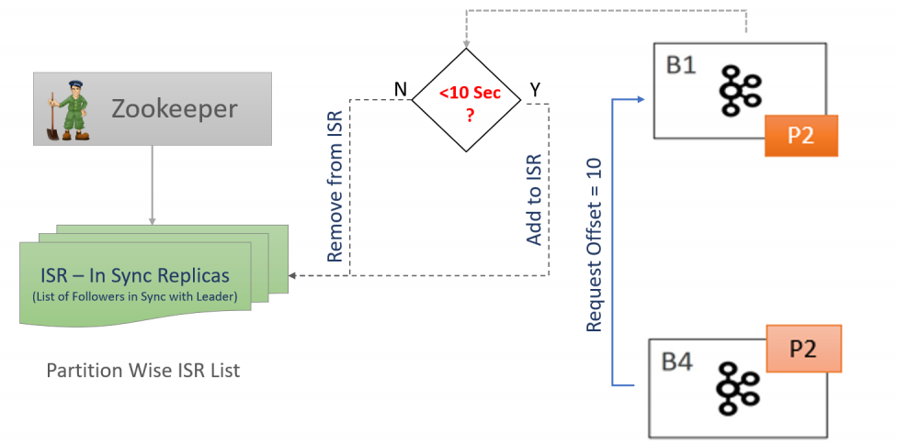

However, there is one more question that follows. You might wonder, how do a leader would know if the follower is in sync or still lagging? Let's try to understand that. The follower will connect to the leader and request for the messages. The first request would ask the leader to send messages starting from the offset zero. Assume that the leader has got 10 messages, so it sends all of them to the follower.

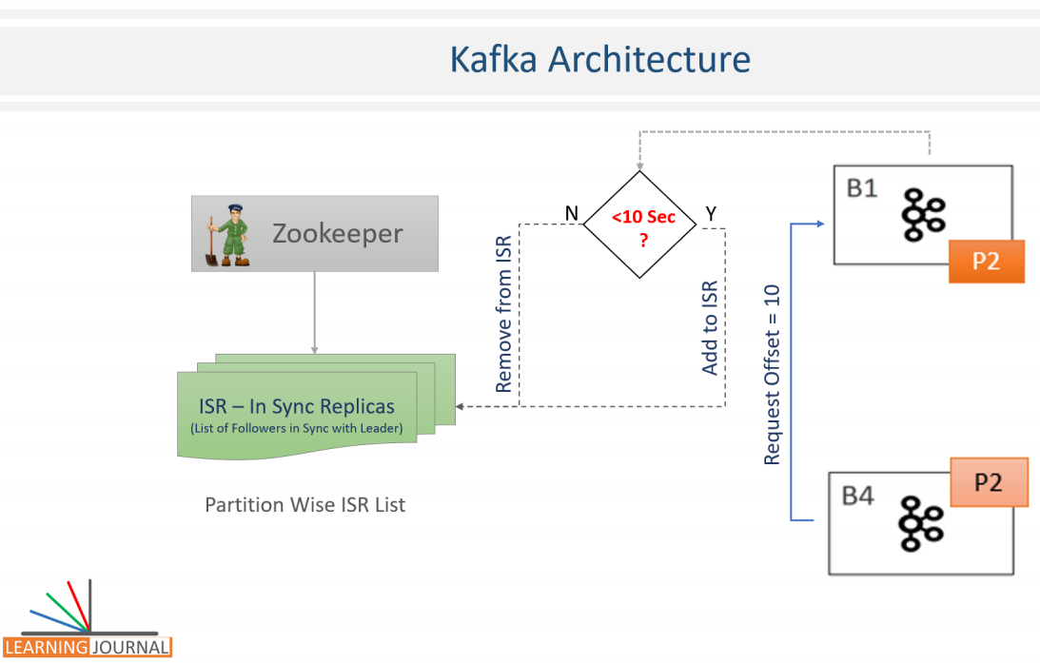

The follower stores them into the replica and again requests for new messages starting from offset 10. In this case, since the follower asked for offset 10, that means a leader can safely assume that the follower has already persisted all the earlier messages. So, by looking at the last offset requested by the follower, the leader can tell how far behind is the replica. Now the ISR list is easy to maintain. If the replica is "not too far," the leader will add the follower to the ISR list, else, the follower is removed for the ISR list. That means, the ISR list is dynamic and the followers keep getting added and removed from the ISR list depending on how far they maintain their In-Sync status.

However, there is a catch here. How do we define the "not too far"? As a matter of fact, the follower will always be a little behind than the leader, and that's obvious because follower needs to ask for the message from the leader, receive the message over the network, store them into the replica and then ask for more. All this activity takes some time. And hence, the leader gives them some minimum time as a margin to accomplish this. That is where the notion of "not too far" arrives. The default value of "not too far" is 10 seconds. However, you can increase or decrease it using Kafka configurations. So, the replica is kept in the ISR list if they are not more than 10 seconds behind the leader. That means, If the replica has requested the most recent message in the last 10 seconds, they deserve to be in the ISR. If not, the leader removes the replica from the ISR list. Great! The mechanism to maintain the ISR list is quite fancy. However, we still have a gotcha in this mechanism. The maintainance of the ISR list leades to some new concepts. Let's try to understand it. We already understand that the followers may be lagging behing the leader for several reasons and they might get removed from the ISR. Right? Assume all the followers in the ISR list are 11 seconds behind the leader.

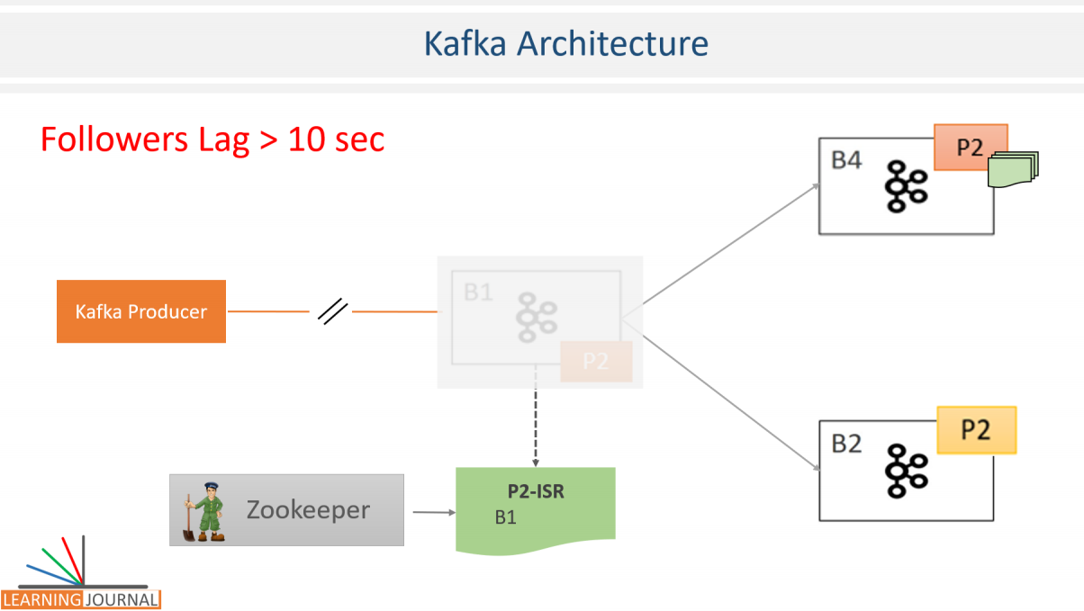

That means, none of them to qualify to be in the ISR. So, your ISR list becomes logically empty. The messages are only at the leader. Right? Now for some reason, the leader crashed, and we need to elect a new leader. Who do we choose? If we elect a new leader among the followers that are not in the ISR, don't we lose those messages that are collected at the leader during the most recent 11 seconds? Yes, we miss them. But How do we handle that? We don't want to lose anything. The solution is simple which is implemented using two concepts. The first idea is to introduce the notion of committed and uncommited messages The second idea is to set a minimum in-sync replicas configuration. Let's try to understand these two things. You can configure the leader to not to consider a message committed until the message is copied at all the followers in the ISR list. If you do that, the leader may have some committed as well as some uncommitted messages.



The message is committed when it is safely copied at all replicas in the ISR. Now, if the message is committed, we can't lose it until we lose all the replicas. Right? So commited messages are now taken care, we cannot loose them. However, if we lose the leader, we still miss the uncommitted messages. Isn't it? But the uncommited messages shouldn't be a worry because those can be resent by the producer. Why? Because, Producers can choose to receive acknowledgments of sent messages only after the message is fully committed. In that case, the producer waits for the acknowledgment for a timeout period and resend the messages in the absence of commit acknowledgment. So, the uncommitted messages are lost at the failing leader, but the newly elected leader will receive those again from the producer. That's how all the messages can be protected from loss. If you are not too clear about the idea, no worries. We will be covering it again in this course when we start creating examples.

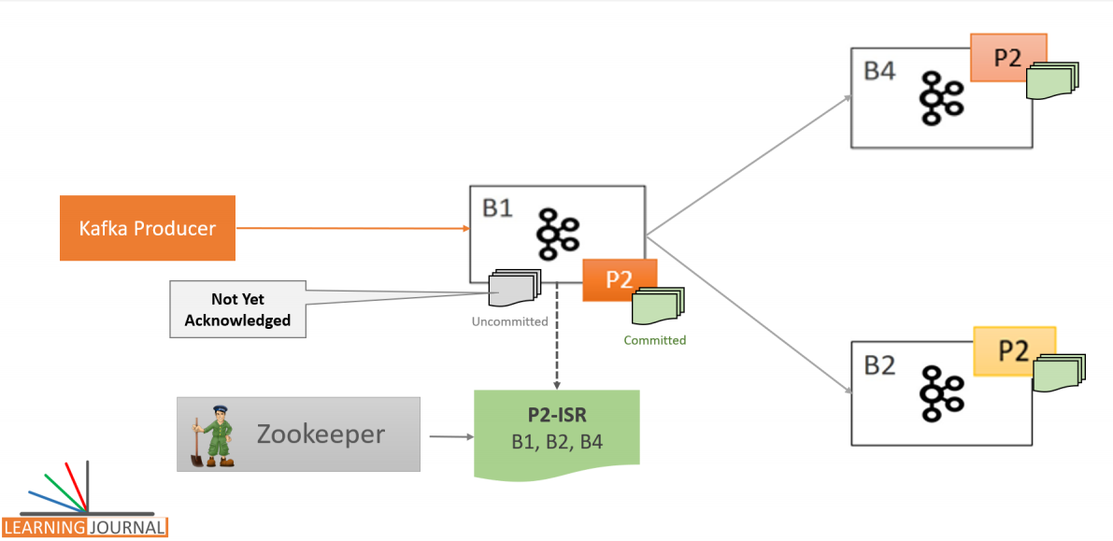

Let's come to the second idea which is associated with the ISR. The data is considered committed when it is written to all the in-sync replicas. Right? That's what I explained. Now, Let's Assume that we start with three replicas and all of them are healthy enough to be in the ISR. However, after some time, two of them failed, and as a result of that, the leader will remove them from the ISR. In this case, even though we configured a topic to have three replicas, we are left with a single in-sync replica that is the leader itself. Now the data is considered committed when it is written to all in-sync replicas, even when all means just one replica (the leader itself). Right? It is a risky scenario for data consistency because data could be lost if we lose the leader.

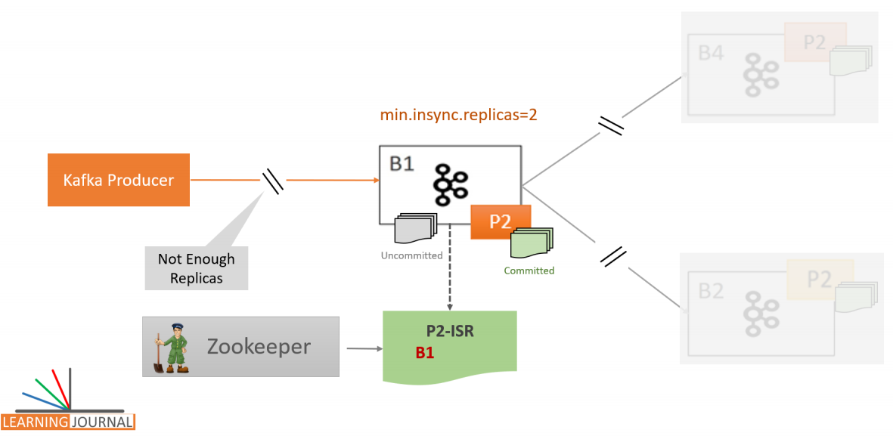

Kafka protects this scenario by setting the minimum number of in-sync replicas for a topic. If you would like to be sure that committed data is written to at least two replicas, you need to set the minimum number of in-sync replicas as two. However, there is a side effect of this setting. If a topic has three replicas and you set minimum in-sync replicas to 2, then you can only write to a partition in the topic if at least two out of the three replicas are in-sync. When at least two replicas are not in sync, the broker will not accept any messages and respond with "Not Enough Replicas" Exception. In other words, the leader becomes a read-only partition. You can read, but you can't write until you bring another replica online and wait for it to catch up and get in sync. Great! We covered a lot of things in this and the arlier session.

Summary

We spoke about the Kafka Storage Architecture, Cluster Architecture, and how work is distributed among the brokers. While explaining all these, I used a three-node Kafka Cluster, Created a topic, and executed a producer application. However, I haven't explained how to install a Kafka Cluster and how can you do similar things on your own machine.

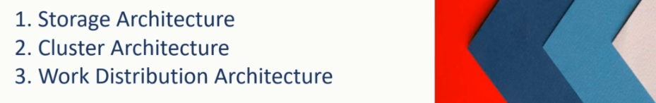

The next section of the training is going to be more technically intense working sessions. And you would definitely need a running Kafka Cluster on your local machine. I have created some lectures in the appendix section of the course to help you set up your local Kafka cluster environment and perform some necessary activities such as creating a Kafka topic, setting broker configuration, and topic level configurations and few other things to accomplish your development activities.

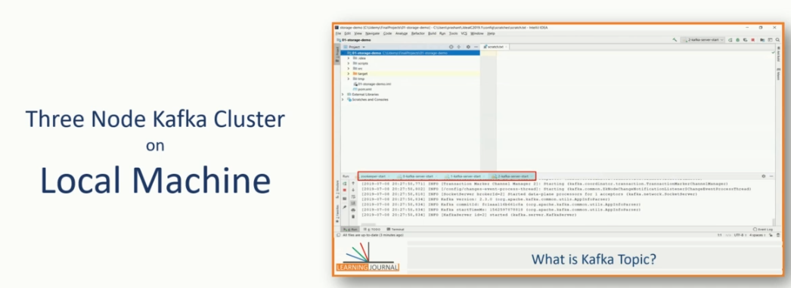

I recommend you to go through the appendix section before you finish this section and move on to the next part of the course. I also recommend that you start navigating Kafka documentation at this stage and refer it further throughout the course. I will teach many things in the course, and also keep referring you to different sections of the documentation throughout the course. However, at this stage, you must have a quick look at following sections of the documentation. Quick Start is an excellent place to learn some basic operations quickly.

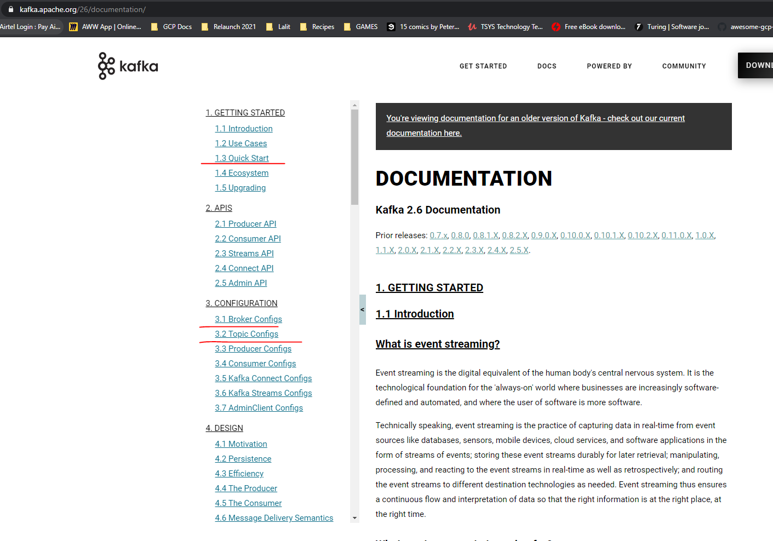

Broker configurations and topic configurations are other two important areas that you must look at.

You may not get the meaning of every configuration at this stage; however, many obvious settings should start making sense now. I will keep talking about several critical configuration settings throughout the course, and you can always come back to the documentation and refer it again in more detail. The next important area of the documentation is the operations section. You can start exploring command for the following things.

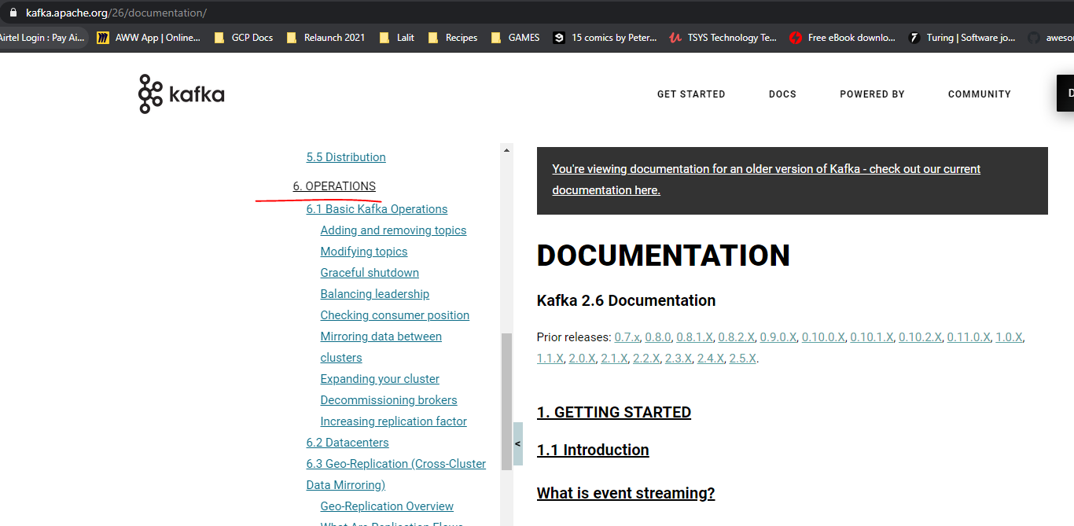

Starting and Shutting down Zookeeper and Kafka Brokers. Creating, adding, modifying, and removing topics. There are some other interesting utilities such as console producer, console consumer, log dump, and zookeeper shell. I have already covered a few things in the appendix. However, I left out a few obvious and simple ideas for you to explore yourself. You can also go through the design section of the documentation and see if things are making sense. Few things will definitely make good sense at this stage, and other items will start becoming clear as you progress with the course. The point is straightforward. No Kafka course can teach you everything for obvious reasons. You can become a specialist if you start Start augmenting the course with the document and I will keep directing you to the different sections of the document and also help you understand that how can you interpret the cryptic sections of the technical documentation.

## Streaming into Kafka

We learned a lot about the Kafka broker, Kafka cluster, and the work division among the brokers. All of that was great. However, bringing data streams into Kafka is your first step towards developing real-time stream processing applications. Hence, we dedicate one full section for bringing data into a Kafka cluster as a stream. In this section, we will learn some alternatives to stream your business events into Apache Kafka. So, let's start. Events are generated by transactional systems.

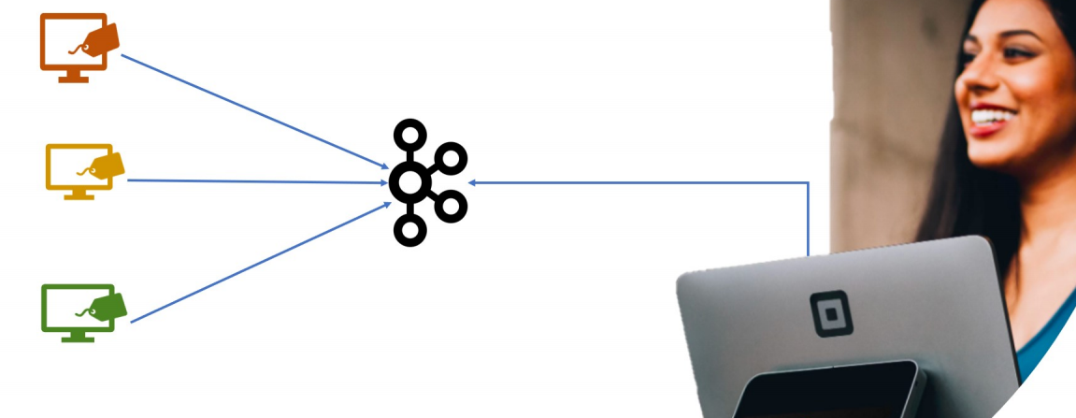

To process them in real-time, you might want to bring them to Apache Kafka. However, bringing your events to your Kafka cluster is not that straight forward. Depending upon your event-generating application, you might end up in two situations.



In the first and the most straightforward scenario, your event generating application is an in-house developed application, and you have access to the source code of the application. In such cases, it could be an easy thing for you to make some changes in your current application to start sending events to Apache Kafka. In the second type of scenario, you might not have the source code of your application. Or, for some other reasons, it is not feasible for you to make changes in the current software. So, your event generating system behaves like a closed box, and you cannot alter the application for directly sending the events to Kafka. However, the same system allows you to access the event records using some other method.

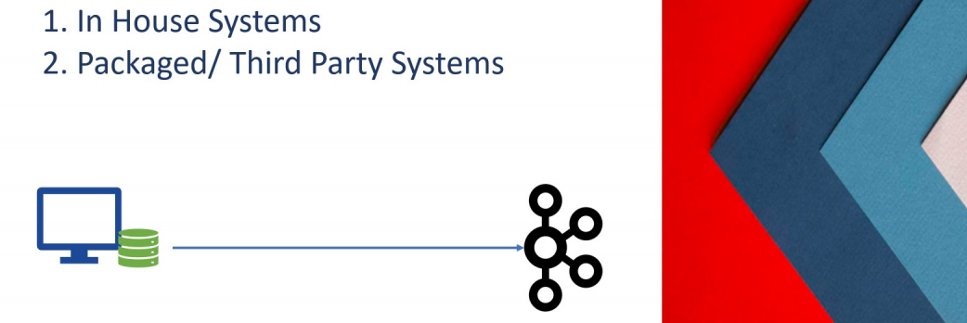

For example, you may have direct database access to the underlying tables, and you can read those events connecting to the database. Another standard option is to have access to some application APIs that allow you to extract those events.

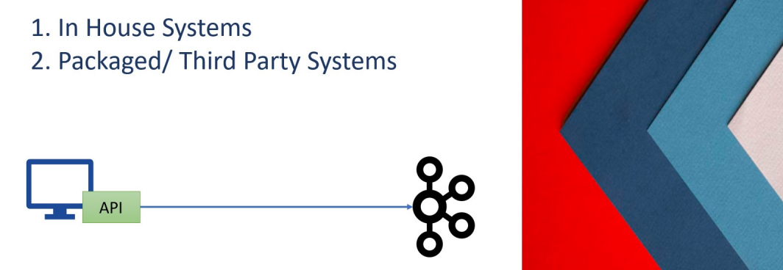

Apache Kafka allows you to handle both the scenarios. At a high level, there are two methods to bring data into Apache Kafka. Kafka Producer APIs and Data Integration Tools

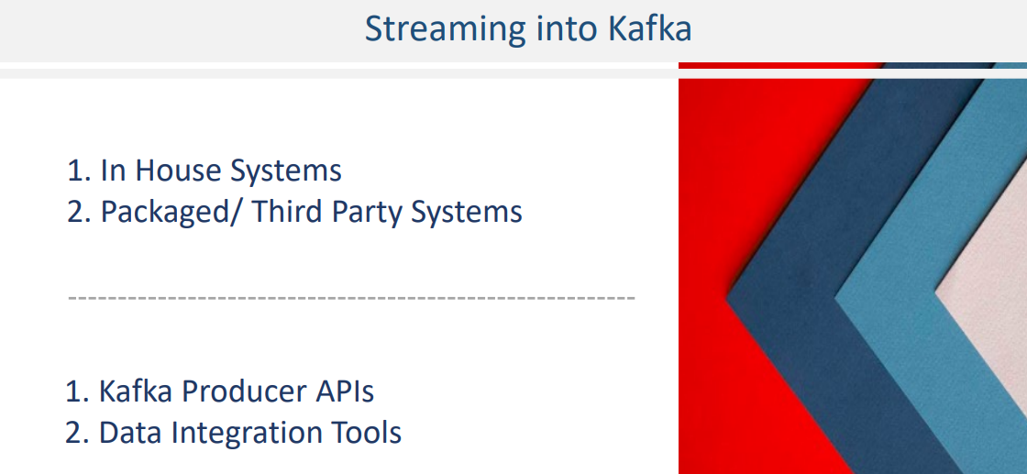

You can use Kafka producer APIs in the first scenario when making changes in the current application is a feasible option. For our POS example, the present application can continue to save the invoice in the designated local POS database. However, you can make changes in the application code and send the event records to the Kafka broker also. The event is persisted in the local database, and it also goes to Kafka broker for real-time consumption.

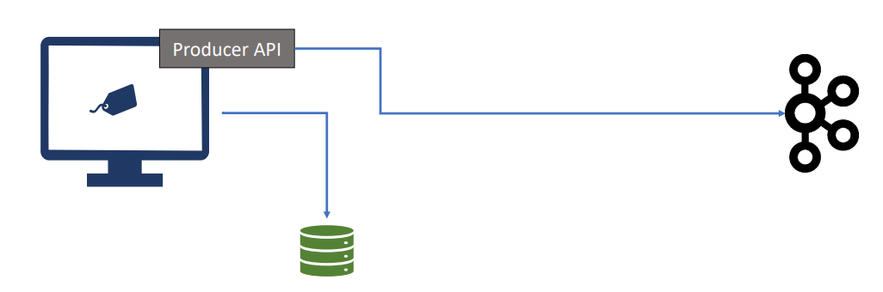

When it is not feasible to make changes to your application code, you can use data integration tools such as HVR, Talend, and Pentaho. These tools extract data from the existing systems using APIs or a direct database connection. Once retrieved, they can publish data to Apache Kafka. Apache Kafka also offers Kafka Connect Framework and a bunch of out-of-the-box connectors to bring data into Apache Kafka from third-party systems.

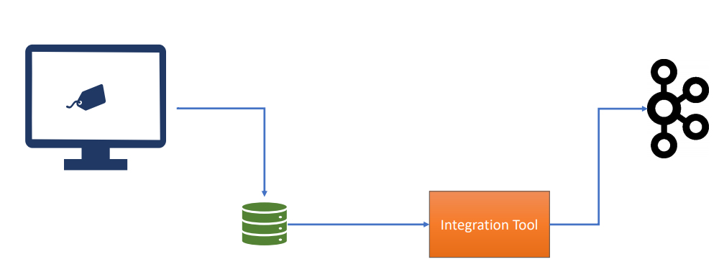

These third-party integration tools such as HVR and Talend, as well as Kafka Connect, they offer you a mechanism to bring data into Apache Kafka from a variety of sources. Great! So now you know two approaches to stream your events to Kafka. First approach is to use Kafka Producer APIs Second approach is to use Kafka Connect or Other similar integration tools.



I will cover details of Kafka Producer APIs and help you understand the usage with the help of some examples. I will not cover Kafka connect or other similar tools in this course because those tools are beyond the scope of this course and require a separate focus. Great! That's all for this session. In the next lecture, we will start streaming events to Apache Kafka using Producer APIs.

## Kafka Producers – Quick Start

In the earlier lecture, we spoke about the Kafka Producer APIs. In this section, I will help you understand the producer API structure and create an example to help you understand the usage. Kafka Producer API is primarily made available in Java. In this course, we will be using Java APIs. However, the APIs are also available in other languages, and all those language bindings follow the same structure as Java APIs. Some of the most commonly used language libraries are listed here. There are many more language bindings that are implemented by the open source community. But except for Java API, all the above language APIs are based on C Kafka client library named librdkafka.

1. Kafka Client for Java

<https://kafka.apache.org/documentation/#api>

2. Kafka Client for C++

<https://github.com/mfontanini/cppkafka>

3. Kafka Client for .NET

<https://github.com/confluentinc/confluent-kafka-dotnet>

4. Kafka Client for Go

<https://github.com/confluentinc/confluent-kafka-go>

5. Kafka Client for Python

<https://github.com/confluentinc/confluent-kafka-python>

6. Kafka Client for Node.js

<https://github.com/Blizzard/node-rdkafka>

<https://github.com/edenhill/librdkafka>

You can find documentation and an exhaustive list of supported languages at following URL. Great! with that preface, let's start creating some examples to understand the mechanics of sending events to Apache Kafka. To help you build the concept more clearly, I want to take a problem-solution approach. In this approach, I will describe a problem first. Then we will go ahead and see how can we build and implement a solution for the given problem. Here is my first problem. We want to create a simplest possible Kafka producer code that sends one million string messages to a Kafka topic.

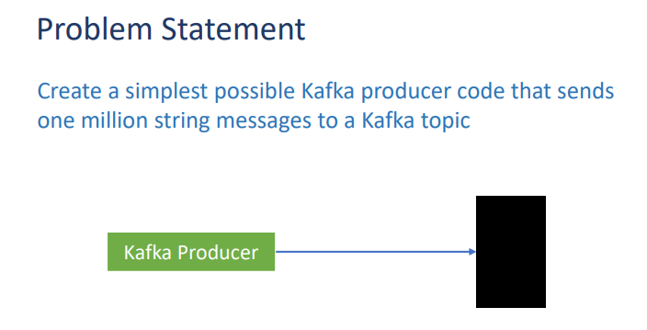

Simple, isn`t it? How would you go about it? So I have an empty starter maven project here. I named the project as hello-producer. This starter and the empty project is also included in your course material. All you need to do is to download the project and open it using IntelliJ Idea. Once loaded in IntelliJ, You should see the same thing that I am showing on the current screen. All the necessary things are already set up in this project. I have a pom.xml file with all the required dependencies. I also have a log4j2.xml configuration file. Other than these basics things, I have added an AppConfig class definition with some static constants. We will be using these constants in the example, and I will explain them in a minute. I have also added some scripts to start your Kafka Cluster on your local machine. In most of the examples in this course, we will be using a three-node Kafka cluster setup on your local computer.

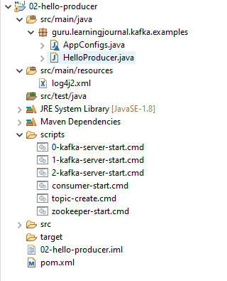

Method to set up the Kafka development cluster is explained separately in the appendix of the course. Good! with this starter project template loaded, we are now ready to write our first producer example. Let's create a class with a main method. I name it as HelloProducer. We define a logger so we can create some log entries. This one is not mandatory but a good practice to have a logger. Next, let's create a main method. These are simple things, isn`t it? Let me place a log entry. The log entry is to know if the program started. Now we come to the real stuff. Sending data to Apache Kafka is a multi-step process. The first step is to create a Java Properties object and put some necessary configurations in it. Kafka producer API is highly configurable, and we customize the behavior by setting different producer configurations. In this first example, we will set four basic configurations. These are the bare minimum configurations for the producer to work. The first configuration is the CLIENT_ID_CONFIG, which is a simple string that is passed to the Kafka server.

**AppConfigs.java**

class AppConfigs {

final static String applicationID = "HelloProducer";

final static String bootstrapServers = "localhost:9092,localhost:9093";

final static String topicName = "hello-producer-topic";

final static int numEvents = 1000000;

}

**HelloProducer.java**

import org.apache.kafka.clients.producer.KafkaProducer;

import org.apache.kafka.clients.producer.ProducerConfig;

import org.apache.kafka.clients.producer.ProducerRecord;

import org.apache.kafka.common.serialization.IntegerSerializer;

import org.apache.kafka.common.serialization.StringSerializer;

import org.apache.logging.log4j.LogManager;

import org.apache.logging.log4j.Logger;

import java.util.Properties;

public class HelloProducer {

private static final Logger logger = LogManager.getLogger();

public static void main(String[] args) {

logger.info("Creating Kafka Producer...");

Properties props = new Properties();

props.put( ProducerConfig.CLIENT_ID_CONFIG, AppConfigs.applicationID);

props.put( ProducerConfig.BOOTSTRAP_SERVERS_CONFIG, AppConfigs.bootstrapServers);

props.put( ProducerConfig.KEY_SERIALIZER_CLASS_CONFIG,

IntegerSerializer.class.getName());

props.put( ProducerConfig.VALUE_SERIALIZER_CLASS_CONFIG,

StringSerializer.class.getName());

KafkaProducer<Integer, String> producer = new KafkaProducer<>(props);

logger.info("Start sending messages...");

for ( int i = 1; i <= AppConfigs.numEvents; i++ ) {

producer.send( new ProducerRecord<>( AppConfigs.topicName,

i, "Simple Message-" + i));

}

logger.info("Finished - Closing Kafka Producer.");

producer.close();

}

}

The purpose of the client id is to track the source of the message. The second one is BOOTSTRAP_SERVER_CONFIG. The BOOTSTRAP_SERVER_CONFIG is a comma-separated list of host/port pairs. The producer will use this information for establishing the initial connection to the Kafka cluster. If you are running on a single node Kafka, you can supply an individual host/port information. The bootstrap configuration is used only for the initial connection. Once connected, the Kafka producer will automatically query for the metadata and discover the full list of Kafka brokers in the cluster. That means you do not need to supply a complete list of Kafka brokers as a bootstrap configuration. However, it is recommended to provide 2-3 broker addresses of a multimode cluster. Doing so will help the producer to check for the second or third broker in case the first brokers in the list is down. I have defined all these configuration values as constants in the AppConfig class, and that is why I added this class in the starter project template. Remaining two mandatory configurations are the key and the value serializers.

Now there are two concepts here. The first one is the key/value pair. A Kafka message must have a key/value structure. That means, each message that we want to send to the Kafka server should have a key and a value. You can have a null key, but the message is still structured as a key/value pair. The second concept is about serializer. Kafka messages are sent over the network. So, the key and the value must be serialized into bytes before they are streamed over the network. Kafka producer API comes with a bunch of ready to use serializer classes. In this example, we are setting an IntegerSerializer for the key and a StringSerializer for the message value. That's all about the first step. Step two is to create an instance of KafkaProducer. The key for my message is going to be an integer, and the value would be a string. We need to pass the properties that we created earlier to the constructor. That's all.

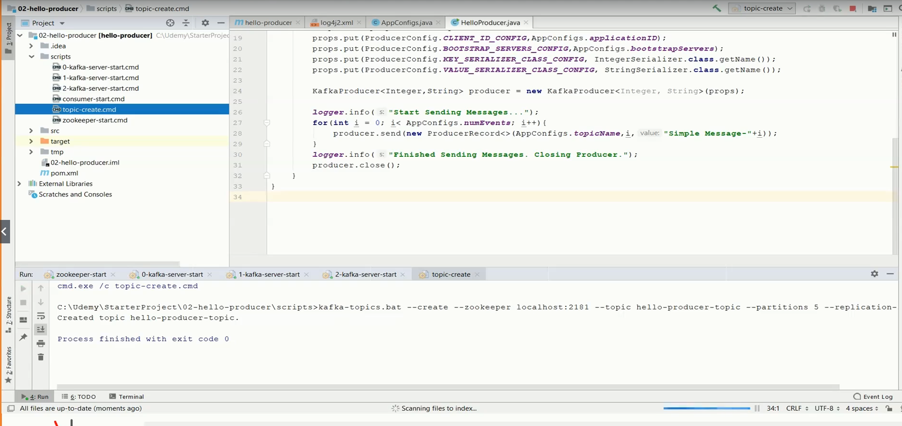

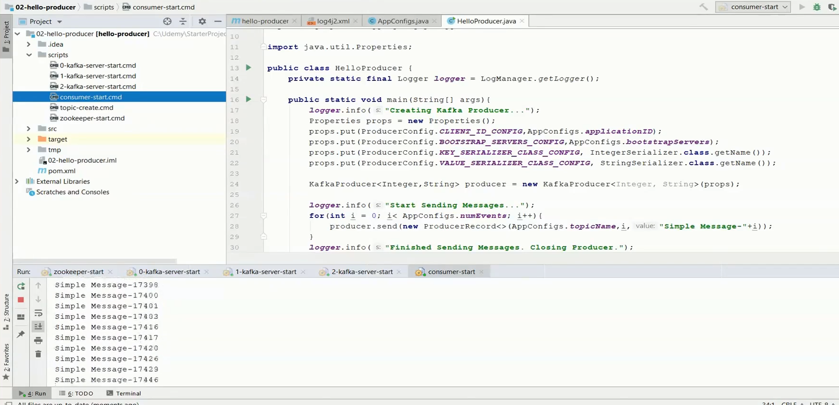

The third step is to start sending messages to Kafka. So, what I want to do is to create a loop that executes a million times. Inside the loop, you can send the message. The send method takes a ProducerRecord object and sends it to the Kafka cluster. So, we create a new producer record. The ProducerRecord constructor takes three arguments. The first argument is the topic name. We send messages to Kafka topic, right? So, this is the topic name. The second argument is the message key. Let's pass the loop counter as a key. The final argument is the message itself. We want to send a simple string message. To keep it unique, let me concatenate the loop counter. Great! So your third step is over. Once this loop completes, you would have sent a million string messages to the Kafka cluster. The last and final step is to close the producer instance. The producer functionality is little involved, and it does a lot of things internally. We will cover producer internals as we progress with this course. However, it is essential to understand that the producer consists of some buffer space and background I/O thread. If you do not close the producer after sending all the required messages, you will leak the resources created by the producer. That's all.

Let me quickly summarize. Sending messages to Kafka using producer API is a four-step process. In the first step, you will set some configurations that will control the behavior of your producer API. The second step is to create a producer object. The third step is to send all the messages. Finally, if you have no further messages to send, close the producer. The final completed project file is also included in your course material. But I recommend that you take up the starter project, and try creating the completed example yourself. If you have some doubts, you can refer to the completed project files that I have included in your course material. Great! Do you want to execute this example? Let's do it. Start your zookeeper. Then start all three Kafka brokers. Wait for the brokers to start. Finally, Create the topic. All these scripts are already included in your starter project. Great! You are now ready to execute the example. Start sending a message and finished sending the message. It took a few seconds to send a million small messages. Great! Isn't it? That's all for this video. In the next video, we will learn some internals of Kafka Producer.

### Kafka Producer Internals

We have learned some basics of Kafka producer. Now it is time to deep dive into the producer APIs. Kafka producer APIs are straightforward. You can create a producer by setting some essential configurations and start sending messages using the send() method. There is only one restriction that you must package your message in a ProducerRecord object. While the send() method is straightforward, a lot of things happen behind the scenes.

Properties props = new Properties();

props.put(ProducerConfig.CLIENT_ID_CONFIG, AppConfigs.applicationID);

props.put(ProducerConfig.BOOTSTRAP_SERVERS_CONFIG, AppConfigs.bootstrapServers);

props.put(ProducerConfig.KEY_SERIALIZER_CLASS_CONFIG, IntegerSerializer.class.getName());

props.put(ProducerConfig.VALUE_SERIALIZER_CLASS_CONFIG, StringSerializer.class.getName());

KafkaProducer<Integer, String> producer = new KafkaProducer<>(props);

for (int i = 1; i <= AppConfigs.numEvents; i++) {

producer.send(new ProducerRecord<>(AppConfigs.topicName, i, "Simple Message-" + i));

}

producer.close();

Let's try to understand it in detail. We package the message content in the ProducerRecord object with at least two mandatory arguments. Kafka Topic Name and Message Value Kafka topic name is the destination address of the message. The message value is the main content of the message. Right? Other than these two mandatory arguments, you can also specify the following optional items. Message Key Target Partition, Message Timestamp. The message key is one of the most critical argument, and it is used for many purposes, such as partitioning, grouping, and joins. You will learn more about the usage of a key as you progress with the course. However, at this stage, consider it as another mandatory argument even if the API does not mandate it. Target partition and timestamp are purely optional, and you may want to set these arguments rarely. I will talk about these arguments in a minute.

The ProducerRecord wraps your message content with all necessary information such as topic name, Key, and timestamp. Once created, you can hand over the ProducerRecord to the KafkaProducer using the send() method. The Kafka producer is supposed to transmit the ProducerRecord to the Kafka Broker over the network. However, it does not immediately transfer the records. Every record goes through **serialization**, **partitioning**, and then it is **kept in the buffer**. The serialization is necessary to send the data over the network. Without serializing data, you can't transmit it to a remote location. However, Kafka does not know how to serialize your Key and value. That is why specifying a key serializer, and a value serializer class is mandatory that we supply as part of the producer configuration. In the earlier example, we have used IntegerSerializer for the Key and a StringSerializer for the value. However, these serializers are the most elementary serializers, and they do not cover most of the use cases.

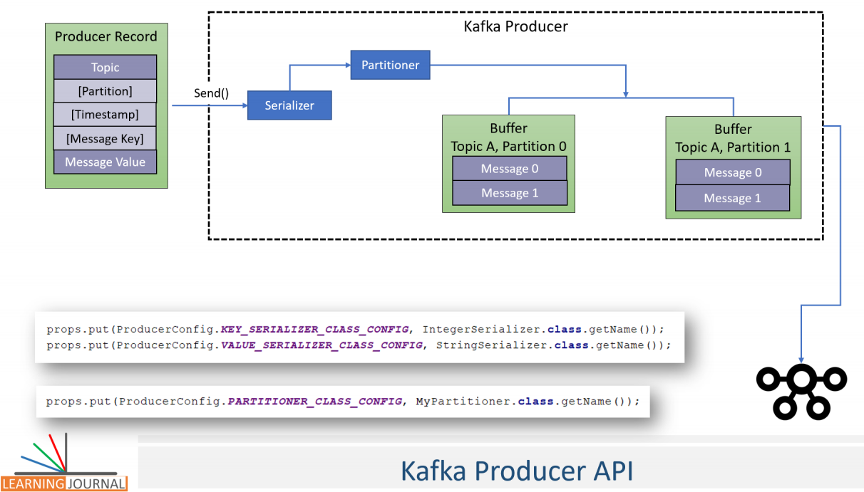

In a real-life scenario, your events are represented by complex Java objects. These objects must be serialized before the producer can transmit them to the Broker. The StringSerializer may not be a good help for those requirements. Kafka gives you an option to use a generic serialization library like Avro, or Thrift. Alternatively, you have a choice to create custom serializer. In the upcoming lectures, I will create a JSONSerializer and show the processes of creating and using a custom serializer. Great!

The next thing is the **partitioner**. Well, every ProducerRecord includes a mandatory topic name as the destination address of the data. However, the Kafka topics are partitioned, and hence, the producer should also decide on which partition the message should be sent. There are two approaches to specify the target partition number for the message. Set partition number argument in the ProducerRecord and Supply a Partitioner class to determine the partition number at runtime. As you can see in the Figure, you can optionally specify the partition number in the ProducerRecord. However, that approach is rarely used. Instead, we supply a Partitioner class that implements your desired partitioning strategy and assigns a partition number to each message at runtime.

You can specify a custom partitioner using the properties object. However, even creating a custom partitioner is often not needed. Why? Because KafkaProducer comes with a default partitioner which is the most commonly used partitioner. The default partitioner takes one of the two approaches to determine the destination topic partition. Hash Key Partitioning or Round Robin Partitioning The first approach is based on the message key. When the message key exists, the default partitioner will use a hashing algorithm on the Key to determining the partition number for the message. It is as simple as hashing the Key to convert it into a numeric value. Then use the hash number to deduce the target partition. The hashing ensures that all the messages with the same Key go to the same partition. However, this algorithm also takes the total number of partitions as one of the inputs. So, if you increase the number of partitions in the topic, the default partitioner starts giving a different output. That means, if the partition is based on the Key, then you should create a topic with enough partitions and never increase it at the later stage.

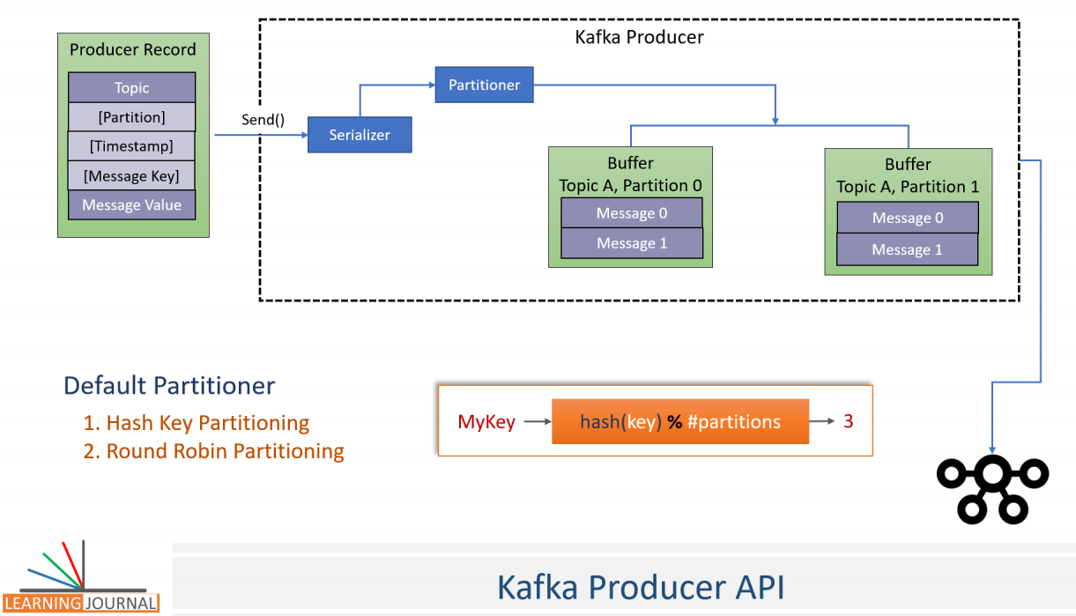

You can easily over provision the number of partitions in the topic. I mean, if you needed 100 partitions, you can easily overprovision it by 25% and create 125 partitions. There is not much harm in taking this approach. But remember, If you do increase the number of partitions later, you may have to redistribute the existing messages. Right? When the message key is null, the default partitioner will use a round robin method to achieve an equal distribution among the available partitions. That means the first message goes to the one partition, the second one goes to another partition and the partitioner repeats it in a loop. The default partitioner is the most commonly used partitioner in most of the use cases. However, Kafka allows you to implement your partitioning strategy by implementing a custom partitioner class. But you may not even need a custom partitioner in most of the cases. Great!

The next thing is the timestamp. The ProducerRecord takes an optional timestamp field. The message timestamp is optional. However, for a real-time streaming application, the timestamp is the most critical value. For that reason, every message in Kafka is automatically time stamped even if you do not explicitly specify it. Kafka allows you to implement one of the two types of message time stamping mechanism. Create Time and Log Append Time The CreateTime is the time when the message was produced. The LogAppendTime is the time when the message was received at the Kafka broker. However, you cannot use both. Your application must decide between these two timestamping methods while creating the topic.

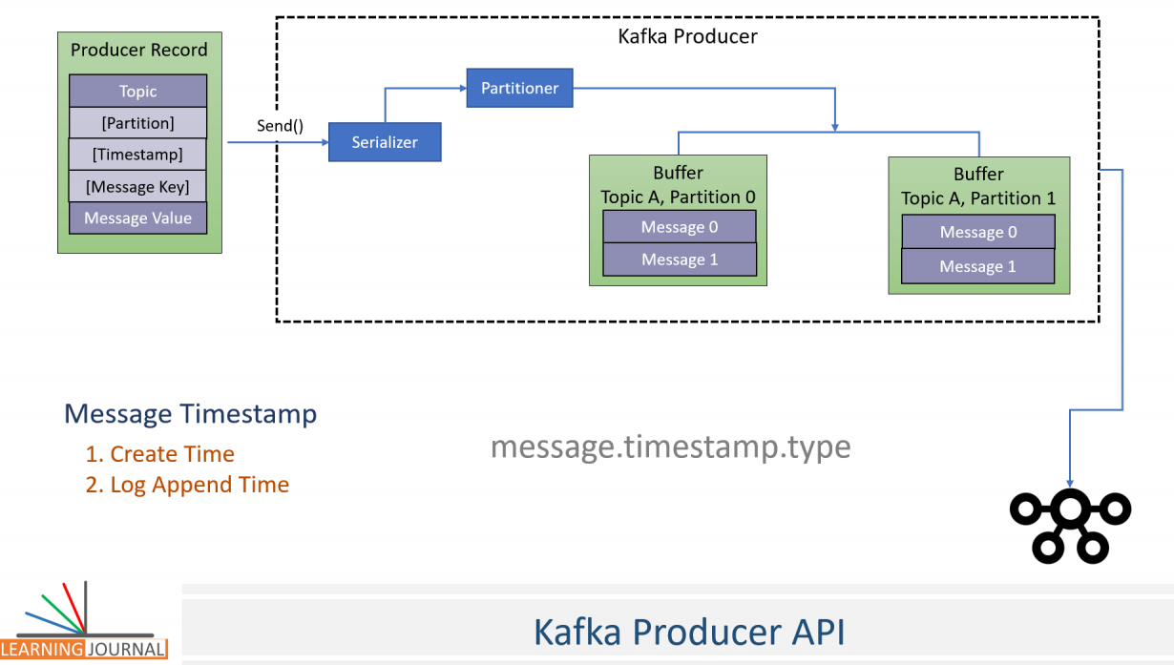

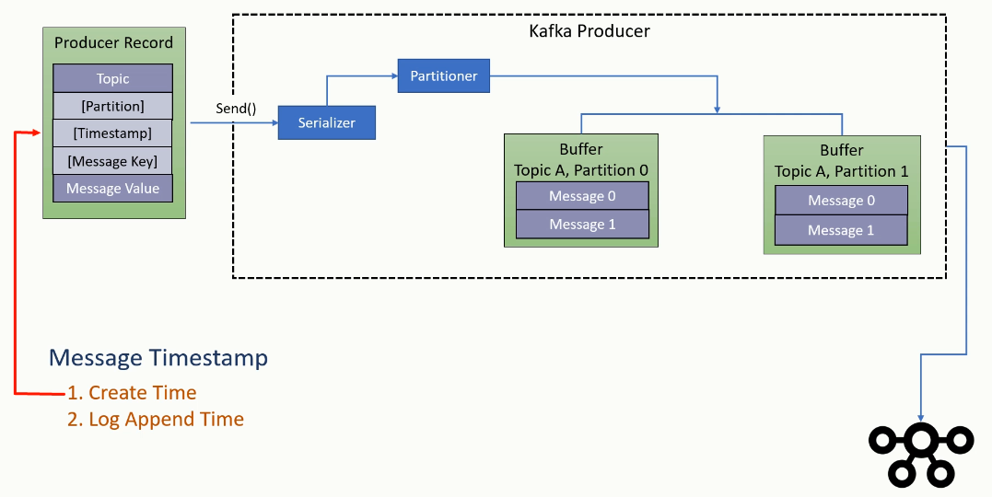

Setting up a default time stamping method for a topic is straightforward; you can set the message.timestamp.type topic configuration to 0 for using CreateTime, or you can set it to 1 for using LogAppendTime. The default value is zero (CreateTime). The producer API automatically sets the current producer time to the ProducerRecordtimestamp field. However, you can override the auto time stamping by explicitly specifying this argument. So, the message is transmitted with a producer time, either automatically set by the producer, or explicitly set by the developer. When using LogAppendTime configuration, the broker will override the producer timestamp with its current local time before appending the message to the log. In this case, the producer time is overwritten by the broker time. However, the message will always have a timestamp, either a producer time or the broker time. I prefer using default configuration as CreateTime whenever I am using producer API to bring data to Kafka because the producer API automatically assigns a timestamp.

However, When I am using some other tool to bring data into Kafka, I need to understand how the tool handles the time stamping. A safer method is to configure the topic for LogAppend Time so even if your tool is not setting a time, at least the Broker will set some value. Great! So we understand the Key, serialization, and partitioning. However, still, a lot is going inside the producer. Let's see what happens next. Once serialized and assigned a target partition number, the message goes to sit in the buffer waiting to be transmitted. The producer object consists of a partition-wise buffer space that holds the records that haven't yet been sent to the server. The producer also runs a background I/O thread that is responsible for turning these records into requests and transferring them to the cluster. Why do have this buffering? The buffering of the message is designed to offer two advantages.

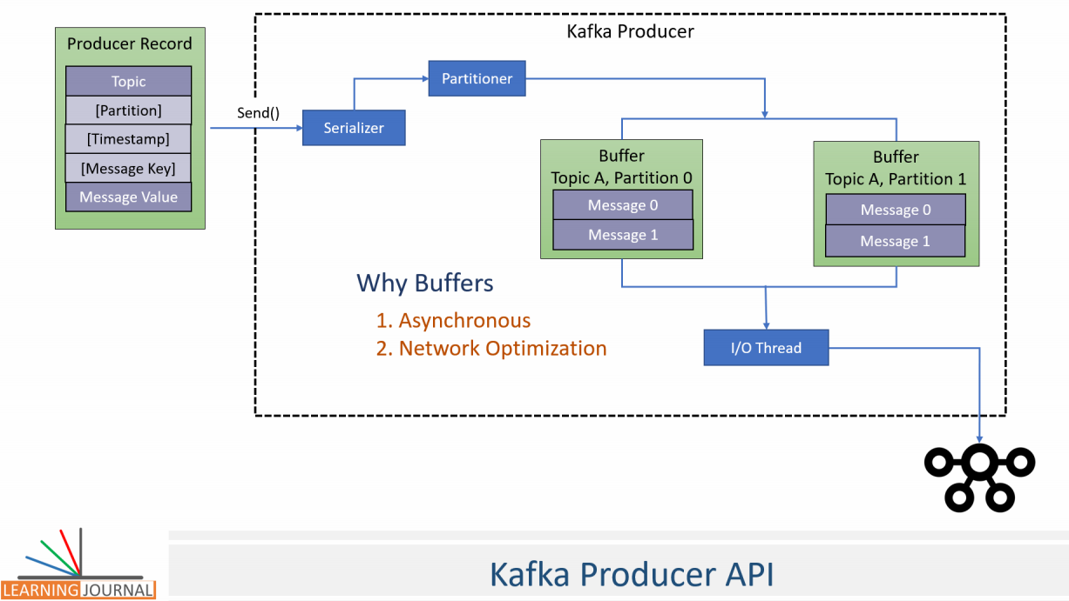

Asynchronous send API and Network Roundtrip Optimization Buffering arrangement makes the send method asynchronous. What does it mean? That means the send method will add the messages to the buffer and return without blocking. Those records are then transmitted by the background thread. This arrangement is quite convincing as your send() method is not delayed for the network operation. Buffering also allows the background I/O thread to combine multiple messages from the same buffer and transmit them together as a single packet to achieve better throughput. But there is a critical consideration here. If the records are posted faster than they can be transmitted to the server, then this buffer space will be exhausted, and your next send method will block for few milliseconds until the buffer is freed by the I/O thread. Isn't it? If the I/O thread takes too long to release the buffer, then your send method throws a TimeoutException. When you are seeing such timeout exceptions, you may want to increase the producer memory. The default producer memory size is 32 MB. You can expand the total memory allocated for the buffer by setting buffer.memory producer configuration.

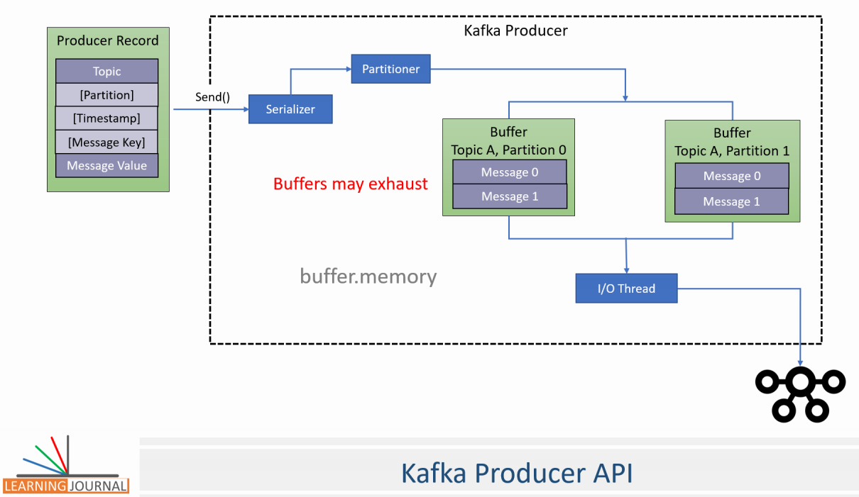

Great! Before moving further, I want to highlight one thing quickly. I have been talking and will be talking about setting different configuration parameters. In this video itself, I spoke about two configurations. buffer.memory and earlier I spoke of message.timestamp.type You might be wondering how to set these configuration values. Well, these configurations are of different types. The buffer.memory is a producer configuration. So you can set it in the properties object as we did in the earlier producer example. The message.timestamp.type is a topic configuration. So you can set it while creating a topic using the command line tool. Great! Let's come back to the producer internals.

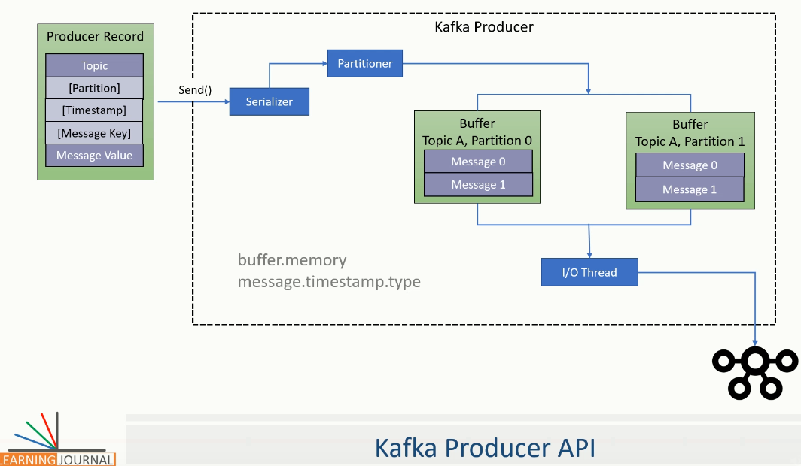

The producer background I/O thread is responsible for transmitting the serialized messages that are waiting in the topic partition buffer. When the broker receives the message, it sends back an acknowledgment. If the message is successfully written to Kafka, the broker will return a success acknowledgment. If the broker failed to write the message, it would return an error. When the background I/O thread receives an error or does not receive any acknowledgment, it may retry sending the message a few more times before giving up and throwing back an error. You can control the number of retries by setting the retries producer configuration. When all the retries are failed, the I/O thread will return the error to the send() method. That's all. That's what I wanted to cover in this lecture.

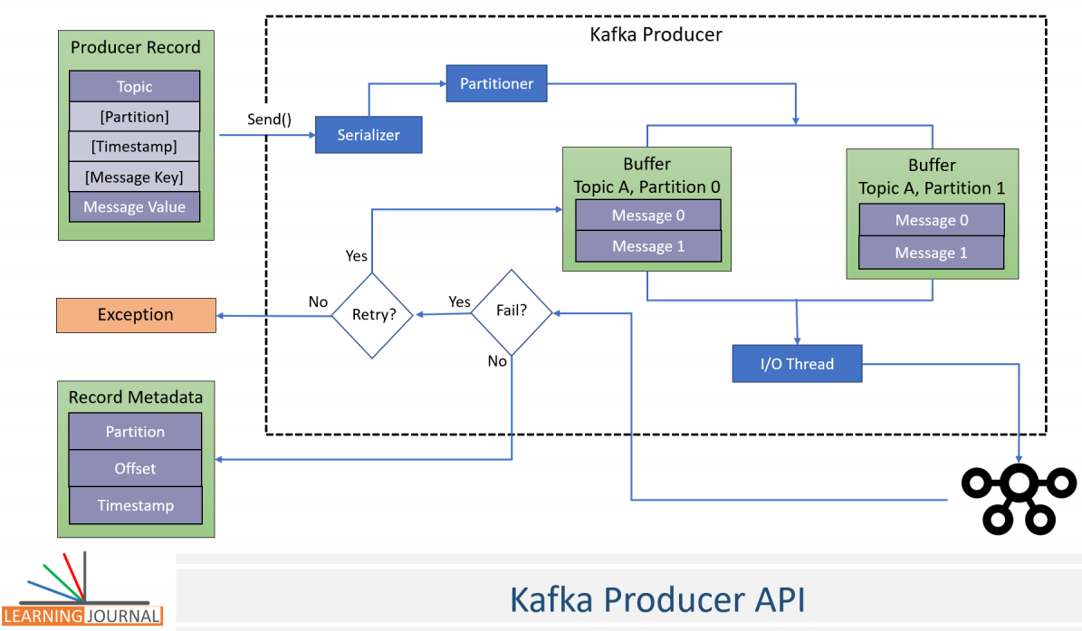

But let me summarize the flow before we close this lecture. We use the producer.send() method to handover the ProducerRecord to the KafkaProducer object. The KafkaProducer object will internally serialize the message key and the message value. And we provide the serializers using the properties object. Then the producer will determine the target partition number for the message to be delivered. You can provide a custom partitioner class using the properties object or provide a key and let the producer use the default partitioner. The serialized message goes and sites into a buffer depending upon the destination address. For each destination, we have a separate buffer. Finally, an I/O thread that runs in background will pick up some messages from the buffer, combine them to make one single data packet and send it to the broker. The broker would save the data in the log file and send back an acknowledgment to I/O thread. If the I/O thread does not receive an acknowledgment, it will try resending the packet and again wait for an acknowledgment. If we do not get an acknowledgment at all even after some retries, or get an error message, the I/O thread will give the error back to the send method. It was all theoretical concept. But I will demonstrate all of these using suitable examples in future lectures.

### Scaling Kafka Producer

We created a very simple producer and sent one million short messages to the Kafka Server. Then we also looked inside the producer and learned how those messages are finally delivered to the Kafka server. But Kafka is all about scalability. How can we scale our application and send hundreds of thousands of events per second? In this lecture, we will explore some details about scaling up the producers. So, let's start. Apache Kafka was designed with the scalability in mind, and scaling a Kafka application is straightforward. If you consider the POS example, then each POS system can create a KafkaProducer object and send the invoices. The Figure here shows the scenario where multiple POS systems can send invoices in parallel. At the cluster end, it is the Kafka broker that receives the messages and acknowledges the successful receipt of the message. So, if you have hundreds of producers sending messages in parallel, you may want to increase the number of brokers in your Kafka cluster.

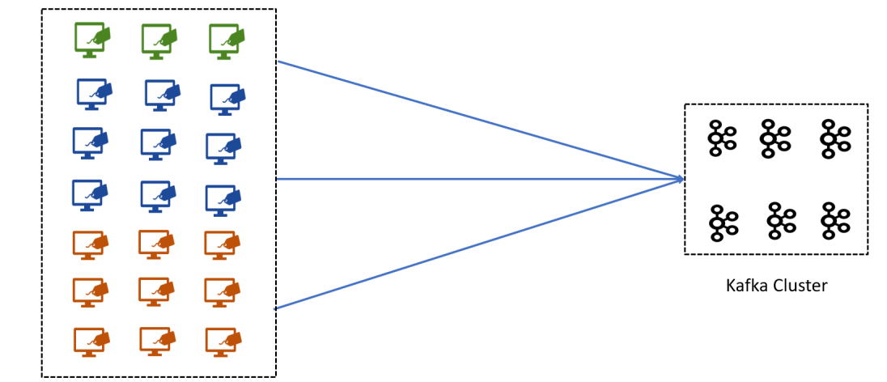

A single Kafka broker can handle hundreds of messages or maybe thousands of messages per second. However, you can increase the number of Kafka brokers in your cluster and support hundreds of thousands of messages to be received and acknowledged. On the producer side, you can keep adding the new producers to send the messages to the Kafka server in parallel. This arrangement provides linear scalability by merely adding more producers and brokers. This approach works perfectly for scaling up your overall streaming bandwidth. However, you also have an opportunity to scale an individual producer using multithreading technique. A single producer thread is good enough to support the use cases where the data is being produced at a reasonable pace. However, some scenarios may require parallelism at the individual producer level as well. You can handle such requirements using multithreaded Kafka producer.

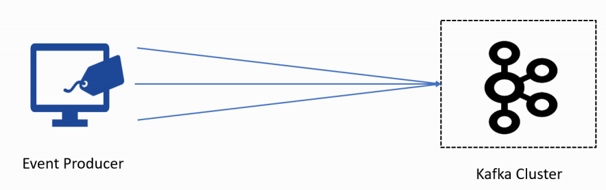

The multithreading scenario may not apply to applications that do not frequently generate new messages. For example, an individual POS application would be producing an invoice every 2-3 minutes. In that case, a single thread is more than enough to send the invoices to the Kafka cluster. However, if you have an application that generates or receives data at high speed and wants to send it as quickly as possible, you might want to implement a multithreaded application. Let's try to understand the need for multithreading with a realistic example. Let's assume a stock market data provider application, as shown in Figure. The application receives tick by tick stock data packets from the stock exchange over a TCP/IP socket. The data packets are arriving at high frequency.

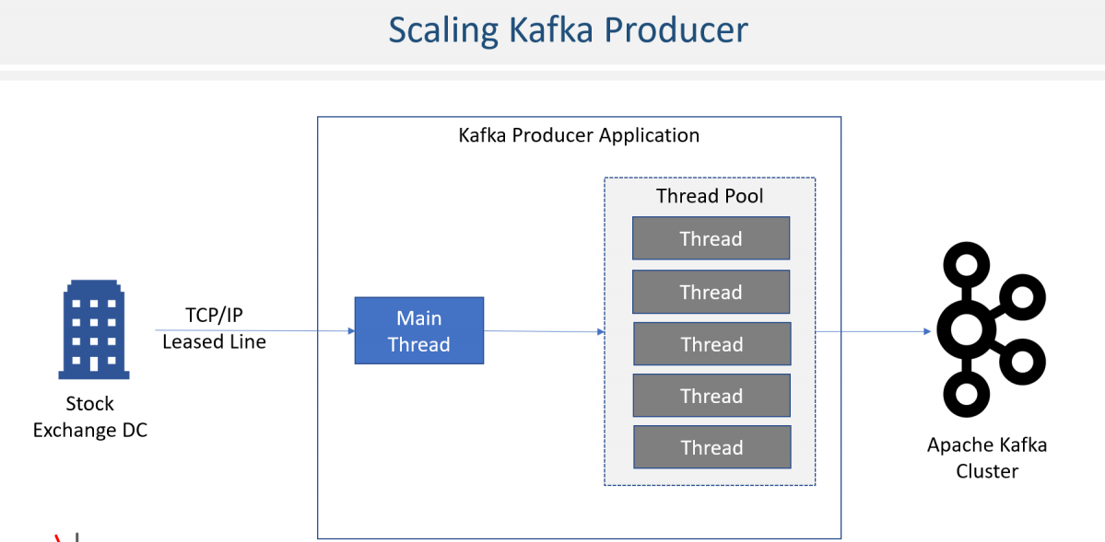

So, you decided to create a multithreaded data handler. The main thread listens to the Socket and reads the data packet as they arrive. The main thread immediately handovers the data packet to a different thread for sending the data to the Kafka broker and starts reading the next data packet. The other threads of the application are responsible for uncompressing the packet, reading individual messages from the data packet, validating the message, and sending it further to the Kafka broker. Similar scenarios are common in many other applications where the data arrives at high speed, and you may need multiple application threads to handle the load. Kafka producer is thread-safe. So, your application can share the same producer object across multiple threads and send messages in parallel using the same producer instance. It is not recommended to create numerous producer objects within the same application instance. Sharing the same producer across the threads will be faster and less resource intensive. Great!

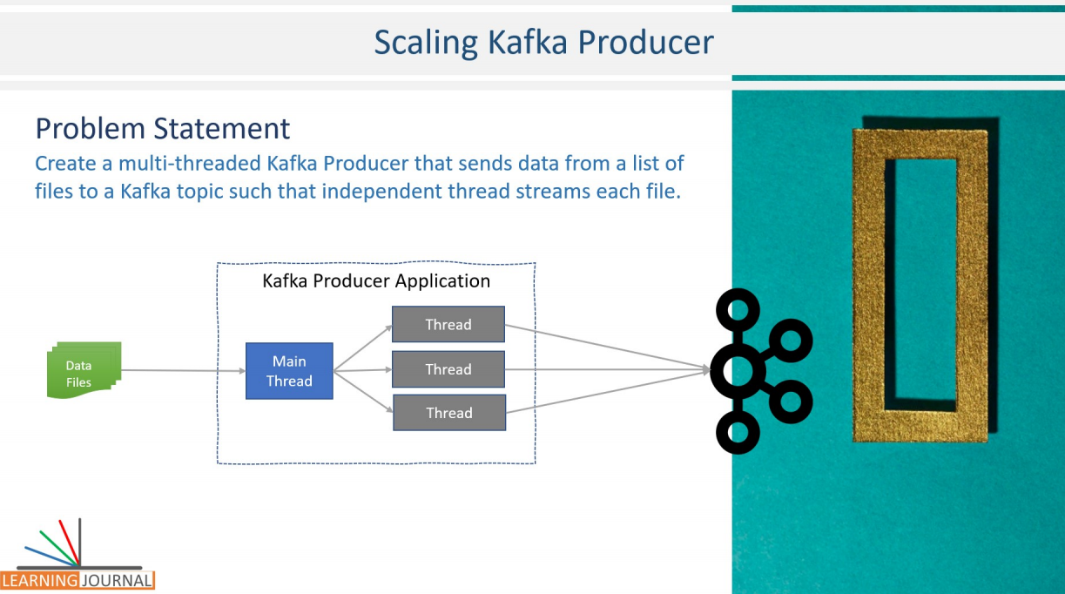

Let's create a scenario that we can use to create an example and understand the producer thread implantation. I will again take a problem-solution approach. So, here is the problem statement. Assume you have multiple data files and you want to send data from all those files to the Kafka Cluster. So, basically what we want to do is to create one main thread that reads a bunch of data files and create one independent thread to process each data file. For example, if you are supplying three data files to the application, it must create three threads, one for each data file. Each thread is responsible for reading records from one file and sending them to Kafka cluster in parallel.

|  |  |
| --- | --- |
|  | In all this, we do not want to create a bunch of Kafka producer instances, but as a recommended best practice, we want to share the same Kafka Producer Instance among all threads. Great! The problem is defined. How you wanna go about the solution? Same like earlier, I have created a starter project for you, and it is included in your course material. If you load the starter project file in your IntelliJ idea, you will see something similar to my current screen. Like the earlier example, the starter project comes with maven pom file to define the dependencies, preconfigured log4j2.xml, scripts to start your Kafka cluster, create Kafka topic, and start a console consumer if you want to look at the received messages.  I have also included two sample data files. We will be writing a multithreaded producer to send data from these files to the Kafka cluster. Same like earlier, the project also includes an AppConfig class where I have defined some constants that we will be using in the code that we are going to write. This time, I have also included a Kafka.properties file to help you understand how can you keep some producer level configurations outside the source code. Basically, we want to keep the Kafka Broker coordinates outside the application code. This arrangement allows us to deploy the application and connect to any Kafka cluster by simply changing the connection details in the properties file which resides outside the application. Great! That's all I preconfigured in your starter project. Rest of the things are going to be a live coding session. Let's start. To solve this problem, we need at least two classes. |

class AppConfigs {

final static String applicationID = "Multi-Threaded-Producer";

final static String topicName = "nse-eod-topic";

final static String kafkaConfigFileLocation = "kafka.properties";

final static String[] eventFiles =

{"data/NSE05NOV2018BHAV.csv","data/NSE06NOV2018BHAV.csv"};

}

The first one is required to create a producer thread. I am going to implement Java Runnable Interface to define a class named as Dispatcher. The Dispatcher class implements the Runnable interface. The Runnable interface allows us to execute an instance of this class as a separate Thread.

The second part of the puzzle is to implement a main() method to create threads and start them. I am going to implement a separate class named DispatcherDemo, which would have a main() method. Now with two classes defined, let's work on the Dispatcher class first. The Dispatcher class will do the following things. Read all records from a given data file. So let's create a private member for the data file. Send all the records from the file to a given Kafka topic. So, let's create a private member for the Kafka topic. In order to send the data to Kafka, we need a Kafka Producer. So let's create a private member for the producer as well. All these things will be given to the Dispatcher by the main application thread. So, let's create a constructor to take these values. Great! Finally, we need to override the run method and implement all the steps that I talked about. Let's do it. The first thing is to get the data file handle. Then create a file scanner. Ok, Let me add a try-catch here. Start scanning each line of the file. Good. Now I have a nice loop where I get each line of data from the file. We need to send these lines to Kafka. So, let's do producer.send. You already learned that the send method takes a producer record. We provide the topic name, a message key, which could be null, and finally, the message value. That's all. You can adjust your try catch block the way you want. You may also want to add a counter to count the number of lines. Also, put up a log message for starting. Similarly, one more for finishing. Great!

**Project – 03-multi-threading-producer**

import org.apache.kafka.clients.producer.KafkaProducer;

import org.apache.kafka.clients.producer.ProducerRecord;

import org.apache.logging.log4j.LogManager;

import org.apache.logging.log4j.Logger;

import java.io.File;

import java.io.FileNotFoundException;

import java.util.Scanner;

public class Dispatcher implements Runnable {

private static final Logger logger = LogManager.getLogger();

private String fileLocation;

private String topicName;

private KafkaProducer<Integer, String> producer;

Dispatcher(KafkaProducer<Integer, String> producer, String topicName,

String fileLocation) {

this.producer = producer;

this.topicName = topicName;

this.fileLocation = fileLocation;

}

@Override

public void run() {

logger.info("Start Processing " + fileLocation);

File file = new File(fileLocation);

int counter = 0;

try (Scanner scanner = new Scanner(file)) {

while (scanner.hasNextLine()) {

String line = scanner.nextLine();

producer.send(new ProducerRecord<>(topicName, null, line));

counter++;

}

logger.info("Finished Sending " + counter + " messages from " + fileLocation);

} catch (FileNotFoundException e) {

throw new RuntimeException(e);

}

}

}

My runnable class is ready. Now, let's move to the DispatcherDemo and complete that one. The first thing is to create a Kafka Producer. And I hope you already know the steps. We define a properties object. Now, I want to do two things. The first thing is to load some properties that I defined in the Kafka.properties file. You can do that by creating an input stream from a file. Then load it into the properties. That's it. Finally,the second part. Put other necessary configurations directly into the properties. Great. We are now ready to create a Kafka producer. Let's do it. The key would be an integer, I am giving null as the key in the Dispatcher, but that should be fine. The value is a string. Create an instance of the producer supplying the properties. Now we are ready to create dispatcher threads. Let me create an array. Each element of this array will hold the handle for the thread so I can join them to wait for their completion. The number of threads must be equal to the number of files. In our case, the length will result as two. Good. Now, I will create a loop. Inside the loop, create a new thread. We will use the dispatcher class constructor for creating the thread. We will be passing the same producer instance. So all the threads will use the same producer, and that's what we wanted to do. Right? Rest of the parameters are straightforward. Topic name and the file location. Simple! Isn't it? Let's start the thread.

import org.apache.kafka.clients.producer.KafkaProducer;

import org.apache.kafka.clients.producer.ProducerConfig;

import org.apache.kafka.common.serialization.IntegerSerializer;

import org.apache.kafka.common.serialization.StringSerializer;

import org.apache.logging.log4j.LogManager;

import org.apache.logging.log4j.Logger;

import java.io.FileInputStream;

import java.io.IOException;

import java.io.InputStream;

import java.util.Properties;

public class DispatcherDemo {

private static final Logger logger = LogManager.getLogger();

public static void main(String[] args){

Properties props = new Properties();

try{

InputStream inputStream = new FileInputStream(AppConfigs.kafkaConfigFileLocation);

props.load(inputStream);

props.put(ProducerConfig.CLIENT_ID_CONFIG,AppConfigs.applicationID);

props.put(ProducerConfig.KEY_SERIALIZER_CLASS_CONFIG, IntegerSerializer.class);

props.put(ProducerConfig.VALUE_SERIALIZER_CLASS_CONFIG, StringSerializer.class);

}catch (IOException e){

throw new RuntimeException(e);

}

KafkaProducer<Integer,String> producer = new KafkaProducer<>(props);

Thread[] dispatchers = new Thread[AppConfigs.eventFiles.length];

logger.info("Starting Dispatcher threads...");

for(int i=0;i<AppConfigs.eventFiles.length;i++){

dispatchers[i]=new Thread(

new Dispatcher(producer, AppConfigs.topicName, AppConfigs.eventFiles[i]));

dispatchers[i].start();

}

try {

for (Thread t : dispatchers) t.join();

}catch (InterruptedException e){

logger.error("Main Thread Interrupted");

}finally {

producer.close();

logger.info("Finished Dispatcher Demo");

}

}

}

In the end, in a separate try-catch block, loop through the thread handles, and join them together. This joining will allow the main thread to wait for all the threads to complete. Finally, don't forget to close the producer. Great! We are done. Let me quickly summarize it, and then we will run this test application. We created a runnable dispatcher that takes a Kafka producer instance, topic name, and the file location. Then we created a main method which would create a single instance of Kafka producer. It will then create two threads using the runnable Dispatcher and pass the producer instance, along with topic name and file location to the dispatcher thread. Each dispatcher thread will simply send all the lines from the file to the given Kafka topic. The main thread will wait for all the threads to complete and finally close the producer and terminate. That's all. If you want to run this application. Start the zookeeper, Start all Kafka brokers. Create a topic. And execute the producer application. Great!

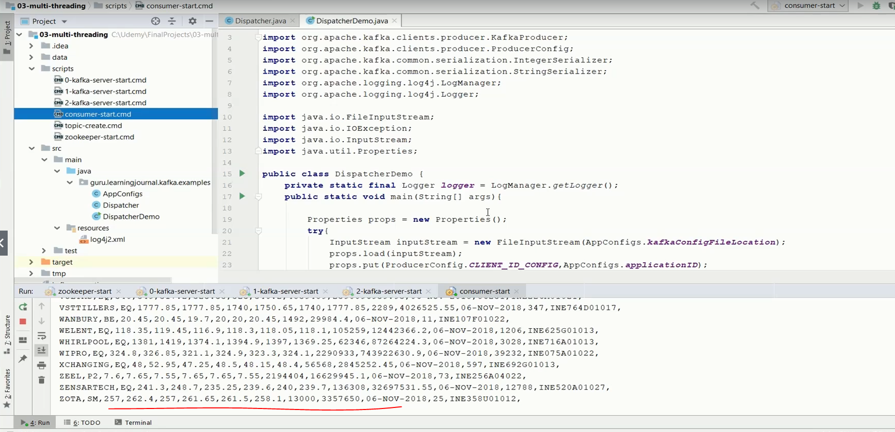

All the lines from both the files are sent. Re-execute the producer, and it will send all the data once again. You want to start clean. Stop your Kafka Brokers, Zookeeper, and delete this tmp directory. And restart your zookeeper and Kafka brokers again and repeat the test. The tmp directory is the data directory for zookeeper and Kafka brokers. When you delete it and restart your services, Kafka server starts fresh.

**Rest of the code for project**

**Project - 03-multi-threading-producer**

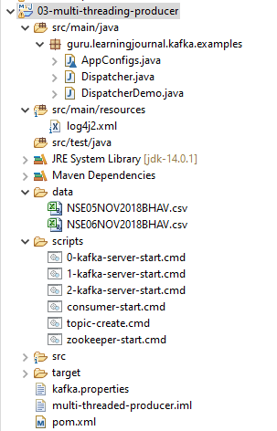

**log4j2.xml**

<Configuration status="ERROR">

<Appenders>

<Console name="stdout" target="SYSTEM_OUT">

<PatternLayout pattern="[%d] (%c) %p - %m %n"/>

</Console>

</Appenders>

<Loggers>

<Root level="error">

<AppenderRef ref="stdout"/>

</Root>

<Logger name="org.apache.kafka.clients" level="warn" additivity="false">

<AppenderRef ref="stdout"/>

</Logger>

<Logger name="guru.learningjournal.kafka.examples" level="trace" additivity="false">

<AppenderRef ref="stdout"/>

</Logger>

</Loggers>

</Configuration>

**data/**

**NSE05NOV2018BHAV.csv**

20MICRONS,EQ,44.4,44.4,42.9,43.05,43.1,43.4,25589,1108912.35,05-NOV-2018,275,INE144J01027,

21STCENMGM,EQ,23.95,23.95,23.05,23.25,23.05,23.5,4903,114697.2,05-NOV-2018,31,INE253B01015,

3IINFOTECH,EQ,3.3,3.5,3.3,3.4,3.4,3.3,1563338,5293597.1,05-NOV-2018,647,INE748C01020,

3MINDIA,EQ,20280,20440,19811,20077.85,19999.95,20282.85,1735,35031334.75,05-NOV-2018,639,INE470A01017,

5PAISA,EQ,189.9,189.9,182.4,185.3,185.3,186.15,1373,255637.1,05-NOV-2018,106,INE618L01018,

**NSE06NOV2018BHAV.csv**

20MICRONS,EQ,43.35,44.15,42.25,42.85,42.95,43.05,40692,1745361.65,06-NOV-2018,353,INE144J01027,

21STCENMGM,EQ,22.9,23.45,22.8,22.8,22.8,23.25,2031,46371.8,06-NOV-2018,26,INE253B01015,

3IINFOTECH,EQ,3.45,3.45,3.3,3.3,3.35,3.4,705204,2363457.05,06-NOV-2018,388,INE748C01020,

3MINDIA,EQ,20397.6,20397.6,19600,19845.7,19800,20077.85,1445,28788376.05,06-NOV-2018,550,INE470A01017,

3PLAND,BE,11.5,11.5,11.5,11.5,11.5,11.5,277,3185.5,06-NOV-2018,1,INE105C01023,

**scripts/**

**0-kafka-server-start.cmd**

kafka-server-start.bat %KAFKA_HOME%\config\server-0.properties

**1-kafka-server-start.cmd**

kafka-server-start.bat %KAFKA_HOME%\config\server-1.properties

**2-kafka-server-start.cmd**

kafka-server-start.bat %KAFKA_HOME%\config\server-2.properties

**consumer-start.cmd**

kafka-console-consumer.bat

--bootstrap-server localhost:9092

--topic nse-eod-topic

--from-beginning

**topic-create.cmd**

kafka-topics.bat --create --zookeeper localhost:2181

--topic nse-eod-topic

--partitions 5

--replication-factor 3

**zookeeper-start.cmd**

zookeeper-server-start.bat %KAFKA_HOME%\config\zookeeper.properties

**kafka.properties**

bootstrap.servers=localhost:9092,localhost:9093

**pom.xml**

<?xml version="1.0" encoding="UTF-8"?>

<project xmlns="http://maven.apache.org/POM/4.0.0"

xmlns:xsi="http://www.w3.org/2001/XMLSchema-instance"

xsi:schemaLocation="http://maven.apache.org/POM/4.0.0 http://maven.apache.org/xsd/maven-4.0.0.xsd">

<modelVersion>4.0.0</modelVersion>

<groupId>guru.learningjournal.kafka.examples</groupId>

<artifactId>multi-threaded-producer</artifactId>

<version>2.3.0</version>

<properties>

<java.version>1.8</java.version>

<kafka.version>2.3.0</kafka.version>

</properties>

<build>

<plugins>

<!-- Maven Compiler Plugin-->

<plugin>

<groupId>org.apache.maven.plugins</groupId>

<artifactId>maven-compiler-plugin</artifactId>

<version>3.8.0</version>

<configuration>

<source>${java.version}</source>

<target>${java.version}</target>

</configuration>

</plugin>

</plugins>

</build>

<dependencies>

<!-- Apache Kafka Clients-->

<dependency>

<groupId>org.apache.kafka</groupId>

<artifactId>kafka-clients</artifactId>

<version>${kafka.version}</version>

</dependency>

<!-- Apache Log4J2 binding for SLF4J -->

<dependency>

<groupId>org.apache.logging.log4j</groupId>

<artifactId>log4j-slf4j-impl</artifactId>

<version>2.11.0</version>

</dependency>

</dependencies>

</project>

### Advanced Kafka Producers ( Exactly Once )

In the earlier lectures, you learned to create Kafka producers, and I am assuming that you are now comfortable in meeting most of the basic requirements of streaming events to the Kafka cluster.

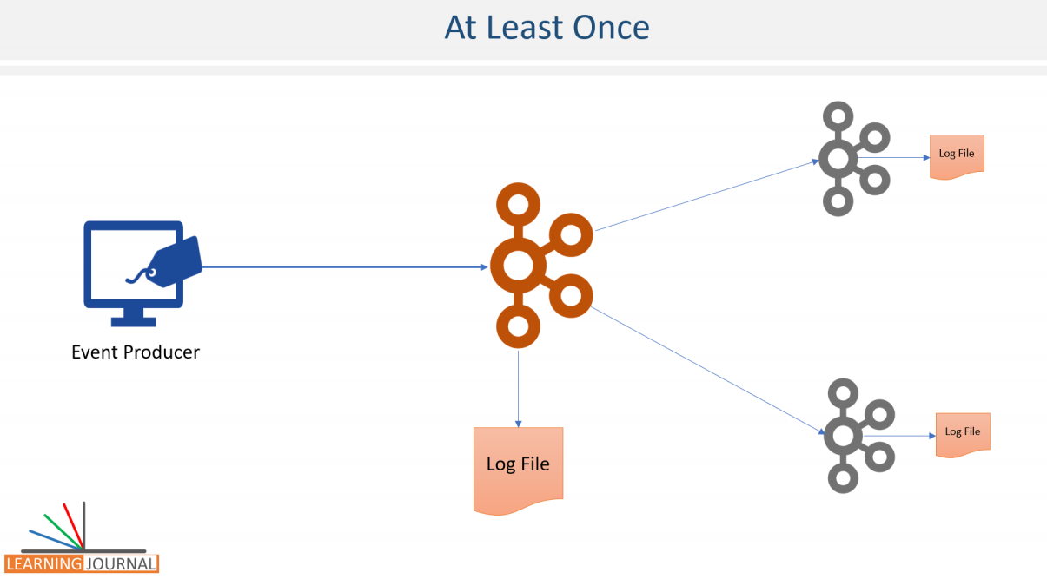

However, some specific and intricate scenarios require some extra attention. In this lecture, I will talk about some advanced producer concepts. Let's start. Apache Kafka provides message durability guaranties by committing the message at the partition log. The durability simply means, Once the data is persisted by the leader broker in the leader partition, we can't lose that message till the leader is alive. However, if the leader broker goes down, we may lose the data. To protect the loss of records due to leader failure, Kafka implements replication, right? Kafka implements replication using followers. The followers will copy messages from the leader and provide fault tolerance in case of leader failure. In other words, when the data is persisted to the leader as well as the followers in the ISR list, we consider the message to be fully committed.

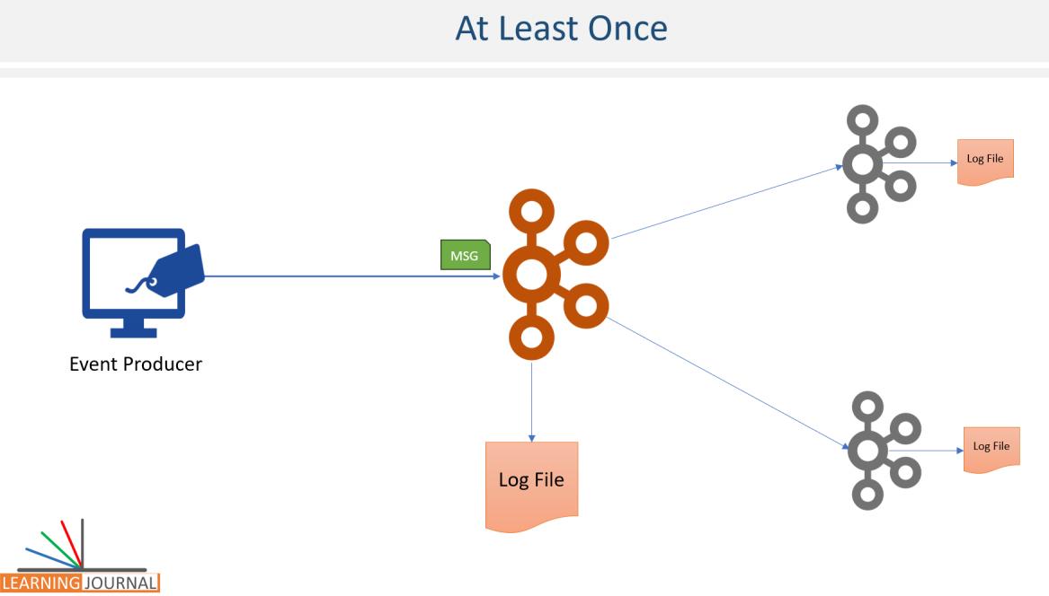

Once the message is fully committed, we can't lose the record until the leader, and all the replicas are lost, which is an unlikely case. However, in all this, we still have a possibility of committing duplicate messages due to the producer retry mechanism. As we learned in the earlier section, if the producer I/O thread fails to get a success acknowledgment from the broker, it will retry to send the same message. Now, assume that the I/O thread transmits a record to the broker. The broker receives the data and stores it into the partition log. The broker then sends an acknowledgment for the success, and the response does not reach back to the I/O thread due to a network error. In that case, the producer I/O thread will wait for the acknowledgment and ultimately send the record again assuming a failure.

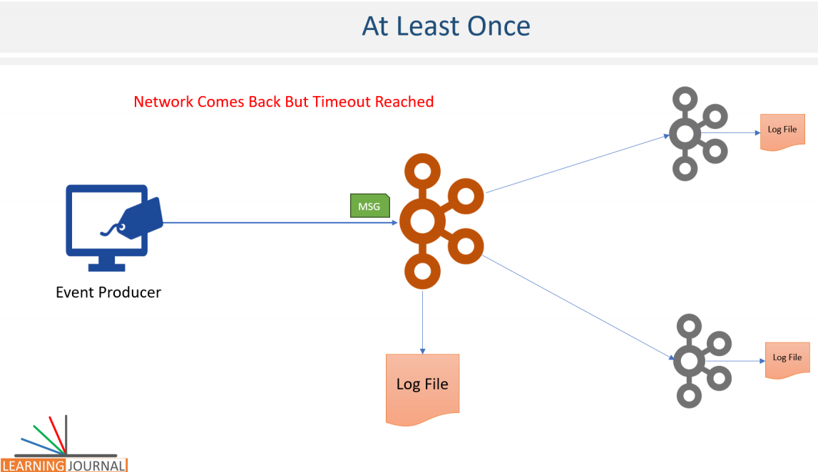

The broker again receives the data, but it doesn't have a mechanism to identify that the message is a duplicate of an earlier message. Hence, the broker saves the duplicate record causing a duplication problem. This implementation is known as at-least-once semantics, where we cannot lose messages because we are retrying until we get a success acknowledgment. However, we may have duplicates because we do not have a method to identify a duplicate message. For that reason, Kafka is said to provide at-least-once semantics.



Kafka also allows you to implement at-most-once semantics. How? Well, that`s easy. You can achieve at-most-once by configuring the retires to zero.

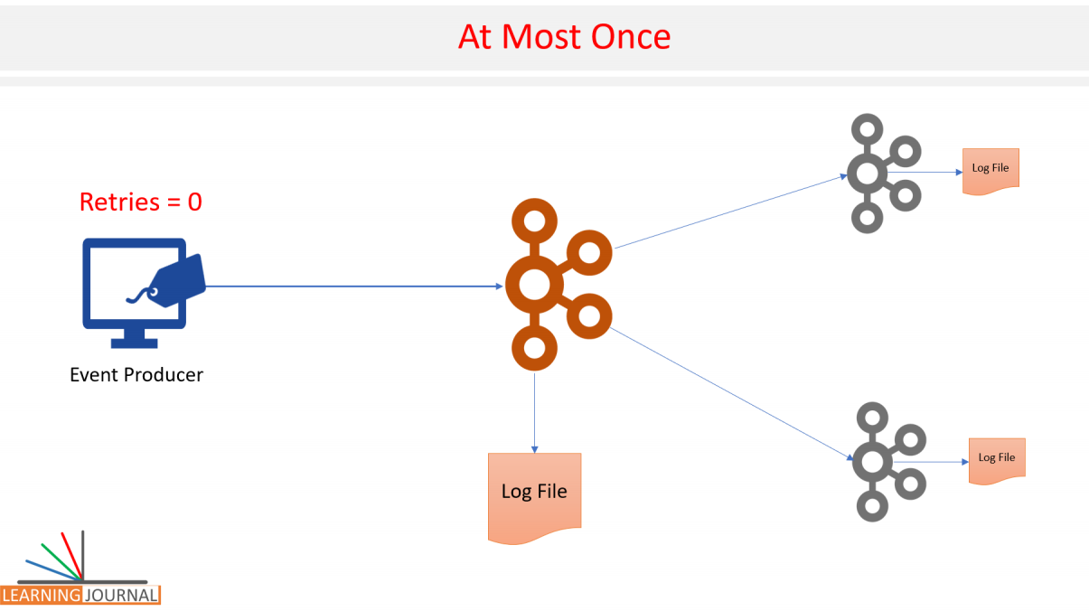

In that case, you may lose some records, but you will never have a duplicate record committed to Kafka logs. However, some use cases want to implement exactly-once semantics. I mean, we don't lose anything, and at the same time, we don't create duplicate records. To meet exactly once requirement, Kafka offers an idempotent producer configuration. All you need to do is to enable idempotence, and Kafka takes care of implementing exactly-once. To enable idempotence, you should set the enable.idempotence producer configuration to true. Once you configure the idempotence, the behavior of the producer API is changed. There are many things that happen internally, but at a high level, the producer API will do two things. It will perform an initial handshake with the leader broker and ask for a unique producer id.

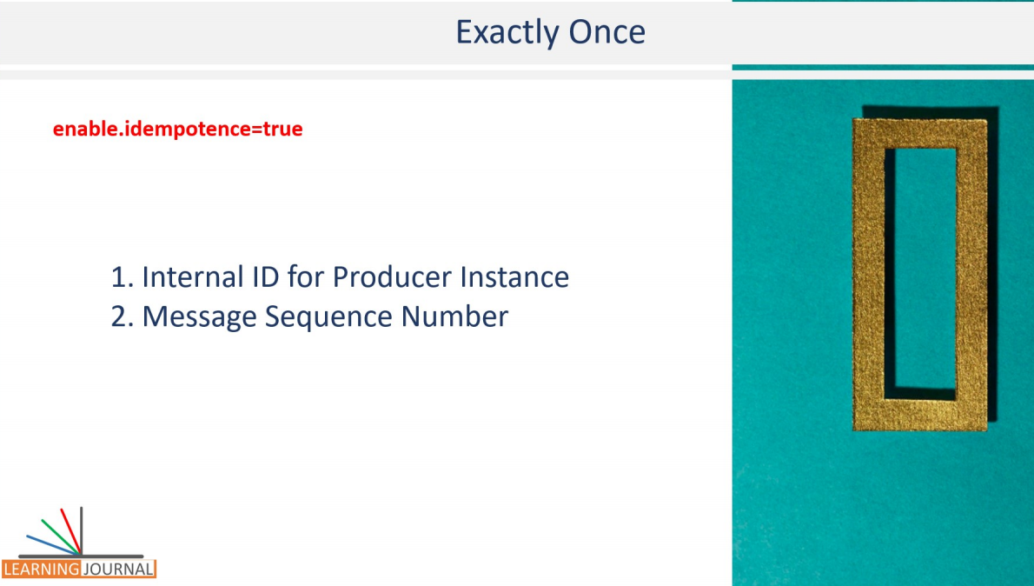

At the broker side, the broker dynamically assigns a unique ID to each producer. The next thing that happens is the message sequencing. The producer API will start assigning a sequence number to each message. This sequence number starts from zero and monotonically increments per partition. Now, when the I/O thread sends a message to a leader, the message is uniquely identified by the producer id and a sequence number. Now, the broker knows that the last committed message sequence number is X, and the next expected message sequence number is X+1.

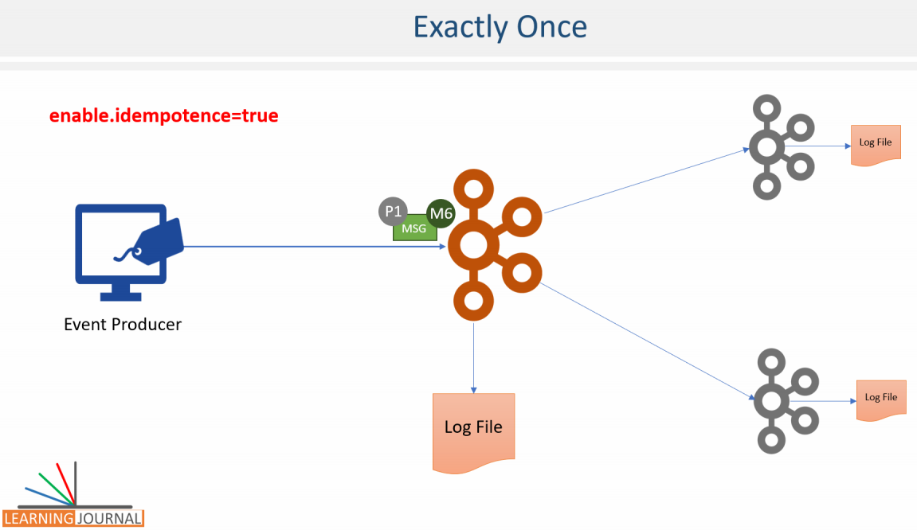

This allows the broker to identify duplicates as well as missing sequence numbers. So, setting enable.idempotence to true will help you ensure that the messages are neither lost not duplicated. How exactly it happens is not much relevant. We leave that on producer API and broker. All you need to do is to set the configuration to activate this behavior. However, you must always remember one thing. If you are sending duplicate messages at your application level, this configuration cannot protect you from duplicates. That should be considered as a bug in your application. Even if two different threads or two producer instances are sending duplicates, that too is an application design problem. The idempotence is only guaranteed for the producer retires. And you should not try to resend the messages at the application level. Idempotence is not guaranteed for the application level message resends. Or duplicates send by the application itself. Great! That's all for this lecture. I`ll talk about one more advance producer concept in the next lecture. And will call it, Transactional producer.

### Advanced Kafka Producer ( Implementing Transactions )

In the earlier lecture, we learned about the idempotent producer. There is another advance producer concept. We call it as Transactional producer. The transactional producer goes one step ahead of idempotent producer and provides the transactional guarantee, i.e., an ability to write to several partitions atomically.

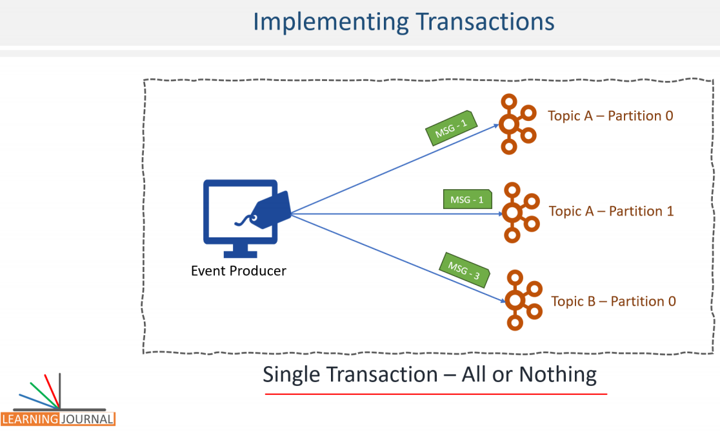

The atomicity has the same meaning as in databases, that means, either all messages within the same transaction are committed, or none of them are saved. Let's create a simple example to understand the implementation details of a transaction in Kafka Producer. I am going to keep things very simple and hence, let's take the most simple example that we created earlier and modify it to play a little with transactions.

I am opening this hello producer example. This one is not the starter project but the completed hello producer project. In this example, we created one topic and sent some messages to the same topic. The first thing that I want to change in this example is to copy the create-topic script and create another topic.

**topic-1-create.cmd**

kafka-topics.bat --create

--zookeeper localhost:2181

--topic hello-producer-1

--partitions 5

--replication-factor 3

--config min.insync.replicas=2

**topic-2-create.cmd**

kafka-topics.bat --create

--zookeeper localhost:2181

--topic hello-producer-2

--partitions 5

--replication-factor 3

--config min.insync.replicas=2

So now, we have two topics. hello-producer-1 and hello-producer-2. We are going to implement a transaction that would send some messages to both the topics. When we commit the transaction, the messages will be delivered to both the topics. If we abort or rollback the transaction, our messages should not be sent to any of these topics. That's what atomicity means. Right? Implementing transactions requires some mandatory topic level configurations. All topics which are included in a transaction should be configured with the replication factor of at least three, and the min.insync.replicas for these topics should be set to at least 2.

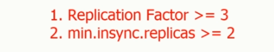

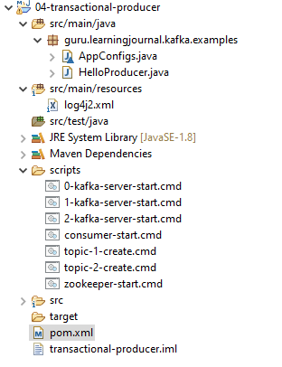

The other file contents

**Project - 04-transactional-producer**

**scripts/**

**0-kafka-server-start.cmd**

kafka-server-start.bat %KAFKA_HOME%\config\server-0.properties

**1-kafka-server-start.cmd**

kafka-server-start.bat %KAFKA_HOME%\config\server-1.properties

**2-kafka-server-start.cmd**

kafka-server-start.bat %KAFKA_HOME%\config\server-2.properties

**consumer-start.cmd**

kafka-console-consumer.bat --bootstrap-server localhost:9092

--from-beginning

--whitelist "hello-producer-1|hello-producer-2"

**zookeeper-start.cmd**

zookeeper-server-start.bat %KAFKA_HOME%\config\zookeeper.properties

**topic-1-create.cmd**

kafka-topics.bat --create

--zookeeper localhost:2181

--topic hello-producer-1

--partitions 5

--replication-factor 3

--config min.insync.replicas=2

**topic-2-create.cmd**

kafka-topics.bat --create

--zookeeper localhost:2181

--topic hello-producer-2

--partitions 5

--replication-factor 3

--config min.insync.replicas=2

**log4j2.xml**

<?xml version="1.0" encoding="UTF-8"?>

<Configuration status="ERROR">

<Appenders>

<Console name="stdout" target="SYSTEM_OUT">

<PatternLayout pattern="[%d] (%c) - %p %m %n"/>

</Console>

</Appenders>

<Loggers>

<Root level="error">

<AppenderRef ref="stdout"/>

</Root>

<Logger name="org.apache.kafka.clients" level="warn" additivity="false">

<AppenderRef ref="stdout"/>

</Logger>

<Logger name="guru.learningjournal.kafka.examples" level="trace" additivity="false">

<AppenderRef ref="stdout"/>

</Logger>

</Loggers>

</Configuration>

**pom.xml**

<?xml version="1.0" encoding="UTF-8"?>

<project xmlns="http://maven.apache.org/POM/4.0.0"

xmlns:xsi="http://www.w3.org/2001/XMLSchema-instance"

xsi:schemaLocation="http://maven.apache.org/POM/4.0.0 http://maven.apache.org/xsd/maven-4.0.0.xsd">

<modelVersion>4.0.0</modelVersion>

<groupId>guru.learningjournal.kafka.examples</groupId>

<artifactId>transactional-producer</artifactId>

<version>2.3.0</version>

<properties>

<java.version>1.8</java.version>

<kafka.version>2.3.0</kafka.version>

</properties>

<build>

<plugins>

<!-- Maven Compiler Plugin-->

<plugin>

<groupId>org.apache.maven.plugins</groupId>

<artifactId>maven-compiler-plugin</artifactId>

<version>3.8.0</version>

<configuration>

<source>${java.version}</source>

<target>${java.version}</target>

</configuration>

</plugin>

</plugins>

</build>

<dependencies>

<!-- Apache Kafka Clients-->

<dependency>

<groupId>org.apache.kafka</groupId>

<artifactId>kafka-clients</artifactId>

<version>${kafka.version}</version>

</dependency>

<!-- Apache Log4J2 binding for SLF4J -->

<dependency>

<groupId>org.apache.logging.log4j</groupId>

<artifactId>log4j-slf4j-impl</artifactId>

<version>2.11.0</version>

</dependency>

</dependencies>

</project>

Let's look at our create-topic script. We already have a replication factor of three. So the first requirement is already met. The second requirement is to ensure that the min.insync.replicas is set to at least 2 for these topics. Let's add that configuration to our create-topic command. Great! We are now all set from the topic perspective. Now, these two topics can participate in a transaction. Now, I will go to AppConfigs class and make some changes there. Let me reduce the number of events. I make it 2. Why? Just because it will be easy to verify the results with 2-3 records.

class AppConfigs {

final static String applicationID = "HelloProducer";

final static String bootstrapServers = "localhost:9092,localhost:9093";

final static String topicName1 = "hello-producer-1";

final static String topicName2 = "hello-producer-2";

final static int numEvents = 2;

final static String transaction_id = "Hello-Producer-Trans";

}

I have one constant for the topic. But now we are going to deal with two topics. So let me create one more constant for the other topic. Great! It looks good now. Now I want to add one more constant here named transaction ID. I will use this value to set TRANSACTIONAL_ID_CONFIG for the producer. Let me fix that configuration first, and then I will explain it. So, here in my properties, I am going to set a transaction id. Setting a TRANSACTIONAL_ID for the producer is a mandatory requirement to implement producer transaction, and there are two critical points to remember here.



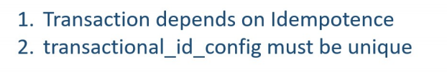

First- When you set the transactional id, idempotence is automatically enabled because transactions are dependent on idempotence. Second and most important one - TRANSACTIONAL_ID_CONFIG must be unique for each producer instance. What does that mean? That means you can't run two instances of a producer with same transactional id. If you do so, then one of those transactions will be aborted because two instances of the same transaction are illegal.

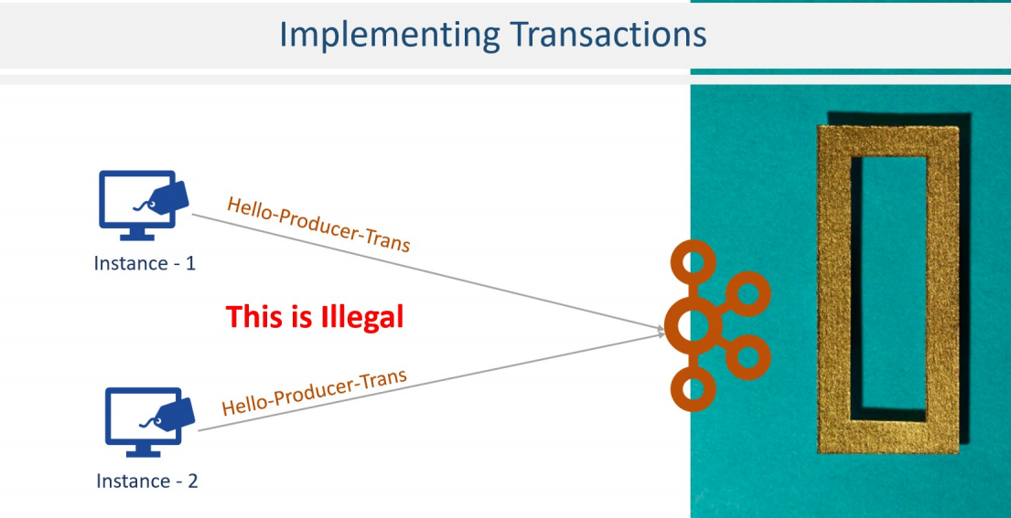

The primary purpose of the transactional id is to rollback the older unfinished transactions for the same transactional id in case of producer application bounces or restarts. You might be wondering, then how do I scale? I mean, how do I run multiple instances of the producer to achieve horizontal scalability. Well, that is simple. Each instance can set its own unique transaction id, and all of those would be sending data to the same topic implementing similar transaction but all those transactions would be different and will have their own transaction id. Right? And that should be the case anyway. Two customers performing two transactions in parallel should have two unique transaction ids. Isn't it? That's all about transaction id. Setting a transaction id is a mandatory requirement for the producer to implement a transaction and I always keep the transaction id outside the producer code in a kafka.properties file as I showed in one of the examples. Great! We are now ready to implement a transaction. Implementing transaction in the producer is a three-step process. The first step is to initialize the transaction by calling initTransactions(). So, let's do it. This method performs the necessary check to ensures that any other transaction initiated by previous instances of the same producer is closed. That means, if an application instance dies, the next instance can be guaranteed that any unfinished transactions have been either completed or aborted, leaving the new instance in a clean state before resuming the work. It also retrieves an internal producer_id that will be used in all future messages sent by the producer.

import org.apache.kafka.clients.producer.KafkaProducer;

import org.apache.kafka.clients.producer.ProducerConfig;

import org.apache.kafka.clients.producer.ProducerRecord;

import org.apache.kafka.common.serialization.IntegerSerializer;

import org.apache.kafka.common.serialization.StringSerializer;

import org.apache.logging.log4j.LogManager;

import org.apache.logging.log4j.Logger;

import java.util.Properties;

public class HelloProducer {

private static final Logger logger = LogManager.getLogger();

public static void main(String[] args) {

logger.info("Creating Kafka Producer...");

Properties props = new Properties();

props.put( ProducerConfig.CLIENT_ID_CONFIG, AppConfigs.applicationID);

props.put( ProducerConfig.BOOTSTRAP_SERVERS_CONFIG, AppConfigs.bootstrapServers);

props.put( ProducerConfig.KEY_SERIALIZER_CLASS_CONFIG,

IntegerSerializer.class.getName());

props.put( ProducerConfig.VALUE_SERIALIZER_CLASS_CONFIG,

StringSerializer.class.getName());

props.put( ProducerConfig.TRANSACTIONAL_ID_CONFIG, AppConfigs.transaction_id);

KafkaProducer<Integer, String> producer = new KafkaProducer<>(props);

producer.initTransactions();

logger.info("Starting First Transaction...");

producer.beginTransaction();

try {

for (int i = 1; i <= AppConfigs.numEvents; i++) {

producer.send( new ProducerRecord<>( AppConfigs.topicName1, i,

"Simple Message-T1-" + i));

producer.send( new ProducerRecord<>( AppConfigs.topicName2, i,

"Simple Message-T1-" + i));

}

logger.info("Committing First Transaction.");

producer.commitTransaction();

}catch (Exception e){

logger.error("Exception in First Transaction. Aborting...");

producer.abortTransaction();

producer.close();

throw new RuntimeException(e);

}

logger.info("Starting Second Transaction...");

producer.beginTransaction();

try {

for (int i = 1; i <= AppConfigs.numEvents; i++) {

producer.send(new ProducerRecord<>( AppConfigs.topicName1, i,

"Simple Message-T2-" + i));

producer.send(new ProducerRecord<>(AppConfigs.topicName2, i,

"Simple Message-T2-" + i));

}

logger.info("Aborting Second Transaction.");

producer.abortTransaction();

}catch (Exception e){

logger.error("Exception in Second Transaction. Aborting...");

producer.abortTransaction();

producer.close();

throw new RuntimeException(e);

}

logger.info("Finished - Closing Kafka Producer.");

producer.close();

}

}

**Scripts**

**0-kafka-server-start.cmd**

kafka-server-start.bat %KAFKA_HOME%\config\server-0.properties

**1-kafka-server-start.cmd**

kafka-server-start.bat %KAFKA_HOME%\config\server-1.properties

**2-kafka-server-start.cmd**

kafka-server-start.bat %KAFKA_HOME%\config\server-2.properties

**consumer-start.cmd**

kafka-console-consumer.bat --bootstrap-server localhost:9092

--from-beginning

--whitelist "hello-producer-1|hello-producer-2"

**topic-1-create.cmd**

kafka-topics.bat --create

--zookeeper localhost:2181

--topic hello-producer-1

--partitions 5

--replication-factor 3

--config min.insync.replicas=2

**topic-2-create.cmd**

kafka-topics.bat --create

--zookeeper localhost:2181

--topic hello-producer-2

--partitions 5

--replication-factor 3

--config min.insync.replicas=2

**zookeeper-start.cmd**

zookeeper-server-start.bat %KAFKA_HOME%\config\zookeeper.properties

**pom.xml**

<?xml version="1.0" encoding="UTF-8"?>

<project xmlns="http://maven.apache.org/POM/4.0.0"

xmlns:xsi="http://www.w3.org/2001/XMLSchema-instance"

xsi:schemaLocation="http://maven.apache.org/POM/4.0.0 http://maven.apache.org/xsd/maven-4.0.0.xsd">

<modelVersion>4.0.0</modelVersion>

<groupId>guru.learningjournal.kafka.examples</groupId>

<artifactId>transactional-producer</artifactId>

<version>2.3.0</version>

<properties>

<java.version>1.8</java.version>

<kafka.version>2.3.0</kafka.version>

</properties>

<build>

<plugins>

<!-- Maven Compiler Plugin-->

<plugin>

<groupId>org.apache.maven.plugins</groupId>

<artifactId>maven-compiler-plugin</artifactId>

<version>3.8.0</version>

<configuration>

<source>${java.version}</source>

<target>${java.version}</target>

</configuration>

</plugin>

</plugins>

</build>

<dependencies>

<!-- Apache Kafka Clients-->

<dependency>

<groupId>org.apache.kafka</groupId>

<artifactId>kafka-clients</artifactId>

<version>${kafka.version}</version>

</dependency>

<!-- Apache Log4J2 binding for SLF4J -->

<dependency>

<groupId>org.apache.logging.log4j</groupId>

<artifactId>log4j-slf4j-impl</artifactId>

<version>2.11.0</version>

</dependency>

</dependencies>

</project>

The producer_id is used by the broker to implement idempotence. The next step is to wrap all your send() API calls within a pair of beginTransaction() and commitTransaction().In case you receive an exception that you can't recover from, abort the transaction and finally close the producer instance. Simple. Isn't it? All messages sent between the beginTransaction() and commitTransaction() will be part of a single transaction. I would also want to put some log entries, so I know what is happening there. We created two topics for this example. My current code is sending messages to only one topic. Let me duplicate this line and make some changes, so I send one message to the first topic and another message to the second topic. Nice! So, I am assuming that this transaction will begin here. The loop will run twice. I will send two messages in each loop, one message to each topic. We don't expect any exceptions, and hence the code is not likely to get into the catch block. In normal condition, we will commit the transaction here. So far, so good. Now, I want to add some code for the rollback scenario. So let me duplicate this entire thing here. This would be my second transaction. My loop will again execute twice, and I will send a total of 4 messages. Two messages to each topic. But this time, instead of committing the transaction, I will abort it.

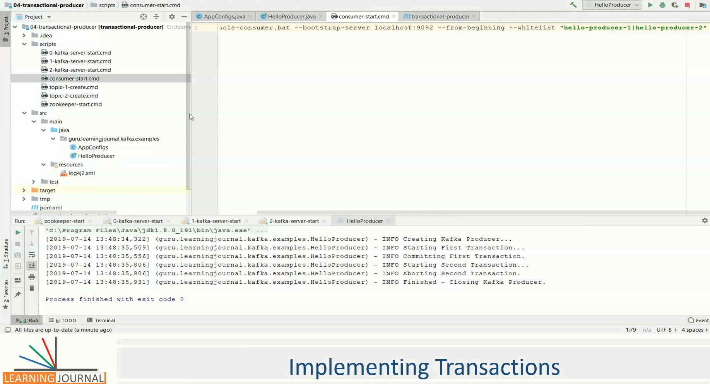

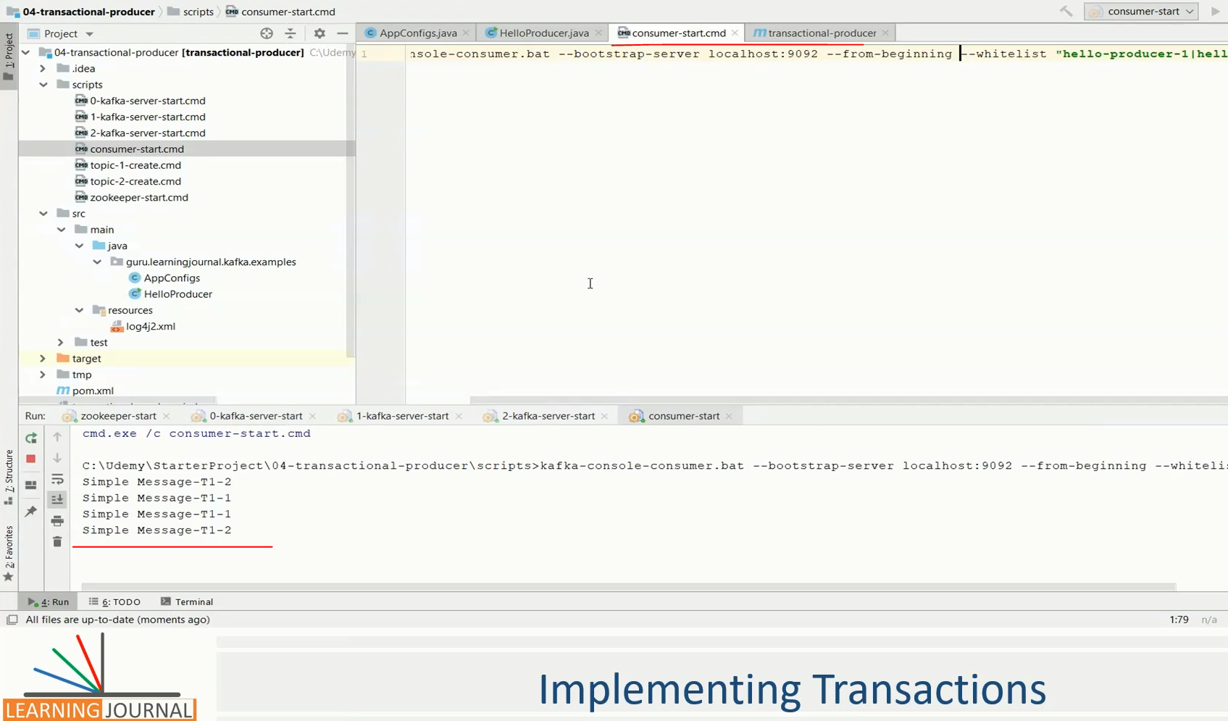

So, all the 4 messages that I am sending in this second transaction will rollback. If the begin, commit and abort works correctly, I would receive only four messages sent by the first transaction. The messages sent by the second transactions should not appear in any of the topics. Right? Let's test it. Let me start the cluster services. Great! All services are up, and we have the required topics. Let's execute the application. Good. The first transaction committed, and the second one is aborted. Now its time to investigate the results. I have added this Kafka console consumer script. This script reads both topics. So, If I execute the consumer. I should see 4 messages tagged as T1. I shouldn't see any message tagged as T2. Right? Let's execute the consumer. Do you see the expected results?

Great! One final note about the transactions. The same producer cannot have multiple open transactions. You must commit or abort the transaction before you can begin a new one. The commitTransaction() will flush any unsent records before committing the transaction. If any of the send calls failed with an irrecoverable error, that means, even if a single message is not successfully delivered to Kafka, the commitTransaction() call will throw the exception, and you are supposed to abort the whole transaction. And that's reasonable because that is what a transaction means, either all or nothing. In a multithreaded producer implementation, you will call the send() API from different threads. However, you must call the beginTransaction() before starting those threads and either commit or abort when all the threads are complete.

### Kafka Producer – Micro Project ( Point of Sale Simulator )

In the earlier lectures, we learned methods to scale Kafka producers. Now It is time to take a long jump and create something more significant. So, let's start. In this session, we are going to create a point of sale simulator.

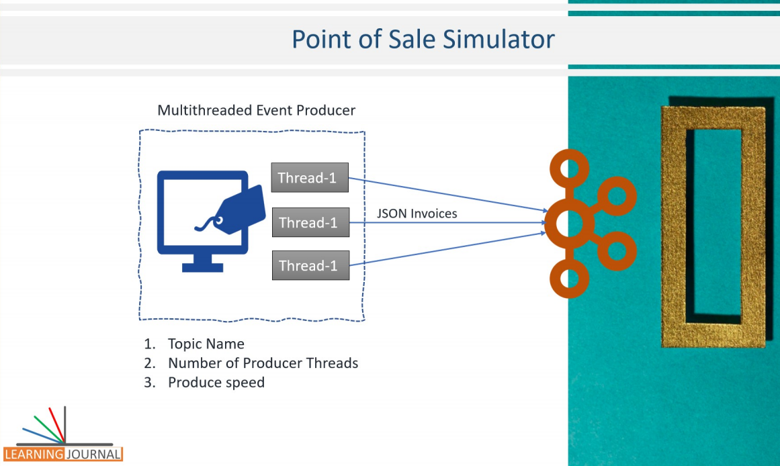

The POS simulator is a producer that generates an infinite number of random but realistic invoices and sends it to the Kafka broker. The simulator takes three arguments from the command line. Topic name - That tells which topic do you want the producer to send all the invoices. Number of Producer threads - That says how many parallel threads do you want to create for this application. Produce speed - that tell the number of milliseconds that each thread will wait between two invoices. So if you are creating 10 threads and giving a 100 milliseconds sleep time. That means, each thread will send 10 messages in one second, and since you have 10 threads, you will generate 100 messages per second. The only thing that we are not configuring is the size of each message. Otherwise, this application could be an excellent tool for generating specific workload on your Kafka cluster and perform some load testing and monitoring.

|  |  |
| --- | --- |
|  | However, this application would not generate random text string but will generate JSON formatted realistic invoices that we would be using in the later part of the course to implement some real-time stream processing scenarios. Interesting example. Isn't it? Let's do it. Same as earlier examples, I have again created a starter project for you.  In this starter project, I have already setup usual Java project things such as dependency pom, log4j2.xml, scripts to start your zookeeper and Kafka services, and script to create Kafka topic. The starter project also comes with two predefined java packages that I have already created and kept in the starter project. I created them beforehand because these are everyday Java things, and we do not have any Kafka specific code.  If you already know a little Java, these things are straightforward. Let me explain these two packages. The first package is the types package. We have three classes in this package that defines the invoice structure. The Class LineItem defines the structure of a line item in the Invoice, which includes ItemCode, ItemDescription, Price, quality, and total value.  The Class DeliveryAddress defines the structure of an address, which includes AddressLine, City, State, Pin code, and other similar things. Finally, we have PosInvoice which again a structure that includes some standard fields such as InvoiceNumber, CreatedTime, StoreID and also includes the delivery address as well as an array of line items.  So, the types package defines all the necessary objects to represent an Invoice. And the code for all these classes is well annotated using Jackson annotations for usage with Jackson DataBind package. In fact, I haven't handwritten these classes. I have generated these classes from a schema definition using jsonschema2pojo maven plugin. |

**DeliveryAddress.java**

import com.fasterxml.jackson.annotation.JsonInclude;

import com.fasterxml.jackson.annotation.JsonProperty;

import com.fasterxml.jackson.annotation.JsonPropertyOrder;

import org.apache.commons.lang.builder.ToStringBuilder;

@JsonInclude(JsonInclude.Include.NON_NULL)

@JsonPropertyOrder({

"AddressLine",

"City",

"State",

"PinCode",

"ContactNumber"

})

public class DeliveryAddress {

@JsonProperty("AddressLine")

private String addressLine;

@JsonProperty("City")

private String city;

@JsonProperty("State")

private String state;

@JsonProperty("PinCode")

private String pinCode;

@JsonProperty("ContactNumber")

private String contactNumber;

@JsonProperty("AddressLine")

public String getAddressLine() { return addressLine; }

@JsonProperty("AddressLine")

public void setAddressLine(String addressLine) { this.addressLine = addressLine; }

@JsonProperty("City")

public String getCity() { return city; }

@JsonProperty("City")

public void setCity(String city) { this.city = city; }

@JsonProperty("State")

public String getState() { return state; }

@JsonProperty("State")

public void setState(String state) { this.state = state; }

@JsonProperty("PinCode")

public String getPinCode() { return pinCode; }

@JsonProperty("PinCode")

public void setPinCode(String pinCode) { this.pinCode = pinCode; }

@JsonProperty("ContactNumber")

public String getContactNumber() { return contactNumber; }

@JsonProperty("ContactNumber")

public void setContactNumber(String contactNumber) {

this.contactNumber = contactNumber;

}

@Override

public String toString() {

return new ToStringBuilder(this).append("addressLine", addressLine).append("city", city).append("state", state).append("pinCode", pinCode).append("contactNumber", contactNumber).toString();

}

}

**LineItem.java**

import com.fasterxml.jackson.annotation.JsonInclude;

import com.fasterxml.jackson.annotation.JsonProperty;

import com.fasterxml.jackson.annotation.JsonPropertyOrder;

import org.apache.commons.lang.builder.ToStringBuilder;

@JsonInclude(JsonInclude.Include.NON_NULL)

@JsonPropertyOrder({

"ItemCode",

"ItemDescription",

"ItemPrice",

"ItemQty",

"TotalValue"

})

public class LineItem {

@JsonProperty("ItemCode")

private String itemCode;

@JsonProperty("ItemDescription")

private String itemDescription;

@JsonProperty("ItemPrice")

private Double itemPrice;

@JsonProperty("ItemQty")

private Integer itemQty;

@JsonProperty("TotalValue")

private Double totalValue;

@JsonProperty("ItemCode")

public String getItemCode() { return itemCode; }

@JsonProperty("ItemCode")

public void setItemCode(String itemCode) { this.itemCode = itemCode; }

@JsonProperty("ItemDescription")

public String getItemDescription() { return itemDescription; }

@JsonProperty("ItemDescription")

public void setItemDescription(String itemDescription) {

this.itemDescription = itemDescription;

}

@JsonProperty("ItemPrice")

public Double getItemPrice() { return itemPrice; }

@JsonProperty("ItemPrice")

public void setItemPrice(Double itemPrice) { this.itemPrice = itemPrice; }

@JsonProperty("ItemQty")

public Integer getItemQty() { return itemQty; }

@JsonProperty("ItemQty")

public void setItemQty(Integer itemQty) { this.itemQty = itemQty; }

@JsonProperty("TotalValue")

public Double getTotalValue() { return totalValue; }

@JsonProperty("TotalValue")

public void setTotalValue(Double totalValue) { this.totalValue = totalValue; }

@Override

public String toString() {

return new toStringBuilder(this)

.append("itemCode", itemCode)

.append("itemDescription", itemDescription)

.append("itemPrice", itemPrice)

.append("itemQty", itemQty)

.append("totalValue", totalValue).toString();

}

}

**PosInvoice.java**

import java.util.ArrayList;

import java.util.List;

import com.fasterxml.jackson.annotation.JsonInclude;

import com.fasterxml.jackson.annotation.JsonProperty;

import com.fasterxml.jackson.annotation.JsonPropertyOrder;

import org.apache.commons.lang.builder.ToStringBuilder;

@JsonInclude(JsonInclude.Include.NON_NULL)

@JsonPropertyOrder({

"InvoiceNumber",

"CreatedTime",

"StoreID",

"PosID",

"CashierID",

"CustomerType",

"CustomerCardNo",

"TotalAmount",

"NumberOfItems",

"PaymentMethod",

"TaxableAmount",

"CGST",

"SGST",

"CESS",

"DeliveryType",

"DeliveryAddress",

"InvoiceLineItems"

})

public class PosInvoice {

@JsonProperty("InvoiceNumber")

private String invoiceNumber;

@JsonProperty("CreatedTime")

private Long createdTime;

@JsonProperty("StoreID")

private String storeID;

@JsonProperty("PosID")

private String posID;

@JsonProperty("CashierID")

private String cashierID;

@JsonProperty("CustomerType")

private String customerType;

@JsonProperty("CustomerCardNo")

private String customerCardNo;

@JsonProperty("TotalAmount")

private Double totalAmount;

@JsonProperty("NumberOfItems")

private Integer numberOfItems;

@JsonProperty("PaymentMethod")

private String paymentMethod;

@JsonProperty("TaxableAmount")

private Double taxableAmount;

@JsonProperty("CGST")

private Double cGST;

@JsonProperty("SGST")

private Double sGST;

@JsonProperty("CESS")

private Double cESS;

@JsonProperty("DeliveryType")

private String deliveryType;

@JsonProperty("DeliveryAddress")

private DeliveryAddress deliveryAddress;

@JsonProperty("InvoiceLineItems")

private List<LineItem> invoiceLineItems = new ArrayList<LineItem>();

@JsonProperty("InvoiceNumber")

public String getInvoiceNumber() { return invoiceNumber; }

@JsonProperty("InvoiceNumber")

public void setInvoiceNumber(String invoiceNumber) { this.invoiceNumber = invoiceNumber; }

@JsonProperty("CreatedTime")

public Long getCreatedTime() { return createdTime; }

@JsonProperty("CreatedTime")

public void setCreatedTime(Long createdTime) { this.createdTime = createdTime; }

@JsonProperty("StoreID")

public String getStoreID() { return storeID; }

@JsonProperty("StoreID")

public void setStoreID(String storeID) { this.storeID = storeID; }

@JsonProperty("PosID")

public String getPosID() { return posID; }

@JsonProperty("PosID")

public void setPosID(String posID) { this.posID = posID; }

@JsonProperty("CashierID")

public String getCashierID() { return cashierID; }

@JsonProperty("CashierID")

public void setCashierID(String cashierID) { this.cashierID = cashierID; }

@JsonProperty("CustomerType")

public String getCustomerType() { return customerType; }

@JsonProperty("CustomerType")

public void setCustomerType(String customerType) { this.customerType = customerType; }

@JsonProperty("CustomerCardNo")

public String getCustomerCardNo() { return customerCardNo; }

@JsonProperty("CustomerCardNo")

public void setCustomerCardNo(String customerCardNo) { this.customerCardNo = customerCardNo; }

@JsonProperty("TotalAmount")

public Double getTotalAmount() { return totalAmount; }

@JsonProperty("TotalAmount")

public void setTotalAmount(Double totalAmount) { this.totalAmount = totalAmount; }

@JsonProperty("NumberOfItems")

public Integer getNumberOfItems() { return numberOfItems; }

@JsonProperty("NumberOfItems")

public void setNumberOfItems(Integer numberOfItems) { this.numberOfItems = numberOfItems; }

@JsonProperty("PaymentMethod")

public String getPaymentMethod() { return paymentMethod; }

@JsonProperty("PaymentMethod")

public void setPaymentMethod(String paymentMethod) { this.paymentMethod = paymentMethod; }

@JsonProperty("TaxableAmount")

public Double getTaxableAmount() { return taxableAmount; }

@JsonProperty("TaxableAmount")

public void setTaxableAmount(Double taxableAmount) { this.taxableAmount = taxableAmount; }

@JsonProperty("CGST")

public Double getCGST() { return cGST; }

@JsonProperty("CGST")

public void setCGST(Double cGST) { this.cGST = cGST; }

@JsonProperty("SGST")

public Double getSGST() { return sGST; }

@JsonProperty("SGST")

public void setSGST(Double sGST) { this.sGST = sGST; }

@JsonProperty("CESS")

public Double getCESS() { return cESS; }

@JsonProperty("CESS")

public void setCESS(Double cESS) { this.cESS = cESS; }

@JsonProperty("DeliveryType")

public String getDeliveryType() { return deliveryType; }

@JsonProperty("DeliveryType")

public void setDeliveryType(String deliveryType) { this.deliveryType = deliveryType; }

@JsonProperty("DeliveryAddress")

public DeliveryAddress getDeliveryAddress() { return deliveryAddress; }

@JsonProperty("DeliveryAddress")

public void setDeliveryAddress(DeliveryAddress deliveryAddress) { this.deliveryAddress = deliveryAddress; }

@JsonProperty("InvoiceLineItems")

public List<LineItem> getInvoiceLineItems() { return invoiceLineItems; }

@JsonProperty("InvoiceLineItems")

public void setInvoiceLineItems(List<LineItem> invoiceLineItems) { this.invoiceLineItems = invoiceLineItems; }

@Override

public String toString() {

return new ToStringBuilder(this).append("invoiceNumber", invoiceNumber)

.append("createdTime", createdTime)

.append("storeID", storeID).append("posID", posID)

.append("cashierID", cashierID)

.append("customerType", customerType)

.append("customerCardNo", customerCardNo)

.append("totalAmount", totalAmount)

.append("numberOfItems", numberOfItems)

.append("paymentMethod", paymentMethod)

.append("taxableAmount", taxableAmount).append("cGST", cGST)

.append("sGST", sGST).append("cESS", cESS)

.append("deliveryType", deliveryType)

.append("deliveryAddress", deliveryAddress)

.append("invoiceLineItems", invoiceLineItems).toString();

}

}

You will often need these kinds of POJOs in your day to day stream processing application. Hence, I have a separate lecture to explain the plugin and code generation. However, In this example, we want to focus on other important things, and hence, I have included these classes in your starter project and the detailed explanation of how you can generate these classes will come in a separate lecture. The second package is the data generator package. The data generator package also comes with three classes. AddressGenerator which exposes a getNextAddress method to give you a new random address. The ProductGenerator class exposes getNextProduct method, which gives you a random line item for your Invoice. You won't be using these two classes directly. Both of these classes are internally used by the third class InvoiceGenerator. This is the class that your producer threads would use to create random Invoices and simply send it to Kafka. So, the stage is set for you. You are expected to create a multithreaded application which creates several producer threads. Each thread will use InvoiceGenerator.getNextInvoice() method and send the given Invoice to Apache Kafka. Simple. Isn't it? You have already created a multithreaded producer application in the earlier example.

This example doesn't pose a new problem. Ok, Let me add a new problem here to make it a little more interesting. Earlier we always sent plain string messages. But now, we have an Invoice which is a reasonably complex Java Object. The invoice object has got several fields, and they are of different data types. Some are String, but others are of Integer, number and Long types. The DeliveryAddress field is a more sophisticated type which in itself is an object. The InvoiceLineItems is an array of objects. So, basically an invoice is not a plain string, but it is a complex document with a predefined structure. You are supposed to serialize this complex PosInvoice Java Object before you can transmit it over the network. You also need to be sure that the serialized Invoice, once received at the consumer, can be correctly de-serialized back into a PosInvoice Java Object. This is why a Kafka producer needs a serializer configuration.

props.put(ProducerConfig.VALUE_SERIALIZER_CLASS_CONFIG, StringSerializer.class);

We have used StringSerializer in earlier examples, but this time, the StringSerializer does not fit our requirement. We need a better alternative. There are two popular alternatives in the Kafka world. JSON Serializer and a Deserializer. Avro Serializer and a corresponding Deserializer.

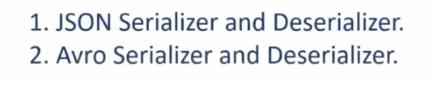

The JSON Serializer is easy to use because JSON serialized objects are represented as strings, and that makes them a convenient option. You can easily cast them to a String and print it on the console or in your logs. The simplicity of JSON makes debugging your data issues quite simple. Hence, they are commonly used and supported by many data integration tools. However, JSON serialized messages are large in size. The JSON format includes field names with each data element. These field names may increase the size of your serialized messages by 2X or more, and ultimately, it causes more delays at the network layer to transmit these messages.

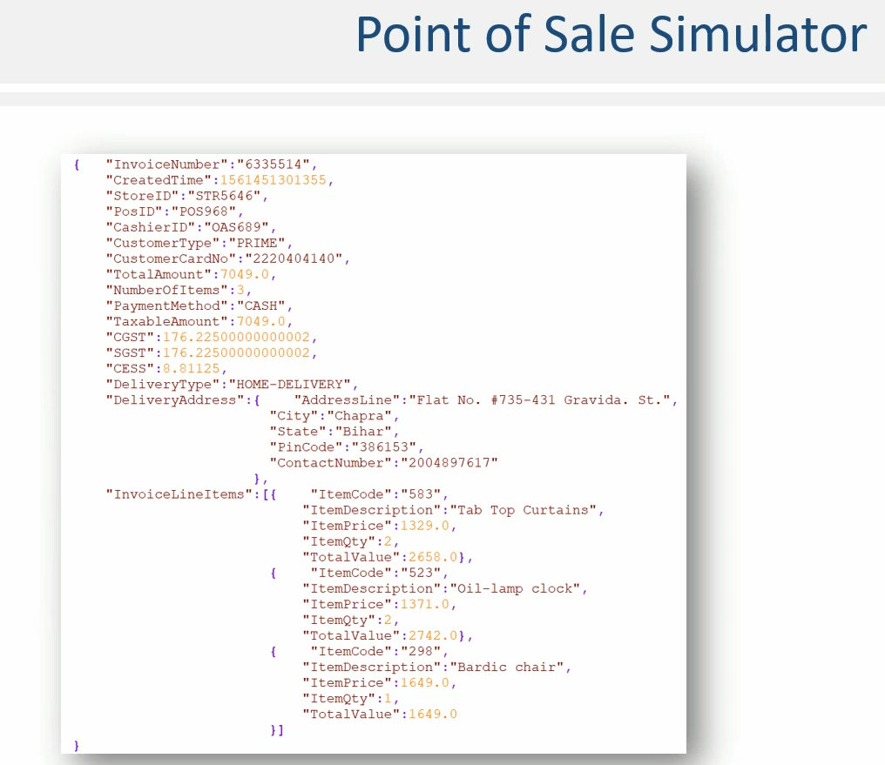

The alternative is the Avro Serializer. The Avro is a binary format, and the serialization is much more compact. So, if you are using Avro serialization, your messages will be shorter over the network, giving you a more substantial network bandwidth. But in this example, we want to use JSON Serializer. You do not need to implement a JSON serializer yourself because it is a standard thing, and I have already included a JsonSerializer class in your startup project.

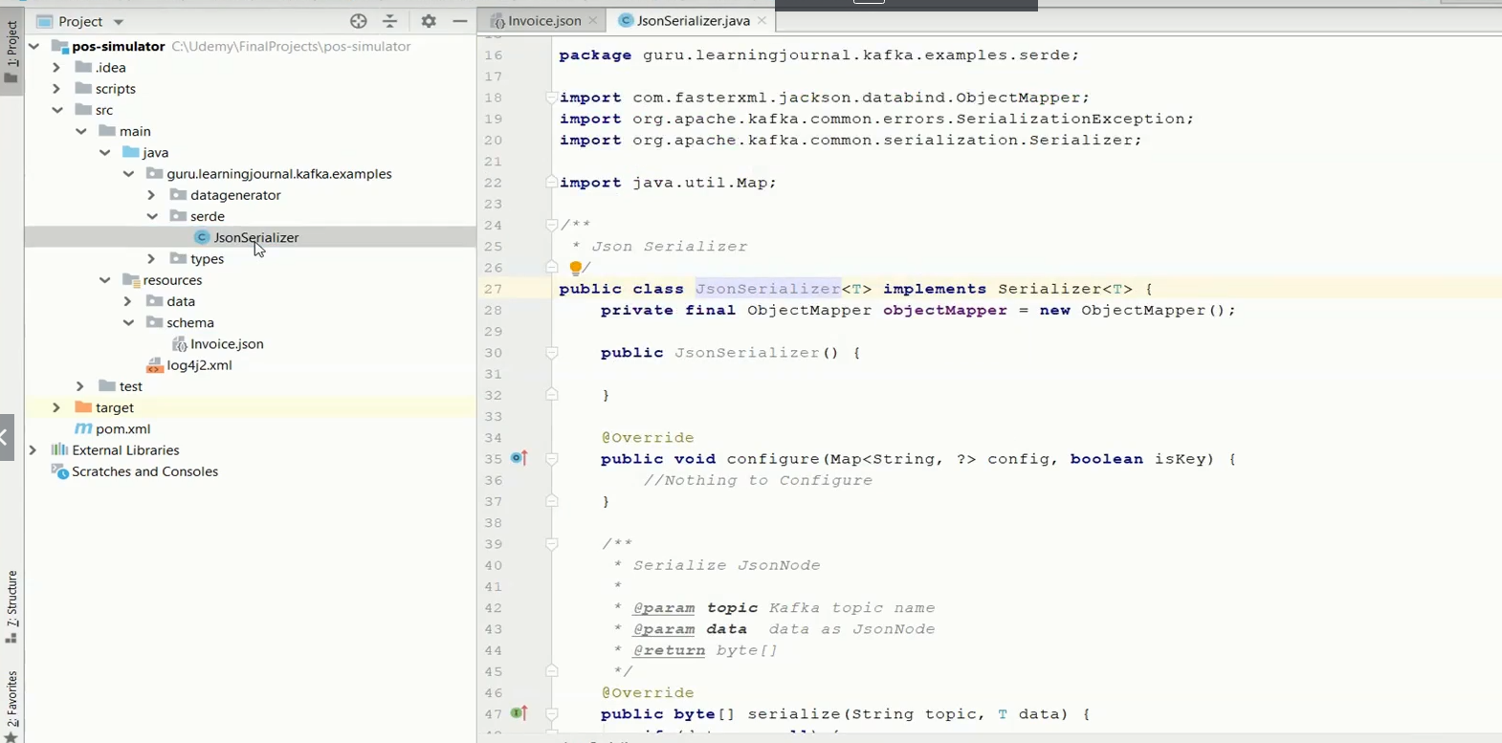

You can use the same in this example, and you are also free to use it in any other application wherever you want to serialize your messages as JSON. Great! So that's all you have in the startup project. Now you are supposed to implement a POS simulator that generates invoices and sends to a Kafka topic. I am not going to write the code as I did for other earlier examples. You already learned to implement a multithreaded Kafka Producer, and I leave this example for you to be completed as an exercise. However, if you are getting stuck somewhere, I have also included a complete implementation source code in your course material. You can use it as a reference, but I recommend that you dirty your hand and start coding a few things.

**Full Code apart from the JSON POJOs above**

**Project - 05-pos-simulator**

**AddressGenerator.java**

import com.fasterxml.jackson.databind.ObjectMapper;

import guru.learningjournal.kafka.examples.types.DeliveryAddress;

import java.io.File;

import java.util.Random;

class AddressGenerator {

private static final AddressGenerator ourInstance = new AddressGenerator();

private final Random random;

private DeliveryAddress[] addresses;

private int getIndex() {

return random.nextInt(100);

}

static AddressGenerator getInstance() {

return ourInstance;

}

private AddressGenerator() {

final String DATAFILE = "src/main/resources/data/address.json";

final ObjectMapper mapper;

random = new Random();

mapper = new ObjectMapper();

try {

addresses = mapper.readValue(new File(DATAFILE), DeliveryAddress[].class);

} catch (Exception e) {

throw new RuntimeException(e);

}

}

DeliveryAddress getNextAddress() {

return addresses[getIndex()];

}

}

**InvoiceGenerator.java**

import com.fasterxml.jackson.databind.ObjectMapper;

import guru.learningjournal.kafka.examples.types.DeliveryAddress;

import guru.learningjournal.kafka.examples.types.PosInvoice;

import guru.learningjournal.kafka.examples.types.LineItem;

import org.apache.logging.log4j.LogManager;

import org.apache.logging.log4j.Logger;

import java.io.File;

import java.util.ArrayList;

import java.util.List;

import java.util.Random;

public class InvoiceGenerator {

private static final Logger logger = LogManager.getLogger();

private static InvoiceGenerator ourInstance = new InvoiceGenerator();

private final Random invoiceIndex;

private final Random invoiceNumber;

private final Random numberOfItems;

private final PosInvoice[] invoices;

public static InvoiceGenerator getInstance() {

return ourInstance;

}

private InvoiceGenerator() {

String DATAFILE = "src/main/resources/data/Invoice.json";

ObjectMapper mapper;

invoiceIndex = new Random();

invoiceNumber = new Random();

numberOfItems = new Random();

mapper = new ObjectMapper();

try {

invoices = mapper.readValue(new File(DATAFILE), PosInvoice[].class);

} catch (Exception e) {

throw new RuntimeException(e);

}

}

private int getIndex() {

return invoiceIndex.nextInt(100);

}

private int getNewInvoiceNumber() {

return invoiceNumber.nextInt(99999999) + 99999;

}

private int getNoOfItems() {

return numberOfItems.nextInt(4) + 1;

}

public PosInvoice getNextInvoice() {

PosInvoice invoice = invoices[getIndex()];

invoice.setInvoiceNumber(Integer.toString(getNewInvoiceNumber()));

invoice.setCreatedTime(System.currentTimeMillis());

if ("HOME-DELIVERY".equalsIgnoreCase(invoice.getDeliveryType())) {

DeliveryAddress deliveryAddress = AddressGenerator.getInstance().getNextAddress();

invoice.setDeliveryAddress(deliveryAddress);

}

int itemCount = getNoOfItems();

Double totalAmount = 0.0;

List<LineItem> items = new ArrayList<>();

ProductGenerator productGenerator = ProductGenerator.getInstance();

for (int i = 0; i < itemCount; i++) {

LineItem item = productGenerator.getNextProduct();

totalAmount = totalAmount + item.getTotalValue();

items.add(item);

}

invoice.setNumberOfItems(itemCount);

invoice.setInvoiceLineItems(items);

invoice.setTotalAmount(totalAmount);

invoice.setTaxableAmount(totalAmount);

invoice.setCGST(totalAmount * 0.025);

invoice.setSGST(totalAmount * 0.025);

invoice.setCESS(totalAmount * 0.00125);

logger.debug(invoice);

return invoice;

}

}

**ProductGenerator.java**

import com.fasterxml.jackson.databind.ObjectMapper;

import guru.learningjournal.kafka.examples.types.LineItem;

import java.io.File;

import java.util.Random;

class ProductGenerator {

private static final ProductGenerator ourInstance = new ProductGenerator();

private final Random random;

private final Random qty;

private final LineItem[] products;

static ProductGenerator getInstance() {

return ourInstance;

}

private ProductGenerator() {

String DATAFILE = "src/main/resources/data/products.json";

ObjectMapper mapper = new ObjectMapper();

random = new Random();

qty = new Random();

try {

products = mapper.readValue(new File(DATAFILE), LineItem[].class);

} catch (Exception e) {

throw new RuntimeException(e);

}

}

private int getIndex() {

return random.nextInt(100);

}

private int getQuantity() {

return qty.nextInt(2) + 1;

}

LineItem getNextProduct() {

LineItem lineItem = products[getIndex()];

lineItem.setItemQty(getQuantity());

lineItem.setTotalValue(lineItem.getItemPrice() * lineItem.getItemQty());

return lineItem;

}

}

**JsonSerializer.java**

import com.fasterxml.jackson.databind.ObjectMapper;

import org.apache.kafka.common.errors.SerializationException;

import org.apache.kafka.common.serialization.Serializer;

import java.util.Map;

public class JsonSerializer<T> implements Serializer<T> {

private final ObjectMapper objectMapper = new ObjectMapper();

public JsonSerializer() { }

@Override

public void configure(Map<String, ?> config, boolean isKey) {

//Nothing to Configure

}

/**

* Serialize JsonNode

*

* @param topic Kafka topic name

* @param data data as JsonNode

* @return byte[]

*/

@Override

public byte[] serialize(String topic, T data) {

if (data == null) {

return null;

}

try {

return objectMapper.writeValueAsBytes(data);

} catch (Exception e) {

throw new SerializationException("Error serializing JSON message", e);

}

}

@Override

public void close() { }

}

**AppConfigs.java**

public class AppConfigs {

public final static String applicationID = "PosSimulator";

public final static String bootstrapServers = "localhost:9092,localhost:9093";

}

**RunnableProducer.java**

import guru.learningjournal.kafka.examples.datagenerator.InvoiceGenerator;

import guru.learningjournal.kafka.examples.types.PosInvoice;

import org.apache.kafka.clients.producer.KafkaProducer;

import org.apache.kafka.clients.producer.ProducerRecord;

import org.apache.logging.log4j.LogManager;

import org.apache.logging.log4j.Logger;

import java.util.concurrent.atomic.AtomicBoolean;

public class RunnableProducer implements Runnable {

private static final Logger logger = LogManager.getLogger();

private final AtomicBoolean stopper = new AtomicBoolean(false);

private KafkaProducer<String, PosInvoice> producer;

private String topicName;

private InvoiceGenerator invoiceGenerator;

private int produceSpeed;

private int id;

RunnableProducer(int id, KafkaProducer<String, PosInvoice> producer, String topicName,

int produceSpeed) {

this.id = id;

this.producer = producer;

this.topicName = topicName;

this.produceSpeed = produceSpeed;

this.invoiceGenerator = InvoiceGenerator.getInstance();

}

@Override

public void run() {

try {

logger.info("Starting producer thread - " + id);

while (!stopper.get()) {

PosInvoice posInvoice = invoiceGenerator.getNextInvoice();

producer.send(new ProducerRecord<>(topicName, posInvoice.getStoreID(), posInvoice));

Thread.sleep(produceSpeed);

}

} catch (Exception e) {

logger.error("Exception in Producer thread - " + id);

throw new RuntimeException(e);

}

}

void shutdown() {

logger.info("Shutting down producer thread - " + id);

stopper.set(true);

}

}

**PosSimulator.java**

import guru.learningjournal.kafka.examples.serde.JsonSerializer;

import guru.learningjournal.kafka.examples.types.PosInvoice;

import org.apache.kafka.clients.producer.KafkaProducer;

import org.apache.kafka.clients.producer.ProducerConfig;

import org.apache.kafka.common.serialization.StringSerializer;

import org.apache.logging.log4j.LogManager;

import org.apache.logging.log4j.Logger;

import java.util.ArrayList;

import java.util.List;

import java.util.Properties;

import java.util.concurrent.ExecutorService;

import java.util.concurrent.Executors;

import java.util.concurrent.TimeUnit;

public class PosSimulator {

private static final Logger logger = LogManager.getLogger();

public static void main(String[] args) {

if (args.length < 3) {

System.out.println("Please provide command line arguments:

topicName noOfProducers produceSpeed");

System.exit(-1);

}

String topicName = args[0];

int noOfProducers = new Integer(args[1]);

int produceSpeed = new Integer(args[2]);

Properties properties = new Properties();

properties.put(ProducerConfig.CLIENT_ID_CONFIG, AppConfigs.applicationID);

properties.put(ProducerConfig.BOOTSTRAP_SERVERS_CONFIG, AppConfigs.bootstrapServers);

properties.put(ProducerConfig.KEY_SERIALIZER_CLASS_CONFIG, StringSerializer.class);

properties.put(ProducerConfig.VALUE_SERIALIZER_CLASS_CONFIG, JsonSerializer.class);

KafkaProducer<String, PosInvoice> kafkaProducer = new KafkaProducer<>(properties);

ExecutorService executor = Executors.newFixedThreadPool(noOfProducers);

final List<RunnableProducer> runnableProducers = new ArrayList<>();

for (int i = 0; i < noOfProducers; i++) {

RunnableProducer runnableProducer = new RunnableProducer( i, kafkaProducer,

topicName, produceSpeed );

runnableProducers.add(runnableProducer);

executor.submit(runnableProducer);

}

Runtime.getRuntime().addShutdownHook(new Thread(() -> {

for (RunnableProducer p : runnableProducers) p.shutdown();

executor.shutdown();

logger.info("Closing Executor Service");

try {

executor.awaitTermination(produceSpeed * 2, TimeUnit.MILLISECONDS);

} catch (InterruptedException e) {

throw new RuntimeException(e);

}

}));

}

}

**src/main/resources/address.json**

[

{

"AddressLine": "HN. 535, 4472 Eu St.",

"City": "Katihar",

"State": "Bihar",

"PinCode": "867820",

"ContactNumber": ""

},

{

"AddressLine": "7418 Dolor St.",

"City": "Nagpur",

"State": "Maharastra",

"PinCode": "710782",

"ContactNumber": ""

},

. . .

]

|  |  |
| --- | --- |
| **src/main/resources/Invoice.json**  [  {  "InvoiceNumber": 0,  "CreatedTime": "0",  "StoreID": "STR1534",  "PosID": "POS364",  "CashierID": "OAS898",  "CustomerType": "NONPRIME",  "CustomerCardNo": "3006055636",  "TotalAmount": 0,  "NumberOfItems": 0,  "PaymentMethod": "CASH",  "TaxableAmount": 0,  "CGST": 0,  "SGST": 0,  "CESS": 0,  "DeliveryType": "HOME-DELIVERY"  },  {  "InvoiceNumber": 0,  "CreatedTime": "0",  "StoreID": "STR1534",  "PosID": "POS135",  "CashierID": "OAS285",  "CustomerType": "PRIME",  "CustomerCardNo": "5582740626",  "TotalAmount": 0,  "NumberOfItems": 0,  "PaymentMethod": "CARD",  "TaxableAmount": 0,  "CGST": 0,  "SGST": 0,  "CESS": 0,  "DeliveryType": "TAKEAWAY"  },  . . .  ]  **Products.json**  [  {  "ItemCode": 203,  "ItemDescription": "Bunk bed",  "ItemPrice": "1686",  "ItemQty": 0  },  {  "ItemCode": 208,  "ItemDescription": "Canopy bed",  "ItemPrice": "508",  "ItemQty": 0  },  . . .  ] |  |

**src/main/resources/schema/Invoice.json**

{

"type": "object",

"javaType": "guru.learningjournal.kafka.examples.types.PosInvoice",

"properties": {

"InvoiceNumber": {

"type": "string"

},

"CreatedTime": {

"javaType": "java.lang.Long",

"type": "object"

},

"StoreID": {

"type": "string"

},

"PosID": {

"type": "string"

},

"CashierID": {

"type": "string"

},

"CustomerType": {

"type": "string"

},

"CustomerCardNo": {

"type": "string"

},

"TotalAmount": {

"type": "number"

},

"NumberOfItems": {

"type": "integer"

},

"PaymentMethod": {

"type": "string"

},

"TaxableAmount": {

"type": "number"

},

"CGST": {

"type": "number"

},

"SGST": {

"type": "number"

},

"CESS": {

"type": "number"

},

"DeliveryType": {

"type": "string"

},

"DeliveryAddress": {

"type": "object",

"javaType": "guru.learningjournal.kafka.examples.types.DeliveryAddress",

"properties": {

"AddressLine": {

"type": "string"

},

"City": {

"type": "string"

},

"State": {

"type": "string"

},

"PinCode": {

"type": "string"

},

"ContactNumber": {

"type": "string"

}

}

},

"InvoiceLineItems": {

"type": "array",

"items": {

"type": "object",

"javaType": "guru.learningjournal.kafka.examples.types.LineItem",

"properties": {

"ItemCode": {

"type": "string"

},

"ItemDescription": {

"type": "string"

},

"ItemPrice": {

"type": "number"

},

"ItemQty": {

"type": "integer"

},

"TotalValue": {

"type": "number"

}

}

}

}

}

}

**pom.xml**

<?xml version="1.0" encoding="UTF-8"?>

<project xmlns="http://maven.apache.org/POM/4.0.0"

xmlns:xsi="http://www.w3.org/2001/XMLSchema-instance"

xsi:schemaLocation="http://maven.apache.org/POM/4.0.0 http://maven.apache.org/xsd/maven-

4.0.0.xsd">

<modelVersion>4.0.0</modelVersion>

<groupId>guru.learningjournal.kafka.examples</groupId>

<artifactId>pos-simulator</artifactId>

<version>2.3.0</version>

<properties>

<java.version>1.8</java.version>

<kafka.version>2.3.0</kafka.version>

</properties>

<build>

<plugins>

<!-- Maven Compiler Plugin-->

<plugin>

<groupId>org.apache.maven.plugins</groupId>

<artifactId>maven-compiler-plugin</artifactId>

<version>3.8.0</version>

<configuration>

<source>${java.version}</source>

<target>${java.version}</target>

</configuration>

</plugin>

<!-- Json Schema to POJO plugin-->

<plugin>

<groupId>org.jsonschema2pojo</groupId>

<artifactId>jsonschema2pojo-maven-plugin</artifactId>

<version>0.5.1</version>

<executions>

<execution>

<goals>

<goal>generate</goal>

</goals>

<configuration>

<sourceDirectory>

${project.basedir}/src/main/resources/schema/

</sourceDirectory>

<outputDirectory>${project.basedir}/src/main/java/</outputDirectory>

<includeAdditionalProperties>false</includeAdditionalProperties>

<includeHashcodeAndEquals>false</includeHashcodeAndEquals>

</configuration>

</execution>

</executions>

</plugin>

</plugins>

</build>

<dependencies>

<!-- Apache Kafka Clients-->

<dependency>

<groupId>org.apache.kafka</groupId>

<artifactId>kafka-clients</artifactId>

<version>${kafka.version}</version>

</dependency>

<!-- Apache Log4J2 binding for SLF4J -->

<dependency>

<groupId>org.apache.logging.log4j</groupId>

<artifactId>log4j-slf4j-impl</artifactId>

<version>2.11.0</version>

</dependency>

<!--Apache commons-->

<dependency>

<groupId>commons-lang</groupId>

<artifactId>commons-lang</artifactId>

<version>2.6</version>

</dependency>

<!--Jackson Databind-->

<dependency>

<groupId>com.fasterxml.jackson.core</groupId>

<artifactId>jackson-databind</artifactId>

<version>2.9.9</version>

</dependency>

</dependencies>

</project>

**scripts/**

**create-topic.cmd**

kafka-topics.bat --create --zookeeper localhost:2181 --replication-factor 3 --partitions 3 --topic pos

**start-consumer.cmd**

kafka-console-consumer.bat --bootstrap-server localhost:9092 --topic pos --from-beginning

**start-kafka-server-0.cmd**

kafka-server-start.bat %KAFKA_HOME%\config\server-0.properties

**start-kafka-server-1.cmd**

kafka-server-start.bat %KAFKA_HOME%\config\server-1.properties

**start-kafka-server-2.cmd**

kafka-server-start.bat %KAFKA_HOME%\config\server-2.properties

**start-zookeeper.cmd**

zookeeper-server-start.bat %KAFKA_HOME%\config\zookeeper.properties

**log4j2.xml**

<?xml version="1.0" encoding="UTF-8"?>

<Configuration status="ERROR">

<Appenders>

<Console name="stdout" target="SYSTEM_OUT">

<PatternLayout pattern="[%d] (%c) - %p %m %n"/>

</Console>

</Appenders>

<Loggers>

<Root level="error">

<AppenderRef ref="stdout"/>

</Root>

<Logger name="org.apache.kafka.clients" level="warn" additivity="false">

<AppenderRef ref="stdout"/>

</Logger>

<Logger name="guru.learningjournal.kafka.examples" level="trace" additivity="false">

<AppenderRef ref="stdout"/>

</Logger>

</Loggers>

</Configuration>

### Kafka Producer – Final Note & References

So far in this course, I have covered the most critical concepts of creating Streams and sending it to Kafka cluster using Producer APIs. We still have a few small things that you may want to learn to implement some corner cases. In this lecture, I am going to talk about those corner cases and close my discussion on producer APIs. This is going to be the last lecture on producer APIs. So, let's start. In my lecture about producer internals, I talked about several low-level concepts relating to Kafka producer APIs. Since then, we created a few producer examples to understand the implementation details of many things.

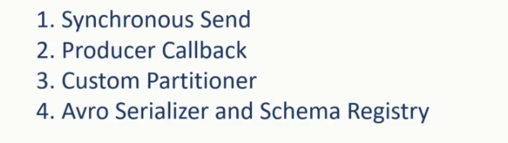

However, we are yet to develop examples for the following items. Synchronous Send Producer Callback Custom Partitioner and finally, Avro Serializer and Schema Registry In this lecture, I will briefly talk about these concepts and help you understand the implementation details using some straightforward examples. Let's start with Synchronous Send and Producer callback. Default Kafka producer send API is asynchronous and non-blocking. When you call the send API, it merely adds the ProducerRecord into the buffer and returns immediately. You have already learned this in the earlier lectures. Asynchronous and non-blocking send is efficient. However, it also leaves the possibility to lose some messages without even knowing that some of your messages never reached the Kafka broker. Kafka producer internally takes care of this problem using automatic retries. However, if retries are also failing, you can still lose some messages.

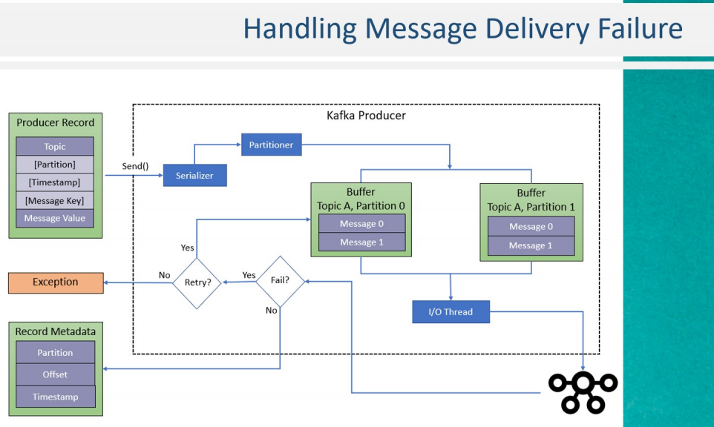

In real life, this loss is not more than 1-2 percent of the total messages, and in some use cases, missing 1-2 percent of data may not be a problem. However, in many use cases, you don't want to miss even a single record. So, the question is, How to deal with this problem? The first thing is to take a decision on what do you want to do with the failing records? In most of the cases, you may want to store the failing records in separate storage and take some necessary action at a later stage. Right? Now the next question is, How do we implement it because the send() method is asynchronous and returns immediately without waiting for the acknowledgment. There are two ways to deal with this problem. In the first approach, you can call a get() method over the send() method, as shown in this code snippet.

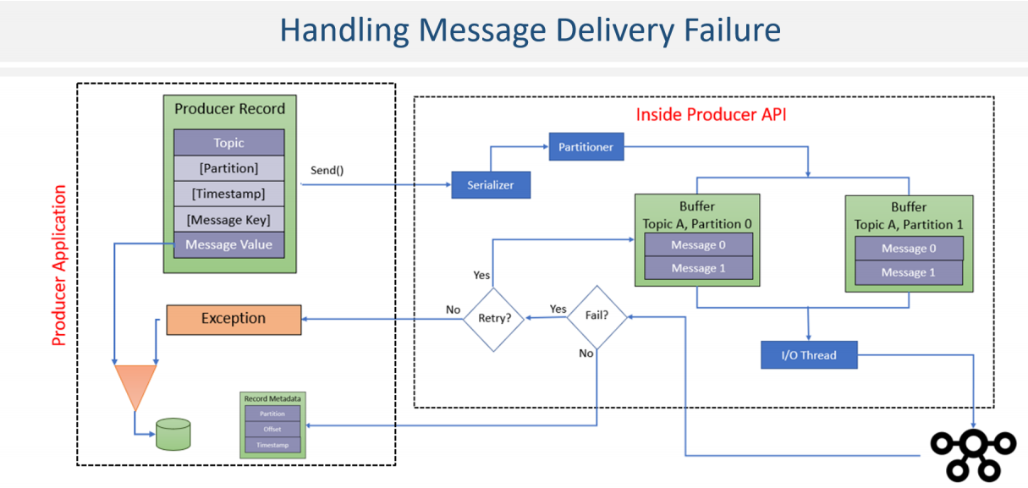

The get method is synchronous and blocking call, which will wait for the acknowledgment. The get() method will throw an exception in case of failure, or it will return the metadata in case of success. This approach makes your send() method as a synchronous call and allows us to take whatever action you want to take in case of failure. However, such blocking send method call is suitable for scenarios where your messages are produced at a slower pace. Asynchronous sends were more efficient as the producer can leverage grouping multiple messages and optimize network roundtrips to achieve better throughput. So, to handle high throughput use cases, and also knowing which messages failed to deliver, Kafka API offerss a second alternative. Producer Callback.

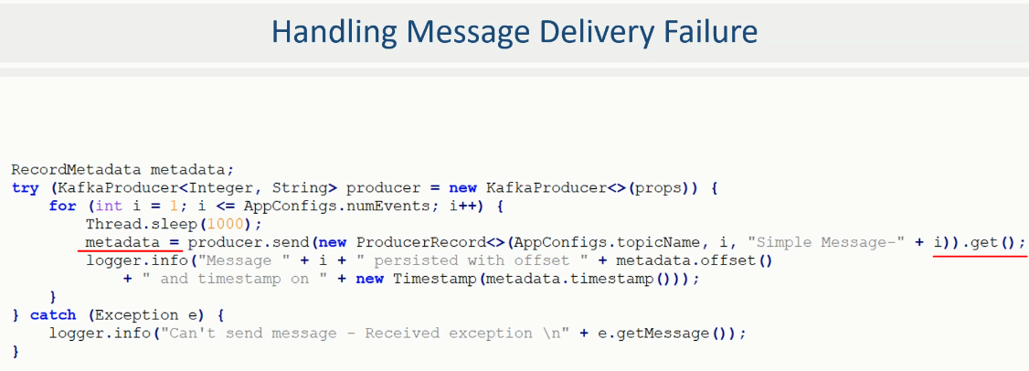

In this approach, you can supply a callback method to your producer to be invoked when the acknowledgment arrives. The code snippet shown here implements a lambda expression for passing a callback method. In this case, the send method returns immediately. But the internal I/O thread will call the lambda function when the acknowledgment arrives, and you can take necessary action in your lambda method. I have taken hello producer example and modified it to create two different fully functional examples to demonstrate the synchronous send().get() implementation as well as call-back implementation. Both of these examples are included in your course material. The example code is well documented, and it also explains how to forcefuly fail the message delivery, and generate an exception. so you can see the callback behavior in case of success and failure both. The next item I wanted to talk about the custom Partitioner. We have already learned about the importance of Kafka partitions and the default partitioner. Kafka topic partitions are a tool to support scalability by evenly distributing data across partitions and assigning partitions for the consumers for parallel reading and processing. You will learn more about Kafka consumer groups in the following section.

#### Sync Hello Producer code

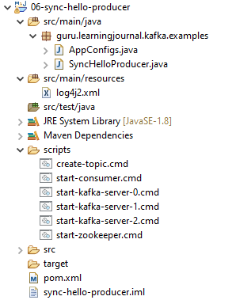

**AppConfigs.java**

public class AppConfigs {

public final static String applicationID = "SyncHelloProducer";

public final static String bootstrapServers = "localhost:9092,localhost:9093";

public final static String topicName = "sync-hello-producer";

public final static int numEvents = 100;

}

**SyncHelloProducer.java**

import org.apache.kafka.clients.producer.KafkaProducer;

import org.apache.kafka.clients.producer.ProducerConfig;

import org.apache.kafka.clients.producer.ProducerRecord;

import org.apache.kafka.clients.producer.RecordMetadata;

import org.apache.kafka.common.serialization.IntegerSerializer;

import org.apache.kafka.common.serialization.StringSerializer;

import org.apache.logging.log4j.LogManager;

import org.apache.logging.log4j.Logger;

import java.sql.Timestamp;

import java.util.Properties;

public class SyncHelloProducer {

private static final Logger logger = LogManager.getLogger();

public static void main(String[] args) {

logger.trace("Creating Kafka Producer...");

Properties props = new Properties();

props.put(ProducerConfig.CLIENT_ID_CONFIG, AppConfigs.applicationID);

props.put(ProducerConfig.BOOTSTRAP_SERVERS_CONFIG, AppConfigs.bootstrapServers);

props.put(ProducerConfig.KEY_SERIALIZER_CLASS_CONFIG, IntegerSerializer.class);

props.put(ProducerConfig.VALUE_SERIALIZER_CLASS_CONFIG, StringSerializer.class);

//We want to raise an exception - So, do not retry.

props.put(ProducerConfig.RETRIES_CONFIG, 0);

//We want to raise an exception - So, take acknowledgement only when

// message is persisted to all brokers in ISR

props.put(ProducerConfig.ACKS_CONFIG, "all");

/*

Follow below steps to generate exception.

1. Start three node cluster

2. Create topic with --config min.insync.replicas=3

3. Start producer application

4. Shutdown one broker while producer is running - It will cause NotEnoughReplicasException

*/

RecordMetadata metadata;

try (KafkaProducer<Integer, String> producer = new KafkaProducer<>(props)) {

for (int i = 1; i <= AppConfigs.numEvents; i++) {

Thread.sleep(1000);

metadata = producer.send( new ProducerRecord<>(AppConfigs.topicName,

i, "Simple Message-" + i)).get();

logger.info("Message " + i + " persisted with offset " + metadata.offset()

+ " and timestamp on " + new Timestamp(metadata.timestamp()));

}

} catch (Exception e) {

logger.info("Can't send message - Received exception \n" + e.getMessage());

}

}

}

**scripts/**

**create-topic.cmd**

kafka-topics.bat --create --zookeeper localhost:2181 --replication-factor 3 --partitions 3 --topic pos

**start-consumer.cmd**

kafka-console-consumer.bat --bootstrap-server localhost:9092 --topic pos --from-beginning

**start-kafka-server-0.cmd**

kafka-server-start.bat %KAFKA_HOME%\config\server-0.properties

**start-kafka-server-1.cmd**

kafka-server-start.bat %KAFKA_HOME%\config\server-1.properties

**start-kafka-server-2.cmd**

kafka-server-start.bat %KAFKA_HOME%\config\server-2.properties

**start-zookeeper.cmd**

zookeeper-server-start.bat %KAFKA_HOME%\config\zookeeper.properties

**pom.xml**

<?xml version="1.0" encoding="UTF-8"?>

<project xmlns="http://maven.apache.org/POM/4.0.0"

xmlns:xsi="http://www.w3.org/2001/XMLSchema-instance"

xsi:schemaLocation="http://maven.apache.org/POM/4.0.0 http://maven.apache.org/xsd/maven-4.0.0.xsd">

<modelVersion>4.0.0</modelVersion>

<groupId>guru.learningjournal.kafka.examples</groupId>

<artifactId>sync-hello-producer</artifactId>

<version>2.3.0</version>

<properties>

<java.version>1.8</java.version>

<kafka.version>2.3.0</kafka.version>

</properties>

<build>

<plugins>

<!-- Maven Compiler Plugin-->

<plugin>

<groupId>org.apache.maven.plugins</groupId>

<artifactId>maven-compiler-plugin</artifactId>

<version>3.8.0</version>

<configuration>

<source>${java.version}</source>

<target>${java.version}</target>

</configuration>

</plugin>

</plugins>

</build>

<dependencies>

<!-- Apache Kafka Clients-->

<dependency>

<groupId>org.apache.kafka</groupId>

<artifactId>kafka-clients</artifactId>

<version>${kafka.version}</version>

</dependency>

<!-- Apache Log4J2 binding for SLF4J -->

<dependency>

<groupId>org.apache.logging.log4j</groupId>

<artifactId>log4j-slf4j-impl</artifactId>

<version>2.11.0</version>

</dependency>

</dependencies>

</project>